Азбука Бережливого Подхода

Крейг Ларман (Craig Larman) и Бас Водд (Bas Vodde)

Версия 1.6

*Пожалуйста, присылайте нам комментарии для будущих версий, на www.leanprimer.com.*

*Замечание: Проверьте последнюю версию на сайте; для актуальности передавайте ссылку на сайт (а не файл).*

Крейг Ларман и Бас Водд являются авторами *Масштабируемой Бережливой и Гибкой Разработки*. Они работают в качестве коучей менеджмента в организациях, внедряющих бережливое мышление.

Для получения консалтинга или другой информации, смотрите, пожалуйста, *craiglarman.com* и *odd-e.com*.

*Замечение*: Бережливое мышление и Путь Toyota являются довольно *обширными* темами, охватывающими разработку продуктов, оказание услуг, продажи, Управление Персоналом и производство, и включающими функции: менеджмента, проектирования, поставки и другие. Мы советуем более глубокое изучение; см. раздел *Рекомендуем к Прочтение* в конце.

## Содержание

Введение 2

Бережливое Мышление: Общая Картина 3

Предыстория 8

Обзор Бережливого Подхода: Дом Бережливого Мышления 9

LEAN GOAL: SUSTAINABLY DELIVER VALUE FAST 10

LEAN FOUNDATION: LEAN THINKING MANAGER-TEACHERS 11

PILLAR ONE: RESPECT FOR PEOPLE 13

PILLAR TWO: CONTINUOUS IMPROVEMENT 15

PRINCIPLES 26

LEAN PRODUCT DEVELOPMENT 35

# 

# Введение

*У меня достаточно денег, чтобы хватило на всю оставшуюся жизнь, пока я не куплю что-нибудь. —* *Джеки Мейсон (Jackie Mason)*

Бережливое мышление — это проверенная система, масштабируемая до уровня крупной разработки, что подтверждается корпорацией Toyota и другими. Несмотря на то, что этот термин чаще применим к промышленному производству, он также используется в сфере обслуживания — как внутри Toyota так и в таких областях, как здравоохранение. [1].

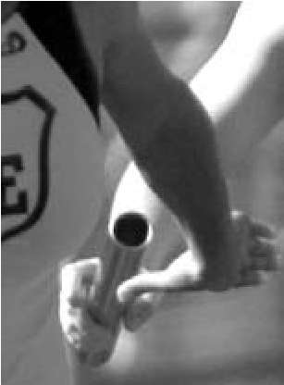Изображение и метафора, с помощью которой нам нравится доносить ключевую ошибку в понимании — и вместе с ней основную идею — это эстафетный бег.

Представьте себе эстафетных бегунов, которые *топчутся на месте* в ожидании эстафетной палочки от своих бегущих коллег. Бухгалтер финансового департамента, в ужасе глядя на такие кошмарные 'потери' из-за недостаточной загрузки, вероятно потребовал бы установить политику "95% утилизация ресурсов", чтобы удостовериться, что все бегуны загружены и ‘продуктивны’. Наверняка — посоветовал бы он — бегуны могли бы бежать три эстафеты в одно и то же время, чтобы увеличить “утилизацию ресурсов”, или они могли бы бежать в гору в процессе ожидания эстафетной палочки.

Забавно... Но такое мышление лежит в основе многих традиционных управленческих подходов и процессов в области разработки и прочих [2]. И конечно, в противоположность этому, вот как звучит ключевая идея бережливого мышления:

**Следи за эстафетной палочкой, а не за бегунами.**

Измеряет ли ваша организация “продуктивность” и “эффективность” с точки зрения того, насколько люди *загружены* или сколько времени тратится на “наблюдение за бегунами”? Или она измеряет “продуктивность” с точки зрения быстроты поставки ценности реальному (конечному) потребителю, тем самым “следя за эстафетной палочкой”? Какое *соотношение* *поставляемых ценностей к потерям* в вашей работе? Каковы препятствия в потоке поставки ценности и как люди могут быть мотивированы стремиться постоянно улучшать этот поток? Вот какие вопросы рассматривает бережливое мышление.

# Бережливое Мышление: Общая Картина

**Бережливый подход** или **бережливое мышление** (lean, lean thinking) — это английское название, популяризированное исследователями из Массачусетского технологического института (MIT), сейчас известное внутри создавшей его компании как **Путь Toyota** (Toyota Way). [3] Toyota — сильная, стабильная компания, которая, как можно видеть, совершенствуется на протяжении длительного времени.

|  |  |
| --- | --- |
| – В 2008 превзошла GM (General Motors) и стала крупнейшей компанией по продажам автомобилей, при этом будучи ещё и намного более прибыльной. | – Капитализация рынка в Мае 2007 была более чем в 1.5 раза выше чем у GM, Ford и DaimlerChrysler ***вместе взятых***. |
| – J.D. Power[4] (и прочие) неоднократно отмечали Toyota, Lexus и Scion в списке самых качественных авто. | – Инновационная, с заботой об экологии и социальной среде — например, создатель Prius и гибридной технологии. |
| – В 2006 прибыль составила $13.7 биллионов USD, в то время как GM и Ford отчитывались о потерях.a | – Показатели разработки продуктов до 2 раз превышали некоторых конкурентов. |

a. В 2009, после мирового финансового кризиса, GM объявили себя банкротом. Toyota же, понёсшая убытки наряду с другим автомобильными компаниями, остаётся платежеспособной.

В качестве примера; книга Экстремальная *Toyota* [OST08] посвящает главу своей *устойчивой* производительности в сравнении с другими компаниями в своей индустрии. Там говорится, что Toyota далека от совершенства, и существует масса уникальных вещей в других системах, которым следует поучиться (таких как *гибкий подход* в разработке программного обеспечения), и которые не найти в бережливом мышлении. Мы не настаиваем на том, что Toyota или бережливое мышление — это единственные модели, из которых следует извлекать уроки или просто следовать их примеру. Тем не менее, это эволюционирующая на протяжении длительного времени, заслуживающая внимания система, созданная довольно надёжной и устойчивой компанией.

### Столпы Бережливого Подхода - Это *Не* Инструменты или Уменьшение Потерь

Есть несколько заблуждений относительно бережливого подхода. Этот раздел начинается с того, чтобы развеять их.

Что является сутью и силой бережливого мышления и Toyota?

*Когда я впервые начал изучать TPS*[5]*, я был очарован силой [потоком в одно изделие, канбаном и другими инструментами бережливого подхода]. Но на протяжении всего пути, опытные лидеры Toyota не переставали объяснять мне, что эти инструменты и техники не были ключевыми. Сила, лежащая в основе TPS, это скорее* ***стремление менеджмента компании постоянно инвестировать в своих людей*** *и* ***проповедовать культуру непрерывного улучшения****. После обучения в течение почти 20-ти лет…..я наконец-то полностью это осознал. [Liker04] (выделение добавлено)*

Вакамацу (Wakamatsu) и Кондо (Kondo), эксперты Toyota, выражают это кратко:

*Суть [системы Toyota] в том, чтобы каждому отдельному сотруднику была предоставлена возможность самостоятельно, своим собственным способом находить и решать проблемы, а также вносить необходимые улучшения. [Hino06]*

### Инструменты Менеджмента Не являются Столпами Бережливого подхода

Приведённые выше цитаты подчёркивают жизненно важный момент, потому что на протяжении многих лет существовали некие якобы ‘бережливые’ сторонники, которые опустили бережливое мышление до механического, поверхностного уровня инструментов управления, таких как *канбан* и управление очередями. Эти вторичные, производные описания игнорируют основное послание экспертов Toyota, которые подчёркивают, что основная суть успешного бережливого мышления заключается в том, чтобы “сначала выращивать людей, а потом создавать продукты” и в культуре “бросающей вызов статус-кво” путём непрерывного совершенствования. [Hino06]

*Сужение бережливого мышления до уровня канбана, управления очередями и других инструментов, подобно сокращению подлинной демократии до обычного голосования.* Голосование — это хорошо, но демократия намного более изощрённая и сложная. Посмотрите на внутренний девиз Toyota, изображённый на фотографии, которую мы сделали во время посещения

Toyota в Японии несколько лет назад; он отражает самую суть бережливого подхода, устанавливая акцент на образовании людей, чтобы они стали мастерами системного мышления:

Упрощение бережливого мышления до инструментов — это хождение по тем же граблям, по которым до вас уже много раз прошли другие компании, поверхностно и безуспешно пытаясь внедрить то, что они считали бережливым подходом.

*...* *это случилось только после того, как Американские автопроизводители исчерпали все возможные объяснения успеха Toyota (заниженный курс иены, послушная рабочая сила, японская культура, превосходная автоматизация), тогда они наконец-то смогли признать, что* ***настоящее преимущество Toyota в способности задействовать интеллектуальный потенциал ‘обычных’ сотрудников****. [Hamel06]*

Следовательно, **Шесть Сигм Бережливого подхода** [6] рассматривается людьми в Toyota, как просто *инструменты* Шести Сигм, но не как реальное бережливое мышление. Бывший управляющий завода Toyota и менеджер по персоналу объясняет:

*“Шесть Сигм Бережливого подхода” это подборка инструментов и тренингов, ориентированных на конкретные, изолированные аспекты для снижения стоимости единицы продукции… Подход Toyota […] гораздо более всеобъемлющий и глубокий. Отправной точкой является философия Пути Toyota: уважение к людям и непрерывное совершенствование. Этот принцип заключается в выращивании квалифицированных людей, которые постоянно улучшают процессы… При этом ответственность лежит не на специалистах с “чёрными поясами”, но на руководстве, которое запускает весь процесс и является учителями и наставниками. [LH08]*

### Уменьшение Потерь Не является Столпом Бережливого Подхода

Книга “Бережливое Производство” (Lean Thinking) [WJ96] была по праву популярной и представила некоторые идеи Toyota гораздо более широкой аудитории. Мы рекомендуем её — с замечанием, что она представляет краткое описание системы Toyota. *“Бережливое Производство”* опирается в значительной степени на исследования 1980-х и начала 1990-х годов, которые фокусируются на производственной системе Toyota [WJR90], и были опубликованы до ‘Зелёной Книги’ “*Путь Toyota 2001*”, представленной самой Toyota, которая резюмирует, что более глобальные принципы приоритетнее с их внутренней точки зрения. Подзаголовок книги “Бережливое Производство” — *“Как Избавиться от* ***Потерь*** *и Добиться Процветания Вашей Компании”*, поэтому не удивительно, что те, кто прочитал одну только эту книгу, зачастую ассоциируют бережливый подход в первую очередь с “устранением потерь”.

Несмотря на свою пользу, сокращение потерь не является основой бережливого подхода. Оно упоминается только лишь на некотором из подуровней в *“Путь Toyota 2001”*. Кроме того, в *“Бережливом Производстве”* некоторые выдающиеся принципы, такие как *Пойди и Посмотри* (особо выделяемые в Toyota) рассматриваются в занимательной, но лишь в шутливой или эпизодической форме, что позволяет упустить относительную важность некоторых принципов бережливого подхода в Toyota. Поэтому, изучайте *“Бережливое Мышление”*, но также изучайте и остальное из списка *Рекомендованной Литературы*.

## Два Столпа Бережливого Подхода

Что же тогда *является* основными принципами бережливого подхода? Президент Toyota Гари Конвис (Gary Convis):

*Путь Toyota можно кратко изложить в двух столпах, на которых он основывается:* ***Непрерывное Совершенствование*** *и* ***Уважение к Людям****. Непрерывное совершенствование, часто называемое* ***кайдзен****, определяет основной подход Toyota к бизнесу.* ***Бросайте вызов всему!*** *(Всё может быть подвергнуто сомнению). Более значимая, чем фактические улучшения, которые вносят отдельные лица, истинная ценность непрерывных улучшений заключается в создании атмосферы непрерывного обучения и среды, которая не просто принимает, но и фактически* ***приветствует изменения****. Такая среда может быть создана только там, где есть уважение к людям — этим объясняется второй столп Пути Toyota. (выделение добавлено)*

И от генерального директора Toyota Кацуаки Ватанабэ (Katsuaki Watanabe):

*Путь Toyota опирается на два основных столпа: непрерывное совершенствование и уважение к людям. Уважение является обязательным в работе с людьми. Под “людьми” мы подразумеваем сотрудников, партнёров-поставщиков и клиентов. …Мы не имеем в виду только конечных потребителей; человек на следующем участке конвейера тоже является вашим клиентом. Это способствует командной работе.* ***Если вы следуете этому принципу, вы будете также анализировать то, что вы делаете, чтобы понять всё ли вы делаете правильно, таким образом вы не заставите ваших клиентов беспокоиться.*** *Это подпитывает вашу способность выявлять проблемы и если вы внимательно наблюдаете за вещами, это приведёт к кайдзен — непрерывному совершенствованию.* ***Основа Пути Toyota — быть постоянно несогласным со статус-кво; вы постоянно должны задаваться вопросом: “Зачем мы это делаем?”*** *(выделение добавлено)*

Уважение к людям и непрерывное совершенствование “бросают вызов всему” и создают образ “поддерживающего изменения” мышления. Эти столпы бережливого подхода рассматриваются подробнее далее. Если программа внедрения бережливого подхода

игнорирует важность этих вещей — **карго-культ** внедрения бережливого подхода[7] — тогда существенное понимание и условия для стабильного успеха в бережливом подходе будут упущены.

# Предыстория

Английский термин ‘бережливый’ был придуман для системы Toyota — исследователями Toyota из MIT в книге *“Машина, Которая Изменила Мир”* [WJR90] — чтобы противопоставить их *бережливое производство* как альтернативу *массовому производству*. Следствием этого стало радикальное сокращение объёма партии продукции, находящейся в производстве, и прекращение попыток конкурировать за счёт экономии на масштабе, а скорее конкурировать за счёт возможности адаптироваться, избегать запасов и работать в очень небольших подразделениях. Термин *бережливый* теперь также используется и внутри Toyota; например, в их внутреннем буклете *“Путь Toyota 2001”*.

Двое из авторов книги *“Машина, Которая Изменила Мир”* продолжили писать *“Бережливое Производство”* — популярное вводное издание, в котором резюмируются пять принципов.

Довольно подробными описаниями бережливого подхода являются книги: *“Дао Toyota”*, *“Система Разработки Продукции в Toyota. Люди, Процессы, Технология”*, *“Inside the Mind of Toyota”*, *“Экстремальная Toyota”* и *“Lean Product and Process Development”*. Все они основаны на изучении опыта Toyota. Текст *“Дао Toyota”* [Liker04] используется в Toyota для обучения, в дополнении к их внутреннему *“Путь Toyota 2001”*. Настоящее введение в бережливый подход сходно со всеми этими описаниями.

Рис. 1.1 дом бережливого мышления



# Обзор Бережливого Подхода: Дом Бережливого Мышления

Рис 1.1 кратко описывает современный Путь Toyota на диаграмме “дом бережливого мышления”, потому что более ранняя версия системы Toyota также впервые была приведена внутри Toyota с помощью похожей диаграммы-дома[8]. Этот дом также определяет основные подразделы настоящего документа,

такие как *Уважение к Людям* и *Непрерывное Совершенствование*. Последующая часть этого документа рассматривает основные элементы диаграммы в следующем порядке::

|  |  |
| --- | --- |
| 1. цель (крыша) 2. основа 3. столп—уважение к людям | 1. столп—бережливое мышление 2. 14 принципов 3. бережливая разработка продуктов |

# Цель Бережливого Подхода: Стабильная и Быстрая Поставка Ценности

*Стабильные кратчайшие сроки поставки, наилучшее качество и ценность (для общества и людей), максимальное удовлетворение клиента, наименьшие затраты, высокий моральный дух, безопасность.*

Вообще говоря, глобальной или системной целью бережливого мышления в Toyota является быстрая поставка ценности (для клиента и *общества*) всё больше и больше сокращая время цикла всех процессов, в то же время продолжая обеспечивать высочайшее качество и уровень морального духа — *поток ценности* к клиенту без задержек. Toyota стремится уменьшать время цикла, но не за счёт “срезания углов” и ухудшения качества, или работая в нестабильном, небезопасном темпе; а скорее, благодаря неустанному *непрерывному совершенствованию*, что требует корпоративной культуры осознанного *уважения к людям*, в которой люди чувствуют, себя безопасно, чтобы бросить вызов и изменить статус-кво.

Отголоски этой цели есть в словах создателя Производственной Системы Toyota (TPS), Тайити Оно (Taiichi Ohno):

*Всё что мы делаем — это наблюдаем за промежутком времени, с момента получения заказа от клиента до момента получения денег. И мы уменьшаем этот промежуток времени, сокращая не добавляющие ценности потери.[9] [Ohno88]*

Таким образом фокус в бережливом подходе на *эстафетной палочке*, а не на бегунах — устраняя узкие места для ускорения поставки ценности для клиентов, вместо локальной оптимизации, нацеленной на максимизацию загрузки рабочих или машин.

Toyota (и её подразделения Lexus и Scion) не только производят автомобили, но также успешно и эффективно *разрабатывают* новые продукты — принципы бережливого производства также применяются и в продуктовой разработке. Как Toyota достигает “глобальную цель” в двух своих основных процессах: разработке новых продуктов и производстве?

❑ **Разработка продуктов** — *превзойти конкурентов в обучении*, путём генерации большего количества полезных знаний и их эффективного использования и сохранения.

❑ **Производство** — *превзойти конкурентов в улучшении*, фокусируясь на коротких циклах, небольших партиях и очередях, останавливаясь, чтобы найти и исправить корень проблемы, беспрестанно устраняя все потери (ожидания, лишние передаточные звенья, …).

Позднее мы вернёмся к *обучению* и *улучшению*. Конечно, эти два подхода не являются взаимоисключающими. Разработка продуктов в Toyota также улучшается, а Производство также постоянно обучается.

# Фундамент Бережливого Подхода: Бережливо-Мыслящие Менеджеры-Учителя

*Менеджмент сам применяет бережливое мышление, обучает ему и основывает свои решения на этой долговременной философии.*

Когда мы впервые посетили Toyota в Японии, мы опрашивали людей, чтобы больше узнать об их культуре управления и системе образования. Одна из вещей, которую мы узнали заключается в том, что большинство новых сотрудников сначала проходят несколько месяцев обучения, прежде чем приступить к работе. В течение этого периода они изучают основы бережливого мышления, они учатся видеть ‘потери’ (предмет, к которому мы ещё вернёмся), а также они проходят практику во многих подразделениях Toyota. Таким образом, новые люди Toyota…

❑ учатся *“видеть целое”* (системное мышление)

❑ учатся видеть, как бережливое мышление применяется в различных областях

❑ учатся образу мышления *кайдзен* (непрерывное совершенствование)

❑ узнают ценность основного принципа в Toyota называемого *Пойди и Посмотри* и *гемба*

*Пойди и Посмотри* означает что люди, особенно менеджеры, готовы “сами пойти и посмотреть своими собственными глазами” вместо того, чтобы сидеть на своём рабочем месте или верить в то, что правду можно узнать только из отчётов и цифр. Это относится к признанию важности *гемба* — отправиться на “передовую”, где создаётся ценность, и где находятся рабочие, собственноручно создающие эту ценность.

Lean Foundation: Lean Thinking Manager-Teachers

Michikazu Tanaka, a student of Taiichi Ohno, summarized the lessons he learned:

*You can’t come up with useful kaizen [improvement] sitting at your desk… We have too many people these days who don’t understand the workplace… They think a lot, but they don’t see. I urge you to make a special effort to see what’s happening in the workplace. That’s where the facts are. [SF09]*

We also learned that potential executive managers have worked their way up through years of hands-on lean thinking practice and mentoring to others. When Eiji Toyoda was president, he said to the management team, “I want you actively to train your people on how to think for themselves” [Hino06]. Note that this is *not* simply a message of *let people think for themselves*. Rather, the management culture is *managers act as* ***teachers*** *of thinking skills*. Toyota managers are educated in lean thinking, continuous improvement, root cause analysis, the statistics of variability, and systems thinking—and coach others in these thinking tools.

From this, we came especially to appreciate that for successful adoption of lean, there are management qualities needed for any meaningful, sustained success—the leadership team cannot “phone in” their lean support. Toyota is one of few companies that seems to demonstrate these qualities; to summarize [OST08]:

❑ Long-term philosophy—many in the company are educated in lean thinking through courses and mentoring from manager-teachers.

❑ Long-term philosophy—virtually all management, including the executive level, must have a solid understanding of lean principles, have lived them for years, and teach them to others.

❑ Long-term philosophy—manager-teachers have cultivated systems thinking and process-improvement problem-solving thinking skills, and they teach it to others. The culture is imbued with the mentality and behavior, “Let’s stop and understand the root causes of problems.”

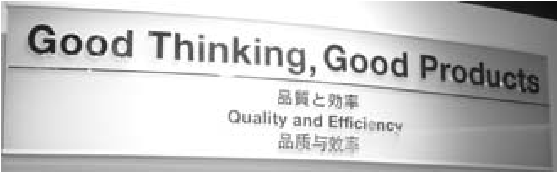**Manager-teachers**—the internal motto is *Good Thinking, Good Products*. How do they achieve this “good thinking” which forms the foundation of their success? It is through *a culture of mentoring.* Managers are expected to be hands-on masters of their domain of work (the saying is, “my manager can do my job better than me”), are expected to understand lean thinking, and are expected to *spend time teaching and coaching others*. We learned during an interview in Japan that Toyota HR policies include analysis of how much time a manager spends teaching. In short, managers are less directors and more

teachers in the principles of lean thinking, “stop and fix right,” and *kaizen* mentality. In this way, the *Toyota DNA* is propagated [LH08].

Atsushi Niimi, Toyota North America president, said that the greatest challenge in teaching the Toyota Way to foreign managers was, “They want to be managers, not teachers.”

In [Liker03], a matrix of management cultures is presented; ideal lean manager-teachers are in the top-left quadrant—bottom-up consensus builders and real team leaders who are work experts, and who mentor their team members:

|  |  |  |
| --- | --- | --- |
|  | **expert knowledge of the work** | **only general management knowledge** |
| **bottom-up** | *coach/mentor; builder of a learning organization* | facilitator |
| **top-down** | detailed task master | bureaucrat |

The more one learns about lean, the more one appreciates that the foundation is manager-teachers who live and teach it and have long hands-on experience. The foundation is not tools or waste reduction.

Any executive team that wants to succeed with lean thinking will need to pay attention to this basic lesson—that they cannot “phone in” their support to “do lean.”

# PILLAR ONE: RESPECT FOR PEOPLE

*Respect for people* sounds nebulous, but includes concrete actions and culture within Toyota. They broadly reflect respect for and sensitivity to morale, not making people do wasteful work, real *teamwork*, mentoring to develop skillful people, humanizing the work and environment, safe and clean environment (inside *and outside* of Toyota), and philosophical integrity among the management team. Figure 1.2 illustrates some implications.

**Foundation**

**Goal**

**Product**

**Develop-**

**ment**

**14**

**Principles**

**Continuous**

**Improvement**

**Respect for**

**People**

Pillar One: Respect for People

Figure 1.2 respect for people

**Lean “Respect**

**for People”**

**Dont Trouble Your Customer**

your customer is anyone who

-

consumes your work or decisions

-

relentlessly analyze and change to

stop troubling them

don

-

t force people to do wasteful work

-

don

t give them defects

-

don

t make them wait

don

-

t impose wishful thinking on them

-

don

t overload them

**“Develop People and Then**

**Build Products”**

-

managers act as teachers, not

directors

mentor people closely, for years, in

-

engineering and problem solving

-

teach people to analyze root

causes and make problems visible;

then they discover how to improve

**Teams & Individuals Evolve**

**Their Own Practices &**

**Improvements**

-

management challenges

people to change and may

ask what to improve , but…

-

workers learn problem solving

and reflection skills and then...

-

decide how to improve

**Managers**

**“Walk the Talk”**

managers understand and

act on the goal of

“eliminating waste” and

“continuous improvement”

in their own actions and

decisions—and

employees see this

**Develop Teams**

real, jelled teams of 5-6 people

-

team-work, not group-work, culture

-

**Build Partners**

-

form long relationships based on trust

help partners improve and stay profitable

-

# PILLAR TWO: CONTINUOUS IMPROVEMENT

*Continuous improvement* is based on several ideas:

❑ Go See

**Foundation**

**Goal**

**Product**

**Develop-**

**ment**

**14**

**Principles**

**Continuous**

**Improvement**

**Respect for**

**People**

❑ kaizen

❑ perfection challenge

❑ work toward flow (covered in the *14 Principles*)

**Go See for Yourself (Go See)**

*Go to the source [the place of real value work—gemba] to find the facts to make correct decisions, build consensus, and achieve goals at our best speed. [Toyota01]*

**Go See** is a principle not found in many management cultures. This principle is described as critical and fundamental. In the internal *Toyota Way 2001* it is highlighted as *the first factor for success* in continuous improvement. *Go See* shows up repeatedly in Toyota manager quotes, in Toyota culture and habits [LH08], in education on the Toyota Way, and in the research done by Japanese analysts of lean thinking (for example, [OST08]). All that said, it is missing from some derivative ‘lean’ descriptions and so—unfortunately—some are unaware of its vital role.

In a lean-thinking culture, all people, but especially managers—including senior managers—should not spend all their time in separate offices or meeting rooms, receiving information via reports, computers, management reporting tools, and status meetings.

Rather, to know what is going on and help improve (by eliminating the distortion that comes from indirect information), *management should frequently go to the place of real work and see and understand for themselves*. This “real front-line place of work” (*gemba*) does not mean proximity to the building where work happens, nor does it mean going to visit other managers. It implies to be as physically close to the real front-line work as possible—not sitting in an office nearby, but “breathing the same air.” ‘Work’ in lean does not primarily mean the overhead or secondary work of accounting and so on, but the value-adding work that the customer cares about—engineering, designing a car, producing things, delivering customer service.

An example of Go See is for managers to regularly visit and then sit with hands-on engineers or service-delivery people while they are working, with the aim of under-

standing problems and opportunities to improve. It is similar to the unfortunately now-lost HP practice of “management by walking around.”

In an interview, Toyota’s chief engineer quoted Taiichi Ohno, who insisted on managers practicing Go See at *gemba*:

*Don’t look with your eyes, look with your feet… people who only look at the numbers are the worst of all. [Hayashi08]*

The Japanese term for Go See, **genchi genbutsu**, has also been broadly rendered as implying *solve problems at the source instead of behind desks*. Go See not only implies *walking* to the source to find facts and decide with direct insight; it means—once you are there—to *build consensus* for goals and experiments to change. The full implication of Go See is for people—especially managers—to frequently spend time at the real place of value work, build relationships of trust with the people there, and help them fix things.

For example, Figure 1.3 shows a picture of Craig’s ‘office’ in Bangalore, Valtech India: a little desk physically among hands-on teams. He has spent time sitting with the real workers while they work, and attending their kaizen events. In this way, getting a direct understanding of what’s working and what’s not—and how to better help.

Figure 1.3 ‘office’—Go See attitude

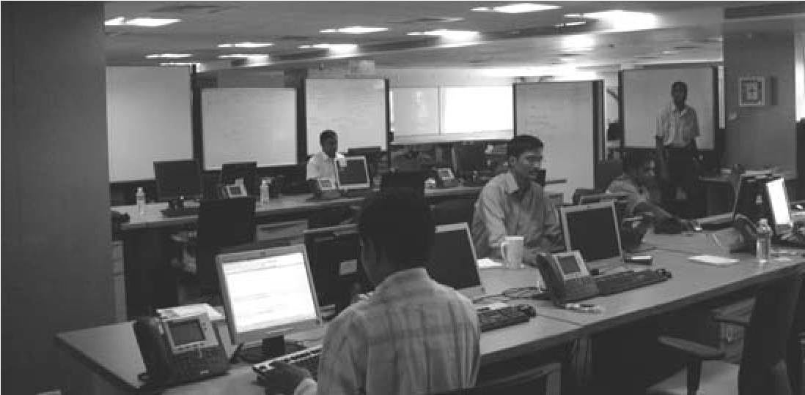

**Kaizen**

*Improve for improvements’ sake, endlessly.*

**Kaizen** is sometimes translated as simply “continuous improvement” but that confuses it with the broader lean *pillar* of “continuous improvement” and does not capture the full flavor. So, we will stick with the Japanese term.[10]

Kaizen is both a personal mindset and a practice. As a mindset, it suggests *“My work is to do my work and to* ***improve*** *my work”* and *“continuously improve for its own sake.”* More formally as a practice, kaizen implies:

1. choose and practice techniques the team has agreed to try, until they are wellunderstood—that is, master standardized work
2. experiment until you find a better way
3. repeat forever

***Step 1—Choose and practice techniques the team has agreed to try, until they are well understood (master standardized work).*** The idea is for a group to first find (hopefully) skillful baseline practices and learn to do them well. People learn to do <X> in a standardized way, with plenty of practice, coaching, and good education. Step one in kaizen implies having patience through the awkward learning phase and not abandoning new techniques quickly. *People need a valid baseline to improve against*. And in Deming’s terminology, they need to be able to distinguish between commoncause and special-cause variability.

This step-one point of kaizen is that a person or team cannot accurately see if they need to improve or change a practice unless they have first mastered the basics, understood its subtle points, and can do it well. Have you ever seen, “Oh, <X> doesn’t work” comments that were based on insufficient skill, practice, or education? There is no point in ‘improving’ or rejecting based on misunderstanding.

**In lean thinking, standardized work *does not* mean conforming to centralized standards**—A gross misunderstanding of lean thinking is the notion that “standardized work” means conformance to centrally-defined standards. This is such a profound mistake from the lean perspective, yet so easily misunderstood, that this point deserves special emphasis. Rather, the idea is for a team to master a baseline against which improvement experiments can be compared. This baseline—the standard—is *created by the team themselves* (not by a centralized group) and is *ever-evolving*. As Ohno said:

*I told everyone that they weren’t earning their pay if they left the standardized work unchanged for a whole month. The idea was to let people know that they were responsible for making continual improvements in the work procedures and for incorporating those improvements in the standardized work. [SF09]*

***Share* rather than enforce practices**—To reiterate, the standardized work or team norms should not be misconstrued to mean a fixed practice to follow “until notified otherwise” or a centralized top-down ‘standard’ from a central process group that is forced on people—ideas contrary to the lean pillar of *continuous improvement*. Toyota people promote **yokoten**—**spread knowledge laterally** that may evolve uniquely in different locations, like a graft from a tree. *Yokoten* means literally to *unfold* or *open out sideways*. **Spread knowledge** implies a culture that emphasizes horizontal knowledge sharing, but not being forced to conform to central processes pushed top-down.[11]Some quotes from Toyota people:

*If we try to simply get everyone to the current standard you are missing opportunities to get better. You are not taking into account how times are changing. There has to be lots of flexibility in allowing creativity along the way… Standards are not developed and then communicated from headquarters to all the plants. Rigid standards will only kill kaizen… It is yokoten every time—share best practices. …We must let individuals from plants decide what they will do to fix their problems and close gaps. We cannot have someone from corporate saying you need to do X, Y, Z, because this is completely contrary to Toyota problem solving. [LH08]*

**Communities of practice**—something we recommend—are created to *spread knowledge laterally*.

***Steps 2 and 3—Small, incremental, relentless change of anything***. Kaizen is an on-going activity by all people (including managers) to *relentlessly* and *incrementally* change and improve practices, usually in *small* experiments, though large-scale *system kaizen* is also an option. Almost no practice, process, or existing policy is sacred—anything can go. “Challenge everything,” in the words of Toyota President Convis. Also, a kaizen culture is not one where only big improvement projects by process experts are initiated. Rather, each team does it regularly themselves.

*Learn process improvement by doing*—Kaizen implies, by ceaseless repetition and mentoring, people learn by themselves how to make problems visible, analyze their root causes, and improve by experimenting. And ‘failure’ of experiments is OK. The only failure in kaizen is to not continuously experiment.

Kaneyoshi Kusunoki, another student of Taiichi Ohno, and executive vice-president at Toyota, said about kaizen and management support:

*A defining characteristic of the corporate culture at Toyota is that managers don’t scold you for taking initiative, for taking a chance and screwing up. Rather, they’ll scold you for not trying something new, for not taking a chance. Leaders aren’t there to judge. They’re there to encourage people. That’s what I’ve always tried to do. Trial and error is what it's all about!*

In *Kaizen* by Masaaki Imai, he shares:

*The essence of Kaizen is simple and straightforward: Kaizen means improvement. Moreover, Kaizen means ongoing improvement involving everyone, including both managers and workers. The kaizen philosophy assumes that our way of life—be it our working life, our social life, or our home life—deserves to be constantly improved*. *[Imai86]*

Kaizen reflects the Plan-Do-Check-Act (PDCA) Shewhart improvement cycle (also known as the Deming cycle) [Deming67]. In fact many people within Toyota formally know PDCA and sometimes describe what they are doing as “endless PDCA” [LH08].

### Kaizen Events

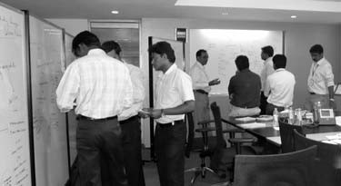Kaizen most often happens during repeating team kaizen events; a regular and frequent cadence of events is desirable, such as daily or weekly. Broadly, a kaizen event includes the steps (1) analyze some current situation until it is well-understood, and (2) design experiments for improvement. During this analysis and design, focus on *activities* rather sitting around a table and talking. Try creative activities at whiteboards, on flip charts, and so forth.

Beware *dead kaizen* events in which people go through the motions, but have burned out from over-analysis or lack of empowerment and engagement. Avoid taking on too

many improvement experiments at once—better to focus on one thing well, than many things poorly.

### Five Whys

Five Whys (usually written **5 Whys**) is a simple and widely used tool used in kaizen. It helps develop problem solving and root cause analysis skills. In response to a problem or defect, a team considers “why?” at least five times.[12] These questions may have multiple and related answers, so some teams create a “5 Whys graph” of branching answers (see Figure 1.4), or a more structured*fishbone (Ishikawa) diagram*.

The important point of 5 Whys is not the technique or the number 5, but that it is part of the “stop and fix” root-cause problem-solving mindset and culture pervasive at Toyota. People are taught to become deep problem solvers; to not live with problems, but to think things through deeply. There is also a connection between *Go See* and 5 Whys: It is easy for people to *guess* wrong or weak answers unless they see the facts at the real place of the problem.

Figure 1.4 5 Whys graph—people changing teams too frequently

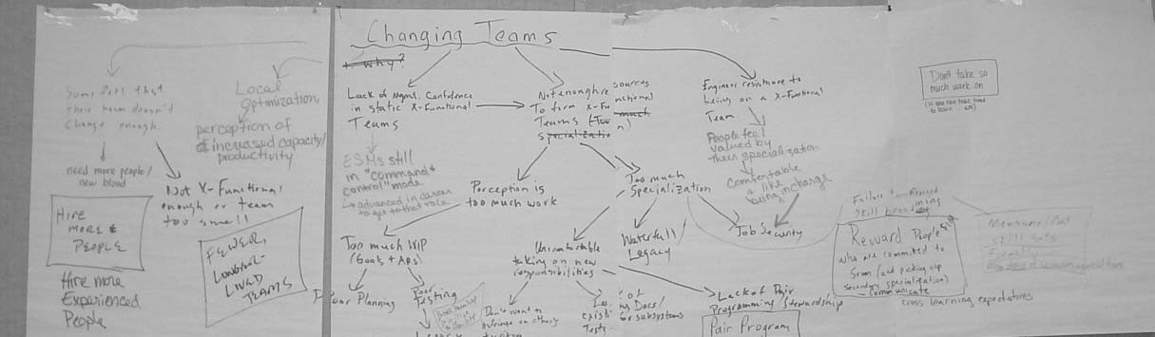

### Value and Waste

What to improve during kaizen? In lean thinking the answer requires an understanding of value and waste.

**Value**—*The moments of action or thought creating the product that the customer*[13] *is willing to pay for*. In other words, value is defined in the eyes of the *external* customer.[14] Imagine a customer was observing the work in your office. At what moments would they be willing to reach into their pocket, pull out money, and give it to you?

**Waste**—All other moments or actions that do not add value but consume resources. Wastes come from overburdened workers, bottlenecks, waiting, handoff, wishful thinking, and information scatter, among many others.

One kind of analysis in lean thinking is to estimate all waste and value moments “from concept to cash.”[15] From such a time line one can sum the value time and *lead time*

(concept to cash), and then calculate **value ratio** = total-value-time / total-lead-time

We have done many time lines with product development groups and *have not seen a value ratio in a development organization higher than 7 percent. In other words, 93 percent or more of the time in development was waste time****.***[16]

**Improvement by Banishing Waste**—After having defined value and waste, we come to a noteworthy difference in lean improvement. Other systems focus on refining *existing* *value* *actions*; for example, improving skill in design. A worthy goal no doubt.

However, since there are typically few value-adding moments in the time line—maybe 5 percent—then improving those does not amount to much. But with a *mountain* of waste time in the process, there are *big opportunities to improve the value ratio by eliminating waste*.

For example, a common waste in product development is the waste of *overproduction*— creating solutions or features not really wanted by the customer. It makes little sense to focus on measuring and improving engineering efficiency by 2 percent if there is a mountain of unused-feature waste due to poor decisions in product management.

As another example, one of the wastes is waiting or *delay*—customers do not pay for that. Have you ever seen the waste of waiting…

❑ for clarification?

❑ for approval?

❑ for another team to finish their part?

**Non-Value-Adding Action Categories**—Within Toyota people are educated to develop “eyes for waste.” As a learning aid, lists of non-value-adding (NVA) actions have been created. There is not one correct list—the point is not the categories, but to learn to see and banish waste from the customer perspective. The following productdevelopment NVA action categories are drawn from *The Toyota Way*, *Implementing Lean Software Development*, and *Lean Product and Process Development*.

|  |  |
| --- | --- |
| Non-Value-Adding Action | Example or Comment |
| 1. Overproduction of solutions or features, or of elements ahead of the next step; duplication | * features or services the customer doesn’t really want * large engineering documents, more detailed designs than can be quickly implemented * duplication of data |
| 2. Waiting, delay | • …for clarification, documents, approval, components, other groups to finish something |
| 3. Handoff, conveyance, moving | * giving a specification from an analyst to an engineer * giving a component to another group for testing |
| 4. Extra processing (includes extra *processes*), relearning, reinvention | * forced conformance to centralized process checklists of ‘quality’ tasks * recreating something made |
| 5. Partially done work, work in progress (WIP) or design in progress (DIP) | * designs documented but not built * things built but not integrated or tested |
| 6. Task switching, motion between tasks; interrupt-based multitasking | * interruption * multitasking on 3 projects * partial allocation of a person to many projects |
| 7. Defects, testing and correction after creation of the product | • testing and correction at-the-end to find and remove defects is not a value action; it may be a *temporarily* *necessary* waste |
| Non-Value-Adding Action | Example or Comment |
| 8. Under-realizing people’s potential and varied skill, insight, ideas, suggestions | * people only working to single-speciality job title, or …? * do people have the chance to change what they see is wasteful? |
| 9. Knowledge and information scatter or loss | * information spread across many separate documents * communication barriers such as walls between people, or people in multiple locations |
| 10. Wishful thinking (for example, that plans, estimates, and specifications are ‘correct’) | * “The estimate cannot increase; the effort estimate is what we want it to be, not what it is now proposed.” * “We’re behind schedule, but we’ll make it up later.” |

*Improving through Removing NVAs*—The focus on delivering value through waste reduction orients a lean organization toward following the baton rather than the runners. Notice that the improvement strategy is subtractive rather than additive. Rather than (for example), “What can we get the workers to do to increase utilization?”, the question is “What can we *remove* or stop doing?” In our consulting we have found this to be a mindset change for traditional quality-assurance people in large organizations who focus on conformance to checklists and *adding* activities for ‘improvement.’

**Temporarily Necessary Waste versus Pure Waste**—Not every waste battle can be won given current capabilities and constraints. For example, it is wickedly hard or virtually impossible to create a product that never had a defect to begin with. Plus there are many cases where it is cheaper to resolve defects through feedback loops with testat-the-end in *small batches and short cycles*, especially as modern testing tools and techniques reduce the cost and cycle time of a test. To be clear: This is not a recommendation to wait and only test at the end of development. However, many short and cheap cycles of small batches with automated testing may—not always—be the cheapest solution to the “build quality in” problem. Thus it is sometimes prudent or necessary, given today’s capabilities, to test and correct *after* creation of a small item in a very short cycle—the waste of defects. Even Toyota does this ‘waste’ step, but only in short cycles with small batch sizes so that defects do not linger, replicate, or pile up.

Because of this, Toyota recognizes two types of waste:

1. **temporarily necessary waste**… a future battle; for example, testing at the end of a short cycle
2. **pure waste**… in principle can and should be eliminated now

*Is Inventory Always Pure Waste?*—A common view among those new to lean thinking is that inventory is *pure waste* and should always be eliminated. Inventories of physical things or of intangible WIP—such as requirement specifications—imply investment without profit and hidden defects. That’s not good. However, a common practice in lean improvement is to create **level pull**, removing variability (one of the sources of waste) in a downstream process step by *inserting a small buffer of high-quality “equally sized” inventory items* before that downstream step.

Figure 1.5three sources of waste

**Sources**

**3**

**of**

**Waste**

**Variability**

varying cycle lengths, varying batch sizes of

work packages, varying size of one work

package, varying team members or size,

varying delivery times, defects (these

introduce much variability), interruption to

handle hot defects, irregular arrival of

requests

**Resolution**

?

leveling the work

-

cadence; for example, timeboxed 2-week

-

cycles

decompose large work packages into many

-

smaller ones, so that a more consistent

amount of work is taken each cycle

**Overburden**

-

overtime for arbitrary deadlines

one Product Manager having to know

-

hundreds of features in detail

often seen with specialist bottlenecks

-

and over-dependence on super-

specialists

**Resolution**

?

-

develop “eyes to see” queues &

bottlenecks and those who are doing

too much

-

take on less work in cycle; descope

-

spread the work and skill—cross-train

**NVA actions**

-

for example, handoff, waiting, scattered information, partially done work, task switching

**Resolution**

?

-

kaizen events, to learn to see it and experiments to reduce

**Focus on Variability, Overburden, and NVA Actions**—In addition to NVA actions, in the Toyota Way people are taught *three sources of waste*, illustrated and commented with resolution ideas in Figure 1.5.[17]

Toyota people who observe outside attempts to adopt lean note a common mis-education about waste—*the mis-education to only focus on eliminating NVA actions* [LM06a].Within Toyota, all three weaknesses are given importance, and in fact *variability* and *overburden* are viewed as frequent root causes that give rise to NVA actions. For example, overburdened workers create more defects.

**Perfection Challenge**

This is the third element of continuous improvement in lean.

During a visit to Toyota we invited a retired engineer to dinner in Nagoya. After several rounds of *sake*, we asked, “What do you miss, no longer working at Toyota?” He replied, “No longer discussing perfection with people.”

We sometimes visit an organization to discuss lean adoption and someone objects with essentially the argument, “We’re making good money, and have established processes. Why should we change?” We do not think you would hear that question in Toyota. They are far from perfect and we are not suggesting simply copying them, but their culture is to have a kaizen mindset—to have high expectations and to challenge ourselves, team members, and partners to levels of skill, mastery, waste reduction, and vision beyond the status quo.

That’s powerful.

**No Final Process**

In 2001, Toyota created an internal *Toyota Way* booklet summarizing the lean principles. On hearing the proposed title, chairman Toyoda suggested renaming the booklet *Toyota Way* ***2001***. Why? To emphasize that there is no final process in Toyota (which would stifle kaizen), but rather, continuous improvement and change.

The implication of *kaizen* and *spread knowledge laterally* is that there is not a final or correct ‘defined’ process to follow everywhere that is communicated from a central process group. Kaizen does include learning and mastering working agreements, but they

travel and evolve by the *spread knowledge laterally* model. People who have the mindset “let’s define (or buy) the central process, write it down, and then we should focus on conformance to it” will not be comfortable with lean thinking. To quote the Toyota CEO, *“The root of the Toyota Way is to be dissatisfied with the status quo; you have to ask constantly, “Why are we doing this?”* In Toyota and in lean thinking, the idea is to repeat cycles of improvement experiments *forever*.

# PRINCIPLES

The two pillars, *respect for people* and *continuous improvement*, are not the entire picture—literally or figuratively. There are other potent lean principles that form the overall *system* of lean, some of which recapitulate elements in the two pillars.

**Foundation**

**Goal**

**Product**

**Develop-**

**ment**

**14**

**Principles**

**Continuous**

**Improvement**

**Respect for**

**People**

To quote Fujio Cho, chairman of Toyota:

*Many good American companies have respect for individuals, and practice kaizen and other [Toyota] tools. But what is important is having all the elements together as* ***a system****. It must be practiced every day in a very consistent manner. [Liker04]*

Part of this broader *system* is covered in the 14 principles described in the *Toyota Way* book that comes out of decades of direct observation and interviews with Toyota people. Table 1.1 summarizes the principles, some of which are further discussed after the table.

Table 1.1 14 principles

|  |  |
| --- | --- |
| Principle | Comment/Reference |
| 1. Base management decisions on a ***long-term philosophy***, even at the expense of short-term financial goals. | see local optimization p. 32 |
| 2. Move toward ***flow***; move to ever-smaller batch sizes and cycle times to deliver value fast & expose weakness. | see p. 27 |
| 3. Use ***pull systems***; ***decide as late as possible***. | see p. 30 |

|  |  |
| --- | --- |
| Principle | Comment/Reference |
| 4. ***Level the work***—reduce variability and overburden to remove unevenness. | see also p. 23 |
| 5. Build a culture of ***stopping and fixing problems***;teach everyone to methodically study problems. | not only fix, but apply **5 Whys** analysis to understand the root causes, and *really* fix it; see p. 19 |
| 6. ***Master norms*** (practices) to enable kaizen and employee empowerment. | these are changeable working agreements, not rigid organization standards; see p. 16 |
| 7. Use***simple visual management*** to reveal problems and coordinate. | see p. 31 |
| 8. Use only ***well-tested technology*** that serves your people and process. |  |
| 9. Grow ***leaders from within*** who thoroughly understand the work, live the philosophy, and ***teach it to others***. | *leaders from within* may *not* be a good idea if your existing culture is not lean—the point is *educated* lean-thinking leaders; see p. 10 |
| 10. Develop ***exceptional*** ***people*** and teams who ***follow your company’s philosophy***. | this reflects the Toyota “build (lean thinking) people, then products” message; it includes “towering technical competence” |
| 11. Respect your extended network of ***partners*** by challenging them to grow and ***helping them improve***. | bring partners into lean thinking as well; there is an emphasis on sharing knowledge and openness |
| 12. ***Go see for yourself at the real place of work*** to really understand the situation and help. | see p. 14 |
| 13. Make ***decisions slowly by consensus***, thoroughly considering options; ***implement rapidly***. | activities such as kaizen events support this |
| 14. Become and sustain a learning organization through ***relentless reflection*** and ***kaizen***. | see p. 16 |

**Flow**

**Flow** suggests making value flow without delay to the customer. As a counter example, a customer request waits in a queue waiting to be approved, analyzed, implemented, reworked, or tested. That is *not* flow. Rather, as value is created—in products, software, information, decisions, service—it flows immediately to the customer. It is related to the *follow the baton* metaphor and to the goal of faster “concept to cash.” Flow is a *perfection challenge*; zero waste in the system and immediate continuous flowing delivery of value are profound challenges, probably never achieved. The journey is usually *moving toward* flow.

In the lean ‘house’ diagram (Figure 1.1), flow is included in both the 14 principles and in the key elements of continuous improvement. Why? Because to move toward flow it is necessary to reduce batch size, cycle time, delay, WIP, and other wastes. And this has the beneficial side effect of revealing more weaknesses and waste, providing new opportunities for continuous improvement. *This is an important but subtle point*, expanded in the next section.

Moving toward flow is associated with applied queueing theory, pull systems, and more. By understanding these, people can move the system toward flow by smaller work package sizes, smaller queue sizes, and reduction in variability.

**Indirect Benefits of Reducing Batch Size and Cycle Time**

Why work in small batch sizes and with many small cycles? Doesn’t that increase your overhead because of the transaction cost associated with each cycle? People asking this question may not yet appreciate the advantages of small batches in short cycles:

❑ The *overall* larger release-cycle-time reduction that can come by eradicating queues and by applying queue management so that many cycles are shorter.

❑ The elimination of **batch delay**, where one part of a solution is unnecessarily held back because it is moving through the system attached to a larger batch of other solutions. Eliminating this provides another degree of freedom for the business to ship a smaller product earlier with the highest-priority solutions.

❑ And last but not least, there are *indirect* benefits due to the “*lake and rocks*” effect described next.

### Indirect Benefits: The Lake and Rocks Metaphor

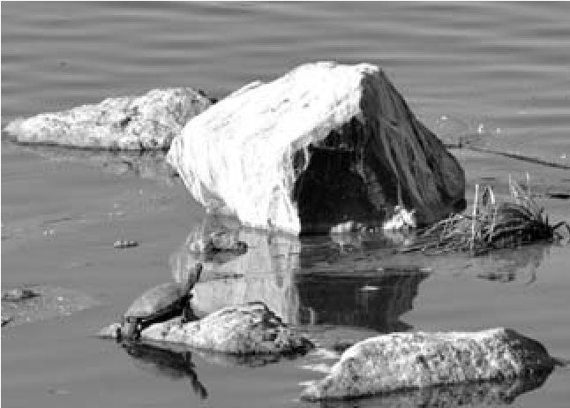A metaphor shared in lean education: **lake** **and rocks**. The depth of the water may represent the inventory level, batch size, or cycle time. When the water is high (large batch or inventory size, or long cycle time), many rocks are hidden. These rocks represent weaknesses. For example, consider an eighteen- month sequential release cycle with a massive batch transfer; inefficient testing, integration, and poor collaboration are all hidden below the surface of such a long cycle and such a large batch. But if we work with that group and

ask, “Please deliver a small set of solutions that is potentially deliverable in two weeks, every two weeks,” then suddenly all the ineffective practices become painfully obvious.

Said another way, the *transaction cost* (overhead cost) of the old process cycle becomes unacceptable. That pain then becomes a force for improvement, because people cannot stand re-experiencing it each short cycle, and indeed it may simply be impossible to do the goals of the cycle with the old inefficient practices.

This dynamic has been central to Toyota’s continual improvement approach.

*Tip*: Not all ‘rocks’ are big or immediately visible. The lean journey is to *start with the big rocks* that are most painfully obvious yet movable, and over time work on smaller impediments.

The causal loop diagram in Figure 1.6 illustrates this lake and rocks effect in terms of a system dynamics model.

Figure 1.6 indirect and delayed benefits of reducing batch and cycle size

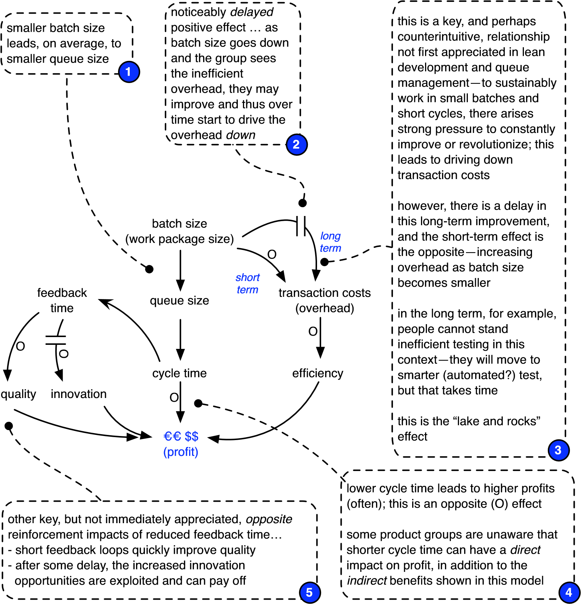

**Pull Systems**

**Pull versus push**. Consider a process for manufacturing and storing laptop computers. In a pure **pull system**[18] no laptop is built or stored in inventory until there is a customer order. Zero inventory[19] is a goal, and work is done only in response to a ‘pull’ signal from the customer. That is the key meaning of pull: Build in response to a signal from the ‘customer,’ and otherwise rest or improve. Pull examples? Printing just the twenty-book order or preparing just one restaurant dish.

*But a pull system goes deeper than that*—the ‘customer’ is not just the final customer. Rather, in a multi-stage process with an upstream team doing partial work before a downstream team, *a downstream team is the customer to their upstream team*. In a pure pull system the upstream team does not create anything unless pulled from downstream request.

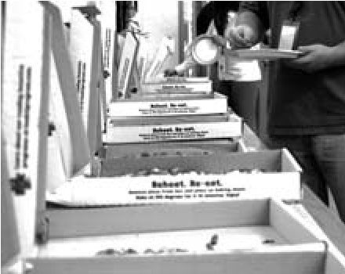On the other hand, in a **push system**, one speculatively builds and stores laptops in the hope of orders, and then tries to push them to customers. In a multi-stage process, upstream teams create an inventory of partially done work for downstream teams. Any kind of speculative inventory— pizzas, big detailed plans, books, designs for many features whose value is uncertain—are related to push systems.

Resource management strategies that focus on high utiliza-

tion of workers—a focus on *watch the runners* rather than *watch the baton*—create an environment in which people will create a large inventory of things (analysis documents, designs, …) in a push model.

**Expose defects**—If you only create *one* thing in response to *pull* from a ‘customer’ request (in this context, your customer is anyone downstream) and the customer consumes it quickly, any *defects* in that one thing—created either by accident or design— are quickly discovered. That can lead to further systemic improvement if people have “stop and fix” mindset. On the other hand, in push systems, defects are hidden in an unconsumed inventory (of documents, …). For example, pushing a large batch of design decisions will delay the discovery of misunderstandings or problems, because it is a long time before they are implemented and evaluated by a customer.

**Decide as late as possible**—In pull systems, you do not decide early, quite the opposite—you **“decide as late as possible”** and **“commit at the last responsible moment”** [Smith07]. In this way, you have the most information to make an informed decision. You do not waste resources making unnecessary inventory or early decisions that will have to—or at least should—change in response to discovery.

**Small batches can lead to radical improvement**—As explored in the “Indirect Benefits of Reducing Batch Size and Cycle Time” section on page 27.

Thus, in several ways, pull systems support moving towards flow.

**Avoid a false dichotomy**—To categorically state that pull is good and push is bad would be a *false dichotomy.* Usually because of hard constraints (for example, the speed of transportation), some inventory and some push may be useful—a *temporarily necessary waste*. Toyota dealerships (outside of Japan) hold some inventory of vehicles because foreign customers want to see, buy, and leave with a car immediately.

**Stop and Fix**

Toyota people are coached by manager-teachers to take the time to pause when defects or problems arise. Rather than creating only a *quick fix* response (or no response), a team will hold a kaizen event to grasp the root causes, and then initiate steps toward a deep solution—one that ideally prevents the defect or weakness from being possible and thus building quality in.

For example, Toyota is famous for their “stop the line” practice in which anyone can pull a cord when they see a defect, to stop all work on the line. This is step one in a systematic response toward building quality in. Another example: Toyota encourages human-friendly manufacturing devices that themselves detect a failure, automatically stop, and alert people to the problem. This was inspired by Sakichi Toyoda who made his original fortune by designing a weaving loom that automatically detected a failure and then stopped [Hino06]. This is the lean practice of **jidoka**.[20]

**Simple Visual Management**

Toyota emphasizes simple and BIG visual tools to signal problems, communicate, and coordinate a pull system. There are big displays on walls, bright and big physical colorcoded cards that people can touch and move, and so forth. Key themes are *ease of viewing from a distance, physical tokens* (such as cards), *color,* and *simplicity*. This is the opposite of displaying many little or detailed elements of information on small computer displays from software-based systems; however, a computer display that is simply filled with a blob of red color to show a broken build is in the spirit of visual management.

These **information radiators** for **visual management** are applicable to product development, service delivery, or any domain to make information easily accessible.

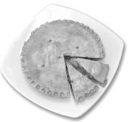A **kanban** (*kan*—visual signal, *ban*—card or board) is used in to signal a pull event (a replenishment request) in a *pull system*. The classic example is a store with something for sale on a shelf, such as one pie. Behind the pie on the shelf is an orange card labeled “one pie”—the **withdraw kanban** (card). When the pie is eventually taken off the shelf by a customer, the withdraw kanban is revealed and taken to the bakery to get another pie to refill the shelf. This is possible because there is one finished pie in inventory in the bakery waiting for this event.

Also at this time, a **creation kanban** is sent to the baker to starting baking one more pie. A single pie is *pulled* onto the shelf by the withdraw kanban, rather than pies being pushed.

An error display (**andon**) is a visual aid in Toyota to signal defects in things.

**Self-directed work**—This is a theme found in effective-team research. Notice that visual management supports self-directed work because people can easily see what is going on, to coordinate. Also, the work of a kanban card is self-explanatory, such as “one pie” or “change style of webpage.”

**Visual Management for Queues in Knowledge Work**

Queues of *physical* things are easy for people to perceive, and to perceive as a problem… My goodness, there’s a *gigantic* pile of *Stuff* queuing up over there! Making any money from the pile? Are there defects in there? Does it need to be combined with other stuff before we can ship it? Do we need—and will we make money with—*each and every item* in the pile?

But what about queues in knowledge work?

**Invisible queues—**In many knowledge-work domains (and some service domains) there are also queues, but because they are *invisible* (usually, as bits on a computer disk) they are not seen as queues or *keenly felt* as problems. A business person who has invested ten million euros to create a gigantic pile of partially done *Stuff* sitting on the floor can *see it* and will feel the pain and urgency to get it moving. But knowledge workers people do not really see and feel the pain of their queues.

Yet, they *are* there. Queues of wasteful WIP or design-in-process (DIP)—information, documents, and bits on a disk. Invisible queues. People in Toyota learn “eyes for waste.” They learn to see things as waste that they had not considered, such as *inventory*—queues of stuff. Similarly, knowledge workers need a lesson in “eyes for queues” so that they can start to perceive what is going on, and develop a sense of urgency about reducing queue sizes.

Figure 1.7 lean visual management creates *physical* tokens, such as task cards on a task board and paper charts on a wall, so that invisible queues can become tangible—really *seen and felt*

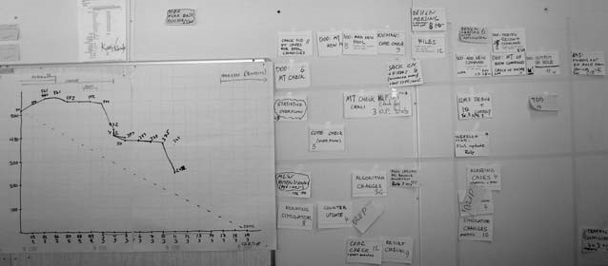

**Physical tokens to see queues**—To develop “eyes for queues” in any domain (service, engineering, …) and a sense of urgent attention to the queues and WIP, apply *visual management* with *physical* tokens, such as cards on a wall. Why physical? Putting these tasks into today’s computers defeats the purpose because these queues need to be *easily* and *noticeably visible at all times,* and they need to be *big*. Storage in today’s computers (for example, in a spreadsheet list) makes them small, and not always visible. And *humans*—with countless eons of evolutionary instinct working with concrete things—need to *see and feel tangible queues*20.

**Visual management to see [21]*and limit* WIP**— One of the lean wastes is WIP; as with queues, this is hard to perceive in knowledge or service work because it is often intangible work with related artifacts hidden inside computers (such as documents). Experiment with a wall area labelled “WIP” and place work-cards in that area. People or groups can establish policies to limit the WIP, such as, “no more than 2 items of WIP.” The visualization aids the policy.

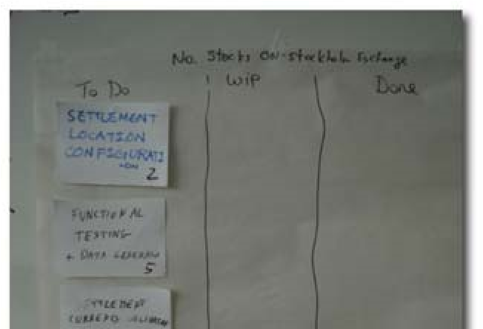

# LEAN PRODUCT DEVELOPMENT

The two pillars and 14 principles are core to lean thinking. However, there are other principles and practices to *outlearn the competition*, specific to lean product development.

**Foundation**

**Goal**

**Product**

**Develop-**

**ment**

**14**

**Principles**

**Continuous**

**Improvement**

**Respect for**

**People**

Toyota people execute two key processes well, (1) product development and (2) production. University of Michigan researchers did a three-year study of Toyota and North American companies product development effectiveness [LM06b]. Results? …

For example, the average die[22] design-to-complete duration was five months for Toyota engineers and twelve months for the competition. All this, while maintaining the lowest development-to-sales ratio of any major automotive company in the world, due to the effectiveness of their development practices.

How do they do it? What is a focus of lean product development? Answer:

*“Outlearn the competition” [23]*

When Toyota developed the hybrid Prius, what did they create?

❑ the *design* of the car (and implementation of embedded software); in development they have a *knowledge* value stream to create a profitable *production* value stream

❑ *knowledge* or *information*—about customers, alternatives, …

Lean product development (LPD) focuses on creating *more* *useful* *knowledge* and *learning better* than the competition.

Also, leveraging that knowledge and not wasting the fruits of the effort by forgetting what has been learned. Figure 1.8 and Figure 1.9 illustrate some of the lean practices to outlearn the competition in LPD; follow-up sections elaborate a few items.

**More-Valuable, Lower-Cost Learning**

Not all new knowledge or information is valuable; the ideal is to create economically useful new information [Reinertsen97]. This is challenging because it is a discovery process—you win some, you lose some.

A general lean strategy, based on a simple insight from information theory, is to *increase the value of information* *created* and *lower the cost of creating knowledge*.

**Higher-value information**—Several ideas help. For example:

❑ *Focus on uncertain things*—Choose to implement and test *unclear* or *risky* things early. The value of the feedback is high precisely because the outcomes are less predictable—predictable things do not teach us much.

❑ *Focus on early testing and feedback*—Information has a real *cost of delay*, which is one reason why testing only once at the end of a long sequential cycle—motivated by the misguided local optimization of believing that it will lower testing costs—is almost always unskillful. It can be very costly to discover during stress performance testing, after 18 months of development, that a key architectural decision was flawed. In lean development, short cycles with early feedback loops are critical; by implementing less predictable things early and in short cycles that include testing, the cost of delay is reduced.[24]

**Lower-cost information**—The “Indirect Benefits of Reducing Batch Size and Cycle Time” section on page 27 examines how adopting lean principles ends up reducing the overhead cost of processes. In fact, one can broadly look at these methods as succeeding by *lowering the cost of change*—competing on agility or flexibility. And that includes lowering the cost of learning. For example:

❑ *Focus on large-scale test automation*—to learn about defects and behavior. The cost of frequently re-executing *automated* tests is usually insignificant in comparison to the valuable early feedback.

❑ *Focus on frequent or continuous integration*—to learn about defects and lack of synchronization. And by integrating frequently in small batches, teams will drive down the average overhead cost by the “lake and rocks” effect.

❑ *Focus on mentoring from experts and spreading knowledge*—to reduce the cost of rediscovery.

**Cadence**

Working in regular rhythms or **cadence** is a lean principle, both in production and development [Ward06]. A steady heart beat. In lean production, it is called *takt* time.[25]In development, it is called cadence. Cadence is a powerful principle in lean product development, so the subject is examined in some detail…

There is something basic and very human about cadence: People appreciate or want *rhythms* in their lives and work—and appreciate or want *rituals* within these rhythms [Kerth01]. Most of us work in a cadence of seven-day weeks. There is the Tuesdaymorning weekly meeting ritual. And so on. Simply, cadence at work improves predictability, planning, and coordinating. At a deeper level, it reflects the rhythms by which we live our lives.

Figure 1.8 how to outlearn the competition

**Lean Product**

**Development**

**—“Outlearn the**

**Competition”**

**New Knowledge**

intensive customer

-

investigation

-

concurrent set-based

development

**Learn from Feedback**

-

“challenge everything”

process culture

-

systematic, repeating

reflection and improvement

**Data-Driven**

experiment, collect data,

-

adapt based on data—

including management

avoid wishful thinking

-

and speculation of plans

and specifications

***Reuse***

**Knowledge**

long mentoring from

-

manager-teachers

who are also master

engineers

record experiments in

-

brief, standard format

-

teach and require

people to use the

records

**Value of Info**

focus on uncertain

-

things

focus on lowering the

-

cost of delayed info

**Cost of Info**

-

test (etc.) automation

-

integrate frequently

- ...

Figure 1.9 LPD practices

**Lean Product**

**Development**

**—“Outlearn the**

**Competition”**

**Develop Long-Lasting Engineers**

**with Highest Skill and**

**Craftsmanship**

-

work as hands-on engineers for

years; not encouraged to

enter management early

mentored closely in engineering

-

and deep problem-solving skills

**Cross-Functional and**

**Product Mindset**

-

people and teams

emphasize cross-

functional integration

focus on product

-

success over

departmental or

functional (e.g., test,

design) goals

**Managers Who Are Master**

**Engineers and Teachers**

-

a key role of manager is

teacher

-

“at Toyota, your boss can

always do your job better

than you”

-

apprenticeship model

**Entrepreneurial Hands-on Chief**

**-**

engineer responsible for technical

*and*

business success

an up-to-date great engineer with

-

entrepreneurial spirit is given not

only technical control, but project

and business control

-

rather than a marketing or other

non-engineering specialist

**Team Room**

**with Visual Management**

chief engineer and others meet

-

and work face-to-face in a large

common room, not separate

offices; cross-functional members

-

visual management: display

engineering/ project data on walls

-

see pictures in this chapter

**Cadence**

with short

-

regularly-timed

cycles, with small

batches of work

**Set-Based Concurrent Engineering**

generate many alternative designs in parallel

-

### Cadence and Timeboxing

One popular approach to improve cadence is **timeboxing**, a fixed—and usually short—cycle time of development work (such as a two-week timebox). Teams are expected to deliver or demonstrate *something* at the end of the fixed duration—ideally something *small and well-done* rather than large and partially done. The duration *may not change*, but the *scope of work can vary* to fit the timebox. Timeboxing is not a panacea for all knowledge-work problems, but it has advantages:

❑ Timeboxing enforces cadence.

❑ Development work is often *fuzzy unbounded (or weakly bounded)* work. When the team knows that the timebox ends on March 15, it bounds the fuzzy work and increases focus. So, timeboxing limits scope creep, limits *gold-plating*, and increases focus.

❑ Timeboxing reduces *analysis paralysis*.

❑ **S**uppose you are in university and have an assignment due on Monday. When do you start? For many, the answer is, “Close to Monday.” This is called *Student Syndrome* [Goldratt97] and timeboxing is a counterbalance.

❑ If teams must deliver something well done in exactly two weeks, the waste and ineffectiveness in current ways of working become painfully clear. Timeboxing creates a change-force to improve—the “lake and rocks” improvement effect.

❑ Timeboxing simplifies scheduling.

❑ Humans are probably more sensitive to time variation than to scope variation— “It was late” is remembered more strongly than, “It had less than I wanted.” Timeboxing reduces the *erosion of confidence* that happens people say, yet again,

“… maybe in *one* more week it will *all* be done.”

**Re-use Information or Knowledge**

In addition to the long-term shift toward a culture of *mentoring* by master engineers and manager-teachers to re-use information, a *simple sharing tool* can help. In our coaching we have seen a pattern that the most ‘sticky’ or successful tool is a wiki. Simplicity and a “Web 2.0”-centric hypertext model seems to win out over older documentcentric tools.

**Team Room with Visual Management**

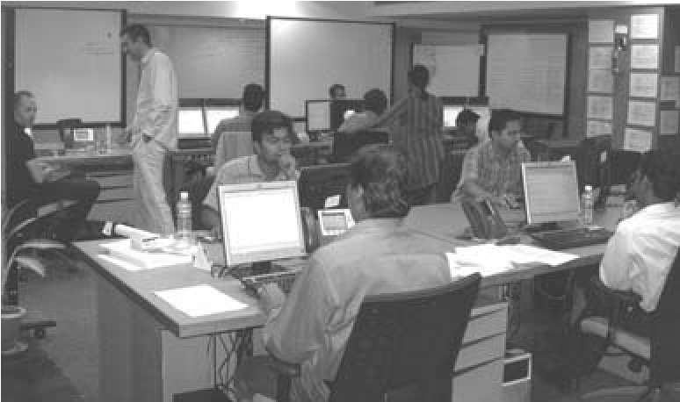Lean product development encourages a **team room** (or “big room”—big enough for a team) without internal partitions or walls, where a cross-functional team works and meets, and the entrepreneurial chief engineer sits. Walls are covered with large physical displays of project and engineering information, to support visual management. The team room is in contrast to people working in separate offices or cubicles

with communication barriers such as partitions between the team members. For a more detailed discussion, see the “Visual Management for Queues in Knowledge Work” section on page 32.

**Entrepreneurial Chief Engineer with Business Control**

There are two key domains in product creation: marketing and technical. In most product organizations that we visit, the leadership for these domains in split. For example, a *product management* group that is responsible for the business goals and feature selection, whose members are not master engineers. Toyota does things differently. They combine marketing and technical leadership in one great entrepreneurial chief engineer with “towering technical excellence” who is also attuned to and responsible for the business success of the new product, and who understands the market.[26]

**Set-Based Concurrent Engineering**

Have you seen development as follows?

1. pick or prototype *one* solution or design (one user interface, one architecture, …)
2. evolve it
3. deliver

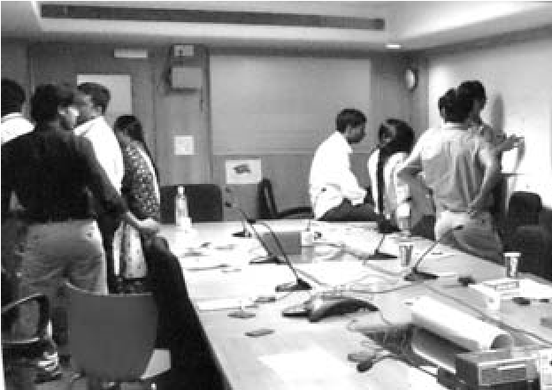**Set-based concurrent engineering** is also called **set-based design**, and is different. For example, rather than one engineer or team creating one cooling system design, several alternatives may be explored at Toyota in parallel by different teams— and so too for other components. These sets of alternatives are explored and combined, and gradually filtered in cycles, converging on a solution from what was at first a large set of alternatives, then a smaller set, and so on. They *outlearn the competition* by *increasing alternatives and combinations*.

A step in this direction is to explore at least *two* alternative for non-trivial design elements during design workshops. For example, rather than all gathering around one wall of whiteboards and doing one design as one team, split into two groups and work at two giant whiteboards at opposite ends of the team room. Every 30 minutes or so visit each other’s wall designs and “show and tell”—collecting ideas.

**Can Lean *Production* Lessons Help Development?**

New product development (NPD) or research and development is not predictable repetitive production (manufacturing), and the assumption they are similar is one cause of the misuse of early-1900s manufacturing “economies of scale” management practices in development; for example, sequential development and big batch transfers of specifications.

Yet, some of the principles and ideas applied in lean production— including short cycles, small batches, stop-and-fix, visual management, and queueing theory—*are* successfully applied in lean product development. Why? Modern lean production is different, the small batches, queues, and cycle times in part reflect *queueing theory* insight (among other sources of insight)—a discipline that was created for the variable behavior in networks that is much more like product development than traditional manufacturing.

An irony in some product organizations is that the *manufacturing* engineers have revolutionized and adopted lean production, moving away from “economies of scale” toward flow and flexibility in small batches without waste. But these lessons—which fit well to NPD—remain unused by development management, who continue to apply practices found in older economies-of-scale manufacturing management.

All that said, a caution: NPD is not manufacturing, and analogies between these two domains are fragile. Unlike production, NPD is (and must be) filled with discovery, change, and uncertainty. Some variability is both normal and desirable in new product development; otherwise, nothing *new* is done. Therefore, lean thinking includes unique practices for NPD.

## CONCLUSION

As you investigate lean thinking, it is easy to see that it is a broad system that spans all groups and functions of the enterprise, including product development, sales, production, service, and HR. *Lean* *applies to the enterprise*.

Lean thinking is much more than *tools* such as visual management or queue management, or merely elimination of waste. As can been seen at Toyota, it is an enterprise system resting on the foundation of manager-teachers in lean thinking, with the pillars of respect for people and continuous improvement. Its successful introduction will take years and requires widespread education and coaching. To re-quote Fujio Cho, chairman of Toyota:

*Many good American companies have respect for individuals, and practice kaizen and other [lean] tools. But what is important is having all the elements together as a system. It must be practiced every day in a very consistent manner…*

## ABOUT THE AUTHORS

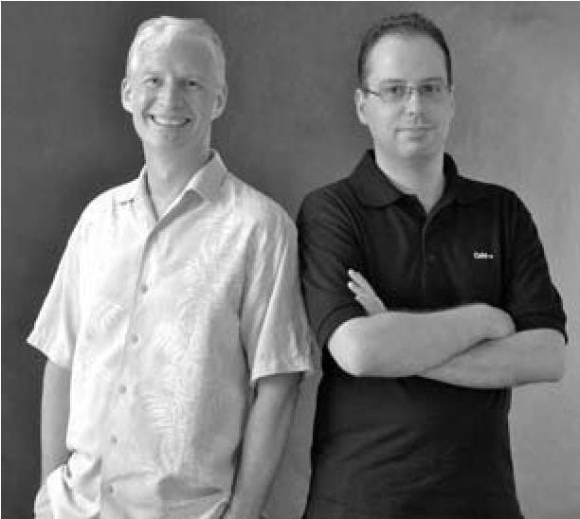Craig Larman works as a management consultant focusing on large-scale projects, lean thinking, and mental models. He served as the lean development coach at Xerox for several years.

Bas Vodde has a background in large embeddedsystems product creation, and leading the adoption of agile and lean principles and practices at Nokia Networks. He also works as a management coach, consultant, and as a development coach.

## RECOMMENDED READINGS

❑ Dr. Jeffrey Liker’s *The Toyota Way* is a thorough cogent summary from a researcher who has spent decades studying Toyota and their principles and practices.

❑ *Inside the Mind of Toyota* by Professor Satoshi Hino. Hino spent many years working in product development, followed by an academic career. Hino has “spent more than 20 years researching the subject of this book.” This is a data-driven book that looks at the evolution and principles of the original lean thinking management system.

❑ *Extreme Toyota* by Osono, Shimizu, and Takeuchi is a well-researched analysis of the Toyota Way values, contradictions, and culture, based on six years of research and 220 interviews. It includes an in-depth analysis of Toyota’s strong business performance.

❑ *Lean Product and Process Development* by Allen Ward and *The Toyota Product Development System* by Liker and Morgan are useful for insights into development from a lean perspective.

❑ *The Birth of Lean*, edited by Shimokawa and Fujimoto, conveys a clear sense of the mindset, principles, culture, and personalities behind lean thinking.

❑ *Toyota Culture* by Liker and Michael Hoseus. Hoseus has worked both as a plant manager and HR manager at Toyota, bringing an insider’s in-depth understanding to this book on the heart of what makes a lean enterprise work.

❑ *Lean Thinking* by Drs. Womack and Jones is an entertaining and well-written summary of some lean principles by authors who know their subject well. As cautioned earlier, it presents an anecdotal and condensed view that may give the casual reader the wrong impression that the essential key of lean is waste reduction rather than a culture of manager-teachers who understand lean thinking and help build the pillars of respect for people and continuous improvement with Go See and other behaviors.

❑ *The Machine That Changed the World: The Story of Lean Production* by Womack, Jones, and Roos was based on a five-year study at MIT into lean and the Toyota system.

❑ *Workplace Management* by Taichii Ohno is a short book by the creator of the Toyota Production System. It was out-of-print but has been recently re-translated by Jon Miller and is now available. The book does not talk much about TPS but it contains a series of short chapters that show well how Taichii Ohno thought about management and lean systems.

## BIBLIOGRAPHY

Fujimoto99. Fujimoto, T., 1999. *The Evolution of a Manufacturing System at Toyota*, Productivity Press

George02. George, M., 2002. *Lean Six Sigma: Combining Six Sigma Quality with Lean Production Speed*, McGraw-Hill

Hayashi08. Hayashi, N., 2008. “Top Engineer Explains How Toyota Develops People,” *Nikkei Business Online*, Translated at http://www.gembapantarei.com/2008/08/ toyotas_top_engineer_on_how_to_develop_thinking_pe.html

Hino06. Hino, S., 2006. *Inside the Mind of Toyota: Management Principles for Enduring Growth*, Productivity Press

Imai86. Imai, M., 1986. *Kaizen: The Key To Japan’s Competitive Success*, McGraw-Hill

Ishikawa85. Ishikawa, K., 1985. *What Is Total Quality Control? The Japanese Way*, Prentice Hall

Ishikawa86. Ishikawa, K., 1986. *Guide to Quality Control*, Asian Productivity Organization

Kato06. Kato, I., 2006. *Summary Notes from Art Smalley Interview with Mr. Isao Kato*, at http://artoflean.com/documents/pdfs/Mr_Kato_Interview_on_TWI_and_TPS.pdf

LH08. Liker, J., Hoseus, M., 2008. *Toyota Culture: The Heart and Soul of the Toyota Way*, McGraw-Hill

Liker04. Liker, J., 2004. *The Toyota Way*, McGraw-Hill

LM06a. Liker, J., Meier, D., 2006. *The Toyota Way Fieldbook*, McGraw-Hill

LM06b. Liker, J., Morgan J., 2006. *The Toyota Product Development System*, Productivity Press

LM07. Liker, J., Meier, D., 2007. *Toyota Talent*, McGraw Hill

McGrath96. McGrath, M., 1996. *Setting the PACE in Product Development*, Butterworth-Heinemann

McGrath04. McGrath, M., 2004. *Next Generation Product Development: How to Increase Productivity, Cut*

*Costs, and Reduce Cycle Times*, McGraw-Hill

NT86. Nonaka, I., Takeuchi, H., 1986. “The New New Product Development Game,” *Harvard Business Review*, Jan 1986, also in [CW95]

NT95. Nonaka, I., Takeuchi, H., 1995. *The Knowledge-Creating Company*, Oxford University Press

NTI84. Nonaka, I., Takeuchi, H., Imai, H., 1984. “Managing the New Product Development Process: How

Japanese Companies Learn and Unlearn,” *Harvard Business School 75th Anniversary Colloquium*, also in [HLC85]

Ohno07. Ohno, T., 2007, *Workplace Management*, Gemba Press

Ohno88. Ohno, T., 1988. *The Toyota Production System: Beyond Large-scale Production*, Productivity Press

OST08. Osono, E., Shimizu, N., Takeuchi, H., 2008. *Extreme Toyota: Radical Contradictions That Drive Success at the World's Best Manufacturer*, Wiley

Parkinson57. Parkinson, C., 1957. *Parkinson’s Law,* Buccaneer Books

Poppendieck, M., Poppendieck, T., 2006. *Implementing Lean Software Development*: *From Concept to Cash*, Addison-Wesley

Reinertsen97. Reinertsen, D., 1997. *Managing the Design Factory*, Free Press

Reinertsen09. Reinertsen, D., 2009. *The Principles of Product Development Flow*, Celeritas Publishing

RS99. Rother, M., Shook, J., 1999. *Learning to See: Value Stream Mapping to Add Value and Eliminate Muda*, Lean Enterprise Institute

SF09. (editors) Shimokawa, K., Fujimoto, T., 2009. *The Birth of Lean*, The Lean Enterprise Institute

Smith, P., 2007. *Flexible Product Development: Building Agility for Changing Markets*, Jossey-Bass

SR98. Smith, P., Reinertsen, D., 1998. *Developing Products in Half the Time: New Rules, New Tools*, Wiley

Toyota01. Toyota, 2001. *Toyota Way 2001*, Toyota Motor Company

Toyota08 . Toyota, 2008. http://www.toyota.co.jp/en/vision/message/ Accessed on 21 Sep 2008

Ward06. Ward, A., 2006. *Lean Product and Process Development*, Lean Enterprise Institute

WJR90. Womack, J., Jones, D. T., Roos, D., 1990. *The Machine That Changed the World*, Harper Perennial

WJ96. Womack, J., Jones, D. T., 1996. *Lean Thinking*, Free Press

1. . Для читателей, работающих в сфере обслуживания, заметим, что большинство принципов бережливого подхода довольно общие, такие как *образ мышления непрерывного совершенствования* и *менеджеры-учителя* которые являются экспертами в своём деле и выступают в роли наставников. Но некоторые принципы потребуют незначительной адаптации, например: *превосходные инженеры с большим стажем* в *превосходные рабочие с большим стажем*, или *разработка новых продуктов* в *новые сервисы*.
2. . Смотрите, например, PRTM [McGrath96, McGrath04] как подборку традиционных — и не-бережливых — идей продуктовой разработки.
3. . В оригинале название звучало как *Система Уважения к Людям.* Некоторые называли это *Путь Мышления (The Thinking Way)*. Система акцентирует внимание на культуре наставничества Toyota в продумывании и устранении корневых причин проблем, в помощи обществу и в гуманизации работы [Fujimoto99, WJR90].
4. . J.D. Power – популярный сайт с рейтингами и обзорами автомобилей (прим. переводчика).
5. . Производственная Система Toyota (Toyota Production System, TPS) является предшественником Пути Toyota [Ohno88].
6. . Lean Six Sigma представляет собой смесь различных инструментов, продвигаемых в подходе “Шесть Cигм” (Six Sigma) [George02].
7. .*Карго культ* в примитивном племенном сообществе представляет ритуалы имитирующие поведение чужеземных посетителей (в основном из Европы). Как аналогия, *карго культ* внедрения процессов предполагает поверхностное и ритуальное выполнение. *Карго культ внедрения бережливого подхода* подразумевает внедрение инструментов бережливого подхода без действительной трансформации менеджмента к бережливому менталитету и поведению.
8. . Фудзио Чо (Fujio Cho), ставший впоследствии председателем правления Toyota, нарисовал первую версию диаграммы “Дом Производственной Системы Toyota” в 1973.
9. . Эта аллюзия *потерь* будет рассмотрена далее. ‘Потери’ имеют важное и особенное значение в бережливом мышлении.
10. . We avoid Japanese terms unless no English term works.
11. . There are exceptions, such as safety and accounting standards.
12. . ‘Five’ is not a magic number; it is meant to imply “dig deep.”
13. . “Value in the eyes of the customer” posits an idealized customer.
14. . There are some quasi-lean descriptions that introduce the idea of *internal* business value. This is not part of lean thinking, and its application can lead to a distortion of improvement because things that are waste can be mislabeled as value.
15. . This is part of the lean practice *value stream mapping* [RS99].
16. . This is consistent with observation by others, such as [Ward06] who estimates an average 5% value ratio in product development.
17. . The widely-used Japanese terms are *mura* (variability), *muri* (overburden), and *muda* (non-value-add actions).
18. . Pull is related to a **Just-in-Time** system—JIT implements pull.
19. . In pull systems for development, low or zero inventory means less inventory of detailed specifications, plans, untested designs, and so on.
20. . Jidoka is difficult to rename in English; it is sometimes described as “automation with a human touch.”
21. . *Physical* tokens are a critical aspect of lean visual management that is not always appreciated. Some people create software systems for “visual management” and miss the purpose of the visceral, tangible dynamic of using physical tokens. Someday, displays will be wall size and one will move computer objects with physical gestures, stimulating this visceral response; that technology will then negate this point.
22. . A *die* is a template for stamping or molding metal or plastic parts.
23. . Coined by Toyota product development researcher Dr. Allen Ward.
24. . Note that reducing the cost of delay of information in product development almost always requires building and testing something.
25. . *takt*—rhythmic beat (German)
26. . We have seen successful products with product managers who are not master engineers—though they *do* need to be great product managers with detailed knowledge of the market, product, and existing customers.