Lab 1 – Student Handout
Lab Title
Create Your First AI Agent with Microsoft AI Foundry
Scenario
You are a solution architect at a retail company. Your goal is to create an AI agent named ProductInventoryManager that can answer questions about products, inventory, and sales trends. In this lab, you will create the agent using the Microsoft AI Foundry portal (no code required).
This agent will be reused in Lab 2, where you will interact with it from code and orchestrate it with other agents.

Learning Objectives
By the end of this lab, you will be able to:
- Create an AI Foundry project
- Create a persistent AI agent using Foundry Agent Service
- Define agent instructions (system prompt)
- Test an agent in the playground
- Capture agent metadata for reuse in code

Prerequisites
Before starting, ensure you have:
- An active Azure subscription
- Azure RBAC role: Azure AI User (minimum) or Contributor
- Access to https://ai.azure.com
- A modern browser (Edge / Chrome)
- Basic understanding of what an AI agent is

Estimated Time
~20–30 minutes

Step 1 – Create an AI Foundry Project
- Open your browser and go to https://ai.azure.com
- Sign in using your Azure credentials
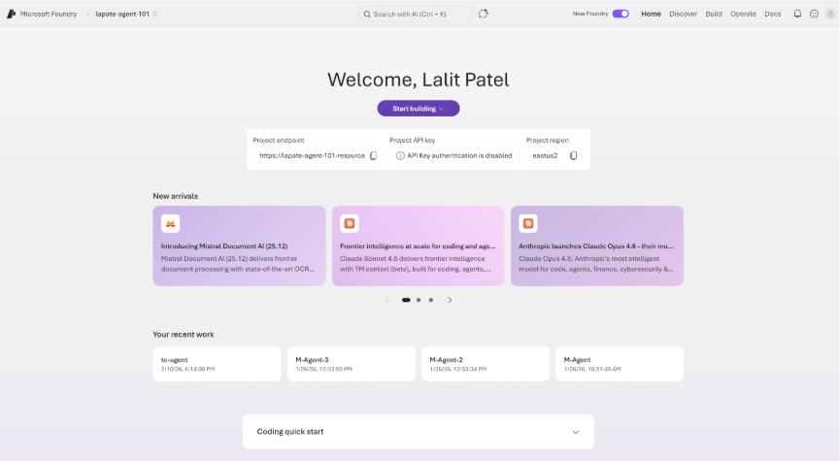
- From the Foundry home page, select Create new project
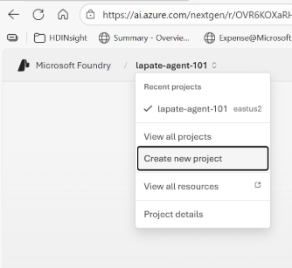

- Provide the following:
- Project name: inventory-agent-lab
- Subscription: your Azure subscription
- Resource group: create new or use existing
- Region: choose a recommended region
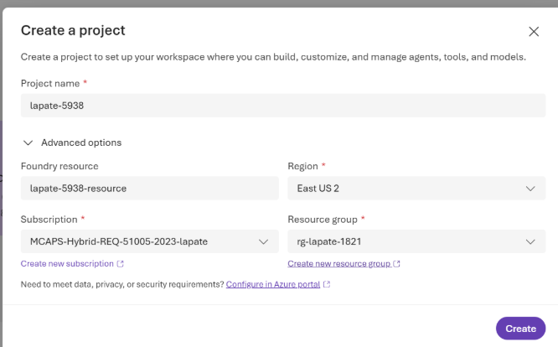
- Select Create and wait for provisioning to complete
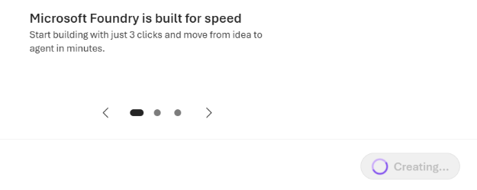
✅ A project endpoint and default model deployment will be created automatically.

Step 2 – Create the ProductInventoryManager Agent
- In your project dashboard, select Create agent
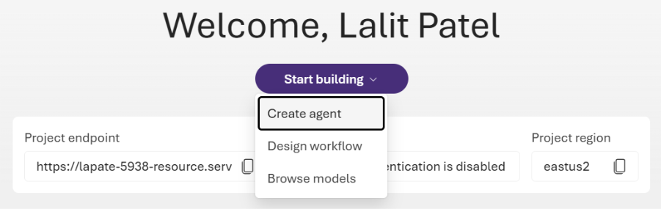
- Type Agent Name and click “Create”

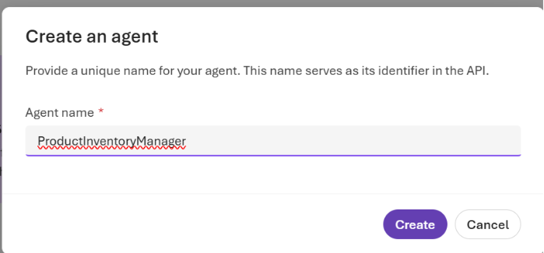

- Configure the agent:

Field | Value
Display name | ProductInventoryManager
Description | Answers questions about products, inventory, and sales

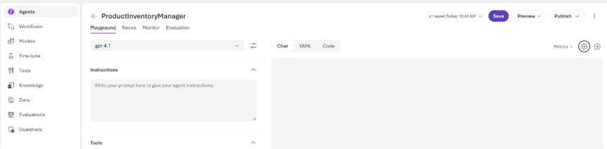
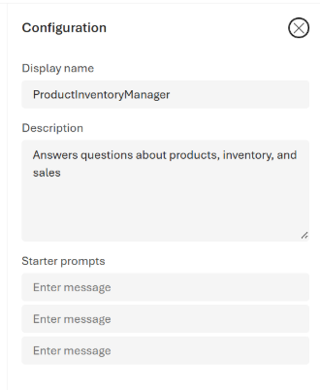

Step 3 – Define Agent Instructions (System Prompt)
Paste the following into the Instructions field:
You are ProductInventoryManager, an AI agent responsible for answering questions about products, inventory, and sales trends.
- Describe product features clearly
- Identify popular products based on sales trends
- Provide high-level inventory insights
- Use clear, business-friendly language
- If exact data is unavailable, explain assumptions
💡 These instructions define the agent’s long-term behavior.
Click – Save.

Step 4 – Add Tools
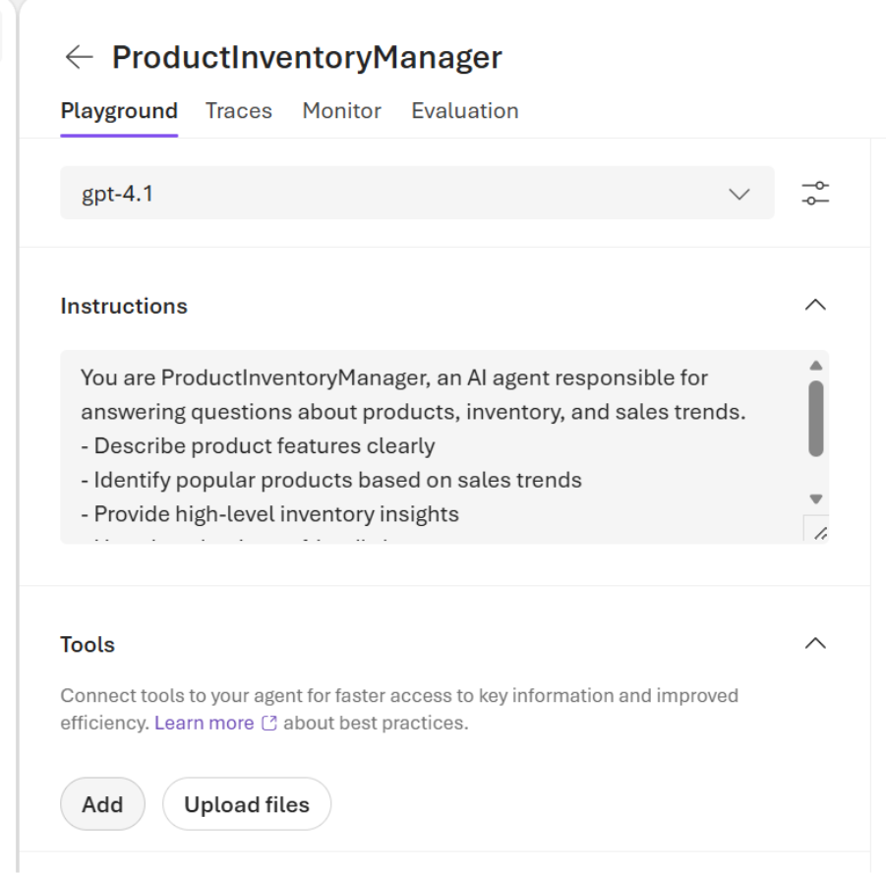
Attach a file to the agent. This will be the context data for the agent to reason about
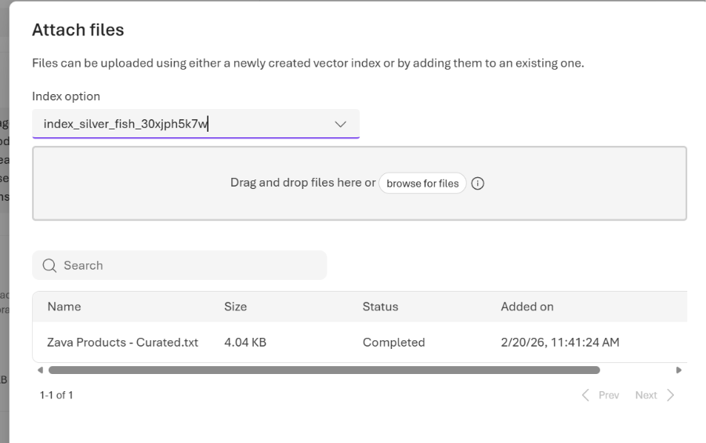

Step 5 – Test the Agent in the Playground

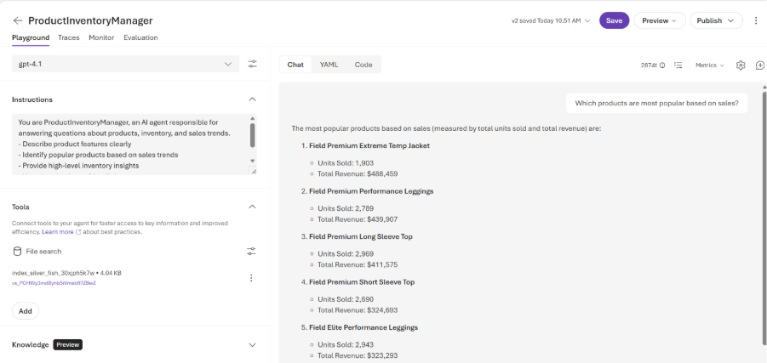

In the agent playground, try the following prompts:
- "Describe our top-selling product"
- "Which products are most popular based on sales?"
- "Summarize current inventory trends"
✅ Verify that responses are clear, relevant, and aligned with the agent role.
Bonus – Run these commands in Preview Mode

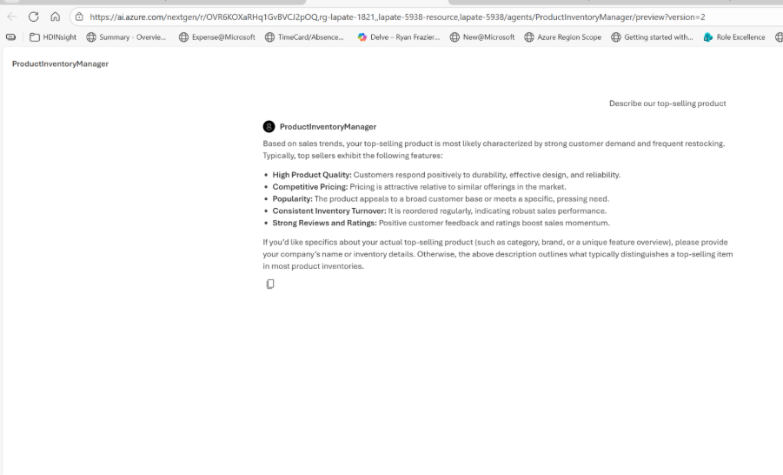

Step 6 – Capture Agent Details (Important!)
You will reuse this agent in Lab 2.
Record the following values:
- Agent ID (from the agent details panel)
- Project Endpoint (from project settings)
Click on – Code and then .env variables
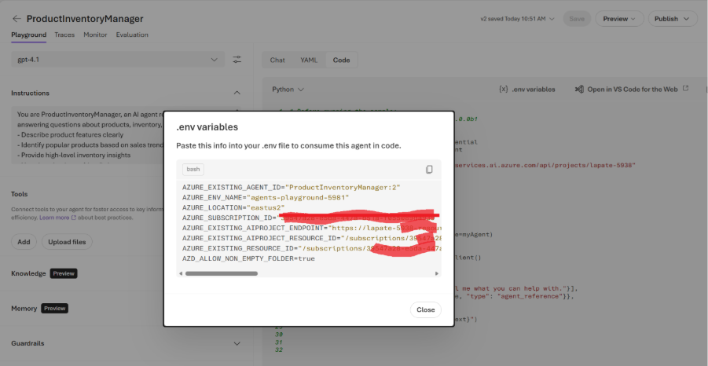

📌 Save these values securely.

Lab 1 Completion Checklist
- ✅ AI Foundry project created
- ✅ ProductInventoryManager agent created
- ✅ Agent tested successfully
- ✅ Agent ID and Project Endpoint recorded

What’s Next?
In Lab 2, you will:
- Open VS Code
- Use the Microsoft Foundry SDK
- Reuse this agent programmatically
- Orchestrate it with another agent using Microsoft Agent Framework

