Requirement Specification & Design Document
for the Library Management System

I. Functional Requirements Library Management System
The functional requirements of the Library Management System are described below. The system provides functions for both members and administrators. After logging in successfully, users can access the system's functions during the active session without having to log in again.
- Login:The system shall allow members and administrators to log in using their username and password.
+ The user enters a username and password.
+ The system verifies the login information.
+ If the information is correct, the system allows the user to access the system.
+ If the information is incorrect, the system displays an error message.
- View Personal Information: The system shall allow members to view their personal information.
The displayed information includes:
+ Full name
+ Member ID
+ Email
+ Date of birth
+ Address
+ Membership type
The personal information is view-only. Members cannot edit their personal information through the system.
- Search Books: The system shall allow members to search for books in the library.
The system shall display the matching books and their availability information.
- View Borrowed Books: The system shall allow members to view their borrowed books.
The borrowing list shall display:
+ Book title
+ Author
+ Due date
- View Fines: The system shall allow members to view fines for overdue books.
The system shall:
+ Display the fine for each overdue book.
+ Display the total outstanding fine.
- Member Management: The system shall allow administrators to manage library members.
Administrators can:
+ View member information.
+ Add new members.
+ Update member information.
+ Delete member accounts.
- Book Management: The system shall allow administrators to manage books in the library.
Administrators can:
+ Add new books.
+ View book information.
+ Update book information.
+ Delete books.
+ Update book quantity and availability.
- Borrow/Return Management: The system shall allow administrators to manage book borrowing and returning.
Administrators can:
+ Record a book borrowing transaction.
+ Record a book return.
+ Set the due date for borrowed books.
+ Update book availability after borrowing or returning.
+ Check whether a returned book is overdue.

II. Non-Functional Requirements Library Management System
- Usability: The system shall provide a simple and clear interface that is easy for members and administrators to use.
- Reliability: The system shall operate stably during normal library operations.
The system shall handle errors and exceptions without causing the program to crash.
- Performance: The system shall process common operations such as searching books, viewing borrowed books, and managing borrowing and returning within a few seconds under normal operating conditions.
- Security: The system shall require users to log in using a valid username and password.
The system shall control access based on user roles:
+ Members can only access their own personal information, borrowed books, and fines.
+ Administrators can access member management, book management, and borrow/return management.
- Data Integrity: The system shall maintain accurate and consistent information about members, books, borrowing records, and fines.
The system shall correctly update book availability when a book is borrowed or returned.
- Supportability: The source code shall be organized clearly and be easy to maintain and debug.
- Design Constraints: The system shall be developed and run directly using Python

III. Data Flow Diagram
Level 0
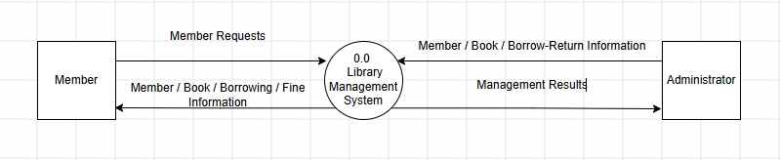
Level 1
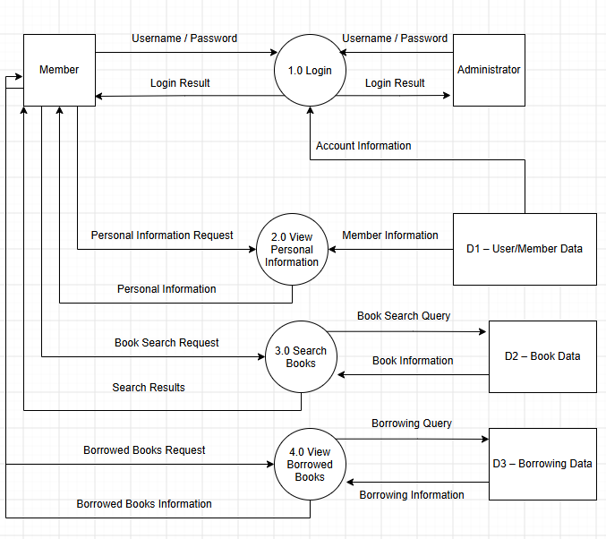

Level 2

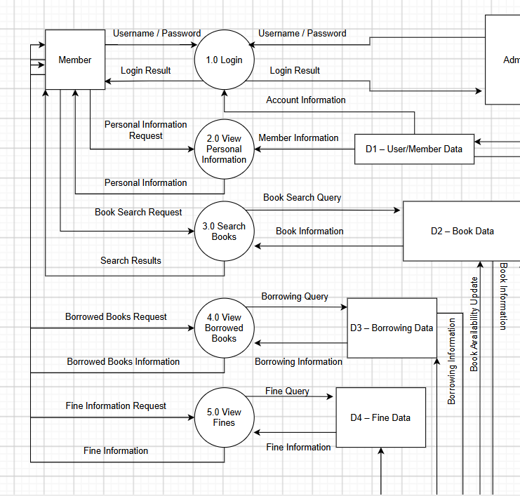

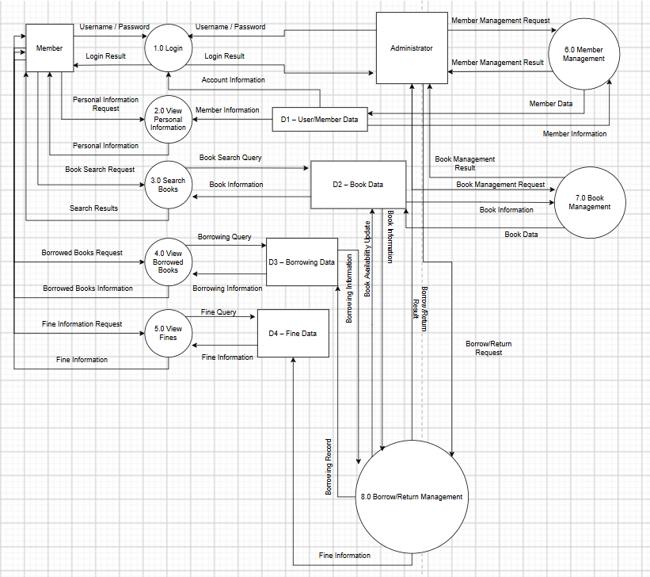

IV. Use case Diagram

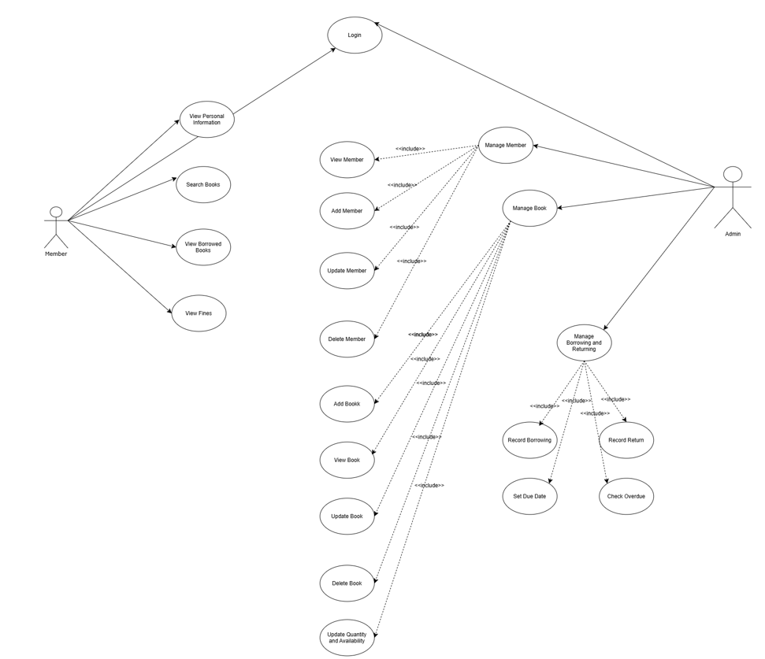

1.1 List of Actor
STT | Actor | Meaning
1 | Member | The main user who can log in, view personal information, search books, view borrowed books, and view fines.
2 | Admin | The system administrator who manages members, books, borrowing, returning, and related library records.

1.2 List of Use-case
STT | Use-case | Meaning | Notes (group)
1 | Login | Log in to the system | Member/Admin
2 | View Personal Information | View personal information | Member
3 | Search Books | Search library books | Member
4 | View Borrowed Books | View currently borrowed books | Member
5 | View Fines | View overdue fines | Member
6 | Manage Members | Manage library members | Admin
7 | Manage Books | Manage library books | Admin
8 | Manage Borrow/Return | Manage borrowing and returning | Admin

2. Use-case: Login
2.1. Summary
This use case allows a member or administrator to log in to the Library Management System using a valid username and password.
2.2. Flow of Events
2.2.1. Main Flow of Events
1. The user enters a username and password.
2. The system validates the login information.
3. If the information is valid, the system authenticates the user and determines the user role.
4. The system grants access and redirects the user to the appropriate main interface.
2.2.2. Alternative Flows
If the username or password is incorrect, the system displays an error message and prompts the user to re-enter the login information.
2.3. Special Requirements
The system must require a valid username and password.
Access to system functions must be controlled according to the authenticated user role.
2.4. System State Before
The user is not logged in.
2.5. System State After
- If successful: The user is authenticated and can access authorized functions during the active session without logging in again.
- If failed: The system remains unauthenticated.
2.6. Extension Point
None.
3. Use-case: View Personal Information
3.1. Summary
This use case allows a logged-in member to view their personal information.
3.2. Flow of Events
3.2.1. Main Flow of Events
1. The member selects "View Personal Information" from the menu.
2. The system retrieves and displays the member's full name, member ID, email, date of birth, address, and membership type.
3.2.2. Alternative Flows
If the personal data cannot be retrieved, the system displays an error message.
3.3. Special Requirements
Personal information must be read-only; no edit option is available to members.
A member may view only their own personal information.
3.4. System State Before
The member is logged in.
3.5. System State After
Personal information is displayed.
3.6. Extension Point
None.
4. Use-case: Search Books
4.1. Summary
This use case allows a logged-in member to search for books in the library and view their availability.
4.2. Flow of Events
4.2.1. Main Flow of Events
1. The member selects "Search Books" from the menu.
2. The member enters one or more search keywords such as book title, author, or other available search criteria.
3. The system searches the book collection.
4. The system displays matching books together with their availability information.
4.2.2. Alternative Flows
If no book matches the search criteria, the system displays a message indicating that no matching books were found.
4.3. Special Requirements
Search results must clearly show the matching book information and current availability.
Common book searches should complete within a few seconds under normal operating conditions.
4.4. System State Before
The member is logged in.
4.5. System State After
Matching search results and availability information are displayed.
4.6. Extension Points
None.
5. Use-case: View Borrowed Books
5.1. Summary
This use case allows a logged-in member to view the books currently borrowed under their account.
5.2. Flow of Events
5.2.1. Main Flow of Events
1. The member selects "View Borrowed Books" from the menu.
2. The system retrieves the member's active borrowing records.
3. The system displays the book title, author, and due date for each borrowed book.
5.2.2. Alternative Flows
If the member has no borrowed books, the system displays a message indicating that there are no active borrowing records.
5.3. Special Requirements
The borrowing list must display the book title, author, and due date.
A member may view only borrowing records associated with their own account.
5.4. System State Before
The member is logged in.
5.5. System State After
The member's current borrowing list is displayed.
5.6. Extension Points
None.
6. Use-case: View Fines
6.1. Summary
This use case allows a logged-in member to view fines associated with overdue books.
6.2. Flow of Events
6.2.1. Main Flow of Events
1. The member selects "View Fines" from the menu.
2. The system retrieves overdue borrowing records for the member.
3. The system calculates or retrieves the fine for each overdue book.
4. The system displays the fine for each overdue book and the total outstanding fine.
6.2.2. Alternative Flows
If the member has no overdue books or outstanding fines, the system displays a message indicating that no fine is due.
6.3. Special Requirements
The fine information must be accurate and consistent with the member's borrowing records.
A member may view only fines associated with their own account.
6.4. System State Before
The member is logged in.
6.5. System State After
Fine details and the total outstanding fine are displayed.
6.6. Extension Points
None.
7. Use-case: Manage Members
7.1. Summary
This use case allows an administrator to view, add, update, or delete library member records.
7.2. Flow of Events
7.2.1. Main Flow of Events
1. The administrator selects "Manage Members" from the menu.
2. The administrator chooses an action: view, add, update, or delete.
3. The system displays or prompts for the required member information.
4. The administrator enters or confirms the requested information.
5. The system validates the input and updates the member records.
6. The system confirms the completed action.
7.2.2. Alternative Flows
If validation fails, the system displays an error message and prompts the administrator to correct the data.
If a requested member record does not exist, the system displays an appropriate message and does not perform the update or deletion.
7.3. Special Requirements
Only authenticated administrators may access member management functions.
Member data must remain accurate and consistent after each operation.
7.4. System State Before
The administrator is logged in.
7.5. System State After
Member records are displayed or updated according to the selected action.
7.6. Extension Points
None.
8. Use-case: Manage Books
8.1. Summary
This use case allows an administrator to add, view, update, or delete books and to maintain book quantity and availability.
8.2. Flow of Events
8.2.1. Main Flow of Events
1. The administrator selects "Manage Books" from the menu.
2. The administrator chooses an action: add, view, update, or delete.
3. The system displays or prompts for the required book information.
4. The administrator enters or confirms book details, quantity, and availability as needed.
5. The system validates the input and updates the book records.
6. The system confirms the completed action.
8.2.2. Alternative Flows
If book information is invalid, the system displays an error message and prompts for correction.
If a requested book record does not exist, the system displays an appropriate message and does not perform the update or deletion.
8.3. Special Requirements
Only authenticated administrators may access book management functions.
Book quantity and availability must remain consistent with borrowing and returning transactions.
8.4. System State Before
The administrator is logged in.
8.5. System State After
Book records, quantity, and availability are displayed or updated according to the selected action.
8.6. Extension Points
None.
9. Use-case: Manage Borrow/Return
9.1. Summary
This use case allows an administrator to record book borrowing and returning transactions, set due dates, and update book availability.
9.2. Flow of Events
9.2.1. Main Flow of Events
1. The administrator selects "Manage Borrow/Return" from the menu.
2. The administrator chooses to record a borrowing transaction or a return.
3. For borrowing, the administrator selects the member and book, then sets the due date.
4. The system records the borrowing transaction and updates book availability.
5. For returning, the administrator selects the relevant borrowing record.
6. The system records the return and checks whether the book is overdue.
7. The system updates book availability and confirms the transaction.
9.2.2. Alternative Flows
If the selected book is not available for borrowing, the system displays a message and does not create the borrowing transaction.
If the member or borrowing record cannot be found, the system displays an error message.
If a returned book is overdue, the system identifies the overdue status so the related fine information can be maintained.
9.3. Special Requirements
Only authenticated administrators may manage borrowing and returning.
The system must maintain consistent borrowing records, due dates, book availability, and fine-related information.
Borrowing and returning operations should complete within a few seconds under normal operating conditions.
9.4. System State Before
The administrator is logged in.
9.5. System State After
The borrowing or return record is saved and the corresponding book availability is updated.
9.6. Extension Points
None.
10. Non-Functional Requirements
10.1. Usability
The system shall provide a simple and clear interface that is easy for members and administrators to use.
10.2. Reliability
The system shall operate stably during normal library operations and shall handle errors and exceptions without causing the program to crash.
10.3. Performance
The system shall process common operations such as searching books, viewing borrowed books, and managing borrowing and returning within a few seconds under normal operating conditions.
10.4. Security
The system shall require valid login credentials and shall restrict access according to user roles. Members may access only their own personal information, borrowed books, and fines; administrators may access member management, book management, and borrow/return management.
10.5. Data Integrity
The system shall maintain accurate and consistent information about members, books, borrowing records, and fines.
10.6. Supportability
The source code shall be organized clearly and be easy to maintain and debug.
10.7. Design Constraints
The system shall be developed and run directly using Python.
V. Class Diagram

