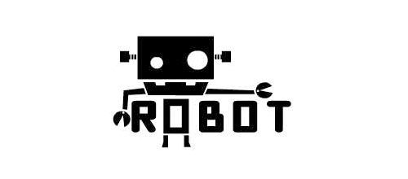

Certificate of Participation

*awarded to*

NAME OF STUDENT

*for contribution to*

Robot Show Case 2023

*as Presenter*



Tan Hui ling

***Director, School of Robots***

***Robotic School***