Senior Project V2
Devon Lapierre
2026-05-31
#Loading Dataset
setwd("C:/Users/devon/OneDrive/Senior Project")
mlb <- read.csv("stats.csv", header = TRUE, sep = ",")
head(mlb)
## last_name..first_name player_id year player_age ab pa hit single double
## 1 Hunter, Torii 116338 2015 39 521 567 125 81 22
## 2 Ortiz, David 120074 2015 39 528 614 144 70 37
## 3 Rodriguez, Alex 121347 2015 39 523 620 131 75 22
## 4 Ramirez, Aramis 133380 2015 37 475 516 117 68 31
## 5 Beltré, Adrian 134181 2015 36 567 619 163 109 32
## 6 Beltrán, Carlos 136860 2015 38 478 531 132 78 34
## triple home_run strikeout walk batting_avg slg_percent on_base_percent
## 1 0 22 105 35 0.240 0.409 0.293
## 2 0 37 95 77 0.273 0.553 0.360
## 3 1 33 145 84 0.250 0.486 0.356
## 4 1 17 68 31 0.246 0.423 0.297
## 5 4 18 65 41 0.287 0.453 0.334
## 6 1 19 85 45 0.276 0.471 0.337
## on_base_plus_slg isolated_power b_rbi b_lob r_total_stolen_base b_ball
## 1 0.702 0.169 81 197 2 648
## 2 0.913 0.280 108 244 0 904
## 3 0.842 0.236 86 219 4 917
## 4 0.720 0.177 75 228 1 559
## 5 0.787 0.166 83 261 1 692
## 6 0.808 0.195 67 205 0 703
## b_called_strike b_foul b_foul_tip b_hit_by_pitch b_swinging_strike r_run
## 1 277 433 20 6 217 67
## 2 339 410 13 0 232 73
## 3 386 362 24 6 317 83
## 4 238 376 13 5 145 43
## 5 404 406 11 3 163 83
## 6 370 371 17 2 138 57
## b_total_ball b_total_strike b_total_swinging_strike b_total_pitches xba
## 1 691 1392 801 2087 0.229
## 2 1021 1451 738 2488 0.301
## 3 1009 1478 661 2503 0.247
## 4 617 1198 840 1815 0.240
## 5 782 1493 847 2288 0.295
## 6 759 1297 492 2069 0.274
## xslg woba xwoba xobp xiso exit_velocity_avg launch_angle_avg
## 1 0.370 0.304 0.290 0.285 0.142 88.5 10.8
## 2 0.616 0.379 0.420 0.388 0.314 93.0 15.7
## 3 0.494 0.361 0.368 0.355 0.247 91.3 12.2
## 4 0.405 0.309 0.304 0.293 0.164 87.4 15.8
## 5 0.482 0.337 0.360 0.346 0.186 89.5 12.6
## 6 0.448 0.346 0.346 0.340 0.174 90.6 15.6
## sweet_spot_percent barrel_batted_rate solidcontact_percent
## 1 28.5 5.6 5.2
## 2 34.8 14.6 8.4
## 3 31.4 11.8 8.1
## 4 33.5 6.1 6.6
## 5 35.7 5.8 7.8
## 6 34.1 6.6 7.5
## flareburner_percent poorlyunder_percent poorlytopped_percent
## 1 21.6 24.5 39.0
## 2 24.9 24.0 27.1
## 3 20.3 23.9 35.1
## 4 23.3 30.3 29.4
## 5 26.3 23.5 33.7
## 6 27.3 27.8 27.8
## poorlyweak_percent hard_hit_percent z_swing_percent z_swing_miss_percent
## 1 2.9 34.9 72.8 17.1
## 2 1.6 49.1 70.7 17.0
## 3 1.0 43.9 67.4 26.0
## 4 3.4 34.5 73.5 12.3
## 5 2.2 40.4 62.3 11.3
## 6 1.8 41.9 65.7 10.8
## oz_swing_percent oz_swing_miss_percent oz_contact_percent out_zone_swing_miss
## 1 34.0 36.2 63.8 128
## 2 26.5 34.9 65.1 135
## 3 24.4 45.8 54.2 153
## 4 34.5 28.7 71.3 95
## 5 35.4 25.4 74.6 108
## 6 28.9 31.6 68.4 104
## out_zone_swing out_zone_percent out_zone meatball_swing_percent
## 1 354 49.9 1042 80.4
## 2 387 58.8 1461 76.8
## 3 334 54.7 1368 75.3
## 4 331 52.9 959 78.2
## 5 425 52.6 1202 64.7
## 6 329 55.1 1139 79.1
## meatball_percent pitch_count_offspeed pitch_count_fastball
## 1 7.6 270 1329
## 2 5.7 366 1425
## 3 6.2 283 1539
## 4 6.6 154 1164
## 5 7.3 292 1452
## 6 5.3 362 1231
## pitch_count_breaking pitch_count iz_contact_percent in_zone_swing_miss
## 1 482 2087 82.9 130
## 2 639 2488 83.0 123
## 3 663 2503 74.0 199
## 4 482 1815 87.7 77
## 5 527 2288 88.7 76
## 6 467 2069 89.2 66
## in_zone_swing in_zone_percent in_zone edge_percent edge whiff_percent
## 1 761 50.1 1045 42.4 884 23.1
## 2 724 41.2 1024 41.8 1039 23.2
## 3 765 45.3 1135 42.4 1062 32.0
## 4 628 47.1 855 41.8 759 17.9
## 5 675 47.4 1084 42.7 976 16.8
## 6 611 44.9 930 43.6 902 18.1
## swing_percent pull_percent straightaway_percent opposite_percent batted_ball
## 1 53.4 34.7 40.4 24.2 421
## 2 44.7 41.9 36.4 21.7 442
## 3 43.9 38.4 43.9 16.6 385
## 4 52.9 36.9 38.3 24.8 412
## 5 48.1 35.3 41.4 23.3 510
## 6 45.4 40.1 38.3 19.3 399
## f_strike_percent groundballs_percent groundballs flyballs_percent flyballs
## 1 64.0 49.4 208 22.6 95
## 2 52.1 37.6 166 25.6 113
## 3 60.3 43.6 168 24.9 96
## 4 65.5 37.6 155 24.5 101
## 5 61.9 42.4 216 18.4 94
## 6 57.3 36.8 147 26.6 106
## linedrives_percent linedrives popups_percent popups
## 1 20.9 88 7.1 30
## 2 28.7 127 8.1 36
## 3 24.9 96 6.5 25
## 4 29.1 120 8.7 36
## 5 31.6 161 7.6 39
## 6 28.1 112 8.5 34
#Basic Cleaning
mlb <- na.omit(mlb)
mlb <- mlb[!duplicated(mlb), ]
summary(mlb)
## last_name..first_name player_id year player_age
## Length:4836 Min. :116338 Min. :2015 Min. :19.00
## Class :character 1st Qu.:519346 1st Qu.:2017 1st Qu.:25.00
## Mode :character Median :596119 Median :2020 Median :28.00
## Mean :582828 Mean :2020 Mean :28.09
## 3rd Qu.:656811 3rd Qu.:2023 3rd Qu.:31.00
## Max. :810938 Max. :2025 Max. :43.00
## ab pa hit single
## Min. : 81.0 Min. :100.0 Min. : 11.00 Min. : 5.00
## 1st Qu.:184.0 1st Qu.:206.0 1st Qu.: 42.00 1st Qu.: 27.00
## Median :314.0 Median :348.5 Median : 76.50 Median : 49.00
## Mean :330.2 Mean :369.0 Mean : 83.64 Mean : 53.56
## 3rd Qu.:473.0 3rd Qu.:529.0 3rd Qu.:120.00 3rd Qu.: 76.00
## Max. :681.0 Max. :753.0 Max. :217.00 Max. :170.00
## double triple home_run strikeout
## Min. : 0.00 Min. : 0.000 Min. : 0.00 Min. : 7.0
## 1st Qu.: 8.00 1st Qu.: 0.000 1st Qu.: 4.00 1st Qu.: 46.0
## Median :15.00 Median : 1.000 Median : 9.00 Median : 73.0
## Mean :16.63 Mean : 1.545 Mean :11.91 Mean : 79.6
## 3rd Qu.:24.00 3rd Qu.: 2.000 3rd Qu.:17.00 3rd Qu.:107.2
## Max. :59.00 Max. :17.000 Max. :62.00 Max. :221.0
## walk batting_avg slg_percent on_base_percent
## Min. : 1.00 Min. :0.1170 Min. :0.1440 Min. :0.154
## 1st Qu.: 15.00 1st Qu.:0.2230 1st Qu.:0.3530 1st Qu.:0.289
## Median : 26.00 Median :0.2475 Median :0.4030 Median :0.315
## Mean : 31.39 Mean :0.2455 Mean :0.4047 Mean :0.315
## 3rd Qu.: 43.00 3rd Qu.:0.2700 3rd Qu.:0.4550 3rd Qu.:0.341
## Max. :145.00 Max. :0.3730 Max. :0.7270 Max. :0.490
## on_base_plus_slg isolated_power b_rbi b_lob
## Min. :0.3220 Min. :0.0000 Min. : 0.00 Min. : 17.0
## 1st Qu.:0.6450 1st Qu.:0.1160 1st Qu.: 20.00 1st Qu.: 78.0
## Median :0.7190 Median :0.1550 Median : 37.00 Median :133.0
## Mean :0.7196 Mean :0.1591 Mean : 42.93 Mean :137.4
## 3rd Qu.:0.7890 3rd Qu.:0.1960 3rd Qu.: 61.00 3rd Qu.:191.0
## Max. :1.1850 Max. :0.4220 Max. :144.00 Max. :323.0
## r_total_stolen_base b_ball b_called_strike b_foul
## Min. : 0.000 Min. : 83.0 Min. : 28.0 Min. : 44.0
## 1st Qu.: 1.000 1st Qu.: 264.0 1st Qu.:129.0 1st Qu.:139.0
## Median : 3.000 Median : 444.0 Median :216.0 Median :240.0
## Mean : 5.599 Mean : 483.6 Mean :236.4 Mean :254.9
## 3rd Qu.: 7.000 3rd Qu.: 674.2 3rd Qu.:324.0 3rd Qu.:361.0
## Max. :73.000 Max. :1236.0 Max. :718.0 Max. :664.0
## b_foul_tip b_hit_by_pitch b_swinging_strike r_run
## Min. : 0.00 Min. : 0.000 Min. : 9.0 Min. : 3.00
## 1st Qu.: 7.00 1st Qu.: 1.000 1st Qu.: 79.0 1st Qu.: 22.00
## Median :12.00 Median : 3.000 Median :127.0 Median : 39.00
## Mean :13.21 Mean : 3.918 Mean :143.7 Mean : 44.68
## 3rd Qu.:18.00 3rd Qu.: 5.000 3rd Qu.:196.0 3rd Qu.: 63.00
## Max. :48.00 Max. :34.000 Max. :457.0 Max. :149.00
## b_total_ball b_total_strike b_total_swinging_strike b_total_pitches
## Min. : 92.0 Min. : 222.0 Min. : 11.0 Min. : 342
## 1st Qu.: 285.0 1st Qu.: 513.8 1st Qu.: 112.0 1st Qu.: 805
## Median : 481.0 Median : 865.0 Median : 201.0 Median :1350
## Mean : 521.9 Mean : 911.3 Mean : 279.6 Mean :1437
## 3rd Qu.: 730.2 3rd Qu.:1298.0 3rd Qu.: 373.0 3rd Qu.:2035
## Max. :1372.0 Max. :1912.0 Max. :1200.0 Max. :3223
## xba xslg woba xwoba
## Min. :0.1260 Min. :0.182 Min. :0.1450 Min. :0.171
## 1st Qu.:0.2210 1st Qu.:0.349 1st Qu.:0.2830 1st Qu.:0.286
## Median :0.2420 Median :0.396 Median :0.3120 Median :0.311
## Mean :0.2407 Mean :0.401 Mean :0.3115 Mean :0.312
## 3rd Qu.:0.2600 3rd Qu.:0.448 3rd Qu.:0.3390 3rd Qu.:0.337
## Max. :0.3590 Max. :0.739 Max. :0.4780 Max. :0.480
## xobp xiso exit_velocity_avg launch_angle_avg
## Min. :0.1810 Min. :0.0290 Min. :77.40 Min. :-7.90
## 1st Qu.:0.2890 1st Qu.:0.1180 1st Qu.:86.90 1st Qu.: 9.40
## Median :0.3120 Median :0.1560 Median :88.50 Median :12.70
## Mean :0.3124 Mean :0.1603 Mean :88.44 Mean :12.62
## 3rd Qu.:0.3350 3rd Qu.:0.1970 3rd Qu.:90.00 3rd Qu.:15.80
## Max. :0.4750 Max. :0.4440 Max. :97.60 Max. :29.80
## sweet_spot_percent barrel_batted_rate solidcontact_percent flareburner_percent
## Min. :16.90 Min. : 0.000 Min. : 0.000 Min. : 8.60
## 1st Qu.:30.40 1st Qu.: 4.200 1st Qu.: 4.500 1st Qu.:21.90
## Median :33.30 Median : 7.000 Median : 5.900 Median :24.30
## Mean :33.29 Mean : 7.491 Mean : 5.934 Mean :24.31
## 3rd Qu.:36.20 3rd Qu.:10.300 3rd Qu.: 7.400 3rd Qu.:26.80
## Max. :49.70 Max. :29.800 Max. :18.000 Max. :40.30
## poorlyunder_percent poorlytopped_percent poorlyweak_percent hard_hit_percent
## Min. : 6.80 Min. : 9.60 Min. : 0.000 Min. : 6.40
## 1st Qu.:21.20 1st Qu.:27.70 1st Qu.: 2.500 1st Qu.:31.50
## Median :25.00 Median :32.00 Median : 3.600 Median :37.30
## Mean :25.19 Mean :32.24 Mean : 4.083 Mean :36.81
## 3rd Qu.:29.10 3rd Qu.:36.50 3rd Qu.: 5.100 3rd Qu.:42.50
## Max. :46.80 Max. :55.90 Max. :21.000 Max. :64.20
## z_swing_percent z_swing_miss_percent oz_swing_percent oz_swing_miss_percent
## Min. :44.90 Min. : 1.60 Min. : 8.10 Min. : 7.9
## 1st Qu.:63.50 1st Qu.:13.50 1st Qu.:24.10 1st Qu.:35.7
## Median :67.30 Median :17.10 Median :28.20 Median :42.5
## Mean :67.34 Mean :17.45 Mean :28.51 Mean :42.6
## 3rd Qu.:71.30 3rd Qu.:21.10 3rd Qu.:32.50 3rd Qu.:49.3
## Max. :85.10 Max. :43.40 Max. :52.40 Max. :80.6
## oz_contact_percent out_zone_swing_miss out_zone_swing out_zone_percent
## Min. :19.4 Min. : 5.00 Min. : 19 Min. :41.30
## 1st Qu.:50.7 1st Qu.: 47.00 1st Qu.:112 1st Qu.:49.40
## Median :57.5 Median : 78.00 Median :193 Median :51.10
## Mean :57.4 Mean : 86.86 Mean :209 Mean :51.17
## 3rd Qu.:64.3 3rd Qu.:118.00 3rd Qu.:293 3rd Qu.:52.90
## Max. :92.1 Max. :312.00 Max. :624 Max. :61.60
## out_zone meatball_swing_percent meatball_percent pitch_count_offspeed
## Min. : 153.0 Min. : 43.80 Min. : 3.800 Min. : 16.0
## 1st Qu.: 407.0 1st Qu.: 71.50 1st Qu.: 6.700 1st Qu.: 97.0
## Median : 686.0 Median : 76.80 Median : 7.300 Median :162.0
## Mean : 737.6 Mean : 76.55 Mean : 7.378 Mean :182.4
## 3rd Qu.:1049.0 3rd Qu.: 81.70 3rd Qu.: 8.000 3rd Qu.:250.0
## Max. :1730.0 Max. :100.00 Max. :11.800 Max. :645.0
## pitch_count_fastball pitch_count_breaking pitch_count iz_contact_percent
## Min. : 165.0 Min. : 62.0 Min. : 342 Min. :56.60
## 1st Qu.: 464.8 1st Qu.: 225.0 1st Qu.: 805 1st Qu.:78.90
## Median : 778.5 Median : 385.0 Median :1350 Median :82.90
## Mean : 836.1 Mean : 413.1 Mean :1437 Mean :82.55
## 3rd Qu.:1173.0 3rd Qu.: 579.0 3rd Qu.:2035 3rd Qu.:86.50
## Max. :1971.0 Max. :1141.0 Max. :3223 Max. :98.40
## in_zone_swing_miss in_zone_swing in_zone_percent in_zone
## Min. : 4.00 Min. : 102.0 Min. :38.40 Min. : 150.0
## 1st Qu.: 44.00 1st Qu.: 262.0 1st Qu.:47.10 1st Qu.: 392.0
## Median : 70.00 Median : 444.0 Median :48.90 Median : 660.0
## Mean : 80.19 Mean : 468.6 Mean :48.83 Mean : 697.4
## 3rd Qu.:109.00 3rd Qu.: 659.0 3rd Qu.:50.60 3rd Qu.: 979.0
## Max. :298.00 Max. :1045.0 Max. :58.70 Max. :1633.0
## edge_percent edge whiff_percent swing_percent
## Min. :35.80 Min. : 141.0 Min. : 5.30 Min. :31.90
## 1st Qu.:41.70 1st Qu.: 344.0 1st Qu.:20.60 1st Qu.:44.00
## Median :42.70 Median : 577.0 Median :24.90 Median :47.30
## Mean :42.73 Mean : 612.5 Mean :25.07 Mean :47.48
## 3rd Qu.:43.80 3rd Qu.: 865.0 3rd Qu.:29.30 3rd Qu.:50.90
## Max. :50.40 Max. :1386.0 Max. :51.10 Max. :65.70
## pull_percent straightaway_percent opposite_percent batted_ball
## Min. :15.10 Min. :21.10 Min. : 7.80 Min. : 47.0
## 1st Qu.:33.60 1st Qu.:34.38 1st Qu.:21.80 1st Qu.:135.8
## Median :37.70 Median :37.20 Median :24.80 Median :237.0
## Mean :37.76 Mean :37.16 Mean :24.96 Mean :253.9
## 3rd Qu.:41.90 3rd Qu.:40.00 3rd Qu.:27.90 3rd Qu.:365.0
## Max. :62.70 Max. :53.90 Max. :47.70 Max. :618.0
## f_strike_percent groundballs_percent groundballs flyballs_percent
## Min. :44.20 Min. :17.30 Min. : 9.0 Min. : 7.2
## 1st Qu.:58.30 1st Qu.:38.88 1st Qu.: 59.0 1st Qu.:20.1
## Median :61.10 Median :43.70 Median :102.0 Median :24.1
## Mean :61.13 Mean :43.97 Mean :111.1 Mean :24.3
## 3rd Qu.:63.90 3rd Qu.:48.70 3rd Qu.:156.0 3rd Qu.:28.4
## Max. :78.10 Max. :68.50 Max. :341.0 Max. :50.0
## flyballs linedrives_percent linedrives popups_percent
## Min. : 5.00 Min. :11.30 Min. : 7.00 Min. : 0.000
## 1st Qu.: 31.00 1st Qu.:22.10 1st Qu.: 32.00 1st Qu.: 4.900
## Median : 55.00 Median :24.60 Median : 58.00 Median : 6.900
## Mean : 61.74 Mean :24.55 Mean : 63.15 Mean : 7.169
## 3rd Qu.: 87.00 3rd Qu.:27.00 3rd Qu.: 90.00 3rd Qu.: 9.100
## Max. :200.00 Max. :42.70 Max. :181.00 Max. :21.200
## popups
## Min. : 0.00
## 1st Qu.: 9.00
## Median :15.00
## Mean :17.91
## 3rd Qu.:25.00
## Max. :75.00
#The dataset is almost perfectly clean, since the data on BaseballSavant is ensured to be up to date, accurate, and complete
# Creating formula for wRAA to measure player performance
# scale vector (first index 2015, last index 2025) from FanGraphs: https://www.fangraphs.com/tools/guts?type=cn
wOBA_scale <- c(1.251, 1.212, 1.185, 1.226, 1.157, 1.185, 1.209, 1.259, 1.204, 1.242, 1.232)
# league average wOBA by season (first index 2015, last index 2025) from FanGraphs: https://www.fangraphs.com/leaders/major-league?pos=all&stats=bat&lg=all&qual=0&type=8&month=0&ind=0&team=0%2Css&rost=0&players=0&sort=0%2Cd&startdate=&enddate=&season1=2015&season=2025
lgwOBA <- c(.313, .318, .321, .315, .320, .320, .314, .310, .318, .310, .313)
# Using the FanGraphs formula Weighted Runs Above Average (wRAA) = ((wOBA - lgwOBA) / wOBA_scale) * PA to have a metric strictly for offensive performance
mlb$wRAA <- 0
#test formula on first observation
#mlb$wRAA[1]<- ((mlb$woba[1] - lgwOBA[mlb$year[1] - 2014]) / wOBA_scale[mlb$year[1] - 2014]) * mlb$pa[1]
#apply formula to all observations
for (i in 1:nrow(mlb)){
mlb$wRAA[i]<- ((mlb$woba[i] - lgwOBA[mlb$year[i] - 2014]) / wOBA_scale[mlb$year[i] - 2014]) * mlb$pa[i]
}
summary(mlb$wRAA)
## Min. 1st Qu. Median Mean 3rd Qu. Max.
## -32.3589 -6.5591 -0.9829 1.7896 7.1913 94.0934
#Data Validation
hist(mlb$batting_avg)
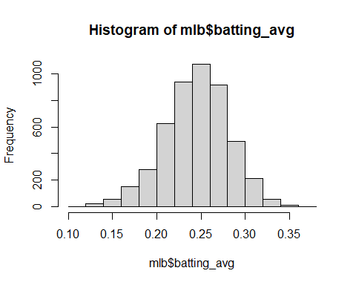
hist(mlb$player_age)
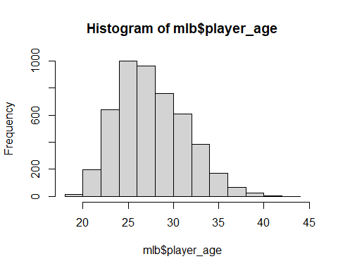
hist(mlb$slg_percent)
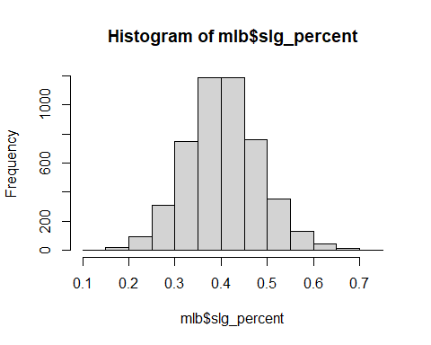
hist(mlb$on_base_percent)
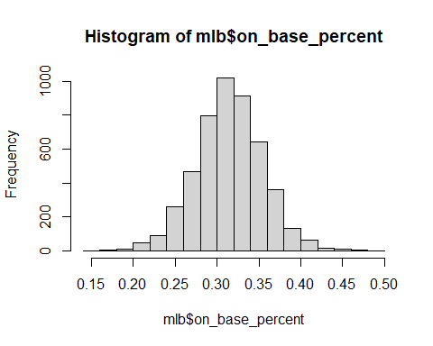
#Exploratory subset selection for wRAA
library(leaps)
## Warning: package 'leaps' was built under R version 4.4.3
#filter out the variables that are not features as well as the variables that are used to calculate wRAA
best_sub <- regsubsets(wRAA~player_age+hit+double+triple+home_run+strikeout+walk+batting_avg+on_base_plus_slg+isolated_power+b_rbi+b_lob+r_total_stolen_base+r_run+exit_velocity_avg+launch_angle_avg+sweet_spot_percent, data = mlb, nvmax = 8)
summary(best_sub)
## Subset selection object
## Call: regsubsets.formula(wRAA ~ player_age + hit + double + triple +
## home_run + strikeout + walk + batting_avg + on_base_plus_slg +
## isolated_power + b_rbi + b_lob + r_total_stolen_base + r_run +
## exit_velocity_avg + launch_angle_avg + sweet_spot_percent,
## data = mlb, nvmax = 8)
## 17 Variables (and intercept)
## Forced in Forced out
## player_age FALSE FALSE
## hit FALSE FALSE
## double FALSE FALSE
## triple FALSE FALSE
## home_run FALSE FALSE
## strikeout FALSE FALSE
## walk FALSE FALSE
## batting_avg FALSE FALSE
## on_base_plus_slg FALSE FALSE
## isolated_power FALSE FALSE
## b_rbi FALSE FALSE
## b_lob FALSE FALSE
## r_total_stolen_base FALSE FALSE
## r_run FALSE FALSE
## exit_velocity_avg FALSE FALSE
## launch_angle_avg FALSE FALSE
## sweet_spot_percent FALSE FALSE
## 1 subsets of each size up to 8
## Selection Algorithm: exhaustive
## player_age hit double triple home_run strikeout walk batting_avg
## 1 ( 1 ) " " " " " " " " " " " " " " " "
## 2 ( 1 ) " " " " " " " " " " " " "*" " "
## 3 ( 1 ) " " " " " " " " " " " " " " " "
## 4 ( 1 ) " " " " " " " " "*" " " "*" "*"
## 5 ( 1 ) " " " " "*" " " "*" " " "*" "*"
## 6 ( 1 ) " " " " "*" " " "*" " " "*" " "
## 7 ( 1 ) " " " " "*" " " "*" "*" "*" " "
## 8 ( 1 ) " " " " "*" "*" "*" "*" "*" " "
## on_base_plus_slg isolated_power b_rbi b_lob r_total_stolen_base r_run
## 1 ( 1 ) "*" " " " " " " " " " "
## 2 ( 1 ) "*" " " " " " " " " " "
## 3 ( 1 ) "*" " " " " "*" " " "*"
## 4 ( 1 ) " " " " " " "*" " " " "
## 5 ( 1 ) " " " " " " "*" " " " "
## 6 ( 1 ) "*" "*" " " "*" " " " "
## 7 ( 1 ) "*" "*" " " "*" " " " "
## 8 ( 1 ) "*" "*" " " "*" " " " "
## exit_velocity_avg launch_angle_avg sweet_spot_percent
## 1 ( 1 ) " " " " " "
## 2 ( 1 ) " " " " " "
## 3 ( 1 ) " " " " " "
## 4 ( 1 ) " " " " " "
## 5 ( 1 ) " " " " " "
## 6 ( 1 ) " " " " " "
## 7 ( 1 ) " " " " " "
## 8 ( 1 ) " " " " " "
Best subset shows the most significant predictors out of the metrics chosen (educated choices) to be On Base + Slugging, walks, Left on Base, runs scored in order.
#Checking the models from best subset selection
wRAA_1 <- lm(wRAA~on_base_plus_slg, data = mlb)
summary(wRAA_1)
##
## Call:
## lm(formula = wRAA ~ on_base_plus_slg, data = mlb)
##
## Residuals:
## Min 1Q Median 3Q Max
## -25.324 -3.846 -1.033 2.921 46.886
##
## Coefficients:
## Estimate Std. Error t value Pr(>|t|)
## (Intercept) -72.6017 0.6193 -117.2 <2e-16 ***
## on_base_plus_slg 103.3728 0.8507 121.5 <2e-16 ***
## ---
## Signif. codes: 0 '***' 0.001 '**' 0.01 '*' 0.05 '.' 0.1 ' ' 1
##
## Residual standard error: 6.519 on 4834 degrees of freedom
## Multiple R-squared: 0.7534, Adjusted R-squared: 0.7533
## F-statistic: 1.477e+04 on 1 and 4834 DF, p-value: < 2.2e-16
wRAA_2 <- lm(wRAA~on_base_plus_slg+walk, data = mlb)
summary(wRAA_2)
##
## Call:
## lm(formula = wRAA ~ on_base_plus_slg + walk, data = mlb)
##
## Residuals:
## Min 1Q Median 3Q Max
## -22.575 -3.531 -0.626 2.889 38.709
##
## Coefficients:
## Estimate Std. Error t value Pr(>|t|)
## (Intercept) -66.203592 0.604280 -109.56 <2e-16 ***
## on_base_plus_slg 88.089535 0.925194 95.21 <2e-16 ***
## walk 0.146555 0.004791 30.59 <2e-16 ***
## ---
## Signif. codes: 0 '***' 0.001 '**' 0.01 '*' 0.05 '.' 0.1 ' ' 1
##
## Residual standard error: 5.967 on 4833 degrees of freedom
## Multiple R-squared: 0.7934, Adjusted R-squared: 0.7933
## F-statistic: 9279 on 2 and 4833 DF, p-value: < 2.2e-16
wRAA_3 <- lm(wRAA~on_base_plus_slg+b_lob+r_run, data = mlb)
summary(wRAA_3)
##
## Call:
## lm(formula = wRAA ~ on_base_plus_slg + b_lob + r_run, data = mlb)
##
## Residuals:
## Min 1Q Median 3Q Max
## -24.895 -3.419 -0.363 3.001 43.360
##
## Coefficients:
## Estimate Std. Error t value Pr(>|t|)
## (Intercept) -57.701468 0.662158 -87.14 <2e-16 ***
## on_base_plus_slg 79.464775 0.986200 80.58 <2e-16 ***
## b_lob -0.073163 0.002511 -29.14 <2e-16 ***
## r_run 0.276621 0.007193 38.46 <2e-16 ***
## ---
## Signif. codes: 0 '***' 0.001 '**' 0.01 '*' 0.05 '.' 0.1 ' ' 1
##
## Residual standard error: 5.687 on 4832 degrees of freedom
## Multiple R-squared: 0.8124, Adjusted R-squared: 0.8123
## F-statistic: 6974 on 3 and 4832 DF, p-value: < 2.2e-16
# swing decision feature column indices
swing_cols <- c(49, 50, 51, 52, 53, 56, 58, 59, 64, 67, 69, 71, 72, 73, 74, 75, 77, 78, 80, 82, 84)
for (i in swing_cols){
mlb[ , i] <- mlb[ , i] / 100
}
swing_cols <- c(13, 17, 20, 28, 86, 49, 50, 51, 52, 53, 56, 58, 59, 64, 67, 69, 71, 72, 73, 74, 75, 77, 78, 80, 82, 84)
#subset of features only including swing decision features and potential response variables
mlb_swings <- mlb[, swing_cols]
#Histograms for all the variables in swing subset
for (v in names(mlb_swings)) {
hist(mlb_swings[[v]], main = paste("Histogram of", v),
xlab = v, col = "lightgray", border = "white")
}
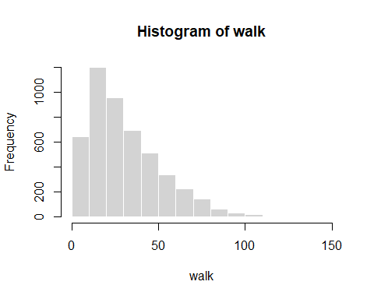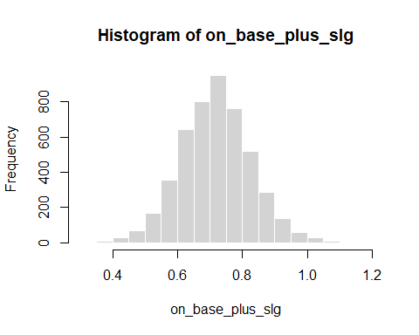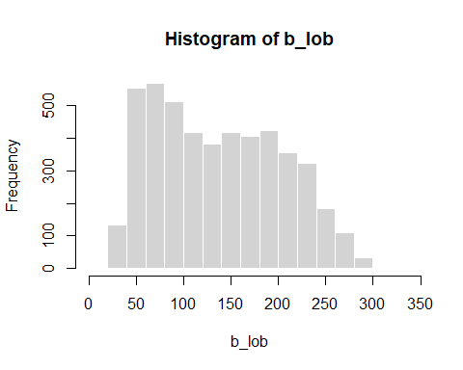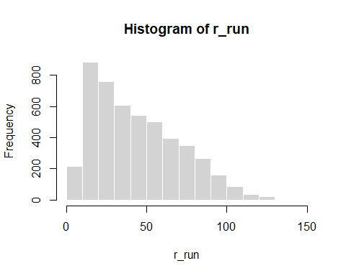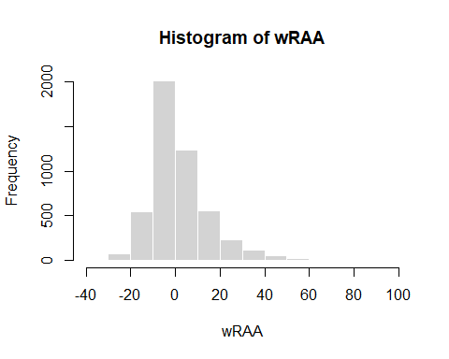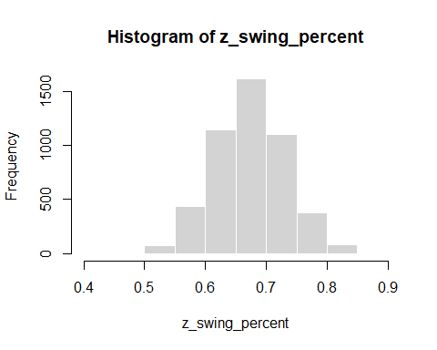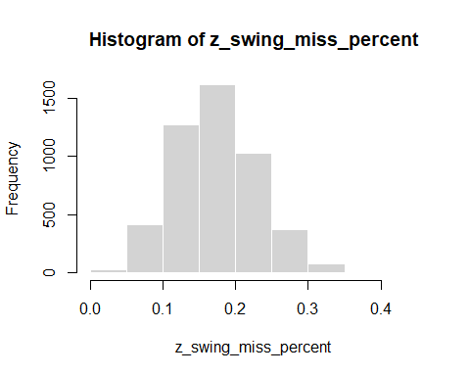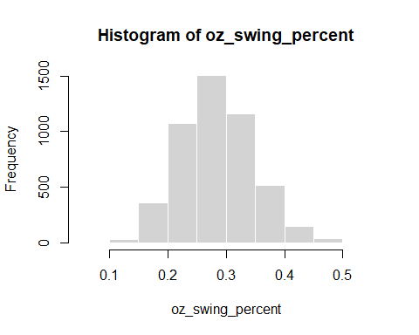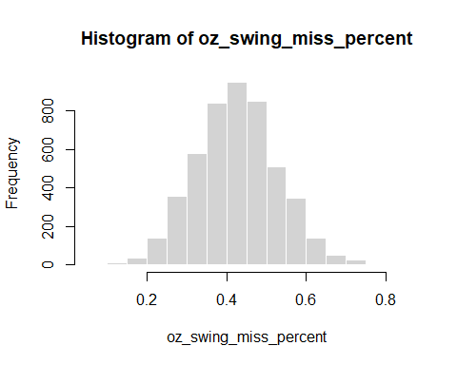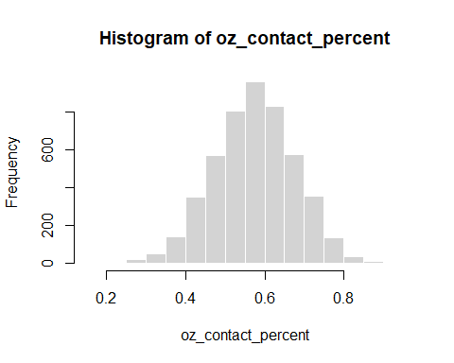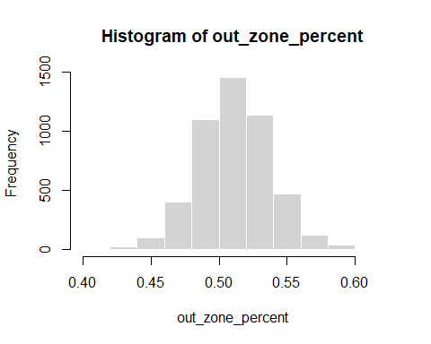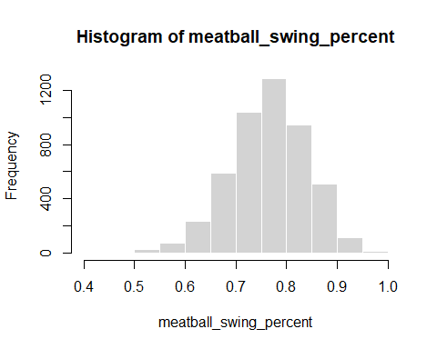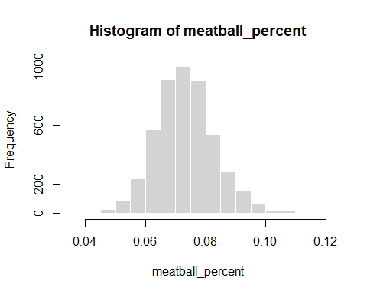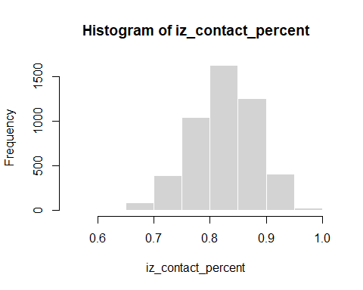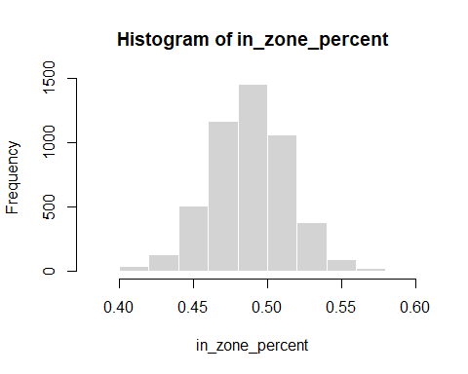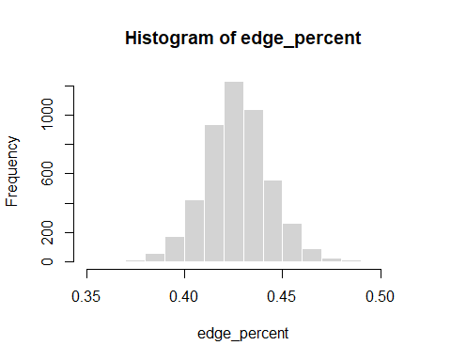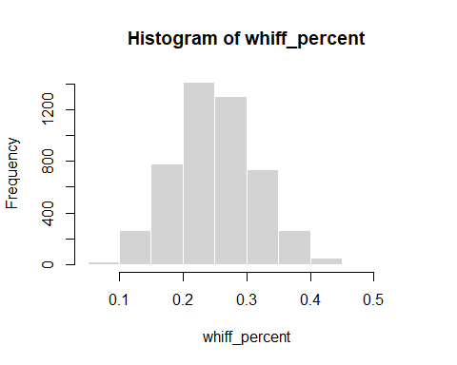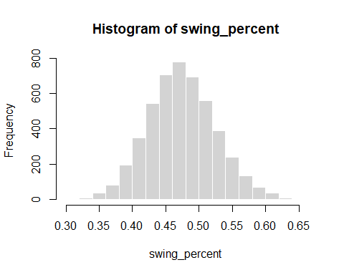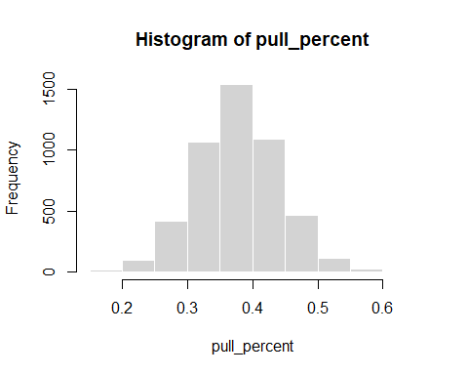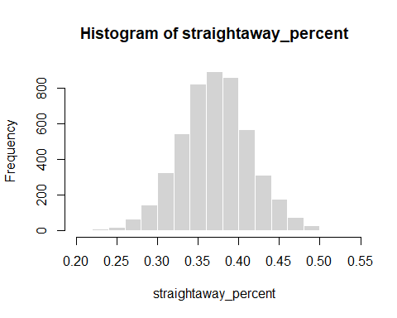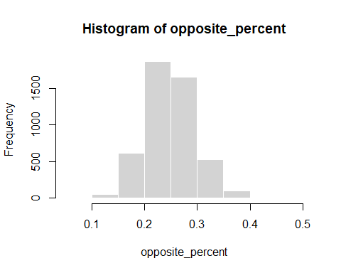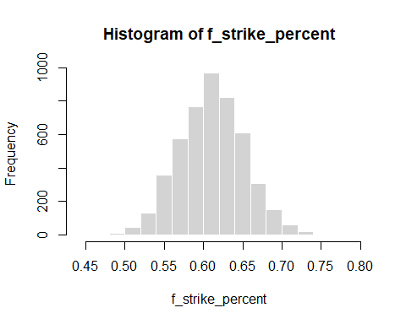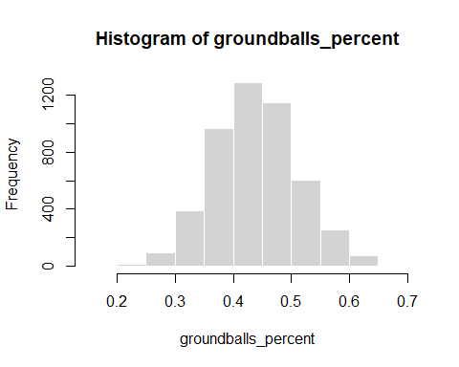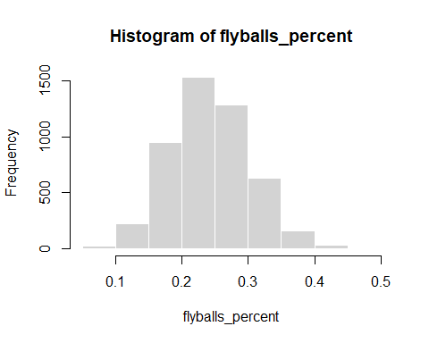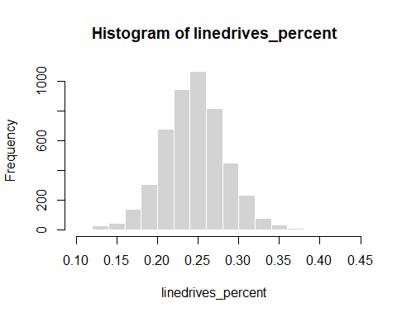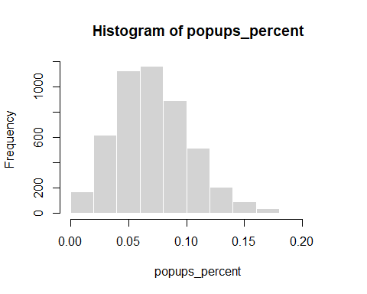
#Skew detection for the variables
skew <- function(x) {
m <- mean(x, na.rm = TRUE)
s <- sd(x, na.rm = TRUE)
mean(((x - m) / s)^3, na.rm = TRUE)
}
sapply(mlb_swings, skew)
## walk on_base_plus_slg b_lob
## 1.22789230 0.12018497 0.27350414
## r_run wRAA z_swing_percent
## 0.67882888 1.45287298 -0.03204324
## z_swing_miss_percent oz_swing_percent oz_swing_miss_percent
## 0.38796903 0.32165974 0.12046361
## oz_contact_percent out_zone_percent meatball_swing_percent
## -0.12074388 0.07139215 -0.26324082
## meatball_percent iz_contact_percent in_zone_percent
## 0.29558889 -0.38769590 -0.07139475
## edge_percent whiff_percent swing_percent
## 0.02384884 0.13984140 0.13956184
## pull_percent straightaway_percent opposite_percent
## 0.04067873 0.01004249 0.34617376
## f_strike_percent groundballs_percent flyballs_percent
## 0.03613784 0.14489097 0.20894684
## linedrives_percent popups_percent
## 0.01968480 0.51310635
Most of the variables pass the skew check. The ones that definitely need to be transformed are walks and wRAA, and runs will be inspected as well.
mlb_swings$walk_percent <- mlb$walk / mlb$pa
hist(mlb_swings$walk_percent)
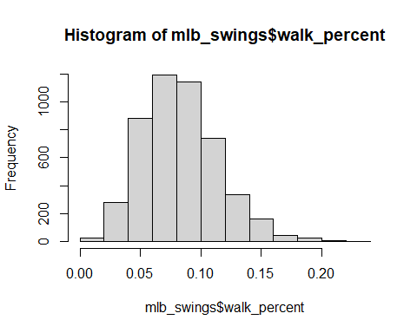
skew(mlb_swings$walk_percent)
## [1] 0.5811195
Changing walks to walk percent helped bring the skew down almost enough.
mlb_swings$run_percent <- mlb$r_run / mlb$pa
hist(mlb_swings$run_percent)
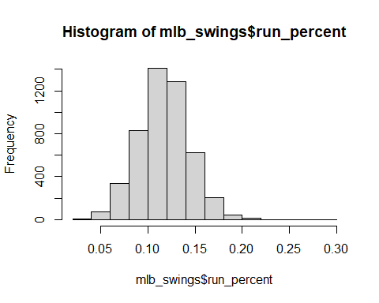
skew(mlb_swings$run_percent)
## [1] 0.1304422
Changing runs to run percent eliminated the skew from the original variable
Still need to figure out wRAA.
#Correlation Matrix
#taking out original walks and runs variables for obvious correlation reasons
mlb_swings <- mlb_swings[ , c(-1, -4)]
cor(mlb_swings, use = "pairwise.complete.obs")
## on_base_plus_slg b_lob wRAA
## on_base_plus_slg 1.00000000 0.387545263 0.867965614
## b_lob 0.38754526 1.000000000 0.373181649
## wRAA 0.86796561 0.373181649 1.000000000
## z_swing_percent 0.03957039 0.084197273 0.004534047
## z_swing_miss_percent -0.04044343 -0.131694774 -0.030083767
## oz_swing_percent -0.13971413 0.062582191 -0.191087929
## oz_swing_miss_percent -0.07065874 -0.158352400 -0.056249052
## oz_contact_percent 0.07027941 0.158173561 0.055928986
## out_zone_percent 0.31544765 0.193945859 0.273053236
## meatball_swing_percent 0.06622398 0.054265618 0.057551331
## meatball_percent -0.19547208 -0.135649872 -0.170789034
## iz_contact_percent 0.04028932 0.131866548 0.029975896
## in_zone_percent -0.31545690 -0.193955694 -0.273059740
## edge_percent -0.13377354 -0.071551319 -0.103918406
## whiff_percent -0.05811133 -0.130859162 -0.055528887
## swing_percent -0.13061719 0.047333496 -0.175105277
## pull_percent 0.10012149 0.032241989 0.094441961
## straightaway_percent -0.04139476 0.009250554 -0.052250833
## opposite_percent -0.09792720 -0.054544232 -0.079571245
## f_strike_percent -0.25363429 -0.074905987 -0.260066959
## groundballs_percent -0.24903961 -0.137698364 -0.223115784
## flyballs_percent 0.18927050 0.118056576 0.194272844
## linedrives_percent 0.26779287 0.083682502 0.212179652
## popups_percent -0.11500921 -0.011295953 -0.115444889
## walk_percent 0.34879638 0.056626357 0.409545764
## run_percent 0.67248450 0.238731776 0.606681611
## z_swing_percent z_swing_miss_percent oz_swing_percent
## on_base_plus_slg 0.0395703916 -0.04044343 -0.13971413
## b_lob 0.0841972734 -0.13169477 0.06258219
## wRAA 0.0045340473 -0.03008377 -0.19108793
## z_swing_percent 1.0000000000 0.30251978 0.51907010
## z_swing_miss_percent 0.3025197799 1.00000000 0.02032075
## oz_swing_percent 0.5190701048 0.02032075 1.00000000
## oz_swing_miss_percent 0.2069486679 0.68475874 -0.08684192
## oz_contact_percent -0.2068831162 -0.68470780 0.08694046
## out_zone_percent 0.2586054367 0.11415278 0.29300785
## meatball_swing_percent 0.7297016465 0.32170821 0.16149873
## meatball_percent -0.1497825086 -0.09032948 -0.18216321
## iz_contact_percent -0.3025173400 -0.99997813 -0.02010098
## in_zone_percent -0.2586066820 -0.11414401 -0.29301780
## edge_percent -0.1317964147 -0.01106513 -0.10501576
## whiff_percent 0.3274551533 0.92786713 0.13594354
## swing_percent 0.8430740561 0.16336686 0.86674047
## pull_percent 0.0561616804 0.22095995 -0.05843089
## straightaway_percent -0.0494361518 -0.14892078 0.04660658
## opposite_percent -0.0269588450 -0.15921342 0.03703180
## f_strike_percent 0.3532835720 0.08332737 0.49150583
## groundballs_percent -0.0611788473 -0.17123614 0.11573621
## flyballs_percent 0.0860069813 0.30382932 -0.14689946
## linedrives_percent -0.0181879140 -0.18781749 -0.02476931
## popups_percent -0.0002604532 0.04642697 0.04273801
## walk_percent -0.3508969416 0.13651709 -0.73197703
## run_percent 0.0043695347 0.01505990 -0.14631445
## oz_swing_miss_percent oz_contact_percent
## on_base_plus_slg -0.070658736 0.070279411
## b_lob -0.158352400 0.158173561
## wRAA -0.056249052 0.055928986
## z_swing_percent 0.206948668 -0.206883116
## z_swing_miss_percent 0.684758739 -0.684707798
## oz_swing_percent -0.086841920 0.086940462
## oz_swing_miss_percent 1.000000000 -0.999983859
## oz_contact_percent -0.999983859 1.000000000
## out_zone_percent 0.044133146 -0.044180112
## meatball_swing_percent 0.262145497 -0.262148997
## meatball_percent -0.016953401 0.017126294
## iz_contact_percent -0.684724442 0.684674843
## in_zone_percent -0.044135262 0.044182228
## edge_percent -0.044439911 0.044270866
## whiff_percent 0.865088675 -0.865040305
## swing_percent 0.055992436 -0.055885345
## pull_percent 0.256488774 -0.256601997
## straightaway_percent -0.153578615 0.153644760
## opposite_percent -0.200172029 0.200261472
## f_strike_percent 0.094453580 -0.094275675
## groundballs_percent -0.156011065 0.156125901
## flyballs_percent 0.311556615 -0.311709549
## linedrives_percent -0.178539303 0.178465677
## popups_percent -0.013758234 0.013858506
## walk_percent 0.143106776 -0.143298543
## run_percent 0.002533864 -0.002860486
## out_zone_percent meatball_swing_percent meatball_percent
## on_base_plus_slg 0.31544765 0.06622398 -0.195472076
## b_lob 0.19394586 0.05426562 -0.135649872
## wRAA 0.27305324 0.05755133 -0.170789034
## z_swing_percent 0.25860544 0.72970165 -0.149782509
## z_swing_miss_percent 0.11415278 0.32170821 -0.090329478
## oz_swing_percent 0.29300785 0.16149873 -0.182163209
## oz_swing_miss_percent 0.04413315 0.26214550 -0.016953401
## oz_contact_percent -0.04418011 -0.26214900 0.017126294
## out_zone_percent 1.00000000 0.13538773 -0.589402012
## meatball_swing_percent 0.13538773 1.00000000 -0.104730101
## meatball_percent -0.58940201 -0.10473010 1.000000000
## iz_contact_percent -0.11411864 -0.32164624 0.090468950
## in_zone_percent -0.99999985 -0.13538354 0.589394742
## edge_percent -0.25662820 -0.02869492 -0.065676281
## whiff_percent 0.21060885 0.31021735 -0.134275698
## swing_percent 0.13161250 0.48894263 -0.081538456
## pull_percent 0.12442407 0.06707350 -0.073435579
## straightaway_percent -0.04252824 -0.05971558 0.019833051
## opposite_percent -0.13175475 -0.03387063 0.085055290
## f_strike_percent -0.20156002 0.18686543 0.138158932
## groundballs_percent -0.11328910 -0.08411136 0.061268490
## flyballs_percent 0.08466386 0.14577178 -0.034464652
## linedrives_percent 0.05802589 -0.04386706 -0.056907408
## popups_percent 0.02734589 -0.02910829 -0.005211457
## walk_percent 0.14745223 -0.06506095 -0.095132760
## run_percent 0.15874745 0.05229901 -0.095557551
## iz_contact_percent in_zone_percent edge_percent
## on_base_plus_slg 0.04028932 -0.31545690 -0.133773540
## b_lob 0.13186655 -0.19395569 -0.071551319
## wRAA 0.02997590 -0.27305974 -0.103918406
## z_swing_percent -0.30251734 -0.25860668 -0.131796415
## z_swing_miss_percent -0.99997813 -0.11414401 -0.011065131
## oz_swing_percent -0.02010098 -0.29301780 -0.105015755
## oz_swing_miss_percent -0.68472444 -0.04413526 -0.044439911
## oz_contact_percent 0.68467484 0.04418223 0.044270866
## out_zone_percent -0.11411864 -0.99999985 -0.256628197
## meatball_swing_percent -0.32164624 -0.13538354 -0.028694922
## meatball_percent 0.09046895 0.58939474 -0.065676281
## iz_contact_percent 1.00000000 0.11410988 0.011006398
## in_zone_percent 0.11410988 1.00000000 0.256626718
## edge_percent 0.01100640 0.25662672 1.000000000
## whiff_percent -0.92779600 -0.21060593 -0.058826858
## swing_percent -0.16323410 -0.13161984 -0.090017412
## pull_percent -0.22125731 -0.12442461 -0.019604488
## straightaway_percent 0.14905279 0.04253026 -0.018859951
## opposite_percent 0.15950933 0.13175363 0.042659059
## f_strike_percent -0.08312268 0.20155676 -0.012060029
## groundballs_percent 0.17134569 0.11329153 0.047633057
## flyballs_percent -0.30384170 -0.08466531 -0.054449107
## linedrives_percent 0.18767958 -0.05802604 0.002615218
## popups_percent -0.04649941 -0.02734849 -0.008835088
## walk_percent -0.13667890 -0.14744542 0.010170262
## run_percent -0.01527910 -0.15875119 -0.066900981
## whiff_percent swing_percent pull_percent
## on_base_plus_slg -0.05811133 -0.130617186 0.10012149
## b_lob -0.13085916 0.047333496 0.03224199
## wRAA -0.05552889 -0.175105277 0.09444196
## z_swing_percent 0.32745515 0.843074056 0.05616168
## z_swing_miss_percent 0.92786713 0.163366863 0.22095995
## oz_swing_percent 0.13594354 0.866740470 -0.05843089
## oz_swing_miss_percent 0.86508867 0.055992436 0.25648877
## oz_contact_percent -0.86504030 -0.055885345 -0.25660200
## out_zone_percent 0.21060885 0.131612501 0.12442407
## meatball_swing_percent 0.31021735 0.488942627 0.06707350
## meatball_percent -0.13427570 -0.081538456 -0.07343558
## iz_contact_percent -0.92779600 -0.163234099 -0.22125731
## in_zone_percent -0.21060593 -0.131619838 -0.12442461
## edge_percent -0.05882686 -0.090017412 -0.01960449
## whiff_percent 1.00000000 0.231270755 0.25138080
## swing_percent 0.23127076 1.000000000 -0.02851022
## pull_percent 0.25138080 -0.028510217 1.00000000
## straightaway_percent -0.15485879 0.008943032 -0.68171489
## opposite_percent -0.19354828 0.033450553 -0.72823618
## f_strike_percent 0.13989763 0.551846170 -0.07113059
## groundballs_percent -0.16197835 0.060256473 -0.47001420
## flyballs_percent 0.30796733 -0.060041729 0.45050507
## linedrives_percent -0.19958492 -0.038600233 -0.15947846
## popups_percent 0.03186297 0.022784081 0.41361061
## walk_percent 0.05726683 -0.691656150 0.14464795
## run_percent -0.00208321 -0.122728270 0.08484246
## straightaway_percent opposite_percent f_strike_percent
## on_base_plus_slg -0.041394763 -0.097927199 -0.25363429
## b_lob 0.009250554 -0.054544232 -0.07490599
## wRAA -0.052250833 -0.079571245 -0.26006696
## z_swing_percent -0.049436152 -0.026958845 0.35328357
## z_swing_miss_percent -0.148920784 -0.159213420 0.08332737
## oz_swing_percent 0.046606583 0.037031802 0.49150583
## oz_swing_miss_percent -0.153578615 -0.200172029 0.09445358
## oz_contact_percent 0.153644760 0.200261472 -0.09427568
## out_zone_percent -0.042528235 -0.131754750 -0.20156002
## meatball_swing_percent -0.059715577 -0.033870625 0.18686543
## meatball_percent 0.019833051 0.085055290 0.13815893
## iz_contact_percent 0.149052793 0.159509331 -0.08312268
## in_zone_percent 0.042530260 0.131753634 0.20155676
## edge_percent -0.018859951 0.042659059 -0.01206003
## whiff_percent -0.154858789 -0.193548282 0.13989763
## swing_percent 0.008943032 0.033450553 0.55184617
## pull_percent -0.681714889 -0.728236180 -0.07113059
## straightaway_percent 1.000000000 -0.001710701 0.02828900
## opposite_percent -0.001710701 1.000000000 0.07504761
## f_strike_percent 0.028288999 0.075047606 1.00000000
## groundballs_percent 0.400697105 0.263963279 0.13098520
## flyballs_percent -0.359116672 -0.269880357 -0.10494318
## linedrives_percent 0.058377299 0.159248365 -0.06474486
## popups_percent -0.305232048 -0.285122517 -0.02167963
## walk_percent -0.106415235 -0.097724287 -0.49162703
## run_percent -0.051247739 -0.065289149 -0.15183790
## groundballs_percent flyballs_percent linedrives_percent
## on_base_plus_slg -0.24903961 0.18927050 0.267792870
## b_lob -0.13769836 0.11805658 0.083682502
## wRAA -0.22311578 0.19427284 0.212179652
## z_swing_percent -0.06117885 0.08600698 -0.018187914
## z_swing_miss_percent -0.17123614 0.30382932 -0.187817486
## oz_swing_percent 0.11573621 -0.14689946 -0.024769306
## oz_swing_miss_percent -0.15601107 0.31155661 -0.178539303
## oz_contact_percent 0.15612590 -0.31170955 0.178465677
## out_zone_percent -0.11328910 0.08466386 0.058025890
## meatball_swing_percent -0.08411136 0.14577178 -0.043867056
## meatball_percent 0.06126849 -0.03446465 -0.056907408
## iz_contact_percent 0.17134569 -0.30384170 0.187679582
## in_zone_percent 0.11329153 -0.08466531 -0.058026039
## edge_percent 0.04763306 -0.05444911 0.002615218
## whiff_percent -0.16197835 0.30796733 -0.199584916
## swing_percent 0.06025647 -0.06004173 -0.038600233
## pull_percent -0.47001420 0.45050507 -0.159478460
## straightaway_percent 0.40069710 -0.35911667 0.058377299
## opposite_percent 0.26396328 -0.26988036 0.159248365
## f_strike_percent 0.13098520 -0.10494318 -0.064744858
## groundballs_percent 1.00000000 -0.80039517 -0.228490854
## flyballs_percent -0.80039517 1.00000000 -0.233083199
## linedrives_percent -0.22849085 -0.23308320 1.000000000
## popups_percent -0.48854352 0.22328550 -0.258379143
## walk_percent -0.21461957 0.25380617 0.027057608
## run_percent -0.14561522 0.15703320 0.074005845
## popups_percent walk_percent run_percent
## on_base_plus_slg -0.1150092130 0.34879638 0.672484498
## b_lob -0.0112959529 0.05662636 0.238731776
## wRAA -0.1154448895 0.40954576 0.606681611
## z_swing_percent -0.0002604532 -0.35089694 0.004369535
## z_swing_miss_percent 0.0464269726 0.13651709 0.015059904
## oz_swing_percent 0.0427380102 -0.73197703 -0.146314445
## oz_swing_miss_percent -0.0137582345 0.14310678 0.002533864
## oz_contact_percent 0.0138585063 -0.14329854 -0.002860486
## out_zone_percent 0.0273458866 0.14745223 0.158747451
## meatball_swing_percent -0.0291082880 -0.06506095 0.052299008
## meatball_percent -0.0052114569 -0.09513276 -0.095557551
## iz_contact_percent -0.0464994148 -0.13667890 -0.015279101
## in_zone_percent -0.0273484904 -0.14744542 -0.158751188
## edge_percent -0.0088350884 0.01017026 -0.066900981
## whiff_percent 0.0318629676 0.05726683 -0.002083210
## swing_percent 0.0227840805 -0.69165615 -0.122728270
## pull_percent 0.4136106076 0.14464795 0.084842465
## straightaway_percent -0.3052320480 -0.10641524 -0.051247739
## opposite_percent -0.2851225172 -0.09772429 -0.065289149
## f_strike_percent -0.0216796300 -0.49162703 -0.151837903
## groundballs_percent -0.4885435179 -0.21461957 -0.145615217
## flyballs_percent 0.2232855016 0.25380617 0.157033197
## linedrives_percent -0.2583791432 0.02705761 0.074005845
## popups_percent 1.0000000000 -0.02153739 -0.053948502
## walk_percent -0.0215373917 1.00000000 0.263381273
## run_percent -0.0539485024 0.26338127 1.000000000
Skimming through the correlation matrix all heavy correlations make sense based on prior knowledge of the variables.
#Collinearity
vif <- function(model) {
X <- model.matrix(model)[, -1] # drop intercept
vifs <- numeric(ncol(X))
names(vifs) <- colnames(X)
for (i in seq_along(vifs)) {
xi <- X[, i]
others <- X[, -i, drop = FALSE]
r2 <- summary(lm(xi ~ others))$r.squared
vifs[i] <- 1 / (1 - r2)
}
vifs
}
model <- lm(wRAA ~ ., data = mlb_swings)
vif(model)
## on_base_plus_slg b_lob z_swing_percent
## 2.677841e+00 1.260462e+00 2.667238e+02
## z_swing_miss_percent oz_swing_percent oz_swing_miss_percent
## 2.340991e+04 3.472865e+02 3.177236e+04
## oz_contact_percent out_zone_percent meatball_swing_percent
## 3.172077e+04 3.361529e+06 2.560004e+00
## meatball_percent iz_contact_percent in_zone_percent
## 1.677731e+00 2.333827e+04 3.361125e+06
## edge_percent whiff_percent swing_percent
## 1.194588e+00 2.261010e+02 8.309253e+02
## pull_percent straightaway_percent opposite_percent
## 3.245679e+02 1.514447e+02 1.730617e+02
## f_strike_percent groundballs_percent flyballs_percent
## 1.738081e+00 1.118747e+04 7.639926e+03
## linedrives_percent popups_percent walk_percent
## 3.208258e+03 2.189756e+03 3.594380e+00
## run_percent
## 1.900961e+00
Variables with acceptable collinearity: OPS, LOB, meatball sw %, meatball %, edge %, strike %, walk %, run %
PCA is needed to adjust other predictors..
# Principal Component Analysis
swings_scaled <- scale(mlb_swings)
pca <- prcomp(swings_scaled)
summary(pca)
## Importance of components:
## PC1 PC2 PC3 PC4 PC5 PC6 PC7
## Standard deviation 2.3340 2.0487 1.8479 1.54651 1.34485 1.08293 1.02822
## Proportion of Variance 0.2095 0.1614 0.1313 0.09199 0.06956 0.04511 0.04066
## Cumulative Proportion 0.2095 0.3710 0.5023 0.59428 0.66384 0.70895 0.74961
## PC8 PC9 PC10 PC11 PC12 PC13 PC14
## Standard deviation 0.98887 0.95204 0.93965 0.8623 0.81014 0.75046 0.71127
## Proportion of Variance 0.03761 0.03486 0.03396 0.0286 0.02524 0.02166 0.01946
## Cumulative Proportion 0.78722 0.82208 0.85604 0.8846 0.90988 0.93155 0.95100
## PC15 PC16 PC17 PC18 PC19 PC20 PC21
## Standard deviation 0.6511 0.61150 0.45538 0.38200 0.3422 0.05824 0.03935
## Proportion of Variance 0.0163 0.01438 0.00798 0.00561 0.0045 0.00013 0.00006
## Cumulative Proportion 0.9673 0.98169 0.98967 0.99528 0.9998 0.99991 0.99997
## PC22 PC23 PC24 PC25 PC26
## Standard deviation 0.02621 0.006569 0.004604 0.003951 0.0003857
## Proportion of Variance 0.00003 0.000000 0.000000 0.000000 0.0000000
## Cumulative Proportion 1.00000 1.000000 1.000000 1.000000 1.0000000
plot(pca)
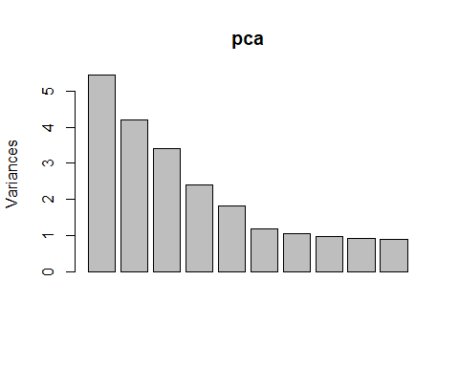
First 10-12 PCs explain about 85-91% of the variable structure
No sharp elbow in the spree means gradual decay
pca$rotation
## PC1 PC2 PC3 PC4
## on_base_plus_slg -0.03809762 0.32932166 -0.24610439 0.108797396
## b_lob 0.01131271 0.14708780 -0.22703144 -0.045737301
## wRAA -0.03511397 0.33332453 -0.20928644 0.120498131
## z_swing_percent -0.20659410 -0.21412042 -0.29151458 -0.037577692
## z_swing_miss_percent -0.36115228 -0.05636850 0.11320905 0.175082264
## oz_swing_percent -0.05751537 -0.30113829 -0.32991483 -0.141917870
## oz_swing_miss_percent -0.34145904 -0.04051582 0.18003472 0.176888047
## oz_contact_percent 0.34147041 0.04035626 -0.17997930 -0.176913056
## out_zone_percent -0.14287902 0.13201815 -0.36456255 0.066458854
## meatball_swing_percent -0.20082640 -0.11475462 -0.16293655 0.036621253
## meatball_percent 0.09616862 -0.09272038 0.26109854 -0.066111344
## iz_contact_percent 0.36116559 0.05624833 -0.11324062 -0.175013375
## in_zone_percent 0.14287823 -0.13201820 0.36456600 -0.066455282
## edge_percent 0.04931254 -0.02616947 0.13573611 -0.007959148
## whiff_percent -0.39042693 -0.08076449 0.08506869 0.174846317
## swing_percent -0.12574851 -0.33857447 -0.29983762 -0.124819281
## pull_percent -0.21493697 0.15293699 0.06643859 -0.407447479
## straightaway_percent 0.14467198 -0.10181108 -0.06348706 0.326994967
## opposite_percent 0.15611940 -0.11452624 -0.03044678 0.252295336
## f_strike_percent -0.04361183 -0.31358097 -0.05843922 -0.087951763
## groundballs_percent 0.17503269 -0.21509294 -0.01016863 0.341554058
## flyballs_percent -0.22775028 0.18196519 0.06915402 -0.244054866
## linedrives_percent 0.09354605 0.08408870 -0.13625823 0.100906534
## popups_percent -0.08322467 0.04442923 0.05877755 -0.438350952
## walk_percent -0.05055083 0.36673606 0.14801882 0.178789513
## run_percent -0.04361630 0.25705876 -0.14871942 0.102563596
## PC5 PC6 PC7 PC8
## on_base_plus_slg -0.284205188 0.110620840 -0.019667578 -0.113826262
## b_lob -0.173406621 0.142831353 -0.069594227 0.091618264
## wRAA -0.280211419 0.111913328 -0.045494321 -0.059696675
## z_swing_percent -0.198025528 -0.060719768 -0.083014366 0.212674511
## z_swing_miss_percent -0.003921332 -0.040669561 -0.031835945 -0.002816322
## oz_swing_percent 0.050989138 0.046966046 0.049724703 -0.190648855
## oz_swing_miss_percent -0.017972990 0.046009636 0.079322467 -0.128992503
## oz_contact_percent 0.018089729 -0.046019981 -0.079097511 0.129082496
## out_zone_percent 0.394703990 -0.045817052 0.084912194 0.031706920
## meatball_swing_percent -0.242778119 -0.111234779 -0.222649094 0.408535369
## meatball_percent -0.347419025 0.185959775 0.327617903 0.061899175
## iz_contact_percent 0.003919188 0.040647803 0.032002474 0.003015330
## in_zone_percent -0.394697648 0.045812473 -0.084914932 -0.031701434
## edge_percent -0.036873971 -0.282441917 -0.802214187 -0.149843625
## whiff_percent 0.045686048 0.006742108 0.039611101 -0.106400314
## swing_percent -0.158338769 0.004462202 -0.031951563 -0.006418695
## pull_percent 0.057412091 0.156850341 -0.127916716 -0.241488961
## straightaway_percent 0.040684036 0.306110165 -0.014003270 0.027487835
## opposite_percent -0.120765636 -0.500087354 0.191795219 0.307309681
## f_strike_percent -0.221706339 0.091876863 0.044981880 -0.197399438
## groundballs_percent 0.145877224 0.350086195 -0.197991740 0.027145064
## flyballs_percent -0.138517507 -0.116164798 0.118322750 0.244934790
## linedrives_percent -0.164888362 -0.489888016 0.180197779 -0.568896787
## popups_percent 0.128558958 0.018371061 0.008164927 0.169913515
## walk_percent 0.062544299 -0.071794626 -0.045109132 0.213175916
## run_percent -0.302693515 0.228127024 -0.090246520 -0.049654337
## PC9 PC10 PC11 PC12
## on_base_plus_slg 0.092419440 0.018340228 -0.124706328 0.005536161
## b_lob 0.030415757 -0.412040672 0.688705230 -0.413378560
## wRAA 0.106198628 0.027846430 -0.082455121 -0.003098968
## z_swing_percent -0.210814128 0.179646106 -0.025668956 -0.022362353
## z_swing_miss_percent 0.078468361 -0.113540481 -0.146227614 -0.315497735
## oz_swing_percent 0.197983744 -0.147795967 -0.045463132 0.041242911
## oz_swing_miss_percent -0.013867468 0.017063938 0.170177121 0.193754964
## oz_contact_percent 0.013801210 -0.017033593 -0.170227531 -0.193913073
## out_zone_percent 0.020928527 0.035993923 0.005954522 0.052259446
## meatball_swing_percent -0.375567832 0.301694980 0.009176434 -0.021210392
## meatball_percent -0.052281802 0.102789878 -0.018416470 -0.186147086
## iz_contact_percent -0.078332136 0.113276541 0.146486362 0.315497638
## in_zone_percent -0.020935946 -0.035988540 -0.005961918 -0.052263938
## edge_percent 0.084952548 -0.196861574 -0.018963604 0.093018836
## whiff_percent 0.094650409 -0.098931091 -0.012930321 -0.091022702
## swing_percent 0.001180056 0.001342396 -0.044411402 0.002930378
## pull_percent -0.017628719 0.334724831 0.152304956 -0.049194433
## straightaway_percent -0.466518729 -0.481435791 -0.254117588 0.102514346
## opposite_percent 0.462043444 -0.010425024 0.031257323 -0.014989427
## f_strike_percent 0.168596393 -0.054327126 0.023732175 0.198343108
## groundballs_percent 0.174811298 0.310452721 0.128107218 -0.115299113
## flyballs_percent -0.020565400 -0.316888018 0.086665213 0.476508384
## linedrives_percent -0.350051746 0.055061982 -0.028016641 -0.204459029
## popups_percent 0.066605206 -0.176247192 -0.418366315 -0.381529531
## walk_percent -0.110494550 0.124456050 0.014825015 -0.047648999
## run_percent 0.303444348 0.052015641 -0.327973501 0.112515860
## PC13 PC14 PC15 PC16
## on_base_plus_slg 0.019181126 3.163373e-02 4.099781e-02 -0.308385680
## b_lob -0.134439945 -6.305024e-03 -3.343145e-02 0.159392721
## wRAA 0.029788976 -3.811000e-02 1.217582e-01 -0.538592806
## z_swing_percent -0.009189207 7.133826e-02 6.753557e-03 -0.033658697
## z_swing_miss_percent 0.288074651 -1.265127e-01 -5.088305e-02 0.040360636
## oz_swing_percent 0.120494132 1.499640e-01 7.014825e-02 -0.075530094
## oz_swing_miss_percent -0.371013740 1.961631e-01 1.911009e-02 -0.077623331
## oz_contact_percent 0.370985559 -1.962753e-01 -1.899407e-02 0.077636221
## out_zone_percent -0.012224539 1.126469e-02 3.205723e-01 0.139678913
## meatball_swing_percent -0.127068338 -5.901414e-02 -2.946333e-02 0.099664759
## meatball_percent 0.147697833 2.663185e-01 6.906283e-01 0.151741172
## iz_contact_percent -0.288147608 1.264836e-01 5.123803e-02 -0.040457325
## in_zone_percent 0.012235459 -1.128140e-02 -3.205880e-01 -0.139667979
## edge_percent -0.011842246 1.535946e-01 3.849874e-01 0.035062998
## whiff_percent 0.021770800 4.042176e-02 1.923620e-02 -0.010463299
## swing_percent 0.072320992 1.333380e-01 -1.605840e-02 -0.093038070
## pull_percent 0.125948874 -2.977984e-02 -2.593563e-02 0.032477474
## straightaway_percent -0.046627956 -1.167683e-02 3.661706e-02 0.004660757
## opposite_percent -0.124457504 5.180159e-02 3.957624e-03 -0.046058054
## f_strike_percent -0.213165944 -7.685236e-01 2.308701e-01 0.078965745
## groundballs_percent 0.023788209 -8.050944e-05 7.116475e-05 -0.051778195
## flyballs_percent 0.301746037 -2.890608e-03 -7.159405e-03 0.040591672
## linedrives_percent -0.071002571 -1.199414e-02 -2.717245e-02 0.144917499
## popups_percent -0.531256836 1.981198e-02 4.613603e-02 -0.134693303
## walk_percent -0.056641945 -3.615304e-01 2.188510e-01 0.012074744
## run_percent -0.139994216 1.329309e-01 -1.819440e-01 0.657443334
## PC17 PC18 PC19 PC20
## on_base_plus_slg 0.130282166 -0.2031616262 0.728335332 1.842076e-03
## b_lob -0.016189028 -0.0001516212 -0.009110130 3.116714e-03
## wRAA 0.071695345 0.0980698904 -0.625932662 2.407376e-04
## z_swing_percent -0.505888603 -0.4392957358 -0.075890914 -1.092853e-01
## z_swing_miss_percent 0.043102055 -0.0636932851 -0.016080337 2.637368e-01
## oz_swing_percent -0.026188759 0.6010737850 0.123368663 9.159775e-02
## oz_swing_miss_percent -0.034721019 0.0127240269 0.008124111 2.025060e-01
## oz_contact_percent 0.034777634 -0.0129437539 -0.008508803 -2.046295e-01
## out_zone_percent 0.093507905 -0.1165898345 -0.043329973 4.791749e-02
## meatball_swing_percent 0.530507911 0.2912760532 0.038757452 2.164720e-04
## meatball_percent 0.045850328 -0.0051404205 0.002348876 2.638535e-03
## iz_contact_percent -0.042648583 0.0641166927 0.016065497 -2.667815e-01
## in_zone_percent -0.093503308 0.1165795631 0.043308484 -4.798920e-02
## edge_percent -0.007582944 -0.0545714838 0.008064997 1.217107e-03
## whiff_percent 0.055853238 0.0830930014 0.016606780 -8.622098e-01
## swing_percent -0.320454352 0.1496735115 0.045639995 8.496189e-02
## pull_percent -0.002892972 0.0072770074 -0.005075085 -2.021578e-02
## straightaway_percent -0.018098036 0.0073871220 -0.010357928 -1.304220e-02
## opposite_percent 0.013743348 -0.0161689289 0.014437518 -1.259603e-02
## f_strike_percent 0.082287600 -0.1278257936 -0.005614386 4.756904e-05
## groundballs_percent -0.010932158 -0.0108059770 0.023617880 2.195617e-03
## flyballs_percent 0.017881311 -0.0109388490 -0.004113008 9.590225e-04
## linedrives_percent -0.015475151 0.0461155768 -0.047616227 -1.576420e-03
## popups_percent 0.008513594 -0.0101045194 0.011372161 1.270373e-03
## walk_percent -0.540435454 0.4672219469 0.173050687 -7.870825e-03
## run_percent -0.088938729 0.0673293863 -0.122650357 -1.012073e-03
## PC21 PC22 PC23 PC24
## on_base_plus_slg 0.0014374273 1.260100e-03 1.451555e-04 8.535699e-05
## b_lob 0.0014931178 2.125132e-04 2.871888e-04 -1.353377e-04
## wRAA -0.0001985615 -2.423051e-03 -1.562272e-04 -1.097150e-04
## z_swing_percent -0.0154035980 4.230630e-01 1.502949e-03 3.945985e-04
## z_swing_miss_percent 0.0095115963 2.020175e-02 -1.032623e-01 6.995096e-01
## oz_swing_percent -0.0104172407 4.850354e-01 1.327446e-03 2.869429e-04
## oz_swing_miss_percent 0.0031934031 1.695803e-02 -8.365415e-02 1.754639e-02
## oz_contact_percent -0.0042266819 -1.486377e-02 -8.290620e-02 1.683857e-02
## out_zone_percent 0.0031773705 -7.158638e-02 -2.642496e-04 7.863610e-05
## meatball_swing_percent 0.0021374835 -1.554483e-04 1.106708e-04 -1.952021e-04
## meatball_percent -0.0013319765 5.487546e-04 1.205606e-04 -1.592059e-04
## iz_contact_percent -0.0061183210 -2.051463e-02 -1.021918e-01 6.984643e-01
## in_zone_percent -0.0031445363 7.195935e-02 2.216852e-04 1.367666e-04
## edge_percent 0.0002330789 -7.438184e-06 -6.170713e-05 -4.500509e-06
## whiff_percent -0.0216718713 -6.515127e-02 1.974196e-03 -1.660837e-03
## swing_percent 0.0197366636 -7.544649e-01 -2.971860e-03 -3.797635e-04
## pull_percent 0.7071937046 1.792164e-02 -4.063030e-03 -2.211643e-03
## straightaway_percent 0.4821282176 1.190466e-02 -2.867965e-03 -1.649226e-03
## opposite_percent 0.5156870227 1.292339e-02 -2.924900e-03 -1.866449e-03
## f_strike_percent -0.0016287326 5.600404e-04 7.743109e-05 -8.686370e-05
## groundballs_percent 0.0058684903 -2.269568e-03 6.675867e-01 1.013303e-01
## flyballs_percent -0.0020032948 -1.894329e-03 5.516671e-01 8.366774e-02
## linedrives_percent 0.0043956098 -1.370021e-03 3.574343e-01 5.434096e-02
## popups_percent 0.0060716699 -2.006498e-04 2.953032e-01 4.479947e-02
## walk_percent -0.0018580823 -2.718703e-03 -3.710533e-04 -6.293030e-05
## run_percent -0.0019793189 -1.023308e-04 -2.114946e-05 1.732376e-04
## PC25 PC26
## on_base_plus_slg 2.663630e-04 1.413837e-05
## b_lob 7.314896e-05 4.831299e-06
## wRAA -9.371449e-05 -1.570941e-06
## z_swing_percent -7.163393e-04 -1.199673e-04
## z_swing_miss_percent -2.905786e-02 -1.148601e-04
## oz_swing_percent -3.112931e-04 -1.111920e-04
## oz_swing_miss_percent 7.022386e-01 1.428809e-04
## oz_contact_percent 7.017076e-01 1.158214e-04
## out_zone_percent -5.373513e-05 7.071279e-01
## meatball_swing_percent 4.733103e-05 -4.025902e-06
## meatball_percent -9.115414e-05 9.173628e-06
## iz_contact_percent -2.955696e-02 -1.156504e-04
## in_zone_percent -2.178344e-04 7.070856e-01
## edge_percent 1.170023e-04 5.132422e-06
## whiff_percent -9.441550e-04 -2.467081e-05
## swing_percent 9.779379e-04 2.087882e-04
## pull_percent 7.063502e-05 -2.285358e-05
## straightaway_percent -2.637694e-06 -1.582057e-05
## opposite_percent 1.133535e-05 -1.359123e-05
## f_strike_percent -7.867051e-05 -2.549856e-06
## groundballs_percent 7.673031e-02 1.977927e-05
## flyballs_percent 6.345851e-02 1.660144e-05
## linedrives_percent 4.106228e-02 8.190750e-06
## popups_percent 3.385478e-02 1.188423e-05
## walk_percent 5.694186e-05 3.275764e-06
## run_percent 8.359268e-05 -3.289181e-06
PC1-5 Interpretation:
PC1: Swing and Miss - High PC1 score -> heavy swing and miss, low PC1 score -> heavy contact hitter PC2: Plate Discipline - High PC2 -> patient, selective hitters, low PC2 -> aggressive free swingers PC3: Direction and Launch - High PC3 -> heavy fly balls/popups, low PC3 -> linedrive, groundball pull hitters PC4: Direction: High PC4 -> pull, low PC4 -> oppo PC5: Zone Exploitation: High PC5 -> less conversion on more hittable pitches, low PC5 -> produces on hittable pitches
If neural network modeling or ridge/lasso regression end up being performed in this project, these principle components could be used to improve performance.
#Baseline Model - Linear Regression
#Creating the 80/20 train/test split
set.seed(1)
n <- nrow(mlb_swings)
train_idx <- sample(seq_len(n), size = 0.8 * n)
train <- mlb_swings[train_idx, ]
test <- mlb_swings[-train_idx, ]
#Will use best subset to investigate the most significant variables
wRAA_sub <- regsubsets(wRAA~.-on_base_plus_slg-b_lob-walk_percent-run_percent, data = mlb_swings, nvmax = 8)
summary(wRAA_sub)
## Subset selection object
## Call: regsubsets.formula(wRAA ~ . - on_base_plus_slg - b_lob - walk_percent -
## run_percent, data = mlb_swings, nvmax = 8)
## 21 Variables (and intercept)
## Forced in Forced out
## z_swing_percent FALSE FALSE
## z_swing_miss_percent FALSE FALSE
## oz_swing_percent FALSE FALSE
## oz_swing_miss_percent FALSE FALSE
## oz_contact_percent FALSE FALSE
## out_zone_percent FALSE FALSE
## meatball_swing_percent FALSE FALSE
## meatball_percent FALSE FALSE
## iz_contact_percent FALSE FALSE
## in_zone_percent FALSE FALSE
## edge_percent FALSE FALSE
## whiff_percent FALSE FALSE
## swing_percent FALSE FALSE
## pull_percent FALSE FALSE
## straightaway_percent FALSE FALSE
## opposite_percent FALSE FALSE
## f_strike_percent FALSE FALSE
## groundballs_percent FALSE FALSE
## flyballs_percent FALSE FALSE
## linedrives_percent FALSE FALSE
## popups_percent FALSE FALSE
## 1 subsets of each size up to 8
## Selection Algorithm: exhaustive
## z_swing_percent z_swing_miss_percent oz_swing_percent
## 1 ( 1 ) " " " " " "
## 2 ( 1 ) " " " " "*"
## 3 ( 1 ) " " " " "*"
## 4 ( 1 ) " " " " "*"
## 5 ( 1 ) " " " " "*"
## 6 ( 1 ) "*" " " "*"
## 7 ( 1 ) "*" " " "*"
## 8 ( 1 ) "*" " " "*"
## oz_swing_miss_percent oz_contact_percent out_zone_percent
## 1 ( 1 ) " " " " " "
## 2 ( 1 ) " " " " " "
## 3 ( 1 ) " " " " " "
## 4 ( 1 ) " " " " " "
## 5 ( 1 ) "*" " " " "
## 6 ( 1 ) "*" " " " "
## 7 ( 1 ) "*" " " " "
## 8 ( 1 ) "*" " " " "
## meatball_swing_percent meatball_percent iz_contact_percent
## 1 ( 1 ) " " " " " "
## 2 ( 1 ) " " " " " "
## 3 ( 1 ) " " " " " "
## 4 ( 1 ) " " " " " "
## 5 ( 1 ) " " " " " "
## 6 ( 1 ) " " " " " "
## 7 ( 1 ) " " " " " "
## 8 ( 1 ) " " " " " "
## in_zone_percent edge_percent whiff_percent swing_percent pull_percent
## 1 ( 1 ) "*" " " " " " " " "
## 2 ( 1 ) "*" " " " " " " " "
## 3 ( 1 ) "*" " " " " " " " "
## 4 ( 1 ) "*" " " " " " " " "
## 5 ( 1 ) "*" " " " " " " " "
## 6 ( 1 ) " " " " " " "*" " "
## 7 ( 1 ) " " " " " " "*" " "
## 8 ( 1 ) " " "*" " " "*" " "
## straightaway_percent opposite_percent f_strike_percent
## 1 ( 1 ) " " " " " "
## 2 ( 1 ) " " " " " "
## 3 ( 1 ) " " " " " "
## 4 ( 1 ) " " " " " "
## 5 ( 1 ) " " " " " "
## 6 ( 1 ) " " " " " "
## 7 ( 1 ) " " "*" " "
## 8 ( 1 ) " " "*" " "
## groundballs_percent flyballs_percent linedrives_percent popups_percent
## 1 ( 1 ) " " " " " " " "
## 2 ( 1 ) " " " " " " " "
## 3 ( 1 ) " " " " "*" " "
## 4 ( 1 ) "*" " " " " "*"
## 5 ( 1 ) "*" " " " " "*"
## 6 ( 1 ) "*" " " " " "*"
## 7 ( 1 ) "*" " " " " "*"
## 8 ( 1 ) "*" " " " " "*"
Best 1 predictor model: in zone % Best 2 predictor: in zone % + out of zone sw % Best 3 predictor: in zone % + out of zone sw % + line drive % Best 4 predictor: in zone % + out of zone sw % + ground ball % + popup % Best 5 predictor: in zone % + out of zone sw % + ground ball % + popup % + out of zone sw/miss %
Will start with these models and check performance
wRAA_sw_m1 <- lm(wRAA~in_zone_percent, data = train)
summary(wRAA_sw_m1)
##
## Call:
## lm(formula = wRAA ~ in_zone_percent, data = train)
##
## Residuals:
## Min 1Q Median 3Q Max
## -34.031 -7.970 -2.072 5.318 90.941
##
## Coefficients:
## Estimate Std. Error t value Pr(>|t|)
## (Intercept) 69.310 3.723 18.62 <2e-16 ***
## in_zone_percent -138.405 7.614 -18.18 <2e-16 ***
## ---
## Signif. codes: 0 '***' 0.001 '**' 0.01 '*' 0.05 '.' 0.1 ' ' 1
##
## Residual standard error: 12.55 on 3866 degrees of freedom
## Multiple R-squared: 0.07875, Adjusted R-squared: 0.07851
## F-statistic: 330.5 on 1 and 3866 DF, p-value: < 2.2e-16
wRAA_sw_m2 <- lm(wRAA~in_zone_percent+oz_swing_percent, data = train)
summary(wRAA_sw_m2)
##
## Call:
## lm(formula = wRAA ~ in_zone_percent + oz_swing_percent, data = train)
##
## Residuals:
## Min 1Q Median 3Q Max
## -34.025 -7.757 -1.785 5.623 84.545
##
## Coefficients:
## Estimate Std. Error t value Pr(>|t|)
## (Intercept) 107.743 4.100 26.28 <2e-16 ***
## in_zone_percent -181.295 7.629 -23.76 <2e-16 ***
## oz_swing_percent -61.360 3.243 -18.92 <2e-16 ***
## ---
## Signif. codes: 0 '***' 0.001 '**' 0.01 '*' 0.05 '.' 0.1 ' ' 1
##
## Residual standard error: 12.01 on 3865 degrees of freedom
## Multiple R-squared: 0.1568, Adjusted R-squared: 0.1564
## F-statistic: 359.5 on 2 and 3865 DF, p-value: < 2.2e-16
The swing metrics definitely don’t seem to be great predictors of wRAA just based off of the R^2 values of the first few models. This was somewhat expected, which is why we first modeled basic offensive statistics that predit wRAA to begin with. The most significant predictor of wRAA was OPS, so we will restart with that as the response variable.
ops_best_sub <- regsubsets(on_base_plus_slg~.-wRAA-b_lob-walk_percent-run_percent, data = mlb_swings, nvmax = 8)
summary(ops_best_sub)
## Subset selection object
## Call: regsubsets.formula(on_base_plus_slg ~ . - wRAA - b_lob - walk_percent -
## run_percent, data = mlb_swings, nvmax = 8)
## 21 Variables (and intercept)
## Forced in Forced out
## z_swing_percent FALSE FALSE
## z_swing_miss_percent FALSE FALSE
## oz_swing_percent FALSE FALSE
## oz_swing_miss_percent FALSE FALSE
## oz_contact_percent FALSE FALSE
## out_zone_percent FALSE FALSE
## meatball_swing_percent FALSE FALSE
## meatball_percent FALSE FALSE
## iz_contact_percent FALSE FALSE
## in_zone_percent FALSE FALSE
## edge_percent FALSE FALSE
## whiff_percent FALSE FALSE
## swing_percent FALSE FALSE
## pull_percent FALSE FALSE
## straightaway_percent FALSE FALSE
## opposite_percent FALSE FALSE
## f_strike_percent FALSE FALSE
## groundballs_percent FALSE FALSE
## flyballs_percent FALSE FALSE
## linedrives_percent FALSE FALSE
## popups_percent FALSE FALSE
## 1 subsets of each size up to 8
## Selection Algorithm: exhaustive
## z_swing_percent z_swing_miss_percent oz_swing_percent
## 1 ( 1 ) " " " " " "
## 2 ( 1 ) " " " " " "
## 3 ( 1 ) " " " " "*"
## 4 ( 1 ) " " " " "*"
## 5 ( 1 ) " " " " "*"
## 6 ( 1 ) "*" " " " "
## 7 ( 1 ) "*" " " "*"
## 8 ( 1 ) "*" " " "*"
## oz_swing_miss_percent oz_contact_percent out_zone_percent
## 1 ( 1 ) " " " " " "
## 2 ( 1 ) " " " " " "
## 3 ( 1 ) " " " " " "
## 4 ( 1 ) " " " " " "
## 5 ( 1 ) "*" " " " "
## 6 ( 1 ) "*" " " " "
## 7 ( 1 ) "*" " " " "
## 8 ( 1 ) "*" " " " "
## meatball_swing_percent meatball_percent iz_contact_percent
## 1 ( 1 ) " " " " " "
## 2 ( 1 ) " " " " " "
## 3 ( 1 ) " " " " " "
## 4 ( 1 ) " " " " " "
## 5 ( 1 ) " " " " " "
## 6 ( 1 ) " " " " " "
## 7 ( 1 ) " " " " " "
## 8 ( 1 ) " " " " " "
## in_zone_percent edge_percent whiff_percent swing_percent pull_percent
## 1 ( 1 ) "*" " " " " " " " "
## 2 ( 1 ) "*" " " " " " " " "
## 3 ( 1 ) "*" " " " " " " " "
## 4 ( 1 ) "*" " " " " " " " "
## 5 ( 1 ) "*" " " " " " " " "
## 6 ( 1 ) "*" " " " " "*" " "
## 7 ( 1 ) " " " " " " "*" " "
## 8 ( 1 ) " " " " " " "*" " "
## straightaway_percent opposite_percent f_strike_percent
## 1 ( 1 ) " " " " " "
## 2 ( 1 ) " " " " " "
## 3 ( 1 ) " " " " " "
## 4 ( 1 ) " " " " " "
## 5 ( 1 ) " " " " " "
## 6 ( 1 ) " " " " " "
## 7 ( 1 ) " " "*" " "
## 8 ( 1 ) " " "*" " "
## groundballs_percent flyballs_percent linedrives_percent popups_percent
## 1 ( 1 ) " " " " " " " "
## 2 ( 1 ) " " " " "*" " "
## 3 ( 1 ) " " " " "*" " "
## 4 ( 1 ) " " "*" "*" " "
## 5 ( 1 ) "*" " " " " "*"
## 6 ( 1 ) "*" " " " " "*"
## 7 ( 1 ) "*" " " " " "*"
## 8 ( 1 ) "*" "*" " " "*"
Best 1 predictor model: in zone % Best 2 predictor: in zone % + line drive % Best 3 predictor: in zone % + line drive % + out of zone swing % Best 4 predictor: in zone % + line drive % + out of zone swing % + fly ball % Best 5 predictor: in zone % + out of zone swing % + out of zone swing/miss % + ground ball % + pop up %
ops_mod1 <- lm(on_base_plus_slg~in_zone_percent, data = train)
summary(ops_mod1)
##
## Call:
## lm(formula = on_base_plus_slg ~ in_zone_percent, data = train)
##
## Residuals:
## Min 1Q Median 3Q Max
## -0.35267 -0.06682 0.00038 0.06591 0.42558
##
## Coefficients:
## Estimate Std. Error t value Pr(>|t|)
## (Intercept) 1.37873 0.03078 44.80 <2e-16 ***
## in_zone_percent -1.35002 0.06294 -21.45 <2e-16 ***
## ---
## Signif. codes: 0 '***' 0.001 '**' 0.01 '*' 0.05 '.' 0.1 ' ' 1
##
## Residual standard error: 0.1038 on 3866 degrees of freedom
## Multiple R-squared: 0.1063, Adjusted R-squared: 0.1061
## F-statistic: 460 on 1 and 3866 DF, p-value: < 2.2e-16
ops_mod2 <- lm(on_base_plus_slg~in_zone_percent+linedrives_percent, data = train)
summary(ops_mod2)
##
## Call:
## lm(formula = on_base_plus_slg ~ in_zone_percent + linedrives_percent,
## data = train)
##
## Residuals:
## Min 1Q Median 3Q Max
## -0.38477 -0.06515 -0.00009 0.06425 0.42192
##
## Coefficients:
## Estimate Std. Error t value Pr(>|t|)
## (Intercept) 1.17805 0.03213 36.66 <2e-16 ***
## in_zone_percent -1.28955 0.06095 -21.16 <2e-16 ***
## linedrives_percent 0.69767 0.04222 16.52 <2e-16 ***
## ---
## Signif. codes: 0 '***' 0.001 '**' 0.01 '*' 0.05 '.' 0.1 ' ' 1
##
## Residual standard error: 0.1003 on 3865 degrees of freedom
## Multiple R-squared: 0.1653, Adjusted R-squared: 0.1649
## F-statistic: 382.7 on 2 and 3865 DF, p-value: < 2.2e-16
ops_mod3 <- lm(on_base_plus_slg~in_zone_percent+linedrives_percent+oz_swing_percent, data = train)
summary(ops_mod3)
##
## Call:
## lm(formula = on_base_plus_slg ~ in_zone_percent + linedrives_percent +
## oz_swing_percent, data = train)
##
## Residuals:
## Min 1Q Median 3Q Max
## -0.35323 -0.06231 0.00216 0.06202 0.39158
##
## Coefficients:
## Estimate Std. Error t value Pr(>|t|)
## (Intercept) 1.45179 0.03542 40.99 <2e-16 ***
## in_zone_percent -1.58837 0.06183 -25.69 <2e-16 ***
## linedrives_percent 0.66925 0.04091 16.36 <2e-16 ***
## oz_swing_percent -0.42398 0.02624 -16.16 <2e-16 ***
## ---
## Signif. codes: 0 '***' 0.001 '**' 0.01 '*' 0.05 '.' 0.1 ' ' 1
##
## Residual standard error: 0.09707 on 3864 degrees of freedom
## Multiple R-squared: 0.2181, Adjusted R-squared: 0.2175
## F-statistic: 359.3 on 3 and 3864 DF, p-value: < 2.2e-16
ops_mod4 <- lm(on_base_plus_slg~in_zone_percent+linedrives_percent+oz_swing_percent+flyballs_percent, data = train)
summary(ops_mod4)
##
## Call:
## lm(formula = on_base_plus_slg ~ in_zone_percent + linedrives_percent +
## oz_swing_percent + flyballs_percent, data = train)
##
## Residuals:
## Min 1Q Median 3Q Max
## -0.36723 -0.06162 0.00278 0.06088 0.38252
##
## Coefficients:
## Estimate Std. Error t value Pr(>|t|)
## (Intercept) 1.23706 0.03803 32.53 <2e-16 ***
## in_zone_percent -1.44548 0.06131 -23.58 <2e-16 ***
## linedrives_percent 0.81444 0.04137 19.69 <2e-16 ***
## oz_swing_percent -0.35555 0.02613 -13.61 <2e-16 ***
## flyballs_percent 0.37060 0.02723 13.61 <2e-16 ***
## ---
## Signif. codes: 0 '***' 0.001 '**' 0.01 '*' 0.05 '.' 0.1 ' ' 1
##
## Residual standard error: 0.09484 on 3863 degrees of freedom
## Multiple R-squared: 0.2539, Adjusted R-squared: 0.2531
## F-statistic: 328.6 on 4 and 3863 DF, p-value: < 2.2e-16
pc_scores <- pca$x[ , 1:5]
pc_model <- lm(mlb$on_base_plus_slg~., data = as.data.frame(pc_scores))
summary(pc_model)
##
## Call:
## lm(formula = mlb$on_base_plus_slg ~ ., data = as.data.frame(pc_scores))
##
## Residuals:
## Min 1Q Median 3Q Max
## -0.268070 -0.027443 -0.001381 0.025584 0.214182
##
## Coefficients:
## Estimate Std. Error t value Pr(>|t|)
## (Intercept) 0.7196410 0.0006256 1150.29 <2e-16 ***
## PC1 -0.0041986 0.0002681 -15.66 <2e-16 ***
## PC2 0.0362931 0.0003054 118.83 <2e-16 ***
## PC3 -0.0271221 0.0003386 -80.10 <2e-16 ***
## PC4 0.0119901 0.0004046 29.64 <2e-16 ***
## PC5 -0.0313210 0.0004652 -67.32 <2e-16 ***
## ---
## Signif. codes: 0 '***' 0.001 '**' 0.01 '*' 0.05 '.' 0.1 ' ' 1
##
## Residual standard error: 0.04351 on 4830 degrees of freedom
## Multiple R-squared: 0.8443, Adjusted R-squared: 0.8442
## F-statistic: 5239 on 5 and 4830 DF, p-value: < 2.2e-16
hist(pc_model$residuals)
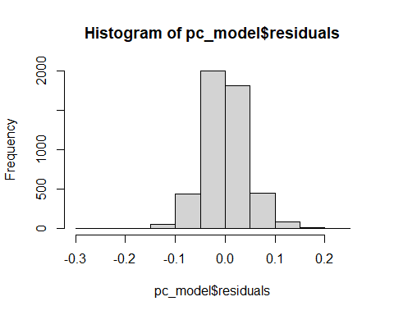
# Standardize helper
z <- function(x) (x - mean(x, na.rm = TRUE)) / sd(x, na.rm = TRUE)
# 1. Contact Skill (PC1-like)
mlb_swings$ContactSkill <- (
z(mlb_swings$iz_contact_percent) +
z(mlb_swings$oz_contact_percent) -
z(mlb_swings$whiff_percent) -
z(mlb_swings$z_swing_miss_percent) -
z(mlb_swings$oz_swing_miss_percent)
) / 5
# 2. Discipline Index (PC2-like)
mlb_swings$DisciplineIndex <- (
-z(mlb_swings$oz_swing_percent) -
-z(mlb_swings$z_swing_percent) -
z(mlb_swings$out_zone_percent) +
z(mlb_swings$walk_percent)
) / 4
# 3. Elevation / Batted-Ball Shape (PC3-like)
mlb_swings$ElevationIndex <- (
z(mlb_swings$popups_percent) +
z(mlb_swings$walk_percent) -
z(mlb_swings$pull_percent)
) / 3
# 4. Zone Coverage (PC4-like)
mlb_swings$ZoneCoverage <- (
z(mlb_swings$in_zone_percent) +
z(mlb_swings$out_zone_percent) -
z(mlb_swings$meatball_percent)
) / 3
# 5. Spray Power (PC5-like)
mlb_swings$SprayPower <- (
z(mlb_swings$opposite_percent) -
z(mlb_swings$pull_percent) +
z(mlb_swings$on_base_plus_slg)
) / 3
retrain <- mlb_swings[train_idx, ]
retest <- mlb_swings[-train_idx, ]
# further sub-dataset with engineered features and response, more features could be added
sw_feats <- c(3, 27, 28, 29, 30, 31)
sw_dat <- mlb_swings[, sw_feats]
# with a small set of features for modeling, Linear Regression in forward stepwise fashion will be performed manually
trainEng <- sw_dat[train_idx, ]
testEng <- sw_dat[-train_idx, ]
contact_mod <- lm(wRAA~ContactSkill, data = trainEng)
discip_mod <- lm(wRAA~DisciplineIndex, data = trainEng)
elev_mod <- lm(wRAA~ElevationIndex, data = trainEng)
zone_mod <- lm(wRAA~ZoneCoverage, data = trainEng)
spray_mod <- lm(wRAA~SprayPower, data = trainEng)
summary(contact_mod)
##
## Call:
## lm(formula = wRAA ~ ContactSkill, data = trainEng)
##
## Residuals:
## Min 1Q Median 3Q Max
## -33.311 -8.285 -2.723 5.383 93.041
##
## Coefficients:
## Estimate Std. Error t value Pr(>|t|)
## (Intercept) 1.7380 0.2100 8.274 < 2e-16 ***
## ContactSkill 0.6139 0.2249 2.729 0.00637 **
## ---
## Signif. codes: 0 '***' 0.001 '**' 0.01 '*' 0.05 '.' 0.1 ' ' 1
##
## Residual standard error: 13.06 on 3866 degrees of freedom
## Multiple R-squared: 0.001923, Adjusted R-squared: 0.001665
## F-statistic: 7.45 on 1 and 3866 DF, p-value: 0.006373
summary(discip_mod)
##
## Call:
## lm(formula = wRAA ~ DisciplineIndex, data = trainEng)
##
## Residuals:
## Min 1Q Median 3Q Max
## -33.867 -8.412 -2.478 5.477 86.952
##
## Coefficients:
## Estimate Std. Error t value Pr(>|t|)
## (Intercept) 1.7378 0.2072 8.386 <2e-16 ***
## DisciplineIndex 4.7321 0.4448 10.639 <2e-16 ***
## ---
## Signif. codes: 0 '***' 0.001 '**' 0.01 '*' 0.05 '.' 0.1 ' ' 1
##
## Residual standard error: 12.89 on 3866 degrees of freedom
## Multiple R-squared: 0.02845, Adjusted R-squared: 0.0282
## F-statistic: 113.2 on 1 and 3866 DF, p-value: < 2.2e-16
summary(elev_mod)
##
## Call:
## lm(formula = wRAA ~ ElevationIndex, data = trainEng)
##
## Residuals:
## Min 1Q Median 3Q Max
## -33.100 -8.192 -2.452 5.781 89.532
##
## Coefficients:
## Estimate Std. Error t value Pr(>|t|)
## (Intercept) 1.7300 0.2081 8.314 <2e-16 ***
## ElevationIndex 4.1903 0.4645 9.022 <2e-16 ***
## ---
## Signif. codes: 0 '***' 0.001 '**' 0.01 '*' 0.05 '.' 0.1 ' ' 1
##
## Residual standard error: 12.94 on 3866 degrees of freedom
## Multiple R-squared: 0.02062, Adjusted R-squared: 0.02037
## F-statistic: 81.4 on 1 and 3866 DF, p-value: < 2.2e-16
summary(zone_mod)
##
## Call:
## lm(formula = wRAA ~ ZoneCoverage, data = trainEng)
##
## Residuals:
## Min 1Q Median 3Q Max
## -34.757 -8.214 -2.371 5.533 91.457
##
## Coefficients:
## Estimate Std. Error t value Pr(>|t|)
## (Intercept) 1.7355 0.2069 8.389 <2e-16 ***
## ZoneCoverage 7.0325 0.6232 11.285 <2e-16 ***
## ---
## Signif. codes: 0 '***' 0.001 '**' 0.01 '*' 0.05 '.' 0.1 ' ' 1
##
## Residual standard error: 12.87 on 3866 degrees of freedom
## Multiple R-squared: 0.03189, Adjusted R-squared: 0.03164
## F-statistic: 127.3 on 1 and 3866 DF, p-value: < 2.2e-16
summary(spray_mod)
##
## Call:
## lm(formula = wRAA ~ SprayPower, data = trainEng)
##
## Residuals:
## Min 1Q Median 3Q Max
## -34.086 -7.767 -1.946 5.349 84.065
##
## Coefficients:
## Estimate Std. Error t value Pr(>|t|)
## (Intercept) 1.7398 0.1976 8.806 <2e-16 ***
## SprayPower 6.6749 0.2950 22.629 <2e-16 ***
## ---
## Signif. codes: 0 '***' 0.001 '**' 0.01 '*' 0.05 '.' 0.1 ' ' 1
##
## Residual standard error: 12.29 on 3866 degrees of freedom
## Multiple R-squared: 0.117, Adjusted R-squared: 0.1167
## F-statistic: 512.1 on 1 and 3866 DF, p-value: < 2.2e-16
spray_mod1 <- lm(wRAA~SprayPower+ContactSkill, data = trainEng)
spray_mod2 <- lm(wRAA~SprayPower+DisciplineIndex, data = trainEng)
spray_mod3 <- lm(wRAA~SprayPower+ElevationIndex, data = trainEng)
spray_mod4 <- lm(wRAA~SprayPower+ZoneCoverage, data = trainEng)
summary(spray_mod1)
##
## Call:
## lm(formula = wRAA ~ SprayPower + ContactSkill, data = trainEng)
##
## Residuals:
## Min 1Q Median 3Q Max
## -33.284 -7.741 -1.899 5.305 83.039
##
## Coefficients:
## Estimate Std. Error t value Pr(>|t|)
## (Intercept) 1.7381 0.1974 8.807 < 2e-16 ***
## SprayPower 6.9104 0.3049 22.666 < 2e-16 ***
## ContactSkill -0.6583 0.2187 -3.010 0.00263 **
## ---
## Signif. codes: 0 '***' 0.001 '**' 0.01 '*' 0.05 '.' 0.1 ' ' 1
##
## Residual standard error: 12.27 on 3865 degrees of freedom
## Multiple R-squared: 0.119, Adjusted R-squared: 0.1186
## F-statistic: 261.1 on 2 and 3865 DF, p-value: < 2.2e-16
summary(spray_mod2)
##
## Call:
## lm(formula = wRAA ~ SprayPower + DisciplineIndex, data = trainEng)
##
## Residuals:
## Min 1Q Median 3Q Max
## -36.542 -7.601 -1.809 5.345 78.802
##
## Coefficients:
## Estimate Std. Error t value Pr(>|t|)
## (Intercept) 1.7412 0.1945 8.952 <2e-16 ***
## SprayPower 6.6441 0.2904 22.878 <2e-16 ***
## DisciplineIndex 4.6410 0.4175 11.117 <2e-16 ***
## ---
## Signif. codes: 0 '***' 0.001 '**' 0.01 '*' 0.05 '.' 0.1 ' ' 1
##
## Residual standard error: 12.1 on 3865 degrees of freedom
## Multiple R-squared: 0.1443, Adjusted R-squared: 0.1439
## F-statistic: 325.9 on 2 and 3865 DF, p-value: < 2.2e-16
summary(spray_mod3)
##
## Call:
## lm(formula = wRAA ~ SprayPower + ElevationIndex, data = trainEng)
##
## Residuals:
## Min 1Q Median 3Q Max
## -34.259 -7.800 -1.874 5.329 83.708
##
## Coefficients:
## Estimate Std. Error t value Pr(>|t|)
## (Intercept) 1.7383 0.1975 8.801 <2e-16 ***
## SprayPower 6.4685 0.3135 20.636 <2e-16 ***
## ElevationIndex 0.9092 0.4687 1.940 0.0525 .
## ---
## Signif. codes: 0 '***' 0.001 '**' 0.01 '*' 0.05 '.' 0.1 ' ' 1
##
## Residual standard error: 12.28 on 3865 degrees of freedom
## Multiple R-squared: 0.1178, Adjusted R-squared: 0.1174
## F-statistic: 258.1 on 2 and 3865 DF, p-value: < 2.2e-16
summary(spray_mod4)
##
## Call:
## lm(formula = wRAA ~ SprayPower + ZoneCoverage, data = trainEng)
##
## Residuals:
## Min 1Q Median 3Q Max
## -31.437 -7.801 -1.520 5.377 83.273
##
## Coefficients:
## Estimate Std. Error t value Pr(>|t|)
## (Intercept) 1.7389 0.1942 8.952 <2e-16 ***
## SprayPower 6.6130 0.2901 22.799 <2e-16 ***
## ZoneCoverage 6.7872 0.5853 11.597 <2e-16 ***
## ---
## Signif. codes: 0 '***' 0.001 '**' 0.01 '*' 0.05 '.' 0.1 ' ' 1
##
## Residual standard error: 12.08 on 3865 degrees of freedom
## Multiple R-squared: 0.1467, Adjusted R-squared: 0.1462
## F-statistic: 332.1 on 2 and 3865 DF, p-value: < 2.2e-16
sprayZone_mod1 <- lm(wRAA~SprayPower+ZoneCoverage+ContactSkill, data = trainEng)
sprayZone_mod2 <- lm(wRAA~SprayPower+ZoneCoverage+DisciplineIndex, data = trainEng)
sprayZone_mod3 <- lm(wRAA~SprayPower+ZoneCoverage+ElevationIndex, data = trainEng)
summary(sprayZone_mod1)
##
## Call:
## lm(formula = wRAA ~ SprayPower + ZoneCoverage + ContactSkill,
## data = trainEng)
##
## Residuals:
## Min 1Q Median 3Q Max
## -31.935 -7.790 -1.504 5.409 82.564
##
## Coefficients:
## Estimate Std. Error t value Pr(>|t|)
## (Intercept) 1.7377 0.1942 8.950 <2e-16 ***
## SprayPower 6.7793 0.3001 22.587 <2e-16 ***
## ZoneCoverage 6.6870 0.5869 11.395 <2e-16 ***
## ContactSkill -0.4621 0.2158 -2.142 0.0323 *
## ---
## Signif. codes: 0 '***' 0.001 '**' 0.01 '*' 0.05 '.' 0.1 ' ' 1
##
## Residual standard error: 12.08 on 3864 degrees of freedom
## Multiple R-squared: 0.1477, Adjusted R-squared: 0.147
## F-statistic: 223.1 on 3 and 3864 DF, p-value: < 2.2e-16
summary(sprayZone_mod2)
##
## Call:
## lm(formula = wRAA ~ SprayPower + ZoneCoverage + DisciplineIndex,
## data = trainEng)
##
## Residuals:
## Min 1Q Median 3Q Max
## -31.643 -7.667 -1.434 5.582 75.507
##
## Coefficients:
## Estimate Std. Error t value Pr(>|t|)
## (Intercept) 1.7406 0.1884 9.237 <2e-16 ***
## SprayPower 6.5452 0.2814 23.257 <2e-16 ***
## ZoneCoverage 9.4417 0.5928 15.926 <2e-16 ***
## DisciplineIndex 6.5752 0.4223 15.570 <2e-16 ***
## ---
## Signif. codes: 0 '***' 0.001 '**' 0.01 '*' 0.05 '.' 0.1 ' ' 1
##
## Residual standard error: 11.72 on 3864 degrees of freedom
## Multiple R-squared: 0.197, Adjusted R-squared: 0.1964
## F-statistic: 316 on 3 and 3864 DF, p-value: < 2.2e-16
summary(sprayZone_mod3)
##
## Call:
## lm(formula = wRAA ~ SprayPower + ZoneCoverage + ElevationIndex,
## data = trainEng)
##
## Residuals:
## Min 1Q Median 3Q Max
## -31.334 -7.832 -1.551 5.480 82.954
##
## Coefficients:
## Estimate Std. Error t value Pr(>|t|)
## (Intercept) 1.7376 0.1942 8.948 <2e-16 ***
## SprayPower 6.4279 0.3082 20.855 <2e-16 ***
## ZoneCoverage 6.7692 0.5852 11.568 <2e-16 ***
## ElevationIndex 0.8163 0.4609 1.771 0.0766 .
## ---
## Signif. codes: 0 '***' 0.001 '**' 0.01 '*' 0.05 '.' 0.1 ' ' 1
##
## Residual standard error: 12.08 on 3864 degrees of freedom
## Multiple R-squared: 0.1473, Adjusted R-squared: 0.1467
## F-statistic: 222.6 on 3 and 3864 DF, p-value: < 2.2e-16
sprayZoneDisc_mod1 <- lm(wRAA~SprayPower+ZoneCoverage+DisciplineIndex+ContactSkill, data = trainEng)
sprayZoneDisc_mod2 <- lm(wRAA~SprayPower+ZoneCoverage+DisciplineIndex+ElevationIndex, data = trainEng)
summary(sprayZoneDisc_mod1)
##
## Call:
## lm(formula = wRAA ~ SprayPower + ZoneCoverage + DisciplineIndex +
## ContactSkill, data = trainEng)
##
## Residuals:
## Min 1Q Median 3Q Max
## -31.937 -7.638 -1.426 5.496 75.757
##
## Coefficients:
## Estimate Std. Error t value Pr(>|t|)
## (Intercept) 1.7412 0.1884 9.240 <2e-16 ***
## SprayPower 6.4561 0.2921 22.105 <2e-16 ***
## ZoneCoverage 9.5372 0.5987 15.930 <2e-16 ***
## DisciplineIndex 6.6804 0.4322 15.455 <2e-16 ***
## ContactSkill 0.2446 0.2144 1.141 0.254
## ---
## Signif. codes: 0 '***' 0.001 '**' 0.01 '*' 0.05 '.' 0.1 ' ' 1
##
## Residual standard error: 11.72 on 3863 degrees of freedom
## Multiple R-squared: 0.1973, Adjusted R-squared: 0.1965
## F-statistic: 237.4 on 4 and 3863 DF, p-value: < 2.2e-16
summary(sprayZoneDisc_mod2)
##
## Call:
## lm(formula = wRAA ~ SprayPower + ZoneCoverage + DisciplineIndex +
## ElevationIndex, data = trainEng)
##
## Residuals:
## Min 1Q Median 3Q Max
## -31.394 -7.542 -1.361 5.415 75.215
##
## Coefficients:
## Estimate Std. Error t value Pr(>|t|)
## (Intercept) 1.7455 0.1877 9.300 < 2e-16 ***
## SprayPower 7.1714 0.3013 23.802 < 2e-16 ***
## ZoneCoverage 9.9787 0.5980 16.686 < 2e-16 ***
## DisciplineIndex 7.7513 0.4690 16.527 < 2e-16 ***
## ElevationIndex -2.8155 0.4967 -5.668 1.55e-08 ***
## ---
## Signif. codes: 0 '***' 0.001 '**' 0.01 '*' 0.05 '.' 0.1 ' ' 1
##
## Residual standard error: 11.67 on 3863 degrees of freedom
## Multiple R-squared: 0.2037, Adjusted R-squared: 0.2028
## F-statistic: 247 on 4 and 3863 DF, p-value: < 2.2e-16
engSwing_mod <- lm(wRAA~SprayPower+ZoneCoverage+DisciplineIndex+ElevationIndex+ContactSkill, data = trainEng)
summary(engSwing_mod)
##
## Call:
## lm(formula = wRAA ~ SprayPower + ZoneCoverage + DisciplineIndex +
## ElevationIndex + ContactSkill, data = trainEng)
##
## Residuals:
## Min 1Q Median 3Q Max
## -31.810 -7.547 -1.374 5.411 75.569
##
## Coefficients:
## Estimate Std. Error t value Pr(>|t|)
## (Intercept) 1.7465 0.1877 9.307 < 2e-16 ***
## SprayPower 7.0589 0.3089 22.851 < 2e-16 ***
## ZoneCoverage 10.1298 0.6049 16.746 < 2e-16 ***
## DisciplineIndex 7.9325 0.4817 16.468 < 2e-16 ***
## ElevationIndex -2.8865 0.4985 -5.791 7.57e-09 ***
## ContactSkill 0.3522 0.2143 1.644 0.1
## ---
## Signif. codes: 0 '***' 0.001 '**' 0.01 '*' 0.05 '.' 0.1 ' ' 1
##
## Residual standard error: 11.67 on 3862 degrees of freedom
## Multiple R-squared: 0.2042, Adjusted R-squared: 0.2032
## F-statistic: 198.2 on 5 and 3862 DF, p-value: < 2.2e-16
The linear regression models with the engineered features perform well predictively, but do not explain more than 20% of the variability in the data meaning that they don’t display much significance outside the training set of data, and there is too much outside noise in the overall dataset to leave predicting up to just these features.
#Random Forests
library(tree)
## Warning: package 'tree' was built under R version 4.4.3
set.seed(1)
# 1 singular decision tree with the engineered features
engSwng_tree <- tree(wRAA~., data = trainEng)
plot(engSwng_tree)
text(engSwng_tree, pretty = 10)
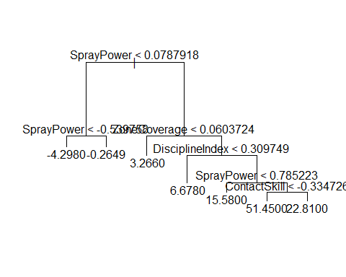
cv_overgrown <- cv.tree(engSwng_tree, FUN = prune.tree)
plot(cv_overgrown$size, cv_overgrown$dev, type = 'b')
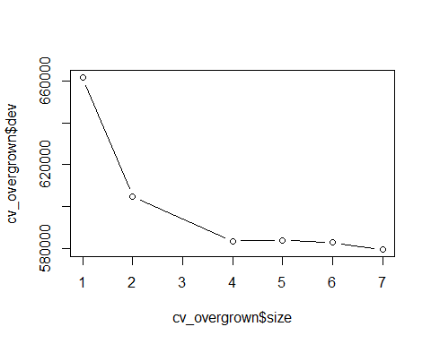
pruned_Swng <- prune.tree(engSwng_tree, best = 4)
plot(pruned_Swng)
text(pruned_Swng, pretty = 10)
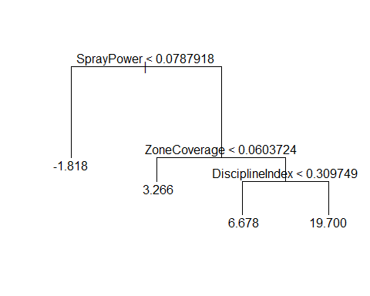
library(randomForest)
## Warning: package 'randomForest' was built under R version 4.4.3
## randomForest 4.7-1.2
## Type rfNews() to see new features/changes/bug fixes.
#Will grow two random forests - one with all of the swing decision metrics as predictors, and one with just the engineered features. Potentially a third with a combination of both depending on how the first two perform.
# forest with only swing metrics
rf_allSwng <- randomForest(wRAA~.-on_base_plus_slg-b_lob-walk_percent-run_percent, data = train, mtry = 7, importance = TRUE)
#forest with only engineered features
rf_engSwng <- randomForest(wRAA~., data = trainEng, mtry = 3, importance = TRUE)
# forest with swing metrics and engineered features
rf_all <- randomForest(wRAA~.-on_base_plus_slg-b_lob-walk_percent-run_percent, data = retrain, mtry = 8, importance = TRUE)
#Cross Validation Testing
kfold_cv <- function(formula, data, k = 5) {
n <- nrow(data)
folds <- sample(rep(1:k, length.out = n))
mse_values <- numeric(k)
for (i in 1:k) {
train_data <- data[folds != i, ]
test_data <- data[folds == i, ]
fit <- lm(formula, data = train_data)
preds <- predict(fit, newdata = test_data)
mse_values[i] <- mean((test_data$wRAA - preds)^2)
}
mean(mse_values)
}
models <- list()
cv_results <- sapply(models, kfold_cv, data = mlb_swings, k = 5)
cv_results
## list()

