Senior Project V3
Devon Lapierre
2026-07-06
#Loading Dataset
setwd("C:/Users/devon/OneDrive/Senior Project")
mlb <- read.csv("stats.csv", header = TRUE, sep = ",")
#Basic Cleaning
mlb <- na.omit(mlb)
mlb <- mlb[!duplicated(mlb), ]
# Creating formula for wRAA to measure player performance
# scale vector (first index 2015, last index 2025) from FanGraphs: https://www.fangraphs.com/tools/guts?type=cn
wOBA_scale <- c(1.251, 1.212, 1.185, 1.226, 1.157, 1.185, 1.209, 1.259, 1.204, 1.242, 1.232)
# league average wOBA by season (first index 2015, last index 2025) from FanGraphs: https://www.fangraphs.com/leaders/major-league?pos=all&stats=bat&lg=all&qual=0&type=8&month=0&ind=0&team=0%2Css&rost=0&players=0&sort=0%2Cd&startdate=&enddate=&season1=2015&season=2025
lgwOBA <- c(.313, .318, .321, .315, .320, .320, .314, .310, .318, .310, .313)
# Using the FanGraphs formula Weighted Runs Above Average (wRAA) = ((wOBA - lgwOBA) / wOBA_scale) * PA to have a metric strictly for offensive performance
mlb$wRAA <- 0
#apply formula to all observations
for (i in 1:nrow(mlb)){
mlb$wRAA[i]<- ((mlb$woba[i] - lgwOBA[mlb$year[i] - 2014]) / wOBA_scale[mlb$year[i] - 2014]) * mlb$pa[i]
}
#Subset Selection
swing_cols <- c(49, 50, 51, 52, 53, 56, 58, 59, 64, 67, 69, 71, 72, 73, 74, 75, 77, 78, 80, 82, 84)
for (i in swing_cols){
mlb[ , i] <- mlb[ , i] / 100
}
swing_cols <- c(13, 17, 20, 28, 86, 49, 50, 51, 52, 53, 56, 58, 59, 64, 67, 69, 71, 72, 73, 74, 75, 77, 78, 80, 82, 84)
#subset of features only including swing decision features and potential response variables
mlb_swings <- mlb[, swing_cols]
mlb_swings$walk_percent <- mlb$walk / mlb$pa
mlb_swings$run_percent <- mlb$r_run / mlb$pa
mlb_swings <- mlb_swings[ , c(-1, -4)]
# Principal Component Analysis
swings_scaled <- scale(mlb_swings)
pca <- prcomp(swings_scaled)
summary(pca)
## Importance of components:
## PC1 PC2 PC3 PC4 PC5 PC6 PC7
## Standard deviation 2.3340 2.0487 1.8479 1.54651 1.34485 1.08293 1.02822
## Proportion of Variance 0.2095 0.1614 0.1313 0.09199 0.06956 0.04511 0.04066
## Cumulative Proportion 0.2095 0.3710 0.5023 0.59428 0.66384 0.70895 0.74961
## PC8 PC9 PC10 PC11 PC12 PC13 PC14
## Standard deviation 0.98887 0.95204 0.93965 0.8623 0.81014 0.75046 0.71127
## Proportion of Variance 0.03761 0.03486 0.03396 0.0286 0.02524 0.02166 0.01946
## Cumulative Proportion 0.78722 0.82208 0.85604 0.8846 0.90988 0.93155 0.95100
## PC15 PC16 PC17 PC18 PC19 PC20 PC21
## Standard deviation 0.6511 0.61150 0.45538 0.38200 0.3422 0.05824 0.03935
## Proportion of Variance 0.0163 0.01438 0.00798 0.00561 0.0045 0.00013 0.00006
## Cumulative Proportion 0.9673 0.98169 0.98967 0.99528 0.9998 0.99991 0.99997
## PC22 PC23 PC24 PC25 PC26
## Standard deviation 0.02621 0.006569 0.004604 0.003951 0.0003857
## Proportion of Variance 0.00003 0.000000 0.000000 0.000000 0.0000000
## Cumulative Proportion 1.00000 1.000000 1.000000 1.000000 1.0000000
plot(pca)
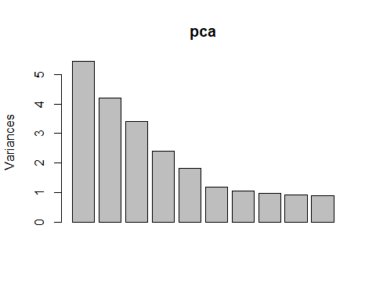
# Standardize helper
z <- function(x) (x - mean(x, na.rm = TRUE)) / sd(x, na.rm = TRUE)
# 1. Contact Skill (PC1-like)
mlb_swings$ContactSkill <- (
z(mlb_swings$iz_contact_percent) +
z(mlb_swings$oz_contact_percent) -
z(mlb_swings$whiff_percent) -
z(mlb_swings$z_swing_miss_percent) -
z(mlb_swings$oz_swing_miss_percent)
) / 5
# 2. Discipline Index (PC2-like)
mlb_swings$DisciplineIndex <- (
-z(mlb_swings$oz_swing_percent) -
-z(mlb_swings$z_swing_percent) -
z(mlb_swings$out_zone_percent) +
z(mlb_swings$walk_percent)
) / 4
# 3. Elevation / Batted-Ball Shape (PC3-like)
mlb_swings$ElevationIndex <- (
z(mlb_swings$popups_percent) +
z(mlb_swings$walk_percent) -
z(mlb_swings$pull_percent)
) / 3
# 4. Zone Coverage (PC4-like)
mlb_swings$ZoneCoverage <- (
z(mlb_swings$in_zone_percent) +
z(mlb_swings$out_zone_percent) -
z(mlb_swings$meatball_percent)
) / 3
# 5. Spray Power (PC5-like)
mlb_swings$SprayPower <- (
z(mlb_swings$opposite_percent) -
z(mlb_swings$pull_percent) +
z(mlb_swings$on_base_plus_slg)
) / 3
#Creating the 80/20 train/test split
set.seed(1)
n <- nrow(mlb_swings)
train_idx <- sample(seq_len(n), size = 0.8 * n)
train <- mlb_swings[train_idx, ]
test <- mlb_swings[-train_idx, ]
# further sub-dataset with engineered features and response, more features could be added
sw_feats <- c(3, 27, 28, 29, 30, 31)
sw_dat <- mlb_swings[, sw_feats]
trainEng <- sw_dat[train_idx, ]
testEng <- sw_dat[-train_idx, ]
#Regression models
spray_mod <- wRAA~SprayPower
sprayZone_mod <- wRAA~SprayPower+ZoneCoverage
sprayZoneDisc_mod <- wRAA~SprayPower+ZoneCoverage+DisciplineIndex
sprayZoneDiscElev_mod <- wRAA~SprayPower+ZoneCoverage+DisciplineIndex+ElevationIndex
engSwing_mod <- wRAA~SprayPower+ZoneCoverage+DisciplineIndex+ElevationIndex+ContactSkill
#Random Forests
library(tree)
## Warning: package 'tree' was built under R version 4.4.3
set.seed(1)
# 1 singular decision tree with the engineered features
engSwng_tree <- tree(wRAA~., data = trainEng)
cv_overgrown <- cv.tree(engSwng_tree, FUN = prune.tree)
pruned_Swng <- prune.tree(engSwng_tree, best = 4)
library(randomForest)
## Warning: package 'randomForest' was built under R version 4.4.3
## randomForest 4.7-1.2
## Type rfNews() to see new features/changes/bug fixes.
#Will grow two random forests - one with all of the swing decision metrics as predictors, and one with just the engineered features. Potentially a third with a combination of both depending on how the first two perform.
# forest with only swing metrics
rf_allSwng <- randomForest(wRAA~.-on_base_plus_slg-b_lob-walk_percent-run_percent-SprayPower-ZoneCoverage-DisciplineIndex-ElevationIndex-
ContactSkill, data = train, mtry = 7, importance = TRUE)
#forest with only engineered features
rf_engSwng <- randomForest(wRAA~., data = trainEng, mtry = 3, importance = TRUE)
# forest with swing metrics and engineered features
rf_all <- randomForest(wRAA~.-on_base_plus_slg-b_lob-walk_percent-run_percent, data = train, mtry = 8, importance = TRUE)
#CV Function
kfold_cv <- function(formula, data, k = 5) {
n <- nrow(data)
folds <- sample(rep(1:k, length.out = n))
mse_values <- numeric(k)
for (i in 1:k) {
train_data <- data[folds != i, ]
test_data <- data[folds == i, ]
fit <- lm(formula, data = train_data)
preds <- predict(fit, newdata = test_data)
mse_values[i] <- mean((test_data$wRAA - preds)^2)
}
mean(mse_values)
}
library(Metrics)
## Warning: package 'Metrics' was built under R version 4.4.3
evaluate_model <- function(model, train, test, response = "wRAA") {
# predictions
train_pred <- predict(model, newdata = train)
test_pred <- predict(model, newdata = test)
# actuals
y_train <- train[[response]]
y_test <- test[[response]]
# metrics
out <- data.frame(
RMSE_train = rmse(y_train, train_pred),
RMSE_test = rmse(y_test, test_pred),
MAE_train = mae(y_train, train_pred),
MAE_test = mae(y_test, test_pred),
R2_train = 1 - sum((y_train - train_pred)^2) / sum((y_train - mean(y_train))^2),
R2_test = 1 - sum((y_test - test_pred)^2) / sum((y_test - mean(y_test))^2)
)
return(out)
}
eval_spray <- evaluate_model(lm(spray_mod, trainEng), trainEng, testEng)
eval_sprayZone <- evaluate_model(lm(sprayZone_mod, trainEng), trainEng, testEng)
eval_sprayDisc <- evaluate_model(lm(sprayZoneDisc_mod, trainEng), trainEng, testEng)
eval_sprayAll <- evaluate_model(lm(engSwing_mod, trainEng), trainEng, testEng)
eval_tree <- evaluate_model(pruned_Swng, trainEng, testEng)
eval_rf_allSwng <- evaluate_model(rf_allSwng, train, test)
eval_rf_engSwng <- evaluate_model(rf_engSwng, trainEng, testEng)
eval_rf_all <- evaluate_model(rf_all, train, test)
# Neural Network
library(RSNNS)
## Warning: package 'RSNNS' was built under R version 4.4.3
## Loading required package: Rcpp
## Warning: package 'Rcpp' was built under R version 4.4.3
library(Metrics)
responses <- c(-1, -2, -3, -25, -26)
# Preprocess manually
train_x <- scale(train[, responses])
test_x <- scale(
test[, responses],
center = attr(train_x, "scaled:center"),
scale = attr(train_x, "scaled:scale")
)
train_y <- train$wRAA
test_y <- test$wRAA
# Train MLP
nn <- mlp(
x = as.matrix(train_x),
y = train_y,
size = c(64, 32, 16), # deeper network
learnFunc = "Std_Backpropagation",
learnFuncParams = c(0.01, 0.9), # learning rate = 0.01, momentum = 0.9
updateFunc = "Topological_Order",
maxit = 500, # more epochs
linOut = TRUE
)
# Predict
nn_pred <- predict(nn, as.matrix(test_x))
# Metrics
nn_rmse <- rmse(test_y, nn_pred)
nn_mae <- mae(test_y, nn_pred)
nn_rmse
## [1] 13.33103
nn_mae
## [1] 9.80334
results <- rbind(
Spray = eval_spray,
SprayZone = eval_sprayZone,
SprayDisc = eval_sprayDisc,
EngSwing = eval_sprayAll,
Tree = eval_tree,
RF_AllSwng = eval_rf_allSwng,
RF_EngSwng = eval_rf_engSwng,
RF_All = eval_rf_all,
NN = data.frame(
RMSE_train = NA,
RMSE_test = nn_rmse,
MAE_train = NA,
MAE_test = nn_mae,
R2_train = NA,
R2_test = NA
),
.id = "Model"
)
print(results)
## RMSE_train RMSE_test MAE_train MAE_test
## Spray 12.2842229974108 12.4680354862968 8.94488545260954 9.18097701848084
## SprayZone 12.0759168966226 12.3490924915819 8.83680299540649 9.2334775687039
## SprayDisc 11.7140582977302 11.9104889667794 8.66276961547102 9.01199874495814
## EngSwing 11.6615687501321 11.8719657185841 8.60078021996019 8.9442226139798
## Tree 12.0916774594772 12.4428277320923 8.88690338665196 9.16025288331668
## RF_AllSwng 4.70070765988224 11.4417207910172 3.38795437052018 8.52526723678748
## RF_EngSwng 5.15549439110185 11.9128068455338 3.7177037237273 8.86829448079012
## RF_All 3.17527546350582 7.67236435128864 2.17556844322371 5.45487706445399
## NN <NA> 13.3310341834301 <NA> 9.80334034618926
## .id Model Model Model Model
## R2_train R2_test
## Spray 0.11695986372854 0.124529829869697
## SprayZone 0.146653735449067 0.141153835708012
## SprayDisc 0.197029070409193 0.20107782462119
## EngSwing 0.204209016106846 0.206237529599787
## Tree 0.144424837387041 0.128066285602015
## RF_AllSwng 0.870696123131525 0.262727585542864
## RF_EngSwng 0.844465872300469 0.200766840759808
## RF_All 0.941000561925741 0.668484582066386
## NN <NA> <NA>
## .id Model Model
# Variable Importance
#Regression is self explanatory as forward stepwise was used
#Decision tree is self explanatory as we can visualize the tree
#Random Forests
importance(rf_allSwng)
## %IncMSE IncNodePurity
## z_swing_percent 15.652781 24918.42
## z_swing_miss_percent 15.120793 17484.55
## oz_swing_percent 29.708688 45569.89
## oz_swing_miss_percent 13.761219 21941.85
## oz_contact_percent 16.102861 22436.37
## out_zone_percent 24.589061 41849.12
## meatball_swing_percent 9.633124 25275.24
## meatball_percent 3.896041 20716.11
## iz_contact_percent 13.584405 17846.97
## in_zone_percent 24.852696 46307.00
## edge_percent 4.182765 25649.90
## whiff_percent 18.268013 20712.77
## swing_percent 19.291405 28170.49
## pull_percent 10.794976 22437.09
## straightaway_percent 3.992752 21511.44
## opposite_percent 9.320304 22656.33
## f_strike_percent 10.430309 43314.68
## groundballs_percent 21.853312 38629.29
## flyballs_percent 18.615772 41335.98
## linedrives_percent 20.646424 43679.66
## popups_percent 23.287603 39892.48
importance(rf_engSwng)
## %IncMSE IncNodePurity
## ContactSkill 13.94133 97291.80
## DisciplineIndex 48.75075 125764.38
## ElevationIndex 10.59001 89993.67
## ZoneCoverage 47.55720 128161.19
## SprayPower 69.95579 177394.10
importance(rf_all)
## %IncMSE IncNodePurity
## z_swing_percent 5.792100 10049.592
## z_swing_miss_percent 9.070798 7724.281
## oz_swing_percent 16.379726 17627.779
## oz_swing_miss_percent 11.135161 9467.586
## oz_contact_percent 12.119658 10021.441
## out_zone_percent 19.152378 27789.815
## meatball_swing_percent 6.431481 10680.185
## meatball_percent 6.614453 8268.870
## iz_contact_percent 7.211681 7713.188
## in_zone_percent 19.101489 29287.085
## edge_percent 1.530784 10338.194
## whiff_percent 12.841680 9086.429
## swing_percent 9.957757 11932.716
## pull_percent 27.656676 70862.063
## straightaway_percent 22.363504 17491.311
## opposite_percent 35.433006 72804.585
## f_strike_percent 10.842346 25331.862
## groundballs_percent 17.865281 23393.561
## flyballs_percent 17.195013 23707.478
## linedrives_percent 11.595442 19301.730
## popups_percent 13.931963 14525.213
## ContactSkill 12.356910 8622.404
## DisciplineIndex 21.137109 33254.935
## ElevationIndex 10.094875 13076.090
## ZoneCoverage 6.384183 11134.439
## SprayPower 49.545096 142033.522
# Neural Net
variable_importance_sensitivity <- function(model, X, delta = 1e-4) {
X <- as.matrix(X)
base_pred <- predict(model, X)
p <- ncol(X)
importance <- numeric(p)
for (j in 1:p) {
X_perturbed <- X
X_perturbed[, j] <- X_perturbed[, j] + delta
pred_perturbed <- predict(model, X_perturbed)
# Sensitivity = average absolute change in prediction
importance[j] <- mean(abs(pred_perturbed - base_pred))
}
importance <- importance / sum(importance)
data.frame(
Variable = colnames(X),
Importance = importance
)[order(importance, decreasing = TRUE), ]
}
variable_importance_sensitivity(nn, train[, responses])
## Variable Importance
## 14 pull_percent 0.06911197
## 16 opposite_percent 0.06563707
## 2 z_swing_miss_percent 0.06254826
## 9 iz_contact_percent 0.06254826
## 22 ContactSkill 0.05752896
## 12 whiff_percent 0.05714286
## 18 groundballs_percent 0.05173745
## 25 ZoneCoverage 0.04942085
## 8 meatball_percent 0.04671815
## 19 flyballs_percent 0.04555985
## 24 ElevationIndex 0.04440154
## 7 meatball_swing_percent 0.04362934
## 4 oz_swing_miss_percent 0.03976834
## 5 oz_contact_percent 0.03938224
## 15 straightaway_percent 0.03474903
## 17 f_strike_percent 0.03436293
## 1 z_swing_percent 0.02741313
## 20 linedrives_percent 0.02625483
## 26 SprayPower 0.02471042
## 11 edge_percent 0.02355212
## 21 popups_percent 0.01969112
## 13 swing_percent 0.01853282
## 6 out_zone_percent 0.01660232
## 10 in_zone_percent 0.01428571
## 3 oz_swing_percent 0.01235521
## 23 DisciplineIndex 0.01235521
#Predicted vs Actual Plots
plot_predicted_vs_actual <- function(pred, actual, model_name="Model") {
plot(actual, pred,
xlab = "Actual Values",
ylab = "Predicted Values",
main = "Actual vs Predicted",
pch = 19, col = "steelblue")
abline(0, 1, col = "red", lwd = 2) # perfect prediction line
}
#Residual Plots
plot_residuals <- function(pred, actual, model_name="Model") {
res <- actual - pred
par(mfrow=c(1,2))
plot(pred, res,
main=paste(model_name, "- Residuals vs Fitted"),
xlab="Fitted Values", ylab="Residuals")
abline(h=0, col="red")
qqnorm(res, main=paste(model_name, "- Residual Q-Q"))
qqline(res, col="red")
par(mfrow=c(1,1))
}
lm_preds <- predict.lm(lm(engSwing_mod, trainEng), newdata = testEng)
rf_allSwng_preds <- predict(rf_allSwng, newdata = test)
rf_engSwng_preds<- predict(rf_engSwng, newdata = testEng)
rf_all_preds <- predict(rf_all, newdata = test)
nn_preds <- predict(nn, newdata = test[, responses])
#Residuals
plot_residuals(nn_preds, test$wRAA, "Neural Network")
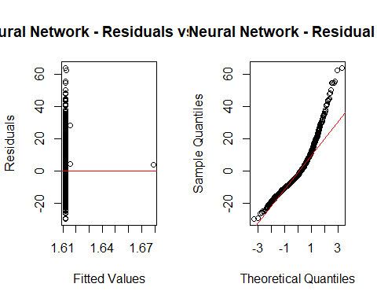
plot_residuals(rf_all_preds, test$wRAA, "Full RF")
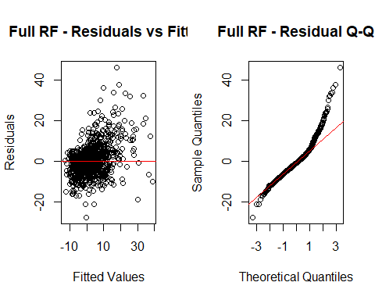
plot_residuals(rf_engSwng_preds, testEng$wRAA, "Eng RF")
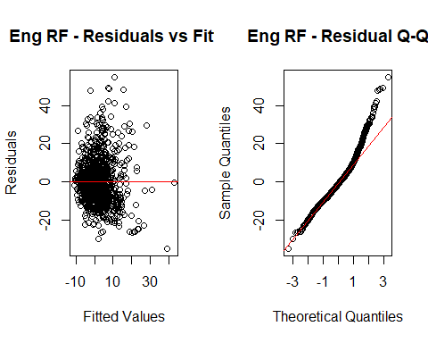
plot_residuals(rf_allSwng_preds, test$wRAA, "Swng RF")
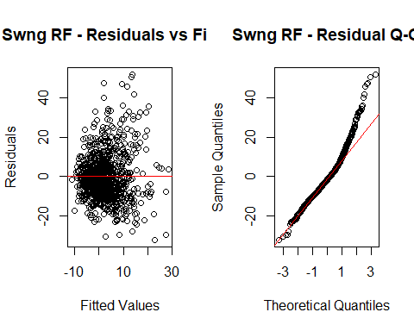
plot_residuals(lm_preds, testEng$wRAA, "Eng Regression")
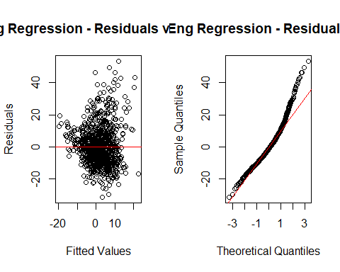
#Actual vs Predicted
plot_predicted_vs_actual(nn_preds, test$wRAA, "Neural Network")
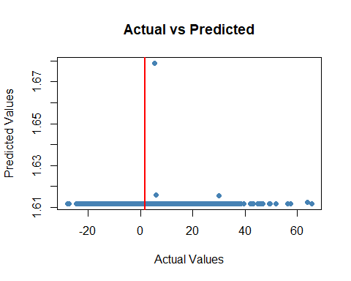
plot_predicted_vs_actual(rf_all_preds, test$wRAA, "Full RF")
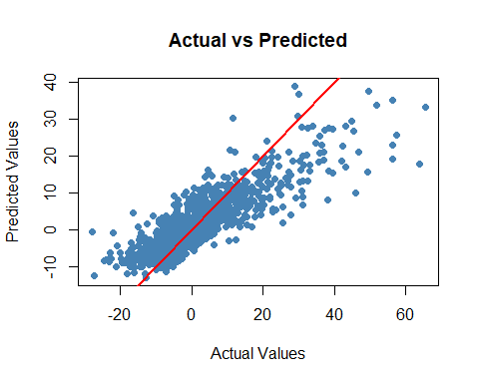
plot_predicted_vs_actual(rf_engSwng_preds, testEng$wRAA, "Eng RF")
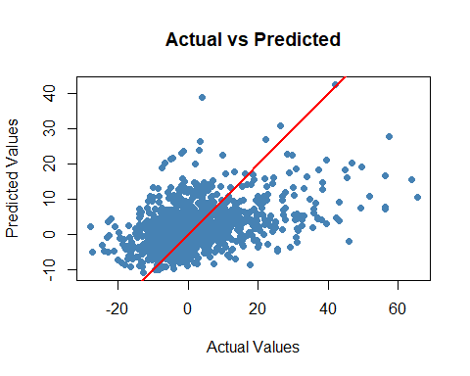
plot_predicted_vs_actual(rf_allSwng_preds, test$wRAA, "Swng RF")
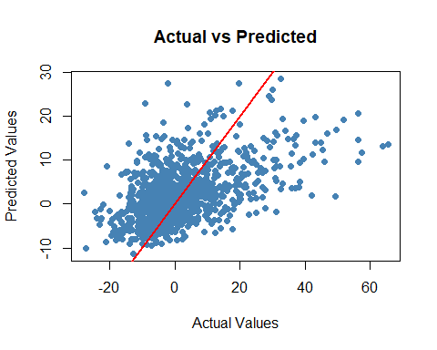
plot_predicted_vs_actual(lm_preds, testEng$wRAA, "Eng Regression")
