  - Decision-Making and Approach as an Offensive Performance Evaluator in Baseball

Devon Lapierre
School of Computing and Data Science
Wentworth Institute of Technology
Boston, MA
lapierred@wit.edu

ABSTRACT
Modern baseball analytics rely heavily on complex biomechanical and athletic-performance metrics, often favoring players with exceptional physical traits. This project investigates whether a simplified feature pool centered on plate discipline, swing decisions, and hitting approach—essentially “baseball IQ”—can meaningfully predict offensive output. Using Statcast data from 2015–2025, engineered features derived from PCA, and multiple machine learning models (linear regression, ridge regression, random forests, and a neural network), the project evaluates the predictive power of decision-making variables for estimating weighted runs above average (wRAA). Results show that hitting approach and batted-ball direction outperform swing decision metrics in predictive significance, suggesting that offensive evaluation may benefit from emphasizing approach-based features rather than plate discipline alone.
CCS CONCEPTS
• Machine learning → Supervised learning • Applied computing → Sports analytics • Information systems → Data mining
KEYWORDS
Baseball analytics, plate discipline, swing decisions, machine learning, Statcast, offensive performance modeling
1 Introduction
Major League Baseball has undergone a dramatic analytical transformation, with front offices increasingly relying on advanced metrics and deep learning models to guide roster decisions, player development, and in-game strategy. Yet many of these models depend on biomechanical or raw athletic metrics that are difficult to interpret and often favor “freak athletes.”
This project explores a simpler alternative: modeling offensive performance using variables that capture decision-making at the plate—swing choices, strike-zone judgment, and hitting approach. The goal is to determine whether these cognitively driven features can predict offensive output with meaningful accuracy and serve as a more interpretable evaluation tool for analysts, coaches, and players.
1.1 Research Questions and Contributions
Primary Research Question: Can swing decision metrics and hitting-approach variables predict offensive performance (wRAA) with competitive accuracy relative to more complex analytical models?
Supporting Questions:
- Which decision-making variables hold the strongest predictive significance?
- Do engineered features derived from PCA improve model stability and accuracy?
- How do models trained on historical data perform on live-season observations?
Contributions:
- A cleaned and engineered dataset of 4,836 MLB player seasons (2015–2025).
- Five PCA-derived engineered features capturing contact ability, discipline, elevation, zone coverage, and spray power.
- A comparative evaluation of regression, random forest, and neural network models.
- Empirical evidence that hitting approach/direction is more predictive than plate discipline.
- A reproducible R-based workflow for offensive performance modeling.
2 Related Work and Background
Modern analytics increasingly incorporate biomechanics, bat speed, and motion-capture data—metrics that are increasingly significant in their own right but difficult to interpret and reproduce for players of varying natural athletic abilities. This project differs by focusing exclusively on publicly available Statcast data and cognitively driven variables, aiming to create a more interpretable and accessible modeling framework.
3 Data and Preprocessing
3.1 Dataset Description and Data Source
The dataset was collected from baseballsavant.mlb.com, containing 4,836 player-season observations from 2015–2025, the full Statcast era [2]. Each observation includes:
- Basic offensive metrics (H, HR, RBI, AVG)
- Swing decision metrics (zone swing %, chase %, whiff %)
- Batted-ball direction and launch metrics
- Plate discipline variables
- Over 80 total features
Observations with fewer than 100 plate appearances were removed to ensure stability.
The response variable weighted runs above average (wRAA) was engineered using the FanGraphs formula [1]:
wRAA = $\frac{wOBA-lgwOBA}{wOBA scale}×PA$
where wOBA is weighted on-base average, lgwOBA is league average OBA, and PA is plate appearances.
3.2 Data Cleaning and Feature Engineering
Preprocessing steps included:
- Converting raw counts to percentages (e.g., BB → BB%) to eliminate skews.
- Removing incomplete observations.
- Normalizing variables where appropriate.
- Splitting data into an 80/20 train-test set.
Engineered Features (from PCA):
ContactSkill – rewards contact ability, penalizes swing-and-miss
DisciplineIndex – rewards swinging at strikes, penalizes chasing out of the strike zone
ElevationIndex – rewards balls in play in the air and walks
ZoneCoverage – combines pitches seen in zone and out of zone
SprayPower – rewards opposite-field and extra-base hits; penalizes pulling the ball
These features significantly improved model stability and reduced multicollinearity.
4 Methodology
Using an R Markdown environment in RStudio, a reproducible modeling workflow was created with all necessary objectives met for the purpose of this project. Data cleaning and Exploratory Data Analysis was performed, including normalization of feature variables, skew detection, collinearity, and Principal Component Analysis. Histograms and other plots were checked for all variables to determine which variables needed manipulation to fit assumptions of modeling techniques.
4.1 Modeling or Analytical Approach
Four modeling families were implemented in R:
- Linear Regression using engineered features
- Ridge Regression to reduce overfitting
- Random Forests
  - RF_Swng: swing decision variables only
  - RF_Eng: engineered features only
  - RF_Full: combined feature pool of engineered features and initial variablles
- Multi-Layer Perceptron Neural Network using RSNNS using same combined feature pool as RF_Full
4.2 Evaluation Metrics and Validation Strategy
Models were evaluated using:
- RMSE (Root Mean Squared Error)
- MAE (Mean Absolute Error)
- Residual analysis
- Variable importance measures
Validation occurred in two phases:
- 20% held-out test set from the historical dataset
- 2026 live MLB data, not included in training
5 Results
5.1 Test Set Results (80/20 Split)
- The Neural Network performed best on the held-out test set (lowest RMSE/MAE).
- The RF_Full model closely followed.
- Regression models performed poorly due to limited variability explanation.
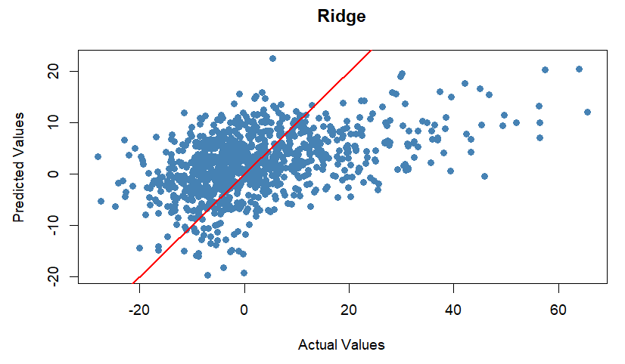
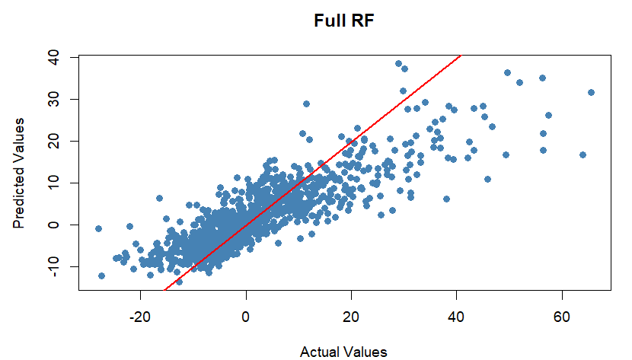
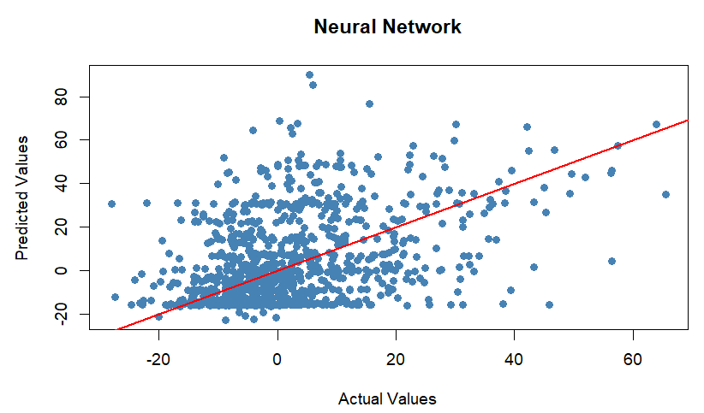
5.2 2026 Live MLB Results
Performance shifted significantly:
- RF_Full was the strongest model on live data.
- Ridge Regression also performed well.
- The Neural Network performed worst, likely due to overfitting.
The RF_Full model achieved:
- 23% of predictions within 2 runs of actual wRAA
- 47% within 5 runs
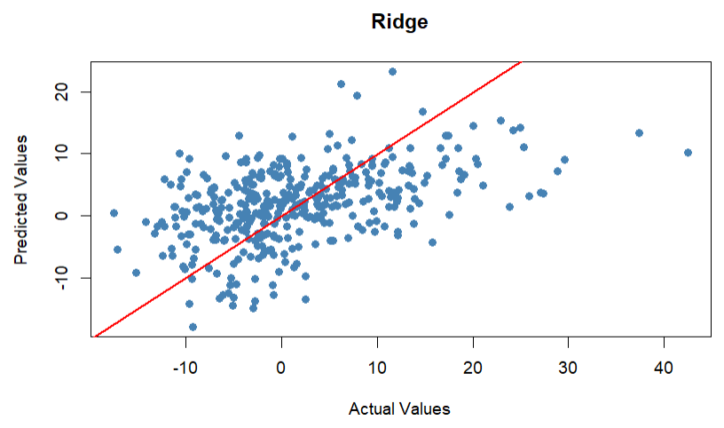
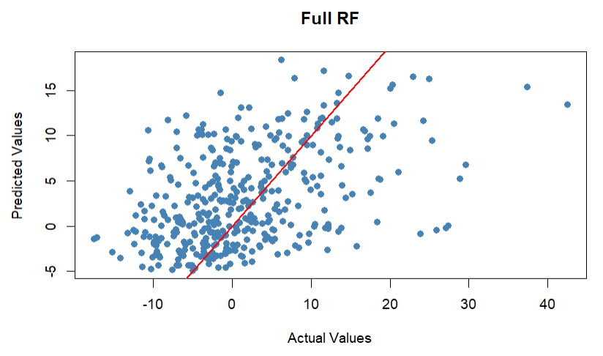
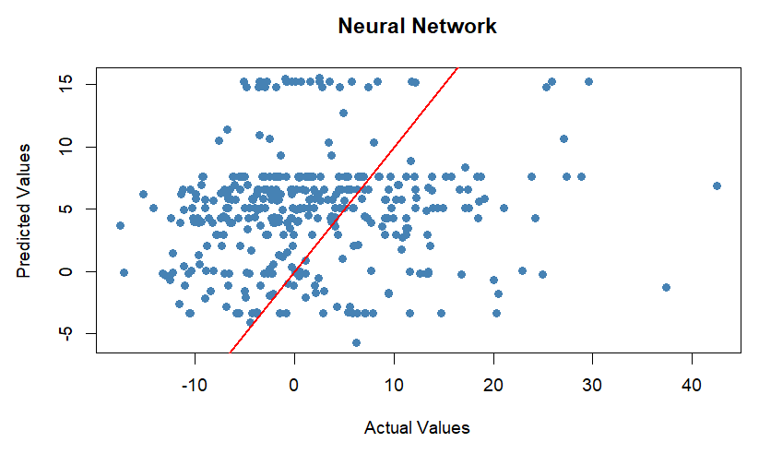
5.3 Variable Importance
Across models, the most significant predictors were:
- SprayPower (engineered feature)
- Opposite_percent
- Straightaway_percent
- Pull_percent
This supports the conclusion that hitting direction and approach are more predictive than plate discipline metrics.
6 Discussion
The project’s results challenge the assumption that plate discipline alone is a strong predictor of offensive output. While swing decisions do contribute meaningfully, the models consistently found batted-ball direction and hitting approach to be more influential. Additionally:
- Models struggled with extreme outliers (superstars, breakout seasons, injury-affected players).
- Neural networks showed instability and overfitting.
- Random forests provided the best balance of interpretability and predictive accuracy.
6.1 Limitations and Threats to Validity
- Multicollinearity required extensive feature engineering.
- Neural network instability limited deep-learning exploration.
- Outlier performance remains difficult to model.
- Plate discipline metrics alone may not capture the full complexity of offensive performance.
7 Conclusion and Future Work
This project demonstrates that cognitively driven variables—plate discipline, swing decisions, and hitting approach—can predict offensive performance with moderate accuracy. However, hitting approach and batted-ball direction appear to be more significant than plate discipline. Finally, there are generally too many factors in play in the game of baseball for this collection of tracked data alone to be capable of modeling offensive performance with legitimate accuracy.
Future work should explore:
- Incorporating spray charts, exit velocity by direction, and launch-angle distributions.
- Developing a more robust neural network architecture.
- Creating a single decision-making metric summarizing swing quality.
- Extending the model to future-season prediction for MLB front-office applications.
ACKNOWLEDGMENTS
I would like to thank Dr. Weijie Pang for her guidance throughout the project, the School of Computing and Data Science for providing resources and support, and the creators of Statcast and FanGraphs for making high-quality baseball data publicly accessible.
REFERENCES
[1] FanGraphs. (2025). FanGraphs Baseball.
[2] Statcast Custom Leaderboards baseballsavant.com. (2026). Statcast Custom Leaderboards. Baseballsavant.Com.

