1. intro 1

2. installation & JSON Server setup 2

a. Install node js 2

b. Install angular cli 2

c. Install vscode 3

d. Angular cli command 3

e. Json-server pour l’api 3

f. postman 3

3. creation des composants et routing 3

4. Bootstrap integration and navbar creation 4

5. Call Get API and create List Page 4

6. Create Reactive Form and save data using API 5

7. How to display success message after saving angular reactive forms 5

8. Delete Record from list page 5

9. Add datatable in angular | Datatable pagination 5

**Introduction | Angular CRUD Project | Student Management with JSON**

<https://www.youtube.com/watch?v=p01Ydl62ObE&list=PLQcBFrxTul9IQFF7fJz7jgdRYJz1OCbll&index=1>

1. intro

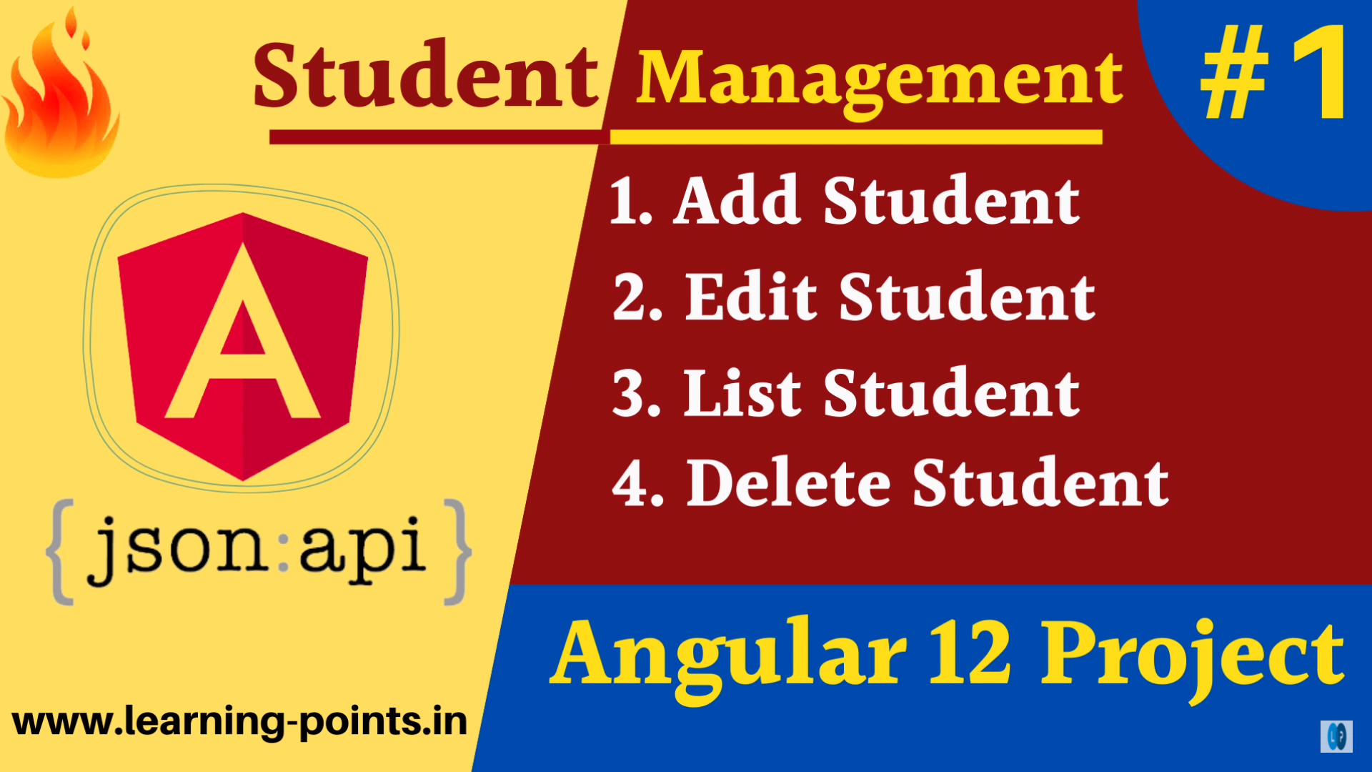

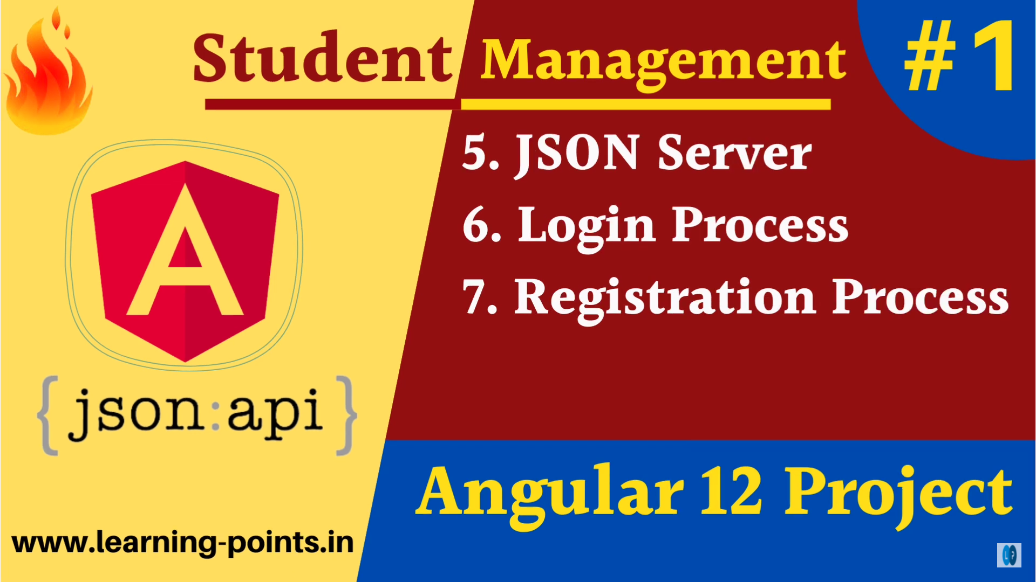

1. installation & JSON Server setup
2. Install node js
3. Install angular cli
4. Install vscode
5. Angular cli command

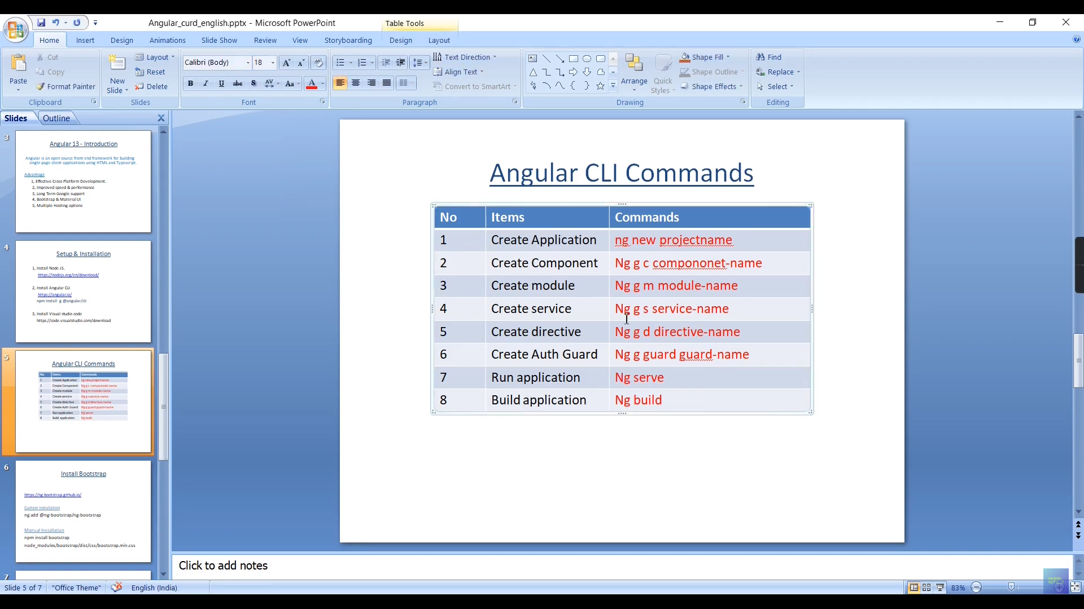

1. Json-server pour l’api

<https://www.npmjs.com/package/json-server#getting-started>

npm install -g json-server

1. postman
2. creation des composants et routing

ng g c components/add-student

ng g c components/edit-student

ng g c components/list-student

ng g c components/login-student

ng g c components/registration-student

1. Bootstrap integration and navbar creation

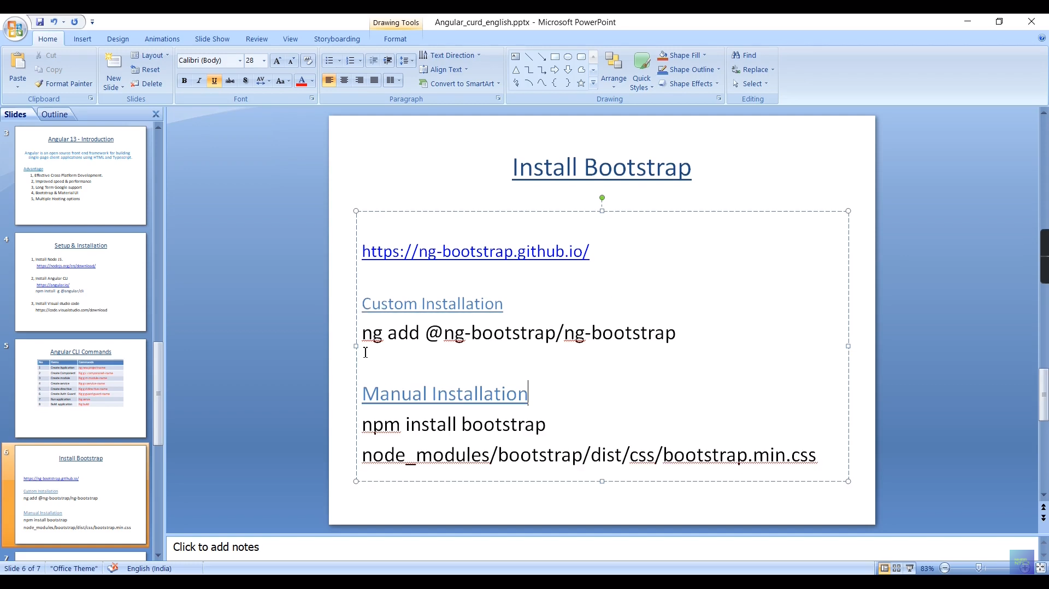

<https://ng-bootstrap.github.io/#/home>

ng add @ng-bootstrap/ng-bootstrap

1. Call Get API and create List Page
2. Create Reactive Form and save data using API
3. How to display success message after saving angular reactive forms
4. Delete Record from list page
5. Add datatable in angular | Datatable pagination

<https://www.softfluent.fr/blog/angular-et-jquery-datatables/>

<https://l-lin.github.io/angular-datatables/#/welcome>