1. Angular intro 1

2. Setup & installation 1

a. Install node js 1

b. Install angular cli 1

c. Install vscode 1

d. Angular cli command 2

3. Create first app 2

4. Add bootstrap 2

5. Generating required components 3

6. Implement routing 3

7. Consume external service 3

8. Reactive form & validation 3

9. Authentication 3

10. Deployement un iis server 3

Angular 13 complete tutorial with CRUD operations ( Reactive forms + bootstrap + .NET CORE Web API)

<https://www.youtube.com/watch?v=DnVRlQBprBs>

1. Angular intro
2. Setup & installation
3. Install node js
4. Install angular cli
5. Install vscode
6. Angular cli command

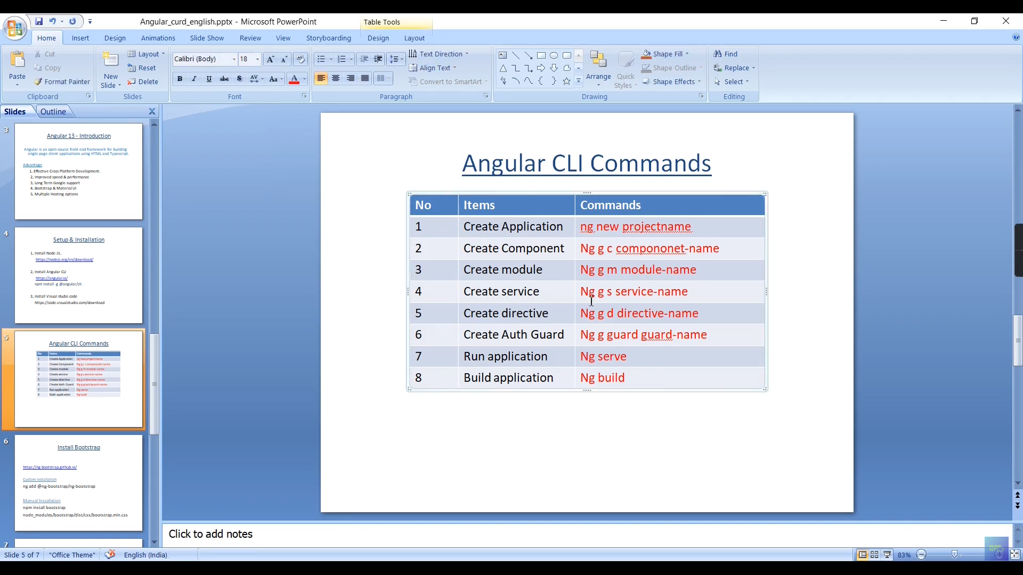

1. Create first app
2. Add bootstrap

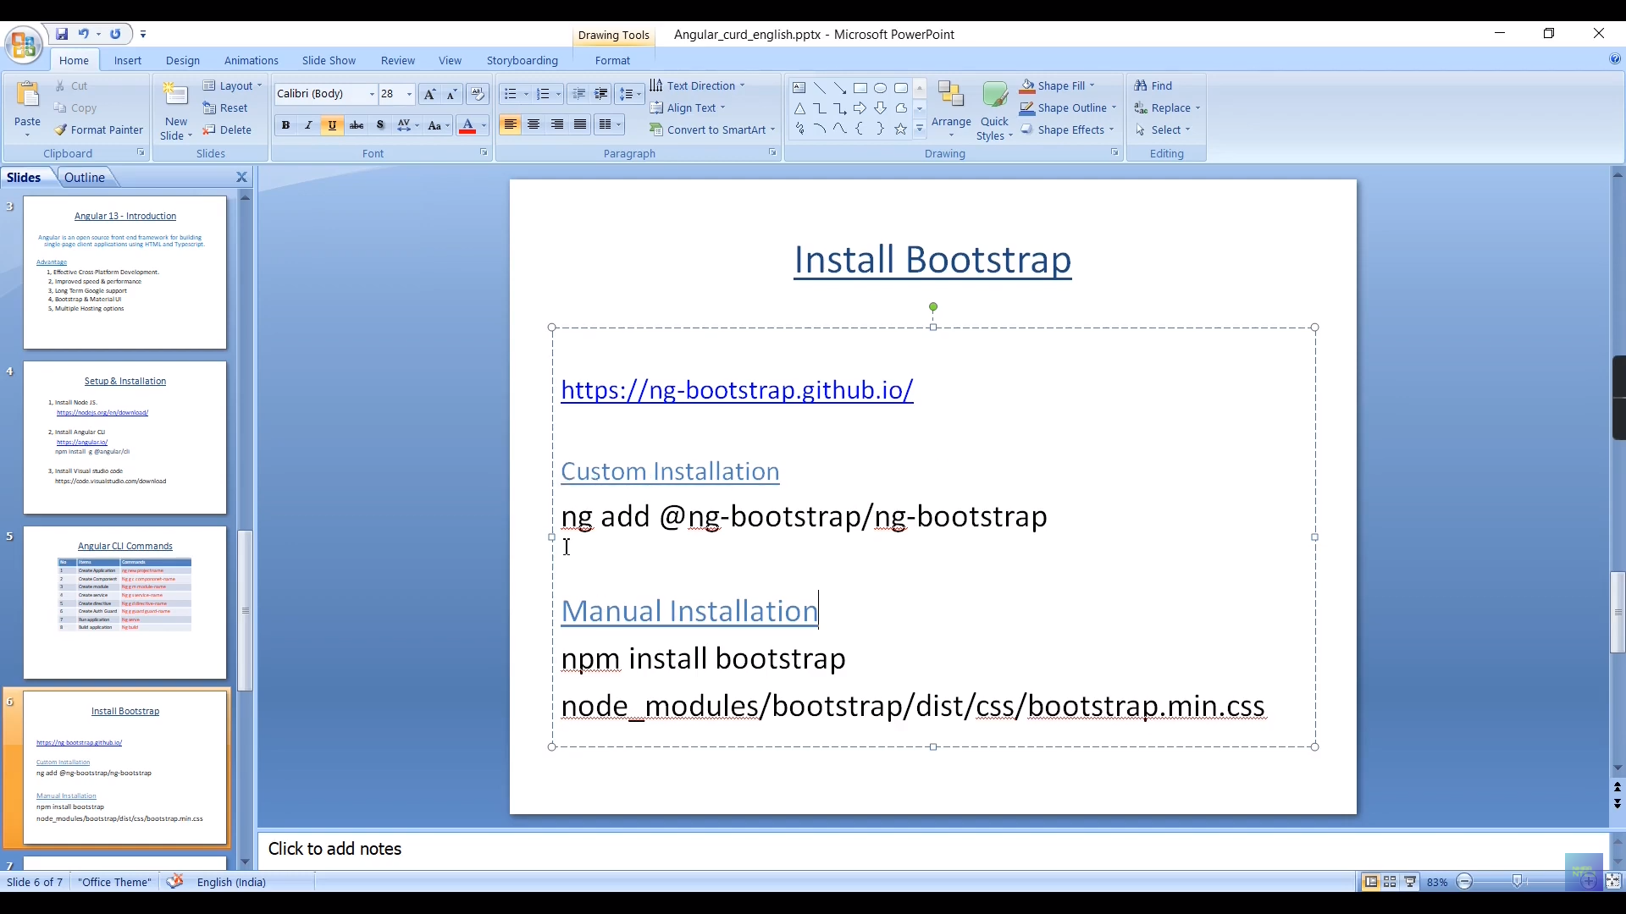

1. Generating required components
2. Implement routing
3. Consume external service
4. Reactive form & validation

Je suis la – et ca ne marche pas encore :

<https://www.youtube.com/watch?v=DnVRlQBprBs>

1. Authentication
2. Deployement un iis server