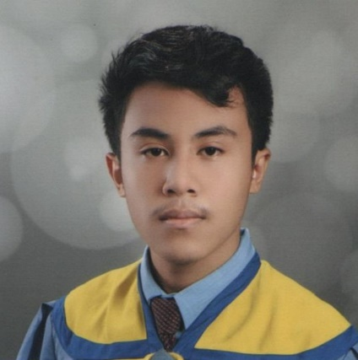JULRIKHA C. DOLERA

Current Address: #45 Zone Litob Calawisan,   
Lapu-Lapu City, Cebu, Philippines

Contact Number: 09213936595

Telephone Number: 260-3216

E-mail Address: julrikhadolera@gmail.com

OBJECTIVE:

Seeking a position at your reputed company where I can utilize my qualifications and capabilities, and apply my skills to the fullest for me to be competent.

EDUCATIONAL BACKGROUND:

Tertiary:

Computer Science

University of Cebu Lapu-Lapu and Mandaue

A.C. Cortes Ave., Looc, Mandaue City

(S.Y. 2019)

Senior High School:

Tech-Voc ICT

University of Cebu Lapu-Lapu and Mandaue

A.C. Cortes Ave., Looc, Mandaue City

(S.Y. 2017-2019)

Secondary:

Babag National High School

Purok Butterfly, Babag 1, Lapu-Lapu City

(S.Y. 2013-2017)

Primary:

Calawisan Elementary School

Calawisan Road, Lapu-Lapu City, Cebu

(S.Y. 2007-2013)

IMMERSION EXPERIENCE:

ICT Assistant in University of Cebu Lapu-Lapu and Mandaue

A.C. Cortes Ave., Looc, Mandaue City

From January 2019 - February 2019

-Keeps organized details of all computer related equipment

-Tracks list of equipment borrowed, making sure they’re returned safely