Get Smart: Tokenized Badges and The No-Loss Student Debt Lottery

**"No Loss" Student Debt Lottery**

* Students buy GETS tokens on Ethereum blockchain, then 'stake' them in the lottery.
* If tokens are staked, they cannot be traded.
* Students can remove their tokens from the lottery anytime and then trade them.
* Students stay in the lottery until they remove the tokens.
* GETS tokens can be exchanged for any other token linked to Ethereum

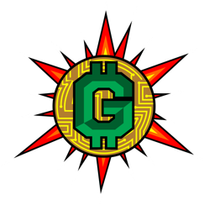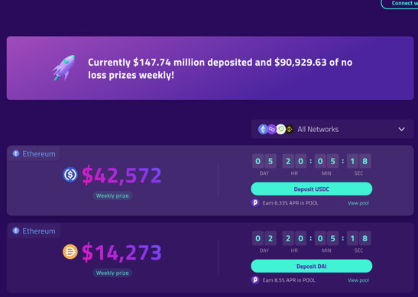

Prizes are made up of the all the interest earned on deposited money in the lottery.

**NDBs "Non-Fungible Digital Badges"**

1. Sponsors can create unique badges that include exchangeable GETS tokens. Sponsors decide how much they are worth and choose the title and award criteria.
2. Students apply for badges as they complete coursework, activities, or social projects.
3. Students then earn badges based on achievements: Once the badge is awarded, the badge is sealed onto the blockchain and the student receives the tokens
4. The GetSmart non-profit takes 3% fee for each awarded badge and commits it to the lottery
5. GETS tokens can be traded on Ethereum or staked as no-loss student debt lottery tickets.

* **40% of GETS tokens are minted for badge creation non-exchangeable**
* **10% of GETS tokens are minted for the non-profit**
* **50% of GETS tokens are minted for students and exchangeable**
* **Students and Sponsors are *not* required to stake tokens in the lottery**
* **Once the tokens tied to badges are released, they can be exchanged**

**GETS token value increases due to both lottery and delayed exchange velocity**

