Khmelnytskyi National University

Department of Computer Engineering and Information Systems

**Report**

Laboratory work №7

Discipline: “Software Requirements and Quality Analysis”

Topic: “Software testing”

Completed: 1st year student, group CEs-24-1 Maksim Lapko

Name, Surname

Checked: Oksana Onyshko

Name, Surname

Khmelnytskyi, 2024

***Purpose of work:*** To form practical skills in working with the basic principles of software testing and the use of various techniques for covering the software code.

**7.1** **Tasks for laboratory work**

1. Write test cases to cover the functionality of the software code.

2. Run automated tests to verify the app's functionality .

3. Analyze the test results and record all detected errors in the report.

**7.2 Completion of the task**

**Write Test Cases**

**Objective:** Create detailed test cases to cover the functionality of the software code.

**Action Steps:**

* **Identify Functional Requirements:** Review the software requirements specification (SRS) document to understand what functions and features need to be tested.
* **Define Test Cases:** Write test cases that specify the input, expected output, and execution steps for each functionality. Ensure you cover:
  + **Positive test cases** (to validate expected behavior).
  + **Negative test cases** (to validate the system's behavior under invalid conditions).
  + **Edge cases** (to test boundaries and limits).

**Test Case Template:**

|  |
| --- |
| Test Case ID: TC001  Title: User Registration  Description: Verify that a user can register with valid credentials.  Preconditions: User is on the registration page.  Test Steps:  1. Enter a valid username.  2. Enter a valid email address.  3. Enter a valid password.  4. Click on the "Register" button.  Expected Result: User should be successfully registered and returned an activation code. |

**Run Automated Tests**

**Objective:** Execute automated tests to verify the application's functionality.

**Action Steps:**

* **Choose a Testing Framework:** Select an appropriate framework based on the programming language and technology stack (e.g., JUnit for Java, pytest for Python, or Jest for JavaScript).
* **Implement Automated Tests:** Write automated test scripts based on the test cases created in the previous step.
* **Execute Tests:** Run the automated tests and collect the results.

**Code Snippet (using Postman for a post-response JavaScript scripts):**

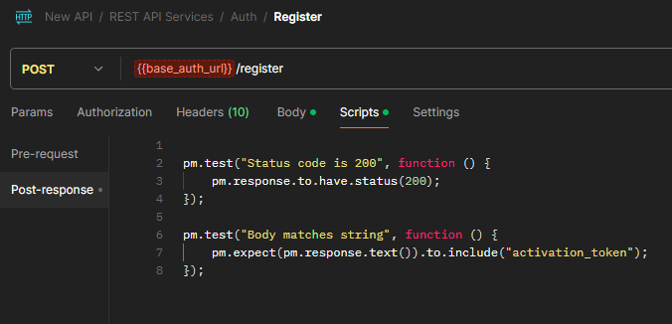

**Analyze Test Results**

**Objective:** Review the outcomes of the tests and document any errors detected.

**Action Steps:**

* **Review Test Output:** Look for passed and failed test cases in the test execution report.
* **Document Errors:** Record all detected errors in a report, providing details such as:
  + **Error ID**
  + **Test Case ID**
  + **Description of the Error**
  + **Steps to Reproduce**
  + **Severity Level**

**Test Results:**

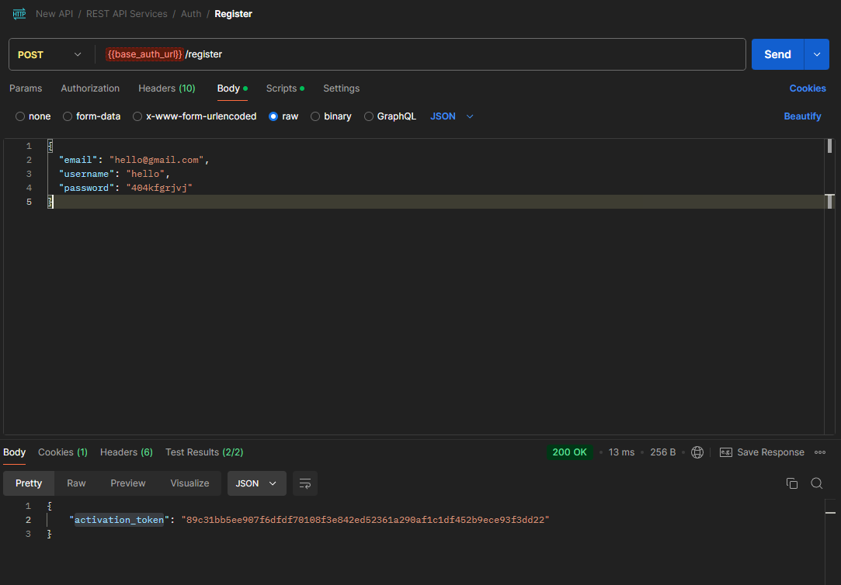

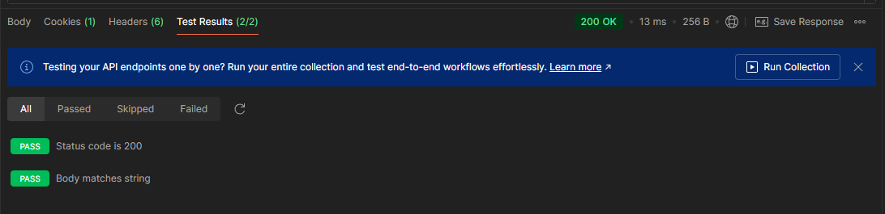

**Example Error Report:**

|  |
| --- |
| Error ID: ERR001  Test Case ID: TC001  Description: User registration fails with a duplicate email.  Steps to Reproduce:  1. Attempt to register with an already used email.  2. Observe the error message displayed.  Severity: High |

**Conclusion:**

In this laboratory work, practical skills in working with the basic principles of software testing and the use of various techniques for covering the software code.