Khmelnytskyi National University

Department of Computer Engineering and Information Systems

**Report**

Laboratory work №1

Discipline: “Object-oriented programming”

Topic: “Introduction to C#. Creating console applications

In C#”

Completed: 1st year student, group CEs-24-1 Maksim Lapko

Name, Surname

Checked: Viacheslav Boiko

Name, Surname

Khmelnytskyi, 2024

Purpose: The goal of this lab is to acquire skills and experience in creating console applications using the C# programming language. The aim is to learn how to write programs in C# that utilize linear, branching, and loop structures. Additionally, this lab introduces the Visual Studio 2008 environment and the basic constructs of the C# language.

**Task 1**

The task requires calculating the kinetic energy (E) and potential energy (P) of an object given its mass (m), height (h), and velocity (v). The formulas used for calculating the energies are:

* Kinetic energy:  
   ​
* Potential energy:

Where:

* *m* is the mass of the object.
* *v* is the velocity of the object.
* *h* is the height at which the object is moving.
* *g* is the gravitational constant, approximated as 9.807 m/s².

The program is implemented as a C# console application. It prompts the user to input values for mass, height, and velocity, and then calculates and displays the corresponding kinetic and potential energies.

**1.2. Program text**

namespace task1;

class Task1 {

    const double g = 9.807;

    static double E(double m, double v) => m*Math.Pow(v, 2)/2;

    static double P(double m, double h) => m*g*h;

    static void Main() {

        Console.WriteLine("Input m: ");

        double m;

        double.TryParse(Console.ReadLine(), out m);

        Console.WriteLine("Input h: ");

        double h;

        double.TryParse(Console.ReadLine(), out h);

        Console.WriteLine("Input v: ");

        double v;

        double.TryParse(Console.ReadLine(), out v);

        Console.WriteLine($"m: {m}; h: {h}; v: {v}");

        Console.WriteLine($"E: {E(m,v)}\nP: {P(m,h)}");

    }

}

**1.3. Program results:**

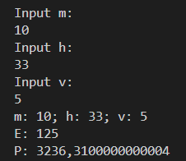

**Task 2**

The task involves computing the value of a function based on the given value of x. The function y is defined as follows:

* If ∣x∣<10, calculate f(v)
* If ∣x∣≥10, calculate f(ω)

Where:

* v=tan(x/i+a)−ln(|b⋅i+7|)
* ω=

Here, i is the variant number, which is set to 7, and a, b, c, and d are input by the user.

The program prompts the user to input values for x, a, b, c, and d, and based on the value of x, it computes and displays the result of either f(v) or f(ω).

**2.2. Program text**

namespace Task2;

class Task2 {

    static double V(double x, int i) {

        double a = InputDouble("Input a: "), b = InputDouble("Input b: ");

        return Math.Tan(x / i + a) - Math.Log10(Math.Abs(b * i + 7));

    }

    static double W(double x, int i){

        double c = InputDouble("Input c: "), d = InputDouble("Input d: ");

        return c * Math.Sqrt(Math.Pow(x, 2) + d * Math.Pow(i, 12));

    }

    const int I = 7;

    static void Main() {

        double x = InputDouble("Input x: ");

        double result;

        if (Math.Abs(x) < 10) {

            result = V(x, I);

        } else {

            result = W(x, I);

        }

        Console.WriteLine($"Result: {result}");

    }

    static double InputDouble(string message) {

        Console.WriteLine(message);

        double value;

        while (!double.TryParse(Console.ReadLine(), out value)) {

            Console.WriteLine("Invalid input. Try again.");

        }

        return value;

    }

}

**2.3. Program results:**

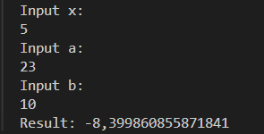

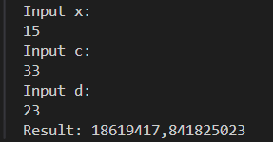

**Task 3**

The task requires creating a program that determines the continent of a country based on the first letter of its name. The program solves this problem in two ways:

1. Using an if-else statement.
2. Using a switch-case statement.

The countries are grouped by their starting letter, and each group corresponds to a continent. The groups are predefined as follows:

* Countries starting with 'G', 'H', or 'F' are located in **Europe**.
* Countries starting with 'V', 'Q', or 'J' are located in **Asia**.
* Countries starting with 'B', 'P', or 'C' are located in **South America**.

If the first letter of the country doesn't match any of these groups, the program outputs "Unknown".

The program prompts the user to input the name of a country, converts the input to uppercase, and then compares the first letter to determine the continent.

**3.2. Program text**

namespace Task3;

class Program {

    static void Main() {

    string? country = "";

    while (string.IsNullOrEmpty(country)){

        Console.WriteLine("Enter country name:");

        country = Console.ReadLine()?.ToUpper();

    }

    char firstLetter = country[0];

    Console.WriteLine($"Using if statement: {UseIf(firstLetter)}");

    Console.WriteLine($"Using switch statement: {UseSwitch(firstLetter)}");

    }

    static string UseIf(char letter){

        if (letter == 'G' || letter == 'H' || letter == 'F'){

            return "Europe";

        } else if (letter == 'V' || letter == 'Q' || letter == 'J'){

            return "Asia";

        } else if (letter == 'B' || letter == 'P' || letter == 'C'){

            return "South America";

        } else {

            return "Unknown";

        }

    }

    static string UseSwitch(char letter){

        switch (letter){

            case 'G' or 'H' or 'F':

                return "Europe";

            case 'V' or 'Q' or 'J':

                return "Asia";

            case 'B' or 'P' or 'C':

                return "South America";

            default:

                return "Unknown";

        }

    }

}

**4.3. Program results:**

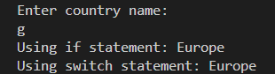

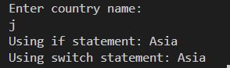

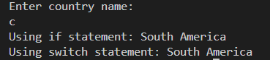

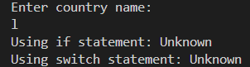

**Task 4**

The task involves calculating the expressions a(k), b(k), and z using the function f(x) defined for the 7th variant:

f(x)=∣sin(2x−1.5)+3∣+2.38

The goal is to compute:

1. , where i=7 for this variant.
2. .
3. z = b(k)*tan(a(k)).

**4.2. Program text**

namespace Task4;

class Program {

    static double Z(double a, double b) => b * Math.Tan(a);

    static double A(int i) {

        double result = 0;

        for (int x = 1; x <= i+3; x++) {

            result += F(x);

        }

        return result;

    }

    static double B(int i) {

        double result = 1;

        for (int x = 1; x <= i+7; x++) {

            result *= F(x);

        }

        return result;

    }

    static double F(double x) => Math.Abs(Math.Sin(2*x - 1.5) + 3*Math.Sin(Math.Pow(x, 2))) + 2.38;

    const int I = 7;

    static void Main() {

        double a = A(I), b = B(I);

        double z = Z(a,b);

        Console.WriteLine($"A: {a}\nB: {b}\nZ: {z}");

    }

}

**4.3. Program results:**

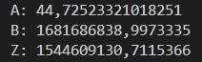

**Conclusions**

1. We studied the creation of console applications in C# using basic constructs such as variables, conditions (if and switch statements), loops, and mathematical functions.
2. We explored the implementation of tasks using both linear and branching structures, including the calculation of kinetic and potential energy, evaluation of mathematical functions, and decision-making based on input.
3. We applied loops for summation and product calculations, and used trigonometric and logarithmic functions to solve more complex mathematical problems. Additionally, we gained experience working with functions in C# to modularize and simplify code.