Khmelnytskyi National University

Department of Computer Engineering and Information Systems

**Report**

Laboratory work №2

Discipline: “Object-oriented programming”

Topic: “BEHAVIORAL MODELING”

Completed: 1st year student, group CEs-24-1 Maksim Lapko

Name, Surname

Checked: Viacheslav Boiko

Name, Surname

Khmelnytskyi, 2024

Purpose: A laboratory work on Behavioral Modeling in OOP aims to help students understand how objects interact over time to achieve specific system behaviors.

**Task 1**

According to the selected problem domain build the Sequence Diagrams.

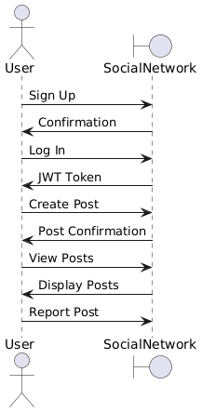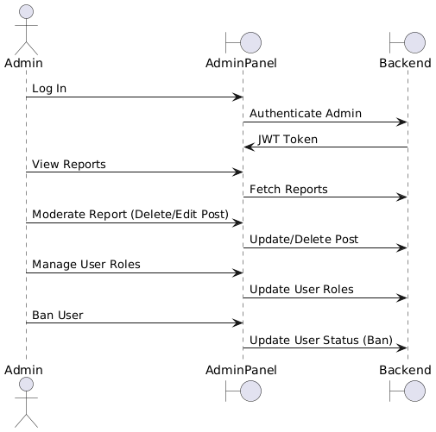

**Task 2**

According to the selected problem domain build the Activity Diagram.

#### 

**Task 3**

According to the selected problem domain build the State Diagram.

#### 

**Task 4**

According to the selected problem domain build the Collaboration Diagram.

#### 

**Conclusions**

In completing the sequence, activity, state, and collaboration diagrams for the **Social Network Y** project, we gained valuable insights into the system's interactions, processes, and states.