Khmelnytskyi National University

Department of Computer Engineering and Information Systems

**Report**

Laboratory work №3

Discipline: “Object-oriented programming”

Topic: “CLASS DESIGN”

Completed: 1st year student, group CEs-24-1 Maksim Lapko

Name, Surname

Checked: Viacheslav Boiko

Name, Surname

Khmelnytskyi, 2024

Purpose: Develop practical experience in designing and implementing classes, following core OOP principles like encapsulation, inheritance, abstraction, and polymorphism. It helps students model real-world scenarios, understand class relationships, and apply design principles to create modular, reusable, and maintainable code. Additionally, how to use abstract classes, interfaces, and UML diagrams to visualize and implement class structures effectively will be learned.

**Task 1**

According to the selected problem define classes of a system. If there is an existing project, enhance its functionality via new classes. Create Class Responsibility Collaboration (CRC) cards for every class with properly defined responsibilities and collaborators.

|  |  |  |
| --- | --- | --- |
| Class Name | Responsibilities | Collaborators |
| User | Store user details.  Determine if the user is an admin.  Track whether the user is banned and manage active bans. | Ban |
| Report | Store report details.  Determine if the report is closed. | User, Post |
| Post | Store post details.  Determine if the post has been edited. | Tag, Comment, Like, User |
| Comment | Store comment details.  Determine if the comment has been edited. | User, Post |
| Like | Store like details. | User, Post |
| Tag | Store tag details. | Post |
| Ban | Store ban details. Determine if the ban still active. | User |

**Task 2**

Create a domain model diagram according to the selected problem domain.

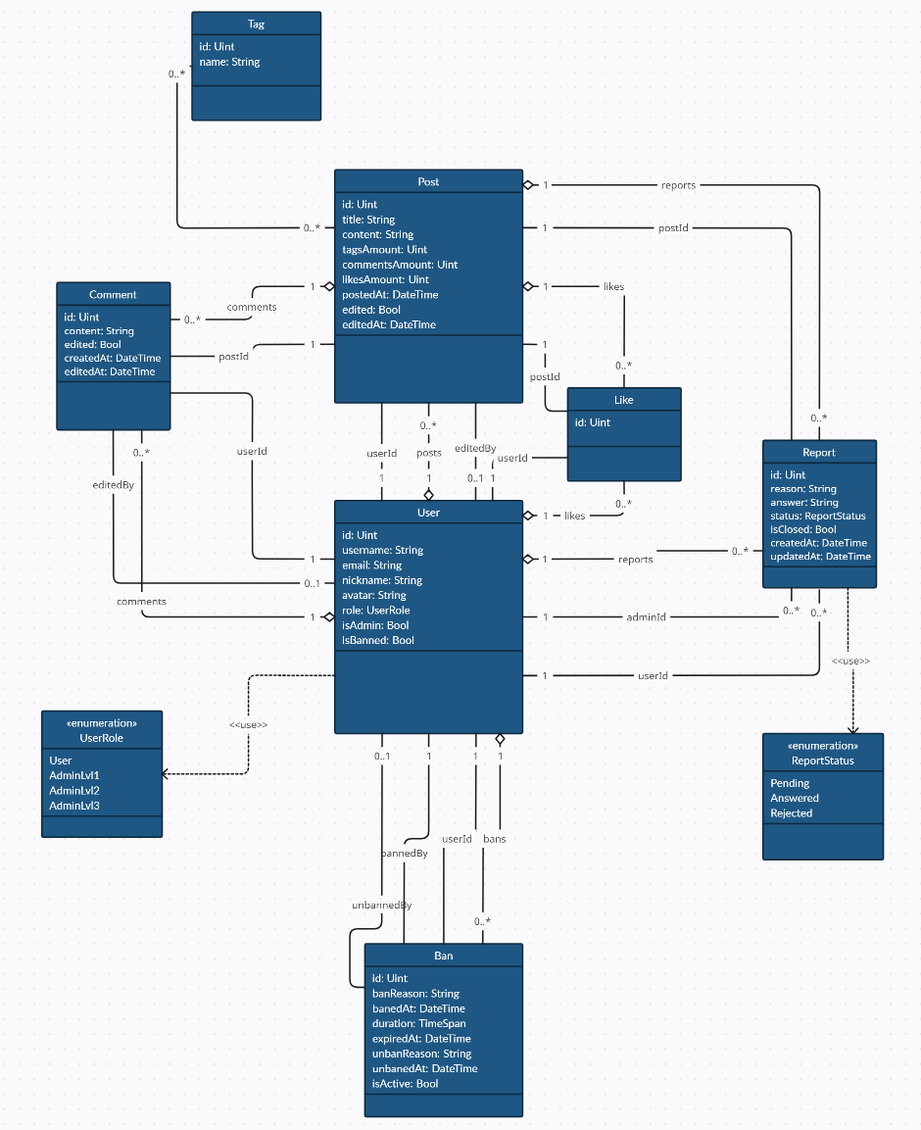

**Task 3**

#### Create a class diagram. Before it, carefully define relationships between classes. If the diagram is too large – split it by class categories into several diagrams.

#### 

**Task 4**

#### Create an object diagram with properly defined instances and relationships between them.

#### 

**Conclusions**

In completing the class design and object diagrams for the Social Network Y project, I gained valuable insights into the system's structure and interactions. Through the design of classes User, Post, Comment, Like, Ban, and Report. I was able to apply core object-oriented programming principles, ensuring that each component is modular, reusable, and maintainable.