Khmelnytskyi National University

Department of Computer Engineering and Information Systems

**Report**

Laboratory work №4

Discipline: “Object-oriented programming”

Topic: “CLASSES AND INTERFACES IMPLEMENTATION AND RELATIONSHIPS BETWEEN THEM”

Completed: 1st year student, group CEs-24-1 Maksim Lapko

Name, Surname

Checked: Viacheslav Boiko

Name, Surname

Khmelnytskyi, 2024

Purpose: Provide students with practical experience in understanding and implementing object-oriented programming concepts, specifically focusing on classes and interfaces; gain familiarity with defining and implementing classes and interfaces, as well as exploring relationships such as inheritance, composition, etc. between them; apply principles of OOP, including encapsulation, abstraction, inheritance, and polymorphism, to build modular and scalable code.

**Task 1**

According to the designed class diagram in previous laboratory work, implement all necessary classes and interfaces. Select the appropriate programming language (C# or C++ can be selected).

Show all OOP principles implemented in your program system. For the code text use the following formatting: Consolas font, 9pt, 1 line interval, left aligned, in border, or screenshots can be used.

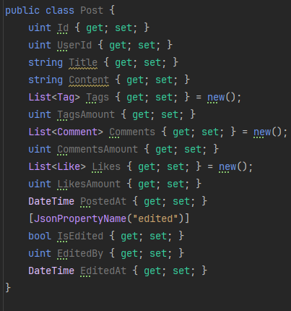

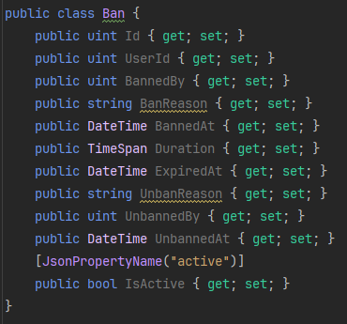

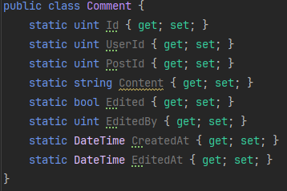

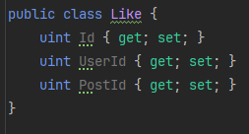

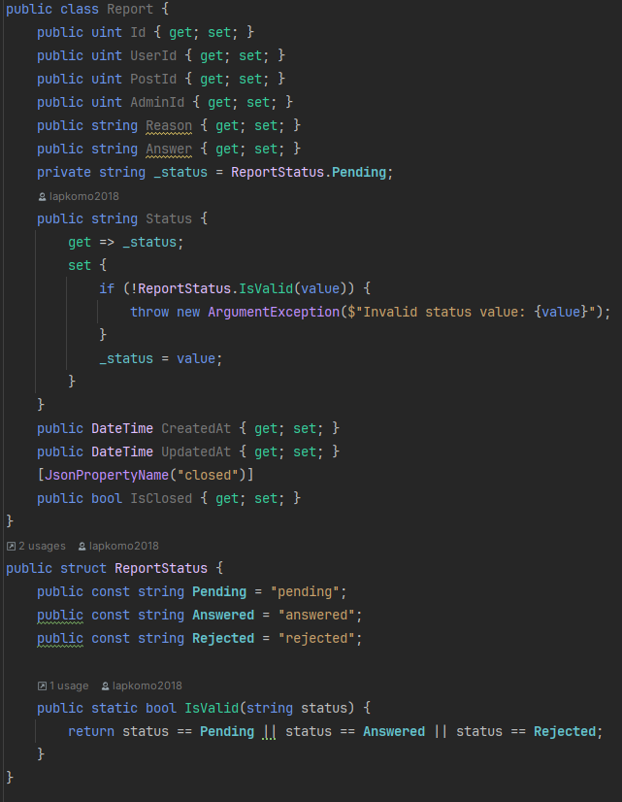

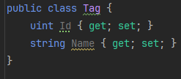

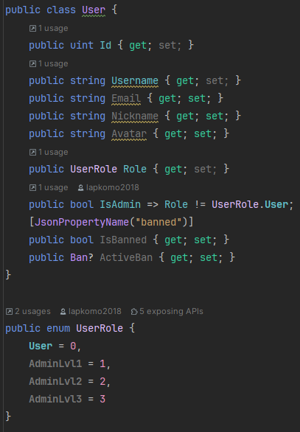

**Task 2**

Show the relationships between objects in your program system. Use the same form in report as in task 2. Attach the appropriate diagrams.

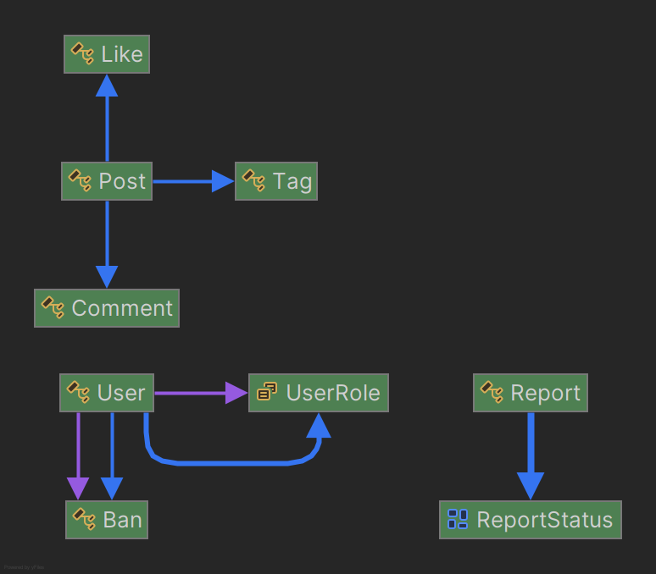

**Conclusions**

In completing this laboratory work, I gained practical experience in applying core object-oriented programming (OOP) concepts such as encapsulation, abstraction, inheritance, and polymorphism.