Khmelnytskyi National University

Department of Computer Engineering and Information Systems

**Report**

Laboratory work №5

Discipline: “Object-oriented programming”

Topic: “MODULES DEVELOPMENT”

Completed: 1st year student, group CEs-24-1 Maksim Lapko

Name, Surname

Checked: Viacheslav Boiko

Name, Surname

Khmelnytskyi, 2024

Purpose: Provide students with practical experience in designing, implementing, and integrating modules within a software system; help students understand modular design by exploring principles such as separation of concerns, cohesion, and coupling.

**Task 1**

According to implemented classes and interfaces in previous laboratory work, determine the classes with common responsibility and properly define modules.

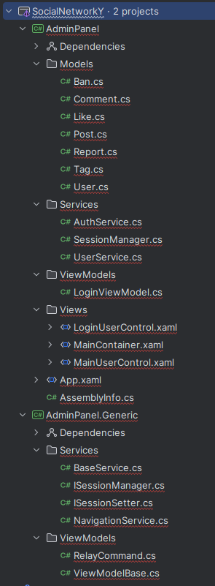

**Task 2**

Create Model diagram.

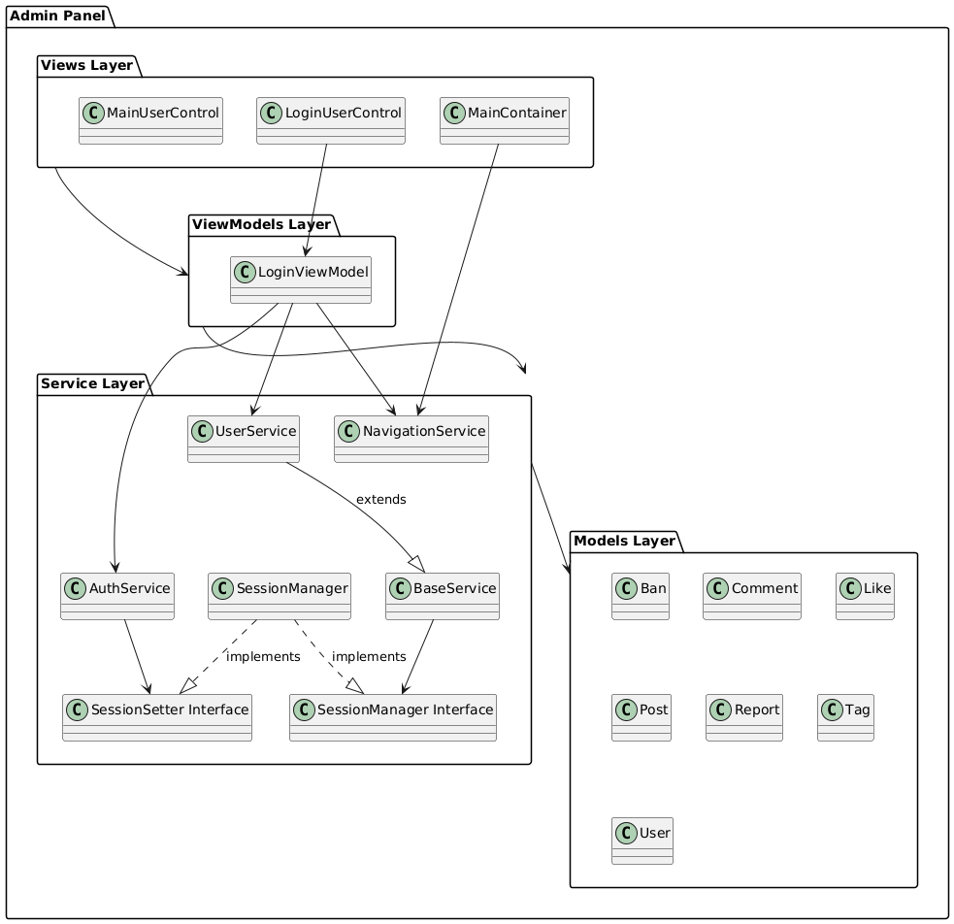**Task 3**

Create Package

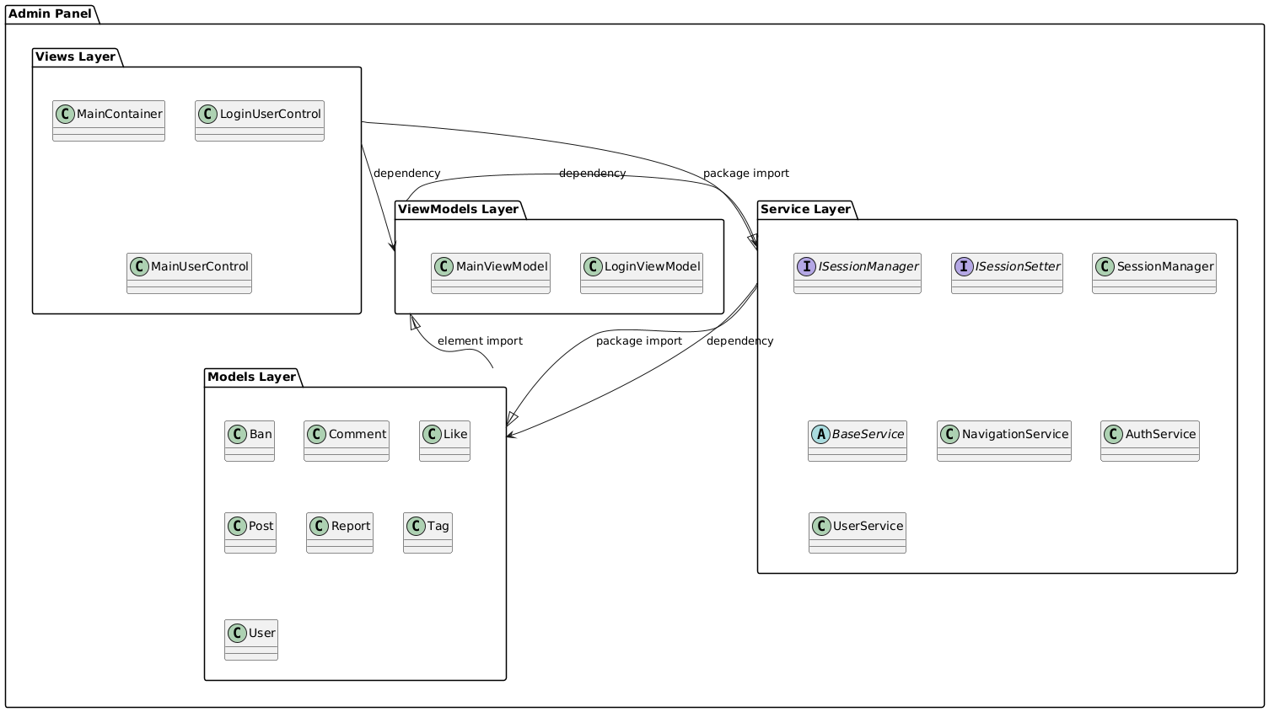**Task 3**

Modify the project by organizing modules and packages.

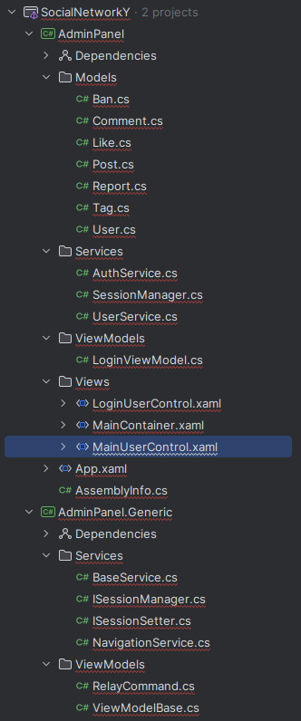**Task 4**

Extract common modules into separate class library. Deploy this library to the package manager which depends on your platform choice (NuGet for .NET, Gradle for Java, CMake for C++ etc.).

Nuget package on https://www.nuget.org/packages/AdminPanel.Generic

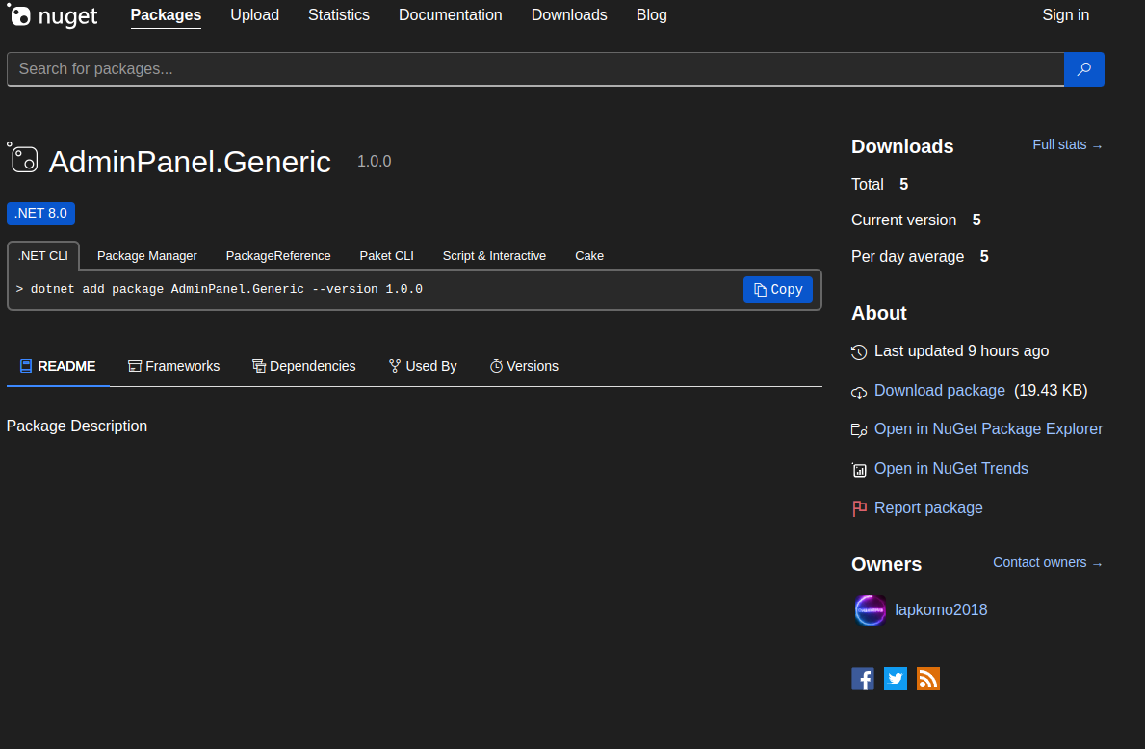Installed package

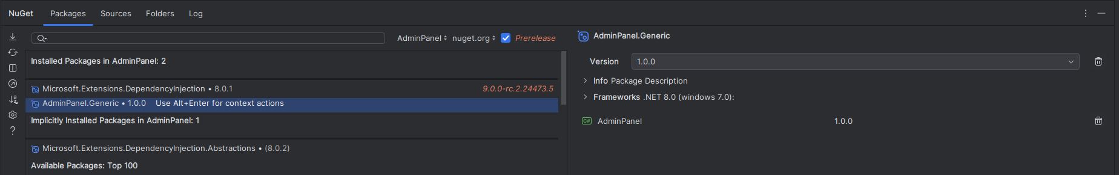

**Conclusions**

In completing this laboratory work, I gained practical experience in designing, implementing, and integrating modules within a software system.