Khmelnytskyi National University

Department of Computer Engineering and Information Systems

**Report**

Laboratory work №6

Discipline: “Object-oriented programming”

Topic: “DEPENDENCY MANAGEMENT”

Completed: 1st year student, group CEs-24-1 Maksim Lapko

Name, Surname

Checked: Viacheslav Boiko

Name, Surname

Khmelnytskyi, 2024

Purpose: Provide knowledge and practice of how to handle dependencies in a way that makes code more modular, testable, and maintainable; understand how to apply dependency injection to decouple components; gain an experience with DI frameworks and best practices, which promote clean architecture principles.

**Task 1**

Perform the dependency audit of the program system. Draw a class diagram

with only aggregation and composition relationships before class decoupling.

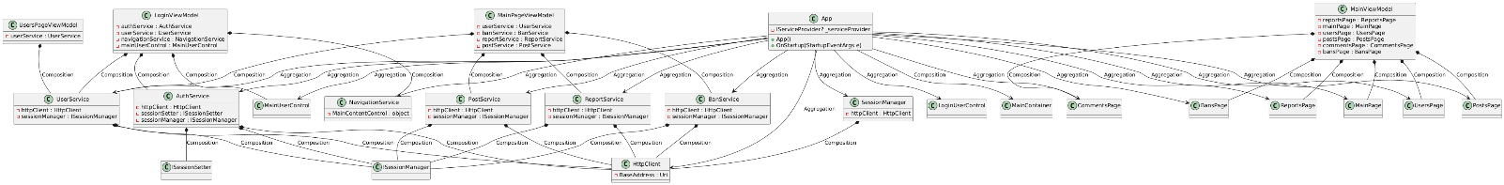

**Task 2**

Draw the dependency graph before class decoupling



**Task 3**

Use at least three different dependency management libraries according to the chosen platform. Provide screenshots of using them and pieces of code. Choose the most convenient and leave the implementation using it.

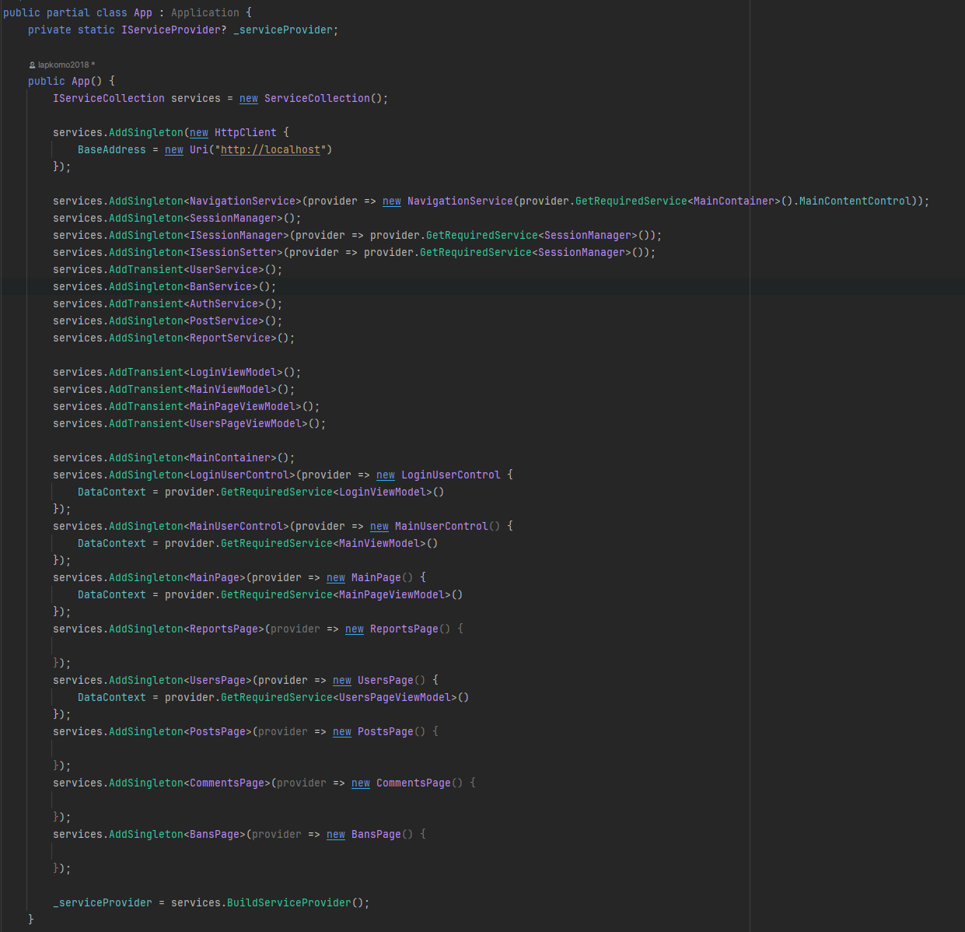

Choosed Microsoft.Extensions.DependencyInjection;

**Task 4**

Draw a dependency graph after applying the DI.



**Task 5**

Draw a class diagram with only aggregation and composition relationships

after applying the DI.

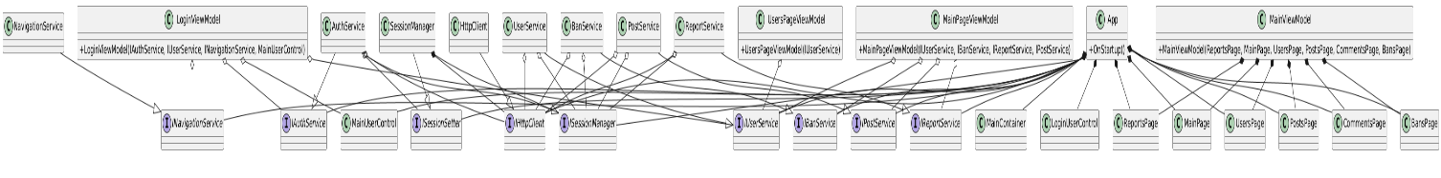

**Conclusions**

In completing this laboratory work, I gained practical experience of how to handle dependencies in a way that makes code more modular, testable, and maintainable.