國立清華大學 電機工程學系碩博士班

101學年度第一學期

EE-6250 超大型積體電路測試 VLSI Testing

期末考 Jan. 16, 2013 (總分 100 分)

(Closed-Book Examination)

參考解答

- (20%) Answer the following questions.
    - There are two basic requirements to produce (2^{n}-1) pseudo random patterns using a LFSR. One of them is to choose a LFSR with a primitive (or irreducible) polynomial. Name the other requirement. (5%)
➔ Use non-zero SEED
    - A walking sequence is often applied to test multiple-bit interconnect between modules to detect stuck-at faults as well as coupling faults. Show the walking-‘1’ sequence of test patterns for 5-bit interconnect. (5%)
➔ A sequence of the following patterns: {10000, 01000, 00100, 00010, 00001}
    - There are three major types of test compression, including code-based compression and linear compression. What is the other type? (Simply give the name.) (5%)
➔ Broadcasting scan
    - 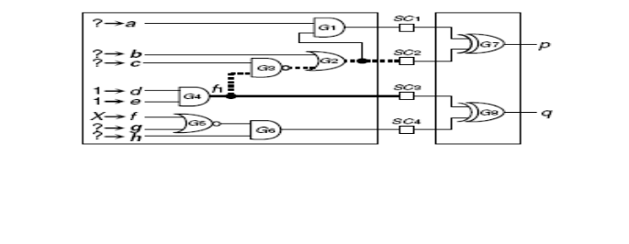In the following combinational circuit, where {SC1, SC2, SC3, SC4} are original scan chain outputs, while p and q are compacted outputs. ATPG is performed to detect f₁-stuck-at-0 fault. Value assignments {d=1, e=1} have been made to activate the fault. Due to the presence of ‘X’ at primary input f, what value should be further assigned to signal g to ensure that the fault effect is not only observable at SC4 but also observable at compacted output q? (5%).
➔ g = 1 (to block the ‘X’ source at f)

- (10%) Answer the following questions.
    - There are two basic registers required by IEEE-1149.1 standard. One is “boundary scan register”. What is the other? (5%)
➔ 1-bit bypass register
    - A Boundary Scan Cell in IEEE-1149.1 standard is controlled by three important control signals, namely ClockDR, ShiftDR, and UpdateDR. Which one controls the output flip-flop of each boundary scan cell? (5%) ➔ UpdateDR

- (10%) The DFT rule often requires that clock gating is avoided in test mode. Try to fix the circuit structure shown below that violates this rule. In the resulting circuit, a clear clock signal (i.e., CK) feeds the clock port of the flip-flop directly when in test mode (defined as TM=’1’).
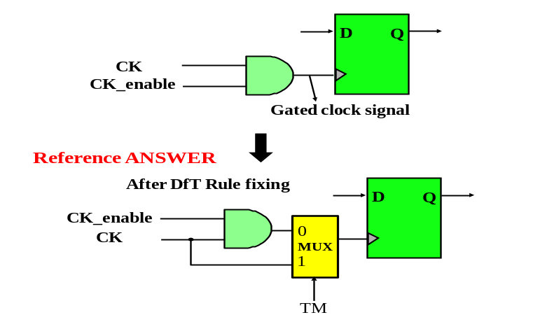
- (10%) Consider the full-scan methodology for a circuit with 99 flip-flops. A combinational ATPG program produces 123 vectors to fully test the logic. Compute the minimum number of clock cycles needed to apply these vectors, assuming that the system clock and test clock are the same and there is only one scan chain. (Note: the scan-in operation and scan-out operation are assumed to be overlapped when applicable).
➔ 12,399

- (10%) Suppose we have 10 random signals produced by a Linear Feedback Shift Register (LFSR), , denoted as {x₁, x₂, x₃, x₄, x₅, x₆, x₇, x₈, x₉, x₁₀}. Show how to use these nine signals to produce a weighted random signal with the signal-1 probability being 19/32 using only two AND gates and one OR gate.

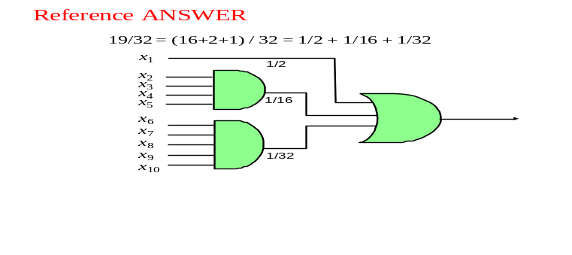

- (10%) Consider the Hoffman encoding for a set of test patterns containing 5 symbols {(A=0001, B=0010, C=0100, D=1000, E=1111)} with their occurring frequencies shown in the table below.
    - Construct a binary tree for the Hoffman encoding, with the accumulated number of occurrences labeled in each node. (5%)
    - Before the Hoffman encoding, the original number of bits to represent this set of test patterns is (10+20+30+40+100)* 4 = 800. What is total number of bits after the Hoffman encoding? (5%)
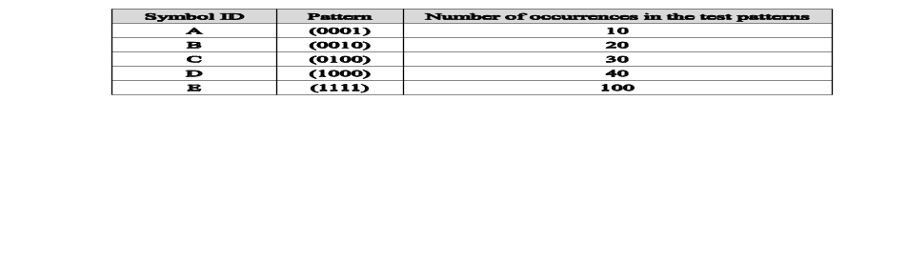➔ 390

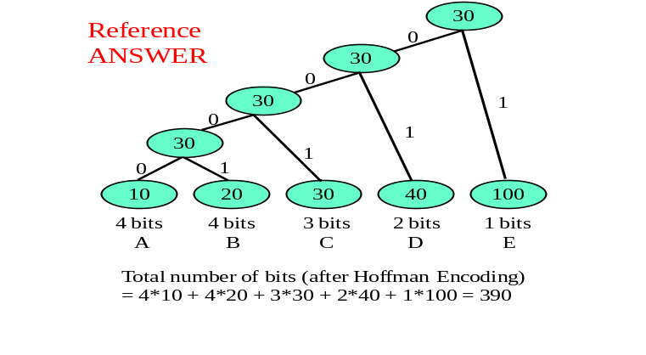

- (15%) Consider the logic BIST using BILBO block shown below (with the clock signal omitted). There are four operation modes supported by this BILBO block, including scan shifting, and parallel loading.
    - What is the operation mode, indicated as Op1 in the table shown below, when <c, B1, B2> is <0, 0, 1>? (5%) ➔ LFSR pattern generation (or PRPG: Pseudo-Random Pattern Generation)
    - What is the last operation mode not mentioned above, as indicated as Op2 in the table? (5%)
➔ MISR Response Compression (or MISR Signature Analysis)
    - What is the value requirement for <c, B1, B2>, as indicated as control-pattern-2 for Op2? (5%)
➔ <c, B1, B2> is <0, 1, 1>

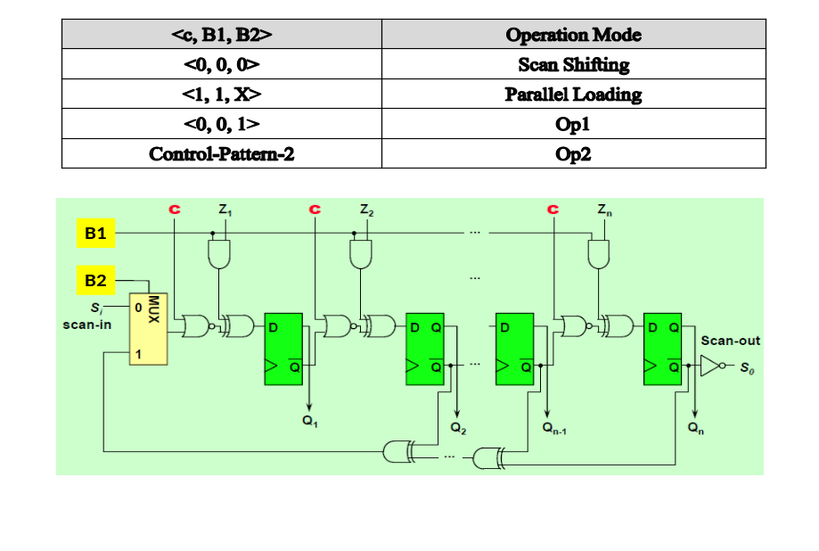

- (15%) Consider the diagnosis of a combinational failing chip with five outputs. Under a test vector v, the output response is (1,1,1,0,0) for the circuit model, and (0,0,1,0,1) for the failing chip under diagnosis. An internal signal f is being checked for a fault location candidate by the inject-and-evaluate paradigm.
  - If the value of signal f is ‘0’ when test vector v is applied to the circuit. What operation should be done before the event-driven simulation is performed to check the output response? (5%) ➔ flip the value at signal f to ‘1’
  - If the output response after the inject-and-evaluate process is (0,0,1,1,1), then is test vector v a curable vector of signal f? (5%) ➔ No
  - If the output response after the inject-and-evaluate process is (1,1,1,1,1), then what is the total number of curable outputs of signal f under test vector v? (5%) ➔ 1

