國立清華大學 電機工程學研究所

八十九學年度第二學期

EE-6250 超大型積體電路測試 VLSI Testing

期末考 June 18, 2001 (總分 100 分)

- (30%) Answer the following questions briefly.
  - What is the basic idea of IDDQ testing? (5%)
  - What is the major limitation of using random patterns to test a logic circuit? (5%)
  - What is the drivability measure used in the BACK algorithm for sequential ATPG? (5%)
  - Compare the pros and cons of full scan and partial scan from at least three different angles. (5%)
  - What is the purpose of the register BYPASS in the IEEE-1149.1 standard of boundary scan? (5%)
  - Give two reasons of why we may need to perform logic diagnosis. (5%)

- (10%) Suppose we have five random signals produced by a Linear Feedback Shift Register (LFSR). Show how to use these five signals to produce a weighted random signal with the signal-1 probability being 19/32 using only AND, OR, and Inverter gates.

- (15%) Consider an input vector {(x₁, x₂, x₃, x₄) | (1, 0, 1, 0)} applied to the circuit shown below. Derive the set of detected faults at the primary output z.
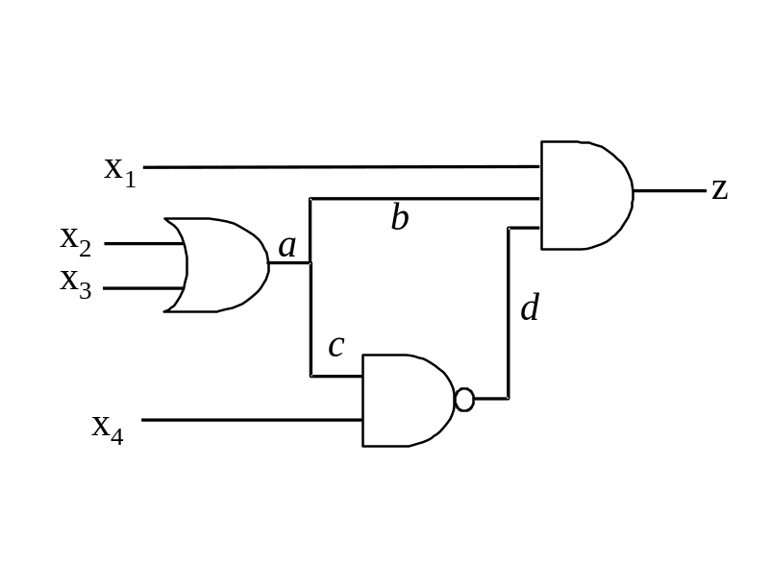

- (15%) Consider the full-scan methodology for a circuit with 99 flip-flops. A combinational ATPG program produces 123 vectors to fully test the logic. Compute the minimum number of clock cycles needed to apply these vectors, assuming that the system clock and test clock are the same and there is only one scan chain.

- (15%) Derive one test pattern for the AND-bridging fault between wires x₁ and L in the circuit shown below.
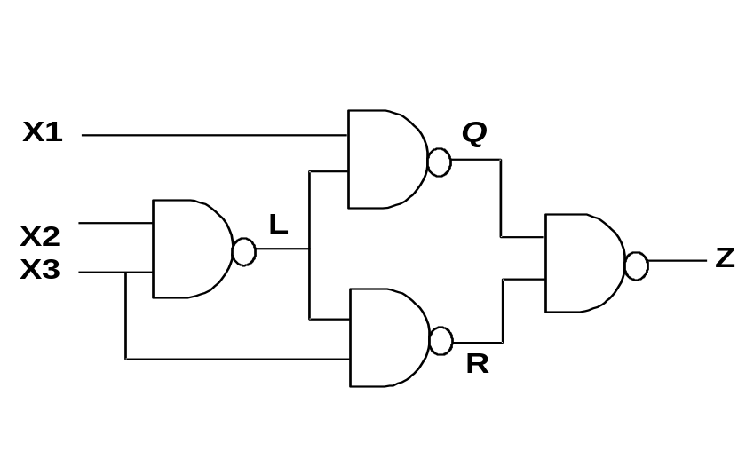

- (15%) Consider a combinational circuit with only one primary output. In response to a set of input patterns {v₁, v₂, v₃}, the fault-free response and the faulty responses of faults f₁, f₂, f₃, f₄, and f₅ are recorded in the table shown below.
  - Construct a tree-based fault dictionary for these faults. (5%)
  - What is the diagnostic resolution of this dictionary? (5%)
  - Assume that the fault response of a failing IC is {1, 0, 1} after the application of {v₁, v₂, v₃}, what are the possible causing faults? (5%)
