國立清華大學 電機工程學系(碩博士班)
104學年度 第一學期

EE6250 超大型積體電路測試 — 期中考題 (Nov. 4, 2015)

(參考解答)

- (20%) Answer the following questions.
    - In the development of a test solution, why does test time matter? (5%) ➔ Longer test time implies higher test cost.
    - What does IDDQ stand for? (5%) ➔ IDDQ means the quiescent current at a VDD pin.
    - In Check-Point Theorem, what signals form a sufficient set for stuck-at fault test pattern? In other words, the stuck-at faults on a signal not in the above sufficient set can be ignored. (5%) ➔ {Primary Inputs} + {Branch Signals}
    - A detection probability of a stuck-at fault by one test vector is p, then what is the detection probability of this fault by applying n test vectors (from a statistical point of view like STAFAN). (Hint: calculate the probability that all n test vectors fail to detect a fault first). (5%) → 1 – (1-p)^{n}

- (20%) Answer the following questions.
    - Consider a Boolean function f(x₁, x₂, x₃). Denote the Boolean difference df/dx₂ as a Boolean expression in terms of f(x₁, x₂=0, x₃) and f(x₁, x₂=1, x₃). (5%)
➔ f(x₁, x₂=0, x₃) ⊕ f(x₁, x₂=1, x₃)
    - During a D-algorithm, what conditions imply the SUCCESS of finding a test pattern for a target stuck-at fault? (5%) ➔ Fault effects (D or D') at a primary output + Empty J-frontier
    - During a D-algorithm, what conditions imply the FAILURE of finding a test pattern for a target stuck-at fault? (5%) ➔ Empty D-frontier
    - Suppose the sub-routine backtrace() of PODEM algorithm finds an all-'x' path from an objective, (k, 0), to an primary input, x_{i}, is identified. There are an odd number of inverting gates along this path. Then, what value should be assigned to the primary input x_{i}? (5%)
➔ '1'

- (10%) Consider a two-input AND gate with two inputs {a, b} and output {z} in a 5-valued D-algorithm for ATPG.
    - What can we imply on the signal value of signal b after assigning a to '1'? (5%) ➔ '0'
    - How should we update the J-frontier set after the implication?
➔ Remove this gate from the J-Frontier Set.
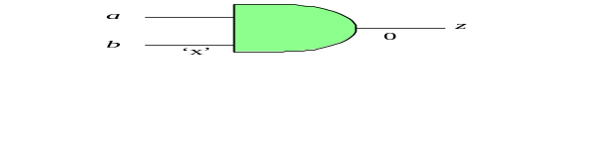
- (10%) Consider the test generation for two stuck-at faults in the following circuit.
    - Derive a test vector for F stuck-at-1 fault in the circuit shown below. (5%)
➔ (A,B,C,D)=(1,1,1,0)
    - Derive a test vector for a branch signal E₂ stuck-at-0 fault. If there exists such a test pattern, report it. If there does not exist such a test pattern, then use the outcome to simplify the circuit. (5%) ➔ E₂ stuck-at-0 fault is untestable. We can replace branch signal E₂ by '0' without changing the functionality of this circuit.
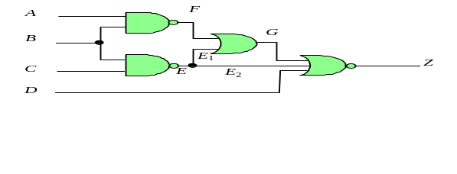
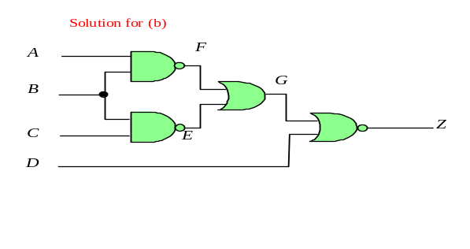
- (10%) Consider a NOR-gate with the inputs {a, b, c} and output {z}.
    - List all equivalent stuck-at faults associated with the input/output signals. (5%)
➔ {a/1, b/1, c/1, z/0}
    - List all dominance relationship among the stuck-at faults associated with the input/output signals. (5%) ➔ z/1 dominates a/0, z/1 dominates b/0, z/1 dominates c/0

- (10%) Consider a two-input OR-gate, Z = (A+B). answer the following questions based on SCOAP (Sandia Controllability and Observability Analysis Program).
    - If CC0(A), CC1(A), CC0(B), CC1(B) are 3, 6, 10, and 1, respectively, what are CC0(Z) and CC1(Z)? ➔ CC0(Z) = 3+10+1=14, CC1(Z) = min(6, 1)+1=2
    - If observability of Z, denoted as CO(Z), is 5, then, what is CO(A). (5%)
➔ CO(A) = 5+10+1=16

- (10%) Consider the testing of a monostable multi-vibrator circuit (also known as one-shot circuit) as shown below.
    - Within a particular test clock cycle, we apply a rising transition to the input signal. Show the waveform of the output signal if the circuit is fault-free. (5%)
    - To detect if the circuit is faulty or not, we can simply use a "fault-detection circuit" with only one "reset-able edge-trigger flip-flop". Note that this flip-flop is assumed to be reset to '0' at the beginning of the test clock cycle and its output is assumed to be observable. Show the "fault-detection circuit" and its proper interconnections to the circuit under test. (5%)
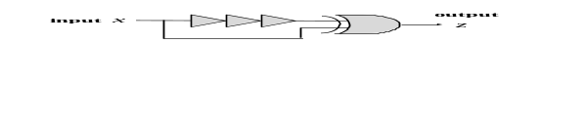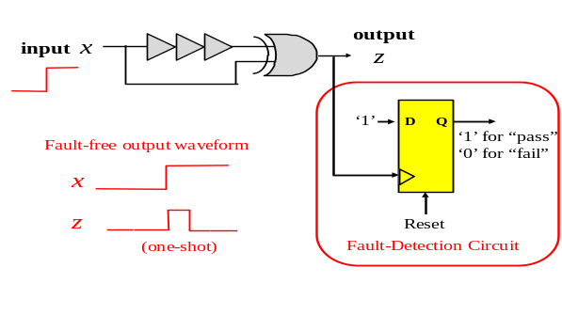

- (10%) Consider the technique of critical-path tracing for fault simulation.
    - Mark the critical lines of the circuit below based on the simulation results in response to an input vector (a,b,c,d)=(1,0,1,0). Note that the critical-path tracing traverses the circuit from the outputs towards the inputs and stops whenever a stem is encountered. (5%) ➔As marked in the figure.
    - Derive the set of detected faults using the information derived in (a). The faults on primary inputs and primary outputs should also be considered. (5%) ➔ 6 detected faults based on critical path tracing = {b1/1, e/1, d/1, g/1, h/1, z/1}.
