國立清華大學 電機工程研究所
八十八學年度 第二學期

EE6250 超大型積體電路測試 — 期中考題 (4/27/2000)

- (30%) Answer the following questions:
    - Give the definitions of untestable fault and redundant fault, respectively? Is an untestable fault always a redundant fault for combinational circuits? (5%)
    - Explain why two vectors are in general needed to test a stuck-open fault? (5%)
    - Explain why the event-driven simulation is often more efficient than the compiled-code simulation, especially for large designs? (5%)
    - Name two major improvements of FAN algorithm over PODEM for combinational test pattern generation. (5%)
    - Show that an OR-bridging fault between an OR-gate’s two inputs is undetectable. (5%)
    - Describe the necessary and sufficient condition for a feedback AND-bridging fault to cause oscillation with respect to a specific input vector v? (5%)

- (20%) Consider the technique of critical-path tracing for fault simulation.
    - What is the definition of sensitive input? (5%)
    - Mark the critical lines of the circuit below based on the simulation results in response to an input vector (a,b,c,d)=(1,0,1,0). Note that the critical-path tracing traverses the circuit from the outputs towards the inputs and stops whenever a stem is encountered. (8%)
    - Derive the set of detected faults and the set of undetected faults by the given input vector using only the information derived in (b). Define your own branch notations when needed. The faults on primary inputs should also be considered. (7%)
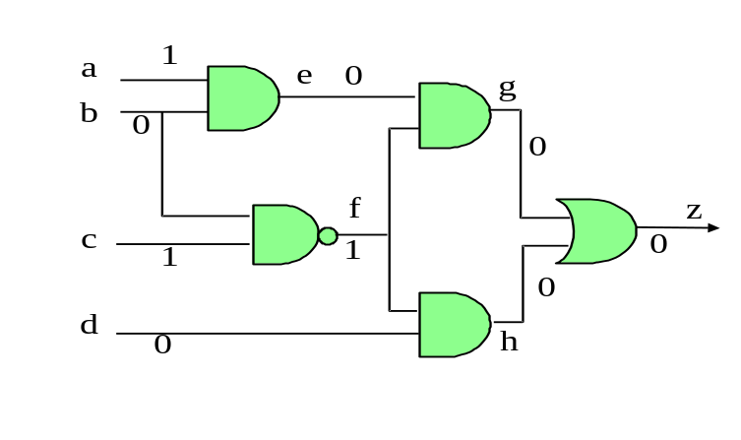
- (15%) Consider a Boolean function Z = AB + BC + CA.
    - Compute the Boolean difference dZ/dA. (8%)
    - Derive the complete test set for A stuck-at-0. (7%)

- (20%) Derive a test sequence for signal f stuck-at-1 fault in the following sequential circuit.
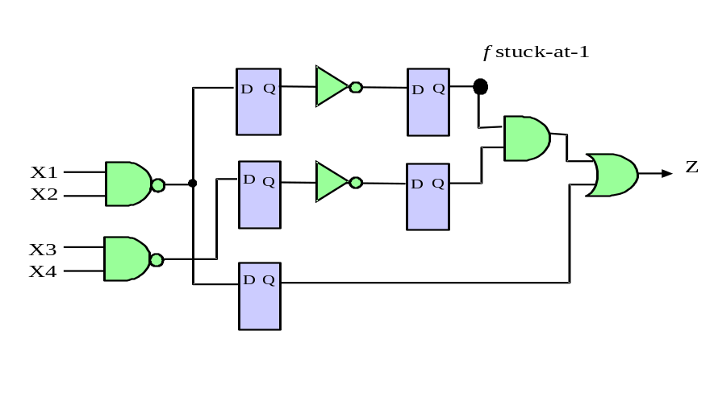
- (15%) Consider the combinational circuit below.
    - Characterize the legal (or valid) input/output combinations of G1 as a Boolean function in product-of-sum form (POS). The function takes signal a, b, d as the input variables. (5%)
    - Characterize the entire circuit’s input/output relation as a Boolean function in POS. (5%)
    - Characterize the test vectors of stem signal d stuck-at-0 fault as a Boolean equation. (Note that it is NOT required to solve the equation). (5%)
