REproducible papers with Rmarkdown

Bryce Mecum, [mecum@nceas.ucsb.edu](mailto:mecum@nceas.ucsb.edu)

Francois Lapointe, [flapointe@umass.edu](mailto:flapointe@umass.edu)

#Abstract

This is the first result of the satellite

# Intro

# Methods

Very simple methods for any dump ppl ax+b = y

# Results

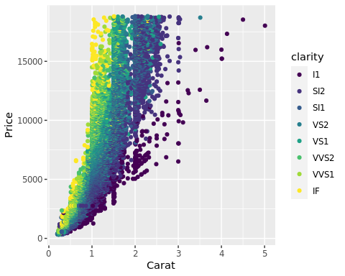 lm,

|  |  |  |  |  |
| --- | --- | --- | --- | --- |
| term | estimate | std.error | statistic | p.value |
| (Intercept) | -2256.36 | 13.06 | -172.83 | 0 |
| carat | 7756.43 | 14.07 | 551.41 | 0 |

We found that hte slope was ‘r round(mod$coefficients[“carats”][[1]]’

/[/sum_{i=1}^{N}{2}log(i)]

# Discussion

#Refenreces