AgentSim — Technical Documentation
Autonomous Hypothesis-Driven Simulation for Scientific Research
v0.1.0 • Python ≥ 3.11 • claude-agent-sdk + Pydantic

1. Overview
AgentSim orchestrates seven specialized LLM agents in an iterative loop to autonomously design, execute, and evaluate scientific simulations. A user provides a natural-language hypothesis and optional data files; the system formalizes the hypothesis, generates runnable simulation code, executes it, evaluates results, and decides whether to iterate or conclude — all without human intervention.

Core Design Properties
Immutable state: All models are frozen Pydantic objects. Transitions return new instances; nothing is mutated.
Domain-agnostic: Not tied to any simulation domain. Agents discover available packages at runtime.
Self-terminating: The Analyst agent decides when confidence is sufficient or diminishing returns are reached.
Literature-grounded: A literature survey runs first and its context flows into every subsequent agent prompt.

2. Architecture
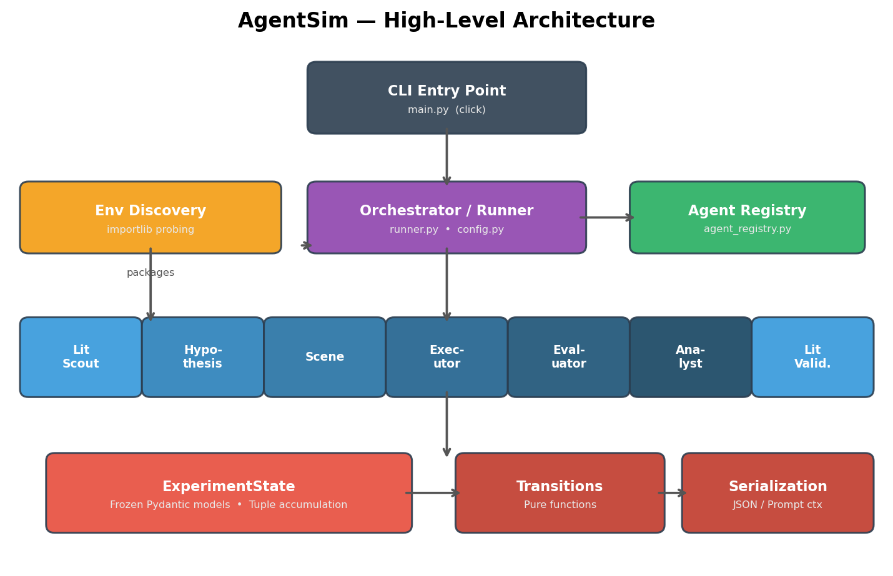

Layer Summary
Layer | Modules | Responsibility
CLI | main.py | Click commands: run, interactive
Orchestrator | runner.py, config.py | Sequences phases, manages budget, persists state
Agents | 7 agent modules + registry | LLM-backed phases with typed JSON output
State | models.py, transitions.py,  serialization.py | Frozen models, pure transitions, prompt serialization

3. Experiment Lifecycle
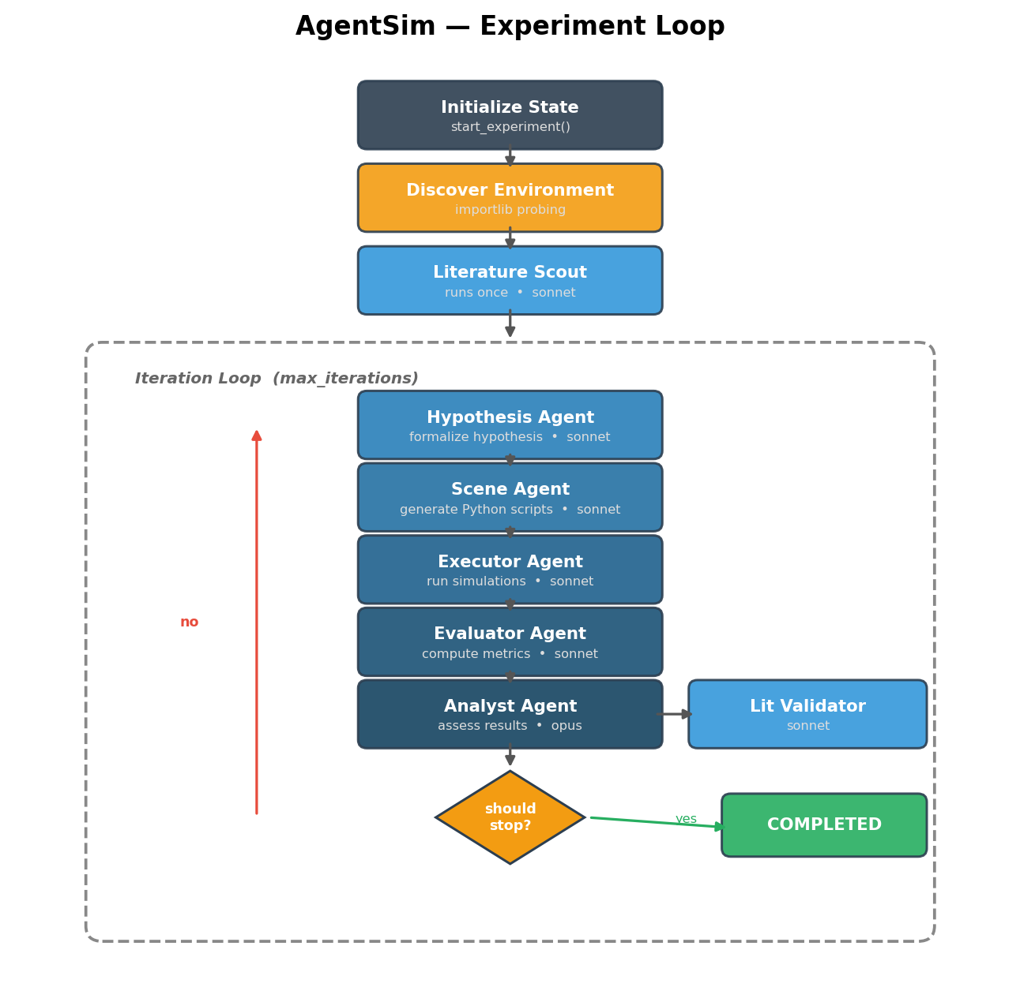

Phase Sequence
Each iteration runs six agent phases in strict order. The Literature Scout runs once before the loop. Each phase is a separate query() call to the claude-agent-sdk, keeping context windows clean.
# | Agent | Model | Output
0 | Literature Scout | sonnet | LiteratureContext (papers, methodology notes)
1 | Hypothesis | sonnet | Structured Hypothesis (variables, params, predictions)
2 | Scene | sonnet | SceneSpec[] — complete runnable Python scripts
3 | Executor | sonnet | ExecutionResult[] — stdout, stderr, output paths
4 | Evaluator | sonnet | EvaluationResult[] — metrics, artifacts
5 | Analyst | opus | AnalysisReport — confidence, should_stop decision
6 | Literature Validator | sonnet | LiteratureValidation — confidence adjustment

4. State Machine
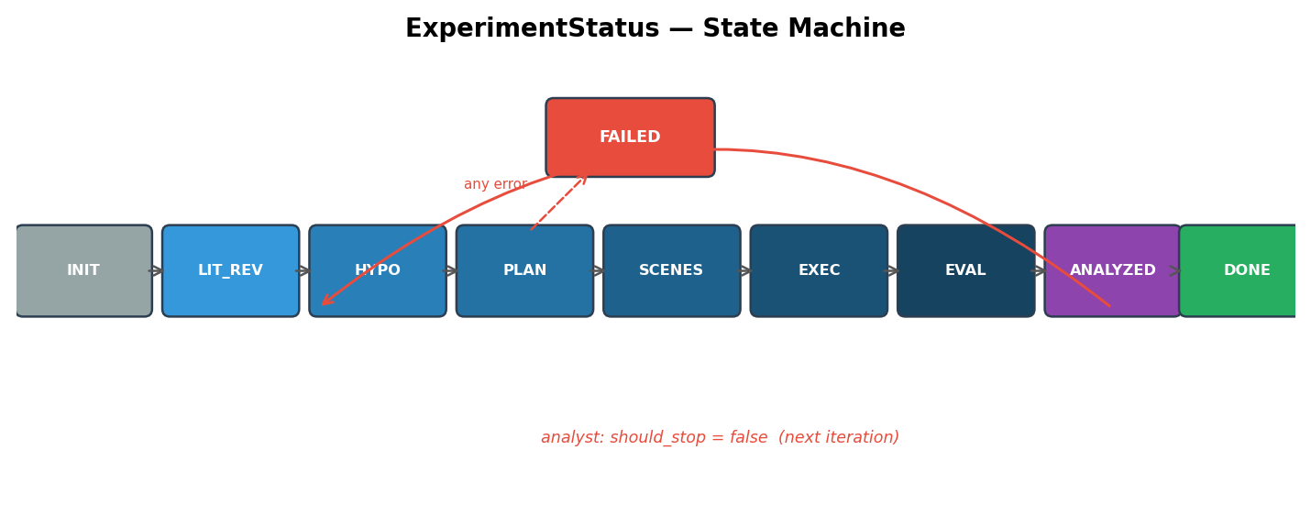
State transitions are pure functions in transitions.py: fn(state, data) → new_state via model_copy(update={...}). Results accumulate in tuples — scenes, execution_results, evaluations, and analyses are appended, never replaced. This preserves full experiment history.

Key Transition Behaviors
- add_analysis() has dual responsibility: increments iteration counter AND sets status to COMPLETED (should_stop=true) or ANALYZED (should_stop=false).
- start_experiment() auto-detects file types from extensions (e.g., .stl → mesh, .yaml → config).
- State >50KB is truncated for prompts: counts replace full lists, only latest analysis is kept.

5. Data Model
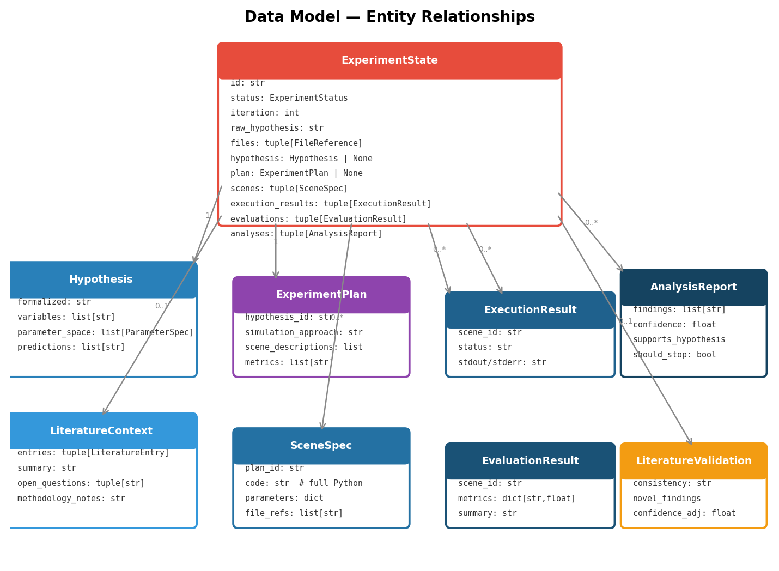
ExperimentState is the single top-level envelope. All nested models are frozen (immutable). Multi-valued fields use tuple[T, ...] for immutability. Each agent phase reads serialized state and returns structured JSON that is validated into the appropriate Pydantic model.

6. Environment Discovery
At startup, discover_environment() probes for known packages (numpy, scipy, mitsuba, opencv, matplotlib, etc.) using importlib.util.find_spec — no imports executed. Results are formatted into a human-readable string baked into agent prompts so they know exactly which packages and versions are available when generating simulation code.
Custom packages can be added via OrchestratorConfig.extra_packages (dict mapping display_name → import_name).

7. JSON Extraction Strategy
Agent responses may contain prose around JSON. The runner uses a four-tier fallback:
1. Direct JSON.parse of full response text
2. Extract from markdown code fences (```json ... ```)
3. Find content between first { and last }
4. Phase-specific fallback (e.g., Analyst defaults to should_stop=true)

8. Configuration
Parameter | Default | Description
max_iterations | 5 | Maximum experiment loop iterations
max_budget_usd | 10.0 | Total budget across all phases
max_turns_per_phase | 30 | Max agent turns per phase
output_dir | ./output | Directory for state and artifacts
save_intermediate_state | True | Persist final_state.json
extra_packages | {} | Additional packages for discovery

9. Quick Reference

Commands
Command | Purpose
pip install -e '.[dev]' | Install with dev dependencies
pytest | Run all tests
pytest tests/unit/ | Unit tests only
pytest tests/unit/test_file.py::test_name | Single test
ruff check src/ tests/ | Lint
agentsim run "hypothesis" | Run experiment
agentsim interactive | Interactive REPL

Dependencies
Core: claude-agent-sdk, pydantic ≥2.0, anyio, click, structlog. Dev: pytest, pytest-asyncio (asyncio_mode=auto), ruff, fastmcp.

