**Report Of Web assignment**

**University Of Northampton**

**Module Code : CSY1018**

**Name Of Student : Sunil Thapa**

**UN Id : 17421492**

**NAMI, Jorpati**

**Table of Contents :**

1. Introduction
2. Design

* **Wireframes**
* **Wireframe of my homepage**
* **Wireframe of my bio page**
* **Wireframe of my contact page**
* **Wireframe of my CV page**
* **Wireframes(responsiveness)**
* **Wireframe of my homepage**
* **Wireframe of my bio page**
* **Wireframe of my contact page**
* **Wireframe of my CV page**
* **Images that I have created**

3. Evidence of good practice(loading time period)

4. Progression report

5. References

1. Introduction :

My WebPages contain an introduction on me with skills that I possess. I also have created a contact page through which viewers can contact me. Before creating my website I took few look at internet about how could a personal website must look like and I gained ideas from following sites:

* http://kellyedmunds.co.uk/
* http://joel.sh

2. Design :

This is my overall web page design .

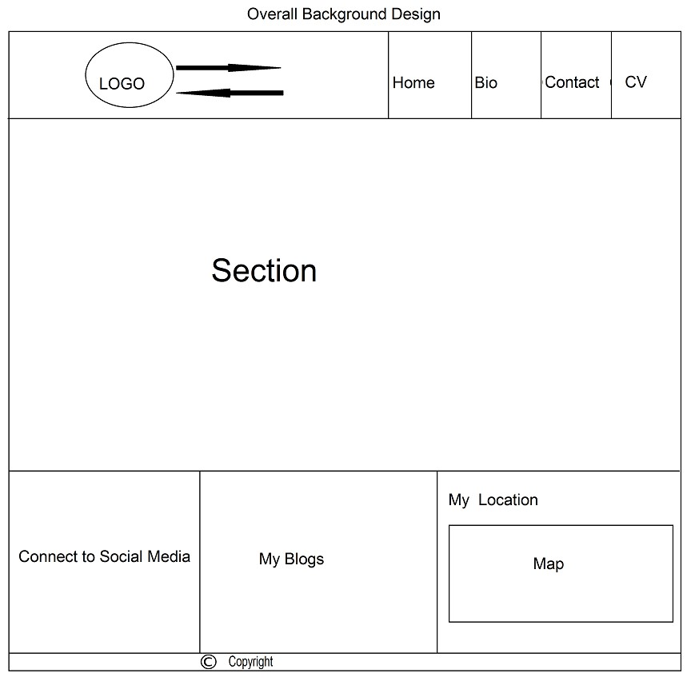

* **Wireframes**
* **Wireframe of my homepage**

This is initial wireframe of my homepage.

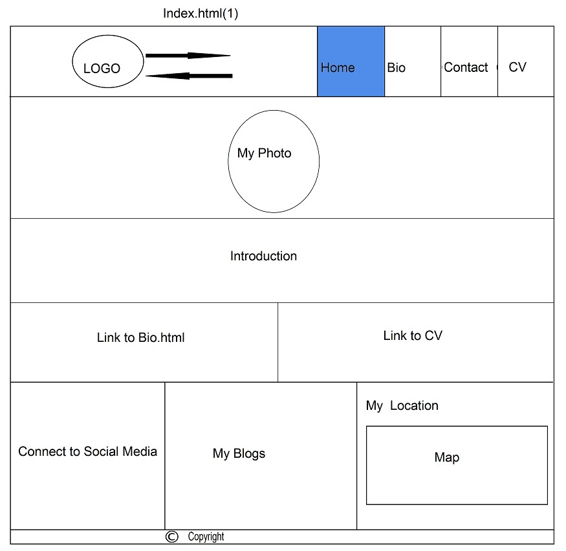

This is final design of my home page

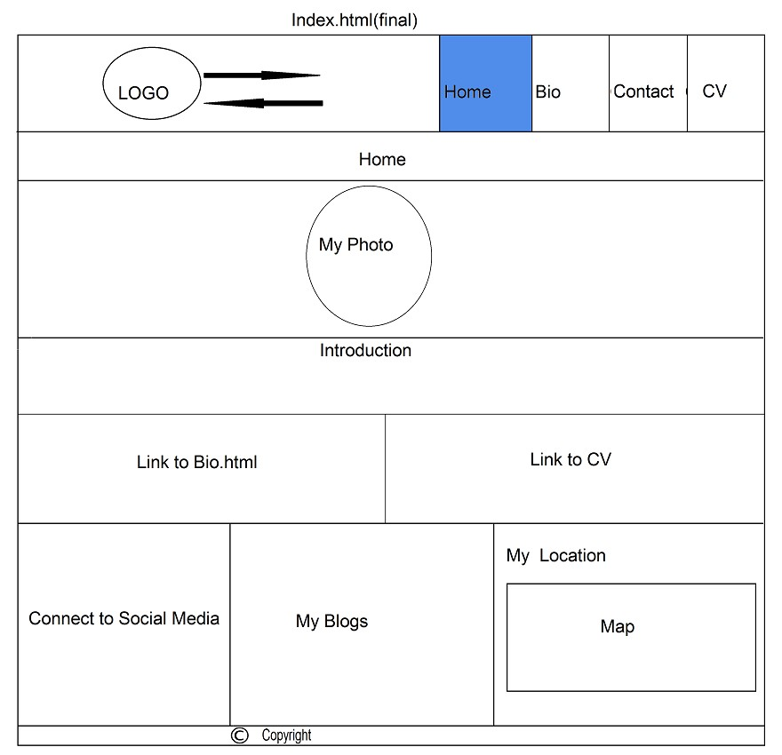

* **Wireframe of my bio page**

This is wireframe of biography page

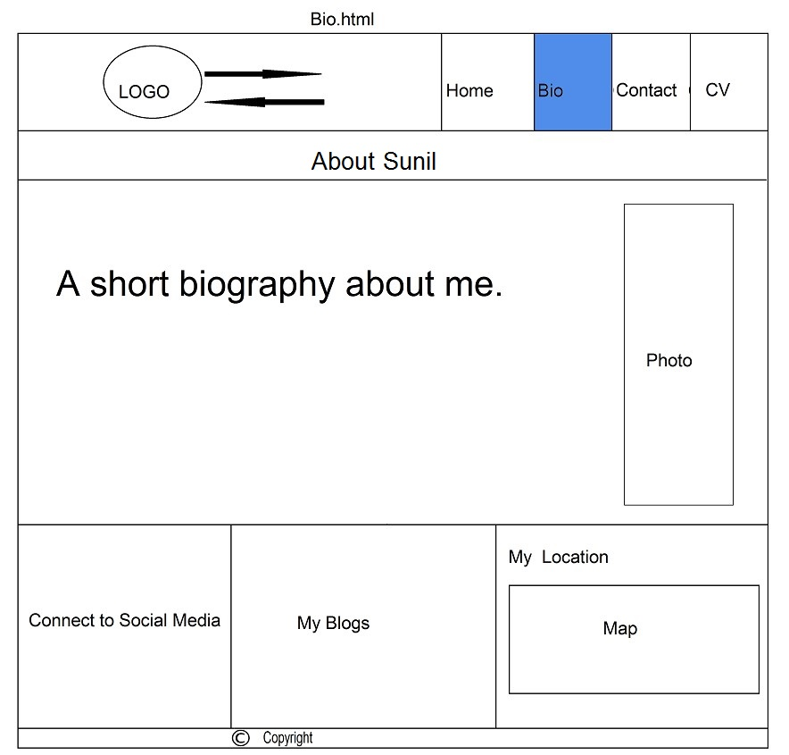

* **Wireframe of my contact page**

This is wireframe of contact page through which viewers can contact me.

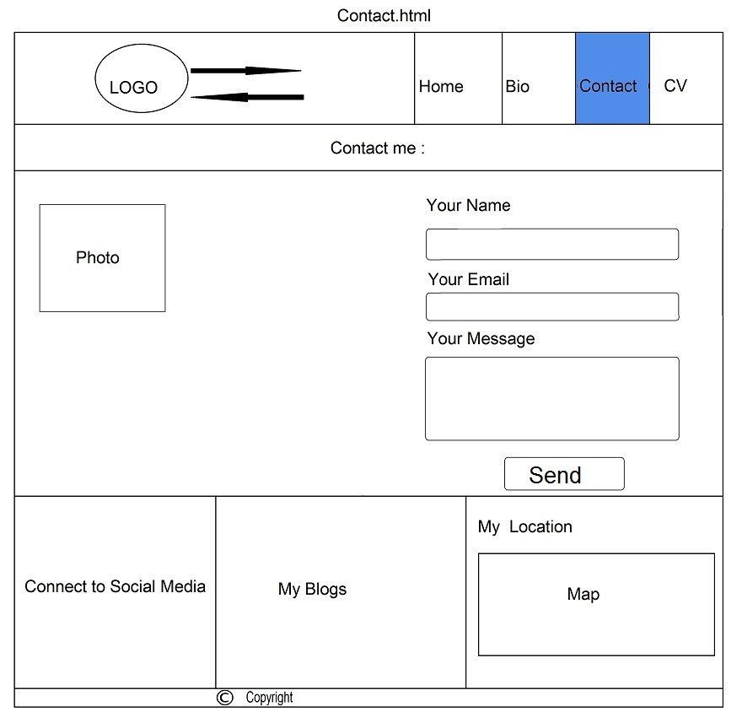

* **Wireframe of my CV page**

This is my curriculum vitae page

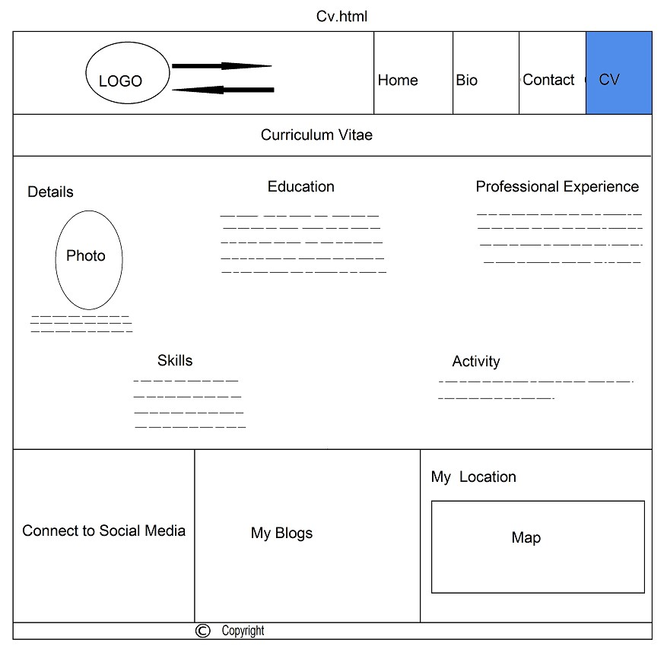

* **Wireframes(responsiveness)**
* **Wireframe of my homepage**

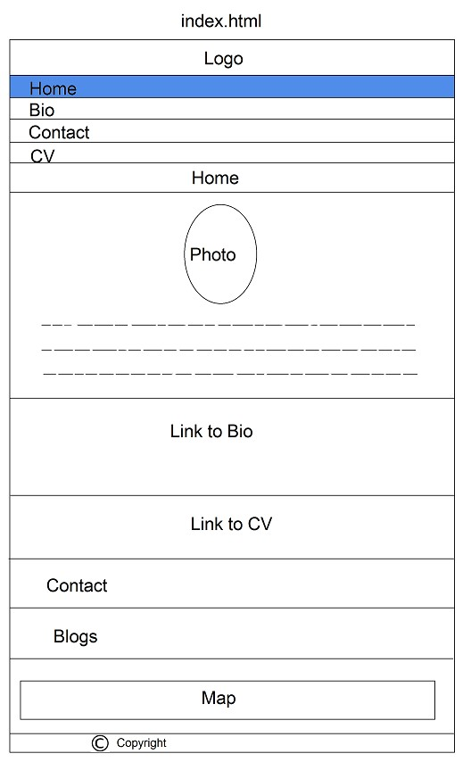

* **Wireframe of my bio page**

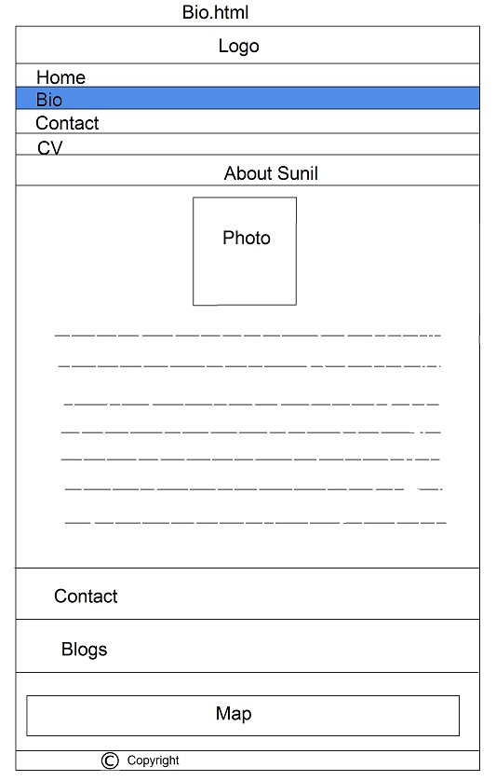

* **Wireframe of my contact page**

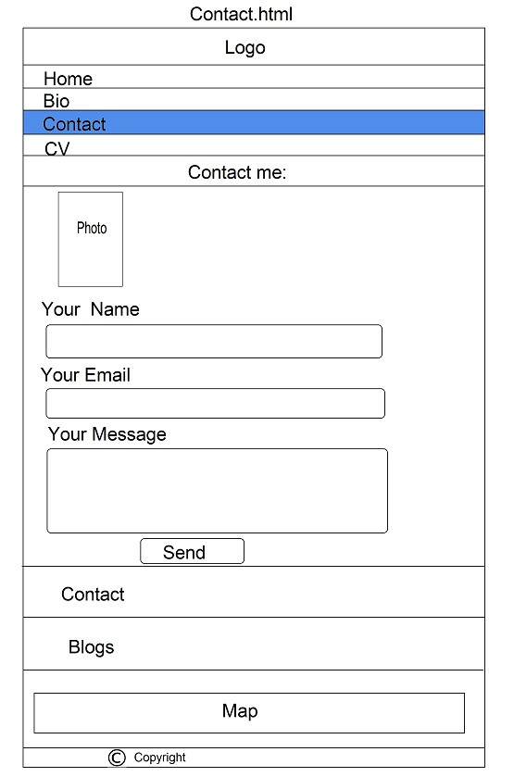

* **Wireframe of my CV page**

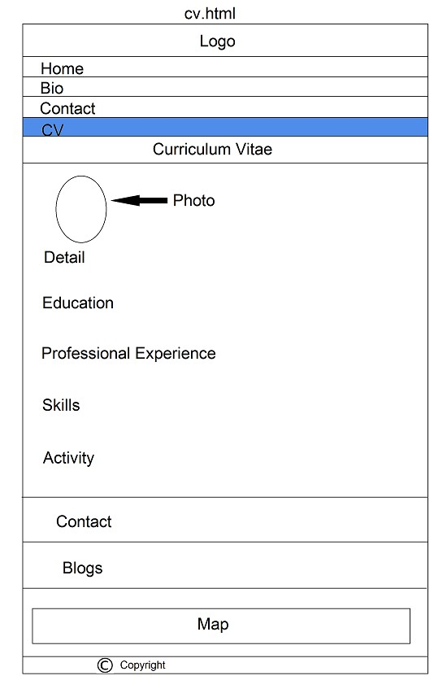

* **Images that I have created**

Here are few image that I have created using Photoshop to stylish my web pages.



These are used in home page to link my page to CV and biography. So would make more user-friendly and more interactive while visiting on this page.

This is my self made logo. This 'S' indicates my initial first name. I have animated my logo to flip around meanwhile moving it horizontally so that it lures attention of visitors visiting on my page.



3. Evidence of good practice(loading time period) :

It is more obvious to use good practices while working. This helps other programmer to understand intention of using particular codes more easier. I also have followed good practices while designing webpage. I have included comments on tags(HTML + CSS) so that it helps non-programming person to understand intention of using particular codes. I also have tested my page loading speed on internet. It is important that contents that are going to be displayed on internet should have less size so that it could load up fast. Here are few screenshots that explains my page load-up speed.

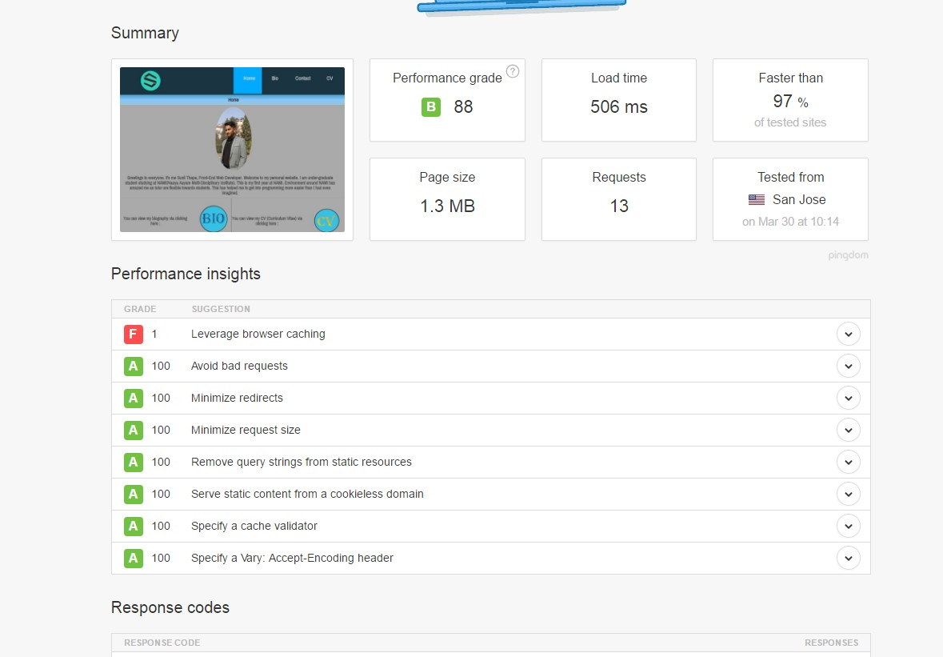

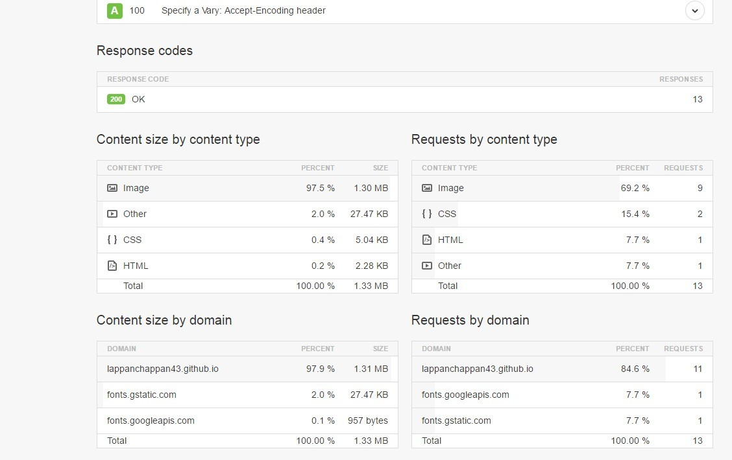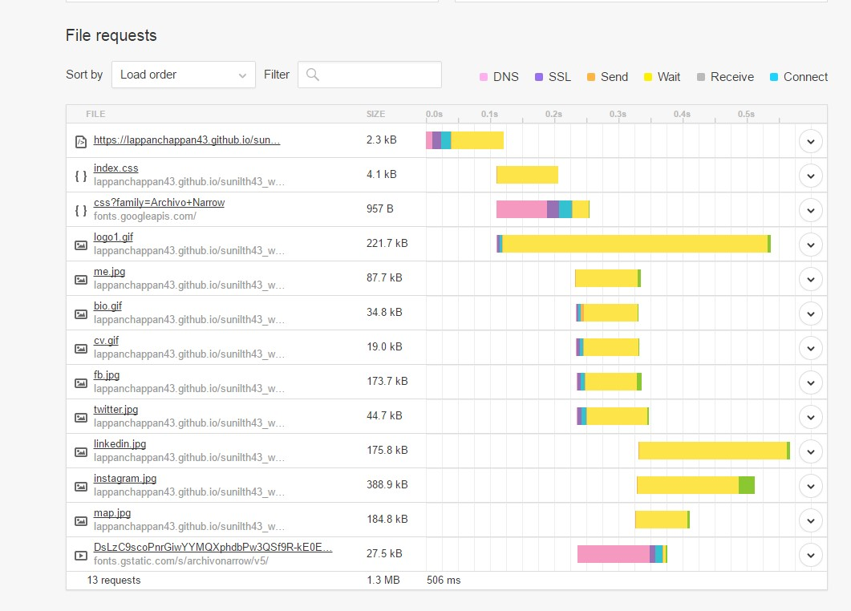

I even have tested validation of codes that I have used while making my WebPages. Here are screenshots that proves no errors.(limitation provided by criteria of assignment)

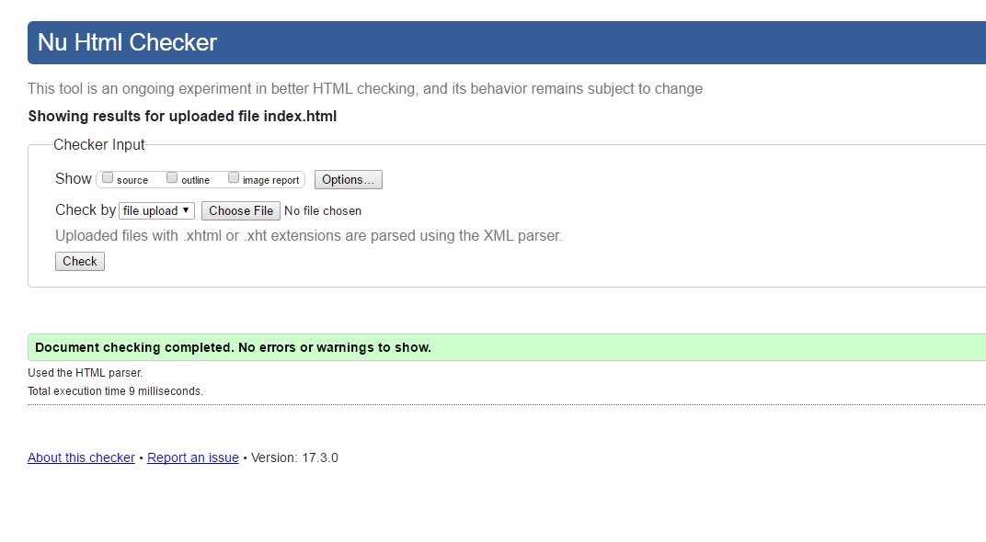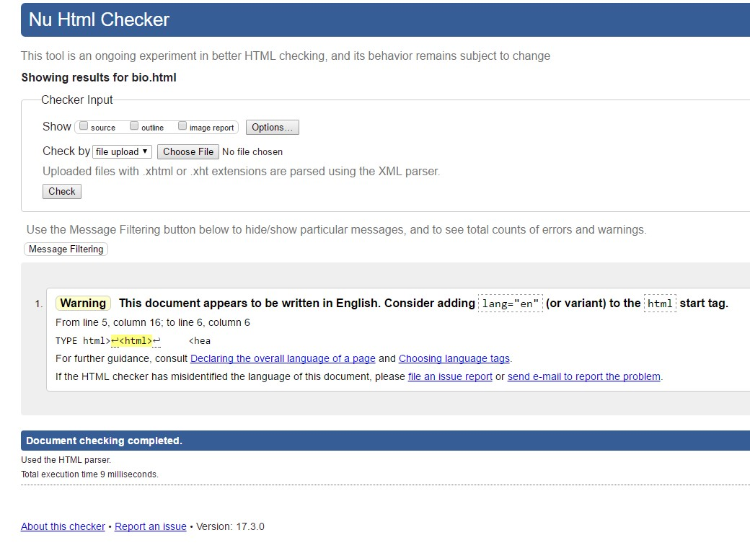

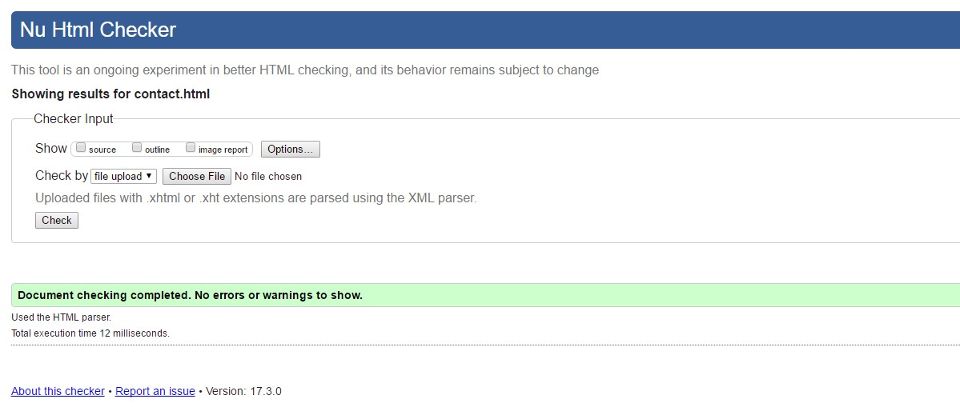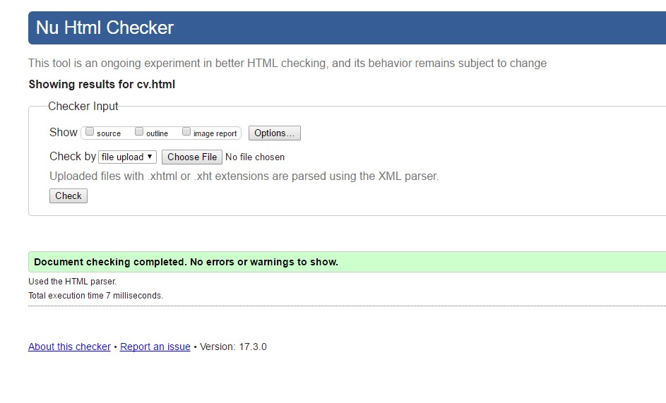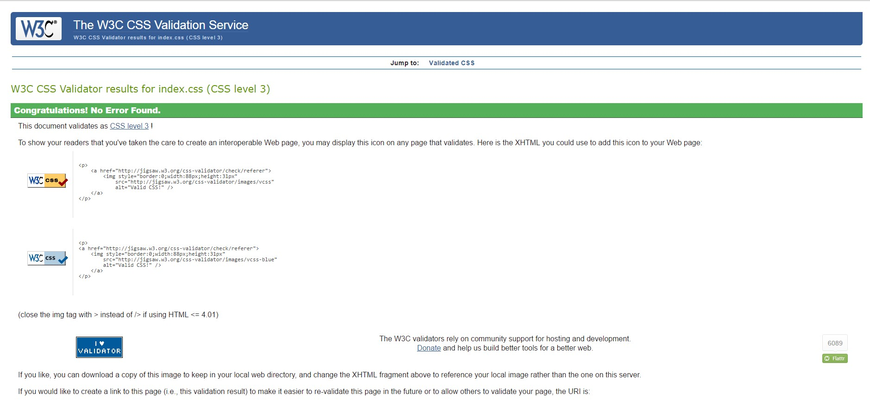

4. Progression report :

I have pretty much focused a lot of time while making these pages. I nearly worked 3-4 hours a day and 3 days a week. There were many problems that I faced during I introduced animations on my pages. But I at least came over those problems by giving more time to understand nature of browser, co-ordinates, time phases and obviously on codes. These were mine keys of success over my problems.

**Week 1-2 :**

Actually I gave my first 2 weeks on developing wireframes and on researching on topics like : best personal websites, personal website templates, and so on. Finally I created a navigation bar and footer on these weeks.

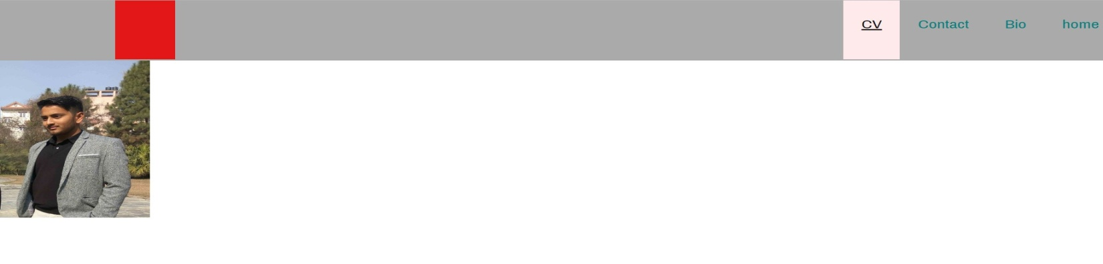

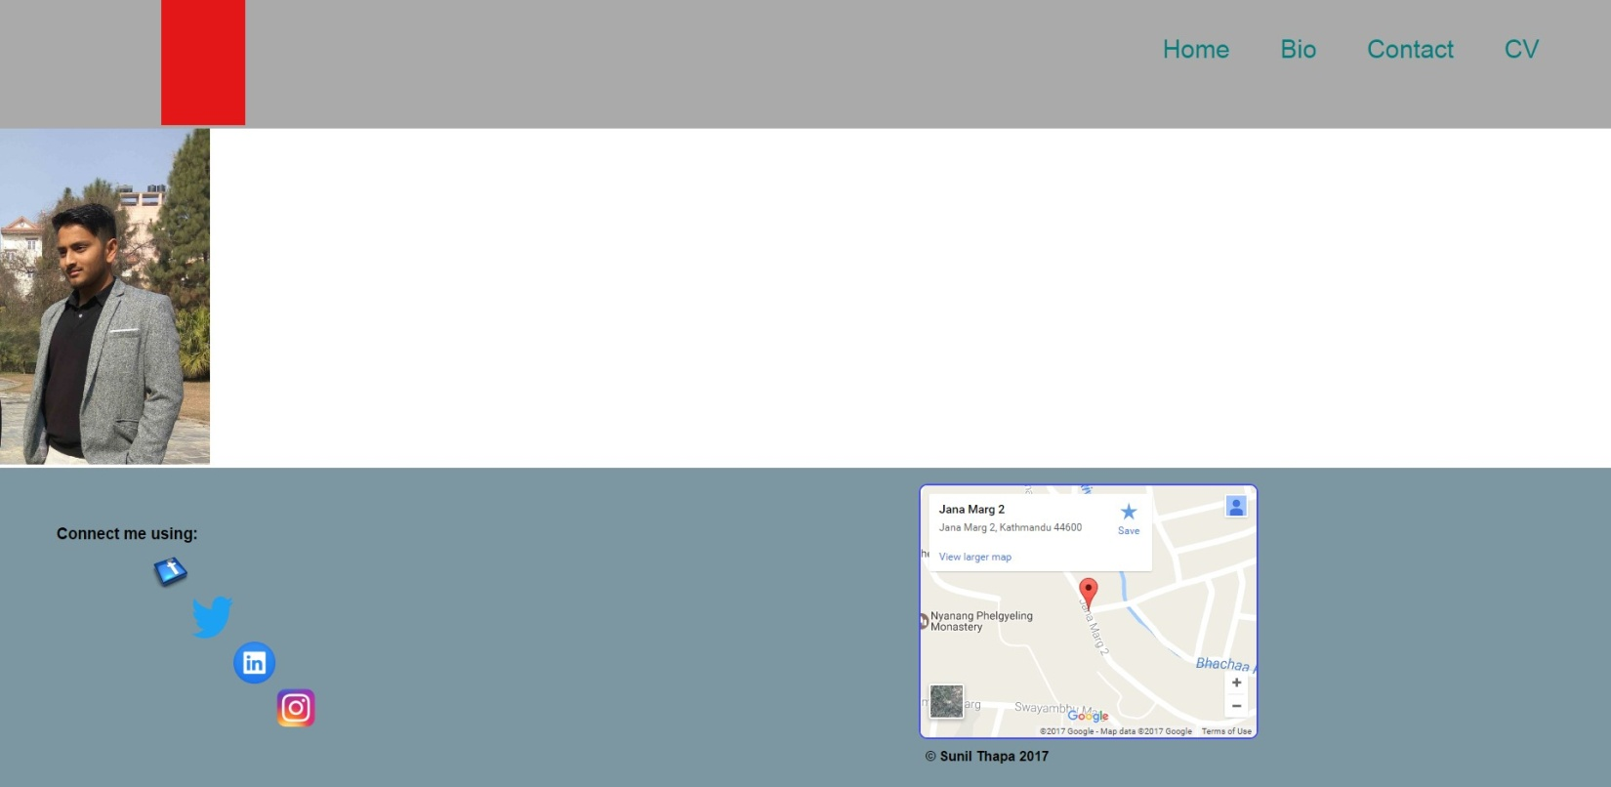

**Week 3-4 :**

In week 3 and 4, I actually created a template that would be common for all 4 web pages so that it would look more consistency. I designed deep layouts for home, contact and CV pages and I had left biography page for coming days. There is even a indicator to acknowledge viewers on page that they are in at the moment. Here is look to layouts of my pages during week 3 and 4.

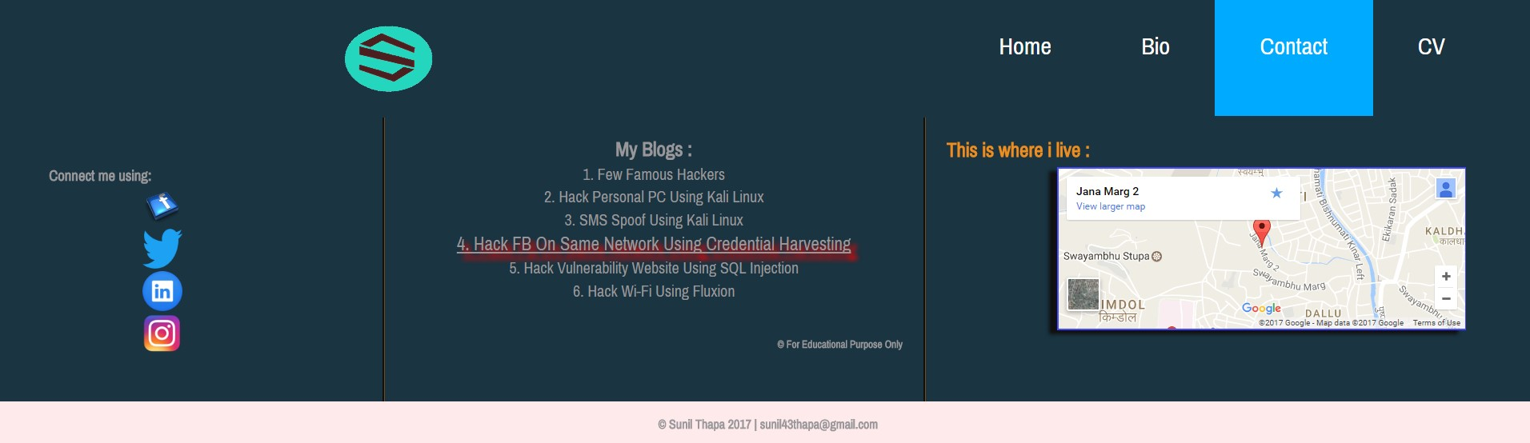

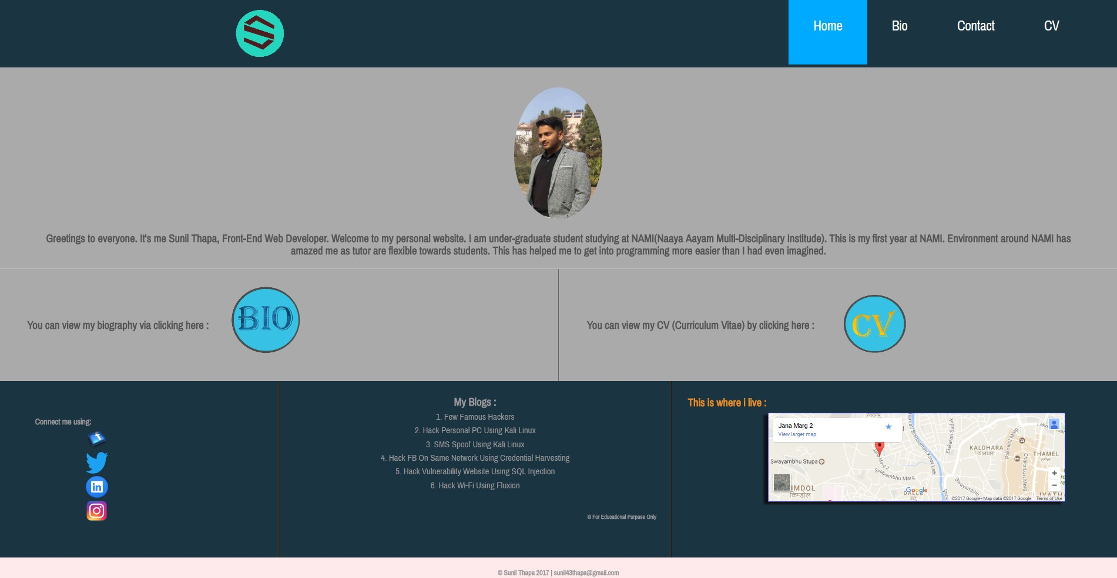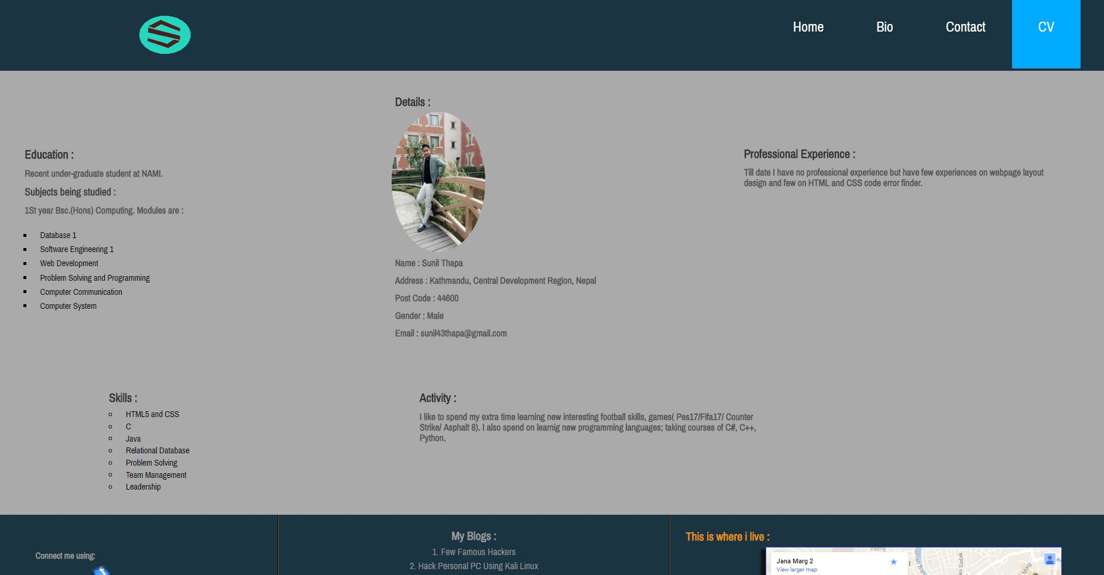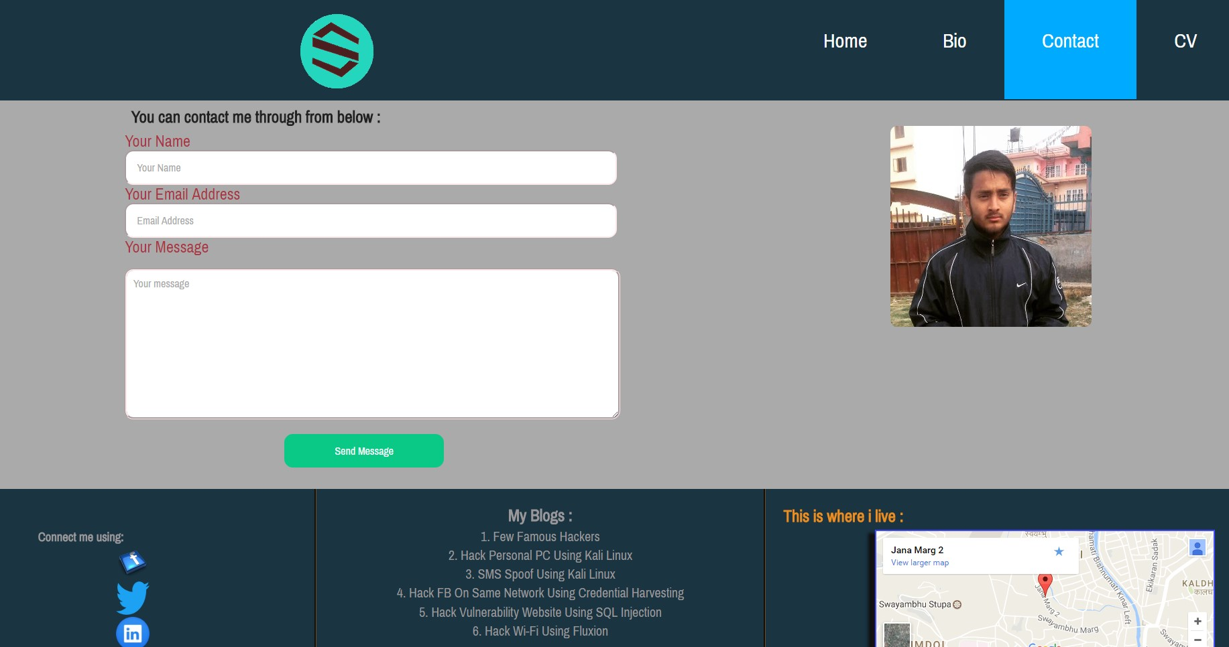

**Week 5-6 :**

On week 5 and 6, I eventually tried to make pages responsive and somewhat I did it. Here is look to few screenshots :

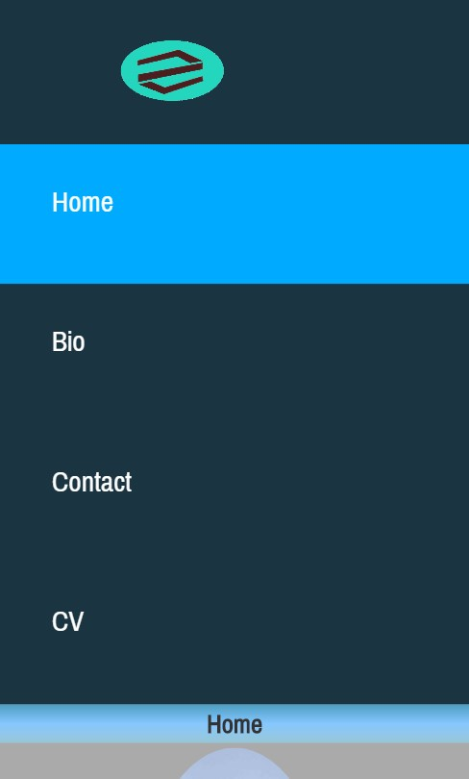

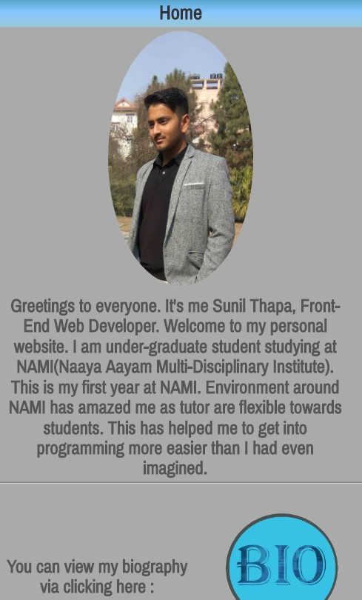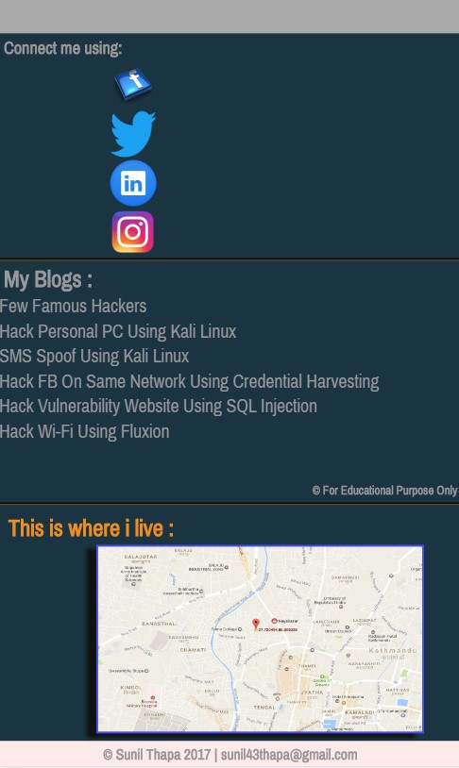

5. References :

* Pingdom[2017],