Creating tables

neighbourhood
CREATE TABLE neighbourhood (
Neighbourhood_ID INT NOT NULL,
Neighbourhood_Name varchar(50) NOT NULL,
PRIMARY KEY(Neighbourhood_Id));

Importing the data
-- data can only be loaded from wamp folder
LOAD DATA INFILE 'C:/wamp64/tmp/Neighbourhoods.csv'
INTO TABLE neighbourhood
FIELDS TERMINATED BY ','
ENCLOSED BY '"'
LINES TERMINATED BY '\r\n'
IGNORE 1 ROWS;
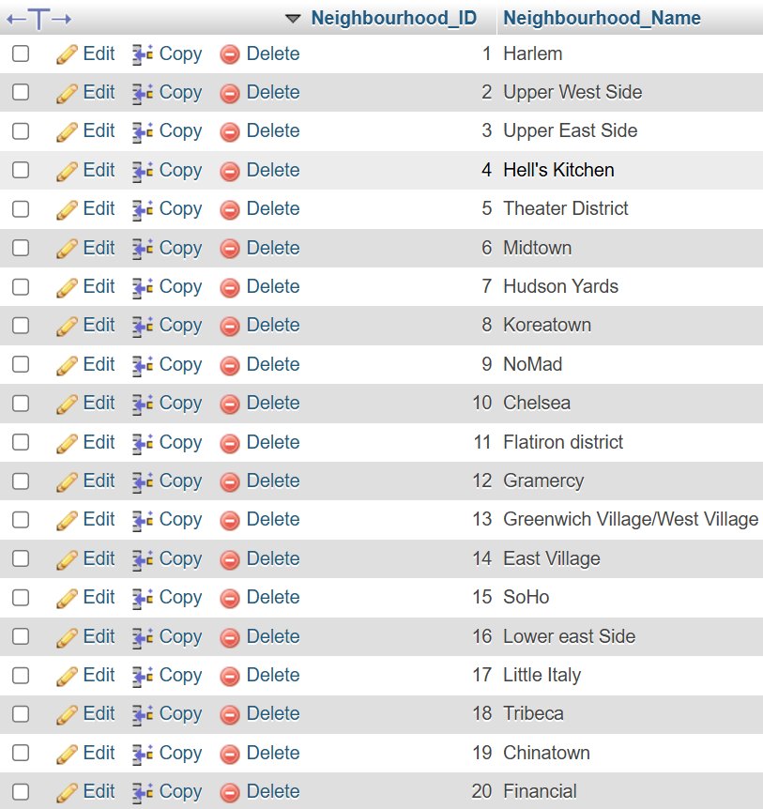

cityblock
CREATE TABLE CityBlock (
Block_ID INT NOT NULL,
Neighbourhood_ID INT NOT NULL,
Population INT NOT NULL,
Infected_Count INT NOT NULL,
Recovered_Count INT NOT NULL,
PRIMARY KEY (Block_ID), FOREIGN KEY(Neighbourhood_ID) REFERENCES neighbourhood (Neighbourhood_ID) );
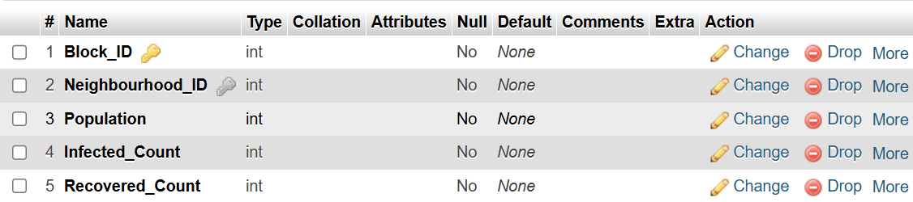
Importing the data
LOAD DATA INFILE 'C:/wamp64/tmp/CityBlock.csv'
INTO TABLE cityblock
FIELDS TERMINATED BY ','
ENCLOSED BY '"'
LINES TERMINATED BY '\r\n'
IGNORE 1 ROWS;
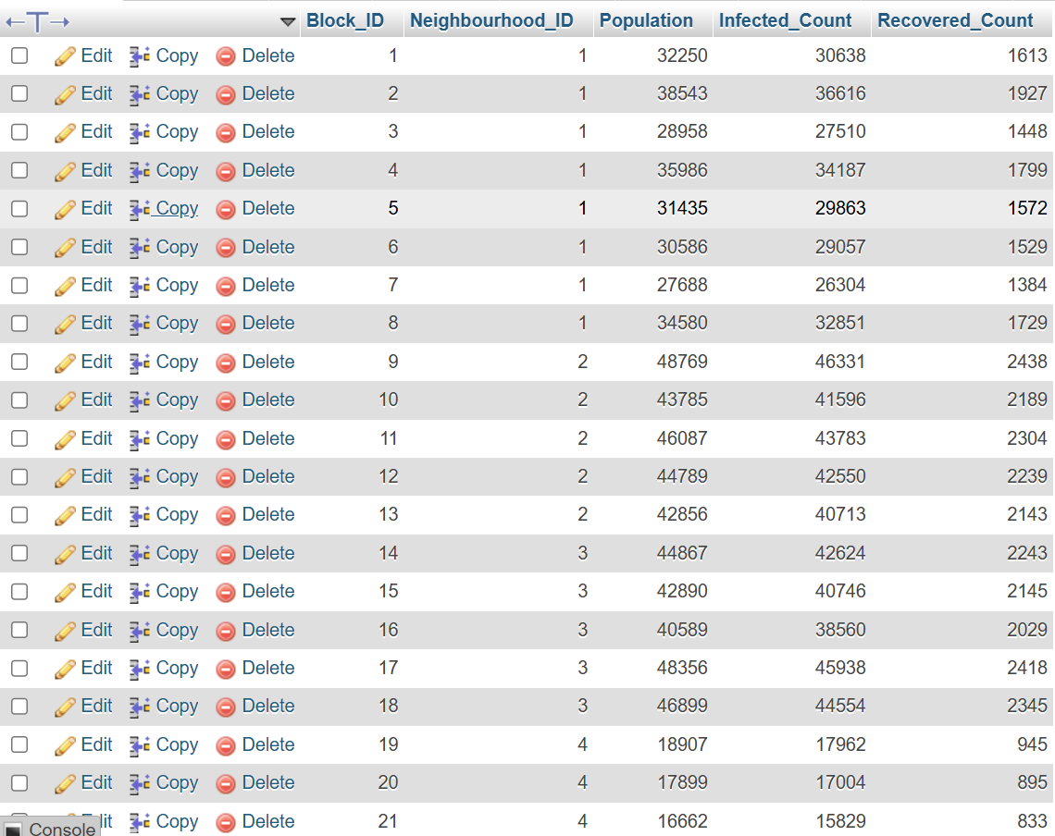

Infectionevent
CREATE TABLE InfectionEvent (
Event_Number INT NOT NULL,
Block_ID INT NOT NULL,
People_Infected INT NOT NULL,
Event_Description VARCHAR(255) NOT NULL,
PRIMARY KEY (Event_Number), FOREIGN KEY(Block_ID) REFERENCES CityBlock (Block_ID) );
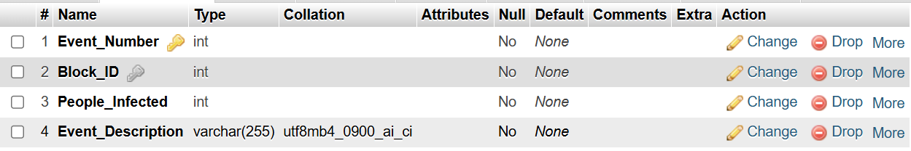
Importing the data
LOAD DATA INFILE 'C:/wamp64/tmp/InfectionEvent.csv'
INTO TABLE infectionevent
FIELDS TERMINATED BY ','
ENCLOSED BY '"'
LINES TERMINATED BY '\r\n'
IGNORE 1 ROWS;
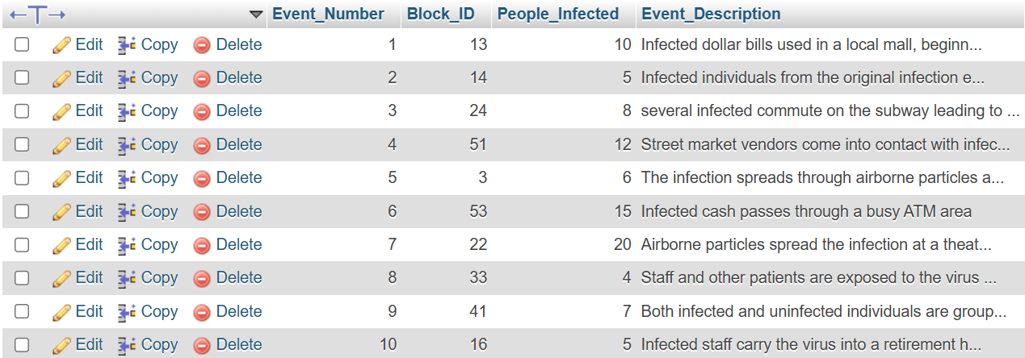

Transmission
CREATE TABLE transmission (
Event_Number INT NOT NULL,
Method VARCHAR(30) NOT NULL,
-- following will act as our compound key
PRIMARY KEY (Event_Number, Method),
FOREIGN KEY (Event_Number) REFERENCES InfectionEvent (Event_Number));
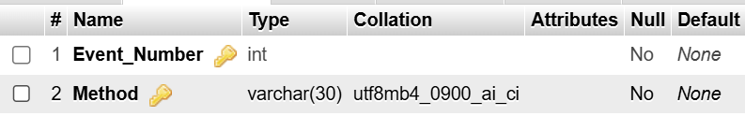
Importing the data
LOAD DATA INFILE 'C:/wamp64/tmp/transmission.csv'
INTO TABLE transmission
FIELDS TERMINATED BY ','
ENCLOSED BY '"'
LINES TERMINATED BY '\r\n'
IGNORE 1 ROWS;
