Home Screen. The Register and Sign In button will be visible if the application is first installed.

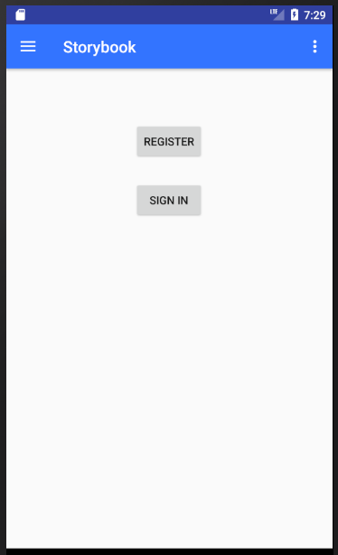

Navigation Drawer. This will not be enabled if the user hasn’t register or sign in.

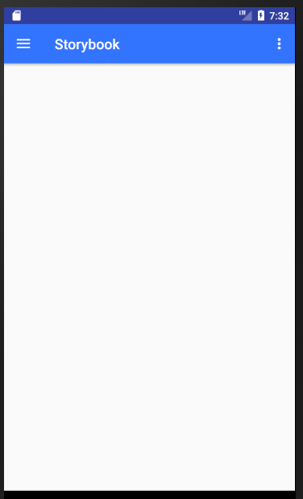 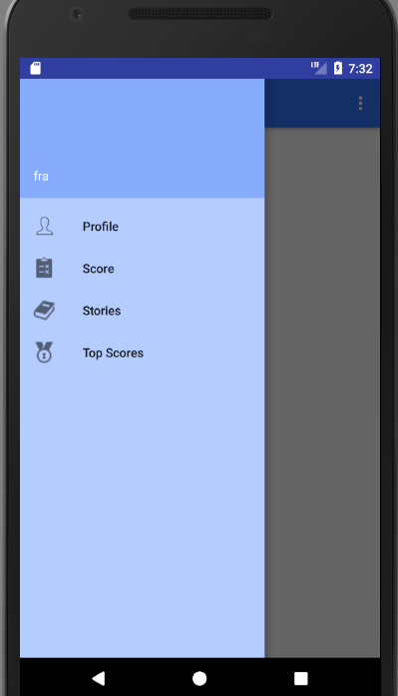

Profile. Username is printed.

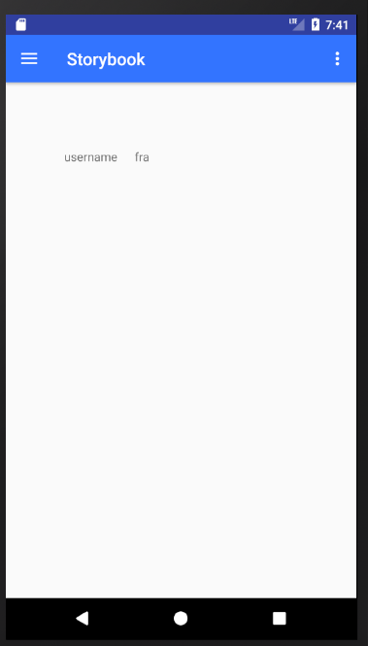

Score. All Scores taken by the user will be printed here.

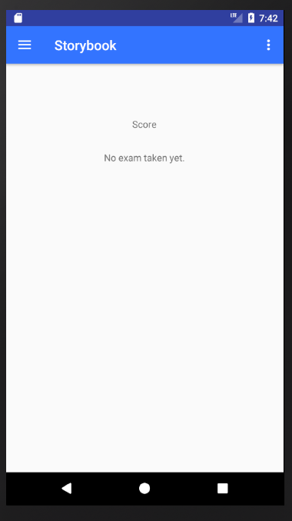

Stories. First screen will be the levels.

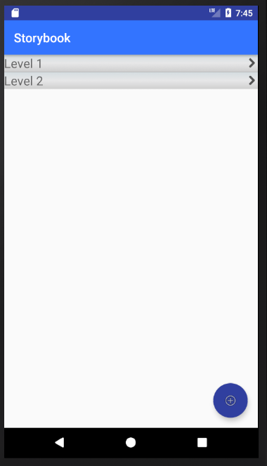

To delete a level just hold the level row.

To add additional level click the Blue circle button. Only admin users can see this button.

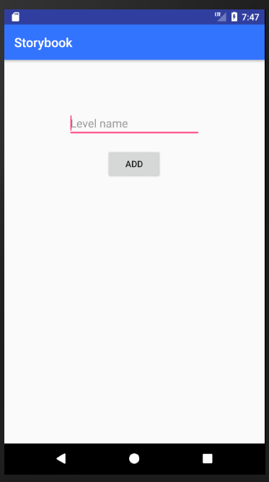

To add a level, enter level name then hit ADD button.

Click one of the Level and all stories created under this level will be shown.

To delete this story just hold the story row.

 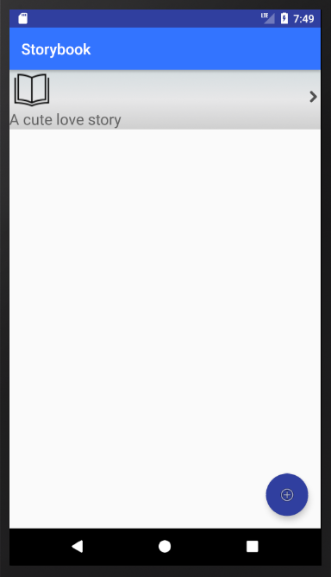

Under stories, a blue circle button is visible to add a story. Only admin users can see this button.

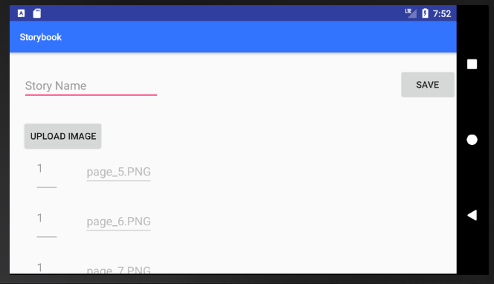

Story Name is a required field.

Click Upload Image to upload the pages of the story.

Important: the number on the left side of the uploaded images will be the page number.

After all required fields and validation have met. Click Save

Click one of the story.

 Story title is printed on the upper left, page number on lower left, Add Exam Question on the upper right and the page uploaded is shown in the middle of the page. To move from another page, swipe left or right.

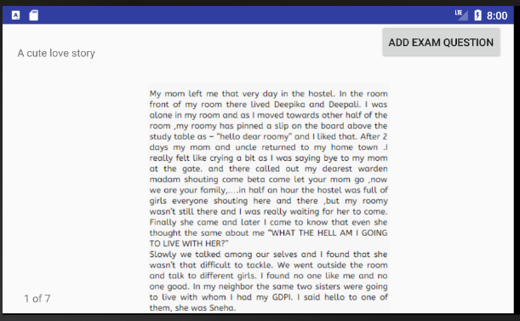

To add an exam to a story, at least one question must be added. Enter the Question details field. Five answers can be added to a question, the user can add one to five answer choices. The Answer (Option 1) field is required to identify which answer option is the correct answer. Click Save And Exit, will save the question then exit the current page. Click Save and Add More will save the current question then clear all fields to be filled-up.

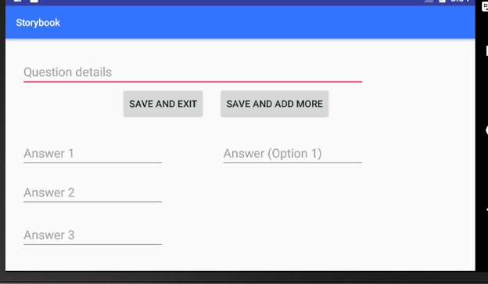

At the end of the page story, if at least one exam question is added the Take Exam button will be visible.

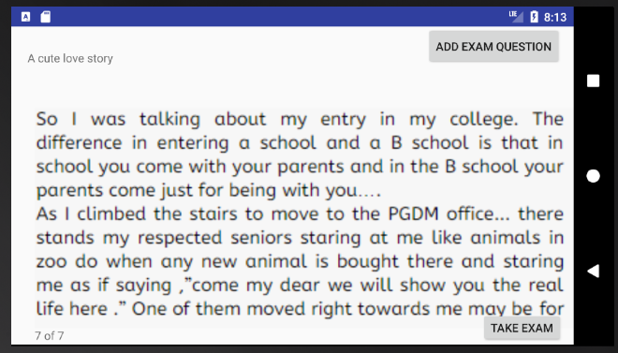

Exam Page. Choose the answer then click submit to save the exam. Swipe left or right to move to another page.

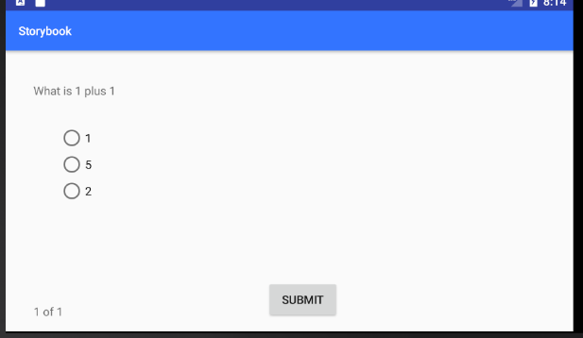

Top Scores. Top 10 users will be printed in this screen.

