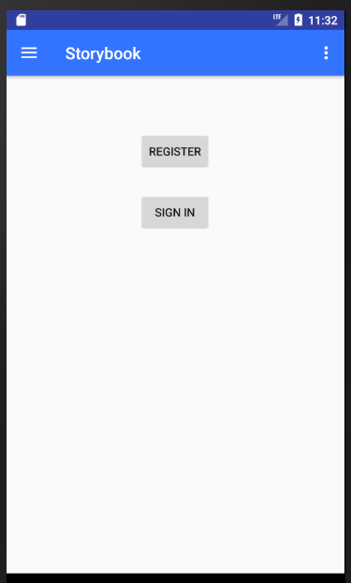

Layout - Storybook\app\src\main\res\layout\app_bar_main.xml

<**android.support.v7.widget.Toolbar  
 android:id="@+id/toolbar"  
 android:layout_width="match_parent"  
 android:layout_height="?attr/actionBarSize"  
 android:background="?attr/colorPrimary"  
 app:popupTheme="@style/AppTheme.PopupOverlay"** />

Color - Storybook\app\src\main\res\values\color.xml - **colorPrimary**

Java - Storybook\app\src\main\java\com\read\storybook\MainActivity.java

Layout - Storybook\app\src\main\res\layout\content_main.xml

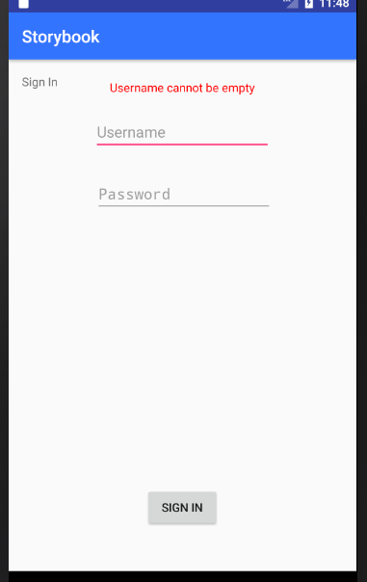

Layout - Storybook\app\src\main\res\layout\activity_sign_in.xml

Java - Storybook\app\src\main\java\com\read\storybook\SignInActivity.java

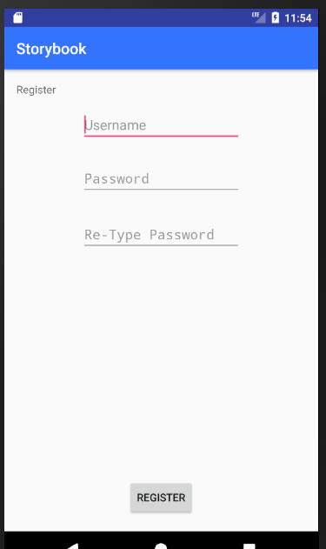

Layout - Storybook\app\src\main\res\layout\activity_register.xml

Java - Storybook\app\src\main\java\com\read\storybook\RegisterActivity.java

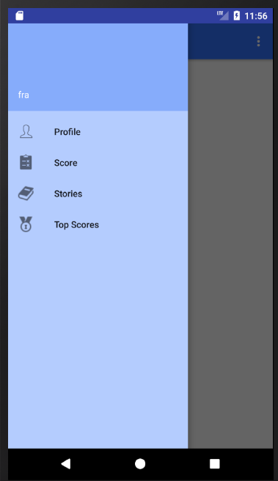

Color - Storybook\app\src\main\res\layout\activity_main.xml

**NavigationView android:background="#B4CCFE"**/>

Layout - Storybook\app\src\main\res\menu\activity_main_drawer.xml

Links

Storybook\app\src\main\java\com\read\storybook\MainActivity.java

**public boolean** onNavigationItemSelected(MenuItem item)

Java - Storybook\app\src\main\java\com\read\storybook\MainActivity.java

TextView name = (TextView)header.findViewById(R.id.headerName);

Layout - Storybook\app\src\main\res\layout\nav_header_main.xml

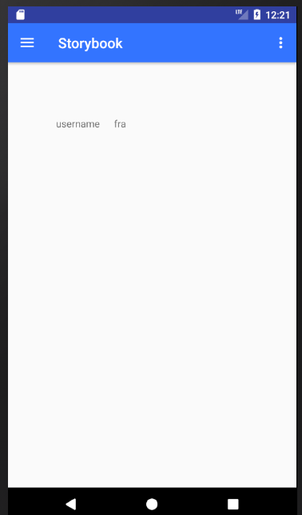

Java - Storybook\app\src\main\java\com\read\storybook\ProfileFragment.java

Layout - Storybook\app\src\main\res\layout\profile_layout.xml

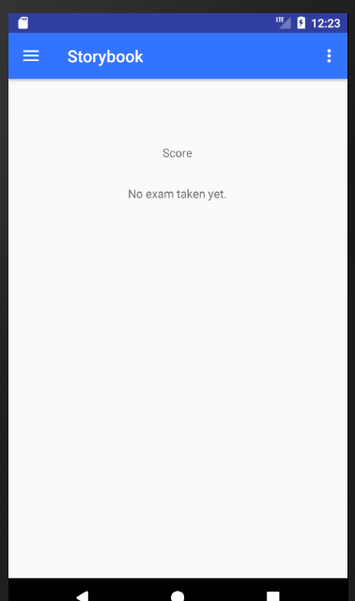

Java - Storybook\app\src\main\java\com\read\storybook\ScoreFragment.java

Layout - Storybook\app\src\main\res\layout\score_layout.xml

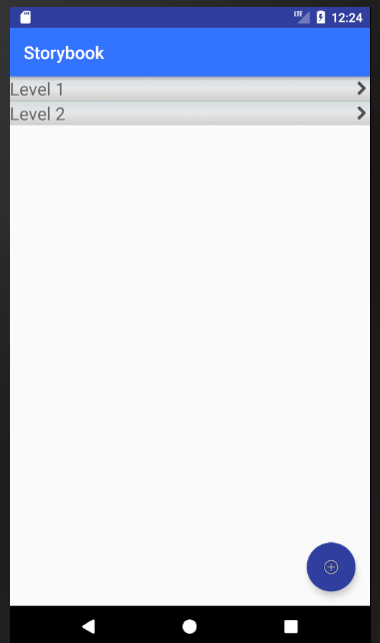

Java - Storybook\app\src\main\java\com\read\storybook\CustomAdapter.java

Layout - Storybook\app\src\main\res\layout\list_row.xml

Java - Storybook\app\src\main\java\com\read\storybook\LevelsActivity.java

Layout - Storybook\app\src\main\res\layout\activity_levels.xml

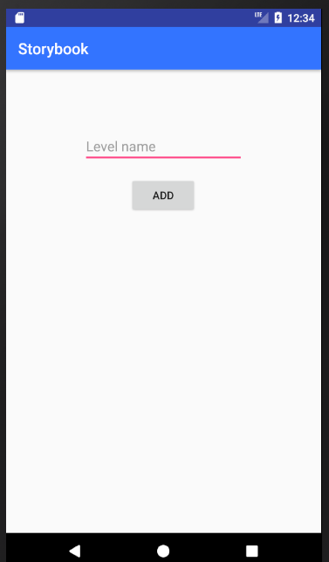

Layout - Storybook\app\src\main\res\layout\activity_level.xml

Java - Storybook\app\src\main\java\com\read\storybook\LevelActivity.java

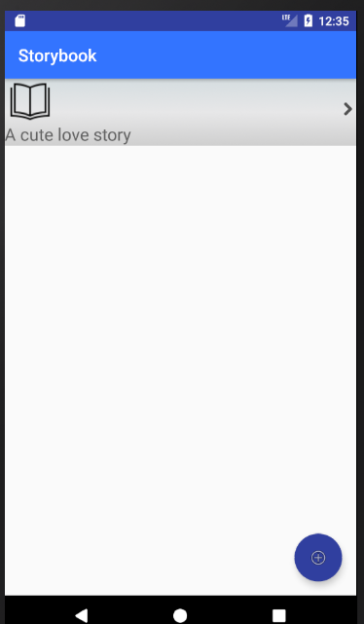

Layout - Storybook\app\src\main\res\layout\activity_stories.xml

Java - Storybook\app\src\main\java\com\read\storybook\StoriesActivity.java

Java - Storybook\app\src\main\java\com\read\storybook\CustomStoryAdapter.java

Layout - Storybook\app\src\main\res\layout\list_story_row.xml

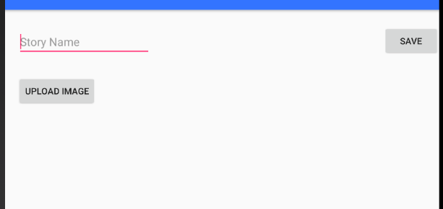

Java - Storybook\app\src\main\java\com\read\storybook\AddStoryActivity.java

Layout - Storybook\app\src\main\res\layout\activity_add_story.xml

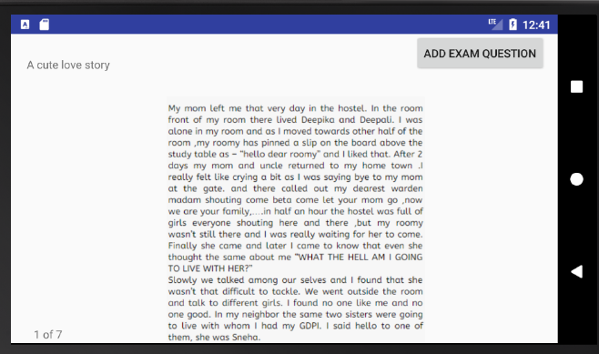

Java - Storybook\app\src\main\java\com\read\storybook\StoryActivity.java

Layout - Storybook\app\src\main\res\layout\activity_story.xml

Storybook\app\src\main\java\com\read\storybook\MyPageAdapter.java

Storybook\app\src\main\java\com\read\storybook\PageStoryFragment.java

Layout - Storybook\app\src\main\res\layout\fragment_page_story.xml

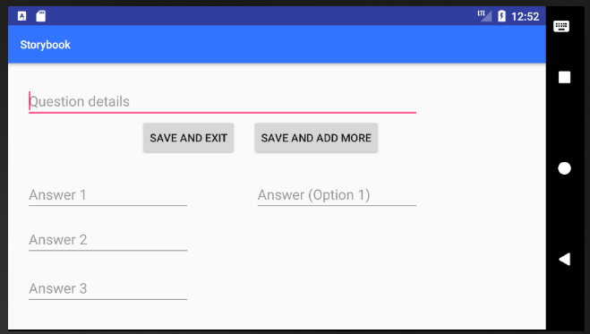

Layout - Storybook\app\src\main\res\layout\activity_add_question.xml

Java - Storybook\app\src\main\java\com\read\storybook\AddQuestionActivity.java

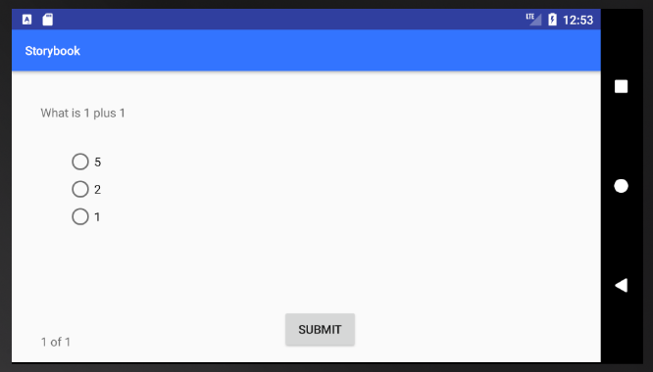

Storybook\app\src\main\java\com\read\storybook\MyPageAdapter.java

Storybook\app\src\main\java\com\read\storybook\PageExamFragment.java

Layout - Storybook\app\src\main\res\layout\fragment_page_exam.xml

Java - Storybook\app\src\main\java\com\read\storybook\ExamActivity.java

Layout - Storybook\app\src\main\res\layout\activity_exam.xml

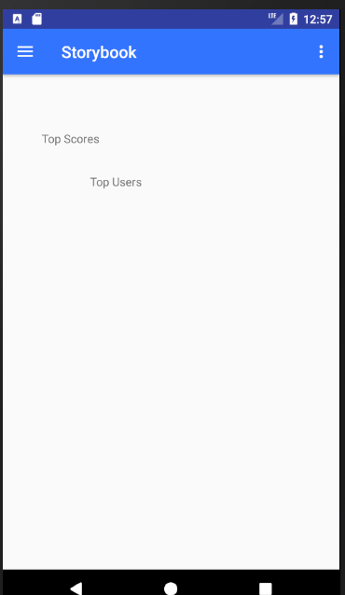

Java - Storybook\app\src\main\java\com\read\storybook\TopScoresFragment.java

Layout - Storybook\app\src\main\res\layout\top_scores_layout.xml