
Suez Canal University
Faculty of Computers and Informatics
Department of Information Systems

TesTly
A Smart Marketplace for Medical Laboratory Testing
A Graduation Project Submitted to the Faculty of Computers and Informatics,
in Partial Fulfillment of the Requirements for the
Degree of Bachelor of Science in Information Systems

Supervised by
Dr. Mohamed Ibrahim

Ismailia, Egypt
2026
TesTly
A Smart Marketplace for Medical Laboratory Testing
Under the Supervision of
Dr. Mohamed Ibrahim

Team Members

# | Full Name
1 | Youssef Ahmed Mahmoud
2 | Mariam Hassan Ali
3 | Omar Khaled Ibrahim
4 | Nourhan Mohamed Saad
5 | Ahmed Sami Fathy
6 | Salma Tarek Abdelrahman
7 | Mostafa Adel Hosny
8 | Habiba Walid Mansour

Abstract
Access to diagnostic laboratory testing in Egypt is hindered by a fragmented and opaque market. Prices for an identical test, such as a Complete Blood Count or a lipid profile, vary widely between laboratories and are rarely published, leaving patients with no neutral means of comparing options by price, quality, or proximity. Results are typically delivered as isolated PDF documents that cannot be trended over time, and there exists no privacy-respecting mechanism by which a patient's longitudinal clinical history can follow them when they change laboratories. Smaller laboratories, in turn, lack an affordable storefront, scheduling, and results-delivery infrastructure, while the ecosystem as a whole lacks a trusted, curated intermediary that verifies a laboratory is operationally complete before exposing it to patients.
This thesis presents TesTly, a curated, multi-actor medical lab-testing marketplace that connects patients with accredited laboratories across Egypt. The platform allows patients to discover and compare tests across laboratories, book through one of three fulfilment modes (lab visit, home sample collection, or mail-in home test kit), pay online or by cash, and receive results both as an authoritative PDF and as structured, queryable data. TesTly is delivered as a Next.js web application and a Flutter mobile application over a single NestJS backend that uses Prisma as its object-relational mapping layer over a PostgreSQL database. Its principal contributions are threefold: a clinical-normalisation engine that resolves each laboratory's differently named and differently united analytes into a canonical, comparable form to enable cross-laboratory health-trend tracking; a patient-controlled privacy model governing what laboratories may see of a patient's history; and an agentic artificial-intelligence health assistant, powered by Google Gemini, that grounds its conversational guidance in the live laboratory catalogue through a server-side function-calling loop.
Among the system's distinguishing features are layered, defence-in-depth security appropriate to medical data, including bcrypt password hashing, short-lived JSON Web Token access tokens combined with hashed, rotating refresh tokens, stacked role and lab-activation guards, and authorisation-checked PDF downloads. An administrator-gated onboarding process enforces a concrete five-point readiness check, guaranteeing that every bookable laboratory is operationally complete. The architecture exhibits graceful, configuration-driven flexibility: file storage is pluggable between local disk and Amazon S3, push notifications and the AI assistant degrade safely when unconfigured, and a single API serves two distinct clients. Cross-laboratory health trends, reference-range shading, and trend-direction analysis give patients a longitudinal view of their health that no single laboratory could previously provide.
The resulting system demonstrates a coherent, end-to-end workflow in which a patient can progress from an AI-assisted conversation to a compared, booked, paid, delivered, and trended test, while a laboratory can move from a gated registration to a fully operational storefront, all on one curated platform. Validated against a rich seeded demonstration dataset of twenty-one active laboratories across eleven Egyptian cities and exercised through per-layer automated testing, TesTly establishes a viable, security-conscious foundation for transparent and continuous diagnostic care in the Egyptian context.

Acknowledgement
The authors wish to express their sincere gratitude to their project supervisor for invaluable guidance, patience, and continuous encouragement throughout the course of this work. Deep appreciation is extended to the faculty and staff of the Department of Information Systems, Faculty of Computers and Informatics, Suez Canal University, for the knowledge and support that made this project possible. The authors are profoundly thankful to their families for their unwavering love, sacrifice, and moral support, and to their teammates and colleagues, whose dedication, collaboration, and shared commitment were essential to bringing TesTly to completion.
Table of Contents

List of Figures
Figure 1.1 High-level architecture of TesTly: two clients (web and mobile) over a single NestJS API, which fronts a PostgreSQL database and four external services.
Figure 2.1 TesTly system architecture, showing the marketplace, booking, results, normalisation, and AI-assistant capabilities that together close the gaps identified in the application survey
Figure 2.2 NestJS backend module structure and the layered authorisation guard pipeline that NestJS's dependency-injection architecture made natural to express
Figure 2.3 Entity-relationship diagram of the PostgreSQL schema, whose relational integrity and unique constraints underpin TesTly's booking and results guarantees
Figure 2.4 Sequence of the agentic AI assistant: Gemini's streaming and function-calling features drive a server-side tool loop grounded in the live Prisma catalogue
Figure 4.1 Patient use-case diagram — anonymous browsing, comparison, booking and payment, results, cross-lab trends, reviews, and AI assistance.
Figure 4.2 Lab Staff use-case diagram — gated onboarding, catalogue and schedule management, booking processing, result upload and delivery, and privacy-scoped patient context.
Figure 4.3 Administrator use-case diagram — lab governance with onboarding-readiness gating, platform analytics, user management, and payments oversight.
Figure 4.4 Layered system architecture — two clients over one NestJS API, backed by PostgreSQL and three external services.
Figure 4.5 Deployment topology — Vercel-hosted web app, Railway/Render-hosted API, managed PostgreSQL, and the external S3, FCM, and Gemini services.
Figure 4.6 Backend module/component diagram — feature modules and the layered guard pipeline.
Figure 4.7 High-level data-flow diagram — client request through validation, guards, and services to the database and external integrations.
Figure 4.8 Entity-relationship diagram — the twenty models with Booking as the central hub and the structured-results marker sub-graph.
Figure 4.9 Lab onboarding and activation sequence — gated registration, readiness check, and admin approval.
Figure 4.10 Lab onboarding and admin approval — registration in PendingReview, readiness evaluation, and the gated activation transition
Figure 4.11 Booking and payment sequence — the online prepaid branch and the cash-on-service branch, including the slot-uniqueness guard and the payment-before-confirm gate
Figure 4.12 Result delivery sequence — PDF upload and validation, structured-observation parsing and normalisation, delivery, and the authorised patient download
Figure 4.13 Agentic AI assistant — the server-orchestrated SSE function-calling loop interleaving delta text and tool-card events
Figure 5.1 End-to-end booking and payment sequence exercised by the functional test cases
Figure 5.2 Patient journey evaluated during the user-experience walkthroughs
Figure 6.1 The TesTly system architecture: two clients (web and mobile) over a single NestJS API, fronting PostgreSQL and four external services.
List of Tables
Table 2.1 Feature comparison of application categories against TesTly's value proposition (✔ = typically present, ◐ = partial or vendor-limited, ✘ = absent)
Table 2.2 Backend framework comparison
Table 2.3 Web framework comparison
Table 2.4 Mobile framework comparison
Table 2.5 Database comparison
Table 2.6 ORM comparison
Table 2.7 Generative-AI provider comparison
Table 3.1 Backend feature areas and their responsibilities
Table 3.2 The three layers of the mobile clean architecture
Table 3.3 Representative delivery phases (sprint-style increments)
Table 4.1 Representative prioritised user-story backlog across the three actors.
Table 4.2 Principal database enumerations and their meaning.
Table 4.3 Representative selection of key REST API endpoints.
Table 4.4 The layered role-based access-control model
Table 4.5 The five onboarding-readiness requirements
Table 4.6 Booking and payment enumerations
Table 4.7 Representative canonical unit-conversion rules
Table 4.8 Push-notification triggers
Table 5.1 Representative functional test cases for the TesTly platform
List of Abbreviations
Abbreviation | Meaning
AI | Artificial Intelligence
API | Application Programming Interface
CI/CD | Continuous Integration / Continuous Deployment
CRUD | Create, Read, Update, Delete
CSV | Comma-Separated Values
DTO | Data Transfer Object
EGP | Egyptian Pound
FCM | Firebase Cloud Messaging
HTTP | Hypertext Transfer Protocol
HTTPS | Hypertext Transfer Protocol Secure
JWT | JSON Web Token
LIS | Laboratory Information System
LLM | Large Language Model
LOINC | Logical Observation Identifiers Names and Codes
MVP | Minimum Viable Product
ORM | Object-Relational Mapping
OTP | One-Time Password
PDF | Portable Document Format
RBAC | Role-Based Access Control
REST | Representational State Transfer
S3 | Simple Storage Service
SDK | Software Development Kit
SPA | Single-Page Application
SQL | Structured Query Language
SSE | Server-Sent Events
SSR | Server-Side Rendering
UI/UX | User Interface / User Experience
Chapter 1

Introduction

1.1 Introduction
Diagnostic laboratory testing is a foundational component of modern healthcare. Blood counts, lipid profiles, glycated-haemoglobin (HbA1c) measurements, thyroid panels, and tumour markers inform diagnosis, guide treatment, and track the progression of chronic disease over time. In Egypt, however, the experience of obtaining such tests remains largely analogue and fragmented. A patient who needs a specific test typically relies on word of mouth or a physician's referral to choose a laboratory, has no neutral means of comparing the price of an identical test between providers, receives the result as a one-off printed or PDF document, and accumulates no continuous, queryable record of their health markers as they move between laboratories over the years.
TesTly is a curated, multi-actor medical lab-testing marketplace for Egypt designed to address this gap. It is a single platform on which a patient can discover accredited diagnostic laboratories nearby, compare the same test across many laboratories by price, rating, distance, and accreditation, book that test through one of three collection channels, pay for it online or in cash, receive the official result both as a secure PDF and as structured, machine-readable data, and track health markers over time across results issued by different laboratories. The system models three human roles through a single Role enumeration — Patient, Lab Staff, and Admin — and supplements them with a non-human, patient-facing AI assistant.
TesTly is delivered as two client applications over one shared application programming interface (API). A Next.js web application serves the public storefront together with the patient, lab-staff, and admin workspaces, while a native Flutter mobile application serves patients and lab staff on iOS and Android. Both clients consume a single NestJS backend backed by a PostgreSQL database accessed through the Prisma object-relational mapper. The backend additionally integrates four external services: object storage for result documents, Firebase Cloud Messaging for push notifications, and Google's Gemini generative-AI model that powers an agentic, function-calling health assistant grounded in the live catalogue. The overall structure of the platform, its clients, backend modules, and external dependencies is shown in the architecture diagram.
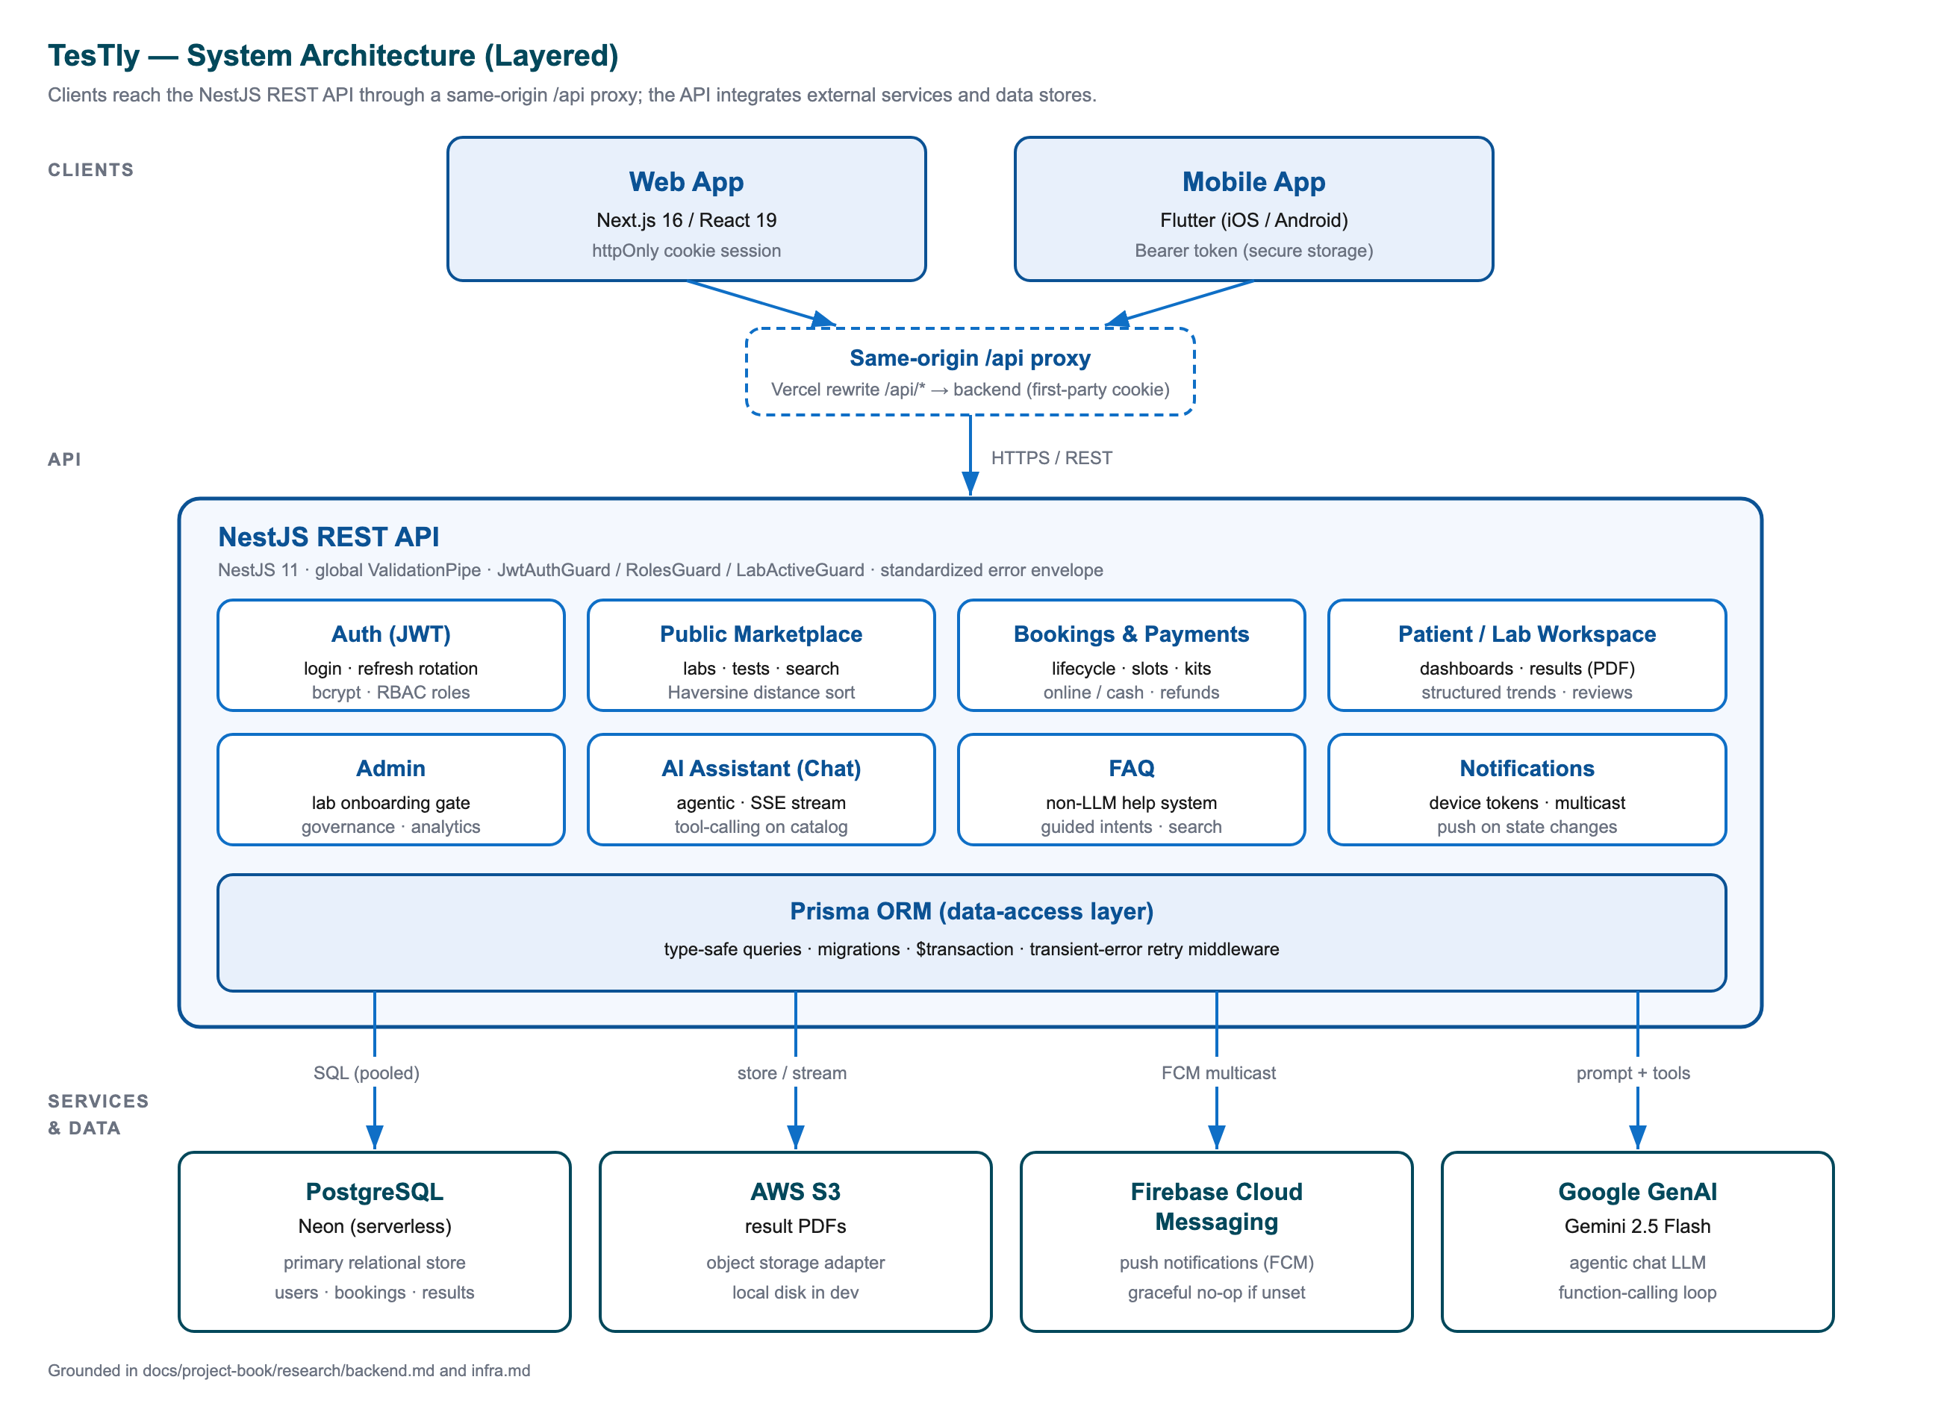
Figure 1.1: High-level architecture of TesTly: two clients (web and mobile) over a single NestJS API, which fronts a PostgreSQL database and four external services.
The platform is distinctive in three respects. First, it is a *curated* marketplace: a laboratory cannot transact until an administrator has verified that it is operationally complete, so every bookable laboratory exposed to patients meets a concrete readiness standard. Second, it solves the cross-laboratory continuity problem through a clinical-normalisation engine that converts each laboratory's differently named and differently united analytes into a canonical, comparable form, governed by a patient-controlled privacy setting. Third, it layers a guard-railed conversational assistant over the real catalogue so that help is both natural-language and factually grounded. Because the domain is medical, security and privacy are treated as first-class concerns throughout the design.

1.2 Problem Statement and Motivation
The market for diagnostic laboratory testing in Egypt is fragmented and opaque, which produces several concrete difficulties for patients, laboratories, and the ecosystem as a whole.
Fragmented lab discovery. There is no neutral, comprehensive directory through which a patient can find the laboratories that offer a particular test near them. Discovery depends on informal referral, advertising, or prior familiarity, none of which lets a patient survey the full set of available options or read other patients' experiences before deciding.
No price transparency. The price of an identical test — a complete blood count, a lipid profile, an HbA1c — varies widely between laboratories and is rarely published in a form that allows side-by-side comparison. A patient therefore cannot easily determine whether a quoted price is reasonable, and competition on price is muted by the absence of a comparison venue.
Paper and one-off digital results. Results are typically delivered as isolated printed sheets or standalone PDF files. Such documents are not machine-readable: their values cannot be queried, charted, or compared, and the patient is left to interpret each report in isolation.
No cross-lab history. Because results are isolated artefacts and because each laboratory names and units its analytes differently, a patient's longitudinal history does not follow them when they switch laboratories. There is no privacy-respecting mechanism by which a marker measured at one laboratory can be trended against the same marker measured at another, even though such longitudinal tracking is precisely what is clinically useful for chronic-disease management.
Manual booking and settlement. Appointment scheduling, capability checks (for example, whether a laboratory offers home sample collection), payment, and status updates are handled manually or by telephone, which is slow, error-prone, and offers the patient no visibility into the state of their order.
For laboratories, especially smaller ones, the corresponding gap is the absence of a low-cost storefront, scheduling, and results-delivery system. For the ecosystem as a whole, there is no trusted intermediary that verifies that a laboratory is operationally complete before exposing it to patients. The motivation behind TesTly is to digitise this entire journey end to end: to give patients a transparent, comparison-first marketplace; to give laboratories a complete back-office behind an administrator-gated onboarding process; and to convert isolated paper results into structured, normalised, trendable data under the patient's control.

1.3 Project Objectives
The principal objective of this project is to design and implement a curated, multi-actor medical lab-testing marketplace that takes a patient from discovery through booking, payment, and result delivery to longitudinal health tracking, while giving laboratories a complete operational workspace and giving administrators the tools to govern the platform. This overarching goal decomposes into the following specific objectives.
- Provide a unified, transparent marketplace. Offer a single public storefront, browsable without registration, on which patients can search and filter accredited laboratories by free-text query, city, rating, distance, price, accreditation, and home-collection capability, and compare a single named test across every laboratory that offers it, ranked by price, with each laboratory's own price, rating, accreditation, and location.
- Support multi-channel booking and payment. Allow a patient to book a test through one of three collection modes — lab visit, home sample collection, or home test kit — selecting a future schedule slot where applicable, and to settle payment either online or through one of three cash modes (cash at the lab, cash to the home collector, or cash on delivery), with the booking lifecycle, payment state, and kit-shipment progress tracked and visible end to end.
- Deliver digital and structured results with cross-lab trends. Deliver each result both as an authoritative PDF, served only through an authorisation-checked endpoint, and as structured observations that are normalised to canonical analytes and units, so that a patient can view longitudinal trends for a marker across results issued by different laboratories, with reference-range shading and abnormal-value flagging, governed by a patient-controlled privacy setting.
- Provide AI-guided discovery. Layer an agentic, function-calling AI assistant over the live catalogue so that a patient can ask, in natural language and in either English or Arabic, where to obtain a test and what it means, and receive grounded answers and clickable laboratory and test cards that lead directly into the booking funnel, complemented by a lightweight deterministic FAQ helper for common questions.
- Implement a secure, role-based platform. Serve three roles — patient, lab staff, and admin — through layered, defence-in-depth access control, ensure that only laboratories which pass a concrete operational-readiness gate become bookable, and treat the confidentiality of medical data as a first-class design concern across both the web and mobile clients.
In meeting these objectives the system is intended to demonstrate a coherent, end-to-end pipeline in which a patient can move from an AI-assisted conversation to a compared, booked, paid, delivered, and trended test, and in which a laboratory can move from a gated registration to a fully operational storefront, all on one curated platform.

1.4 Thesis Organization
The remainder of this thesis is organised as follows.
Chapter 2 — Literature Review and Background. This chapter surveys the domain of diagnostic laboratory testing and digital health marketplaces, reviews comparable systems and the gaps they leave unaddressed, and introduces the core technologies and concepts on which TesTly is built, including the NestJS and Next.js frameworks, the Flutter mobile toolkit, the Prisma object-relational mapper over PostgreSQL, and the agentic, function-calling pattern used for the generative-AI assistant.
Chapter 3 — System Analysis and Requirements. This chapter establishes the functional and non-functional requirements of the platform. It identifies the actors — patient, lab staff, administrator, and the AI assistant — enumerates their use cases, and specifies the business rules that govern booking, payment, result delivery, lab onboarding, and the cross-laboratory privacy model.
Chapter 4 — System Design and Architecture. This chapter presents the architecture of TesTly in depth: the monorepo structure and the single shared API contract, the layered backend modules and the guard pipeline that enforces access control, the data model of twenty tables and eleven enumerations, the clinical-normalisation engine for cross-laboratory trends, and the integration of object storage, push notifications, and the generative-AI service.
Chapter 5 — Implementation and Testing. This chapter describes how the design is realised in code across the backend, web, and mobile applications, walking through the principal end-to-end flows — booking and payment, result upload and delivery, lab onboarding and approval, cross-laboratory health trends, and AI-assisted discovery — and discusses the per-layer testing strategy used to validate the system.
Chapter 6 — Conclusion and Future Work. This chapter summarises the contributions of the project, evaluates the extent to which the stated objectives were met, reflects on the limitations of the current implementation — such as the simulated payment gateway — and outlines directions for future work, including a production payment integration and broader clinical interoperability.
Chapter 2

Related Work

This chapter situates TesTly within the wider landscape of medical diagnostic services and digital health technology. It first establishes the domain background: how patients in Egypt currently navigate laboratory testing, the global rise of electronic-health (e-health) and health-technology marketplaces, and the key technical and clinical concepts that underpin any modern laboratory platform. It then surveys the categories of existing applications that overlap with TesTly's problem space, naming representative real-world systems and identifying the features each category typically offers and the gaps it leaves. Finally, it justifies the engineering choices made for TesTly by comparing each layer of the technology stack against the principal alternatives. The purpose of this related-work review is twofold: to demonstrate that the problem TesTly addresses is real and inadequately served by existing solutions, and to show that the selected tools are a deliberate, defensible response to the project's requirements rather than arbitrary preferences.

2.1 Background
A medical diagnostic laboratory is a facility that performs clinical tests on biological samples — blood, urine, and other specimens — to support the diagnosis, treatment, and monitoring of disease. In Egypt, laboratory testing is delivered by a fragmented mix of large national chains, hospital-affiliated laboratories, and a long tail of independent neighbourhood laboratories. Patients typically reach these laboratories through one of three paths: a physician's referral, a direct walk-in for a routine or self-requested panel, or, increasingly, an online enquiry. The conventional patient journey is notably manual: the patient learns of a laboratory by word of mouth or proximity, telephones or visits to ask about a test and its price, attends in person to provide a sample or arranges an informal home visit, and later returns to collect a paper or PDF result. Because prices for an identical test are rarely published and vary substantially between laboratories, the patient has no neutral means of comparing options before committing.
This opacity is the central pain point that motivates a marketplace approach. A patient seeking a common panel — a complete blood count (CBC), a lipid profile, a thyroid panel, or a glycated-haemoglobin (HbA1c) test — must individually canvass laboratories to discover where the test is available, what it costs, how long results take, and whether the laboratory is accredited. There is no consolidated, patient-facing view of the market, no structured record of other patients' experiences, and no continuity of a patient's results when they move between laboratories. Results delivered as one-off documents cannot easily be trended over time, and a patient who uses different laboratories for successive tests accumulates a disconnected archive rather than a coherent health record.

2.1.1 The Rise of E-Health and Health-Technology Marketplaces
Over the past decade, the broader e-health movement has reshaped how patients discover and consume health services. The same online-marketplace pattern that transformed retail, transport, and hospitality — aggregating fragmented supply, exposing transparent pricing and ratings, and enabling online transactions — has been applied to healthcare. In the Egyptian and wider Middle Eastern market, this is visible in the growth of doctor-booking platforms, online pharmacies, and tele-health services that connect patients to providers through a single digital storefront. These platforms succeed by addressing precisely the frictions described above: they make supply discoverable, make pricing comparable, and reduce the number of phone calls and physical visits a patient must make.
Three capabilities recur across successful e-health products and are directly relevant to TesTly. Online booking lets a patient reserve a service — an appointment slot, a home visit, or a delivery — without a phone call, and gives the provider a managed queue rather than ad-hoc requests. Tele-health and remote service models extend the provider's reach beyond the physical premises; for a diagnostic laboratory the analogue is home sample collection and home test kits, which decouple the service from a clinic visit. Digital results delivery replaces paper with electronic documents and, in more advanced systems, with structured data that can be searched, charted, and integrated with other records. TesTly combines all three: it offers booking across lab-visit, home-collection, and home-test-kit modes; it supports online and cash payment; and it delivers results both as an authoritative PDF and as structured, queryable observations that enable cross-laboratory health-trend tracking.

2.1.2 Key Concepts: LIS, LOINC, and Accreditation
Three concepts from clinical informatics frame the design of any laboratory platform and recur throughout this thesis. Understanding them clarifies both what existing systems do and where TesTly's contribution lies.
- Laboratory Information System (LIS). An LIS is the back-office software a laboratory uses internally to manage its operations: receiving test orders, tracking samples through the workflow, recording results, and producing reports. A traditional LIS is laboratory-centric and closed — it serves the single laboratory that operates it, not a network of laboratories or the patients across them. TesTly's lab-facing workspace performs an analogous operational role (catalogue, schedule, booking queue, results upload) but does so as a shared, multi-tenant marketplace component rather than a per-laboratory silo.
- LOINC (Logical Observation Identifiers Names and Codes). LOINC is an international standard that assigns universal codes to laboratory observations so that the same analyte reported by different laboratories — under different local names and units — can be identified as the same measurement. This is the formal answer to the cross-laboratory comparability problem. TesTly does not adopt the full LOINC catalogue, but it implements the same underlying idea through a canonical-marker normalisation layer: it resolves each laboratory's differently-named, differently-united analytes (for example glucose reported in mmol/L versus mg/dL) into a canonical, comparable form so that values from different laboratories can be charted on one trend line.
- Accreditation. Accreditation is formal recognition that a laboratory meets defined quality and competence standards. For a marketplace, accreditation is a trust signal that helps a patient choose between otherwise similar offerings. TesTly records each laboratory's accreditation as a first-class attribute, exposes it as a filter and a comparison field in the public marketplace, and surfaces it on laboratory and assistant result cards.
Together these concepts define the niche TesTly occupies. It is not merely a single laboratory's LIS exposed online, nor a generic appointment-booking tool, but a curated multi-laboratory marketplace that layers transparent discovery, multi-mode booking, secure digital results, and LOINC-style cross-laboratory normalisation over a network of accredited laboratories — with an agentic AI assistant grounded in the live catalogue as a discovery aid.

2.2 Types of Applications
A number of existing application categories overlap with TesTly's problem space, each solving part of the patient's journey but none addressing it end-to-end as a transparent, cross-laboratory marketplace with longitudinal result tracking. This section surveys those categories, names representative real-world systems, and identifies the features and gaps of each. The categories are ordered from the most laboratory-specific to the most general.

2.2.1 Single-Laboratory Websites and Apps
The most direct comparators are the websites and mobile applications operated by individual laboratory chains. In Egypt the prominent examples are El Mokhtabar and Al Borg Laboratories, two of the largest national chains, each of which offers an online presence through which a patient can browse that chain's own test catalogue, book a home visit or branch appointment, and retrieve results. These applications are typically polished and operationally complete because they are backed by a real laboratory and its internal LIS.
Their defining limitation, however, is that they are single-vendor storefronts: each shows only its own laboratory's tests, its own prices, and its own branches. A patient using El Mokhtabar's app cannot compare its price for a lipid profile against Al Borg's, cannot see independent neighbourhood laboratories, and cannot consolidate results obtained from different chains into a single trend. Because there is no neutral intermediary, price transparency exists only within a vendor, not across the market. The result is that a price-sensitive or comparison-minded patient must install and check several separate apps — exactly the fragmentation a marketplace is meant to remove.

2.2.2 Health-Service Marketplaces
A second category is the broader health-service marketplace that aggregates multiple providers. The leading regional example is Vezeeta, which began as a doctor-booking platform and expanded into laboratory tests, pharmacy, and other services; another is Yodawy, focused primarily on pharmacy and medication fulfilment with some diagnostic offerings. These platforms demonstrate the marketplace pattern in the Egyptian market: they aggregate supply, expose provider ratings, and enable online booking and payment across many vendors.
For diagnostic testing specifically, however, these general health marketplaces treat laboratory tests as one vertical among many, and their laboratory experience is comparatively shallow. They typically offer booking and a degree of price visibility, but they do not deliver structured, normalised results that a patient can trend across laboratories over time, nor do they provide a privacy-controlled mechanism for a patient's longitudinal history to follow them when they change provider. Their value lies in breadth of services rather than depth in the laboratory domain. TesTly, by contrast, is purpose-built for laboratory testing and therefore invests in exactly the depth these platforms lack: cross-laboratory test comparison, structured result data, and longitudinal trend tracking.

2.2.3 Pharmacy and Medication Applications
Pharmacy and medication-delivery applications — of which Yodawy is again a representative regional example, alongside numerous chain-pharmacy apps — share important interaction patterns with a laboratory marketplace: a searchable catalogue, a shopping or booking flow, online and cash-on-delivery payment, and a home-delivery logistics layer. The home-delivery model in particular maps neatly onto TesTly's home-collection and home-test-kit modes, and the cash-on-delivery option mirrors TesTly's cash payment variants.
The relevance of this category is therefore primarily in the transactional and fulfilment mechanics rather than the clinical content. These applications confirm that Egyptian users are comfortable with online catalogues, home delivery, and mixed online/cash payment — assumptions TesTly relies on. What they do not provide is any notion of diagnostic results, structured clinical data, or health-trend tracking, because medication fulfilment has no result artefact to deliver. TesTly adopts their proven commerce patterns while adding the diagnostic and longitudinal-results dimension that a pharmacy app has no reason to support.

2.2.4 Hospital Patient Portals
Many hospitals and integrated health systems provide a patient portal — a secure web or mobile front-end to the institution's electronic health record through which a patient can view appointments, laboratory results, and clinical documents. These portals are strong on secure, structured results delivery and on continuity of care within the institution: a patient's results, once in the portal, are retained and can often be viewed alongside prior values.
Their limitation is that they are bounded by the institution. A hospital portal shows results produced by that hospital's own laboratories; it does not aggregate independent laboratories, expose comparative pricing, or let a patient trend results across institutions. It is a continuity-of-care tool for an existing patient of one provider, not a discovery-and-comparison marketplace for a patient choosing between providers. TesTly takes the secure, structured-results strength of the portal model and generalises it across a network of independent laboratories, adding the discovery, comparison, and cross-vendor trending that an institution-bound portal cannot offer.

2.2.5 International Patient Portals and Lab Networks
Outside Egypt, the most mature comparators are the patient portals of large laboratory networks, notably Quest Diagnostics (MyQuest) and Labcorp (Labcorp Patient) in the United States. These systems are sophisticated: they offer online test ordering, appointment scheduling, secure structured results with reference ranges, and — significantly — historical result tracking that lets a patient see a given marker's values over time. They represent the state of the art in patient-facing laboratory technology.
Even these advanced systems, however, are fundamentally single-network: Quest's portal trends results produced within Quest, and Labcorp's within Labcorp. The cross-network comparability problem — trending the same analyte across genuinely independent laboratories that name and unit it differently — is not their objective, because within one network the analyte names and units are already standardised internally. TesTly's distinguishing contribution is precisely to solve trending across independent laboratories through canonical-marker normalisation and unit conversion, a problem that a single-network portal does not face. Moreover, these international systems are tailored to their home healthcare and insurance context and are not localised for the Egyptian market, its pricing, its languages (Arabic and English), or its cash-payment norms.

2.2.6 General Appointment-Booking Platforms
The most general category is the cross-domain appointment-booking platform exemplified by Practo (widely used in South Asia) and similar tools that schedule appointments across many kinds of health and non-health providers. These platforms excel at the scheduling primitive — calendars, slots, capacity, reminders — and at provider discovery by location and rating.
Because they are domain-agnostic, however, they model a provider as a generic bookable resource and have no concept of a test catalogue with per-test pricing and preparation instructions, no diagnostic result artefact, and no clinical data model. They can book a visit to a laboratory but cannot represent what is being tested, what it costs at each laboratory, what preparation it requires, or what result it produces. TesTly reuses the scheduling primitive these platforms have proven but embeds it in a laboratory-specific domain model — schedule slots tied to a test catalogue, three booking modes, payment-method compatibility rules, and a results pipeline — that a general booking tool deliberately abstracts away.

2.2.7 Feature Comparison and TesTly's Positioning
Table 2.1 consolidates the survey above into a feature matrix, scoring each application category against the seven capabilities that define TesTly's value proposition: cross-laboratory lab discovery, price transparency, home sample collection, online payment, structured (not merely PDF) results, cross-laboratory health-trend tracking, and an integrated AI assistant. The matrix makes the gap visible: no existing category combines all seven, and in particular the combination of cross-laboratory price transparency, structured cross-laboratory trends, and a catalogue-grounded AI assistant is unique to TesTly.
Capability | Single-lab apps (El Mokhtabar, Al Borg) | Health marketplaces (Vezeeta, Yodawy) | Pharmacy apps (Yodawy) | Hospital portals | Intl. lab portals (Quest, Labcorp) | General booking (Practo) | TesTly
Cross-lab discovery | ✘ | ✔ | ◐ | ✘ | ✘ | ✔ | ✔
Price transparency | ◐ | ◐ | ✔ | ✘ | ◐ | ◐ | ✔
Home sample collection | ✔ | ◐ | ✔ | ✘ | ✔ | ✘ | ✔
Online payment | ✔ | ✔ | ✔ | ◐ | ✔ | ✔ | ✔
Structured results | ◐ | ✘ | ✘ | ✔ | ✔ | ✘ | ✔
Cross-lab health trends | ✘ | ✘ | ✘ | ◐ | ◐ | ✘ | ✔
AI assistant | ✘ | ◐ | ◐ | ✘ | ✘ | ✘ | ✔
Table 2.1: Feature comparison of application categories against TesTly's value proposition (✔ = typically present, ◐ = partial or vendor-limited, ✘ = absent)

The pattern in Table 2.1 is instructive. Single-laboratory apps are operationally complete but vendor-bound, so they cannot offer cross-laboratory discovery, comparison, or trending. General marketplaces and booking platforms offer breadth and discovery but lack diagnostic depth — no structured results, no trends. Portals (hospital and international) offer structured results and some trending but only within a single institution or network. Pharmacy apps contribute the commerce and home-delivery patterns but have no diagnostic dimension at all. TesTly is positioned deliberately at the intersection: it adopts the marketplace's discovery and price transparency, the pharmacy app's home-delivery and mixed-payment mechanics, the portal's secure structured results, and adds two capabilities that no comparator combines — privacy-controlled cross-laboratory trend tracking via canonical-marker normalisation, and an agentic AI assistant grounded in the real catalogue. Figure 2.1 (the system architecture) shows how these capabilities are realised across the platform's components.

Figure 2.1: TesTly system architecture, showing the marketplace, booking, results, normalisation, and AI-assistant capabilities that together close the gaps identified in the application survey

2.3 Comparison of Used Development Tools
This section justifies the technology stack selected for TesTly by comparing each major layer against the principal alternatives that were realistically available. The guiding criteria throughout were: suitability for a single, type-safe, end-to-end TypeScript/Dart codebase shared by three applications; the security and data-integrity demands of a medical domain; the productivity and maintainability appropriate to a graduation project built by a small team; and the operational fit with low-cost managed hosting. Each comparison ends with the rationale for TesTly's choice. The stack as actually implemented is NestJS 11 for the backend, Next.js 16 for the web application, Flutter for mobile, PostgreSQL as the database (Neon-hosted in production), Prisma 5 as the ORM, and Google GenAI (Gemini) for the AI assistant.

2.3.1 Backend Framework: NestJS vs Express vs Django/Laravel
The backend is the security-critical core of the system: it owns authentication, authorisation, business rules, payment state, and access to medical data. The candidate frameworks were Express (a minimal Node.js framework), Django (Python) and Laravel (PHP) as full-featured non-JavaScript frameworks, and NestJS (a structured, TypeScript-first Node.js framework). Table 2.2 compares them on the axes that mattered for TesTly.
Criterion | Express | Django / Laravel | NestJS (chosen)
Language | JavaScript/TS | Python / PHP | TypeScript (first-class)
Architecture | Unopinionated, manual | Opinionated, MVC | Modular, DI-driven, decorator-based
Type safety with shared clients | Partial | None (different language) | End-to-end with TS web/mobile DTOs
Built-in structure (guards, pipes, DI) | None (assemble yourself) | Framework-provided | First-class (guards, pipes, filters)
Validation & OpenAPI | Add-on libraries | Built-in / add-on | class-validator + @nestjs/swagger
Learning fit for a TS team | Low ceremony | Requires new language | Structured but TS-native
Table 2.2: Backend framework comparison

Express, while ubiquitous, is deliberately unopinionated: it provides routing and middleware but no built-in structure for dependency injection, modular organisation, validation, or authorisation. For a system with layered role-based access control and many cross-cutting concerns, building that structure on bare Express would mean re-implementing what a higher-level framework provides. Django and Laravel are mature and feature-complete, but adopting either would split the codebase across two languages (Python or PHP on the server, TypeScript and Dart on the clients), forfeiting the type-safety and shared-contract benefits of a single-language stack.
TesTly chose NestJS because it provides exactly the structure a security-sensitive marketplace needs while remaining TypeScript-native. Its decorator-driven, dependency-injection architecture made the layered guard pipeline — JwtAuthGuard, then RolesGuard, then a domain-specific LabActiveGuard, then per-service ownership checks — natural to express and to reason about. Its first-class support for validation pipes (with class-validator) and a global exception filter gave uniform input validation and error handling across every endpoint, and its @nestjs/swagger integration produced API documentation directly from the code. Critically, because NestJS is built on Express under the hood, TesTly retained the entire Express ecosystem while gaining the architecture; and because the server, the web client, and (via mirrored models) the mobile client all speak TypeScript, the API contract is shared and type-checked end-to-end. Figure 2.2 shows the resulting backend component structure and guard pipeline.
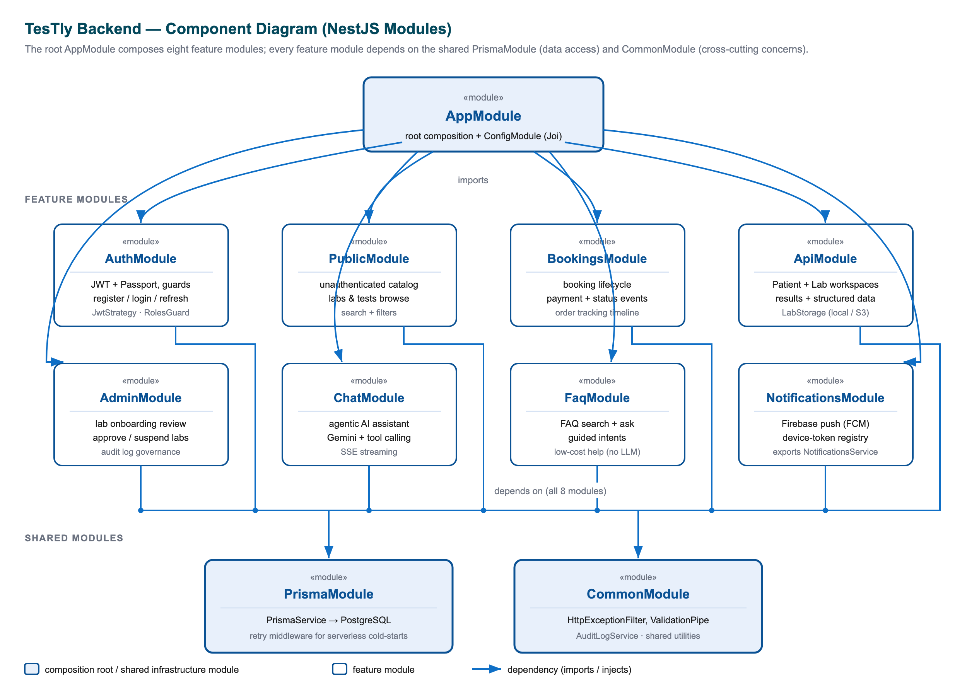
Figure 2.2: NestJS backend module structure and the layered authorisation guard pipeline that NestJS's dependency-injection architecture made natural to express

2.3.2 Web Framework: Next.js vs Create-React-App vs Angular vs Vue
The web application serves the public marketplace plus the patient, lab-staff, and admin dashboards. The candidates were Create-React-App (CRA, a client-only React scaffold), Angular and Vue (full client-side frameworks), and Next.js (a React meta-framework with server-side rendering, routing, and edge middleware). Table 2.3 compares them.
Criterion | Create-React-App | Angular | Vue | Next.js (chosen)
Rendering model | Client-only SPA | Client-only SPA | Client-only SPA | SSR + SSG + client, App Router
Routing | Add library | Built-in | Add library | File-based (App Router)
Edge middleware (route guards) | None | None | None | Built-in (jose JWT check)
SEO for public storefront | Weak (client-rendered) | Weak | Weak | Strong (server-rendered)
Shared language with backend | TypeScript | TypeScript | TypeScript/JS | TypeScript
Ecosystem & deployment | Maturing/deprecated | Mature | Mature | Mature (Vercel-native)
Table 2.3: Web framework comparison

CRA is effectively deprecated and produces a client-only single-page application with no server rendering — a poor fit for a public marketplace whose landing, search, and lab-detail pages benefit from being server-rendered for performance and discoverability. Angular and Vue are capable client frameworks, but both are primarily client-side and would still require a separate solution for server rendering and for the edge route-protection layer that TesTly relies on. Angular in particular imposes a heavier, more prescriptive structure than a small project needs.
TesTly chose Next.js (App Router, React 19) because it uniquely combined three things the project required. First, server-side rendering for the unauthenticated storefront, so anonymous visitors can browse labs and tests without a registration wall. Second, edge middleware, which TesTly uses as a fast, JWT-decoding route guard (via jose) that redirects users away from protected /patient, /lab, and /admin route groups before the page shell even loads — a defence-in-depth layer above the backend's authoritative checks. Third, its tight integration with Vercel hosting, which enabled the same-origin /api rewrite proxy that makes the httpOnly authentication cookie first-party across the split web/API deployment. Sharing TypeScript with the NestJS backend completed the single-language story for the server-and-web pair.

2.3.3 Mobile Framework: Flutter vs React Native vs Native
The mobile application targets both iOS and Android for patients and lab staff. The realistic options were fully native development (Swift/Kotlin, one codebase per platform), React Native (JavaScript/TypeScript, native widgets), and Flutter (Dart, with its own rendering engine). Table 2.4 compares them.
Criterion | Native (Swift + Kotlin) | React Native | Flutter (chosen)
Codebases for iOS + Android | Two | One | One
Language | Swift / Kotlin | JavaScript/TypeScript | Dart
UI consistency across platforms | Diverges | Bridges native widgets | Own engine, pixel-consistent
Performance | Highest (native) | Good (bridge overhead) | Near-native (compiled)
Tooling maturity for a small team | High effort (×2) | Mature | Mature, single toolchain
Localisation / RTL (Arabic) | Per platform | Supported | First-class (flutter_localizations)
Table 2.4: Mobile framework comparison

Building two fully native applications would have doubled the implementation and maintenance effort — an impractical cost for a graduation project that already maintains a backend and a web client. React Native offers a single codebase and would have let the team reuse JavaScript/TypeScript knowledge, but it bridges to native widgets, which can introduce inconsistency and bridge-related overhead. Flutter compiles to native code and renders through its own engine, giving pixel-consistent UI across both platforms from one codebase.
TesTly chose Flutter for its single-codebase efficiency, near-native performance, and — importantly for the Egyptian market — its first-class localisation and right-to-left support, which the app uses to ship full English/Arabic parity (330 localised string keys per language) with automatic RTL layout. Flutter's mature ecosystem supplied the exact native integrations the project needed: secure token storage in the iOS Keychain and Android Keystore (flutter_secure_storage), push notifications (firebase_messaging), geolocation for distance-sorted search (geolocator), in-app PDF rendering of results (pdfx), and biometric unlock (local_auth). The app's feature-first clean architecture with Riverpod state management kept it testable, and its haversineKm distance calculation was made identical to the web client's so both front-ends display the same numbers from the one shared backend.

2.3.4 Database: PostgreSQL vs MySQL vs MongoDB
The data layer must model a richly relational domain — users, profiles, labs, tests, schedule slots, bookings with payment and kit sub-states, results, structured observations, reviews, and conversations — with strong integrity guarantees appropriate to medical and financial data. The candidates were two relational databases, PostgreSQL and MySQL, and a document database, MongoDB. Table 2.5 compares them.
Criterion | MongoDB | MySQL | PostgreSQL (chosen)
Data model | Document (schema-flexible) | Relational | Relational
Fit for highly relational domain | Weak (manual joins) | Strong | Strong
Transactions & integrity | Limited (per-document) | ACID | ACID, robust constraints
Constraint enforcement (unique, FK) | Application-level | Database-level | Database-level
Advanced types (JSONB, decimal) | Native JSON | Partial | JSONB + precise Decimal
Serverless managed option | Atlas | Several | Neon (used in production)
Table 2.5: Database comparison

MongoDB's document model is flexible but a poor fit for TesTly's domain, which is heavily relational and depends on referential integrity (a booking references a patient, a lab, a test, and a slot) and on database-enforced uniqueness — most notably the schedule_slot_id unique constraint that prevents two patients double-booking the same slot, a guarantee TesTly relies on at the database level. MySQL is a capable relational option, but PostgreSQL offered a stronger feature set for this project: robust transactional integrity, precise Decimal types for clinical values and pricing, and a native JSONB type used to store the agentic assistant's structured tool-card payloads alongside relational data.
TesTly chose PostgreSQL for its combination of strict relational integrity, transactional safety (the booking-creation flow runs inside a transaction and depends on a unique constraint to defeat double-booking races), and the advanced types its data model uses. In production the database is hosted on Neon, a serverless, branchable PostgreSQL platform, while local development runs the same PostgreSQL in Docker — so the schema and behaviour are identical across environments. To accommodate Neon's serverless cold-starts, the data layer adds a retry middleware for transient connection errors, a pragmatic resilience measure for serverless Postgres. Figure 2.3 shows the resulting entity-relationship model.
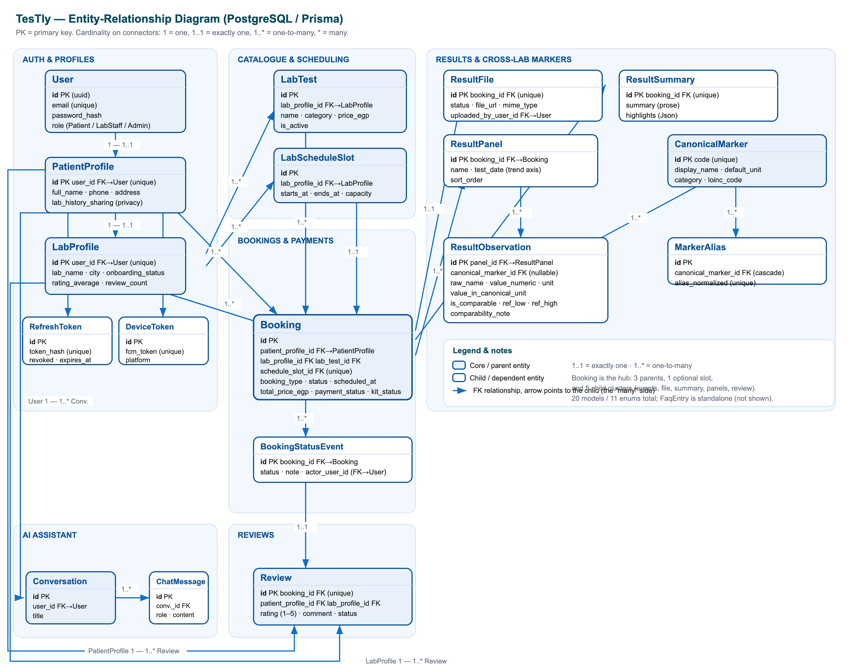
Figure 2.3: Entity-relationship diagram of the PostgreSQL schema, whose relational integrity and unique constraints underpin TesTly's booking and results guarantees

2.3.5 ORM: Prisma vs TypeORM vs Sequelize
An object-relational mapper sits between the NestJS backend and PostgreSQL, providing type-safe queries and managing schema migrations. The principal TypeScript options were Sequelize (a long-established, more loosely typed ORM), TypeORM (a decorator-based ORM common in the NestJS ecosystem), and Prisma (a schema-first toolkit with a generated, fully type-safe client). Table 2.6 compares them.
Criterion | Sequelize | TypeORM | Prisma (chosen)
Type safety | Weak | Partial (decorators) | Strong (generated client)
Schema source of truth | Model classes | Entity decorators | Single schema.prisma file
Migrations | Manual/CLI | CLI (can drift) | Generated, versioned migrations
Query ergonomics | Verbose | Moderate | Concise, autocompleted
Relational modelling fit | Good | Good | Excellent, explicit relations
Table 2.6: ORM comparison

Sequelize predates TypeScript-first design and offers comparatively weak compile-time type safety, which undercuts the end-to-end type-safety goal of the stack. TypeORM integrates naturally with NestJS's decorator style but spreads the schema across entity decorator definitions and is known for migration drift in larger schemas. Prisma takes a schema-first approach: a single schema.prisma file is the authoritative description of the data model, from which Prisma generates a fully typed client and versioned SQL migrations.
TesTly chose Prisma 5 because its generated, strongly-typed client extended the project's type-safety guarantee all the way down to the database, eliminating a class of runtime query errors at compile time. The single schema file served as a clear, reviewable source of truth that evolved through ten versioned migrations as the project grew — from the initial schema through structured results, lab-history sharing, payment fields, lab coordinates, home test kits, and the chat models. Prisma's concise, autocompleted query API kept the data-access code readable, and its migration tooling integrated cleanly with the deployment pipeline, which applies pending migrations automatically on every deploy. A thin retry middleware was layered over the Prisma client to handle serverless-Postgres transient errors.

2.3.6 Generative AI: Google GenAI (Gemini) vs Alternatives
The AI assistant is an agentic, function-calling chatbot that streams replies and calls tools to look up real labs and tests from the catalogue. Selecting the model and SDK involved weighing capability, cost, streaming and function-calling support, and suitability for a high-volume, latency-sensitive, bilingual student-project assistant. The realistic alternatives were OpenAI's GPT models, Anthropic's Claude models, open-source self-hosted models, and Google's Gemini via the Google GenAI SDK. Table 2.7 compares the dimensions that mattered.
Criterion | Self-hosted open models | OpenAI GPT | Anthropic Claude | Google Gemini (chosen)
Function calling / tools | Varies | Yes | Yes | Yes
Streaming responses | Varies | Yes | Yes | Yes (generateContentStream)
Cost for high-volume student use | Infra cost | Higher | Higher | Low (gemini-2.5-flash)
Latency for interactive chat | Hardware-bound | Good | Good | Fast (flash tier)
Operational overhead | High (host & scale) | Managed API | Managed API | Managed API
Arabic/English support | Varies | Good | Good | Good
Table 2.7: Generative-AI provider comparison

Self-hosting an open-source model was rejected on operational grounds: provisioning and scaling inference hardware is impractical and costly for a graduation project, and would distract from the application itself. The major hosted providers — OpenAI's GPT and Anthropic's Claude — are highly capable and support both streaming and function calling, but for a student project serving a price-sensitive market the cost and latency profile of a fast, economical model was the deciding factor.
TesTly chose Google GenAI with the `gemini-2.5-flash` model because it combined the required capabilities — native function calling for the agentic tool loop and token-by-token streaming via generateContentStream — with the low cost and fast response times of the Flash tier, which suits an interactive, high-volume assistant on a graduation-project budget. The function-calling support was essential: the assistant's defining behaviour is to call find_labs and search_tests tools that run real Prisma queries against the live catalogue, so its answers are grounded in actual labs and prices rather than hallucinated. Streaming let the clients render replies as they arrive and pop lab/test cards into view the instant a lookup resolves. The integration was designed to degrade gracefully: when no API key is configured the assistant cleanly disables itself rather than crashing the rest of the system, and a separate, deterministic non-LLM FAQ bot handles common questions without consuming model quota. Figure 2.4 shows the resulting agentic assistant request flow.
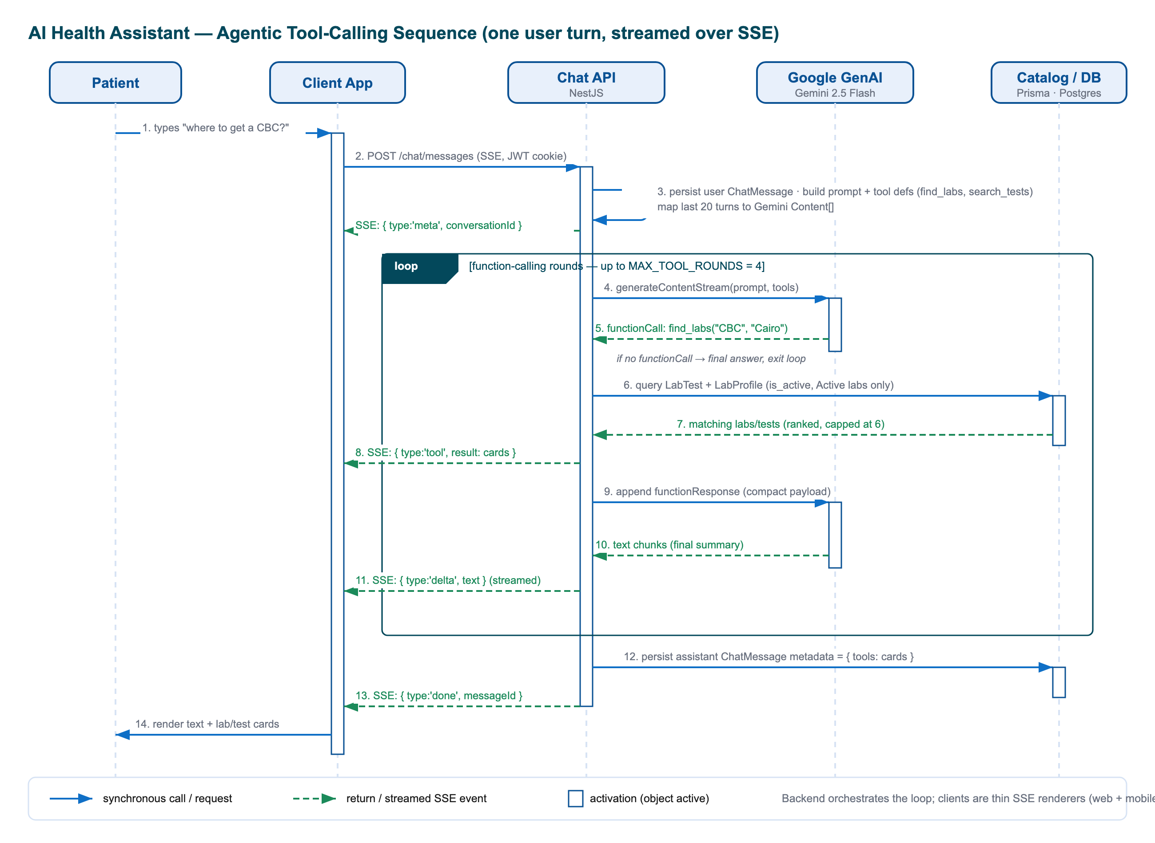
Figure 2.4: Sequence of the agentic AI assistant: Gemini's streaming and function-calling features drive a server-side tool loop grounded in the live Prisma catalogue
Taken together, the choices in this section form a coherent whole rather than a set of independent decisions. A single TypeScript backend (NestJS) and web client (Next.js), a Dart mobile client (Flutter) mirroring the same API contract, a strongly-typed data layer (Prisma over PostgreSQL), and a cost-appropriate, capability-complete AI provider (Gemini) combine into a type-safe, maintainable, and secure platform whose every layer is justified against the alternatives by the requirements of a medical lab-testing marketplace built by a small team. The chapters that follow examine how these tools were assembled into the system's analysis, design, and implementation.
Chapter 3

Methodologies and Tools

This chapter presents the engineering methodologies that shaped the TesTly platform and the concrete development tools used to realise it. TesTly is a medical lab-testing marketplace for Egypt, composed of four cooperating subsystems: a NestJS REST backend, a Next.js web application, a Flutter mobile application, and an agentic AI assistant powered by Google Gemini, all backed by a PostgreSQL database. Because the platform handles sensitive medical data and monetary transactions, the methodologies were selected deliberately to prioritise correctness, maintainability, and security. The chapter first explains the design methods that govern the structure of each subsystem (Section 3.1), then catalogues the development tools per layer (Section 3.2), and finally describes the project-management approach, namely the iterative delivery process and the version-control workflow (Section 3.3).

3.1 Design Methods
The design of TesTly follows a small set of well-established methodological principles, applied consistently across every subsystem so that the four applications form one coherent system rather than four loosely related programs. The unifying idea is separation of concerns: each layer is responsible for one well-defined category of behaviour, depends only on the layer beneath it through a stable contract, and can be reasoned about, tested, and replaced in isolation. The subsections below describe how this principle is expressed as layered backend architecture, contract-first REST API design, database-first modelling, mobile clean architecture, security-by-design, privacy-first data sharing, and component-based user interfaces.

3.1.1 Layered, Modular Backend Architecture
The backend is built with NestJS, a TypeScript framework whose decorator-driven, modular design naturally enforces a layered architecture. Each business capability is organised into a feature area composed of three collaborating layers: controllers that expose HTTP routes and bind request payloads to typed objects, services that hold the business logic and orchestrate data access, and the Prisma data-access layer that performs type-safe database operations. Controllers never contain business logic, and services never parse HTTP requests directly; this strict separation keeps the rules of the domain independent of the transport mechanism.
The platform is decomposed into clearly bounded feature areas, each corresponding to a real-world concern. The principal areas, together with their responsibilities, are summarised below.
Feature area | Responsibility
Auth | Registration, login, JWT issuance, refresh-token rotation, and role-based guards
Public marketplace | Unauthenticated lab and test browsing, search, and comparison
Bookings & payments | The booking lifecycle, availability, payment state, and kit logistics
Patient & lab workspaces | Authenticated dashboards, result handling, and cross-lab health trends
Admin | Lab onboarding governance and platform analytics
Chat & FAQ | The agentic AI assistant and the deterministic guided-FAQ helper
Notifications | Firebase Cloud Messaging push delivery
Table 3.1: Backend feature areas and their responsibilities

Cross-cutting concerns are handled centrally rather than being scattered through the feature areas. A global ValidationPipe, a standardised exception filter that emits a uniform error envelope of the form { statusCode, message, timestamp, path }, a structured audit-logging service, and a configuration module that validates environment variables at boot all apply uniformly across every route. This modular, layered organisation is depicted in the backend component diagram.

3.1.2 REST API Design with Swagger / OpenAPI
Communication between the backend and its two client applications is governed by a RESTful API designed around resources and the standard HTTP verbs. Resource paths name domain entities (for example /public/labs, /bookings, /patient/workspace, /lab/results/:bookingId/upload), and the verb expresses the intent: GET for reads, POST for creation, PATCH for partial updates, PUT for full replacement, and DELETE for removal. Across roughly fifty endpoints the design stays uniform: every response is camel-cased, paginated lists share a common { items, pagination } shape, and every error is reported through the single standardised envelope, so that the web and mobile clients can consume the API through one predictable contract.
The contract is documented automatically using Swagger / OpenAPI via the @nestjs/swagger package. A DocumentBuilder titled "TesTly Backend API" generates an interactive specification that is served at the /api path, giving developers a live, always-current reference of every route, its parameters, and its response shapes. Because the documentation is derived from the same decorated DTOs and controllers that implement the API, it cannot drift out of sync with the running code.

3.1.3 Database-First Modelling with Prisma
Persistence follows a database-first (schema-first) modelling approach using the Prisma ORM over PostgreSQL. A single declarative schema file, schema.prisma, is the authoritative definition of the data model: it declares twenty entities (such as User, PatientProfile, LabProfile, LabTest, Booking, ResultFile, and the structured-results stack) and eleven enumerations that encode the system's state machines (for example BookingStatus, PaymentStatus, and LabOnboardingStatus). From this schema Prisma generates a fully typed client, so the database structure is reflected directly into the TypeScript type system and queries are checked at compile time.
Schema evolution is managed through versioned migrations. The model grew through ten committed migrations, from the initial full schema to the addition of structured results, the lab-history-sharing privacy toggle, payment fields, lab coordinates, home-test-kit support, search indexes, and the chat models. Each migration is applied automatically on every deployment, so the live schema is always consistent with the code. The complete entity-relationship structure that results from this schema is shown in the entity-relationship diagram.
Several deliberate conventions hold across the schema: primary keys are opaque UUIDs so that identifiers are safe to expose in URLs and do not leak row counts; monetary values are stored as integer Egyptian pounds in fields suffixed _egp to avoid floating-point rounding errors; and indexes are declared on the columns the application most often filters or sorts by, such as city, rating, and scheduled time.

3.1.4 Mobile Clean Architecture with Riverpod
The Flutter mobile application is structured according to clean architecture in a feature-first layout: the lib/ tree contains one folder per business capability (auth, labs, booking, results, trends, profile, assistant, and the lab workspace), and within each feature the same strict three-layer split is applied. This split mirrors the separation-of-concerns principle used on the backend and is summarised below.
Layer | Folder | Responsibility
Presentation | presentation/ | Flutter widgets and screens; reads providers, never touches the network directly
Application | application/ | Riverpod notifiers and derived providers; state orchestration
Data | data/ | Repositories over Dio plus immutable models with JSON mapping
Table 3.2: The three layers of the mobile clean architecture

State management and dependency injection are provided by Riverpod. Three provider patterns recur: plain providers expose infrastructure and repositories as injectable singletons (which can be overridden in tests); FutureProvider (and its family variants) fetches and caches read-only server state, such as the single workspaceProvider that loads the patient's bookings, results, and profile in one call and is then sliced by derived selectors so each tab rebuilds only when its own data changes; and Notifier/StateNotifier classes drive stateful flows such as the multi-step booking wizard and the streaming AI chat. Because presentation widgets depend only on providers and immutable models, never constructing a network request themselves, the data layer is swappable and the user interface is testable with simple provider overrides.

3.1.5 Security-by-Design
Because TesTly handles medical records and payments, security is treated as a design constraint from the outset rather than a feature added afterwards. The authentication scheme issues two credentials on login: a short-lived access-token JWT (signed with a required secret key and valid for eight hours) and an opaque refresh token valid for thirty days. Refresh tokens are never stored in plaintext; only their SHA-256 hash is persisted, and on each refresh the presented token is rotated, meaning the used token is revoked and a fresh pair is issued, which limits the damage a leaked token can cause.
Passwords are never stored in clear form: they are hashed with bcrypt using a generated salt of cost factor ten, and the password-hash column is stripped from every object returned to a client. Authorisation is layered for defence in depth: a JWT guard proves identity, a roles guard enforces the actor type (Patient, Lab Staff, or Admin) declared by a @Roles decorator, a lab-active guard ensures only fully onboarded labs can transact, and each service performs an additional ownership check rather than trusting the route guard alone. The token is transported as an HTTP-only cookie for the web client (so that cross-site scripting cannot read it) and as a Bearer header for the mobile client, where it is held in the operating-system secure enclave through flutter_secure_storage.

3.1.6 Privacy-First Cross-Lab Data Sharing
A defining design decision of TesTly is its privacy-first treatment of medical history shared across competing labs. Each patient profile carries a lab_history_sharing setting that defaults to the most restrictive value, SAME_LAB_ONLY, under which a lab can see only the bookings and results created at that same lab. A patient may opt in to FULL_HISTORY_AUTHORIZED, allowing any lab they have a booking with to see cross-lab structured summaries and trends — but never another lab's original PDF document, which always remains private to the issuing lab.
This privacy boundary is enforced at the data-access layer, not merely in the user interface: when a lab requests a patient's context, the query's filter is built conditionally so that, in same-lab mode, results are hard-limited to that lab's own bookings at the database level, and a result PDF download link is produced only for the requesting lab's own uploads. The platform shares only normalised, comparable structured representations of analytes for cross-lab trending; this is precisely why the structured-results and canonical-marker subsystem exists, since it produces a shareable representation that does not require handing over another lab's authoritative document.

3.1.7 Component-Based User Interfaces
Both client applications adopt a component-based approach in which the interface is assembled from small, reusable, independently testable units. On the web, a deliberate pattern separates "smart" route container components, which fetch data, own state, and drive navigation, from "dumb" presentational components, which receive everything through props and report back through callbacks; the two are connected by a typed API-client library so that the URL shape and data types live in a single place. On mobile, the same philosophy appears as a library of shared widgets (animated cards, empty and error states, loading skeletons) composed into feature screens. A shared design-token palette — a blue brand colour, neutral surfaces, and semantic status colours — is expressed once and reused across both clients, including the porting of the web colour tokens into the Flutter theme, so the two front-ends present a consistent visual identity over the same backend.

3.2 Development Tools
This section catalogues the principal tools and libraries used to build TesTly, grouped by subsystem. For each tool, its nature and its specific role within the platform are described. The choice of tools was guided by maturity, type safety, and strong community support, all of which reduce risk in a project of this scope.

3.2.1 Frontend & Web Tools
- Next.js 16 — a React framework providing the App Router, server-side rendering, and Edge middleware. It hosts every web screen for all three roles and implements the route-protection middleware that decodes the JWT to gate the /patient, /lab, /booking, and /admin route groups.
- React 19 — the underlying UI library that renders the component tree, manages local state, and drives the interactive dashboards.
- TypeScript — the statically typed language used throughout the frontend; it mirrors the backend DTOs in the typed API-client layer, giving compile-time safety on every API call.
- Tailwind CSS 4 — a utility-first styling system configured entirely through CSS custom properties (with no JavaScript config file). It expresses the design tokens — brand colour, surfaces, radii, and shadows — and styles every screen consistently.
- Radix UI — accessible, unstyled UI primitives (dialog and label) carried over from the design export, providing a foundation for accessible interactive elements.
- Recharts — a React charting library used for the patient health-trend line charts (with reference-range bands and abnormal-point colouring) and the admin analytics dashboards (booking volume, revenue by city, and popular tests).
- zod — a runtime schema-validation library that validates the frontend's environment variables at build and start time, throwing on invalid configuration so misconfiguration fails fast.
- jose — a JavaScript library for working with JSON Web Tokens; the Edge middleware uses it to decode the access-token cookie and check expiry as a fast route-routing gate.

3.2.2 Backend Tools
- NestJS 11 — the TypeScript, decorator-driven Node.js framework that structures the backend into modules, controllers, and providers and supplies the global validation pipe, exception filter, and guard infrastructure.
- Prisma 5 — the type-safe ORM and migration tool; the schema.prisma file is the single source of truth for the data model, from which a typed client and versioned migrations are generated.
- PostgreSQL / Neon — the relational database. Development runs against a local PostgreSQL 16 container, while production uses Neon, a serverless, branchable PostgreSQL platform, both reached through the same DATABASE_URL abstraction.
- Passport-JWT — the authentication strategy (via @nestjs/passport and passport-jwt) that extracts the JWT from either the HTTP-only cookie (web) or the Bearer header (mobile) and validates it against the database on every request.
- class-validator — together with class-transformer, it provides declarative DTO validation and type coercion enforced by the global validation pipe, so unknown request fields are rejected rather than silently ignored.
- Swagger — the @nestjs/swagger module that generates the interactive OpenAPI documentation served at /api, derived from the same decorated controllers and DTOs that implement the API.
- bcrypt — the password-hashing library used to hash passwords with a cost-factor-ten salt on registration and to compare them on login, ensuring plaintext passwords are never stored.
- Joi — the schema library used by the configuration module to validate environment variables at boot, refusing to start the application if a required secret such as JWT_SECRET is missing.

3.2.3 Mobile Tools
- Flutter — Google's cross-platform UI toolkit (with the Dart language) used to build the single native codebase that runs on both iOS and Android for patients and lab staff, including full English/Arabic localisation with RTL support and a light/dark theme.
- Riverpod — the state-management and dependency-injection library that exposes repositories as injectable providers, caches server state with FutureProvider, and drives stateful flows with notifiers.
- Dio — the HTTP client; a single shared instance carries a queued auth interceptor that attaches the Bearer token and performs silent token rotation on a 401 before retrying the original request.
- go_router — the declarative routing package whose central redirect callback acts as the app's gatekeeper, routing users by authentication state and role and consuming notification deep links.
- fl_chart — the charting library used on the health-trends screen to render customised line charts with abnormal-point highlighting and dashed reference-range lines.
- flutter_secure_storage — the secure credential store that persists the access and refresh tokens in the iOS Keychain and the Android Keystore-backed encrypted preferences, the only place tokens are stored.
- google_maps_flutter — the Google Maps plugin, provisioned together with location services and the GOOGLE_MAPS_API_KEY for geographic features such as nearest-lab sorting.
- firebase_messaging — the Firebase Cloud Messaging plugin (with firebase_core and local notifications) that receives push notifications for booking and result events and supports deep-linking from a notification tap into the relevant screen.

3.2.4 AI, Cloud & Integration Tools
- Google GenAI / Gemini — the @google/genai SDK with the gemini-2.5-flash model powers the agentic Health Assistant. A server-side function-calling loop lets the model call real catalog-lookup tools (find_labs and search_tests) backed by Prisma queries and stream the reply, with structured lab and test cards, to the client over Server-Sent Events.
- AWS S3 — the object-storage target for result PDFs. A pluggable storage adapter selects between local disk (development) and an S3-compatible backend (via @aws-sdk/client-s3) at startup, so the rest of the application is storage-agnostic and files are always streamed back through an authorisation-checked controller rather than a public URL.
- Firebase Cloud Messaging — the push-notification service. The backend initialises the Firebase Admin SDK from a service-account credential and degrades gracefully to a no-op when the credential is absent, multicasting notifications to a user's registered devices and pruning stale tokens automatically.
- Docker — used via Docker Compose to run the local PostgreSQL 16 database in a container with a persistent volume, giving every contributor a reproducible development database.
- Railway / Render — the backend hosting platforms. Railway is the primary host (building with Nixpacks and running migrations on every deploy), with a Render blueprint checked in as an interchangeable alternative; the web frontend is deployed separately on Vercel with a same-origin /api rewrite proxy.
- Neon — the serverless, branchable PostgreSQL platform used for the production database, reached through a pooled connection string and made resilient to cold starts by a Prisma middleware that retries transient connection errors.

3.3 Project Management
TesTly was developed by a small team over the course of a graduation year, which made a lightweight, iterative process more appropriate than a heavyweight, plan-driven one. The project combined an agile, phased delivery rhythm with a disciplined Git-based version-control workflow. The two subsections below describe each in turn.

3.3.1 Agile and Sprints
Development proceeded in an iterative, incremental fashion in the spirit of agile methods, organised as a sequence of numbered phases that played the role of sprints. Each phase delivered a self-contained, working increment of functionality rather than a partial slice of every feature, so the system was always demonstrable and the next increment could build on a stable base. The phases progressed from a foundational core toward the final production-readiness milestone, as outlined below.
Phase | Increment delivered
Foundation | Initial full database schema, identity, authentication, and the public marketplace
Bookings & payments | The booking lifecycle, payment state machine, and cash/online settlement modes
Workspaces | Authenticated patient and lab dashboards and result handling
Phase 5 | Structured results and the cross-lab canonical-marker normalisation stack
Phase 6 | The lab-history-sharing privacy toggle
Later phases | Home-test-kit logistics, lab coordinates, search indexes, and chat models
Phase 7 | The guided agentic AI assistant and production-readiness hardening
Table 3.3: Representative delivery phases (sprint-style increments)

The evidence of this phased rhythm is preserved directly in the codebase: the ten database migrations are named after the increments they introduced (for example a structured-results phase, a lab-history-sharing phase, and the chat-models phase), and the project culminated in a Phase 7 milestone that added the agentic guided assistant alongside production-readiness work, including the cross-site authentication and same-origin-proxy fixes and a documented deployment checklist. Each increment was validated against the layer-appropriate test suites — Jest for the backend, Playwright for the web, and flutter test for mobile — before being treated as complete.

3.3.2 Version Control
The source code is managed with Git and hosted on GitHub as a monorepo organised through npm workspaces. A single repository contains all three npm-managed applications under apps/* (the backend, the frontend, and — alongside them in the tree, with its own Dart toolchain — the mobile app), so one clone gives a reviewer the API, the website, and the phone app version-locked together. Because the backend's API contract is the shared dependency that both clients consume, keeping the applications side by side prevents the clients from drifting against an outdated version of the API.
The team followed a feature-branch workflow: work proceeded on dedicated branches that were merged into the main branch through pull requests, giving an opportunity for review before integration. The project history shows this process in action through merged pull requests for the cross-site cookie and same-origin-proxy fixes. Commit messages follow the conventional-commits convention, where each message is prefixed by its type and scope — for example fix(auth): use SameSite=None cross-site cookie in production and feat(assistant): agentic lab/test cards in chat — which makes the history self-documenting and easy to scan. Continuous delivery is handled by the hosting platforms' native Git integrations: a push to the default branch triggers Railway or Render to build and migrate the backend and Vercel to build the frontend, each running the build commands declared in the repository's configuration files.
Chapter 4

Design and Implementation

4.1 User Story Definitions
Before any screen could be designed or any endpoint implemented, the functional requirements of TesTly were captured as user stories — short, value-oriented statements written from the perspective of a system actor. Each story follows the canonical agile template, "As a <role>, I want <goal> so that <benefit>", which forces every requirement to name not only the action a user performs but also the reason it matters to that user. This keeps the requirement grounded in a real need rather than a technical convenience, and it provides a natural unit of work for incremental development and for acceptance testing later in the project.
TesTly recognises three human actors, modelled by the Role enumeration in the database (Patient, LabStaff, Admin), plus a non-human AI assistant that acts on the patient's behalf. The stories below are grouped by actor. They are deliberately written at a consistent level of granularity — each maps to a coherent slice of functionality that can be exercised end-to-end — and each group corresponds to one of the use-case diagrams presented alongside it. Because the admin console is web-only by design, while patients and lab staff are served by both the web and mobile clients, the actor groupings also implicitly describe the cross-platform reach of each capability.

4.1.1 Patient User Stories
The patient is the primary consumer of the marketplace and therefore has the richest set of stories, spanning anonymous discovery, booking and payment, results consumption, longitudinal health tracking, and conversational assistance. A defining characteristic captured in these stories is that discovery requires no account: the landing page, lab search, lab detail, and test-comparison views are all unauthenticated, and only labs that an administrator has activated are ever exposed. The complete patient actor model is summarised in the patient use-case diagram.
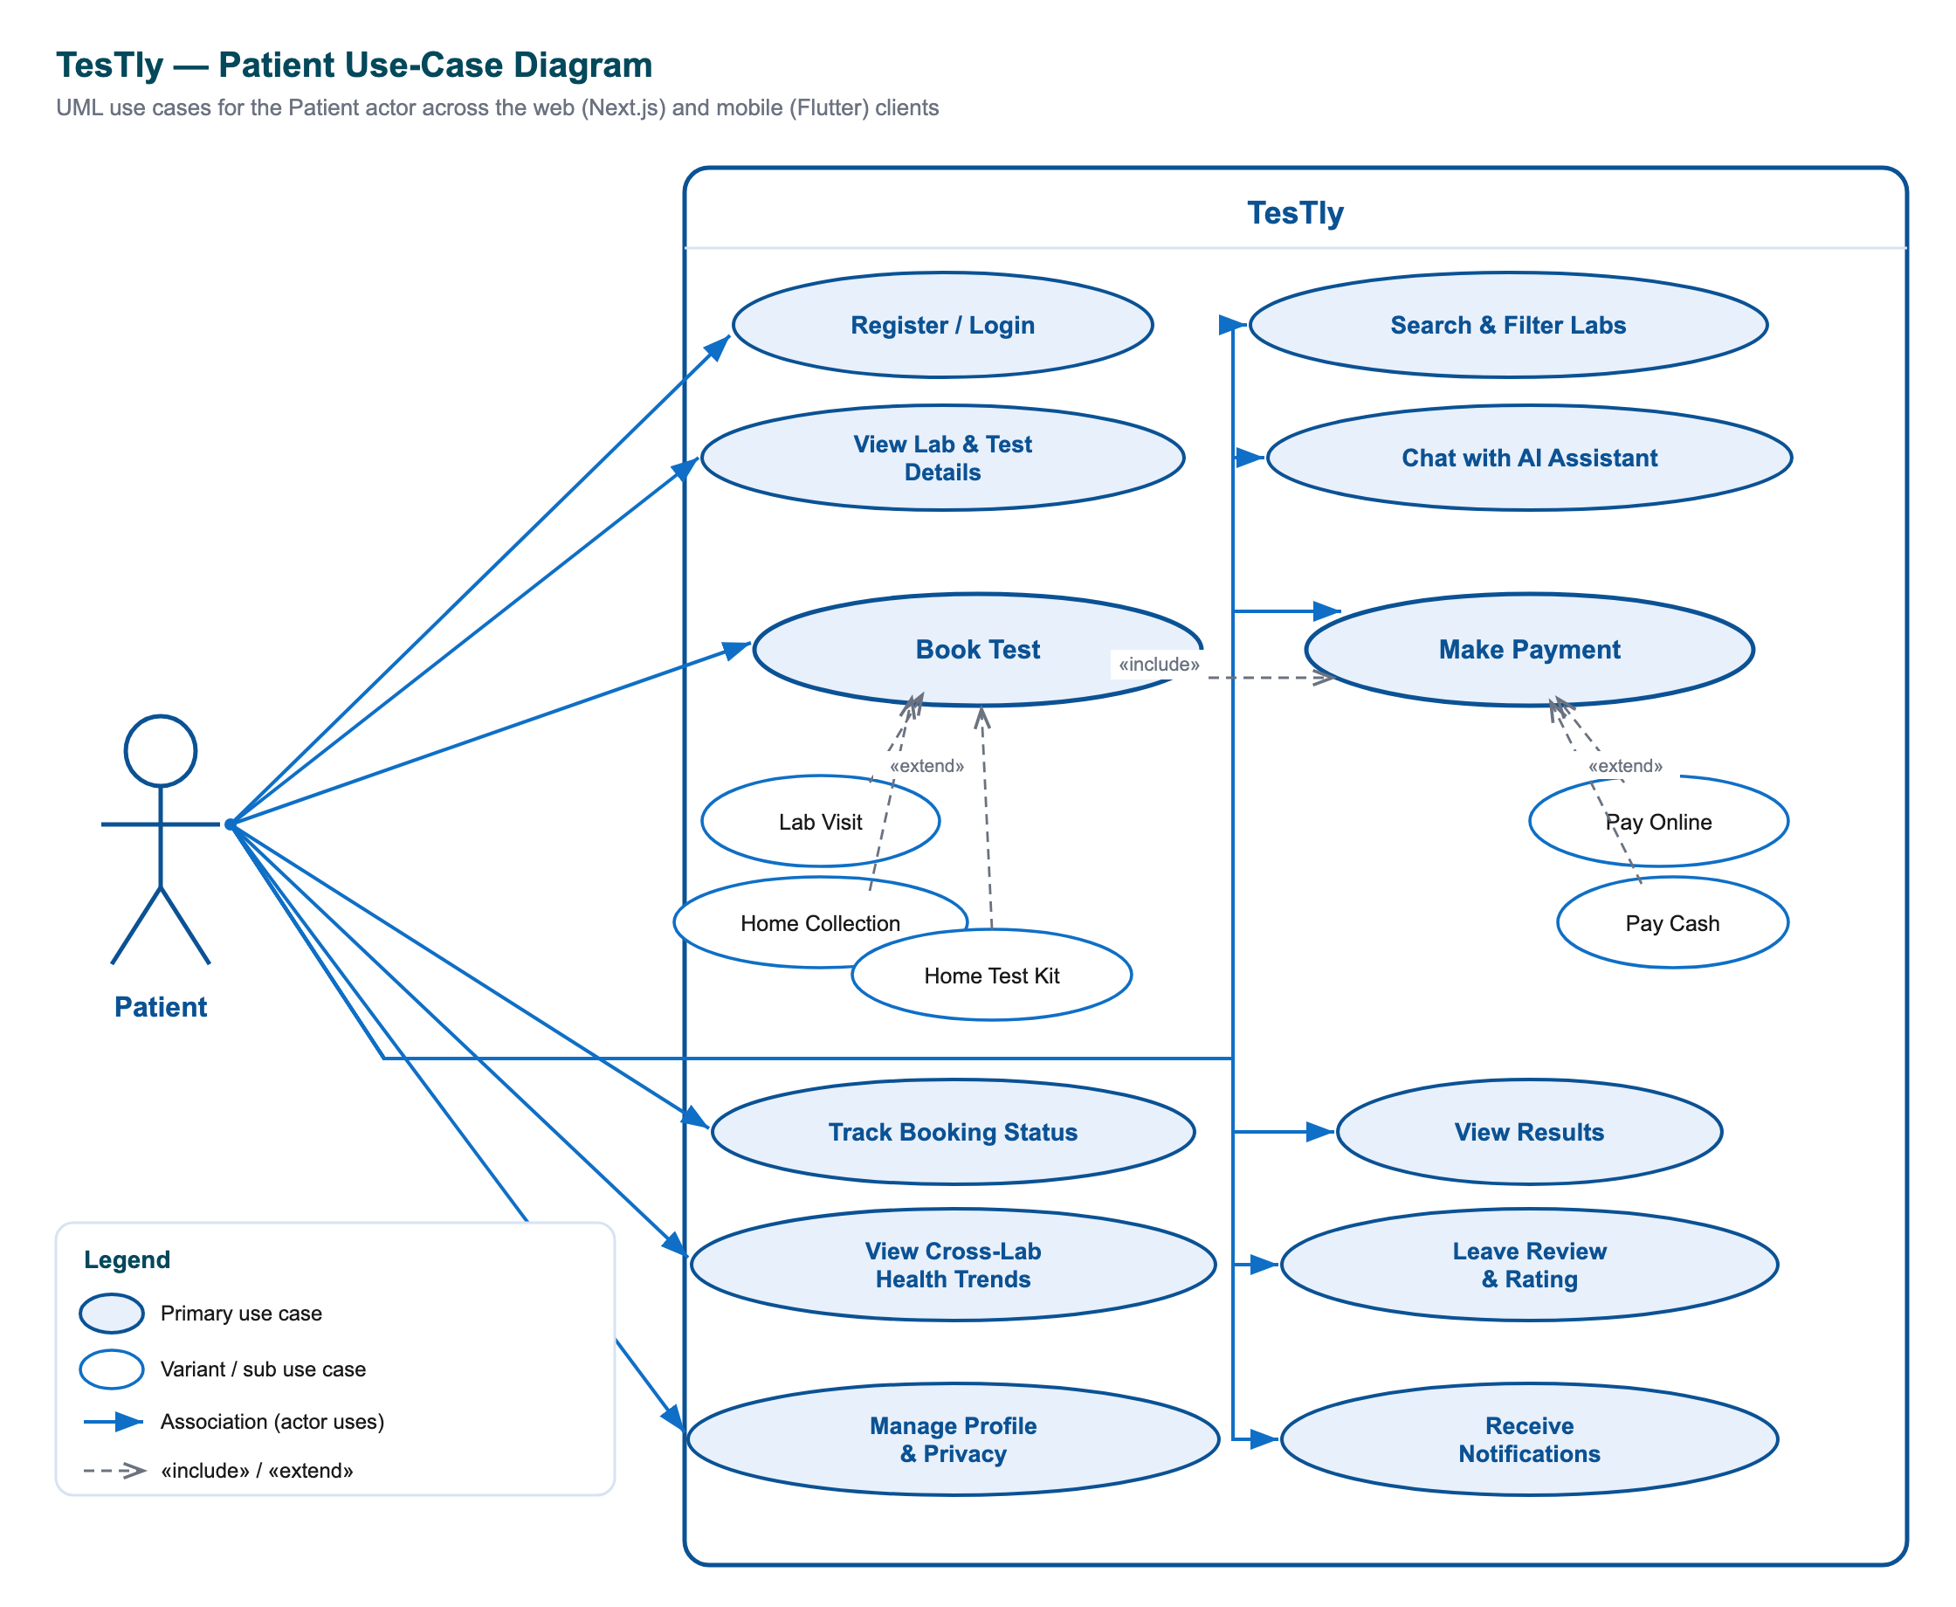
Figure 4.1: Patient use-case diagram — anonymous browsing, comparison, booking and payment, results, cross-lab trends, reviews, and AI assistance.
- As a patient, I want to browse and search the catalogue of accredited labs without first creating an account so that I can evaluate the platform before committing to register.
- As a patient, I want to filter and sort labs by free-text query, city, price, rating, distance, accreditation, and home-collection capability so that I can quickly narrow a fragmented market to the options that fit my needs.
- As a patient, I want to compare the price of a single named test (such as a CBC) across every lab that offers it so that I can find the most affordable accredited provider for the exact test I need.
- As a patient, I want labs to be ranked by how near they are to my current location so that I can prefer a convenient nearby lab over a distant one.
- As a patient, I want to book a test as a lab visit, a home sample collection, or a mail-in home test kit so that I can choose the collection mode that suits my circumstances.
- As a patient, I want to choose a future appointment slot (or receive an estimated kit-delivery date) so that the booking fits my schedule and the slot is reserved for me.
- As a patient, I want to pay online or settle in cash in a manner appropriate to my booking type so that I can use whichever payment method I trust and have available.
- As a patient, I want to track each booking through its lifecycle, see a status timeline and kit-shipment progress, and cancel a pending or confirmed booking so that I always know the state of my order and can change my mind.
- As a patient, I want to receive my official result as a downloadable PDF together with a plain-language summary so that I can both keep the authoritative document and understand my result at a glance.
- As a patient, I want to view longitudinal charts of my health markers spanning results from different labs so that I can observe trends over time even when I switch providers.
- As a patient, I want to control whether my history is shared only with the lab I am currently using or across labs I have booked with so that I retain ownership of my sensitive medical data.
- As a patient, I want to leave a rating and review after a completed booking so that I can share my experience and help other patients choose a lab.
- As a patient, I want to ask an AI assistant where to get a test and what it means, and have it surface clickable lab and test cards, so that I receive trustworthy guidance grounded in the real catalogue.
- As a patient, I want to receive push notifications when a booking is confirmed or rejected, a kit is shipped, or a result is ready so that I do not have to keep checking the app.

4.1.2 Lab Staff User Stories
Lab staff operate a complete back-office storefront, but only after an administrator has activated their account. The stories therefore begin with a gated registration and proceed through catalogue and schedule management, booking processing, results delivery, and a privacy-scoped view of patient history. The lab actor model is shown in the lab use-case diagram.
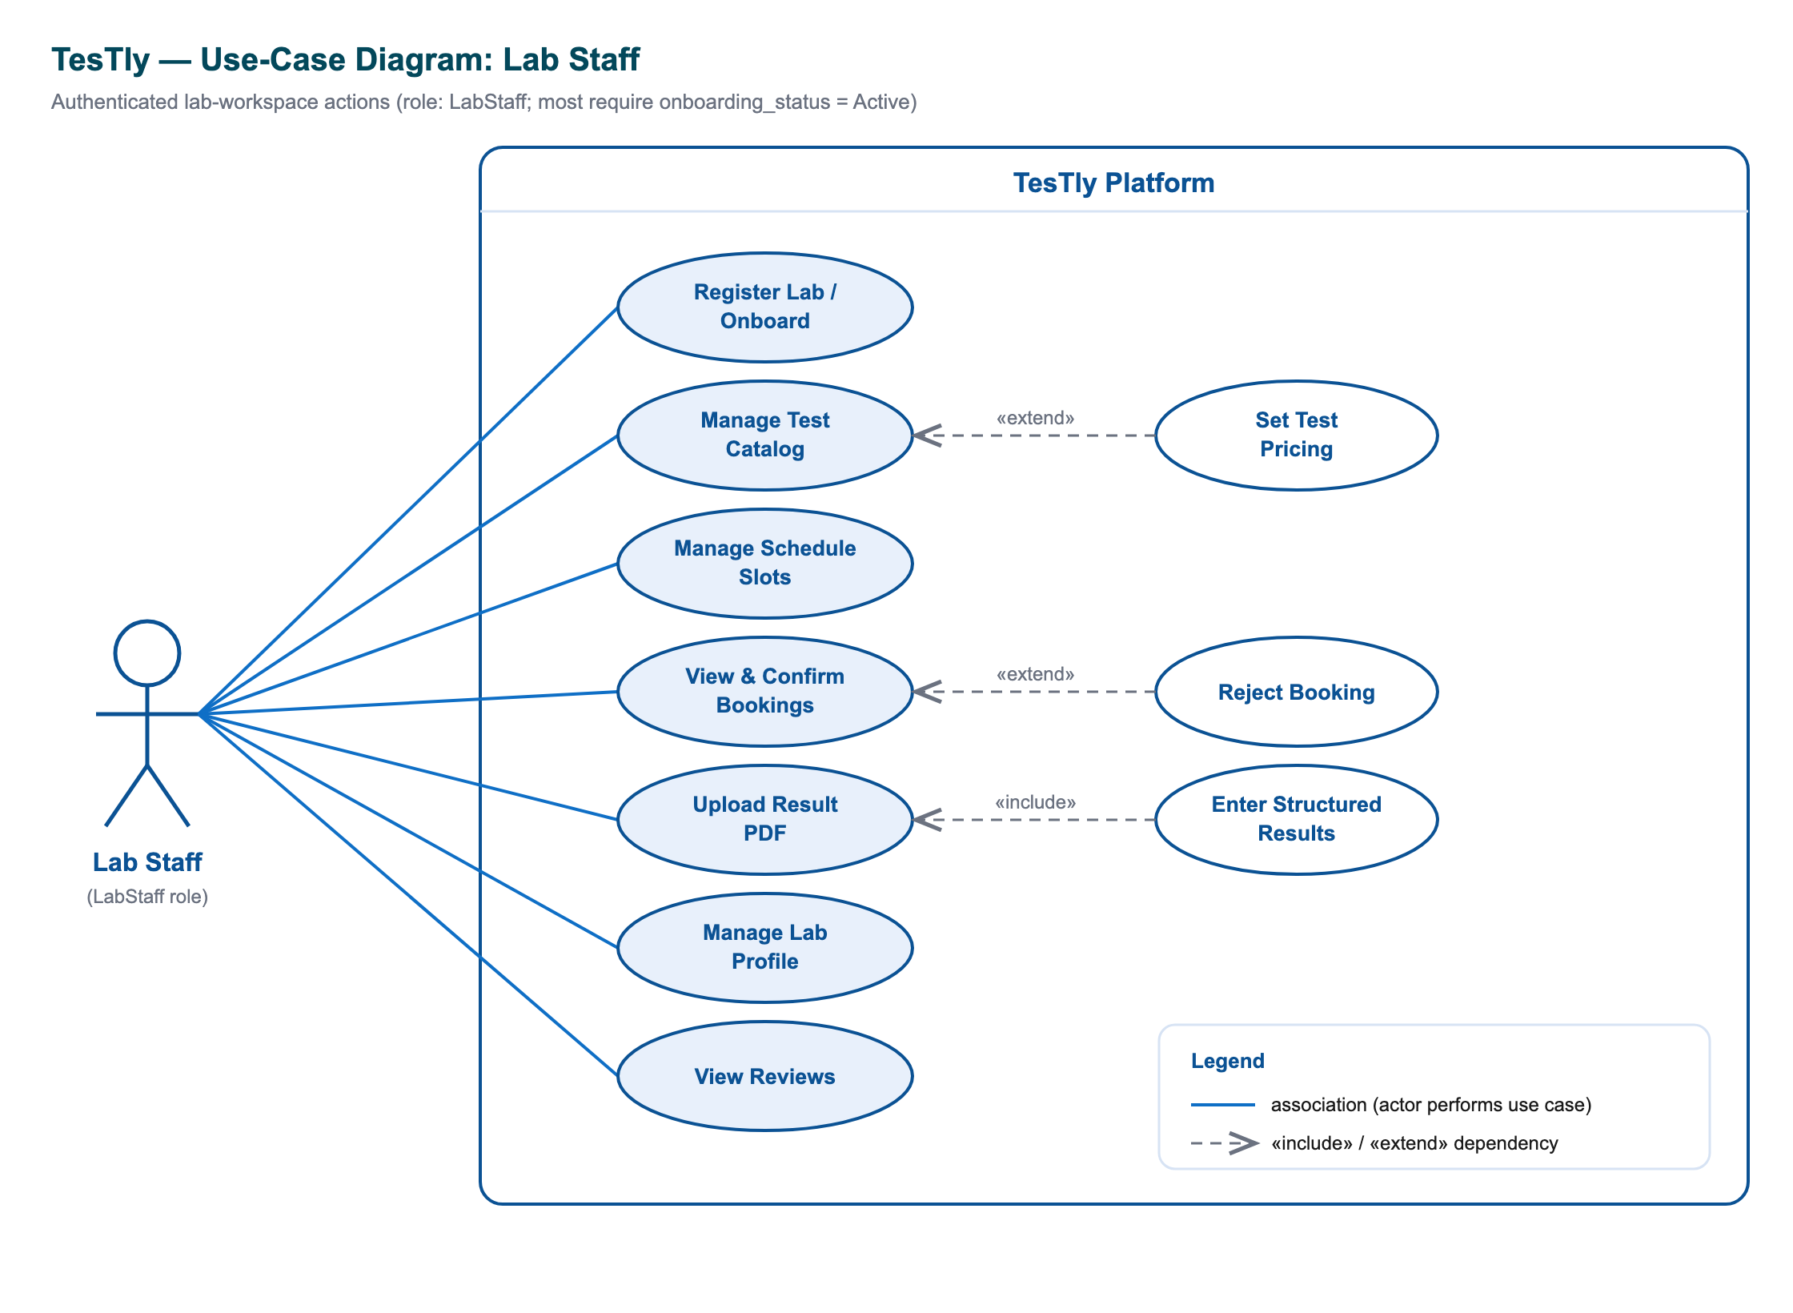
Figure 4.2: Lab Staff use-case diagram — gated onboarding, catalogue and schedule management, booking processing, result upload and delivery, and privacy-scoped patient context.
- As a lab staff member, I want to register my lab and complete an onboarding profile so that I can be reviewed by an administrator and admitted to the marketplace.
- As a lab staff member, I want a workspace dashboard that aggregates my booking queue, catalogue, schedule, and analytics so that I can run my operations from a single screen.
- As a lab staff member, I want to create, update, and retire tests with their own price, description, preparation, and turnaround so that my catalogue reflects exactly what my lab offers and at what price.
- As a lab staff member, I want to publish and manage future appointment slots so that patients can book only when my lab is actually available.
- As a lab staff member, I want to confirm or reject pending bookings — confirming online bookings only once payment has cleared — so that I commit my capacity only to valid, paid orders.
- As a lab staff member, I want to record cash collected and advance the home-test-kit fulfilment through its shipment stages so that the order state stays accurate for the patient and for my records.
- As a lab staff member, I want to toggle whether my lab offers home collection and home test kits so that I expose only the collection modes I can actually service.
- As a lab staff member, I want to upload the official result PDF, attach a summary and highlights, and add structured analyte values so that the patient receives an authoritative document and contributes to cross-lab trends.
- As a lab staff member, I want to view a patient's clinical history, bounded by that patient's privacy setting and never exposing another lab's raw PDF, so that I can prepare and interpret a sample responsibly.
- As a lab staff member, I want to see my own reviews and be notified of new bookings and reviews so that I can monitor demand and reputation.

4.1.3 Administrator User Stories
The administrator is the platform's curator and governor. Because TesTly is a curated marketplace rather than open self-service, the administrator's stories centre on lab governance — verifying that a lab is operationally complete before it becomes bookable — together with platform-wide analytics and user oversight. The admin actor model is shown in the admin use-case diagram.
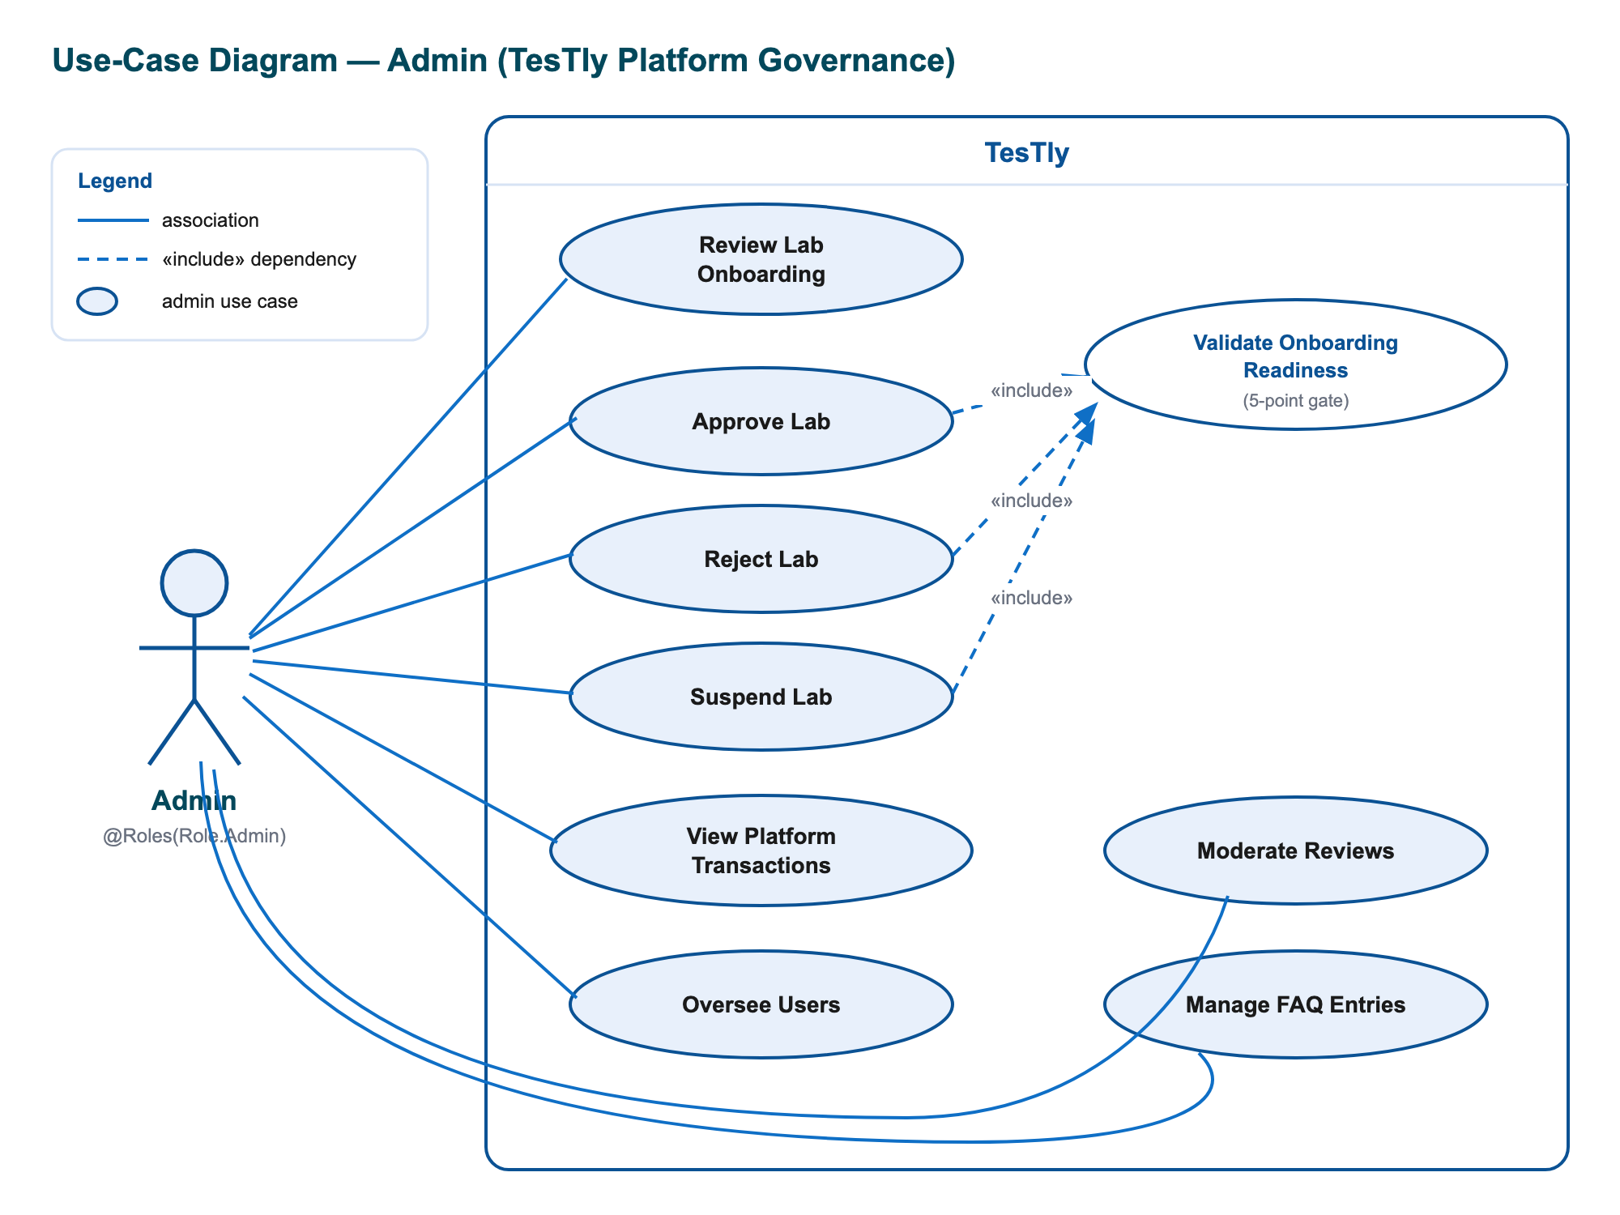
Figure 4.3: Administrator use-case diagram — lab governance with onboarding-readiness gating, platform analytics, user management, and payments oversight.
- As an administrator, I want a governance dashboard listing every lab with its onboarding status and an explicit readiness breakdown so that I can see at a glance which labs are ready for approval and which requirements they still lack.
- As an administrator, I want to activate, reject, or suspend a lab — with activation refused for any lab that fails the readiness gate — so that every bookable lab in the marketplace is guaranteed to be operationally complete.
- As an administrator, I want to view platform statistics and analytics, including booking volume, revenue by city, and the most popular tests, so that I can understand and steer the health of the marketplace.
- As an administrator, I want a searchable list of patients with their booking counts so that I can support and oversee the user base.
- As an administrator, I want a feed of recent payments across the platform so that I can monitor financial activity and investigate issues.

4.1.4 Representative User-Story Backlog
The following table consolidates a representative subset of the backlog into a single prioritised view. Priorities follow the MoSCoW convention (Must, Should, Could): "Must" items constitute the minimum viable marketplace, "Should" items add the differentiating value of TesTly, and "Could" items are valuable enhancements. The identifiers are referenced again in later chapters when mapping requirements to implementation and tests.
ID | Actor | User Story | Priority
US-01 | Patient | Browse and search labs without registering | Must
US-02 | Patient | Compare one named test across all labs by price | Must
US-03 | Patient | Rank labs by distance from my location | Should
US-04 | Patient | Book a test as lab visit, home collection, or home test kit | Must
US-05 | Patient | Pay online or by an appropriate cash method | Must
US-06 | Patient | Track booking status and cancel a pending/confirmed booking | Must
US-07 | Patient | Receive a result PDF plus a plain-language summary | Must
US-08 | Patient | View cross-lab health-marker trends over time | Should
US-09 | Patient | Control cross-lab history-sharing privacy | Should
US-10 | Patient | Review a lab after a completed booking | Should
US-11 | Patient | Chat with an AI assistant grounded in the catalogue | Could
US-12 | Lab Staff | Register a lab and complete onboarding for review | Must
US-13 | Lab Staff | Manage the test catalogue and pricing | Must
US-14 | Lab Staff | Manage future appointment slots | Must
US-15 | Lab Staff | Confirm/reject bookings and record cash collected | Must
US-16 | Lab Staff | Upload result PDF and add structured observations | Must
US-17 | Lab Staff | View privacy-scoped patient context | Should
US-18 | Admin | Review labs with an onboarding-readiness breakdown | Must
US-19 | Admin | Activate/reject/suspend labs with a readiness gate | Must
US-20 | Admin | View platform analytics and recent payments | Should
Table 4.1: Representative prioritised user-story backlog across the three actors.

4.2 User Interface and Wireframe Design
The user-interface design of TesTly was developed concurrently across the two client platforms — a Next.js web application and a Flutter mobile application — over a single shared backend API. The two clients deliberately mirror one another: the mobile palette is ported directly from the web application's design tokens, the two share an identical distance formula, and the same search, booking, results, and trends flows appear on both. This section describes the key screens as wireframe-level layouts, naming each screen's principal regions, components, and navigation paths. Throughout, the design language is consistent: white rounded cards on a light neutral background, a blue brand accent, pill-shaped tab bars, and a clear visual hierarchy of header, primary content, and call-to-action.
Two cross-cutting properties hold for every screen. First, the interface is responsive: the web application uses a CSS-token design system (Tailwind 4) with fluid card grids and sticky headers that adapt from desktop to small viewports, while the mobile application is natively laid out for phone form factors with bottom-navigation shells. Second, the design supports dark mode: a dark theme variant is declared in the web stylesheet and is the default behaviour of the error and loading boundaries, while the mobile application ships a full Material 3 dark theme selectable as System, Light, or Dark in the profile screen. The mobile client additionally provides full English/Arabic localisation with automatic right-to-left layout for Arabic.

4.2.1 Patient Home and Search
The patient's entry point is a landing/home screen built around discovery. On the web, a sticky header carries the brand mark, anchor links, and a role-aware sign-in or dashboard control. Beneath it sits a blue-gradient hero containing a trust badge, a large headline, and a two-field search bar (test or symptom, plus an optional city), followed by popular-search chips (CBC, Lipid Profile, Thyroid Panel, HbA1c) and "browse by" shortcuts for Nearest, Best Price, and Top Rated. Below the hero are a feature grid, a featured-labs section populated by the top-rated labs, a four-step "How It Works" strip, and a footer. Submitting a search composes a query string and navigates to the comparison screen; selecting a featured lab opens its detail page. The mobile home screen mirrors this exactly as a native layout — a gradient hero greeting the user by first name, a tappable search field, the same browse-by and popular-search chips, a horizontally scrolling featured-labs carousel, and the feature and how-it-works sections — with a floating action button that opens the AI assistant.
The search/comparison screen presents two pills toggling between a Tests view and a Labs view. The Tests view shows a grid of aggregated test cards (name, category, "from EGP X", and "available at N labs"). The Labs view shows a sort-and-filter bar — a Filters control with an active-count badge, a home-collection toggle, and a sort selector for Price, Rating, or Distance — above a column of lab cards. An expandable advanced-filter panel exposes range sliders for minimum rating, maximum distance, and maximum price, plus accreditation toggle chips. Each lab card shows the lab name, rating, distance, address, accreditation, turnaround, an optional home-collection tag, the relevant price, and a Book Now action. To support the Distance sort, the client requests the browser (or device) geolocation and, when granted, ranks results by great-circle distance.

4.2.2 Lab Detail and Test Comparison
The lab detail screen opens with a header card naming the lab and showing its rating and review count, distance, and address, followed by a grid of key facts (accreditation, turnaround time, contact phone, and email) and an optional home-collection indicator. A patient-reviews card lists published reviews with reviewer initials, star ratings, comments, and dates, with reviewer names privacy-reduced to a first-name-and-initial form. The screen's main body is the Available Tests catalogue, filterable by category chips, where each test card presents the name, price, description, preparation, turnaround, and parameter count, and a *Book This Test* button that carries the chosen lab and test into the booking flow. The mobile twin renders the same content within a collapsing app bar and a pinned two-tab bar separating Tests from Reviews.
The complementary test-comparison screen answers the inverse question — "who offers this test, and at what price?". It leads with a test-information card (name, category, description, a facts row, and a parsed preparation checklist), then a sort-and-filter bar offering Nearest, Price, and Rating ordering, and finally a list of every lab offering that test. Each entry shows the lab, a distance badge, rating, accreditation, turnaround, the price, home-collection and home-test-kit tags, and *View Lab* and *Book Now* actions. Distance here is computed client-side from each offer's coordinates, so the list re-sorts to Nearest as soon as a location fix arrives.

4.2.3 Booking Flow
The booking flow is a guided, multi-step wizard reached only by authenticated patients. It opens with a lab-information card (lab, address, selected test, and base price) and proceeds through a sequence of clearly separated decisions, each rendered as a card on the web and as a discrete step on mobile:
- Choose collection type — three large selectable tiles for Visit Lab, Home Collection (+EGP 100), and Home Test Kit (+EGP 150); the home options are disabled unless the lab offers them.
- Select a slot — for lab-visit and home-collection bookings, a date grid and a time-slot grid populated from available future slots; for the kit flow, an explanatory delivery banner replaces the slot picker.
- Provide an address — a home-address field appears for the home-collection and kit flows.
- Choose payment — a Pay-online (demo) option or a context-appropriate cash option (cash at lab, cash to collector, or cash on delivery) matched to the booking type.
- Review and confirm — a booking-summary card itemises the test price plus any collection or kit fee to a total, restates the payment method, and presents the Confirm Booking (or Order Kit) action; on success a confirmation card is shown and the patient is returned to the dashboard.
Because a slot is reserved atomically when the booking is created, the interface gracefully handles the case where a slot is claimed concurrently: the conflict surfaces as a toast and availability is re-fetched so the patient can pick again. The mobile booking flow implements the identical sequence as an explicit step state machine and, on success, additionally schedules a local preparation reminder the evening before a test that requires fasting.

4.2.4 Patient Dashboard — Bookings, Results, and Trends
The patient dashboard is the authenticated home for managing activity. A header shows the patient's avatar, name, and role pill alongside actions for the AI Assistant, browsing labs, and logout, with three quick-stat tiles for total bookings, upcoming bookings, and results. The body is organised by a four-tab pill bar:
- Bookings — one card per booking with a status-coloured left border, the test and lab, a status badge, a grid of date/type/total/address, a kit-status progress bar for kit orders, a payment line, demo-payment controls for pending online payments, and a cancel action for pending or confirmed bookings.
- Results — one card per result showing its status, a "structured data · N values" or "PDF only" badge, an AI summary block of highlighted key/value items, an *Open PDF* link, and a review widget (a five-star picker and comment) shown only when the result is reviewable and not yet reviewed.
- Trends — the longitudinal health-trends panel (described below).
- Profile — editable name, phone, and address, a read-only email, and the lab-history-sharing selector with an explanatory privacy note.
The trends panel renders one line chart per analyte series, plotting normalised values over time. A shaded reference band marks the most recently reported reference interval, and individual data points are coloured to flag abnormal versus in-range readings. Each chart carries date-range chips (3, 6, or 12 months, or all), grouping chips (by analyte or by lab test), a textual point-by-point breakdown, a trend badge (rising, falling, stable, or not enough points), an Export-CSV action, and a standing medical disclaimer. On mobile the same panel is drawn with the fl_chart library, including dashed reference lines and a recent-readings table; on the web it uses the Recharts library. Crucially, because the underlying observations are normalised to canonical units, a single chart can combine results from different labs.

4.2.5 AI Assistant Chat
The AI assistant is presented as a familiar chat interface: a header with an assistant avatar and a *New chat* control, a scrollable message area, and a bottom composer with an auto-sizing multi-line input and a send button. An empty state greets the patient by name and offers suggestion chips (for example, "How do I prepare for a fasting blood test?"). User messages render as blue bubbles and assistant messages as neutral bubbles, with an animated typing indicator while a reply streams in. The assistant's distinguishing feature is agentic tool-result cards: when it looks up the catalogue it attaches clickable lab cards and test cards inline, each deep-linking into the corresponding lab-detail or test-comparison screen, which turns the conversation into an on-ramp to the booking funnel. A persistent disclaimer beneath the composer reinforces that the assistant does not provide a diagnosis. This agentic assistant is distinct from the lightweight guided-FAQ chatbot that floats on every web page for cheap, common questions.

4.2.6 Lab Dashboard — Schedule, Catalogue, and Results
The lab workspace is organised under a multi-tab bar covering Bookings, Tests, Results, Schedule, Analytics, Reviews, and Settings. The Bookings tab lists pending bookings first and presents each with the patient, test, date, status, a details grid, a payment line, and the appropriate actions — Confirm and Reject (with Confirm disabled until an online booking is paid), a record-cash-received control for cash bookings, the home-test-kit action ladder (ship with tracking, mark delivered, mark sample received), and a button that opens the privacy-scoped patient-context drawer. The Tests tab combines an add-test form with inline-editable test rows offering edit, delete, and active-toggle. The Schedule tab pairs an add-slot form (start, end, and capacity) with a list of slots that can be deactivated. The Results tab, for confirmed or completed bookings, provides a PDF file picker and summary field with an upload action, a mark-delivered action, and access to the patient-context drawer. The Analytics tab presents stat cards (total bookings, completed, pending results, revenue estimate, capacity-usage percentage, and top tests), while Reviews lists the lab's published reviews and Settings exposes the home-collection and home-test-kit capability toggles.
The patient-context drawer is a right-hand overlay that renders only what the patient's privacy setting permits: a privacy notice, the patient's sharing setting and the lab's effective scope, demographics, recurring-test signals, a twelve-month trend summary, and prior bookings — with cross-lab entries clearly flagged as belonging to another lab and PDF links available only for this lab's own uploads.

4.2.7 Admin Dashboard — Pending Labs and Transactions
The admin dashboard, available only on the web, opens with a gradient header and a stats row (total labs, active labs, total bookings, platform revenue, and a highlighted pending-approvals count). Its content is organised into four tabs. The Lab Approvals tab — carrying a pending-count badge — offers a search box, status-filter chips, and lab cards; pending labs are visually tinted, and each card exposes an Approve action (disabled unless the lab's onboarding readiness is satisfied), a Reject action, and a View-Details expander revealing a stat grid and an onboarding-readiness summary that names exactly which requirements are still missing. The User Management tab presents a searchable patient table; the All Bookings tab shows a table of the most recent payments (booking, patient, lab, test, date, status, and amount); and the Analytics tab renders the platform charts — a booking-volume area chart over thirty days, a revenue-by-city bar chart, and a most-popular-tests bar chart — together with a client-aggregated top-performing-labs list.

4.3 System Architecture and Database Design
This section describes how TesTly is structured internally: its layered runtime architecture, the modular organisation of the backend, the high-level flow of data through the system, the relational database schema with its distinctive structured-results design, the REST API surface, and the authentication and authorisation model that protects the medical and financial data the platform handles.

4.3.1 Layered Runtime Architecture
TesTly is delivered as an npm-workspaces monorepo containing three applications over a single API contract: a NestJS backend, a Next.js web application, and a Flutter mobile application. Architecturally the system is layered. At the top, two thin client layers — the web SPA-plus-storefront and the native mobile app — render the user interface and hold no business logic. Both consume one API layer, the NestJS server, which is the sole holder of business rules and the only component that touches the database. Beneath the API sit a persistence layer (PostgreSQL accessed through the Prisma ORM) and a set of external service integrations (object storage for result PDFs, Firebase Cloud Messaging for push, and Google Gemini for the AI assistant). The overall layering and the placement of each external dependency are shown in the architecture diagram.

Figure 4.4: Layered system architecture — two clients over one NestJS API, backed by PostgreSQL and three external services.
A deliberate theme of the architecture is that the optional external services degrade gracefully when they are not configured: object storage falls back to local disk, push notifications become a no-op, and the chat endpoint returns a service-unavailable response. This lets the core API run in any environment. The deployment topology that realises this architecture — the web app on Vercel, the API on Railway (or Render), and the database on a managed Postgres provider — is presented in the deployment diagram.
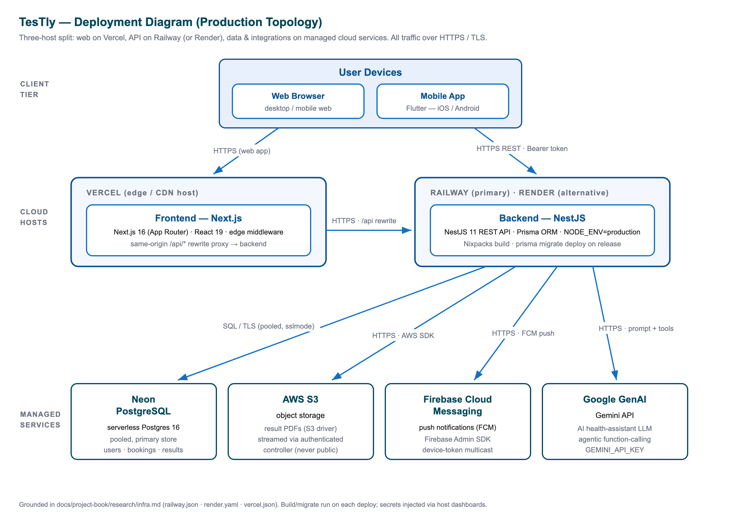
Figure 4.5: Deployment topology — Vercel-hosted web app, Railway/Render-hosted API, managed PostgreSQL, and the external S3, FCM, and Gemini services.

4.3.2 Backend Module Structure
The NestJS backend is decomposed into feature modules under apps/backend/src/, each owning a cohesive slice of the domain: authentication and authorisation; the public marketplace; bookings and payments; the patient and lab workspaces (including results handling); clinical normalisation; administration; the FAQ helper; the AI chat assistant; and notifications. Cross-cutting concerns — a global validation pipe, a standardised exception filter, audit logging, and a Prisma retry middleware for serverless-database resilience — are applied uniformly across the modules. The module layout and the request pipeline are shown in the backend component diagram.

Figure 4.6: Backend module/component diagram — feature modules and the layered guard pipeline.
A distinctive feature of the request pipeline is its layered guard chain. Every protected request passes, in order, through a JwtAuthGuard that proves identity, a RolesGuard that enforces the required actor type, a LabActiveGuard that confirms a lab account has been activated, and finally a per-service ownership check that verifies the caller actually owns the resource being acted upon. No single guard is trusted to be sufficient; together they implement defence in depth appropriate to a system handling medical data and money.

4.3.3 High-Level Data Flow
At a high level, a request originates in one of the two clients, carrying authentication credentials — an HTTP-only JWT cookie for the web app or a Bearer token for the mobile app. It reaches the NestJS API, where it traverses the validation pipe and the guard chain before entering a feature service. The service applies business rules, reads and writes the database through Prisma, optionally invokes an external service (persisting a PDF, sending a push notification, or calling the language model), and returns a uniform, camel-cased response — or, for the AI assistant, a stream of Server-Sent Events. The end-to-end movement of data through these stages is depicted in the data-flow diagram.
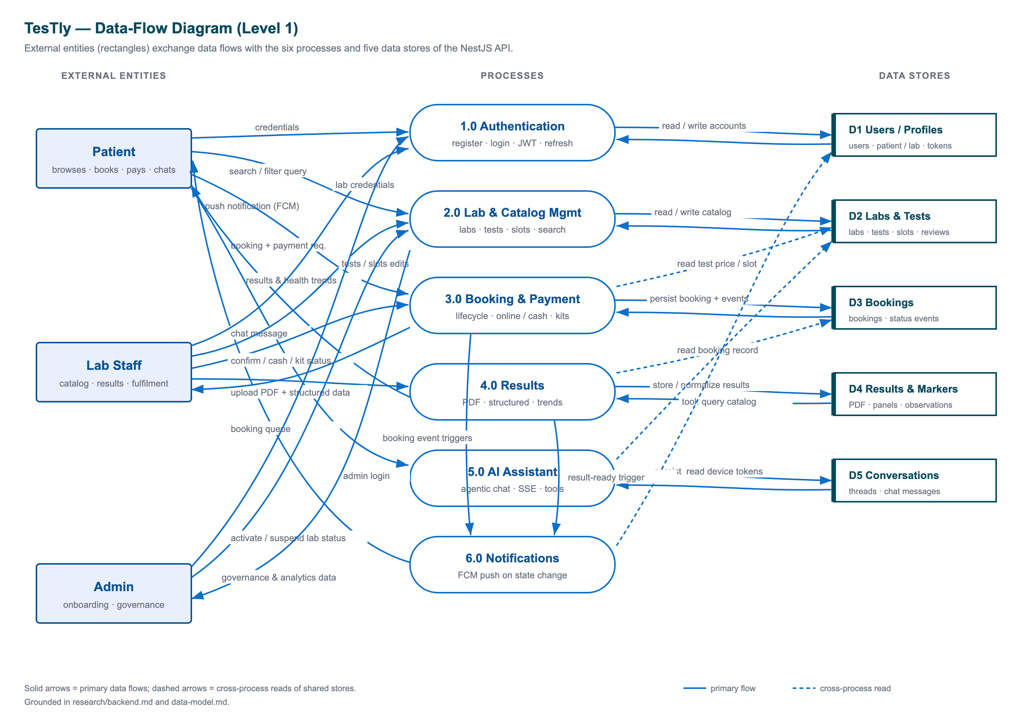
Figure 4.7: High-level data-flow diagram — client request through validation, guards, and services to the database and external integrations.

4.3.4 Database Schema and the Structured-Results Design
The persistence layer is a PostgreSQL database accessed through Prisma, comprising twenty tables (models) and eleven enumerations. Primary keys are opaque UUIDs, monetary amounts are stored as integer Egyptian pounds in fields suffixed _egp, and column names use snake_case with standardised created_at/updated_at timestamps. The schema groups into six functional clusters — identity and accounts, catalogue and scheduling, transactions, results, trust/content/auth plumbing, and the AI assistant — and has evolved through ten migrations. The full entity-relationship model is shown in the ERD.

Figure 4.8: Entity-relationship diagram — the twenty models with Booking as the central hub and the structured-results marker sub-graph.
The identity cluster centres on a single User table with a role discriminator, extended by optional one-to-one PatientProfile and LabProfile records; this keeps authentication uniform while pushing role-specific data into profile tables. LabProfile is the lab's storefront record, carrying location, capability flags, an onboarding status, and denormalised rating_average/review_count aggregates for fast listings. Tests are modelled per-lab (LabTest), so the same conceptual test exists as many rows each with its own price — the basis of the comparison marketplace — while LabScheduleSlot represents bookable time windows.
The Booking table is the hub of the schema. It references the three parties to an order (patient, lab, and test), optionally claims one schedule slot through a unique foreign key that guarantees a slot is held by at most one active booking, and carries three parallel concerns in one row: the order itself, a payment block (method, status, reference, and timestamped failure/clearance fields), and a kit-logistics block for mail-in kits. Each booking owns an append-only BookingStatusEvent trail that records how and by whom every status transition occurred, giving both a fast current-state read and a queryable audit history.
Results are stored in two complementary forms, which is the most architecturally interesting aspect of the schema. The legally authoritative document is the ResultFile (one PDF per booking, served only through an authorisation-checked proxy), accompanied by a human-readable ResultSummary. Alongside these sit the structured-results stack, whose purpose is to let a patient and authorised labs trend a marker — say fasting glucose — across results from *different* labs, even though every lab names and units its analytes differently. Four tables collaborate: a ResultPanel groups observations under a booking; each ResultObservation stores both the raw reading (name, value, unit, and reference range exactly as reported) and a canonical form (a converted value_in_canonical_unit, a comparable_unit, an is_comparable flag, and an explanatory note). The canonical anchor is the CanonicalMarker table — a single internal identity per analyte, with a stable code, a default canonical unit, and an optional LOINC code — and MarkerAlias maps the many normalised raw spellings a lab might print onto that one marker. Resolution proceeds from an explicit code, to an alias match, to a fuzzy display-name match; values whose unit cannot be recognised are explicitly flagged non-comparable so they never pollute a shared trend line, and clinical-precision decimals are used throughout. This canonical-marker design is what makes cross-lab trending possible without ever exposing one lab's raw document to another.
The schema's eleven enumerations encode the controlled vocabularies of the domain. The principal ones are listed below.
Enumeration | Values | Meaning
Role | Patient, LabStaff, Admin | Account type and authorisation level
LabOnboardingStatus | PendingReview, Active, Rejected, Suspended | Admin moderation state of a lab; only Active labs can transact
BookingType | LabVisit, HomeCollection, HomeTestKit | How the sample is collected
BookingStatus | Pending, Confirmed, Rejected, Cancelled, Completed | Order lifecycle state
PaymentMethod | Online, CashHomeCollection, CashLabVisit, CashOnDelivery | Settlement channel
PaymentStatus | Pending, Paid, Failed, Refunded | Payment lifecycle state
KitStatus | AwaitingShipment, Shipped, Delivered, SampleReceived | Mail-in kit shipping lifecycle
ResultStatus | Pending, Uploaded, Delivered | Result-file delivery state
ReviewStatus | Pending, Published, Rejected | Review moderation; only Published feeds ratings
LabHistorySharing | SAME_LAB_ONLY, FULL_HISTORY_AUTHORIZED | Cross-lab privacy scope
ChatRole | User, Assistant | Author of an AI-assistant message
Table 4.2: Principal database enumerations and their meaning.

4.3.5 REST API Design
The backend exposes a REST API of roughly fifty endpoints, documented automatically via an OpenAPI/Swagger UI. The design is conventional and uniform: resources are addressed by noun-based paths, the HTTP verb expresses the operation (GET to read, POST to create, PATCH to partially update, PUT to replace, DELETE to remove), request bodies are validated declaratively by data-transfer objects, and every response — whether success or error — follows a consistent shape, with errors wrapped in a standardised envelope. Endpoints are grouped by module: an unauthenticated public marketplace, the authentication endpoints, the bookings and payments routes, the patient and lab workspaces, the results routes, the admin governance routes, the FAQ helper, and the AI chat endpoints. A representative selection of the most important endpoints is shown below.
Method | Path | Purpose
POST | /auth/register/lab | Register a lab account in PendingReview
POST | /auth/login | Authenticate and issue an access/refresh token pair
GET | /public/labs | Search, filter, sort, and paginate active labs
GET | /public/tests/by-name | List every lab offering a named test, price-ascending
GET | /bookings/availability | Open future slots for a lab and test
POST | /bookings | Create a booking
POST | /bookings/:id/demo-online-payment | Process the (simulated) online payment
PATCH | /bookings/:id/lab-status | Lab confirms or rejects a pending booking
GET | /patient/workspace | Aggregated patient dashboard
GET | /patient/health-profile | Cross-lab analyte trends
POST | /lab/results/:bookingId/upload | Upload the official result PDF and summary
PUT | /lab/results/:bookingId/structured | Upsert structured panels and observations
GET | /results/files/:id | Download a result PDF through an authorisation check
GET | /admin/workspace | Lab-governance dashboard with onboarding readiness
PATCH | /admin/labs/:labProfileId/status | Activate, reject, or suspend a lab
POST | /chat/messages | Send an AI-assistant message; reply streamed over SSE
Table 4.3: Representative selection of key REST API endpoints.

4.3.6 Authentication and Role-Based Access Control
Authentication serves two client transports from one codebase. On login the API issues a short-lived (8-hour) access JWT and a long-lived (30-day) refresh token. For the web client the access token is delivered as an HTTP-only cookie — which, in production, is made first-party by a same-origin /api rewrite so the cookie survives the split deployment — while the mobile client receives the token in the response body and stores it in the device's secure keystore, sending it as a Bearer header. The server's JWT strategy accepts either transport via two extractors. Refresh tokens are opaque random secrets of which only a SHA-256 hash is stored, and they are rotated on use: each refresh revokes the consumed token and issues a fresh pair, limiting the damage a stolen token could do. Passwords are stored only as bcrypt hashes.
Authorisation is enforced as a layered chain, illustrated in the authentication sequence for lab onboarding.
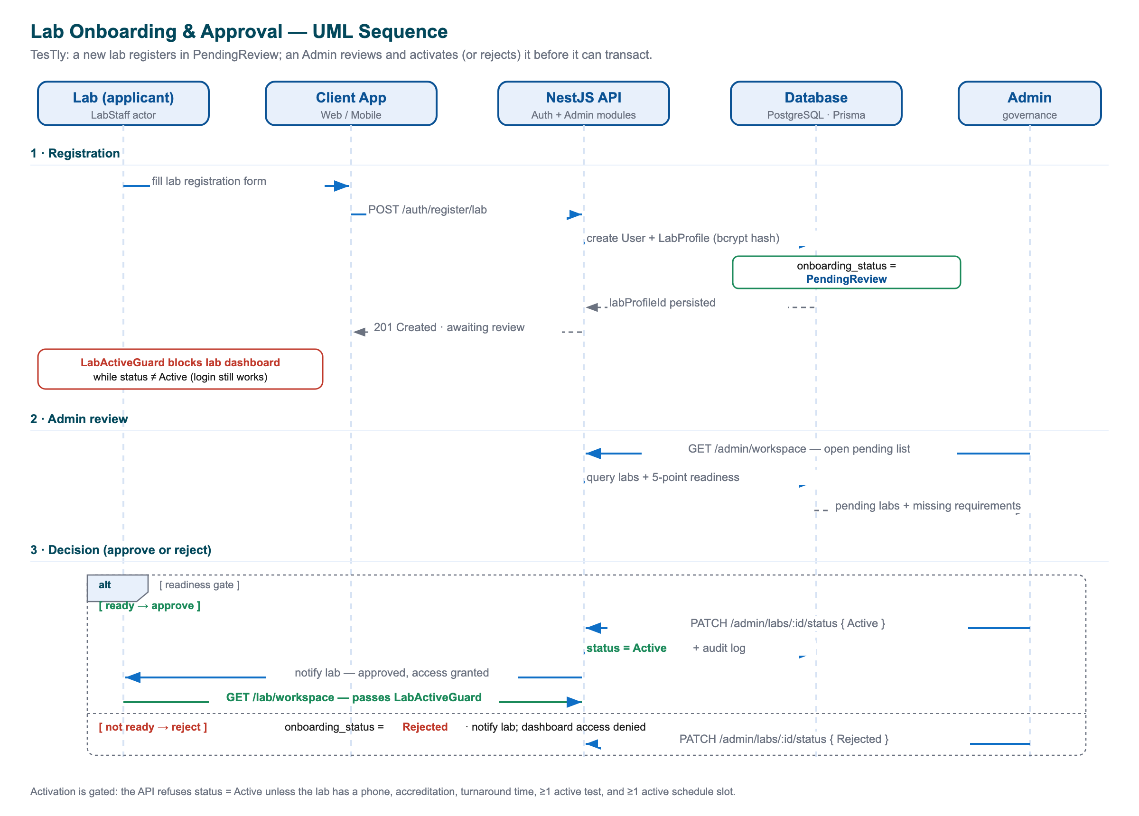
Figure 4.9: Lab onboarding and activation sequence — gated registration, readiness check, and admin approval.
- Identity — the JwtAuthGuard validates the token and re-fetches the user from the database, so a token belonging to a deleted user is rejected.
- Role — the RolesGuard compares the authenticated user's role against the roles declared on the route, admitting only the correct actor type.
- Lab activation — the LabActiveGuard additionally requires that a lab-staff user's account has been moved to the Active onboarding status, blocking pending, rejected, or suspended labs from operating even though they can authenticate.
- Ownership — finally, each service performs an ownership check (for example, a lab may act only on its own bookings), a defence-in-depth layer that does not rely on the route guard alone.
On the web client this server-side model is complemented by a fast Edge-middleware guard that decodes the JWT to route users to the correct dashboards and redirect inactive labs, while the API itself remains the authoritative gate. The result is a consistent, defence-in-depth access-control posture spanning both clients and every protected route.

4.4 Implementation of Core Features
This section turns from the structural design presented earlier in the chapter to the concrete implementation of TesTly's core capabilities. Each subsection follows a consistent narrative: the requirement that the feature satisfies, the server-side logic that enforces the relevant business rules, and the way the web and mobile clients consume that logic. The backend is a NestJS 11 application organised into feature modules under apps/backend/src/, using Prisma 5 over PostgreSQL as the persistence layer, while the two clients — a Next.js 16 web application and a Flutter mobile application — are deliberately thin renderers of one server-defined contract. Because the backend is the single point at which authorisation, validation, payments, and clinical normalisation are enforced, the discussion below is centred on it, with client behaviour described where it materially affects the user experience.
A recurring theme across every feature is layered defence: declarative validation at the edge (via a global ValidationPipe), guard-based access control, and a second tier of ownership and semantic checks inside each service that never trusts the route guard alone. This redundancy is intentional for a marketplace that handles both medical data and money, and it shapes the implementation of all six core features that follow.

4.4.1 Authentication and Role-Based Access
TesTly serves three actors — Patient, Lab Staff, and Admin — modelled by the Role enumeration on a single User table. Using one account table with a role discriminator keeps the authentication surface uniform: one login flow, one password-hash column, and one set of refresh tokens regardless of actor type, with role-specific data pushed into optional one-to-one PatientProfile and LabProfile extensions. This cleanly separates *who can log in* from *what kind of actor they are*.
Credentials are protected with bcrypt: on registration the e-mail is normalised (trim().toLowerCase()), a salt of cost factor 10 is generated, and only the resulting hash is stored — the plaintext password is never persisted. A duplicate e-mail raises a ConflictException. Patient registration nests the creation of a PatientProfile, whereas lab registration nests a LabProfile with onboarding_status set to PendingReview, so a freshly registered lab can authenticate but cannot transact until an administrator activates it.
At login the service looks the user up by normalised e-mail, compares the password with bcrypt.compare, and additionally verifies that the account's role matches the selectedRole the client chose at the login screen. A mismatch is surfaced as a clear *"Wrong account type"* error rather than a generic failure — a deliberate usability decision so a user on the wrong portal receives a meaningful message. On success the service issues a short-lived JWT access token (eight-hour expiry) whose payload carries { email, sub, role }, and for lab staff additionally embeds lab_onboarding_status so guards can check activation without a database round trip.
Session continuity for the mobile client relies on refresh tokens, which are designed for safety. A refresh token is an opaque 64-byte random secret — never a JWT — and only its SHA-256 hash is stored, with a thirty-day time-to-live. Refreshing rotates the pair: the used token is revoked and a fresh access/refresh pair is issued, limiting the blast radius of a stolen token.
// Refresh-token issuance: store only the hash of an opaque secret
const raw = randomBytes(64).toString('hex');
const tokenHash = createHash('sha256').update(raw).digest('hex');
await this.prisma.refreshToken.create({
data: {
user_id: userId,
token_hash: tokenHash,
expires_at: addDays(new Date(), REFRESH_TOKEN_TTL_DAYS),
},
});
return { refreshToken: raw }; // the raw secret is returned once, never stored

The two client types authenticate differently, and the JwtStrategy accommodates both by extracting the token from two sources in order: first an access_token HTTP-only cookie (web), then an Authorization: Bearer header (mobile). Its validate() method re-fetches the user from the database so that a deleted account is rejected even with an otherwise-valid token. The cookie itself is environment-aware: in production it is issued with SameSite=None and Secure (because the web and API are deployed to different sites), while locally it uses SameSite=Lax over plain HTTP.
On top of identity, authorisation is enforced by a stack of guards. JwtAuthGuard proves identity; RolesGuard reads the required roles from @Roles(...) metadata and rejects mismatches; LabActiveGuard asserts that a lab user's onboarding status is Active on lab-only routes; and every service then performs an explicit ownership check as a final layer. On the web client, an Edge middleware decodes the JWT to perform fast role-based routing, but it is treated only as a routing convenience — the backend remains the authoritative gate that verifies the signature on every API call.
Layer | Mechanism | Responsibility
1 | JwtAuthGuard | Proves the caller's identity from cookie or bearer token
2 | RolesGuard + @Roles | Enforces that the actor type is permitted on the route
3 | LabActiveGuard | Blocks non-active labs from operating on lab-only routes
4 | Per-service ownership checks | Confirms the caller owns the specific record being touched
Table 4.4: The layered role-based access-control model

4.4.2 Lab Onboarding and Admin Approval
TesTly is a curated marketplace rather than open self-service, which is essential for medical trust. A lab account begins life in the PendingReview state and cannot appear in the public storefront or accept bookings until an administrator promotes it to Active. The remaining states — Rejected and Suspended — are terminal or punitive. This gate is what guarantees that every lab a patient can discover is a vetted, operationally complete vendor.
The defining mechanism of the onboarding flow is the readiness gate. The admin workspace endpoint enriches each lab with an onboardingReadiness object computed by buildOnboardingReadiness, which checks five concrete requirements. The administrator sees exactly which of these a lab is still missing, and the activation endpoint refuses to set a lab to Active until all five are satisfied, raising a BadRequestException that names the gaps.
# | Requirement
1 | A contact phone number on the lab profile
2 | An accreditation string
3 | A declared turnaround time
4 | At least one active LabTest in the catalogue
5 | At least one active future LabScheduleSlot
Table 4.5: The five onboarding-readiness requirements


Figure 4.10: Lab onboarding and admin approval — registration in PendingReview, readiness evaluation, and the gated activation transition
The interaction proceeds as the sequence diagram illustrates. A lab registers (entering PendingReview) and uses its still-limited account to add tests and schedule slots. When the administrator opens the governance dashboard, the backend recomputes each lab's readiness on the fly; an attempt to activate an incomplete lab is rejected with the missing-requirement list, whereas a complete lab transitions to Active and immediately becomes bookable in the public marketplace. Every status change is recorded by the audit logger as admin.lab_onboarding_status.updated, carrying both the previous and next status for accountability.
// Activation is gated by the readiness check
if (nextStatus === LabOnboardingStatus.Active) {
const readiness = buildOnboardingReadiness(lab);
if (!readiness.isReady) {
throw new BadRequestException(
`Lab is not ready to activate. Missing: ${readiness.missing.join(', ')}`,
);
}
}
await this.prisma.labProfile.update({
where: { id: labProfileId },
data: { onboarding_status: nextStatus },
});

On the clients this flow is honest about state. The web login redirect and Edge middleware send a lab whose status is not Active to an /unauthorized screen whose message is tailored to the reason (pending_review, rejected, or suspended); on mobile, the go_router redirect routes such a lab to a dedicated LabPendingScreen. The administrative console itself is web-only by design — the mobile app shows an *"use the web app"* screen for admin accounts.

4.4.3 Lab Catalog and Schedule Management
Tests in TesTly are modelled per lab, not globally: the same conceptual test — a Complete Blood Count, for instance — exists as many LabTest rows, one per lab, each carrying that lab's own price_egp. This is the foundation of the marketplace's comparison story, allowing the public catalogue to present a single test offered by several labs with differing prices. Each LabTest records a name, category, price, optional description and preparation notes, a parameter count, and an is_active flag that lets a lab retire a test without deleting the historical bookings that reference it.
Availability is decoupled from bookings through the LabScheduleSlot model — a bookable time window (the seed uses thirty-minute slots) with a capacity and an is_active flag, indexed on [lab_profile_id, starts_at] to make "show this lab's available slots in time order" cheap. The one-to-one link between a booking and a slot (with a @unique constraint on the booking side) means a slot can be claimed by at most one active booking, giving simple, race-free reservation semantics.
The lab workspace endpoint assembles the full operational picture for lab staff in a single call, running six queries in parallel via Promise.all: the booking queue, the test catalogue, schedule slots (capped at 120), computed analytics, and a groupBy of the five most-booked tests. The analytics block derives totals, the completed count, the number of results still pending, a revenue estimate over confirmed and completed bookings, and a capacity-usage percentage computed as occupied future active slots divided by total future active slots.
Catalogue and schedule mutations all funnel through an ownership resolver, getLabProfileId(userId), before validating their inputs. Two safety rules are notable. Deleting a slot is implemented as a soft delete (is_active = false) so that referential history is preserved, and slot creation enforces a future, well-ordered time window via validateScheduleWindow. Deleting a test is blocked outright when any booking references it, protecting the integrity of past orders.
// A test cannot be deleted while bookings depend on it
const bookingCount = await this.prisma.booking.count({
where: { lab_test_id: testId },
});
if (bookingCount > 0) {
throw new BadRequestException(
'Cannot delete a test that has existing bookings.',
);
}
await this.prisma.labTest.delete({ where: { id: testId } });

The public-facing side of the catalogue is unauthenticated and hard-filtered to onboarding_status: Active, so only approved labs and their active tests are ever exposed. The most elaborate query, listLabs, accepts a rich set of filters — free-text search, city, price ceiling, minimum rating, home-collection capability, and accreditation — and, when the caller supplies coordinates, computes a great-circle Haversine distance to each lab so results can be sorted by proximity. A companion listTests endpoint uses a groupBy(['name','category']) aggregation so a test offered by many labs appears once with its cheapest price and the count of offering labs — the "compare across labs" view that both clients render.

4.4.4 Booking Lifecycle and Payments
The booking module is the transactional heart of TesTly. A Booking row carries three parallel concerns: the order itself (patient, lab, test, schedule, price), the payment block (method, status, and dedicated timestamp and reason fields), and — only for mail-in kits — a shipment block. Keeping these in one table is a pragmatic choice for a system in which a booking always has exactly one payment and at most one kit shipment. The current lifecycle state lives in Booking.status, while an append-only BookingStatusEvent table preserves *how* the booking reached that state and *who* performed each transition — a queryable audit trail that the clients render as an order-tracking timeline.
Creating a booking enforces a chain of business rules inside a single prisma.$transaction. The caller must own a patient profile; the test must be active at an active lab; capability checks confirm that a HomeCollection or HomeTestKit request is supported by the lab and accompanied by a home address; and the chosen payment method must be compatible with the booking type. Pricing applies fixed surcharges — +100 EGP for home collection and +150 EGP for a home test kit. Most importantly, the transaction relies on the schedule_slot_id @unique constraint to prevent double-booking, catching Prisma's P2002 unique-violation error and translating it into a friendly conflict response.
// Atomic booking creation guards against slot double-booking
try {
return await this.prisma.$transaction(async (tx) => {
const booking = await tx.booking.create({ data: { /* order */
status: BookingStatus.Pending,
payment_status: PaymentStatus.Pending, schedule_slot_id: slotId } });
await tx.bookingStatusEvent.create({ data: { booking_id: booking.id,
status: BookingStatus.Pending, note: 'Booking created by patient' } });
return booking;
});
} catch (e) {
if (isUniqueViolation(e)) // P2002 on the unique schedule_slot_id
throw new ConflictException('Selected slot is already booked');
throw e;
}

Payment is modelled as explicit state: a payment_method (how) crossed with a payment_status (where in the lifecycle). TesTly supports four methods — one online channel and the three cash modes common in Egypt (cash at the lab, cash to the home collector, cash on kit delivery) — and four statuses (Pending, Paid, Failed, Refunded). The online channel is a faithful gateway simulation rather than a live charge: on success it records a Paid status with a synthetic reference and a paid-at timestamp, and on failure it records Failed with a reason — exactly mirroring what a real PayMob webhook would write, so a real provider can later be substituted with a localised change. Cash settlement is recorded by lab staff through a separate, idempotent endpoint, and a refund is modelled as a status transition applied when a paid booking is cancelled.
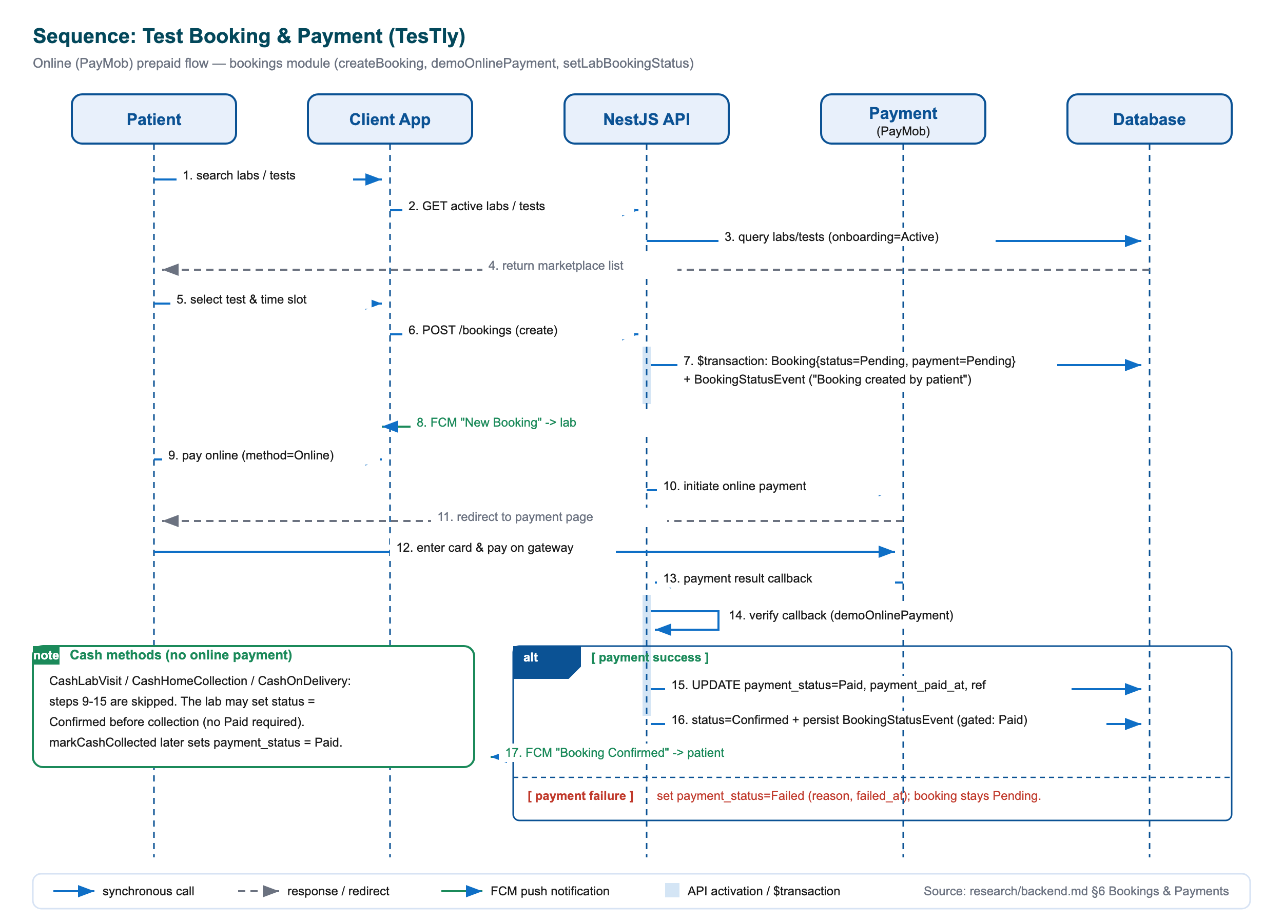
Figure 4.11: Booking and payment sequence — the online prepaid branch and the cash-on-service branch, including the slot-uniqueness guard and the payment-before-confirm gate
A key rule encodes the real-world difference between prepaid and pay-on-service orders: a lab cannot confirm an Online booking until its payment_status is Paid, whereas a cash booking may be confirmed before collection. The lifecycle transitions are tightly constrained — a lab may move a booking only from Pending to Confirmed or Rejected (a rejection releases the slot), and a patient may cancel only from Pending or Confirmed. Home test kits follow a separate, strict one-step-forward state machine — AwaitingShipment → Shipped → Delivered → SampleReceived — that refuses to skip stages and blocks shipment before payment unless the method is cash-on-delivery. Every transition writes a status event, is recorded by the audit logger, and triggers a push notification to the relevant party.
Concern | Enum | Values
Lifecycle | BookingStatus | Pending, Confirmed, Rejected, Cancelled, Completed
Type | BookingType | LabVisit, HomeCollection, HomeTestKit
Method | PaymentMethod | Online, CashHomeCollection, CashLabVisit, CashOnDelivery
Payment state | PaymentStatus | Pending, Paid, Failed, Refunded
Kit shipment | KitStatus | AwaitingShipment, Shipped, Delivered, SampleReceived
Table 4.6: Booking and payment enumerations

4.4.5 Results: PDF Upload, Structured Parsing, and Delivery
TesTly stores results in two complementary forms, a deliberate design that separates the legally authoritative document from the queryable data behind it. The first is the official PDF; the second is a set of structured observations that enable the cross-lab health trends discussed later in this chapter. The two are linked by the constraint that structured data may only be added once the official PDF already exists.
PDF upload is hardened beyond a naive file-extension check. The handler rejects anything whose MIME type is not PDF and independently verifies the file's magic bytes (the leading %PDF signature), uploads are size-limited to 10 MB by a Multer interceptor, and lab ownership of the booking is confirmed before any write. In one transaction the service upserts the ResultFile (status Uploaded) together with an optional plain-language ResultSummary and a flexible highlights JSON payload, and appends a status event. Crucially, the raw storage URL is never exposed — the file is served only through an authorisation-checked proxy path of the form /results/files/<id>.
// Defence-in-depth PDF validation: MIME type AND magic bytes
const isPdfMime = file.mimetype === 'application/pdf';
const hasPdfMagic =
file.buffer.subarray(0, 4).toString('latin1') === '%PDF';
if (!isPdfMime || !hasPdfMagic) {
throw new BadRequestException('Only PDF result files are accepted.');
}
const stored = await this.storage.persist(file); // local disk or S3

The storage layer itself is abstracted behind a LabFileStorageAdapter interface with two implementations — a local-disk adapter for development and an S3-compatible adapter for production — selected once at startup from the LAB_STORAGE_DRIVER environment variable. The S3 SDK is loaded lazily so the heavy dependency is only pulled in when object storage is actually configured, leaving the rest of the codebase storage-agnostic.
Structured parsing is where cross-lab comparability is realised. When a lab submits panels of observations, each observation is resolved against a canonical analyte and, where possible, converted into a canonical unit; the entire panel set is replaced inside a transaction so an upsert is a full overwrite. Setting a result's status to Delivered is the terminal step: it also flips the booking to Completed, writes a "Result delivered" event, and pushes a *"Result Ready"* notification to the patient.
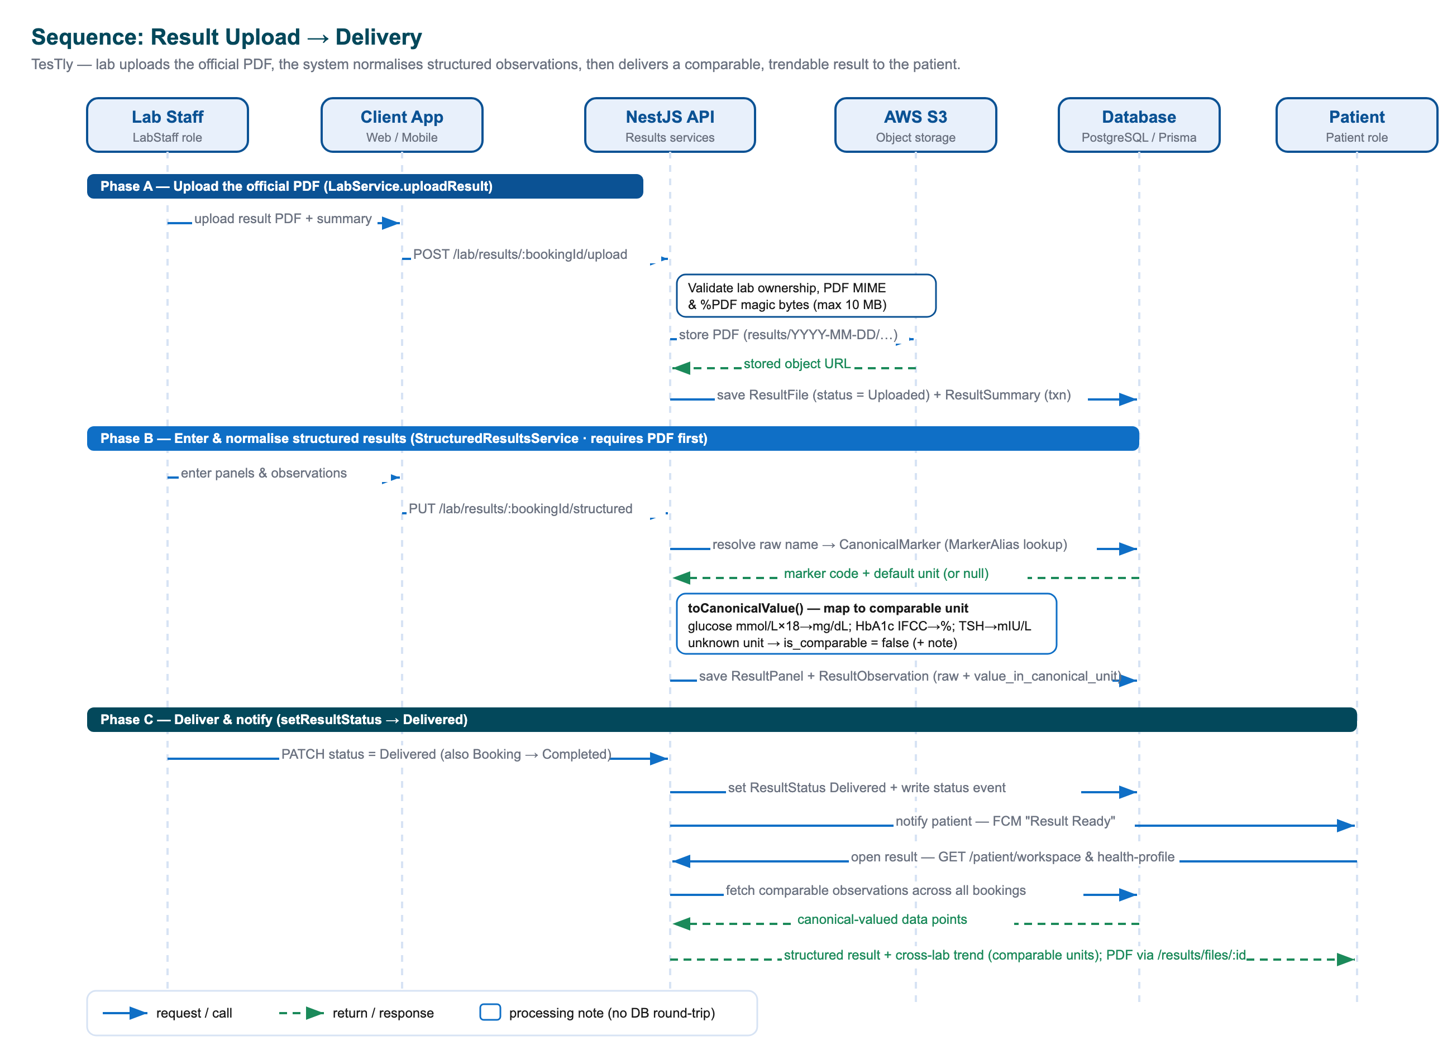
Figure 4.12: Result delivery sequence — PDF upload and validation, structured-observation parsing and normalisation, delivery, and the authorised patient download
Delivery and download honour the privacy model. A patient may download a PDF only once its status is Uploaded or Delivered, and the single download gateway, GET /results/files/:id, authorises by relationship — the request must come from an administrator, the owning patient, or the owning lab staff — before streaming the file with a nosniff content-type header and an attachment disposition. On the mobile client the PDF is fetched through the authenticated Dio client (so the bearer token is attached), rendered in-app with pdfx, and can be shared via the native share sheet.

4.4.6 Reviews and Ratings
Trust in a medical marketplace depends on authentic feedback, and TesTly's review model enforces authenticity structurally. Every Review is tied to a specific booking through a @unique constraint on booking_id, which means a patient cannot review a lab they never used and cannot review the same booking twice — the core anti-spam guarantee for the rating system. A review carries a one-to-five star rating, an optional comment, and a moderation status that begins at Pending; only Published reviews feed a lab's public rating.
Submitting a review enforces a tight set of preconditions: the patient must own the booking, an official result file must exist and be in the Uploaded or Delivered state, and no review may already exist for that booking. Inside a transaction the review is written as Published, after which the service recomputes the lab's denormalised aggregates — rating_average and review_count — from the source review rows. These cached aggregates exist precisely so that lab listing and search do not have to aggregate the review table on every read, and the recomputation keeps them consistent whenever reviews change. The lab is then notified of the new review.
// Recompute denormalised rating from published reviews
const agg = await tx.review.aggregate({
where: { lab_profile_id: labId, status: ReviewStatus.Published },
_avg: { rating: true },
_count: { _all: true },
});
await tx.labProfile.update({
where: { id: labId },
data: {
rating_average: agg._avg.rating ?? null,
review_count: agg._count._all,
},
});

On the read side, published reviews are surfaced on the public lab-detail page with reviewer names privacy-reduced to a "First L." form (or "Anonymous" when blank), so feedback remains useful without exposing full patient identities. The patient workspace exposes a canReview flag — true only when a result is delivered and not yet reviewed — which the web and mobile clients use to gate the star-rating widget so that the review action appears at exactly the right moment in the patient's journey.

4.5 Advanced Features
Beyond the transactional core, TesTly implements five advanced features that distinguish it from a simple booking tool: an agentic AI assistant that grounds its answers in the live catalogue, a cross-lab health-trend engine built on canonical clinical markers, push notifications, a deterministic guided FAQ assistant, and a privacy and audit model that governs sensitive data throughout. These features are where the platform's medical-domain ambitions are most visible, and each is implemented with the same safety-first discipline as the core.

4.5.1 Agentic AI Assistant
The flagship advanced feature is the Health Assistant, a true agentic large-language-model assistant powered by Google's Gemini model (gemini-2.5-flash) through the @google/genai SDK. Unlike a passive chatbot, it does not merely *talk* about labs and tests — it *looks them up in the live catalogue* via tool calls and surfaces the results as interactive lab and test cards. A defining architectural decision is that the backend, not the client, drives the agent loop: tool execution, grounding, and persistence all happen server-side, which keeps the Gemini API key and the database off the client and lets the web and mobile apps share one streaming contract.
Each user turn is a single streaming HTTP request. The patient posts a message to /chat/messages with an Accept: text/event-stream header, and the controller responds with Server-Sent Events carrying four typed event kinds: meta (the conversation id), delta (a streamed text fragment), tool (a structured card payload), and done or error to terminate. This endpoint deliberately bypasses the global exception filter, reporting failures as an error SSE event so that a missing API key or model error degrades gracefully rather than crashing the stream.

Figure 4.13: Agentic AI assistant — the server-orchestrated SSE function-calling loop interleaving delta text and tool-card events
At the centre of the implementation is a function-calling loop bounded to four rounds — a safety limit so a misbehaving model cannot spin indefinitely. Each round streams Gemini's output chunk by chunk: text fragments are forwarded immediately as delta events while function calls are buffered. If a round produces no function calls, the model has produced its final answer and the loop exits. Otherwise the service runs each requested tool, emits a tool event the instant the lookup completes, and feeds the result back into the conversation as a synthetic turn so the next round can summarise it in natural language. This hand-rolled orchestration — in preference to an SDK auto-function-calling helper — is precisely what lets cards appear in the user interface *before* the summarising prose streams in.
for (let round = 0; round < MAX_TOOL_ROUNDS; round++) {
const stream = await client.models.generateContentStream({
model: MODEL, contents,
config: { systemInstruction: SYSTEM_PROMPT, tools: TOOLS } });
const calls = [];
for await (const chunk of stream) {
if (chunk.text) onEvent({ type: 'delta', text: chunk.text });
for (const fc of chunk.functionCalls ?? []) calls.push(fc);
}
if (calls.length === 0) break; // final answer
for (const call of calls) {
const { result } = await this.runTool(call);
if (result) onEvent({ type: 'tool', result }); // card to UI
}
}

Two tools are declared to the model, with intentionally minimal schemas for reliability. find_labs(query, city?) finds real labs offering a given test with price, address, and rating; search_tests(query) looks up tests with their lowest price and the number of labs offering them. Both query live Prisma data filtered to active, approved labs only — there is genuine retrieval-augmented grounding here, not hallucination — and each card carries the underlying lab and test identifiers so the client can deep-link straight into the booking funnel. An elegant detail is that every tool call returns two shapes: a rich result for rendering (full address, rating, accreditation, turnaround) and a deliberately compact `modelPayload` for the model to reason over, which both reinforces concise summaries and reduces token cost.
The assistant's behaviour is governed by a single carefully engineered system prompt that encodes its persona, agentic policy, and safety guardrails. It scopes the model to education and marketplace navigation; instructs it exactly when to call each tool and forbids guessing; offloads detailed rendering to the user interface ("the app renders the lab/test cards for you, so do NOT repeat every price and address"); forbids inventing labs, prices, or availability; and — critically for a health product — establishes hard medical-safety rules: the model is explicitly not a doctor, must defer diagnosis and treatment to a licensed physician, and must direct users with emergency symptoms to seek immediate care. The prompt also instructs the model to reply in the user's language, supporting the bilingual English/Arabic Egyptian market.
- Scoping — the model is confined to test education and marketplace navigation.
- Agentic policy — explicit instructions on when to call each tool, with guessing forbidden.
- Anti-redundancy — rendering is offloaded to the client so replies stay short.
- Anti-hallucination — "never invent labs, prices, or availability," paired with real Prisma grounding.
- Medical safety — non-diagnosis and emergency-escalation rules as a non-negotiable guardrail.
- Bilingual — the reply mirrors the user's language (English or Arabic).
Conversations are persisted so they can be fully reproduced. The assistant's final text is stored in a ChatMessage, and when tool calls occurred the resulting cards ride along in a metadata JSON column shaped as { tools: ToolResult[] }. On read, this column is defensively unwrapped and the cards are re-attached, so a returning patient who reopens an old conversation sees the same lab and test cards re-rendered — the structured output round-trips through PostgreSQL, not just the prose. The web (chatApi.ts) and Flutter (chat_repository.dart) clients are interchangeable renderers of this one server-defined contract, each parsing the SSE stream by hand and differing only in framework and styling. Everything is bounded for predictable latency and cost: a twenty-turn history window, a 1500-token output cap, four tool rounds, and six cards per tool.

4.5.2 Cross-Lab Health Trends and Canonical Markers
A signature capability of TesTly is letting a patient see a marker — fasting glucose, say — trended across results from *different* labs, even though every lab names and units its analytes slightly differently. A PDF alone cannot be trended; structured, normalised observations can. The problem this solves is real: naive trending across labs is meaningless when one lab reports "Fasting glucose" in mg/dL and another reports "FBS" in mmol/L. The solution is canonical normalisation, realised by four collaborating tables — CanonicalMarker, MarkerAlias, ResultPanel, and ResultObservation.
A CanonicalMarker is the single identity of a clinical analyte inside TesTly, with a stable internal code (such as GLUCOSE_FASTING, HBA1C, or TSH), a default canonical unit, and an optional LOINC code anchoring it to the international standard for lab observations. MarkerAlias collapses the many raw spellings labs use into one marker, storing each alias already normalised. The normalisation function lowercases, strips accents and diacritics, and collapses whitespace, after which resolution proceeds in order: an explicit canonical code if provided, then an exact alias match, then a fuzzy match against canonical display names — returning null when an observation cannot be mapped.
Each ResultObservation stores two representations of the same reading: the raw form exactly as the lab reported it (name, value, unit, reference range), which is never lost, and a canonical form (value_in_canonical_unit, comparable_unit, is_comparable, comparability_note) re-expressed in the marker's unit so it can be plotted against other labs' readings. Unit conversion uses explicit, hand-coded clinical rules rather than guesswork, and any unrecognised unit is flagged non-comparable with an explanatory note instead of being silently mis-converted — a safety-first choice so that an unmappable value can still be shown raw without ever polluting a shared trend line.
Marker | Source unit | Canonical unit | Rule
Glucose | mmol/L | mg/dL | multiply by 18
HbA1c | mmol/mol (IFCC) | % (NGSP) | (value + 23.5) / 10.93
Creatinine | µmol/L | mg/dL | divide by 88.4
TSH | µIU/mL, uIU/mL, mU/L | mIU/L | unit harmonisation (equivalent)
Table 4.7: Representative canonical unit-conversion rules

The patient-facing endpoint, GET /patient/health-profile, pulls comparable, canonical-valued observations within a chosen time range, groups them into series by analyte or by lab test, and computes a per-series trend — increasing, decreasing, stable, or insufficient_data using a two-percent relative threshold between the first and last point — together with a note on whether the value crosses the reference band and a per-point abnormal flag. The response also surfaces pdfOnlyBookings (results that exist only as PDFs with no structured data) and a repeated disclaimer that the information is educational, not clinical advice. The web client renders these series as Recharts line charts with a shaded reference area and abnormal-point colouring; the Flutter client renders the equivalent with fl_chart, including dashed reference-range lines and red dots for out-of-range readings.

4.5.3 Push Notifications via FCM
TesTly keeps both parties informed of every meaningful state change through Firebase Cloud Messaging (FCM). The backend's NotificationsModule initialises the Firebase Admin SDK from a service-account credential supplied in the FCM_SERVICE_ACCOUNT_JSON environment variable; if that variable is absent, the service logs a warning and degrades gracefully — push becomes a no-op while the rest of the application continues to work. This fault tolerance is a recurring design principle applied to every optional integration.
Devices register their FCM token through POST /notifications/device (and remove it on logout via DELETE /notifications/device), persisting one DeviceToken row per device keyed by a unique token. When an event occurs, sendToUser looks up all of a user's device tokens and sends a multicast message. The token table is self-cleaning: FCM responses reporting an unregistered or invalid token cause that row to be deleted automatically, so stale tokens never accumulate. Push is emitted at every significant transition, summarised below.
Event | Recipient | Notification
New booking created | Lab | New Booking
Booking confirmed or rejected | Patient | Confirmation / rejection
Home test kit shipped | Patient | Kit Shipped
Result delivered | Patient | Result Ready
New review submitted | Lab | New Review
Table 4.8: Push-notification triggers

On the Flutter client the integration is comprehensive. Firebase is initialised inside a try/catch so a device without credentials still runs, a top-level background handler is registered as required by the plugin, and the notification service wires foreground, background-tap, terminated-state, and token-refresh listeners. Incoming foreground pushes are re-shown as local notifications, and a payload of the form {type: 'booking'|'result', id} is mapped to a deep link into the relevant booking or result screen — stashed and replayed by the router if the app is cold-started. The permission request is deferred and rationale-first: rather than prompting at launch, the patient shell shows an explanatory bottom sheet on first reaching the patient area, and only then requests authorisation. The same notification stack also schedules local preparation reminders at 8 p.m. the evening before a test that requires fasting or other preparation.

4.5.4 Guided FAQ Assistant
Complementing the agentic assistant is a deliberately simpler guided FAQ bot — a deterministic, non-LLM assistant with no AI model involved at all. Its purpose is to answer the most common support questions cheaply and predictably, without consuming Gemini quota or risking hallucination, reserving the paid model for genuinely open-ended, catalogue-aware help. The two assistants are clearly distinguished in the user interface: the FAQ bot is a floating widget labelled "Guided FAQ," while the agentic assistant is a full-page experience.
The knowledge base is a small FaqEntry table seeded with curated answers (covering fasting and preparation, result turnaround, home-collection booking, test bundles, thyroid-panel preparation, and data privacy). Three public routes serve it: GET /faq/intents returns four hard-coded quick-topic buttons; GET /faq/search performs paginated keyword search; and POST /faq/ask returns the single best-matching answer plus an escalation message. The search is intentionally simple and explainable — a case-insensitive contains match over the question and answer combined with a hasSome match over the tags array, ordered by recency — with no semantic ranking. When nothing matches, the bot returns a graceful fallback pointing the user to support.
// Deterministic keyword/tag match — no model involved
const where: Prisma.FaqEntryWhereInput = { is_active: true };
if (q) {
const words = q.split(/\s+/).filter((w) => w.length > 1);
where.OR = [
{ question: { contains: q, mode: 'insensitive' } },
{ answer: { contains: q, mode: 'insensitive' } },
{ tags: { hasSome: words } },
];
}
return this.prisma.faqEntry.findMany({ where, orderBy: { updated_at: 'desc' } });

This non-LLM design is an intentional engineering trade-off: it gives the platform a reliable, zero-cost answer path for the long tail of routine questions, and acts as a deterministic fallback that is fully testable — its behaviour is locked down by unit tests covering non-empty intents, paginated search, and the no-match escalation path.

4.5.5 Privacy Model and Audit Logging
Because TesTly handles sensitive medical data across competing labs, privacy is a first-class design concern rather than an afterthought. The natural default for a multi-lab marketplace would be leakage between competitors; TesTly inverts this with a privacy-by-default, patient-controlled model governed by the LabHistorySharing setting on each patient profile, which defaults to the most restrictive value, SAME_LAB_ONLY.
Under SAME_LAB_ONLY, a lab the patient is currently transacting with can see *only* that patient's bookings and results at that same lab — nothing from any other lab. A patient may opt in to FULL_HISTORY_AUTHORIZED, which additionally lets any lab they have a booking with see cross-lab structured summaries and trends — but crucially never another lab's raw PDF document. This is exactly why the structured-results stack exists: it produces a comparable, shareable representation that supports cross-lab continuity without ever handing over another lab's original document.
The enforcement lives in the lab patient-context service. It reads the patient's sharing setting and builds the query's where clause conditionally — filtering to the requesting lab's bookings only in same-lab mode, or across all labs in full-history mode — so the restriction is applied at the database level rather than after the fact. Prose summaries and structured marker summaries are included only when the data belongs to the requesting lab or full-history is authorised, and a PDF download link is produced only for the lab's own uploads, even in full-history mode. Access itself requires a confirmed relationship: the lab must either pass a booking it owns or a patient identifier for which at least one booking exists between that lab and the patient. The response carries an explicit privacyNotice and an effectiveScopeForThisLab, so the user interface is honest with the lab about what it is and is not seeing.
// Privacy scoping applied at the database level
const fullHistory =
patient.lab_history_sharing === LabHistorySharing.FULL_HISTORY_AUTHORIZED;
const where: Prisma.BookingWhereInput = fullHistory
? { patient_profile_id: patient.id } // all labs
: { patient_profile_id: patient.id, // this lab only
lab_profile_id: labProfile.id };
// PDF links are emitted only for this lab's own uploads, never others'.

Running alongside the privacy model is a lightweight but comprehensive audit trail. A structured audit logger emits a JSON line for every security- or money-relevant action — registration, login and logout, booking creation, every payment transition, booking-status changes, kit updates, result upload and delivery, test deletion, and admin lab-status changes. This log-stream trail is complemented by the persistent BookingStatusEvent table, which records each booking transition together with the acting user, giving the platform both a real-time operational log and a queryable historical record — the combination needed for dispute resolution and accountability in a system that handles health data and payments.
Together, these five advanced features build on the transactional core to deliver the platform's distinctive value: an assistant that is genuinely grounded in real data and bounded by medical-safety rules, longitudinal health insight that survives the fragmentation of a multi-lab market, timely notifications, an inexpensive deterministic help path, and a privacy posture that treats patient data with the caution medical information demands.
Chapter 5

Testing and Evaluation

This chapter describes how the TesTly platform was tested and evaluated against its functional requirements and quality goals. Because TesTly is a multi-platform system — a NestJS backend, a Next.js web application, and a Flutter mobile application sharing one API contract — a single testing technique is insufficient. The project therefore adopts a layer-appropriate testing strategy in which each application is verified with the framework idiomatic to its stack, supported by a rich seeded demonstration dataset that allows realistic, repeatable quality-assurance (QA) walkthroughs of every role. The chapter then evaluates the user experience of the delivered system, summarises the advantages it offers over the status quo, and honestly documents the limitations that remain at the conclusion of the graduation project.

5.1 Functional Testing
Functional testing confirms that each feature of TesTly behaves as specified across the three applications. The testing approach is organised per layer: the backend is covered by automated unit and integration tests and an end-to-end (e2e) smoke harness; the web frontend is covered by end-to-end user-journey tests; and the mobile application carries the broadest widget and unit test suite of the three. These automated suites are complemented by manual QA walkthroughs performed against a deterministic seeded dataset, following the project's deployment checklist.

5.1.1 Backend Testing — Jest Unit and End-to-End Tests
The backend is tested with Jest (using ts-jest), configured inline in apps/backend/package.json with a testRegex of .*\.spec\.ts$, a src root directory, and a Node test environment. There are 18 colocated `.spec.ts` files that cover the critical surface of the system: the authentication service and controller, the bookings service and controller, the patient service and controller, the lab service and controller, the lab-storage service, the admin service and controller, the public-labs controller, the FAQ service and controller, the notifications service and controller, and the Prisma service. These tests exercise the business rules that protect health data and money — for example, the payment-before-confirmation gate, the one-step home-test-kit state machine, and the lab-activation readiness checks.
End-to-end tests use Jest together with Supertest against a fully bootstrapped Nest application, configured separately through test/jest-e2e.json (testRegex of .e2e-spec.ts$) and executed with npm run test:e2e. The current e2e harness (test/app.e2e-spec.ts) boots the complete AppModule and asserts the root endpoint, acting as a smoke test that proves the entire dependency-injection graph wires up correctly and the HTTP server responds. Coverage can be collected with npm run test:cov, configured via collectCoverageFrom: ["**/*.(t|j)s"].

5.1.2 Web Frontend Testing — Playwright User Journeys
The Next.js web application is tested at the end-to-end level with Playwright (apps/frontend/playwright.config.ts), structured around the three user roles. There are exactly three specification files — patient-journey.spec.ts, lab-journey.spec.ts, and admin-journey.spec.ts. The configuration is production-aware: it runs against Chromium, auto-starts the development server as its webServer (reusing a running instance locally), and, under continuous-integration conditions, enables forbidOnly, two retries, a single worker, and trace capture on first retry for debuggability. The patient journey, for example, exercises the guest-search experience, then login, then viewing seeded results — validating that the application functions correctly against the seeded demonstration data.

5.1.3 Mobile Testing — Flutter Widget and Unit Tests
The Flutter application carries the most extensive automated test suite in the project — roughly 20 Dart test files under apps/mobile/test/, organised to mirror the feature-first lib/ architecture. Coverage spans the networking layer (api_exception_test.dart), secure token storage, the notification service and repository, and — most thoroughly — the patient feature set: authentication (models, repository, session notifier, and the login screen widget), labs, the booking flow notifier and repository, the workspace aggregation, and the health-profile trends. Tests use flutter_test with `mocktail` for mocking, exploiting Riverpod's provider-override mechanism to inject fakes in place of real repositories, and are executed with flutter test.

5.1.4 Seeded Demo Accounts and QA Scenarios
To make functional testing realistic and repeatable, the project ships a rich seeded demonstration dataset, populated by npm run db:seed. The seed creates one admin, 21 active labs, additional pending and rejected lab accounts, and several patients with historical results, so that cross-lab health-trend tracking and the admin governance views have meaningful data on first run. For convenience during QA, all demonstration accounts share the password password123; on the production web login screen the demo-credential hints are hidden by setting NEXT_PUBLIC_SHOW_DEMO_CREDENTIALS to false.
QA scenarios follow the manual gate prescribed in docs/DEPLOYMENT_CHECKLIST.md, which walks a smoke flow for every role: a guest browses labs and tests without registering; a patient registers, books, completes a (simulated) payment, views the result PDF, and submits a review; and lab staff confirm a booking, upload a result, and mark it delivered. Operational checks confirm that audit events are emitted, that the uploads directory is writable under the local storage driver, and that pagination limits bound responses.
Table 5.1 lists a representative subset of the functional test cases executed across the three applications. Each maps to behaviour verified either by an automated suite or by the seeded-data QA walkthrough, and each is reported with a final status of Pass.
ID | Feature | Test Case | Expected Result | Status
TC-01 | Authentication | Register a new patient with a unique email and valid password | Account and patient profile created; bcrypt-hashed password stored; audit event emitted | Pass
TC-02 | Authentication | Log in selecting the wrong role (patient credentials, lab portal) | Clear "Wrong account type" error returned, not a generic invalid-credentials message | Pass
TC-03 | Authentication | Rotate a refresh token via POST /auth/refresh | Used token revoked, a fresh access/refresh pair issued; reused old token rejected | Pass
TC-04 | Public marketplace | Search active labs by test name and city | Only labs with onboarding_status Active returned, with starting-from price and distance | Pass
TC-05 | Booking | Create a Home Collection booking at a lab that offers it | Booking created as Pending with a +100 EGP surcharge and the home address recorded | Pass
TC-06 | Booking | Attempt to book an already-taken schedule slot concurrently | Unique-constraint violation caught; friendly "Selected slot is already booked" conflict returned | Pass
TC-07 | Payment | Confirm an Online booking before payment is completed | Lab confirmation refused until payment_status is Paid | Pass
TC-08 | Payment | Simulate a successful online payment (demo gateway) | payment_status set to Paid with a synthetic DEMO-PAY reference and paid-at timestamp | Pass
TC-09 | Home test kit | Advance kit status from Delivered straight to AwaitingShipment | Out-of-order transition rejected by the one-step-forward state machine | Pass
TC-10 | Results | Upload a non-PDF file as an official result | Upload rejected by MIME check and %PDF magic-byte validation | Pass
TC-11 | Results | Download a result PDF as an unrelated patient | Request rejected with 403 by the ownership-checked download controller | Pass
TC-12 | Health trends | View cross-lab analyte trends with full-history sharing enabled | Canonical, unit-converted series rendered with reference bands and a trend direction | Pass
TC-13 | Privacy | Lab requests patient context under SAME_LAB_ONLY sharing | Only the requesting lab's own bookings and results exposed; other labs' PDFs withheld | Pass
TC-14 | Admin governance | Activate a lab missing an active schedule slot | Activation refused with a message naming the unmet readiness requirements | Pass
TC-15 | AI assistant | Ask the assistant to find labs for a named test | Streamed reply plus structured, clickable lab cards grounded in real catalog data | Pass
TC-16 | Mobile auth | Encounter a 401 mid-session on mobile | Auth interceptor silently refreshes the token and retries the original request | Pass
Table 5.1: Representative functional test cases for the TesTly platform


Figure 5.1: End-to-end booking and payment sequence exercised by the functional test cases

5.2 User Experience Testing
Beyond verifying that features work, the project evaluated whether they are pleasant and accessible to use. User-experience (UX) testing focused on usability, responsive and adaptive design, dark-mode support, accessibility, and navigation, and was conducted through guided demonstration walkthroughs of the patient, lab, and admin journeys against the seeded dataset.

5.2.1 Usability and Visual Consistency
Both clients present a consistent visual language drawn from a shared design system. The web application expresses its design tokens entirely in CSS through Tailwind 4 — a blue brand accent (--brand #2563eb), a neutral surface palette, semantic success/warning/destructive colours, and a chart palette — and the Flutter application ports the same palette from globals.css into Material 3 themes built with ColorScheme.fromSeed. The result is a uniform look across roles and platforms: white rounded cards on a light-grey background, pill-style tabs, and lucide-react icons on the web mirrored by equivalent iconography on mobile.
Usability is reinforced by consistent feedback scaffolding. The web app provides a single toast system (useToast().success/error/info) that drives every dashboard mutation, a shared breadcrumb component, and a single shimmering .skeleton utility used for all loading states. Errors are handled uniformly through a typed ApiError: 401 redirects to login, 403 to an access-denied screen, and 404/409 surface specialised messages. The mobile app mirrors this with reusable EmptyState, ErrorState, and skeleton widgets, and a motion toolkit (FadeSlideIn, CountUpText, AnimatedProgressBar) that honours the operating-system "reduce motion" setting.

5.2.2 Responsive and Adaptive Design
The web application is built mobile-first with Tailwind utility classes and adapts fluidly from phone to desktop widths — for example, the lab-search experience renders a sticky filter sidebar alongside a results column on wide screens. The Flutter application is natively adaptive, using shell routes with bottom navigation for both the patient and lab roles, collapsing app bars (SliverAppBar) on detail screens, and horizontally scrolling carousels for featured labs. Geolocation is integrated on both clients so that distance-based sorting adapts to the user's position, with the mobile and web haversineKm helpers computing identical distances.

5.2.3 Dark Mode
The mobile application provides first-class dark-mode support: AppTheme defines complete light and dark Material 3 themes, and a ThemeController lets the user choose System, Light, or Dark from the profile screen, defaulting to ThemeMode.system and persisting the choice. On the web, a dark custom variant is declared in the stylesheet and the error and loading boundaries are dark-mode aware, although the web app ships light by default.

5.2.4 Accessibility and Navigation
Accessibility considerations are present throughout. The web breadcrumb is a semantic <nav aria-label="Breadcrumb">, forms use real <label> elements, and the password field offers a show/hide toggle. The clinically aware charts colour abnormal readings red and in-range readings green and pair every chart with a textual point-by-point breakdown, so trend information is not conveyed by colour alone. Navigation is predictable: the web uses Next.js App Router with edge middleware that routes each role to its correct dashboard, while the mobile app uses go_router with a central role-aware redirect that sends patients, lab staff, and admins (the last to a "use the web app" screen) to the appropriate destination. The mobile application additionally ships full English and Arabic localization with right-to-left support, each ARB file carrying 330 keys.

5.2.5 Demonstration Walkthroughs
Three guided walkthroughs were used to evaluate each role's journey end to end against the seeded data.
- Patient journey: from the public landing page the patient searches for a test, compares labs by price, rating, and distance, opens a lab's detail page, books an appointment (lab visit, home collection, or home test kit), completes a simulated online payment or selects a cash option, tracks the booking, views the delivered result as a PDF and structured summary, inspects cross-lab health trends, submits a review, and consults the agentic AI health assistant.
- Lab journey: lab staff sign in to the workspace, work the booking queue (confirming or rejecting requests, recording cash receipts, advancing home-test-kit fulfilment), manage the test catalogue and schedule slots, upload official result PDFs with structured panels, mark results delivered, review analytics (revenue estimate, capacity usage, top tests), and open the privacy-scoped patient-context drawer.
- Admin journey: the administrator reviews the platform dashboard, filters labs by onboarding status, expands a lab to inspect its onboarding-readiness summary, approves a ready lab or rejects an incomplete one, browses patients and recent payments, and reads the analytics charts for booking volume, revenue by city, and popular tests.

Figure 5.2: Patient journey evaluated during the user-experience walkthroughs

5.3 Advantages and Benefits of the System
Evaluated against the fragmented status quo of laboratory testing in Egypt — where patients phone individual labs, cannot compare prices, and collect paper results that no system aggregates — TesTly delivers several concrete advantages.
- Unified marketplace. TesTly brings many accredited labs into a single, searchable storefront, letting patients discover and compare tests by price, rating, distance, accreditation, and turnaround time. The same test offered by multiple labs is grouped into one comparison view that surfaces the cheapest price and the number of labs offering it.
- Transparency. Prices, accreditations, turnaround times, and published patient reviews are visible before booking. Reviewer names are privacy-reduced to a "First L." form, and a lab's denormalized rating is recomputed from published reviews so listings stay both fast and trustworthy.
- Multi-channel booking. Patients can book a lab visit, a home sample collection, or a home test kit, each with its own scheduling, surcharge, and fulfilment logic — including a strict four-stage kit-tracking state machine — so the platform matches how people actually want to be served.
- Flexible payment. Online (simulated gateway) and three cash methods are supported, with the real-world distinction between prepaid online orders and pay-on-service cash orders enforced at confirmation, and refunds modelled as an explicit status transition.
- Structured results and cross-lab trends. Results are stored in two complementary forms — an authoritative PDF and normalized structured observations. A clinical-normalization layer maps differently named analytes to canonical markers and converts units (for example glucose mmol/L to mg/dL, HbA1c IFCC to NGSP), enabling safe health-trend tracking even across labs that report in different units.
- AI guidance. An agentic AI assistant, powered by Google Gemini, answers patient questions and can call real catalog tools (find_labs, search_tests) to surface clickable lab and test cards grounded in live data, never inventing prices or availability, while a lightweight guided-FAQ chatbot provides a deterministic, quota-free fallback on every page.
- Multi-platform reach. A Next.js web application and a native Flutter iOS/Android application share one backend, giving patients and lab staff a consistent experience on whichever device they prefer; the mobile app adds biometric unlock, push notifications, and offline-secure token storage.
- Security and privacy by design. Health data is protected with bcrypt password hashing, rotating SHA-256-hashed refresh tokens, layered role-based access control, ownership-checked authenticated PDF downloads with magic-byte validation, and a patient-controlled lab-history sharing setting that governs exactly what each lab may see.

5.4 Limitations of the System
As a graduation project delivered within a fixed timeframe, TesTly has a number of honest limitations. Documenting them transparently both scopes the present work and frames the future work discussed in the next chapter.
- Payment gateway is a simulation. Online payment is implemented as a faithful demo (demo-online-payment) that mirrors what a real gateway webhook would do — setting a synthetic reference and the appropriate status — but no real charge is made and no live PayMob integration is wired in. The design localises this so a real provider could be dropped in later.
- Manual structured-result entry. Structured observations that power cross-lab trending must be entered by lab staff alongside the official PDF; there is no automatic extraction of values from the uploaded document, so trend data depends on labs taking that extra step.
- Coverage limited to seeded labs. The live catalogue consists of the seeded demonstration labs (21 active labs and supporting accounts) rather than real, contracted laboratories; the platform has not yet been populated with production lab partners.
- Push notifications constrained on simulators. Firebase Cloud Messaging push is fully wired but degrades gracefully when Firebase credentials are absent, and reliable push delivery requires real devices and APNS configuration, limiting what can be demonstrated on emulators and simulators.
- No Arabic web UI yet. While the mobile application ships full English/Arabic localization with RTL, the web application is currently English-only; Arabic web localization remains future work.
- Google Maps not yet rendered. Location and distance are surfaced numerically; the Google Maps plugin and API key are provisioned on mobile but no interactive map view is rendered yet.
- No automated CI gate. Although substantial test suites exist for all three apps, there is no GitHub Actions pipeline enforcing them before deploy; quality is currently governed by a manual deployment checklist rather than an automated machine gate.
- Admin console is web-only. By design the administrative functions are available only on the web; the mobile app redirects admin users to a "use the web app" screen.
- Operational hardening pending. A live developer .env file containing real credentials in the working tree highlights a secret-hygiene gap, and rate limiting and more comprehensive monitoring are not yet in place — appropriate next steps before any real-world deployment handling medical data.
Chapter 6

Conclusions and Future Work

6.1 Conclusions
This thesis set out to address a concrete and widely felt problem in the Egyptian healthcare market: the lab-testing sector is fragmented and opaque. Prices for an identical test vary widely between laboratories and are rarely published, patients have no neutral way to compare options or read other patients' experiences, results arrive as one-off PDF documents that cannot be trended over time, and there is no privacy-respecting mechanism for a patient's longitudinal history to follow them when they switch laboratories. Smaller laboratories, in turn, lack a low-cost storefront, scheduling, and results-delivery system, and the ecosystem as a whole lacks a trusted, curated intermediary that verifies that a laboratory is operationally complete before exposing it to patients.
In response, this project delivered TesTly, a curated, multi-actor medical lab-testing marketplace that connects patients with accredited laboratories to discover tests, book them in one of three fulfilment modes (lab visit, home sample collection, or home test kit), pay online or in cash, and receive results as both an authoritative PDF and structured, queryable data. The system was realised as a coherent, end-to-end platform in which a patient can move from an AI-assisted conversation to a compared, booked, paid, delivered, and trended test, while a laboratory can move from a gated registration to a fully operational storefront, all on one platform governed by an administrator.
A defining characteristic of the work is its technical breadth across four distinct layers of a modern software system, each built with an industry-standard stack:
- Backend. A NestJS 11 REST API backed by Prisma 5 and PostgreSQL, exposing modules for authentication, the public marketplace, bookings and payments, patient and laboratory workspaces, results, clinical normalisation, administration, and the conversational endpoints. Business logic is protected by a layered guard pipeline (JwtAuthGuard to RolesGuard to LabActiveGuard to per-service ownership checks).
- Web application. A Next.js 16 / React 19 single-page application that serves an unauthenticated public storefront alongside role-specific dashboards for the patient, laboratory staff, and administrator, styled with Tailwind CSS 4 and visualised with Recharts.
- Mobile application. A native Flutter (Dart) application for iOS and Android serving the patient and laboratory roles, using Riverpod for state management, a Dio client with silent refresh-token rotation, biometric unlock, and on-device PDF rendering.
- Artificial intelligence. An agentic health assistant powered by Google Gemini (gemini-2.5-flash) that streams replies over Server-Sent Events and runs a server-side function-calling loop grounded in the live catalogue, complemented by a deterministic, non-LLM guided-FAQ bot for cheap, common questions.

Figure 6.1: The TesTly system architecture: two clients (web and mobile) over a single NestJS API, fronting PostgreSQL and four external services.
Beyond breadth, the platform exhibits three architectural signatures that recur across every subsystem. First, layered, defence-in-depth security appropriate to medical data: bcrypt password hashing, short-lived access JWTs paired with SHA-256-hashed, rotating refresh tokens, dual token transport (an httpOnly cookie for the web and a secure-storage Bearer token for mobile), the SameSite=None; Secure and same-origin /api rewrite combination that makes cross-site authentication work, stacked role and lab-active guards, and ownership-checked, authenticated PDF downloads with magic-byte upload validation. Second, a clinical-normalisation engine that resolves each laboratory's differently named and differently united analytes into a canonical, comparable form, enabling cross-lab health trends while a patient-controlled privacy toggle (SAME_LAB_ONLY versus FULL_HISTORY_AUTHORIZED) governs exactly what a laboratory may see. Third, graceful, configuration-driven flexibility: pluggable local-disk or S3 storage, optional push and AI that degrade to no-ops when unconfigured, one API serving two clients, and a schema that runs identically on local Docker Postgres or serverless Neon.
The administrative onboarding gate deserves particular emphasis as a contribution to the trust problem the project targets. An administrator cannot activate a laboratory until it satisfies five readiness requirements (phone, accreditation, turnaround, at least one active test, and at least one active slot); activation is refused with an explicit list of missing requirements otherwise. This guarantees that every bookable laboratory exposed to patients is operationally complete, directly addressing the absence of a trusted, curated intermediary identified in the problem statement.
In summary, TesTly demonstrates that a single, version-locked monorepo can deliver a production-shaped, multi-platform marketplace whose intelligence, grounding, and security all reside in a shared backend, while two thin client renderers and an agentic assistant present that capability to end users. The project met its objective of turning a fragmented, opaque lab-testing market into a transparent, comparison-first, continuity-preserving experience for patients and a complete back-office for laboratories.

6.2 Future Work
While TesTly is functionally complete as a graduation project, several concrete enhancements would raise it toward a production-grade commercial service. The following directions are ordered roughly from the most immediately actionable to the most ambitious.

6.2.1 Production Payment Integration
The current online payment path uses a simulated gateway (POST /bookings/:id/demo-online-payment) that sets the payment status without contacting a real provider. The clearest next step is to integrate a production payment processor such as PayMob, which is the standard gateway for the Egyptian market. This entails replacing the demo endpoint with a real charge-and-callback flow, handling asynchronous webhooks to reconcile Paid and Failed states, securing the refund path that already exists for cancellations, and adding reconciliation and idempotency safeguards around the existing booking transaction.

6.2.2 Automated Lab-Report OCR and Parsing
Today, structured observations that feed the cross-lab trend engine are entered through the laboratory workspace and upserted via PUT /lab/results/:bookingId/structured. A high-value enhancement is an automated pipeline that applies optical character recognition (OCR) and parsing to the uploaded result PDF, extracting analyte names, values, units, and reference ranges directly and feeding them into the existing ClinicalNormalizationService for canonical-marker resolution and unit conversion. This would dramatically reduce manual data entry for laboratories and increase the proportion of results that contribute to trends rather than remaining PDF-only.

6.2.3 Full Arabic Localization
The mobile application already supports English and Arabic with right-to-left layout via flutter_localizations, and the AI system prompt mirrors the user's language. Extending complete Arabic localization, including right-to-left support, to the web application would make the platform fully accessible to the broader Egyptian audience and bring web-mobile parity to the internationalisation story.

6.2.4 Real-Time Chat with Laboratories
The system currently communicates booking and result events to patients through push notifications and status timelines. Adding a real-time, two-way chat channel between a patient and the laboratory handling their booking, for example to clarify preparation instructions or coordinate a home collection, would close the communication loop. Because the agentic assistant already establishes a server-orchestrated streaming pattern, this feature could reuse much of the existing transport and persistence design.

6.2.5 Insurance Integration
A natural commercial extension is integration with health-insurance providers, allowing a patient to attach a policy, check coverage for a given test, and have eligible costs settled directly rather than paid out of pocket. This would require new data models for policies and claims, coordination with insurer APIs, and pricing logic that distinguishes the patient's co-payment from the insured portion at booking time.

6.2.6 Expanded AI Capabilities
The agentic assistant is deliberately bounded today, exposing two grounded tools (find_labs and search_tests) over the public catalogue and explicitly forbidden from interpreting an individual patient's results. Future work could, with appropriate clinical safeguards and explicit consent, allow the assistant to reason over a patient's own normalised trend data to offer educational context, add tools that initiate a booking directly from the conversation, and broaden the catalogue grounding to richer test metadata, all while preserving the existing non-diagnosis and emergency-escalation guardrails.

6.2.7 Analytics for Laboratories
Laboratory staff already receive an aggregated dashboard (totals, completed bookings, pending results, a revenue estimate, capacity-usage percentage, and top tests). Deeper analytics would extend this into longitudinal reporting: demand forecasting, time-series revenue and booking trends, competitive price benchmarking against other laboratories offering the same test, and capacity-planning insights, giving smaller laboratories the kind of business intelligence that the platform's data uniquely makes possible.

6.2.8 Deeper Accreditation and Verification
The administrative onboarding gate currently records accreditation as a self-declared field among the five readiness requirements. A stronger verification process would validate accreditation against authoritative external registries, support document upload and review, and potentially introduce periodic re-verification and tiered trust badges. This would harden the curation guarantee that underpins patient trust in the marketplace.

6.2.9 Continuous Integration and Delivery
Finally, although the project carries substantial per-layer test suites (Jest with Supertest on the backend, Playwright role journeys on the web, and the most extensive suite of all, the Flutter unit tests on mobile), there is no automated CI pipeline; quality is currently governed by a manual deployment checklist. Wiring these existing suites into an automated pipeline (for example, GitHub Actions) that enforces typecheck and test passes before deployment would be the single highest-leverage step for engineering rigour and the natural foundation for all the feature work above.

References
[1] NestJS, "NestJS Documentation — A progressive Node.js framework," 2024. [Online]. Available: https://docs.nestjs.com
[2] Vercel, "Next.js Documentation," 2024. [Online]. Available: https://nextjs.org/docs
[3] Meta Open Source, "React Documentation," 2024. [Online]. Available: https://react.dev
[4] Google, "Flutter Documentation," 2024. [Online]. Available: https://docs.flutter.dev
[5] Prisma, "Prisma ORM Documentation," 2024. [Online]. Available: https://www.prisma.io/docs
[6] The PostgreSQL Global Development Group, "PostgreSQL 16 Documentation," 2024. [Online]. Available: https://www.postgresql.org/docs/16/
[7] Google, "Google Gen AI SDK and Gemini API Documentation," 2024. [Online]. Available: https://ai.google.dev/gemini-api/docs
[8] Amazon Web Services, "Amazon Simple Storage Service (S3) Documentation," 2024. [Online]. Available: https://docs.aws.amazon.com/s3/
[9] Google, "Firebase Cloud Messaging Documentation," 2024. [Online]. Available: https://firebase.google.com/docs/cloud-messaging
[10] M. Jones, J. Bradley, and N. Sakimura, "JSON Web Token (JWT)," RFC 7519, Internet Engineering Task Force, May 2015. [Online]. Available: https://datatracker.ietf.org/doc/html/rfc7519
[11] Tailwind Labs, "Tailwind CSS Documentation," 2024. [Online]. Available: https://tailwindcss.com/docs
[12] Riverpod, "Riverpod — State Management for Flutter and Dart," 2024. [Online]. Available: https://riverpod.dev
[13] Regenstrief Institute, "LOINC — Logical Observation Identifiers Names and Codes," 2024. [Online]. Available: https://loinc.org
[14] K. Beck et al., "Manifesto for Agile Software Development," 2001. [Online]. Available: https://agilemanifesto.org
[15] R. T. Fielding, "Architectural Styles and the Design of Network-based Software Architectures," Ph.D. dissertation, University of California, Irvine, 2000. [Online]. Available: https://www.ics.uci.edu/~fielding/pubs/dissertation/top.htm
[16] OpenJS Foundation, "Node.js Documentation," 2024. [Online]. Available: https://nodejs.org/docs
[17] Radix UI, "Radix UI Primitives Documentation," 2024. [Online]. Available: https://www.radix-ui.com
[18] Recharts, "Recharts — A composable charting library built on React components," 2024. [Online]. Available: https://recharts.org
[19] N. Provos and D. Mazières, "A Future-Adaptable Password Scheme," in Proc. USENIX Annual Technical Conference, 1999. [Online]. Available: https://www.usenix.org/legacy/events/usenix99/provos.html
[20] WHATWG, "HTML Living Standard — Server-Sent Events," 2024. [Online]. Available: https://html.spec.whatwg.org/multipage/server-sent-events.html
ملخص المشروع
يُعدّ مشروع «تيست لي» (TesTly) منصةً رقميةً متكاملةً تعمل كسوقٍ إلكترونيٍّ منظَّمٍ للتحاليل الطبية في جمهورية مصر العربية، إذ تربط المرضى بالمعامل الطبية المعتمدة في مكانٍ واحد. وتعالج المنصة مشكلةً جوهريةً في القطاع الصحي المصري، تتمثل في تشتُّت سوق التحاليل الطبية وغياب الشفافية في أسعارها واختلافها الكبير بين المعمل والآخر، فضلاً عن وصول النتائج في صورة ملفاتٍ منفصلةٍ يتعذَّر تتبُّعها بمرور الوقت. ومن خلال «تيست لي» يستطيع المريض اكتشاف المعامل القريبة منه، ومقارنة التحليل ذاته عبر معاملَ متعددةٍ من حيث السعر والتقييم والمسافة والاعتماد، ثم حجز التحليل بإحدى ثلاث طرقٍ هي الزيارة إلى المعمل، أو سحب العينة في المنزل، أو طلب جهاز فحصٍ منزليٍّ، والدفع إلكترونيًّا عبر بوابة بايموب (PayMob) أو نقدًا، وأخيرًا استلام النتائج بصيغة ملفٍ رسميٍّ (PDF) وفي صورةٍ بيانيةٍ مُهيكلةٍ قابلةٍ للتحليل.
ومن أبرز ما يميّز المنصة محرّكُ التوحيد السريريِّ (Clinical Normalization) الذي يحوّل القياسات المختلفة في تسمياتها ووحداتها بين المعامل إلى صورةٍ معياريةٍ موحَّدةٍ قابلةٍ للمقارنة، مما يتيح للمريض متابعة مؤشّراته الصحية بيانيًّا عبر الزمن وعبر معاملَ مختلفةٍ في آنٍ واحد، مع تظليلٍ للنطاقات المرجعية وتمييزٍ للقيم غير الطبيعية. كما تتضمّن المنصة مساعدًا ذكيًّا تفاعليًّا (Agentic AI Assistant) مبنيًّا على نموذج جيميني (Gemini) من جوجل، يعمل وفق حلقة استدعاءٍ للدوال على بيانات الكتالوج الحيّة فقط، فيرشد المريض إلى أماكن إجراء التحاليل بأسلوبٍ محادثيٍّ موثوقٍ لا يختلق معلوماتٍ أو أسعارًا، إلى جانب روبوت أسئلةٍ شائعةٍ موجَّهٍ للأسئلة المتكررة.
وقد بُنِيت المنصة وفق معماريةٍ حديثةٍ تتألف من تطبيق ويب باستخدام Next.js، وتطبيقٍ محمولٍ أصيلٍ باستخدام Flutter، وخادمٍ خلفيٍّ مبنيٍّ على إطار NestJS مع Prisma وقاعدة بيانات PostgreSQL، يخدم العملاء جميعًا عبر واجهةٍ برمجيةٍ واحدةٍ مشتركة. وتُولِي المنصة عنايةً قصوى لأمن البيانات الطبية وخصوصية المريض باعتبارهما من الأولويات الأساسية، عبر طبقاتٍ متعددةٍ من الحماية تشمل المصادقة برموز JWT والتوكنات المُتجدِّدة، وحرّاسًا للأدوار والصلاحيات، وتحققًا من ملكية الموارد، ومفتاحًا تتحكّم فيه يد المريض لضبط مشاركة سجلّه الصحي بين المعامل. وتخدم المنصة ثلاثة أدوارٍ رئيسيةٍ هي المريض، وموظف المعمل، والمدير، فتقدّم نظامًا متكاملاً من الاكتشاف إلى الحجز والدفع وتسليم النتائج وتتبُّع الاتجاهات الصحية على منصةٍ واحدةٍ موثوقةٍ ومنظَّمة.
جامعة قناة السويس - كلية الحاسبات والمعلوماتية
مشروع تخرج مقدم إلى كلية الحاسبات والمعلوماتية، قسم نظم المعلومات
تيست لي (TesTly): منصة لحجز وإدارة التحاليل الطبية
للحصول على درجة البكالوريوس في نظم المعلومات
تحت إشراف:
د. محمد إبراهيم
فريق العمل:
يوسف أحمد محمود
مريم حسن علي
عمر خالد إبراهيم
نورهان محمد سعد
أحمد سامي فتحي
سلمى طارق عبد الرحمن
مصطفى عادل حسني
حبيبة وليد منصور
الإسماعيلية، مصر - 2026

