|  |  |  |
| --- | --- | --- |
| Chức năng | name | pass |
| Tk cài đặt | dvgp_admin | ThuyLinh@123 |
| Link Rocket chat | Chat.digital.vn(http) không dung https |  |
| http://10.60.131.66:8899/jenkins | Tienmh/tienmh@123 |  |
| ftp://10.58.244.195/ | admin – co quyen copy… | nmthn@#123 |
| ftp://10.58.244.195/ | it | Zaq1@wsx |
| ftp://10.58.244.195/0.%20IT%20DIGITAL/ |  |  |
| http://10.58.244.198:8080 | Vao host  10.58.244.185;  uctt, 123123a@ | Port 8198 |
| Graylog  http://10.58.244.167:9000/sources#3600 | KPP |  |
| <http://10.58.244.183:9075/risk/query> | Quản lý cảnh báo |  |
| link web admin tra cứu cập nhật dữ liệu: <http://10.60.99.203:8712/WEB/pages/sql.jsf> User/pass: admin/ admin@123 |  |  |
| https://mail.viettel.com.vn/#1 | Va mail viettel  [soc_digital@viettel.com.vn](mailto:soc_digital@viettel.com.vn) của đồng chí là: #i^0C3D#JTs! |  |
| http://10.58.244.197:8888/monitor | Server window |  |
| http://10.58.244.197:8888/monitor/admin/index |  |  |
| <http://10.61.75.152/group.htm?id=0&tabid=1>  nhiem vu xem cac con server con nao dang telnet duoc hay kg telnet duoc, server khong ket noi duoc bao do.  Server chay bt bao xanh |  |  |
| Jenkin new  <http://10.58.244.203:8080/jenkins> | sannv1; sanvn1 |  |
| Gray log  <http://10.58.244.167:9000/alerts> | kpp |  |
| <http://jira.digital.vn/projects/UP/issues/UP-6?filter=allopenissues> | Jira quản lý upcode | Tk win |

Loi cai composer

The Composer installer script was not successful [exit code 1].

Script Output:

The "https://getcomposer.org/versions" file could not be downloaded: failed to open stream: A connection attempt failed because the connected party did not properly respond after a period of time, or established connection failed because connected host has failed to respond.

* <http://10.58.244.183:9075/risk/query>  
  hadoop  
  select * from :parquetBccsTransGwVhkt: limit 1  
  select * from :parquetPaymentTransHisVhkt: limit 1  
  select * from :parquetTppTransDailyHisVhkt: limit 1
* link web tra cứu cập nhật dữ liệu: <http://10.60.99.203:8712/WEB/pages/sql.jsf>  
  User/pass: admin/ admin@123

cltv

SELECT * FROM log_elasticsearch WHERE alerts_code LIKE 'w04%' ORDER BY id DESC LIMIT 50;

SELECT DISTINCT `alerts_code` FROM `log_elasticsearch` WHERE `alerts_code` LIKE 'telnet_fail%' LIMIT 5000

**Tìm kiếm theo id**

SELECT * FROM `history_error` WHERE `id` LIKE '%102%';

SELECT * FROM `history_error` WHERE `service` LIKE 'BI%' LIMIT 50;

`history_error``list_error`

SELECT h.`id` ,h.`error`,h.`error_name`,l.`status` FROM `history_error` h

JOIN `list_error` l

ON h.`error` = l.`error_code``list_error`

WHERE l.`status`=1 AND h.`status`!=2;

|  |  |
| --- | --- |
| Cau lenh | Y nghia |
| SELECT `time` FROM log_elasticsearch | Lay cot time trong bang … |
| SELECT * FROM log_elasticsearch ORDER BY `time` DESC LIMIT 10; | Lay 10 ban ghi gan nhats theo cot |
| SELECT * FROM log_elasticsearch ORDER BY `alerts_code` LIKE 'W04%' DESC; |  |

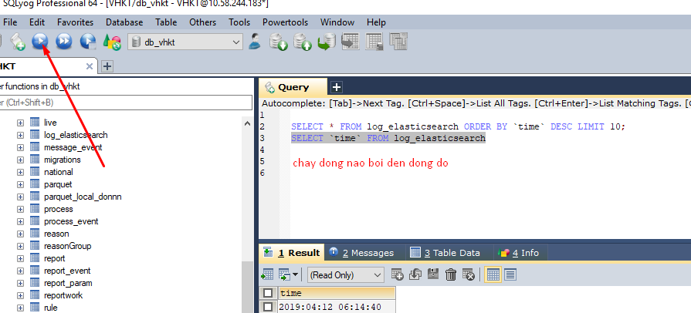

[https://www.weichieprojects.com/blog/curl-api-calls-with-php/#](https://www.weichieprojects.com/blog/curl-api-calls-with-php/)!

<http://10.240.132.135:8080/MobileServiceKenh/ServiceAPI>

<http://10.61.75.152/group.htm?id=0&tabid=1>

|  |  |  |
| --- | --- | --- |
| Warning level =1 | Minor level =2 | Crical level =3 |

Monitor

|  |  |  |
| --- | --- | --- |
| Link, chức năng | Chức năng | database |
| admin/index | Show all cb | history_error |
| Đóng cảnh báo home | Đóng cảnh báo | * Đổi trạng thái cột status bảng **history_error** =2 * Thêm các thông tin nguyên nhân, cách khắc phục, ảnh hưởng, ghi chú   Vào bảng **history_eror_log** |
|  |  |  |

|  |  |
| --- | --- |
| huy | 0379306948 |
| ngoc | 0[335801112](tel:+84335801112) |

|  |  |  |  |  |  |  |  |  |  |  |
| --- | --- | --- | --- | --- | --- | --- | --- | --- | --- | --- |
| **STT** | **Tên kết nối (ID kết nối)** | **Loại kết nối** | **Đối tượng nguồn** *Nếu có ID thì để ID, ko thì để mô tả* | **IP nguồn** | **Port nguồn** *Logical port như 443, 80...* | **Đối tượng đích** | **IP đích** | **Port đích** *Logical port như 443, 80...* | **Mô tả kết nối** | **Ghi chú** |
| 1 | MS-PayApp | Internal | Mobile service | 10.240.132.135  10.240.132.137  10.240.132.139 | 8080  8087 | PayApp | 10.60.99.226  10.60.99.211  10.60.99.228  10.60.99.203 | 8375  8275 | Kết nối từ app đến gossip | Giao thức TCP/IP |
| 2 | PayApp-Egate | Internal | PayApp | 10.60.99.226  10.60.99.211  10.60.99.228  10.60.99.203 | 8375  8275 | Egate | 10.60.99.228  10.60.99.203 | 8020  8022 | Kết nối từ app tới Egate | Giao thức TCP/IP |
| 3 | Egate | Internal | Egate | 10.60.99.228  10.60.99.203 | 8020  8022 | Bank | LongTH1 cập nhật |  | Kết nối tới ngân hàng | Giao thức TCP/IP |
| 4 | PayApp Merchant | Out | PayApp | 10.60.99.226  10.60.99.211  10.60.99.228  10.60.99.203 | 8375  8275 | Merchant | 10.240.132.131/133  10.60.105.132/133 |  | Kết nối Merchant | Giao thức TCP/IP |
| 5 | PayApp SMS | 1 | PayApp | 10.60.99.226  10.60.99.211  10.60.99.228  10.60.99.203 | Dải port 1000-9999 | SMS GW | 10.60.5.13:9131  10.58.4.51:8008 |  | Kết nối SMS GW | https |
| 6 | PayApp BCCS | 1 | PayApp | 10.60.99.226  10.60.99.211  10.60.99.228  10.60.99.203 | 8375  8275 | SRV_APP_06 | 10.60.92.246 |  | Kết nối tới LB BCCS | Giao thức TCP/IP |
| 7 | Mobile Service DB | 1 | Mobile Service | 10.240.132.135  10.240.132.137  10.240.132.139 | Dải port 1000-9999 | DB | 10.240.132.162  10.240.132.163 | 1521 | Kết nối Vasgw - ussdapp | Giao thức TCP/IP |
| 8 | PayApp DB | 1 | PayApp | 10.60.99.226  10.60.99.211  10.60.99.228 | Dải port 1000-9999 | DB | 10.60.99.241/242  10.60.99.245/245 | 1521 | Kết nối Vasgw - ussdapp | Giao thức TCP/IP |

<http://bankplus.viettel.vn/Authentication.do?request_locale=vi_VN>

<https://bankplus1.viettel.vn:8443/passportv3/login?appCode=bankplus&service=http%3A%2F%2Fbankplus.viettel.vn>