DATA STRUCTURE AND ALGORITHMS PROJECT

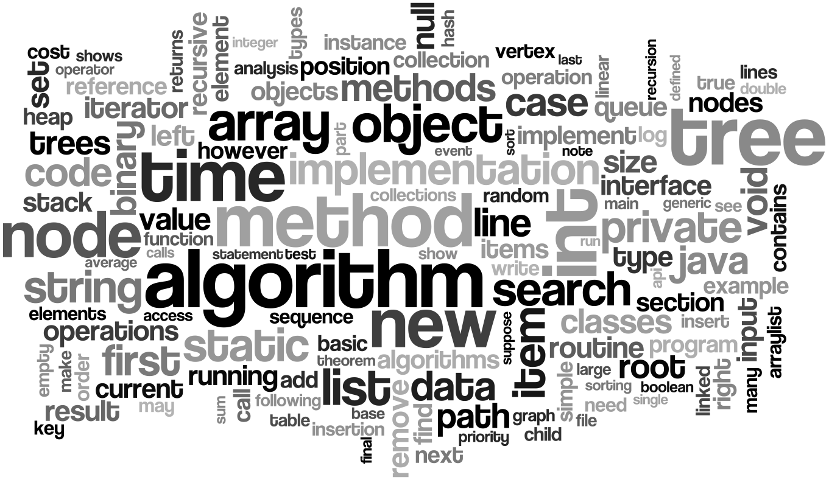

WINTER SEMESTER 2015-2016

**TITLE OF THE PROJECT: AKS PRIMALITY TEST**

**STUDENT LIST (NAME & REGNO.):**

**Osho Agyeya(15BCE1326)**

**Shivam Prasad(15BCE1196)**

**Malladi Tejasvi(15BCE1208)**

**Shubankar B(15BCE1123)**

**Shivam Pratap Singh(15BCE1053)**

**Under the guidance of UMITTY SRINIVASA RAO, Work done at VIT University, Chennai**

**B.Tech Computer Science Engineering (2015-2016)**

**SCHOOL OF COMPUTING SCIENCE & ENGINEERING, VIT UNIVERSITY**

INTRODUCTION:

The AKS primality test (also known as Agrawal–Kayal–Saxena primality test and cyclotomic AKS test) is a deterministic primality-proving algorithm created and published by Manindra Agrawal, Neeraj Kayal, and Nitin Saxena, computer scientists at the Indian Institute of Technology Kanpur, on August 6, 2002, in a paper titled "PRIMES is in P". The algorithm determines whether a number is prime or composite within polynomial time. The authors received the 2006 Gödel Prize and the 2006 Fulkerson Prize for this work. Significant aspects of this algorithm are:

* Invented by Manindra Agrawal,Neeraj Kayal & Nitin Saxena
* Unconditional:No constraints involved
* Deterministic:Solves the problem with exact decision at every step;no guesses involved;machine’s current state determines what its next state will be; computes a mathematical function which has a unique value for any input in its domain
* Polynomial time complexity:Running time is upper bounded by a polynomial expression in the size of the input(no. of digits) for the algorithm

OBJECTIVE:

The project focusses mainly on the following aspects:

* History of PRIMES
* Basic idea of AKS Primality Test
* Deduction of AKS algorithm from Fermat’s theorem
* Main algorithm of AKS test
* Improvements made to AKS test
* Correctness of AKS test
* Time complexity analysis
* Implementation of AKS test
* Improvement in time complexity via our own ideas

LITERATURE SURVEY:

Prior to this algorithm,various researches have been conducted on primality testing.We have included a few of them in our project.

Sieve of Eratosthenes: In mathematics, the **sieve of Eratosthenes** ,one of a number of prime number sieves, is a simple, ancient algorithm for finding all prime numbers up to any given limit. It does so by iteratively marking as composite (i.e., not prime) the multiples of each prime, starting with the multiples of 2.

The multiples of a given prime are generated as a sequence of numbers starting from that prime, with constant difference between them that is equal to that prime. This is the sieve's key distinction from using trial division to sequentially test each candidate number for divisibility by each prime.

The sieve of Eratosthenes is one of the most efficient ways to find all of the smaller primes.

Fermat’s theorem: **Fermat's little theorem** states that if *p* is a prime number, then for any integer *a*, the number *a* *p* − *a* is an integer multiple of *p*. In the notation of modular arithmetic, this is expressed as

a^p \equiv a \pmod p.

For example, if *a* = 2 and *p* = 7, 27 = 128, and 128 − 2 = 7 × 18 is an integer multiple of 7.

WORKFLOW/ARCHITECTURE DIAGRAM/SYSTEM DESIGN:

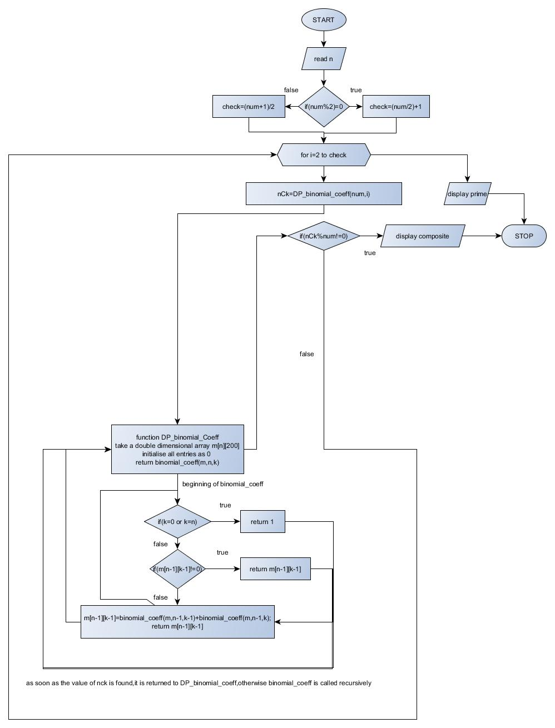

METHODS AND TECHNOLOGIES:

The focal point of the algorithm is as follows:

The binomial coefficients of the no. input are generated. Since the binomial coefficients are symmetrically arranged ,only half coefficients are generated. The binomial coefficients are generated by dynamic programming using top down approach. Now,each of these coefficients is checked for divisibility by the input number. nC0=1 is ignored for divisibility check. If all the coefficients are divisible by the input no, then the no. is prime. Otherwise, the no. is composite.

Let a be an integer & n be a natural number such that n>=2,HCF of a & n is 1.Then n is prime iff:

(x+a)n =xn +a (mod n) ,i.e. all the coefficients in ((x+a)n –(xn +a) ) should be perfectly divisible by n.

In other words,nCi*a(n-i) is perfectly divisible by n for 0<i<n.

**RESULTS AND OBSERVATIONS:**

The algorithm developed by us tests the primality upto 61(due to the limitations of the datatype involved).The no. to be input cannot be 1,0 or any –ve integer.

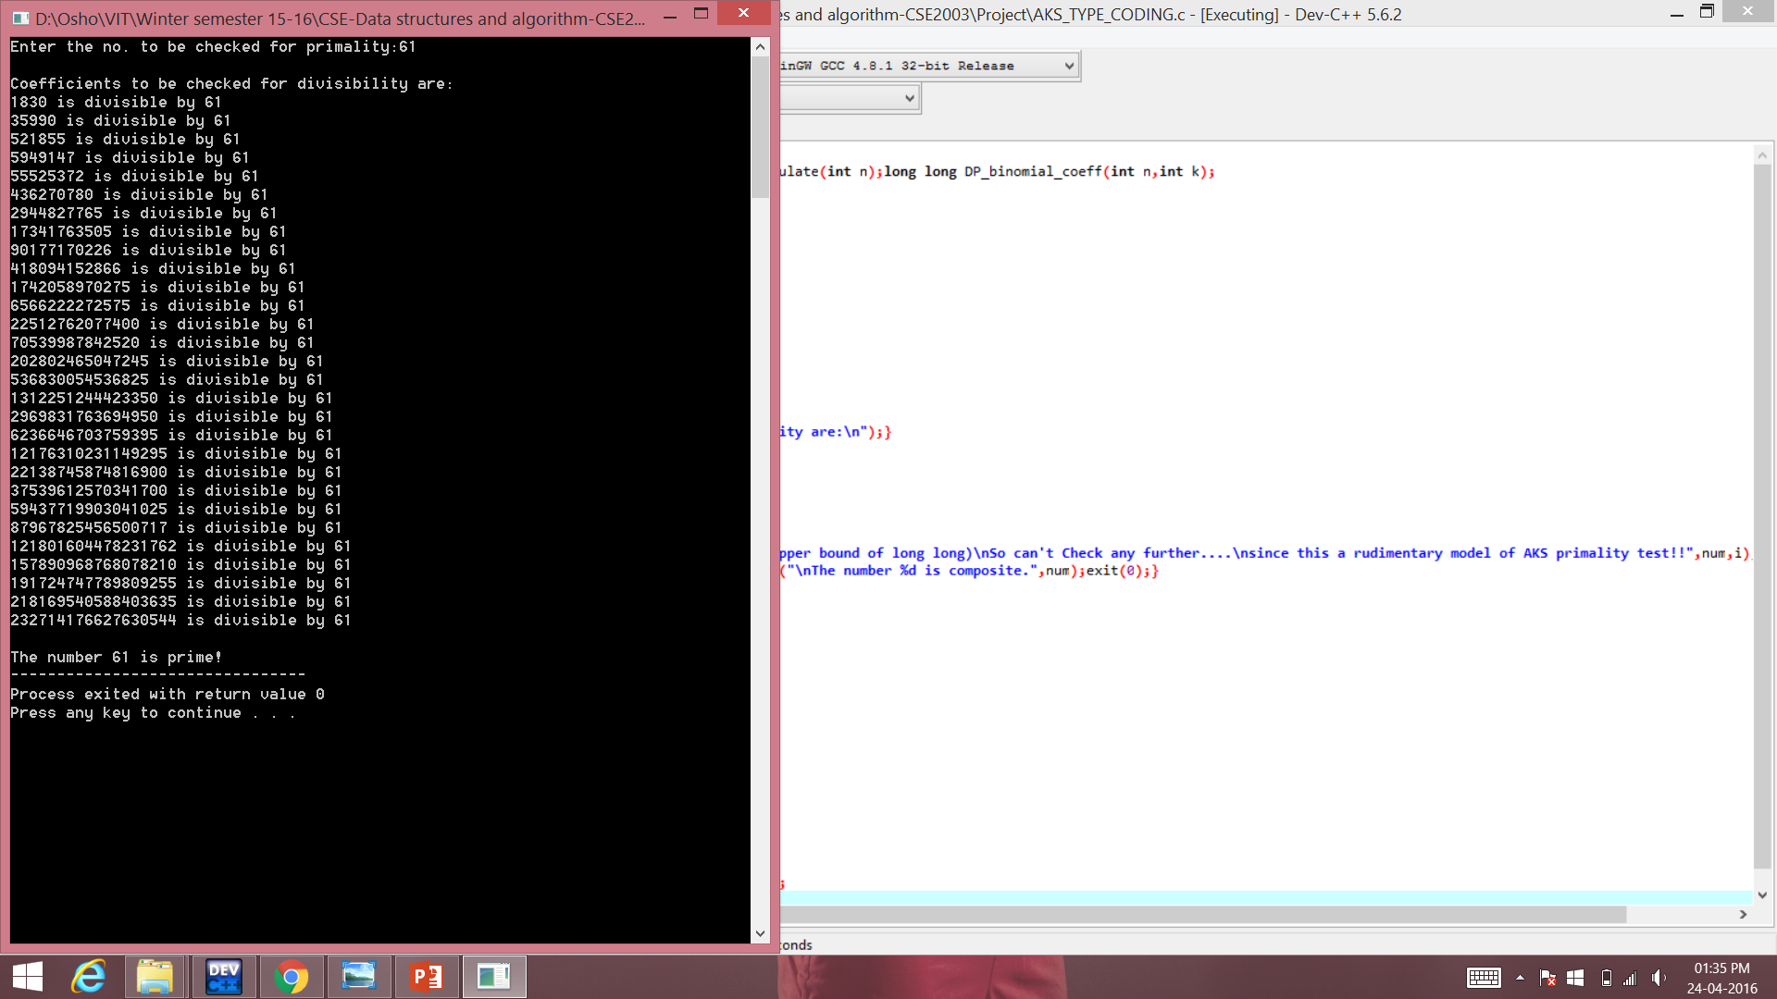

**REFERENCES:**

Introduction to Algorithms-Book by Charles E. Leiserson, Clifford Stein, Ronald Rivest, and Thomas H. Cormen

[www.wikipedia.com](http://www.wikipedia.com)

[www.youtube.com](http://www.youtube.com)

PRIMES is in P

Manindra Agrawal Neeraj Kayal

Nitin Saxena

Department of Computer Science & Engineering

Indian Institute of Technology Kanpur

Kanpur-208016, INDIA

Email: {manindra,kayaln,nitinsa}@iitk.ac.in

<http://mathworld.wolfram.com/AKSPrimalityTest.html>

<https://terrytao.wordpress.com/2009/08/11/the-aks-primality-test/>

Sanjoy Dasgupta, C.Papadimitriou and U.Vazirani , Algorithms , Tata McGraw-Hill, 2006.

A. V. Aho, J.E. Hopcroft and J. D. Ullman, Data Strucures and Algorithms ,Pearson India, Ist Edition, 2002

Mark Allen Weiss, Data Structures and Algorithm Analysis in C, 2nd edition, Pearson

Education, 2007