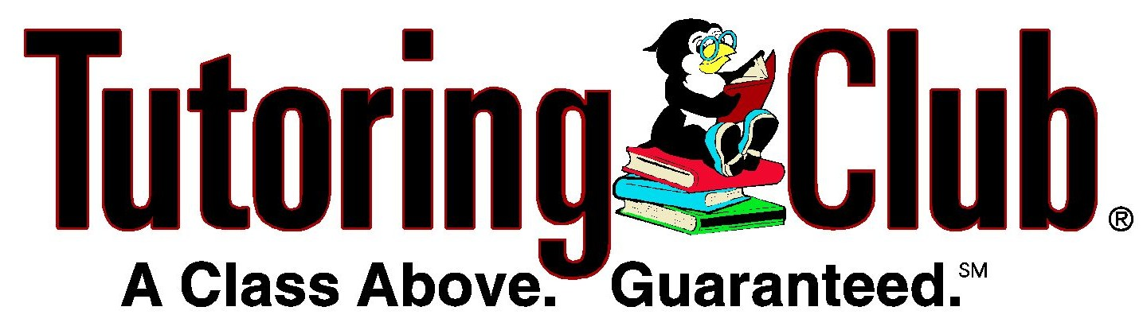
Eric Laquer
Tutoring Club of Washington Twp
New Market Place
279 D Egg Harbor Rd.
Sewell , NJ 08080
Birches Elementary School PTO
Jennie Minich
416 Westminister Blvd.
Turnersville, NJ 08012
Birches Elementary School PTO
Jennie Minich
416 Westminister Blvd.
Turnersville, NJ 08012
Dear Mrs. Minich,

As we all approach the new school year, I would like to take this opportunity to introduce myself as the new Director of the Tutoring Club of Washington Township. The business was established by Steve Iatarola who proudly served the community for more that 4 years before my company purchased it in July of this year.

As you might already be aware, the Tutoring Club delivers highly personalized educational programs focused on efficiently increasing a students' skills in Reading, Writing and Math. Further, we offer a range of specialized programs focusing on preparing to be an effective student, preparing for the SATs, and preparing for the ACTs. One of our newest programs guides students and their parents thru the whole process of college preparedness throughout the high school years. Our tutors also provide help in subject areas like Calculus, Biology, Physics, and Chemistry.

While maintaining the business's reputation for high quality service and integrity, we are introducing some new programs that could both RAISE ACADEMIC ACHIEVEMENT LEVELS and RAISE FUNDS for worthy PTO projects. Please accept my invitation to come and visit me to see what we offer your students and what we can offer your organization. We have included a couple of pages from our web site and one of my business cards.

Sincerely

Eric Laquer

Director of the Tutoring Club of Washington Township
New Market Place 279 D Egg Harbor Rd.
Sewell, NJ 08080
Email: LaquerEric@gmail.com
Cell: 215 527 1106

