NORTHSTAR ANALYTICS | WORKPLACE CONDUCT AND PROFESSIONAL STANDARDS
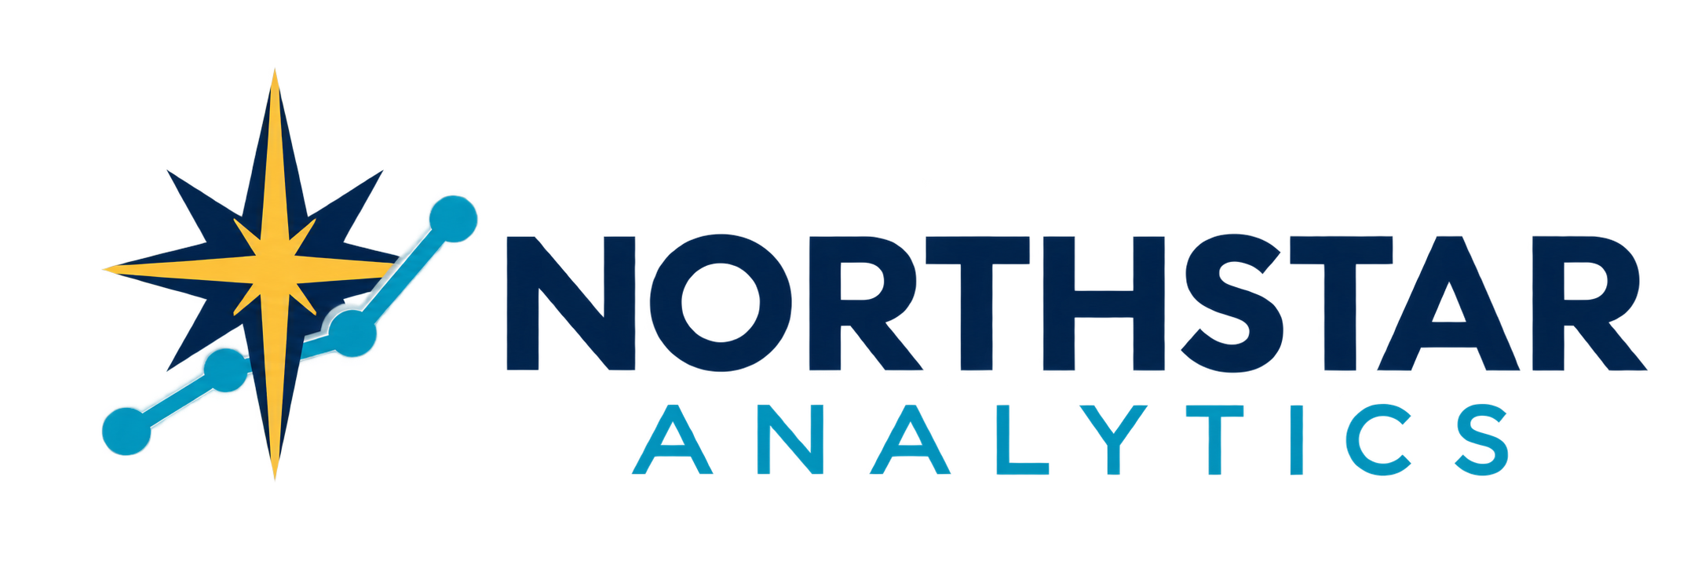

Northstar Analytics Workplace Conduct and Professional Standards
Expected behavior ethical judgment collaboration and accountability
Policy owner | People Operations | Version | 1.0
Effective date | September 26 2026 | Applies to | Employees and covered workers

1 Purpose and Scope
Northstar Analytics expects everyone representing the company to act lawfully, ethically, respectfully, and professionally. These standards apply to employees and, where incorporated into an agreement, contractors, temporary workers, interns, and other covered workers in offices, remote settings, client locations, business travel, online channels, and company-sponsored events.
This policy does not replace more specific requirements. Employees must follow applicable law, client commitments, professional obligations, and Northstar policies. When standards appear to conflict, pause the activity and seek guidance from a manager, People Operations, Legal, Compliance, or Information Security.

2 Core Standards
- Integrity. Be truthful, keep commitments, correct mistakes, and never falsify records, results, credentials, time, expenses, or approvals.
- Respect. Treat others with dignity and communicate without harassment, discrimination, bullying, threats, or degrading conduct.
- Accountability. Understand assigned responsibilities, meet reasonable deadlines, raise risks early, and accept appropriate feedback.
- Sound judgment. Protect people, clients, data, company resources, and Northstar's reputation when making decisions.

3 Respectful and Inclusive Workplace
Employees must support a workplace free from unlawful discrimination, harassment, retaliation, and abusive conduct. Prohibited behavior may be verbal, visual, physical, written, or digital and can occur between coworkers or involve managers, clients, vendors, applicants, or other third parties. Conduct can violate policy even when it does not violate law.
Differences should be addressed directly and constructively when safe and appropriate. Disagreement, performance feedback, and business debate must remain professional and focused on work. Employees should respect names, identities, backgrounds, viewpoints, accessibility needs, personal boundaries, and reasonable privacy expectations.

4 Professional Communication and Collaboration
Use clear, accurate, and respectful language in meetings, email, chat, documents, tickets, and client communications. Do not knowingly misrepresent facts, conceal material risks, take credit for another person's work, or use insulting, intimidating, sexually explicit, or discriminatory content. Written messages may be retained or disclosed and should be composed accordingly.
Collaboration includes sharing necessary information, documenting decisions, meeting agreed handoffs, and raising blockers without blame. Employees must not deliberately exclude others from information needed to perform their roles or misuse authority to silence questions or concerns.

5 Client Vendor and Public Interactions
Represent Northstar accurately and within assigned authority. Employees may not make unauthorized commitments, guarantees, pricing decisions, legal representations, or public statements on Northstar's behalf. Treat clients, vendors, partners, and community members fairly; avoid favoritism, deceptive practices, and any conduct that could compromise an objective business decision.
NORTHSTAR ANALYTICS | WORKPLACE CONDUCT AND PROFESSIONAL STANDARDS

6 Conflicts of Interest Gifts and Outside Activities
Employees must avoid actual, potential, or perceived conflicts between personal interests and Northstar duties. Disclose relevant financial interests, close personal relationships, outside employment, board service, investments, or other circumstances that could affect business judgment, supervision, purchasing, hiring, project assignment, or access to information.
Do not request or accept cash, kickbacks, personal commissions, or anything intended to influence a decision. Modest lawful business courtesies may be accepted only when infrequent, transparent, consistent with client rules, and unlikely to affect judgment. Employees must obtain required approval before giving or receiving gifts, hospitality, travel, or entertainment.

7 Confidentiality Data and Intellectual Property
Protect Northstar, employee, applicant, client, vendor, and partner information according to its classification and approved use. Access and share information only for authorized business purposes and use approved systems, devices, storage, and transmission methods. Do not discuss confidential matters where unauthorized people may hear or view them.
Respect copyrights, licenses, patents, trademarks, trade secrets, contractual restrictions, and ownership of work product. Do not copy, upload, publish, reuse, or provide third-party materials, code, data, models, or credentials unless authorized. Confidentiality obligations continue after employment ends.

8 Company Resources Records and Time
Use company funds, equipment, systems, accounts, facilities, and paid work time responsibly and primarily for authorized purposes. Limited personal use is permitted only when lawful, reasonable, secure, and not disruptive or costly. Maintain accurate business, financial, project, personnel, security, expense, and time records; never bypass approvals or delete records to conceal activity.

9 Safety Violence and Impairment
Follow safety and security requirements and promptly report hazards, threats, violence, weapons concerns, injuries, and emergencies. Violence, threats, stalking, intimidation, and deliberate property damage are prohibited. Contact emergency services first when there is an immediate danger, then notify the appropriate Northstar contact when safe.
Employees must not work while impaired in a way that creates a safety, security, performance, or legal risk. Possession, use, distribution, or sale of illegal drugs in connection with work is prohibited. Lawful medication and alcohol use must not interfere with safe and effective job performance or client requirements.

10 Remote Hybrid and Travel Conduct
The same conduct, confidentiality, attendance, and performance standards apply in remote and hybrid work, virtual meetings, messaging platforms, client sites, and business travel. Employees must maintain a professional environment, protect screens and conversations, follow local rules, and avoid conduct that could reasonably be attributed to Northstar or undermine a client relationship.
NORTHSTAR ANALYTICS | WORKPLACE CONDUCT AND PROFESSIONAL STANDARDS

11 Social Media and External Communications
Only authorized spokespersons may speak for Northstar. Employees must not disclose confidential information, imply company endorsement of personal views, or use Northstar or client brands without permission. Personal activity must not interfere with work or violate this policy. Nothing here restricts lawful communications about wages, hours, working conditions, suspected misconduct, or other legally protected activity.

12 Reporting Concerns and Seeking Guidance
Employees should promptly report suspected misconduct, conflicts, harassment, discrimination, retaliation, fraud, safety issues, data misuse, or other material policy violations. Reports may be made to a manager, People Operations, Legal, Compliance, Information Security, or another reporting channel identified by Northstar. Managers must promptly escalate reports rather than investigate independently unless assigned to do so.
Employees should provide information honestly and preserve relevant records. Good-faith reports are encouraged even when the concern is not substantiated. Knowingly false reports or deliberate interference with a review may lead to corrective action, but an unproven good-faith concern is not misconduct.

13 Reviews Confidentiality and Nonretaliation
Northstar will assess concerns promptly, fairly, and as confidentially as practical. Information may be shared with those who need it to review the issue, protect participants, comply with law, or take corrective action; absolute confidentiality cannot be guaranteed. Covered workers must cooperate truthfully and must not alter, conceal, or destroy relevant information.
Retaliation is prohibited against anyone who raises a good-faith concern, requests help, participates in a review, or exercises a legal right. Report suspected retaliation immediately. Northstar may take interim measures to protect people, information, clients, or operations while a matter is reviewed.

14 Accountability and Corrective Action
Violations may result in coaching, training, access restrictions, reassignment, repayment, disciplinary action up to and including separation, referral to a client or professional body, or legal action, as appropriate. Northstar considers the facts, severity, intent, impact, prior conduct, consistency, and legal requirements. Employment remains subject to applicable agreements and law.

15 Decision Guide
Question | Expected response
Is it lawful and authorized | Confirm applicable law, policy, contract, approval, and role authority before proceeding.
Is it accurate and transparent | Correct errors, disclose material facts, and create a reliable record of the decision.
Could judgment be affected | Disclose the conflict or benefit and step back until guidance or approval is provided.
Are people or information at risk | Pause, protect immediate safety or data, and escalate through the appropriate channel.
Would public review change the choice | Reconsider the action and seek guidance when the decision would be difficult to explain.

16 Administration and Related Documents
People Operations owns this policy; Legal, Compliance, Information Security, Finance, and management support administration within their responsibilities. Questions should be raised before acting when practical. Nothing in this policy prohibits reporting possible legal violations to a government agency, cooperating with an investigation, or exercising rights protected by law.
Related documents include the Employee Handbook; Anti-Harassment and Discrimination Policy; Information Security and Acceptable Use Policy; Data Classification and Handling Standard; Conflicts of Interest and Outside Activities Policy; Business Expense Reimbursement Policy; Business Travel and Booking Policy; and Remote and Hybrid Work Policy.

