NORTHSTAR ANALYTICS | ANTI HARASSMENT AND DISCRIMINATION POLICY
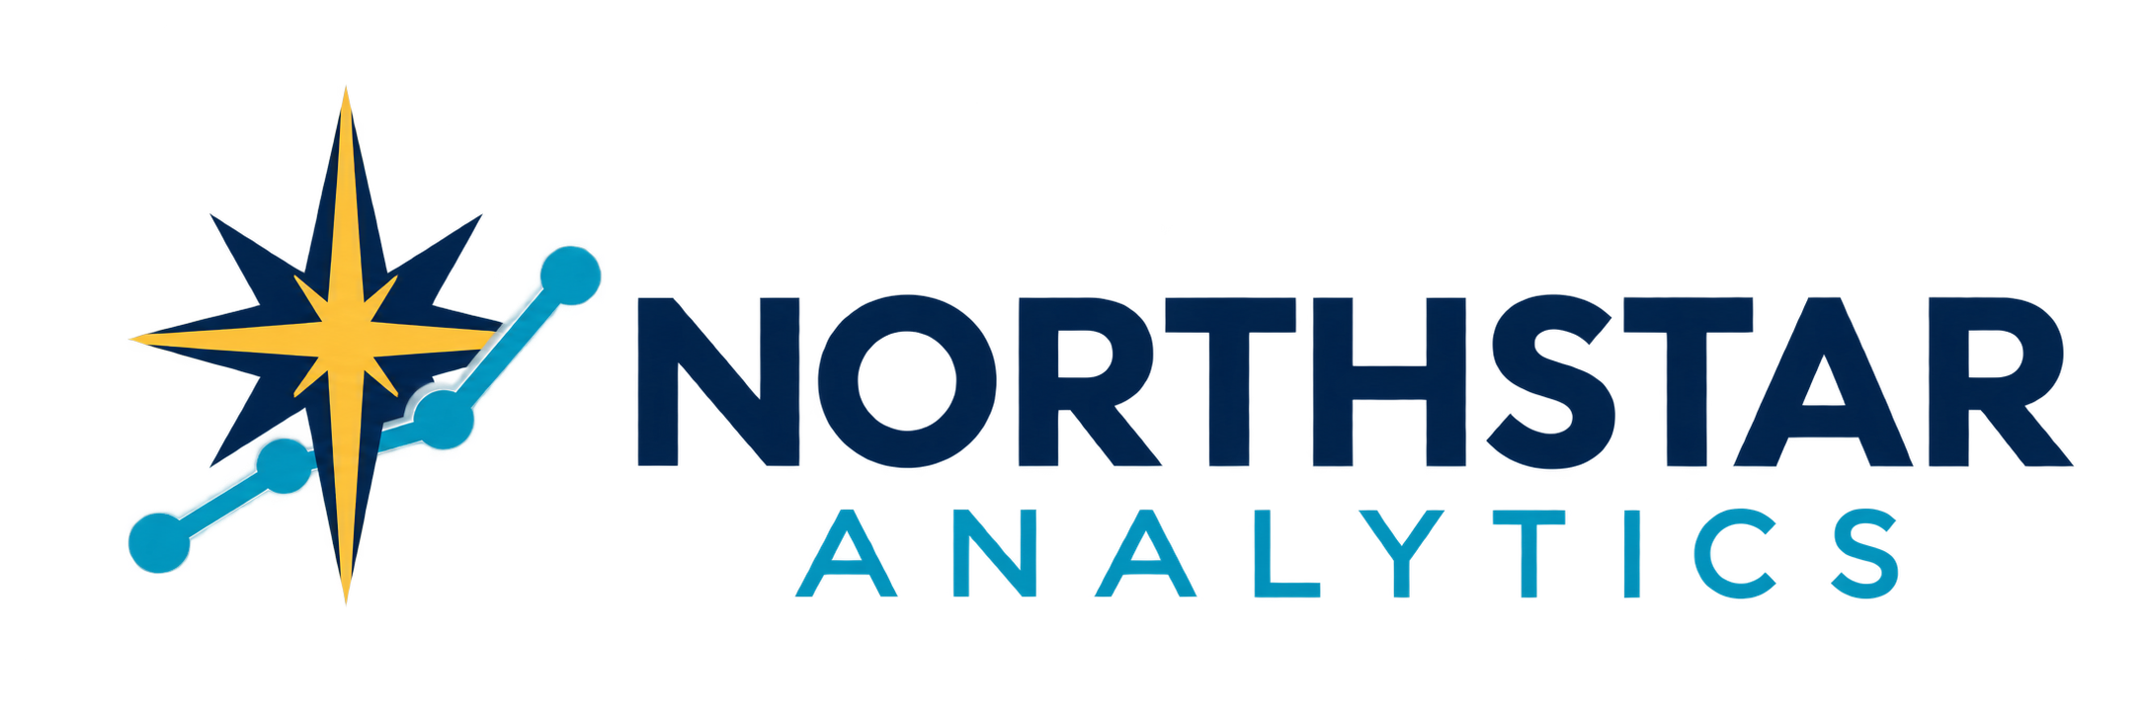

Northstar Analytics Anti Harassment and Discrimination Policy
Equal opportunity respectful conduct reporting and nonretaliation
Policy owner | People Operations | Version | 1.0
Effective date | September 26 2026 | Applies to | Applicants employees and covered workers

1 Purpose and Scope
Northstar Analytics provides equal employment opportunity and prohibits discrimination, harassment, and retaliation. This policy applies to applicants, employees, interns, temporary workers, contractors where applicable, and anyone interacting with Northstar personnel, including managers, coworkers, clients, vendors, partners, and visitors.
The policy applies wherever work-related conduct occurs, including offices, remote and hybrid settings, virtual meetings, messaging platforms, client sites, recruiting activities, business travel, conferences, social functions, and communications connected to work. Conduct may violate this policy even when it does not meet the legal definition of unlawful harassment.

2 Equal Employment Opportunity
Employment decisions must be based on legitimate business factors and not on race, color, religion, creed, national origin, ancestry, citizenship status where protected, sex, pregnancy or related conditions, sexual orientation, gender identity or expression, age, disability, genetic information, veteran or military status, marital or family status, or any other status protected by applicable law.
This requirement applies to recruiting, hiring, assignment, scheduling, compensation, benefits, training, promotion, performance management, discipline, leave, accommodation, access to opportunities, and separation. Northstar also prohibits discrimination based on association with a person in a protected group or on a perception that an individual has a protected characteristic.

3 Prohibited Harassment
Harassment is unwelcome verbal, visual, physical, written, or digital conduct based on a protected characteristic. It is prohibited when it affects employment, interferes with work, creates an intimidating, hostile, or offensive environment, or otherwise violates Northstar standards. The conduct may come from any person and may target or affect someone other than the person to whom it is directed.
- Verbal or written conduct. Slurs, insults, stereotypes, degrading comments, repeated offensive jokes, threats, or mocking a protected trait.
- Visual or digital conduct. Offensive images, symbols, gestures, messages, posts, memes, video, or material displayed or shared through work channels.
- Physical conduct. Unwanted touching, blocking movement, intimidation, assault, or interference with a person's work or property.
- Exclusion or sabotage. Withholding opportunities, information, support, or access because of a protected characteristic.

4 Sexual and Sex Based Harassment
Sexual and sex-based harassment includes unwelcome sexual advances, requests for sexual favors, sexual comments or images, unwanted touching, repeated requests for dates, sexual rumors, or hostility based on sex, pregnancy, sexual orientation, gender identity, or gender expression. It includes conduct between people of any sex or gender.
No employment benefit or decision may be conditioned on accepting sexual conduct, and rejection or reporting of such conduct must not affect employment. Consensual relationships do not excuse favoritism, conflicts of interest, or conduct that creates an inappropriate workplace. Employees are never required to confront the person involved before reporting.

5 Accommodation and Accessibility
Northstar will provide reasonable accommodation for disability, sincerely held religious belief or practice, and pregnancy, childbirth, or related medical conditions as required by law. Requests may be made to People Operations or through another designated channel and will be handled through an interactive process. Retaliation for requesting or using an accommodation is prohibited.
NORTHSTAR ANALYTICS | ANTI HARASSMENT AND DISCRIMINATION POLICY

6 Reporting Options
Anyone who experiences, observes, or learns of possible discrimination, harassment, or retaliation should report it promptly. A report may be made orally or in writing to any manager, People Operations, Legal, Compliance, or another reporting channel designated by Northstar. If one channel is involved in the concern, unavailable, or uncomfortable, use another. Reports may be made without following the reporting line.
Provide the names of involved persons, what occurred, dates or approximate timing, locations or channels, witnesses, and relevant messages or records when available. A report will still be reviewed when some details are unknown. In an immediate safety threat, contact emergency services first and notify Northstar when safe.

7 Manager Responsibilities
Managers who observe or receive information about possible misconduct must promptly notify People Operations or another designated function, even if the reporting person asks the manager to keep the matter private or does not use legal terms. Managers must not investigate independently, promise confidentiality or a particular outcome, discourage reporting, or take action that could appear retaliatory.

8 Supportive and Interim Measures
Northstar may take reasonable interim steps to protect participants and preserve a fair process, such as adjusting reporting relationships, schedules, work locations, contact, travel, or access. Measures are not disciplinary findings and will be selected to avoid burdening the reporting person when practical. Safety, confidentiality, business continuity, and the rights of everyone involved will be considered.

9 Review Process
Northstar will assess reports promptly and assign an appropriate reviewer. The scope and method will reflect the allegations, available information, conflicts, and legal obligations. Reviews may include interviews, document or system-record collection, credibility assessment, consultation with specialists, and written findings based on the information available.
The reporting person and the person whose conduct is reviewed will be treated fairly and given an appropriate opportunity to provide relevant information. Northstar will communicate completion and, when appropriate, whether action was taken, while protecting privacy and confidential personnel information.

10 Confidentiality and Record Preservation
Information will be shared only with those who need it to review the matter, protect participants, comply with law, or implement action. Absolute confidentiality cannot be guaranteed. Participants must preserve relevant records and must not alter, conceal, delete, or coordinate accounts. This requirement does not prevent lawful communication with a government agency or legal adviser or other protected activity.

11 Nonretaliation
Northstar prohibits retaliation against anyone who makes a good-faith report, opposes suspected discrimination, requests an accommodation, supports another person, participates in a review, files or assists with a government charge, or exercises a protected right. Retaliation may include threats, intimidation, exclusion, unfavorable assignments, schedule changes, reduced opportunities, unjustified scrutiny, or other action that could discourage protected activity.
NORTHSTAR ANALYTICS | ANTI HARASSMENT AND DISCRIMINATION POLICY

12 Cooperation and Good Faith
Covered workers must cooperate honestly in company reviews and may not pressure, coach, intimidate, or retaliate against participants. A good-faith report is not misconduct merely because it is unsubstantiated. Knowingly false statements, fabricated evidence, or deliberate interference may result in corrective action, but this provision will not be used to punish protected participation or reasonable mistakes.

13 Findings and Corrective Action
If Northstar determines that this policy was violated, it will take prompt and proportionate action designed to stop the conduct, address its effects, and reduce recurrence. Action may include coaching, training, monitoring, changes in duties or access, removal from an assignment, discipline up to and including separation, ending a vendor or contractor relationship, or other remedial measures.
A policy violation may be found even if the conduct is not unlawful. Northstar considers the nature, frequency, severity, context, impact, authority of the persons involved, prior conduct, consistency, and applicable law. No outcome is predetermined, and interim measures are not proof of wrongdoing.

14 External Rights
Nothing in this policy requires internal reporting before contacting the U.S. Equal Employment Opportunity Commission or another federal, state, or local agency, law-enforcement authority, or legal adviser. An internal review does not pause or extend any external filing deadline. Northstar will not interfere with lawful agency communication, participation, or rights protected by law.

15 Responsibilities
Role | Required action
All covered workers | Follow this policy, report concerns or seek help, preserve information, cooperate honestly, and avoid retaliation.
Managers | Model respectful behavior, act on concerns promptly, maintain appropriate boundaries, escalate reports, and monitor for retaliation.
People Operations | Receive reports, coordinate accommodations and reviews, maintain records, communicate process steps, and support corrective action.
Legal and Compliance | Advise on legal obligations, conflicts, investigation scope, external matters, and consistent risk-based response.
Company leadership | Provide resources, reinforce accountability, review trends, and support prevention, training, and corrective measures.

16 Training Records and Related Documents
Northstar may require periodic training and acknowledgments. People Operations will maintain policy, training, report, review, accommodation, and corrective-action records with access limited by role and retention requirements. Questions about this policy or reporting options should be directed to People Operations.
Related documents include the Employee Handbook; Workplace Conduct and Professional Standards; Reasonable Accommodation Procedure; Remote and Hybrid Work Policy; Business Travel and Booking Policy; Information Security and Acceptable Use Policy; and Data Classification and Handling Standard.

