NORTHSTAR ANALYTICS | PERFORMANCE REVIEW AND DEVELOPMENT POLICY
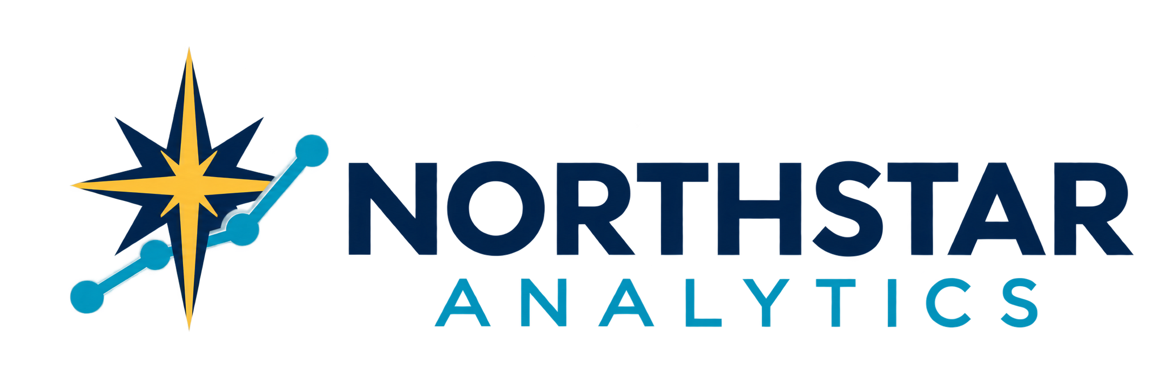

Northstar Analytics Performance Review and Development Policy
Clear expectations evidence based feedback growth and accountability
Policy owner | People Operations | Version | 1.0
Effective date | September 26 2026 | Applies to | Employees and people managers

1 Purpose and Scope
Northstar Analytics uses performance reviews to clarify expectations, recognize contributions, identify development needs, and support fair employment decisions. The process combines ongoing feedback with documented periodic reviews; it is not intended to replace regular coaching, project debriefs, or timely discussion of performance concerns.
This policy applies to employees and people managers. People Operations may adapt timing or forms for new hires, transfers, promotions, leaves, organizational changes, or local requirements while preserving consistent principles. Contractors may receive project feedback under their agreements but do not participate in the employee review process unless specified.

2 Guiding Principles
- Clarity. Expectations, priorities, decision rights, and success measures should be documented and understood.
- Evidence. Assessments should rely on relevant results and observed behaviors across the review period, not recency, reputation, or assumptions.
- Dialogue. Employees and managers share responsibility for candid, respectful, two-way feedback and early problem solving.
- Development. Reviews should identify practical opportunities to build capability, expand impact, and prepare for future work.
- Consistency. Comparable standards should be applied across similarly situated employees, with appropriate context for role and opportunity.

3 Review Cycle
Northstar will establish and communicate the review calendar, required forms, rating approach, and completion deadlines. The cycle generally includes goal setting, periodic check-ins, an employee self-assessment, a manager assessment, calibration where used, a review discussion, and a documented development plan.
A formal review covers the designated review period. Managers and employees should not wait for the formal cycle to recognize strong performance, adjust priorities, request support, or address concerns. People Operations may require an interim review after a significant role or manager change.

4 Goals and Role Expectations
At the start of a cycle or role change, the manager and employee should align on core responsibilities and a manageable set of measurable goals. Goals should connect to team, client, quality, security, financial, and operational priorities; identify expected outcomes and timing; and distinguish individual accountability from shared dependencies.
Goals may be revised when business needs, staffing, client direction, scope, resources, or risk changes. Material changes should be discussed and documented so the employee is assessed against reasonable, current expectations rather than obsolete priorities.

5 Ongoing Feedback and Check Ins
Managers should hold regular check-ins appropriate to the role and work cadence. Discussions should cover progress, quality, workload, collaboration, barriers, priorities, support, and development. Feedback should be specific, timely, actionable, and connected to observable behavior or outcomes. Employees should ask questions, share context, and identify needed resources or clarification.
NORTHSTAR ANALYTICS | PERFORMANCE REVIEW AND DEVELOPMENT POLICY

6 Employee Self Assessment
Employees should summarize significant results, progress against goals, challenges, lessons, collaboration, client or stakeholder impact, and development interests. Relevant evidence may include deliverables, agreed metrics, quality indicators, feedback, incident prevention, knowledge sharing, or process improvements. A self-assessment is an input, not the final determination.

7 Manager Assessment
Managers evaluate performance against the employee's role, documented goals, Northstar standards, and expectations communicated during the period. Assessments should consider the full review period, work opportunities provided, changes in scope, approved leave or accommodation, dependencies, and reliable feedback from relevant stakeholders.
Managers must separate performance from personal style preferences and avoid bias based on protected characteristics, remote or onsite visibility, participation in protected activity, use of approved leave, or accommodation. Ratings and narratives must be supported by examples and should not introduce significant concerns that were reasonably known but never discussed.

8 Review Areas
- Results and quality. Completion, accuracy, usefulness, timeliness, and sustainability of work relative to role expectations.
- Client and business impact. Contribution to responsible outcomes, stakeholder trust, sound judgment, and effective prioritization.
- Collaboration and communication. Information sharing, reliability, feedback, inclusion, documentation, and cross-functional work.
- Professional standards. Integrity, security, compliance, ownership, respectful conduct, and appropriate escalation of risk.
- Growth and adaptability. Learning, application of feedback, problem solving, resilience, and readiness for changing work.

9 Calibration and Quality Review
People Operations and authorized leaders may conduct calibration to improve consistency across teams. Calibration may compare the application of standards, evidence quality, rating distribution, opportunity differences, and proposed employment actions. It must not be used to force predetermined distributions or replace the manager's responsibility to provide an accurate assessment.

10 Review Discussion and Acknowledgment
The manager will meet with the employee to discuss accomplishments, expectations, ratings if used, development priorities, and next steps. The employee should have a reasonable opportunity to ask questions, provide context, and identify factual errors. Acknowledgment confirms receipt and discussion, not agreement. Employees may submit a concise written response for the record.

11 Development Planning
Development plans should identify one or more practical priorities, actions, support, and target dates. Options may include coaching, mentoring, training, stretch assignments, job shadowing, professional reading, certification, project leadership, or deliberate practice. Development activity depends on business need, budget, readiness, and available opportunities and does not guarantee promotion or a particular assignment.
NORTHSTAR ANALYTICS | PERFORMANCE REVIEW AND DEVELOPMENT POLICY

12 Performance Concerns and Improvement Plans
Managers should address performance concerns promptly and clearly, explain the gap and expected standard, provide relevant examples, invite employee input, and identify reasonable support and follow-up. Depending on the circumstances, Northstar may use coaching, written expectations, a performance improvement plan, reassignment, discipline, or another action.
An improvement plan should state the performance gaps, required outcomes or behaviors, measurement method, available support, check-in schedule, target period, and possible consequences. Northstar may act without an improvement plan when warranted by the seriousness of the issue, prior communication, business needs, policy violations, or applicable law.

13 Compensation Promotion and Employment Status
A review does not automatically determine pay, bonus, promotion, equity, assignment, or continued employment. Those decisions may consider performance along with market data, internal equity, role scope, skills, business results, budget, conduct, tenure where relevant, and other lawful factors. A positive review is not a promise of future compensation or employment.

14 Fairness Accessibility and Concerns
Employees may request an accommodation to participate in the review process. Concerns about bias, discrimination, retaliation, factual accuracy, process integrity, or a conflict involving the manager may be raised with People Operations or another designated channel. Good-faith concerns will be reviewed without retaliation; disagreement with a rating alone does not establish a policy violation.

15 Records and Confidentiality
Completed reviews, acknowledgments, employee responses, and formal development or improvement plans are company personnel records. They must be created and stored in approved systems, shared only with authorized persons, and retained according to Northstar's schedule and law. Employees must not alter, fabricate, or improperly disclose review records or confidential feedback.

16 Review Workflow
Step | Required action
1 Align | Manager and employee confirm role expectations, priorities, measures, and development interests.
2 Check in | Discuss progress, evidence, feedback, changing priorities, barriers, and needed support throughout the cycle.
3 Assess | Employee completes self-assessment; manager evaluates the full period using documented expectations and evidence.
4 Calibrate | Authorized reviewers examine consistency, evidence quality, bias risks, and proposed outcomes where applicable.
5 Discuss and plan | Manager delivers the review, employee responds, and both document development priorities and follow-up.

17 Responsibilities and Related Documents
Employees provide accurate input, participate in discussions, seek clarification, and act on agreed priorities. Managers set expectations, observe work, give timely feedback, document evidence, apply standards fairly, and complete reviews. People Operations maintains the process, trains managers, supports calibration, reviews concerns, and monitors completion and consistency.
Related documents include the Employee Handbook; Workplace Conduct and Professional Standards; Anti-Harassment and Discrimination Policy; Reasonable Accommodation Procedure; Remote and Hybrid Work Policy; Information Security and Acceptable Use Policy; and applicable compensation, promotion, and corrective-action procedures.

