**ITT-310 Design Report Template**

| **Topic:** | *6 - Milestone 4: Application Release 3* |
| --- | --- |
| **Date:** | *April 27th, 2022* |
| **Revision:** | *1.3* |
| **Milestone Summary:** | | **User Story / Task** | **Hours Worked** | **Hours Remaining** | | --- | --- | --- | | *Started structure base for date and time* | *2* | *10* | | *Added features to display current date and time* | *6* | *4* | | *Struct is away from the main source* | *4* | *0* | |  |  |  | |  |  |  | |  |  |  | |  |  |  | |  |  |  | |  |  |  | |  |  |  | |  |  |  | |  |  |  | |  |  |  | |
| **GIT URL:** | *https://github.com/laquintain/Milestone-4-Application-Release-3.git* |

**Design Documentation**

**General Technical Approach:**

*The application did not have a way to tell the user the time and date. In any application that can be displayed in full screen, most users will prefer a way to tell the time as well as the date. Structures and unions make it easier to shorten the number of functions that need defining. The structure essentially creates a bookshelf or a library that can be sorted through for future integers. Once the functions and variables are defined, smaller words can make larger arguments easier to publish.*

**Application Logic Design:**

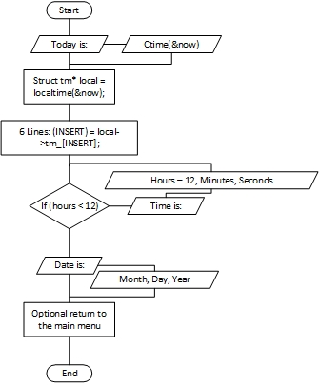

**Risks and Issues:**

*There are no further issues that need tracking at this time other than secure _s terms when required.*

**Other Documentation:**

The example listed in application logic design explains the addition of providing the date and time to students to they remember what day it is because it can be hard to keep up with everything. Students who have multiple assignments may forget what day it is and how far off they are from their assigned projects. The program does not change in pseudocode, except for when new entries are required.