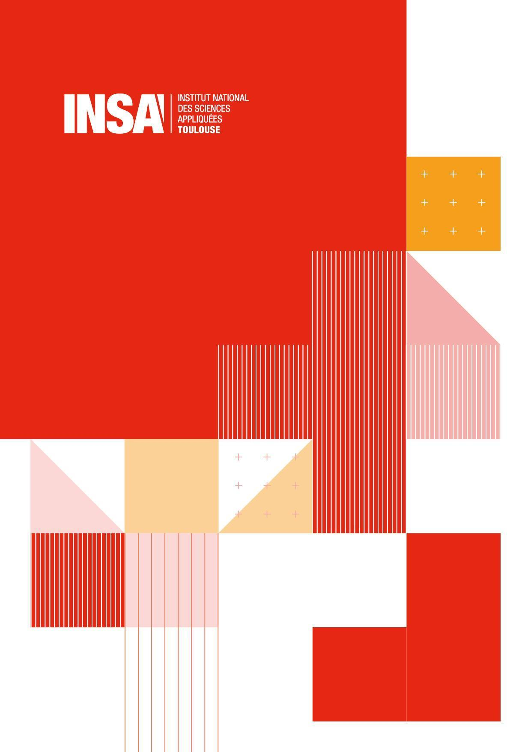
Tomboul-Rosette Joshua 4A AE FISA
El-Chawa Lara
Craig Cassar

Oriented Object Programming BE: HW Audio Mixer

Contains:
Part 1: simulation of an order 1 low-pass filter 3
Q3. Input parameters: 3
Schematic: 3
Q4. DC simulation (numeric values): 3
Q5. Transient simulations (temporal behavior): 4
Q6. Transient simulation parameters comparison (calculating operating point Vs zero initial values): 4
Q7. AC simulation (Bode diagram): 6
Q8. Cutoff frequency (theorical): 7
Cutoff frequency (simulation): 7
Part 2: Integrated circuit simulation 9
Components used: 9
Input parameters: 9
Q9. Schematic: 9
Q10. Transient simulation (temporal behavior): 10
Q11. Measure of the slew rate 10
Q12. Gain-bandwidth product 12
Some values of gain and measured of gain, cutoff frequency and gain-bandwidth product 13

What is the HW Audio Mixer

Purpose and use cases

Class diagram
HMI ---- encoder/LEDs/LCD = composition relationship and private because:
- components will not exist without HMI (box) which is composed of them.
- The information (IN/OUT) destined to components needs to pass through the HMI

BTNS ---- n button = composition relationship and private because: for the same reasons as above

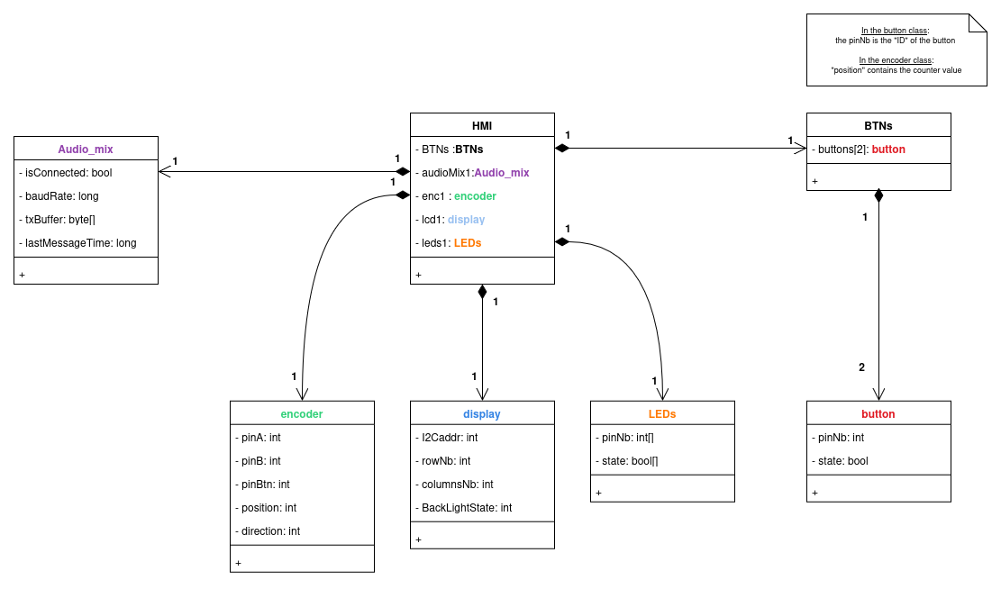
There are more explanations in the program, before each methods
Encoder methods: (all are public)
void init() → see what are necessary (pull-up, pinmode(), …)
int update() → launch the reading (polling purpose) OR use IT???
int getPosition() → +1 for right direction & -1 for left OR using int cnt value???
void resetPosition() → if using an integer cnt value for counting
int GetDirection() → if using an integer cnt value for counting
int isBtnPushed() → if there is a push button

display methods: (all are public)
void init() → see what are necessary
void clear() → no text + one color
void setCursor(int x, int y) → for text display purpose
void printText(string text) → write ‘text’ at the cursor position
void turnBackLightOn(int Y_N) → Y_N = 1 (=YES) → ON | Y_N = 0 (=NO) → OFF
void printImage(int nb) → display an image chosen (= in the firmware) by its number (e.g. 1→ shrek, 2→ Donkey (from shrek too)

LEDs methods: (all are public)
int toggleLED(int ledNb) → toggle the state & return the current one
int setLedColor(int LedNb) → set the color (RGB) of the led chosen
void setLedsAllOff() →
void blinkLed (int LedNb, int ms_period) →

HMI methods: (all are public)
if polling:
void encoderReading() → call encoder update() & isBtnPushed() methods
void displayText(string text, int x, int y) → print text on the display
void displayImage(int imageNb) → print image on the display
void LedsUpdate() → According to the encoder reading

button methods: (all are public)
void init() → see what are necessary (pull-up, pinmode(), ...)
int update() → launch the reading (polling purpose) OR use IT??? Return the state (given by isPressed() method)
int isPressed() → ‘1’=Yes, ‘0’=No, other=error (?)

BTNs methods: (all are public)
void addButton(int pin) →
void suppButton(int pin) →
void updateAllButtons() →
int getState(int pinNb) →

Audio_mix: (all are public)
void int() → setup the drivers
void setVolume(int channelID, int desiredVolume) → set the volume
void toggleMute(int channelID, bool state) →
void sendKeepAliveMsg →
int GetPCStatus () → ‘1’=OK ‘0’=issue occurs

help from gemini:
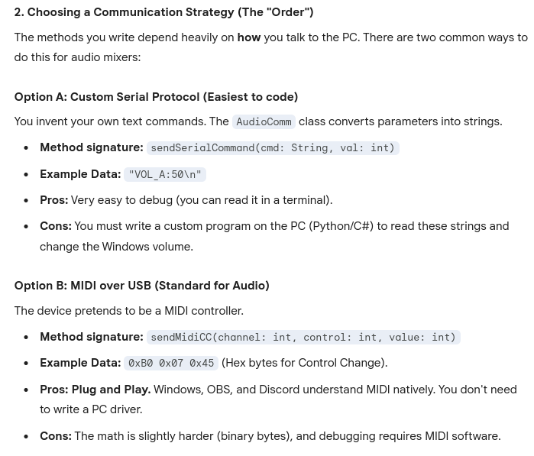

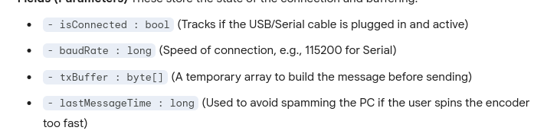

Sequence diag???

How we made the HW Audio Mixer

Tasks and Planning

Steps of development

Improvement ideas

