NEAR FOUNDATION GRANT APPLICATION
VELCRO WALLET
HOOK. LOOP. HOLD.
—
Lara Stuart Mueller, Founder
loveconcursall · Swiss GmbH (in formation) · United States
lara@loveconcursall.com
velcro.dev · velcro-technologies.com
Grant Request: $150,000 USD · Wallet Infrastructure + AI Integration

Section 1 — Project Summary

Project Name | Velcro Wallet
Tagline | Hook. Loop. Hold.
Applicant | Lara Stuart Mueller
Organization | loveconcursall (Swiss GmbH in formation)
Email | lara@loveconcursall.com
Developer Site | velcro.dev — open source docs, SDK, developer onboarding
Product Site | velcro-technologies.com — consumer-facing product, waitlist, brand
Primary Location | United States (Swiss national)
Swiss Entity | GmbH formation in progress — FINMA-compliant architecture
Build Stage | Early development — architecture complete, core build in progress
Grant Category | Wallet Infrastructure / AI Integration / Open Source Public Goods
Grant Requested | $150,000 USD (USD/EUR + NEAR tokens, milestone-based)

Section 2 — The Product

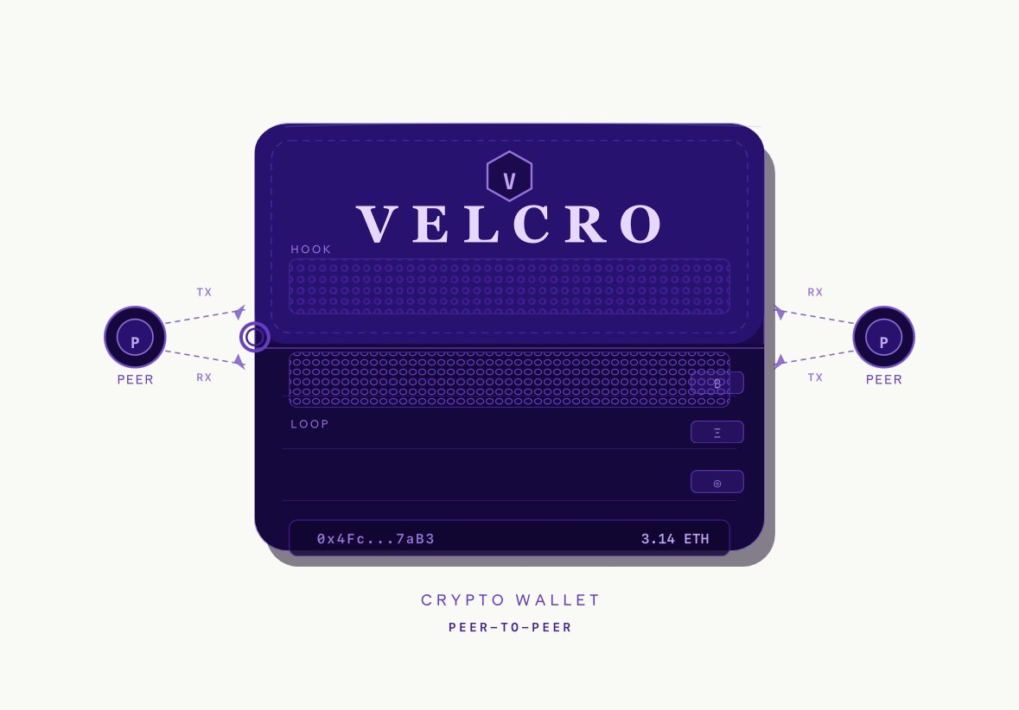
Velcro Wallet — Peer-to-Peer Crypto Wallet
Hook layer (NEAR Intents cross-chain execution) · Loop layer (P2P trade) · On-chain identity

The Velcro wallet interface is designed around three visible structural layers that mirror the product’s architecture. The Hook layer represents NEAR Intents integration — cross-chain execution where the user states an outcome and the system routes it. The Loop layer is the P2P trade surface, where two peers exchange directly with the Counterparty Intelligence Agent running silently underneath. The bottom bar shows the user’s wallet address and balance — always in dollar terms in Everyday mode, always on-chain terms in Pro mode.

Two peer nodes flank the wallet on each side, showing TX (transmit) and RX (receive) connections — a visual representation of the non-custodial, peer-to-peer architecture where no central party sits between sender and receiver.

Section 3 — Project Description

What is Velcro Wallet?
Velcro is a non-custodial, peer-to-peer crypto and fiat wallet with a six-agent AI coordination layer, a three-mode language toggle for mainstream accessibility, integrated traditional banking, and native NEAR Intents and Chain Signatures integration. It is built to be as easy as PayPal for a first-time user and as powerful as a professional trading terminal for an experienced trader — free forever, radically transparent, and designed from the ground up with human dignity at the architecture level.

Why NEAR Protocol — Alignment of Values
Velcro is not approaching NEAR Foundation purely for capital. We are approaching NEAR because the philosophical alignment between what NEAR is building and what Velcro stands for is exact and rare.

- NEAR’s on-chain governance, open-source protocol development, and public Infrastructure Committee funding decisions reflect the same radical transparency that Velcro encodes into its product. We show users our spread. NEAR shows token holders its roadmap decisions. Both are built on the conviction that opacity is how extraction hides, and transparency is how trust compounds. Transparency by design.
- NEAR’s Network Nervous System and community governance through DevHub mean that the protocol’s direction is accountable to its stakeholders, not a founding team behind closed doors. Velcro’s non-custodial architecture and open source agent SDK extend that same accountability to users — the code is readable, the fees are disclosed, the keys stay with the owner. Accountability through governance.
- NEAR’s explicit focus on user-owned AI — agents that act in users’ interests rather than extracting from them — is precisely Velcro’s founding principle. Every agent in the Velcro stack is designed to serve the user holding the wallet, not to extract data or route trades for platform benefit. This is civil rights architecture applied to AI. User-owned AI as a civil right.
- Neither NEAR nor Velcro pursues decentralisation as a philosophical position. Both pursue it because centralised systems create single points of failure, exploitation, and exclusion. The 2.6 billion unbanked people on earth are not unbanked because they lack access to good people — they are unbanked because centralised financial infrastructure has no business model that serves them. NEAR’s chain abstraction and Velcro’s language toggle are both attempts to solve the same problem from different ends of the stack. Decentralisation as inclusion, not ideology.

The Alignment in One Sentence
NEAR is building the infrastructure for a more transparent, accountable, and user-owned Web3. Velcro is building the consumer product that delivers that infrastructure to the people who need it most. This grant funds the bridge between the two.

The Problem We Are Solving
- Phantom, MetaMask, and Rabby are excellent products for technically literate users. For the other 99%, they are unusable. Gas, slippage, contract risk — none of it is explained. Powerful wallets are inaccessible.
- Friendly interfaces to a system that can drain a wallet in one tap. No pre-trade simulation. No contract audit checking. No honeypot detection. The FBI reported $3.9B lost to crypto scams in 2023 alone. Simple wallets are unsafe.
- 2.6 billion people remain unbanked or underbanked. The wallets that exist today assume a bank account, a recent device, and English-language technical literacy. Neither serves the global majority.

Section 4 — Web Presence — Two Sites, Two Audiences

Velcro operates two complementary web properties, each serving a distinct audience and purpose:

velcro.dev — The Developer Hub
Purpose
Open source documentation, SDK, technical architecture, NEAR integration guides, and developer onboarding. This is where the NEAR ecosystem builders come to integrate Velcro’s open source components into their own wallets and dApps.

- Open source agent coordination SDK documentation
- NEAR Intents and Chain Signatures integration guide
- Language Agent API reference — how any NEAR dApp can use the plain-English toggle
- Trade Safety Agent API reference — pre-trade simulation and contract checking
- On-chain contacts architecture specification
- Contribution guidelines and GitHub links
- Testnet and mainnet deployment guides

velcro.dev is the NEAR ecosystem’s entry point to Velcro’s open source infrastructure. It makes the grant’s public goods commitment tangible and accessible.

velcro-technologies.com — The Consumer Product Site
Purpose
The consumer-facing brand and product destination. This is where mainstream users, press, investors, and partners discover Velcro — sign up for the waitlist, understand the product in plain English, and join the community.

- Product landing page with the Hook. Loop. Hold. brand
- Waitlist signup — early access before mainnet launch
- Plain-English explainer of what Velcro does and why it is different
- The Founding Thesis — published as a public document
- Press and media kit
- Transparency page — how the spread works, what we charge, why
- Blog — Lara’s writing on digital divide, Web3 civil rights, financial inclusion

velcro-technologies.com is the product’s public face. It speaks in plain English. It never uses the word “gas.” It is the Everyday mode version of everything Velcro is.

Section 5 — Technical Architecture

Core Design Principles
- Keys never leave the user’s device. No server holds funds. This is a technical fact, not a policy. Non-custodial by architecture
- Solana fees absorbed by platform. EVM fees via ERC-4337 paymaster on Layer 2. NEAR Intents gas handled by solver network. No gas fees to users
- Contacts layer lives on-chain — portable, user-owned, not platform-locked. On-chain public contacts
- The signing step is always and exclusively human-initiated. Agents analyze. Users decide. Wallets execute.

The Six-Agent AI Coordination Stack
Supervisor architecture: a master Orchestrator delegates to five specialist sub-agents and aggregates outputs before anything reaches the user or chain.

Agent 1 — Market Intelligence Agent
- Tracks price, volume, liquidity depth, and volatility for held and watched assets
- Monitors whale wallet movements on Solana (Helius webhooks) and EVM (Alchemy)
- Tracks funding rates as overcrowding signals. Produces plain-language daily brief.

Agent 2 — Trade Safety Agent (fires on every transaction — non-skippable)
- Simulates transaction via Tenderly (EVM) and simulateTransaction (Solana) before signing
- Checks contract audit history via Forta, GoPlus, De.Fi. Detects honeypot tokens.
- Produces three-line plain English verdict before every trade

Agent 3 — Counterparty Intelligence Agent
- Builds on-chain trust profile for every P2P counterparty from public chain data
- Checks against Chainalysis / TRM Labs for sanctions and scam history

Agent 4 — Portfolio Intelligence Agent
- Tracks concentration risk, unrealized P&L, and user’s own behavioral patterns
- Monitors yield on idle stablecoins. Exit scenario modeling.

Agent 5 — Language Agent
- Renders all agent output in Everyday (plain English), Informed, or Pro (technical) mode
- One tap switches everything. Multilingual V2: Arabic, Spanish, Tagalog, Dari.

Agent 6 — Orchestrator
- Manages conflicts, prioritises alerts, applies relevance filter
- Manages human-in-the-loop checkpoints. Logs every handoff for audit trail.

NEAR Integration Points
NEAR Technology | Velcro Integration
NEAR Intents | Cross-chain execution layer. Users state outcome, solver network executes. No bridging, no wrapping, no manual routing.
Chain Signatures | Single NEAR identity signs transactions on Solana, EVM, and NEAR simultaneously. Enables multi-chain agent actions without centralised custodian.
User-Owned AI | Agent coordination stack architecture. Every agent serves the user. No extraction. No platform benefit routing.
DevHub | Open source SDK publication and community grant submission channel.
On-chain Governance | Velcro’s community governance model inspired by NEAR’s NNS — token holders vote on protocol direction.

Section 6 — Milestones & Budget

Grant Total: $150,000 USD
Structured across four milestones with verifiable deliverables. Funds released upon milestone completion and NEAR Foundation review.

# | Milestone | Verifiable Deliverable | Amount
M1 | Architecture & NEAR Integration | Open source repo on GitHub. NEAR Intents + Chain Signatures on testnet. Agent coordination architecture documented. velcro.dev and velcro-technologies.com live. | $25,000
M2 | Core Wallet V1 — Testnet | Working testnet: send/receive (Solana + EVM), P2P trade flow, Trade Safety Agent, Counterparty Intelligence Agent, Language Toggle (Everyday + Pro). NEAR Intents cross-chain swap live. | $40,000
M3 | Security Audit | Third-party audit by qualified firm (e.g. Zellic, OtterSec, Trail of Bits). All critical findings resolved. Report published publicly on velcro.dev. | $50,000
M4 | Mainnet Launch + Full Stack | Public mainnet launch. All six agents live. Bank integration (Plaid + Circle). Savings vault. Open source agent SDK published on velcro.dev for NEAR ecosystem. | $35,000

Budget Breakdown
Item | Amount | % of Total
Core wallet development (Solana + EVM + NEAR Intents) | $45,000 | 30%
Six-agent AI coordination stack | $30,000 | 20%
Third-party security audit | $50,000 | 33%
Swiss GmbH legal formation + FINMA compliance review | $12,000 | 8%
Infrastructure APIs (Helius, Alchemy, GoPlus, etc.) | $8,000 | 5%
Open source SDK + velcro.dev documentation | $5,000 | 3%
Total | $150,000 | 100%

Section 7 — Team

Lara Stuart Mueller — Founder
- Swiss national based in the United States — international perspective and access to both Swiss regulatory environment and US market
- Founder, loveconcursall — building at the intersection of technology, civil rights, and financial inclusion
- Direct professional experience with the UNHCR — intimate knowledge of the unbanked and refugee market that is Velcro’s long-term mission
- Contact: lara@loveconcursall.com
- Developer site: velcro.dev · Product site: velcro-technologies.com

Development Team
Core development team being recruited using grant funds: one senior Rust/Solana developer, one EVM/TypeScript developer, one AI agent orchestration engineer. Legal and compliance: Swiss legal counsel on FINMA compliance being engaged in Milestone 1.

Section 8 — Open Source Commitment

The following components will be published as open source on velcro.dev and GitHub upon mainnet launch, available to any builder in the NEAR ecosystem:

- Full six-agent supervisor architecture, communication protocols, state management, and orchestration logic. Standalone SDK on velcro.dev. Agent coordination SDK
- Crypto-to-plain-English terminology dictionary and three-mode rendering engine. Any NEAR dApp can use this for mainstream accessibility. Language Agent + toggle system
- NEAR-native contacts layer with on-chain discoverability, portable social graph, and trust signal schema. Publishable as a NEAR ecosystem standard. On-chain contacts architecture
- Pre-trade simulation and contract risk module, including Forta, GoPlus, and honeypot detection integrations. Available to any wallet or DeFi front-end. Trade Safety Agent

All components published under MIT license with full documentation and integration examples on velcro.dev.

Section 9 — Legal & Compliance

Entity Structure
- Formation in progress. FINMA-compliant by design — Velcro is software, not a financial service. Keys never leave user devices. The wallet holds no user funds. Legally correct architecture under Swiss law. Swiss GmbH
- Secondary entity for US operations. Most crypto-friendly US jurisdiction. Wyoming LLC
- Being engaged during Milestone 1. Budget allocated in this application. Swiss FINMA counsel

Regulatory Approach
- No banking licence required in any jurisdiction. Non-custodial by design
- Tier 0: no KYC, receive-only. Tier 1: phone verification, $200/month send limit. Tier 2: document, $1,000/month. Tier 3: full KYC, unlimited. Tiered KYC
- No personal data stored on any server. All user data on device. GDPR compliant
- NEAR Intents naturally carries originator data for qualifying cross-chain transactions. Travel Rule

Section 10 — Why This Grant, Why Now

NEAR Protocol is building exactly what Velcro needs at the infrastructure level: user-owned AI, chain abstraction, NEAR Intents, and Chain Signatures. Velcro is building exactly what NEAR needs at the product level: a mainstream consumer wallet that makes all of that infrastructure genuinely accessible to people who have never heard of a blockchain.

The alignment is not incidental. NEAR’s founding commitment to transparency, community governance, and user-owned technology is encoded into Velcro’s product at every level — from the disclosed spread to the open source SDK to the non-custodial architecture. We are not just building on NEAR’s infrastructure. We are building in NEAR’s spirit.

The window to build Web3 infrastructure with civil rights and human dignity at the foundation is open. It will not stay open forever. This grant funds the product that proves it can be done.

Hook. Loop. Hold.
Lara Stuart Mueller — Founder, loveconcursall
lara@loveconcursall.com
velcro.dev · velcro-technologies.com
Submit via: grants.near.org · grants@near.foundation

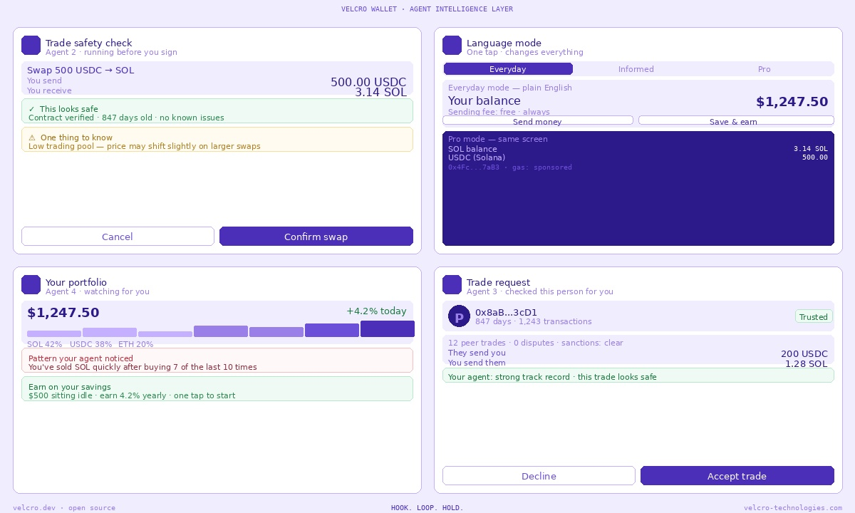
Velcro Wallet — four AI agent screens: Trade Safety, Language Toggle, Portfolio Intelligence, P2P Counterparty Trust.

