Software Requirements Specifications

Version 1.0

<annotated version>

May 8,2021

Website to sells laptops

Lara Rahmaa

Maha Almouie

<<any comment inside double brackets such as this are not part of SRS but are comments upon this SRS example to help the reader understand the point being made >>

Table of contents

1. Introduction

1.1-Purpose

1.2- scope of projec

1.3-Glossary

1.4- References

1.5-over of documet

2.0-Overall description

2.1-System Environment

2.2-Functional Requirements Specifications

2.2.1-Customer use case

Use case:display standard Computer

Configuration

Use case:Build Computer Configuration

Use case:Request Selsperson contact

Use case:submit the application form

2.2.2- Selsperson use case

Use case:Contact with costumer

Use case:Confirm order from store

Use case:Submit the invoice to costumer

2.3- Use Characteristics

2.4- Non-functional Requirements

3.0- Requirements Specifications

3.1- External Interface Requirements

3.2- Functional Rrequirements

3.3- Detailed Non-financial Requirements

3.3.1- Logical Structure of the data

3.3.2- Security

List of Figures

Figure 1-System Environment

Figure 2- Costumer use case

Figures 3- Selsperson use case

Figure 4- Logical Structure of Selsperson data

1. Introduction

1.1-Purpose

the purpose of this document is to present a detailed description of the website to sells laptops. It will explain the purpose and futures of the website, the Interfaces of the website, what the website will do ,the constraints under which it must operate and how the website will react with costumers .This documet is intended for developers and store owners.

1.2-scope of project

The site will provide a web page for customers to use in order to order computers or to build computers with a more suitable assortment,

Or in order to communicate with the sales representative to explain some details and then approve the request and fill out a form that includes shipping information.

6The site contains a relational database that includes the devices in the store and their specifications,

And parts from which the user can build new and appropriate combinations.

1.3-Glossary

|  |  |
| --- | --- |
| Term | Defination |
| Active Actor | Everyone interacts  With website in some way |

1.4-References

IEEE .IEEE Std 830-1998 Recommended Practice for Software Requirements Specifications. Computer Socity,1998.

1.5-Overview of documet

The next chapter, the Overall Description Section, of this document gives an overview of the functionality of the website .it describe the Functional and non-financial Requirements, and is used to establish context for Requirements Specifications in the next chapter.

The third chapter, Requirements Specifications Section, of this document, is written primarily for developers ,and describe precisely functionality of the website.

Both Section of the documet, describe the entire site,but are intended for different audiences.

2.0-Overall Description

2.1-System Environment

Figure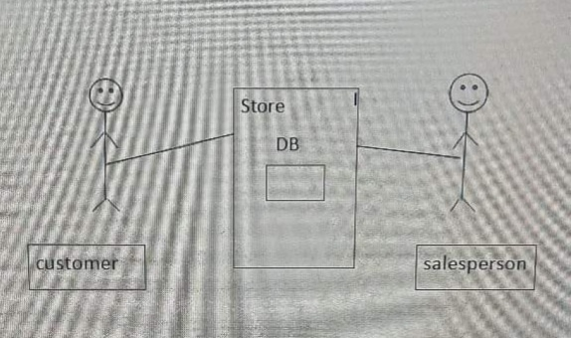 1 System Environment

The website has two active Actors and one cooperating system. The costumer accesses the website through internet

The Selsperson accesses the entire website directly.

2.2- Functional Requirements Specifications

This section outlines the use cases of each active actors separately.

2.2.1-Customer use case:

The customer has the following set of use cases:

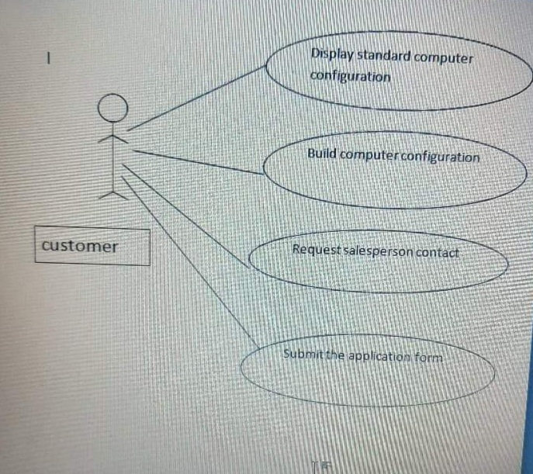

Figure 2 Customer use case

Brief description:

The customer enters the site in order to search for and sell a computer with suitable specifications.

Initial step by step description:

Before this use case begins the customer has already arrived at the website.

1. Customer display standard Computer configuration in store.
2. The customer asks to create a more suitable computer configuration.

3- The customer requests to communicate with the Selsperson

4-Fill out the application form

2.2.2- Selsperson use case:

The Selsperson has the following set of use cases:

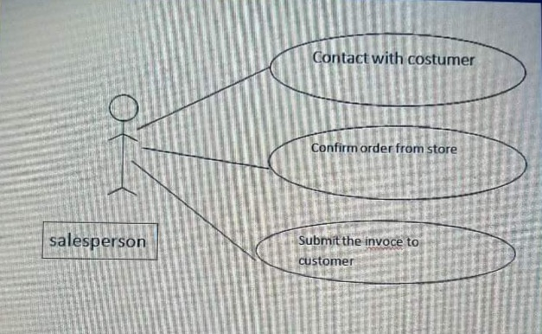

*Figure 3 Selsperson use case*

Brief description:

Facilitate and update store purchases.

Initial step by step description:

Before this use case starts, the Selsperson is directly on the site.

1. Selsperson contact with costumer.
2. Confirm order from store.
3. Send invoice to costumer.

*2.3- User Characteristics:*

It is assumed that the customer is aware of the Internet and is able to deal with the sites easily.

The Selsperson and the customer are expected to be familiar with the Windows system, and to be able to use buttons and drop-down menu.

*2.4- Non-financial Requirements:*

The website is required to be on a server with high speed internet access.

The Selsperson will work on a computer that has an access database. Access is already installed on this computer and a Windows operating system.

*3.0-Specifications Requirements*

*3.1- External Interfaces Requirements:*

The only link to an external system is to link to the store database to verify existing devices.

The site required the customer to complete the request to enter the e-mail address and name.

3.2- Functional Requirements:

3.2.1- Display standard Computer configuration.

|  |  |
| --- | --- |
|  |  |
| Use case name | Display standard Computer configuration |
| Trigger | Customer entires the site |
| Precondition | Search of the website and log into |
| Basic path | 1.customer log into website  2.costomer request to display standard Computer configuration in store  3.display standard Computer configuration |
| Post condition | Ensure that there are configurations in the store to display |
| Alternative path | User may abandon the display process at any time |

*3.2.2- Build Computer configuration:*

|  |  |
| --- | --- |
|  |  |
| Use case name | Build Computer configuration |
| Trigger | Costumer entire website |
| Precondition | Costumer accesses the main screen of website |
| Basic path | 1.display pieces in store to build configuration  2.confirm pieces  3. build configuration |
| Post condition | Make sure of ability to build a new configuration |
| Alternative path | Customer can abandon the process at any time |

3.2.3- Request contact with Selsperson:

|  |  |
| --- | --- |
|  |  |
| Use case name | Request contact with Selsperson. |
| Trigger | True access to website . |
| Precondition | Customer access to the main screen of website |
| Basic path | 1.customer send request to contact with Selsperson  2. The contact between customer and Selsperson is done  3.explain detail about devices  4.contact finished |
| Post condition | Define method of communication |
| Alternative path | Customer can destroy the contact at any time |

3.2.5- contact with customer:

|  |  |
| --- | --- |
|  |  |
| Use case name | Contact with customer |
| Trigger | Confirm information of communication |
| Precondition | Send request to contact |
| Basic path | 1.customer send request to contact with Selsperson  2.confirm information and method to contact  3. establish contact |
| Post condition | Update information of communication |

3.2.6-Confirm order from store:

|  |  |
| --- | --- |
|  |  |
| Use case name | Confirm order from store |
| Trigger | Customer send order |
| Precondition | Contact Selsperson with store |
| Basic path | 1.order arrived from customer to Selsperson  2.selsperson communicate with store to check on order  3. Confirm the order |
| Post condition | Communication between Selsperson and customer |

3.2.7- Send invoice to costumer

|  |  |
| --- | --- |
|  |  |
| Use case name | Send invoice to costumer |
| Trigger | Confirm order |
| Precondition | Communication between Selsperson and customer |
| Basic path | 1.confirm order in store  2.send invoice from store to Selsperson  3.send invoice from Selsperson to costumer |
| Post condition | Updated information of communication |

3.3- Detailed Non-financial Requirements:

3.3.1- Logical Structure of the data:

The Logical Structure of the data to be stored in the store.

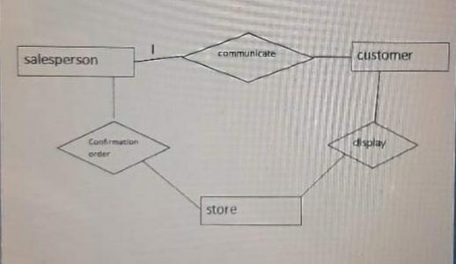

Figure 4 Logical Structure of Selsperson data

The data description of each of these data entities is as follows :

Selsperson data entity:

|  |  |  |  |
| --- | --- | --- | --- |
| Data item | Type | Description | Comment |
| Name | Text | Selsperson name |  |
| Id | Integer | Selsperson number in a set of Selspersons | Used as key |

Customer data entity:

|  |  |  |
| --- | --- | --- |
| Data item | Type | Description |
| Name | Text | Main customer name |
| E-mail | Text | Address on the internet |

Store data entity:

|  |  |  |
| --- | --- | --- |
| Data item | Type | Description |
| Name | Text | Main store name |
| Content | Text | Contents of store |

3.3.2-Security

The server on which the website will have its own security to prevent hacking.

The pc on which the Selsperson resides will have its own security.