MSIT 5910 Capstone
Written Assignment Unit 3

University of the People
MSIT 5910 Written Assignment Unit 3

April 25, 2026

Document 1: System Architecture and Git Strategy
1. System Architecture Blueprint
The ParkinSync architecture is a cloud-native, serverless pipeline designed for the asynchronous ingestion and processing of medical logs. The design prioritizes decoupling, where the storage layer (Amazon S3) and the compute layer (AWS Lambda) interact through event-driven triggers. This ensures that the system scales automatically based on the volume of caregiver uploads without requiring manual intervention. As described by Walker (2022), the event-driven architecture pattern provides high scalability and flexibility by allowing components to remain decoupled, which is essential for handling unpredictable data bursts in modern distributed systems.
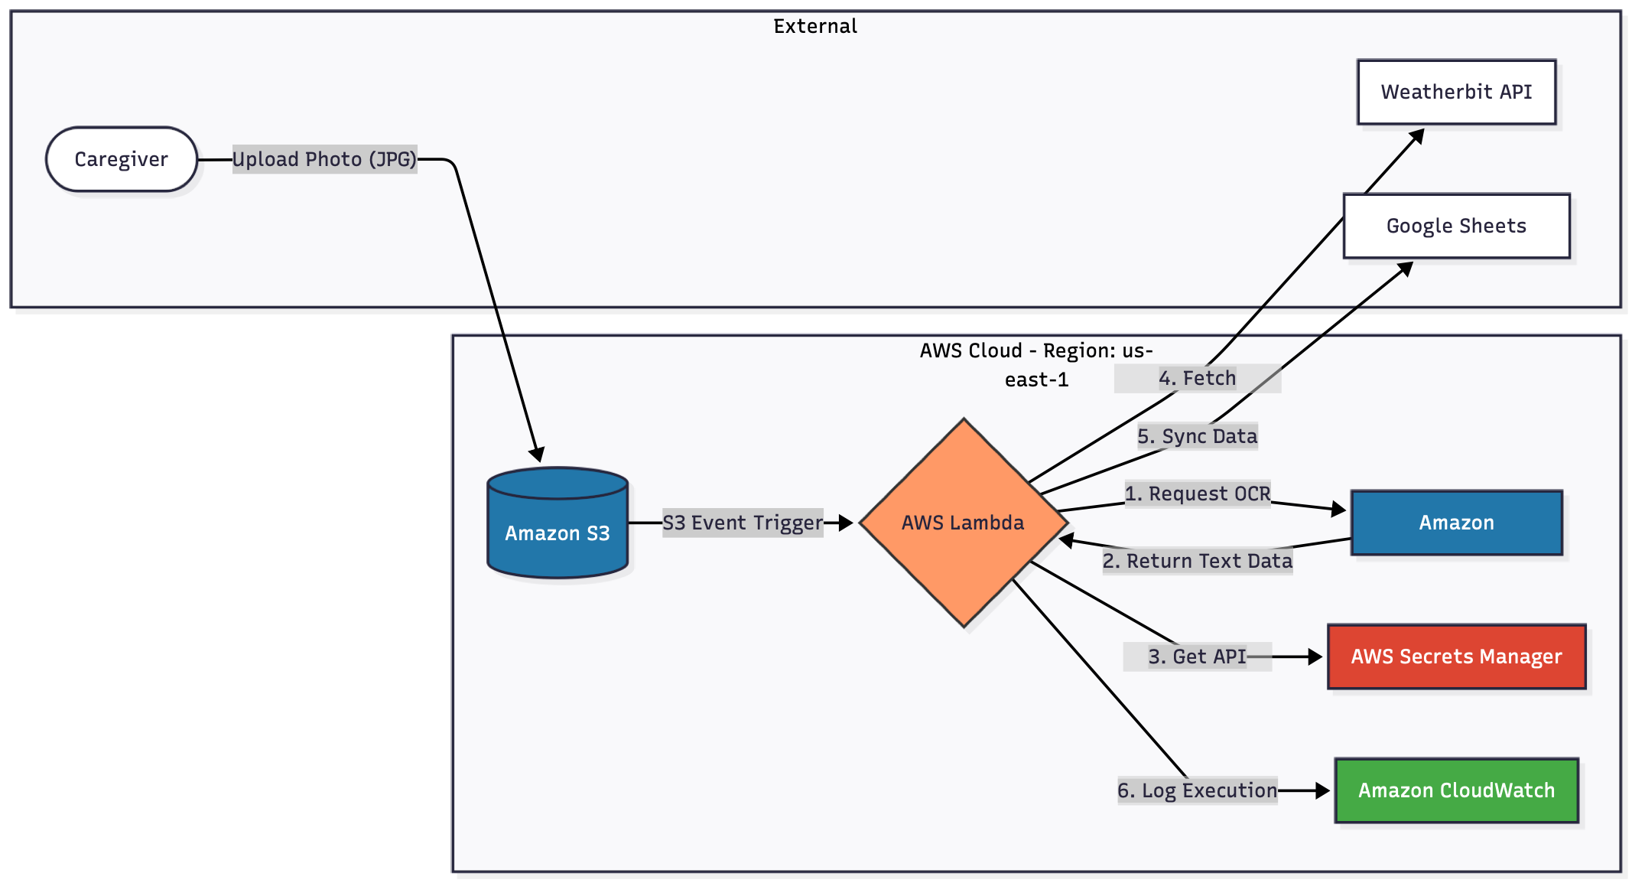
The decision to adopt a serverless model is a strategic response to the "Software Crisis" outlined by Davies (2024), where the complexity of maintaining traditional infrastructure often leads to project delays and operational overhead. By leveraging managed services, the project minimizes the operational burden and focuses on solving the core problem: the translation of analog medical records into actionable digital insights for Parkinson’s Disease (PD) management in rural environments.

2. Module-wise Breakdown
Module A: Data Ingestion and Event Triggering
- Input: Caregiver-uploaded log images (JPEG/PNG) and scanned documents (PDF).
- Methodology: Utilizing S3 Event Notifications. Upon a successful PUT operation in the parkinsync-raw-data-useast1 bucket, an event object is generated.
- Output: Trigger signal containing the S3 bucket name and object key for the Lambda function.
- Rationale: Supporting PDF format is essential for inclusivity.

As noted by Letaw (2024) in the context of Inclusivity Heuristics, systems should accommodate various user habits and tools. Supporting multiple file formats ensures that home-care settings using diverse mobile scanning apps can participate without friction.

Module B: Intelligent Extraction Engine (OCR)
- Methodology: AWS Lambda invokes the AnalyzeDocument API of Amazon Textract. This module specifically utilizes the "TABLES" and "FORMS" features to preserve structural integrity.
- Input: Raw image/PDF data retrieved from S3.
- Output: Structured JSON containing extracted key-value pairs.
- Rationale: The structural integrity of the caregiver’s handwritten grid must be preserved to ensure that "Medication Time" is correctly mapped to the specific day and dose.

Davies (2024) emphasizes that rigorous Design (such as UML sequence diagrams and clear API documentation) is necessary to ensure that complex data flows remain reliable and maintainable.
Module C: Contextual Data Integration (Yabu City Micro-Climate)
- Methodology: Integration of the Weatherbit API to perform RESTful GET requests using coordinates for Oya-cho, Yabu City (35.34, 134.72).
- Input: Latitude and Longitude.
- Output: Real-time meteorological data (Temperature and Humidity).
- Contextual Significance: Yabu City's severe winter cold can exacerbate PD motor fluctuations.
By tracking environmental factors alongside "Movicol" frequency (for gut motility), the system can analyze correlations between medication absorption, climate, and symptoms.

Future Scalability and Generalization: While the current prototype is specifically configured with hardcoded coordinates for Oya-cho, Yabu City (35.34, 134.72) to serve a specific clinical case, the architecture is designed for future generalization. To accommodate users in different geographical regions, the next iteration will implement a User Profile Management layer using Amazon DynamoDB.

In this upcoming phase, the system will dynamically retrieve the latitude and longitude based on the unique User ID associated with the S3 upload. This shift from a "hardcoded" approach to a "data-driven" approach aligns with the Software Engineering principle of Scalability (Walker, 2022), ensuring that ParkinSync can be deployed for Parkinson's patients globally without requiring manual source code modifications for each new user.

Module D: Database Synchronization
- Methodology: Google Sheets API v4 via a Service Account for server-to-server authentication.
- Output: A new record appended to the master care log.
- Rationale: This ensures clinical data is accessible to family members in a familiar interface, supporting the transparency of the care process.

3. Functional and Non-Functional Requirements
Functional Requirements (FR)
- FR-1: Structured Handwriting Extraction: Convert handwritten logs into digital data with at least 90% accuracy.
- FR-2: Micro-Climate Correlation: Fetch humidity and temperature for Oya-cho for trend analysis.
- FR-3: Automated Synchronization: Ensure data is appended to the cloud spreadsheet within 60 seconds of upload.

Non-Functional Requirements (NFR)
As emphasized by Letaw (2024), defining clear Requirements (including non-functional ones) is a critical phase in software engineering to ensure the system meets its operational goals.
- NFR-1: Security (Zero Hardcoding): All API keys must be stored in AWS Secrets Manager to prevent credential leakage.
- NFR-2: Reliability: Maintain 99.9% availability using AWS serverless primitives.
- NFR-3: Cost-Efficiency: Operation must remain within the AWS Free Tier ($0/month target) for long-term sustainability.

4. Ethics and Data Sovereignty
A significant ethical consideration for ParkinSync is the storage of sensitive family health data in a public cloud. While the system does not perform autonomous medical "interventions" (such as changing medication doses), the potential for data misuse is addressed through encryption-at-rest. The project respects Data Sovereignty, meaning the family retains full ownership of the data. The use of a serverless architecture also means that the "attack surface" is minimized compared to a traditional server, fulfilling the ethical duty of "Non-maleficence" by protecting the patient from data breaches.

5. Version Control and Traceability
The project employs a Git-based workflow. Letaw (2024) highlights that version control systems like Git support Teamwork and Accountability by providing a clear history of changes and enabling collaborative development.
- Repository URL: https://github.com/larai-w/ParkinSync.git
- Branching Strategy: A two-branch model (Main for production, Development for iteration ).
- Traceability: Major design decisions (e.g., region selection for Textract features) are documented via descriptive commit messages, providing a transparent audit trail.

References
Davies, S. (2024). Blueprints: Creating, describing, and implementing designs for larger-scale software projects (Version 2.5). University of Mary Washington. https://open.umn.edu/opentextbooks/textbooks/blueprints-creating-describing-and-implementing-designs-for-larger-scale-software-projects-davis
Letaw, L. (2024). Handbook of software engineering methods. Oregon State University. https://open.oregonstate.education/setextbook/
Walker, V. (2022, March 16). 14 software architecture design patterns to know. Red Hat. https://www.redhat.com/en/blog/14-software-architecture-patterns

