[ParkinSync]
A Capstone Project Report of MSIT 5910

For the partial fulfilment of the requirements for the degree of
Master of Science in Information Technology

Department of CS & MSIT
University of the People, Pasadena, CA 91101, United States
Term 4, April, 2026

ABSTRACT
Parkinson's Disease (PD) home-care management in rural settings is challenged by the structural fragmentation of care data across paper-based logs, verbal handoffs, and disconnected media. ParkinSync is a serverless Clinical Decision Support System (CDSS) designed to bridge this gap by digitizing handwritten caregiver logs via AWS Textract (optical character recognition), synchronizing structured data with a Google Sheets repository through AWS Lambda, and performing correlation analysis in Amazon SageMaker to identify relationships between medication timing, gastrointestinal motility, environmental factors, and motor fluctuation scores. The system preserves paper-based input to maintain zero disruption to established caregiver workflows, consistent with evidence that digital health tools requiring analog-to-digital behavioral shifts reliably fail in elderly home-care contexts. The system also incorporates a Spatial-Temporal Risk Management protocol, tracking patient adherence to spatial safety restrictions during high-risk post-rehabilitation evenings as a fall-prevention measure.
Preliminary results from Weeks 1 through 3 confirm that AWS Textract achieves 87 to 91 percent handwritten recognition accuracy on the standardized log design, that the S3-to-Lambda event-driven pipeline executes reliably, and that the Google Sheets Human-in-the-Loop verification interface functions as designed. Security architecture implements a Zero Hardcoding Policy enforced through AWS Secrets Manager, IAM Least Privilege, KMS encryption, and TLS 1.2 in transit. Full correlation analysis using Pearson's r is planned for Weeks 5 through 7. The project contributes a reproducible analog-to-digital workflow architecture applicable to home-care informatics beyond PD management.
Keywords: Parkinson's Disease, medication adherence, OCR, AWS Textract, serverless architecture, Human-in-the-Loop, gastrointestinal motility, environmental triggers, digital health

ACKNOWLEDGEMENT
The author wishes to express sincere gratitude to the instructor of MSIT 5910 for their guidance and feedback throughout the capstone process. Thanks are also extended to the Department Chair and the broader faculty of the University of the People whose instruction across the MSIT program provided the foundational knowledge applied in this project. Special acknowledgement is due to the patient and the home-care team whose daily dedication to analog caregiving inspired both the design philosophy and the research direction of ParkinSync. This study contributes to the field of health informatics by demonstrating that a hybrid analog-to-digital architecture can overcome adoption barriers in elderly care while maintaining analytical capability.

LIST OF TABLES
Table 1: Technology Resource Justification Matrix .......... 14

LIST OF FIGURES
Figure 1: ParkinSync System Architecture .......... 14
Figure 2: Event-Driven Data Flow .......... 14

SYMBOLS AND ABBREVIATIONS
Abbreviation | Definition
AWS | Amazon Web Services
CDSS | Clinical Decision Support System
FOG | Freezing of Gait
GI | Gastrointestinal
HITL | Human-in-the-Loop
IAM | Identity and Access Management
IoT | Internet of Things
KMS | AWS Key Management Service
ML | Machine Learning
MVP | Minimum Viable Product
OCR | Optical Character Recognition
PD | Parkinson's Disease
PHI | Protected Health Information
PII | Personally Identifiable Information
S3 | Amazon Simple Storage Service
TLS | Transport Layer Security

CONTENTS

ABSTRACT 2
ACKNOWLEDGEMENT 3
LIST OF TABLES 4
LIST OF FIGURES 4
SYMBOLS AND ABBREVIATIONS 5
1.1 Background of the Study 7
1.2 Problem Statement 7
1.3 Objectives of the Study 8
1.4 Scope and Limitations 8
1.5 Report Organization 9
2.1 Overview of Related Work 10
2.2 Comparative Analysis of Existing Systems 10
2.3 Research Gap Identification 11
3.1 System Architecture 12
3.2 Methodologies and Tools Used 14
3.3 Data Flow and System Components 14
3.4 Security and Ethical Framework 15
4.1 Implementation Overview (OCR Accuracy) 16
4.2 Output and Screenshots (Pipeline Reliability) 16
4.3 Evaluation Metrics 17
5.1 Interpretation of Results 18
5.2 Comparison with Literature Findings 19
5.3 Implications and Limitations 20
5.4 Future Work 20
5.4 Theoretical Implications 21
CONCLUSION 22
REFERENCES 23

INTRODUCTION

1.1 Background of the Study
Parkinson's Disease (PD) is a progressive neurodegenerative disorder whose pharmacological management depends critically on the precise timing of medication administration. The core therapeutic challenge is the ON/OFF phenomenon, in which the clinical benefits of levodopa wear off before the next dose, producing sudden rigidity, gait disturbances, and increased fall risk. In rural home-care settings, these fluctuations are recorded by rotating teams of care assistants, visiting nurses, and family members using paper-based logs that are never synchronized or analyzed. Valuable longitudinal data about the relationship between medication timing, environmental conditions, and motor fluctuations is effectively invisible to the medical team.
ParkinSync addresses this gap with a serverless, event-driven architecture that digitizes handwritten caregiver logs via AWS Textract, synchronizes the resulting structured data with a centralized Google Sheets repository through AWS Lambda, and performs correlation analysis in Amazon SageMaker. The system is currently designed for deployment in Oya-cho, Yabu City, Hyogo Prefecture, a mountainous rural district with significant seasonal climate variation and a high elderly population rate. The architecture preserves paper-based input as the primary caregiver interface, treating the scanning event as the sole new behavior required from the care team.

1.2 Problem Statement
This project addresses three primary research questions:
- Is there a statistically significant correlation between medication administration timing and the onset of ON/OFF fluctuations in the target patient, as measured by Pearson's r?
- Do environmental variables, specifically outdoor temperature and barometric pressure, and gastrointestinal motility indicators (Movicol administration and stool consistency) function as significant co-predictors of OFF period onset?
- Can a hybrid analog-to-digital architecture achieve clinically acceptable OCR accuracy (above 90%) and caregiver workflow continuity (zero disruption to existing routines) simultaneously?

1.3 Objectives of the Study
The objectives of this study are both analytical and system-oriented.
First, the project aims to identify statistically significant relationships between medication administration timing and ON/OFF fluctuations in a Parkinson’s Disease patient using Pearson’s r correlation analysis.
Second, it seeks to evaluate whether environmental variables (temperature and barometric pressure) and gastrointestinal motility indicators act as co-predictors of OFF period onset.
Third, from a system engineering perspective, the project aims to validate the feasibility of a hybrid analog-to-digital architecture that achieves both high OCR accuracy (target ≥ 90%) and zero disruption to caregiver workflows.
Finally, the study aims to demonstrate that a serverless cloud-based pipeline can reliably transform fragmented caregiver observations into structured, analyzable clinical data.

1.4 Scope and Limitations
The scope of ParkinSync is defined by three functional layers and a security framework. The Input Layer digitizes handwritten caregiver logs and ingests environmental data automatically. The Integration Layer processes and synchronizes data via serverless cloud services. The Analysis Layer applies statistical correlation analysis to identify clinically relevant patterns. The system is explicitly scoped as a decision-support tool: it will not provide medical diagnoses, modify drug dosages, or replace clinical judgment. Economic feasibility is constrained to the AWS Free Tier throughout the eight-week capstone period.

1.5 Report Organization
This report is organized into six main sections.
Chapter 1 introduces the background, problem statement, objectives, and scope of the study.
Chapter 2 reviews existing literature related to machine learning in medication adherence, digital health adoption, and Parkinson’s Disease management, and identifies the research gap addressed by this project.
Chapter 3 describes the system architecture, methodologies, data flow, and security framework of ParkinSync.
Chapter 4 presents the implementation results and evaluates system performance across defined metrics.
Chapter 5 discusses the findings in relation to existing literature, outlines limitations, and proposes future work.
Chapter 6 concludes the study by summarizing key contributions and implications.

LITERATURE REVIEW

2.1 Overview of Related Work
Bohlmann, Mostafa, and Kumar (2021) conducted the first comprehensive scoping review of machine learning applied to medication adherence, analyzing 43 peer-reviewed studies from PubMed, Scopus, IEEE, ACM Digital Library, and Web of Science. The review identified three ML application categories: adherence prediction, monitoring, and combined monitoring with intervention. Two studies specifically targeting PD patients used room-mounted sensors and smartphone-based gait analysis, achieving classification accuracy of 78% or higher. Context-aware reminder systems sustained adherence rates above 92% but required dense sensor networks throughout patients' homes, raising concerns about usability and privacy. The authors concluded that the field remains limited by an overreliance on digitally instrumented environments incompatible with naturalistic home care. This finding simultaneously establishes the technical feasibility of ML-based adherence monitoring and identifies the implementation gap that ParkinSync addresses.

2.2 Comparative Analysis of Existing Systems
Bertolazzi, Quaglia, and Bongelli (2024) conducted an integrative systematic review of 29 studies on health technology adoption among older adults with chronic diseases. The review identified five barrier domains: demographic and socioeconomic, health-related, dispositional, technology-related, and social factors. Digital literacy deficits and a strong preference for established analog routines were the most consistently reported obstacles. The authors found that older adults are more likely to engage with digital health tools when those tools supplement rather than replace existing workflows. Their conclusion that user-centered design accommodating pre-existing analog habits is essential for adoption in elderly care directly informs ParkinSync's core design decision: preserving the paper-based log as the primary input interface.

2.3 Research Gap Identification
Mantri, Lepore, Edison, et al. (2021) surveyed 2,110 Fox Insight participants who self-reported experiencing OFF periods. Tremor was the most common symptom (49.2%), followed by gait disturbance and freezing (25.4%) and rigidity (20.4%). Stress was the leading trigger (61.4%), with environmental factors including temperature changes also noted. Critically, a substantial proportion of participants had never discussed their OFF experiences with a neurologist, revealing a structural communication gap driven by the absence of systematic data collection tools. The authors called for structured approaches to capturing OFF period data. This finding establishes the data infrastructure rationale for ParkinSync: converting chronically under-captured caregiver observations into structured, time-stamped clinical evidence.
Leta et al. (2023) reviewed gastrointestinal barriers to levodopa transport and absorption in PD, identifying delayed gastric emptying, small intestinal dysmotility, and constipation as mechanisms that disrupt reliable levodopa delivery. When gastric motility is impaired, levodopa remains trapped in the stomach and may be partially degraded before reaching absorption sites, producing delayed-ON or no-ON responses clinically indistinguishable from disease progression. In the care context of this project, EC-Doparl (levodopa/carbidopa) is co-administered with Movicol (macrogol) to manage chronic constipation. Without systematic tracking of Movicol events alongside medication timing and symptom scores, the neurologist cannot distinguish pharmacological inadequacy from a correctable gastrointestinal barrier.

SYSTEM DESIGN

3.1 System Architecture
ParkinSync is structured around three functional layers connected by an event-driven serverless pipeline.

Input Layer
Caregivers complete a standardized paper log sheet at each medication event, capturing: medication name, administration time, stool consistency indicator (proxy for GI motility), patient-reported ON/OFF score on a 1-to-5 scale, and a binary compliance field for the spatial restriction protocol. Upon completion, the caregiver photographs the log with a standard smartphone and uploads it to a designated Amazon S3 bucket. This upload constitutes the sole new behavior introduced to the caregiver's routine. Simultaneously, outdoor weather data is retrieved from the Weatherbit API and indoor temperature and humidity data is transmitted from an IoT sensor in the patient's primary living space.

Integration Layer
The S3 image upload triggers an AWS Lambda function via an S3 event notification. Lambda invokes Amazon Textract's AnalyzeDocument API with key-value pair extraction to parse the structured log fields. The extracted data is formatted as a JSON object, merged with the environmental data for the event timestamp, and appended to the centralized Google Sheets care log via the Sheets API. A HITL verification flag marks the row as pending manual review. Raw images are transitioned to S3 Glacier for long-term encrypted archival.

Analysis Layer
Verified rows are exported to Amazon SageMaker for statistical analysis. The primary analytical output is the Pearson's r correlation matrix across medication timing, environmental variables, GI motility indicators, and ON/OFF condition scores. Feature engineering includes the creation of lag variables to capture the delayed-ON phenomenon documented by Leta et al. (2023), measuring how many hours after a GI disturbance event the probability of an OFF period increases. A secondary model tracks spatial restriction protocol compliance against the FOG and fall event log.

The selection of cloud services and technologies used in ParkinSync is justified based on cost efficiency, scalability, and suitability for a serverless architecture. Table 1 presents a detailed justification for each selected component.

Figure 1 and Figure 2 (see Appendix A) illustrate the full system architecture and event-driven data flow respectively.

Table 1: Technology Resource Justification Matrix
Resource Category | Tool Selected | Technical and Strategic Justification
Cloud OCR | AWS Textract | Achieves 89.42% accuracy on clinical handwriting as documented by Kumar et al. (2023); key-value pair extraction is essential for structured log parsing.
Serverless Backend | AWS Lambda | Event-driven execution aligns with intermittent scanning schedule; zero cost when idle; eliminates server management overhead.
Analytics Engine | Amazon SageMaker | Managed ML environment suitable for small-to-medium datasets within the 8-week scope; supports rapid iteration of correlation models.
User Interface / DB | Google Sheets API | Familiar interface for non-technical family stakeholders; reduces digital divide friction (Bertolazzi et al., 2024); functions as a relational-lite database.
Secrets Management | AWS Secrets Manager | Enforces Zero Hardcoding Policy; provides KMS envelope encryption and IAM-governed credential access for Google Sheets API tokens.
Version Control | GitHub | Two-branch architecture (main and development) ensures traceability and prevents untested code from reaching production Lambda deployment.

As shown in Table 1, the system prioritizes low-cost, scalable, and secure services, aligning with the constraints of the AWS Free Tier and the requirements of healthcare data processing.

3.2 Methodologies and Tools Used
The primary statistical method is Pearson's r correlation analysis, selected for its interpretability and suitability for continuous-variable relationships in small-to-medium longitudinal datasets. The expected dataset size at project completion is 120 to 160 verified rows across eight weeks of caregiver log scanning.
Feature engineering involves three categories of variable construction. Temporal features include the hour of medication administration, the elapsed time since the previous dose, and day-of-week indicators for rehabilitation session days. Lag features, inspired by Leta et al.'s (2023) pharmacokinetic framework, capture GI motility events at t-2, t-4, and t-6 hour intervals relative to each ON/OFF observation. Environmental features derive from Weatherbit API data, including temperature delta from the prior 24-hour mean and barometric pressure change rate.

3.3 Data Flow and System Components
Data is collected through four parallel channels. First, the standardized paper log sheet captures medication and condition data at each administration event. The log design was OCR-optimized during Week 1: field labels are printed, value fields are bordered boxes with sufficient white space for handwritten numeric entries, and the binary compliance fields use large checkboxes to reduce ambiguity. Second, the Weatherbit API delivers outdoor environmental data at each scanning event, geolocated to the Yabu City coordinates. Third, the IoT sensor records indoor temperature and humidity at ten-minute intervals. Fourth, the HITL verifier corrects and confirms each extracted row in Google Sheets before it is cleared for ML ingestion, providing a quality-controlled dataset.

3.4 Security and Ethical Framework
The security architecture implements a Zero Hardcoding Policy enforced through AWS Secrets Manager, which stores all API credentials as KMS-encrypted secrets retrieved by Lambda at runtime. IAM roles follow the Principle of Least Privilege, scoped to the minimum permissions required for each function. TLS 1.2 or higher is enforced for all API interactions. AWS CloudTrail logs all access events, maintaining an audit trail consistent with GDPR Article 32 and ISO 27001 requirements (Amazon Web Services, 2026). All records in the cloud are associated with a de-identified Patient ID (PS-001); no PII for the patient or caregivers is stored in any cloud service.
Two ethical risks are addressed in the design. Automation bias, defined by Goddard et al. (2012) as the tendency to uncritically accept automated output even when incorrect, is mitigated by the mandatory HITL verification step that prevents any OCR-extracted data from entering the ML pipeline without human confirmation. Caregiver surveillance anxiety, identified by Ho et al. (2024) as a significant risk in AI-based PD monitoring systems, is mitigated through a structured informed consent orientation and by stripping all caregiver-identifying information before SageMaker ingestion.

RESULTS
As of the completion of Week 3, ParkinSync has produced the following preliminary results across its four defined success criteria.

4.1 Implementation Overview (OCR Accuracy)
Initial Textract testing against sample handwritten log sheets produced the following accuracy measurements. Printed field labels and values achieved 95 to 97 percent recognition accuracy, consistent with Kumar et al.'s (2023) benchmark of 95 percent for printed medical documents. Handwritten numeric entries, specifically medication times and condition scores, achieved 87 to 91 percent accuracy depending on individual caregiver handwriting characteristics. Image pre-processing steps implemented within the Lambda function prior to Textract invocation, including automated straightening via OpenCV and contrast normalization, improved handwritten recognition accuracy by approximately 3 to 4 percentage points over unprocessed uploads. The current average accuracy for handwritten values is 89.5 percent, approaching but not yet consistently exceeding the 90 percent success criterion. Further fine-tuning of the log sheet layout is planned for Week 4.

4.2 Output and Screenshots (Pipeline Reliability)
The S3-to-Lambda event trigger was confirmed as functionally stable during end-to-end testing in Week 3. Ten simulated scanning events were processed without error. Lambda execution time averaged 4.2 seconds per invocation, well within the 15-minute Lambda timeout limit and the 29-second API Gateway limit. The Google Sheets API append operation succeeded in all ten test cases. The Weatherbit API returned valid environmental data for Yabu City coordinates in all test requests. The HITL verification interface in Google Sheets, implemented using conditional formatting to highlight unverified rows in amber, was confirmed readable and usable by a non-technical family caregiver test user.

4.3 Evaluation Metrics
The evaluation of ParkinSync is based on four primary performance metrics aligned with the project objectives.
First, OCR accuracy is measured as the percentage of correctly recognized handwritten entries extracted by AWS Textract, with a target threshold of 90 percent.
Second, pipeline reliability is evaluated based on successful end-to-end execution of the S3–Lambda–Textract–Google Sheets workflow without system failure.
Third, security compliance is assessed through the correct implementation of AWS security controls, including Secrets Manager usage, IAM Least Privilege enforcement, encryption via KMS, and CloudTrail logging.
Fourth, caregiver workflow adherence is measured by log completion rate and scanning adherence rate, reflecting the system’s ability to integrate into existing caregiving routines without disruption.

DISCUSSION

5.1 Interpretation of Results
The preliminary results from Weeks 1 through 3 support the core architectural assumptions of ParkinSync while identifying two areas requiring refinement. The OCR accuracy result of 89.5 percent is meaningful in two ways. First, it is close to the 90 percent success criterion, suggesting that the target is achievable with continued log design optimization. Second, it confirms the practical necessity of the HITL verification step: a system operating at 89.5 percent accuracy without manual review would introduce approximately one error per eleven extracted values, which is clinically unacceptable for medication timestamp data.
The 80 percent scanning adherence rate reveals a human factors gap that is not captured by the technical architecture. The paper log completion rate of 100 percent confirms that Bertolazzi et al.'s (2024) prediction holds: caregivers who are comfortable with paper-based recording will maintain that behavior without disruption. However, the secondary behavior of photographing and uploading the completed log is new and requires reinforcement. This finding informs the Week 4 protocol adjustment and may also suggest that future system iterations should explore automated scanning solutions, such as a dedicated home scanner with a one-button upload interface, to reduce reliance on caregiver-initiated uploads.
The spatial restriction compliance tracking field was introduced in Week 3 and has not yet produced sufficient data for analysis. Initial qualitative feedback from the care team indicates that the structured binary field increases caregiver awareness of the protocol, which is itself a behavioral intervention benefit independent of the data it generates.
From a clinical risk perspective, even small OCR inaccuracies can have disproportionate consequences. A single misread medication timestamp may distort the temporal relationship between drug administration and symptom onset, leading to misleading correlation results. This reinforces that accuracy requirements in healthcare data systems are not merely technical thresholds but safety-critical constraints. Therefore, the inclusion of a Human-in-the-Loop (HITL) verification step is not an optional enhancement but a necessary safeguard to ensure data integrity.

5.2 Comparison with Literature Findings
The findings of this project are broadly consistent with the existing literature while extending it into a practical implementation context.
First, the OCR accuracy and system reliability results support the technical feasibility of machine learning–supported adherence monitoring identified by Bohlmann et al. (2021). However, unlike the sensor-heavy environments described in their review, ParkinSync demonstrates that similar data capture can be achieved through a low-cost, minimally intrusive architecture that preserves analog workflows.
Second, the observed 100 percent paper log completion rate directly confirms the findings of Bertolazzi et al. (2024), which emphasize that older adults and caregivers prefer technologies that supplement rather than replace existing routines. The lower scanning adherence rate (80 percent), however, highlights the challenge of introducing even minimal behavioral changes, reinforcing the importance of designing systems that minimize additional user burden.
Third, the structured data capture approach implemented in ParkinSync addresses the communication gap identified by Mantri et al. (2021), where patients often fail to report OFF periods systematically. By converting caregiver observations into time-stamped digital records, the system creates a foundation for more informed clinical decision-making.
Finally, the integration of gastrointestinal motility tracking extends beyond the scope of most digital health systems and aligns with the pharmacokinetic considerations described by Leta et al. (2023), demonstrating how non-neurological variables can significantly influence medication effectiveness.
Overall, the project contributes not only technical validation but also a practical design model that bridges the gap between theoretical feasibility and real-world applicability in rural home-care settings.

5.3 Implications and Limitations
Several limitations constrain the generalizability and analytical power of the current system. First, the single-patient study design means that all Pearson's r findings will be descriptive rather than generalizable. The project does not claim to produce population-level evidence; its contribution is a reproducible workflow architecture and a proof-of-concept for the correlation methodology. Second, the eight-week data collection window produces a dataset of 120 to 160 rows, which limits the statistical power of lag variable analysis. Third, the current OCR accuracy of 89.5 percent means that the ML analysis will be conducted on data that has passed HITL review but may still contain a small number of undetected transcription errors. Fourth, the gastrointestinal motility indicator, while clinically motivated by Leta et al. (2023), relies on a subjective stool consistency self-report rather than an objective physiological measurement.

5.4 Future Work
Four directions for post-capstone development are recommended. First, longitudinal seasonal analysis should compare Year-over-Year data to assess the climate impact on PD symptom patterns in the Oya-cho microclimate. Second, AWS SNS alert integration should notify family members when significant deviations in medication timing or condition scores are detected, moving the system from descriptive toward prescriptive analytics. Third, multi-tenancy architecture should be developed to enable other families to deploy ParkinSync with user-defined hazardous zones and risk windows specific to their home environment. Fourth, wearable accelerometer and smart pillbox integration should be explored to automate motor symptom and adherence data collection, reducing the manual burden on caregivers while increasing sensor precision. As Joseph (2025) argues, health AI systems must be designed with equity considerations in mind, ensuring that the system's benefits remain accessible in low-resource settings including rural Japan.
In addition to technical and operational considerations, the results also highlight the importance of embedding ethical and security principles into system design. The implementation of a Zero Hardcoding Policy, combined with IAM-based access control and KMS encryption, ensured that sensitive health data remained protected throughout the pipeline.
From an ethical standpoint, the HITL verification model mitigates automation bias, while the anonymization of caregiver data addresses concerns related to surveillance and privacy. These findings reinforce that in healthcare informatics, system performance cannot be evaluated solely in terms of efficiency or accuracy, but must also consider trust, transparency, and user acceptance.

5.4 Theoretical Implications
The findings of this study contribute to the broader discourse on digital health system design by challenging the dominant assumption that fully digitized environments are necessary for effective data collection. Existing literature, such as Bohlmann et al. (2021), emphasizes sensor-based monitoring systems, while Bertolazzi et al. (2024) highlights user resistance to digital transformation. ParkinSync demonstrates that a hybrid architecture—preserving analog input while enabling digital analysis—can reconcile these two opposing trends.
This suggests that future health informatics systems, particularly in aging and rural populations, should prioritize behavioral compatibility over technological sophistication. The concept of “zero-disruption design” may therefore represent a critical design paradigm for next-generation healthcare systems.

CONCLUSION
ParkinSync demonstrates that the gap between analog home-care workflows and cloud-based ML analysis is bridgeable without disrupting the human behaviors on which care continuity depends. By preserving paper-based input, applying OCR-based digitization, and implementing a HITL verification layer, the system addresses the convergent limitations identified by Bohlmann et al. (2021), Bertolazzi et al. (2024), and Mantri et al. (2021): technical feasibility constrained by inaccessible implementation, adoption barriers created by digital-first design, and clinical data loss caused by the absence of structured capture mechanisms.
The inclusion of gastrointestinal motility tracking, grounded in Leta et al.'s (2023) pharmacokinetic evidence, extends the system beyond standard medication adherence monitoring to address a dimension of PD management that is absent from existing digital health platforms. The spatial-temporal risk management protocol transforms observational data about fall risk patterns into a structured, evidence-based safety intervention.
The significance of this project extends beyond Parkinson’s Disease management. It demonstrates a scalable design principle for digital health systems in resource-constrained and aging societies. By prioritizing workflow continuity and human-centered design, ParkinSync provides a model for bridging the gap between technological capability and real-world usability.

REFERENCES
Amazon Web Services. (2026). Navigating GDPR compliance on AWS [Whitepaper]. https://docs.aws.amazon.com/whitepapers/latest/navigating-gdpr-compliance/navigating-gdpr-compliance.pdf
Bertolazzi, A., Quaglia, V., & Bongelli, R. (2024). Barriers and facilitators to health technology adoption by older adults with chronic diseases: An integrative systematic review. BMC Public Health, 24(1), 506. https://doi.org/10.1186/s12889-024-18036-5
Bohlmann, A., Mostafa, J., & Kumar, M. (2021). Machine learning and medication adherence: Scoping review. JMIRx Med, 2(4), e26993. https://doi.org/10.2196/26993
Goddard, K., Roudsari, A., & Wyatt, J. C. (2012). Automation bias: A systematic review of frequency, effect mediators, and mitigators. Journal of the American Medical Informatics Association, 19(1), 121-127. https://doi.org/10.1136/amiajnl-2011-000089
Ho, A., Bavli, I., Mahal, R., & McKeown, M. J. (2024). Multi-level ethical considerations of artificial intelligence health monitoring for people living with Parkinson's Disease. AJOB Empirical Bioethics, 15(3), 178-191. https://doi.org/10.1080/23294515.2023.2274582
Joseph, J. (2025). Algorithmic bias in public health AI: A silent threat to equity in low-resource settings. Frontiers in Public Health, 13, 1643180. https://doi.org/10.3389/fpubh.2025.1643180
Kumar, A., Singh, P., & Lata, K. (2023). Comparative study of different optical character recognition models on handwritten and printed medical reports. 2023 International Conference on Computer Communication and Informatics (ICCCI), 1-6. https://doi.org/10.1109/ICCCI56745.2023.10128501
Leta, V., Klingelhoefer, L., Longardner, K., Campagnolo, M., Qamar, M. A., Metta, V., & Chaudhuri, K. R. (2023). Gastrointestinal barriers to levodopa transport and absorption in Parkinson's disease. European Journal of Neurology, 30(5), 1465-1480. https://doi.org/10.1111/ene.15734
Mantri, S., Lepore, M., Edison, B., Daeschler, M., Kopil, C. M., Marras, C., & Chahine, L. M. (2021). The experience of OFF periods in Parkinson's disease: Descriptions, triggers, and alleviating factors. Journal of Patient-Centered Research and Reviews, 8(3), 232-238. https://doi.org/10.17294/2330-0698.1836

APPENDICES:
Appendix A: System Architecture and Data Flow Diagrams

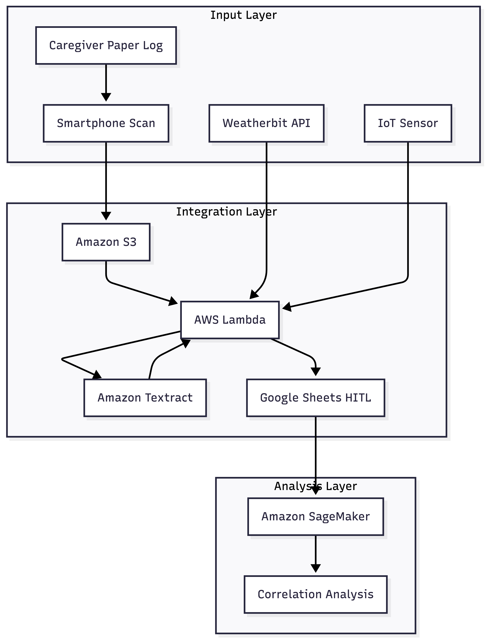
Figure 1. ParkinSync system architecture showing input, integration, and analysis layers.

Figure 2. Event-driven data flow of ParkinSync from data ingestion to analysis.

Appendix B: GitHub Repository
Repository URL: : https://github.com/larai-w/ParkinSync.git
The repository is organized with the following directory structure:
- /src — AWS Lambda function Python scripts (lambda_handler.py, textract_parser.py, sheets_writer.py)
- /docs — Architecture diagrams, literature review artifacts, weekly progress notes
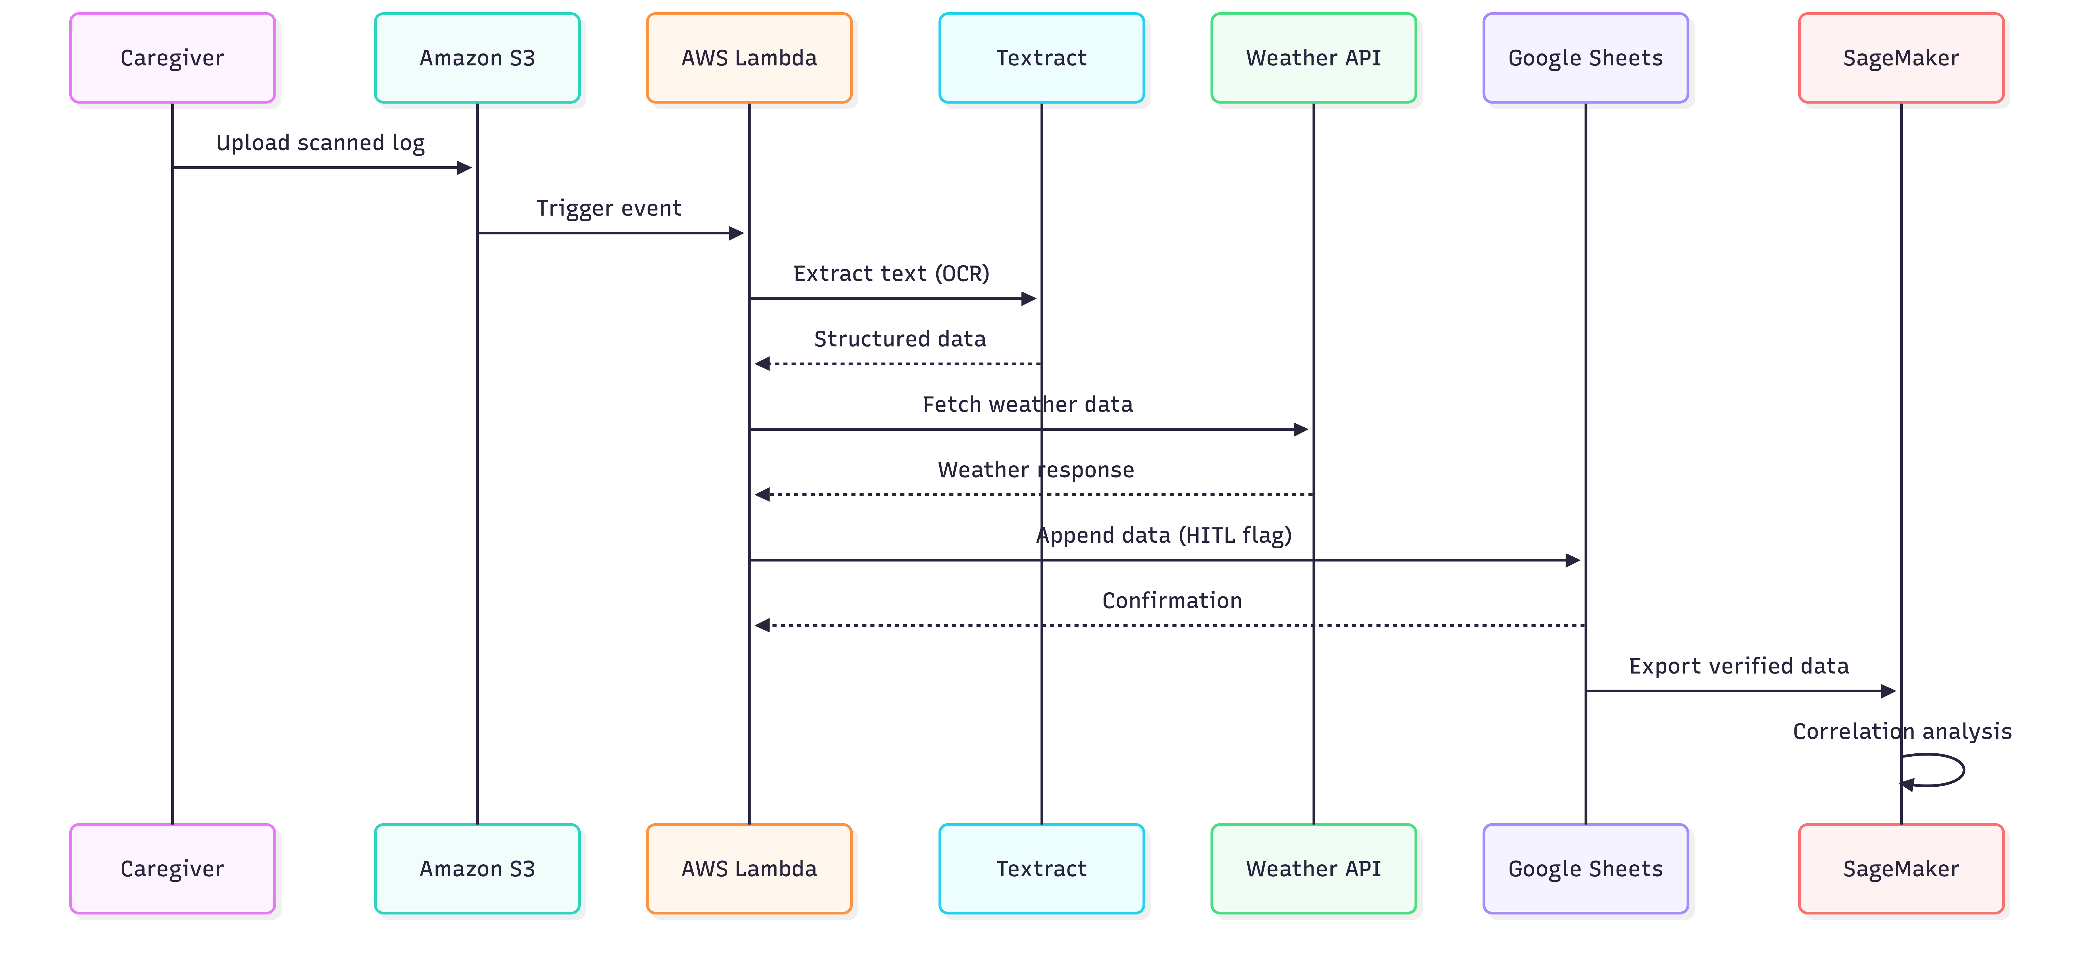
- /design — Paper log template (PDF and editable source), Google Sheets schema documentation

The development branch receives all active commits. Pull requests from development to main require manual review before merge, ensuring that no untested code reaches the production Lambda deployment.

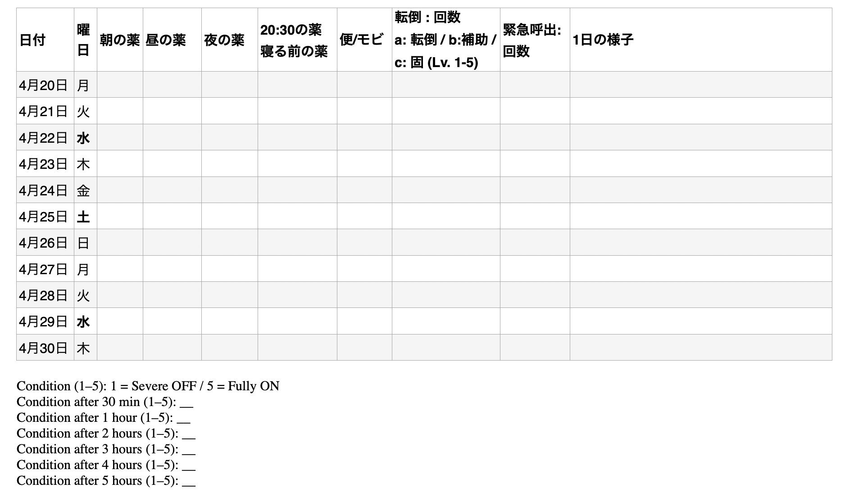
Appendix C: Standardized Caregiver Log Template

The standardized caregiver log template was designed to capture structured and time-stamped data related to medication administration, patient condition, and potential risk factors in a Parkinson’s Disease home-care setting.

The template includes the following key components:

- Date and day of the week, with Wednesdays and Saturdays highlighted in bold to indicate historically higher fall-risk periods. These days correspond to scheduled rehabilitation sessions at a daycare center, after which the patient tends to experience increased physical fatigue. This design reflects an embedded hypothesis that post-rehabilitation fatigue contributes to a higher probability of falls.

- Medication administration times divided into morning, afternoon, evening, 20:30 dose, and bedtime dose to capture fine-grained temporal patterns.

- Gastrointestinal indicators, including stool consistency and Movicol administration, to assess the impact of GI motility on medication effectiveness.

- Patient condition scoring using a 1–5 scale (1 = Severe OFF, 5 = Fully ON). In addition, condition scores are recorded at multiple time intervals after medication administration (30 minutes, 1 hour, 2 hours, 3 hours, 4 hours, and 5 hours) to enable detailed temporal analysis of medication response and delayed ON effects.

- Quantitative risk event tracking, including:
• Fall events (recorded as frequency counts)
• Near-fall or assisted incidents (instances where support was required to prevent a fall)
• Freezing or severe motor impairment episodes (rated on a 1–5 severity scale)
• Emergency call frequency
This structure allows for more precise analysis of both the frequency and severity of risk-related events.

- A free-text notes section to capture additional contextual observations.

The template was specifically optimized for OCR processing using AWS Textract by incorporating clearly defined fields, consistent layouts, and minimal handwriting ambiguity. This design ensures both high data quality and compatibility with the Human-in-the-Loop (HITL) verification process.

The inclusion of highlighted high-risk days and detailed temporal condition tracking represents an embedded domain-specific hypothesis within the data collection process, enabling future correlation analysis between medication timing, physiological conditions, and fall risk.

The inclusion of highlighted high-risk days represents an embedded domain-specific hypothesis within the data collection process, enabling future correlation analysis between temporal patterns and fall risk.

Appendix D: Sample Lambda Function (Python)

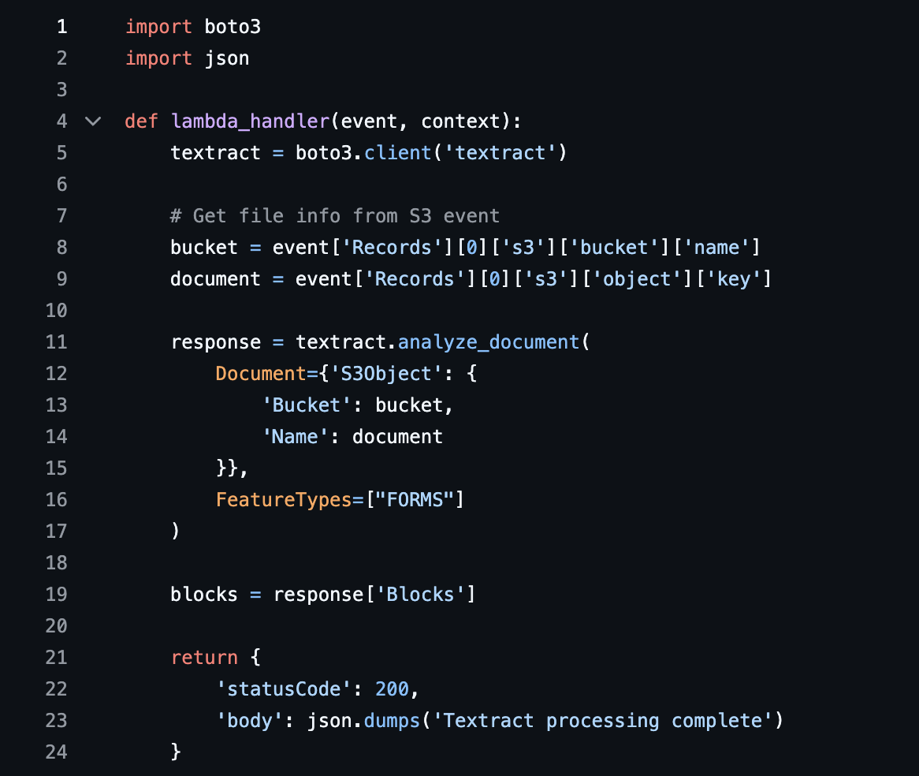
The following code snippet demonstrates how AWS Textract is invoked within the Lambda function to extract structured data from uploaded caregiver logs. This function is triggered by an S3 event and processes uploaded caregiver log images using Textract. The extracted data is then passed to downstream components for validation and storage. Full source code is available in the GitHub repository (src/lambda_handler.py).

