MSIT 5910 Capstone
Discussion Assignment Unit 1

University of the People
MSIT 5910 Discussion Assignment Unit 1

April 11, 2026

Theoretical Foundations and Evidence-Based Design for ParkinSync
1. Purpose and Scope
1.1 Capstone Expectations
As a student concluding the MSIT program, my expectation for this capstone project is to demonstrate a comprehensive integration of advanced knowledge in Algorithms, Databases, and Software Engineering. I aim to build a system that is not only functional but also architecturally sound, adhering to industry-standard practices such as CI/CD and version control. By applying these principles, I intend to prevent the accumulation of technical debt while solving a high-impact, real-world challenge through an AI-driven development lifecycle.
1.2 Purpose of the Project
The primary purpose of ParkinSync is to identify clinically significant patterns in the relationship between medication timing and fluctuations in physical condition, specifically the "ON/OFF" phenomenon in Parkinson's disease (PD). Currently, care records for PD patients are often fragmented across multiple providers (care assistants, nurses, and family members) and various media (paper, email, and verbal handoffs). This project aims to centralize this data and provide predictive insights using Machine Learning (ML) to optimize medication adherence and overall care quality.
1.3 Definition of Scope
The scope of ParkinSync is defined by three distinct layers and a robust security framework:
- Input Layer: A hybrid system that digitizes handwritten caregiver logs via AWS Textract (OCR). It concurrently ingests environmental data, including outdoor weather (via OpenWeatherMap API) and indoor climate (via IoT sensors).
- Integration Layer: Utilizing AWS Lambda to process structured data from Textract and synchronize it with a centralized Google Sheets repository, which serves as the primary database for this prototype.
- Analysis Layer: Developing a pattern-recognition model in Amazon SageMaker to perform feature engineering and calculate Pearson’s r correlation coefficients among medication timing, environmental variables, and ON/OFF scores.
- Security Framework: Aligned with the AWS Shared Responsibility Model, the system enforces de-identification (Patient IDs), encryption at rest and in transit (AWS KMS, TLS 1.2+), and secrets management (AWS Secrets Manager).
- Out of Scope: The system is a decision-support tool and will not provide medical diagnoses or modify drug dosages.
2. Literature Review and Problem Definition
2.1 Summary of Findings
Three recent peer-reviewed studies form the evidentiary foundation of this project, collectively addressing ML-based adherence monitoring, barriers to digital health adoption among elderly users, and the clinical significance of the ON/OFF phenomenon in PD.
Bohlmann, Mostafa, and Kumar (2021)
Bohlmann, Mostafa, and Kumar (2021) conducted the first broad scoping review of machine learning applications to medication adherence, analyzing 43 peer-reviewed studies from PubMed, Scopus, IEEE, ACM Digital Library, and Web of Science. The review organized the literature around key adherence-related actions, especially prediction, monitoring, and monitoring combined with intervention. Among monitoring studies, two systems for patients with Parkinson's disease used movement-based sensing and achieved classification accuracy of 78% or higher. Context-aware reminder systems helped patients maintain adherence above 92%, but these approaches were intrusive and depended on multiple sensors distributed throughout the home, raising concerns about usability, acceptability, and privacy. Overall, the authors suggest that while machine learning shows promise for predicting and monitoring adherence, more realistic and user-acceptable home-care implementations are still needed.
Bertolazzi, Quaglia, and Bongelli (2024)
Bertolazzi, Quaglia, and Bongelli (2024) conducted an integrative systematic review of 29 studies on health technology adoption among older adults with chronic diseases. They identified five main domains affecting adoption: demographic and socioeconomic, health-related, dispositional, technology-related, and social factors. Reported barriers included low education, low income, cognitive and sensory limitations, lack of technical confidence, fear of new technology, strong attachment to established routines, and usability problems. The review also found that adoption is supported by simple, accessible design; adequate training; perceived usefulness; technologies that strengthen communication; and support from healthcare providers and relatives. Overall, the authors argue that health technologies for older adults should be user-centered, accessible, and aligned with the everyday needs and routines of this population.
Mantri, Lepore, Edison, et al. (2021)
Mantri, Lepore, Edison, et al. (2021) surveyed 2,110 Fox Insight participants who self-reported experiencing OFF periods in Parkinson’s disease. Tremor was the most commonly described OFF symptom (49.2%), followed by gait/freezing problems (25.4%) and rigidity (20.4%). Among reported triggers, stress was the most common (61.4%), followed by anxiety/depression and tiredness/fatigue; environmental triggers such as cold or heat exposure were also noted. The study also found that many participants either did not discuss OFF periods with others or lacked specific language to describe them, suggesting a communication challenge around recognizing and conveying OFF experiences. The authors emphasized the need for better counseling and better strategies to ascertain OFF periods, potentially including wearable sensor data.
2.2 Explaining the Gaps
The three studies collectively identify a convergent gap: no practical, analog-compatible system exists to capture longitudinal PD care data in home environments and link it to ML analysis.
Bohlmann et al. (2021) confirm that ML-based monitoring is technically feasible, yet every high-performing system in their review presupposes a digitally instrumented environment. Smartwatches, smart pill bottles, and room sensors are inaccessible in settings where caregivers rely on paper logs and verbal handoffs. Clinical-grade precision does not transfer to naturalistic home care.
Bertolazzi et al. (2024) explain why imposing digital-first tools on elderly patients and non-technical caregivers reliably fails. Preference for analog routines reflects a rational prioritization of cognitive load and continuity of care. Systems that disrupt established workflows introduce friction, reduce data consistency, and increase the risk of abandonment.
Mantri et al. (2021) close the clinical loop: the OFF-period data most valuable to medical teams are precisely the ones least likely to be captured systematically. The patient-clinician communication gap is fundamentally a data infrastructure problem. Without a mechanism to convert caregiver observations into structured, time-stamped records, clinically significant patterns remain invisible.
Together, these findings establish a clear and actionable gap: while ML is technically capable of detecting clinically meaningful patterns in PD medication adherence data, no existing system bridges the analog workflows of real-world home caregivers with the structured data requirements of longitudinal ML analysis. This gap is the direct motivation for the architecture proposed in this project.
2.3 Preliminary Problem Sketch
The core problem is the structural disconnect between how PD care data is generated and how it must be structured for analysis. Medication events, condition scores, and caregiver observations are recorded on paper by a rotating team and remain fragmented, unsynchronized, and non-machine-readable. The patterns linking medication timing to ON/OFF fluctuations, which Mantri et al. (2021) show are clinically significant and chronically under-reported, are inaccessible to the medical team.
This project resolves the tension identified across all three studies through a hybrid architecture. Paper-based logs are preserved as the primary input, maintaining caregiver routines as Bertolazzi et al. (2024) recommend. AWS Textract digitizes these logs, Lambda synchronizes the output to Google Sheets, and environmental data is ingested automatically. SageMaker then calculates Pearson's r across medication timing, environmental variables, and ON/OFF scores. The system functions as a decision-support layer that makes existing analog data analytically accessible, without replacing caregiver judgment or clinical authority.
3. Basic Project Planning Tools
3.1 Gantt Chart (Notion Timeline View)
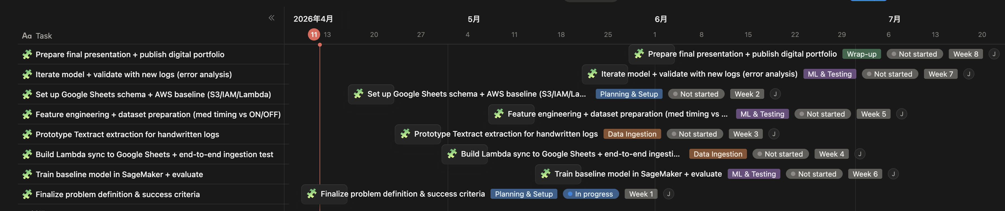
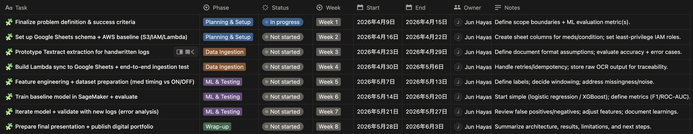
The 8-week project timeline is managed using the Notion Timeline view. Weeks 1 through 4 cover infrastructure setup: problem definition and quantified success criteria (Week 1); AWS baseline configuration including S3, IAM, and Lambda alongside Weather API integration (Week 2); Textract prototyping for handwritten logs and IoT sensor setup for indoor environmental data (Week 3); and end-to-end ingestion testing with Lambda-to-Google-Sheets synchronization (Week 4). Weeks 5 through 7 cover the analytical phase, encompassing feature engineering and dataset preparation, SageMaker model training and evaluation, and iterative model refinement with error analysis. Week 8 is reserved for the final presentation and digital portfolio publication.
3.2 Feasibility Checklist
- Technical: AWS Textract supports handwriting recognition at the accuracy levels documented by Kumar et al. (2023). SageMaker accommodates small- to medium-sized datasets appropriate for an 8-week scope.
- Operational: Preserving paper-based input ensures zero disruption to caregiver routines and maintains consistent data flow from all providers.
- Economic: Estimated monthly cost is $0, achieved by adhering to AWS Free Tier limits (1,000 Textract pages/month, 1M Lambda requests/month, 250 hours of SageMaker ml.t3.medium). A stop-on-idle policy mitigates financial risk.
3.3 Chosen Tool: Notion
Notion serves as an integrated project management and portfolio platform. A Kanban board tracks tasks across each sprint using a lightweight agile approach. Documentation, including AWS architecture diagrams, Python scripts, and literature review artifacts, is centralized in a single linked workspace. A dedicated risk database monitors issues such as OCR recognition errors and low data volume, and documents mitigation strategies for each risk. The course-required digital portfolio is published via the Notion Share to Web feature, making all project artifacts accessible to stakeholders.
Future Iterations
Post-capstone development will extend the system across four directions. First, a longitudinal seasonal analysis will compare Year-over-Year data to assess the impact of climate on PD symptoms. Second, AWS SNS alerts will notify family members when significant deviations in medication timing or condition scores are detected. Third, cost optimization will transition managed ML instances to Serverless Inference for lifelong operational sustainability. Fourth, IoT ecosystem expansion will incorporate wearable accelerometers and smart pillboxes to automate the collection of motor-symptom and adherence data, thereby progressively reducing the manual burden on caregivers.
References
Bertolazzi, A., Quaglia, V., & Bongelli, R. (2024). Barriers and facilitators to health technology adoption by older adults with chronic diseases: An integrative systematic review. BMC Public Health, 24(1), 506. https://doi.org/10.1186/s12889-024-18036-5
Bohlmann, A., Mostafa, J., & Kumar, M. (2021). Machine learning and medication adherence: Scoping review. JMIRx Med, 2(4), e26993. https://doi.org/10.2196/26993
Mantri, S., Lepore, M., Edison, B., Daeschler, M., Kopil, C. M., Marras, C., & Chahine, L. M. (2021). The experience of OFF periods in Parkinson's disease: Descriptions, triggers, and alleviating factors. Journal of Patient-Centered Research and Reviews, 8(3), 232-238. https://doi.org/10.17294/2330-0698.1836

