Computer Organization & Assembly Language BS (DS) Fall 2025
Final Project – Rush Hour



Name: Laraib Butt
Roll Number: 24I-2544
Section: DS-3B

CODE LAYOUT
INITIAL SET UP
main PROC
    - Menu Display
    - Choice Input
    - Game Controls Selection
    - Calls displayInstructions
    - Calls initializeGrid
    - Calls Game
displayInstructions PROC
Displays instructions
initializeGrid PROC
    - Initializes grid array with random 0s and 1s
    - Places ‘o’, ‘t’, and ‘n’ at hardcoded positions for obstacles, trees and NPC people
    - Places ‘z’ in first cell to denote player
    - Calls initializePassengerCoordinates
    - Calls generateDropCoordinates
    - Calls resetFlags
PASSENGER PROCEDURES
initializePassengerCoordinates PROC
    - initializes three arrays (passengerX, passengerY and isPicked)
    - isPicked is set to all zeros
    - x and y coordinates are generated randomly within the x and y boundaries of console ( 3 <= y <= 23, 15 <= x <= 53)
    - validates position with grid’s layout
    - regenerates coordinates if an obstacle, building, tree or person exists there already
    - calls helper function getIndex2
printPassengers PROC
    - checks if passenger has been picked or no
    - prints a cyan box if it is still waiting
    - print a white box if it has been picked
pickUpPassenger PROC
sets a value of isPicked equal to 1 if it corresponds to the passenger’s coordinates
generateDropCoordinates PROC
    - initializes variables dropX and dropY randomly
    - coordinate values are within bounds
    - checks whether coordinates aren’t already used by anything else inside the grid (such as obstacle, tree or person)
    - regenerates if a wrong position was generated
printDropPosition PROC
Prints a lightCyan box on the dropX and dropY coordinates on terminal.
dropPassenger PROC
Prints a white box on the dropX and dropY coordinates and sets isPicking to 0 so player can pick other passengers now.
MAIN GAME LOOP
    - Starts a loop gameLoop
    - Calls GameDisplay
    - Calls printPassengers
    - Calls printDropPosition
    - Takes character input continuously
    - Used WASD for movement
    - Pauses game if ‘P’ or ‘p’ is pressed and resumes again if it is pressed again
    - Switches back to menu screen if ‘B’ or ‘b’ is pressed
    - Refreshes grid if ‘R’ or ‘r’ pressed
    - Jumps to labels moveUp, moveDown, moveLeft, moveRight, goBackToMenu, refresh, pauseGame
    - Temporarily updates player coordinates and then move if valid conditions are met
    - Resets player’s positions if invalid move was taken and deducts score
    - Redraws grid after each movement and overwrites player’s previous position if it was updated
    - Picks up passenger if spacebar is pressed
    - Sets isPicking to 1
    - Updates score accordingly by jumping to updateScoreW or calling updateScore

HELPER FUNCTIONS OF GAMELOOP

isPassengerProc PROC
moves player to passenger’s postions and checks equality between player’s coordinates and passengers’ coordinates if they haven’t been picked up yet

resetFlags PROC
Resets all flag variables to 0 before being used in next iteration

isInvalid PROC
- Converts player’s current coordinates onto indexes (row and column)
- Moves to that row and column position in grid
- Checks if any obstacle, building, person or passenger etc is standing there
- Sets wrongMove to 1.

GAME DISPLAY
- Calls printScore
- Calls drawMapInstr
- Loops through the 20x20 grid and prints white block if road and black block if building
- Prints obstacles, npc persons, and trees according to their hardcoded positions in grid
- Prints instructions at the end
printScore PROC
Prints score and name of driver on top left
drawMapInstr
Prints a map key on the right to guide the player about map elements

GAME OVER
Game ends if score is zero.
IMAGES
Menu Screen:
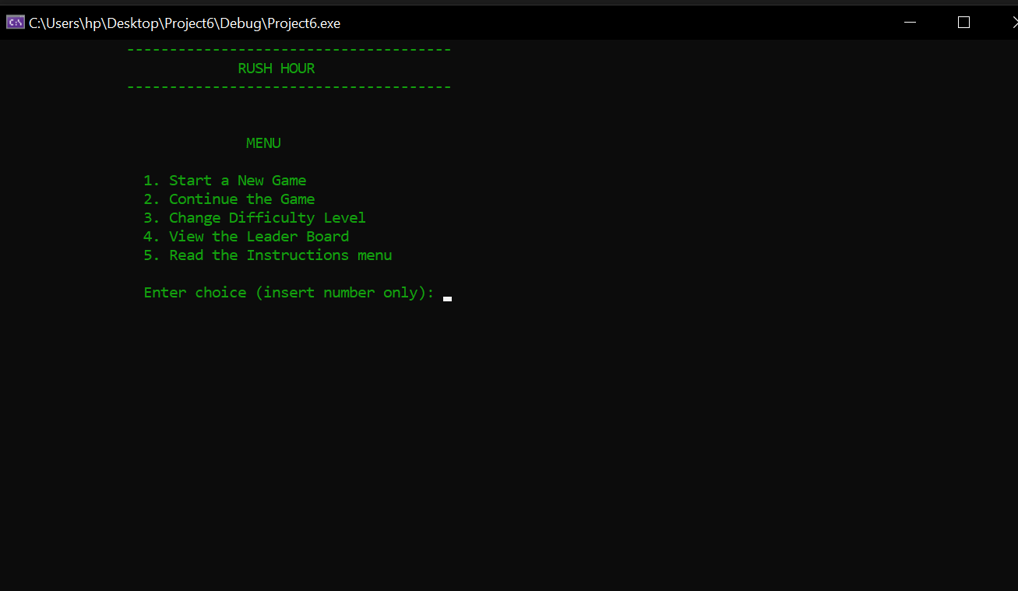
Game Control Selection
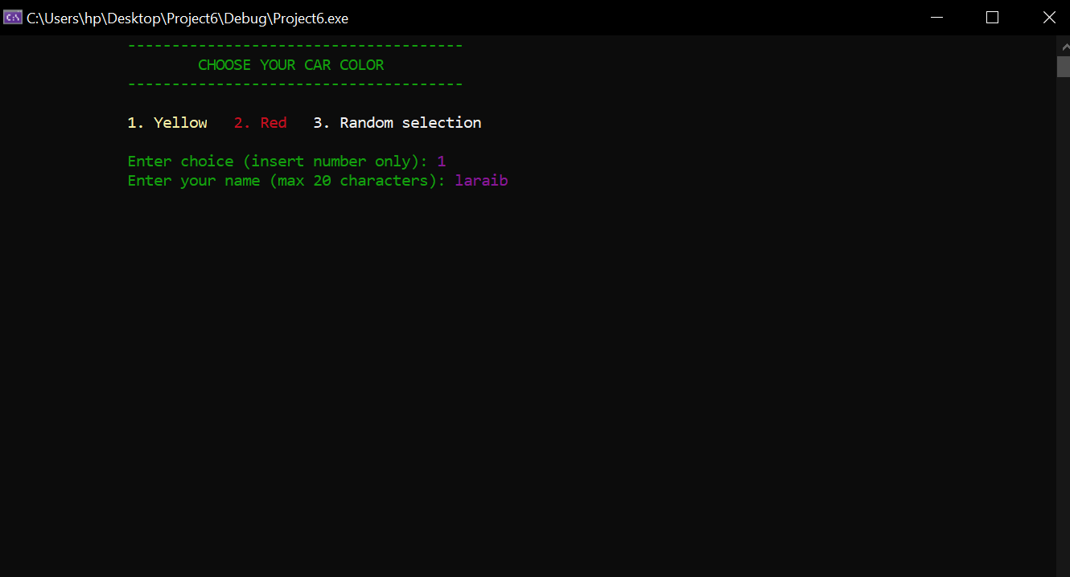
Initial game Screen:
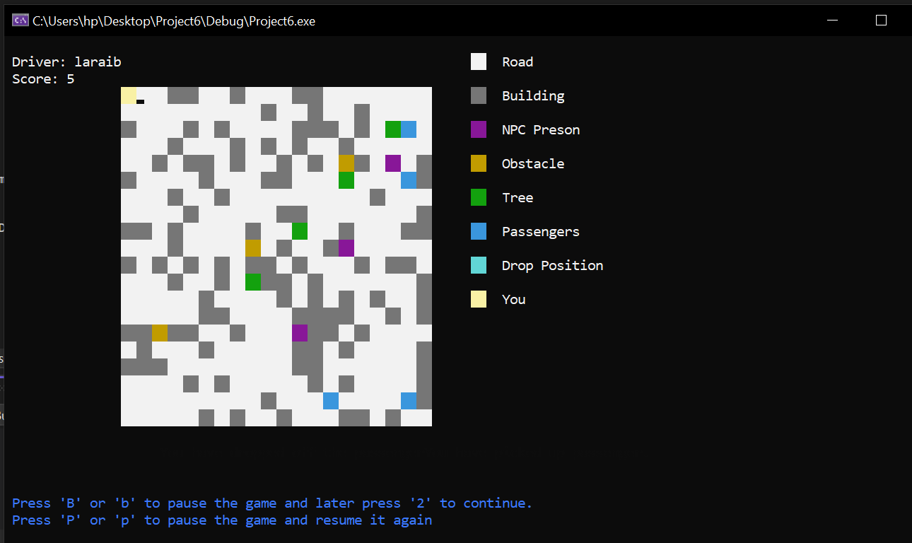
Passenger Pick up:
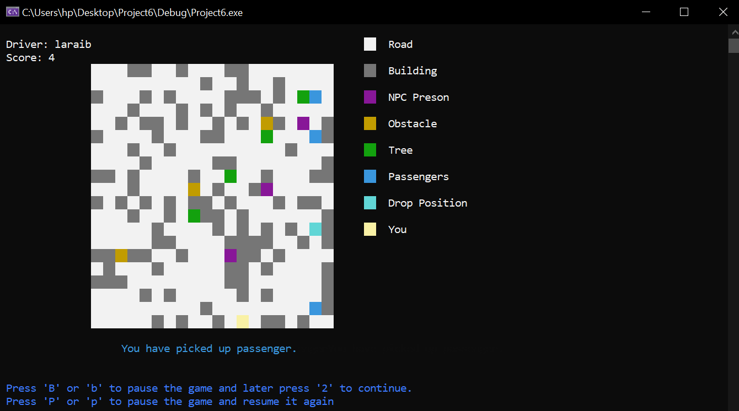
Passenger Drop off:
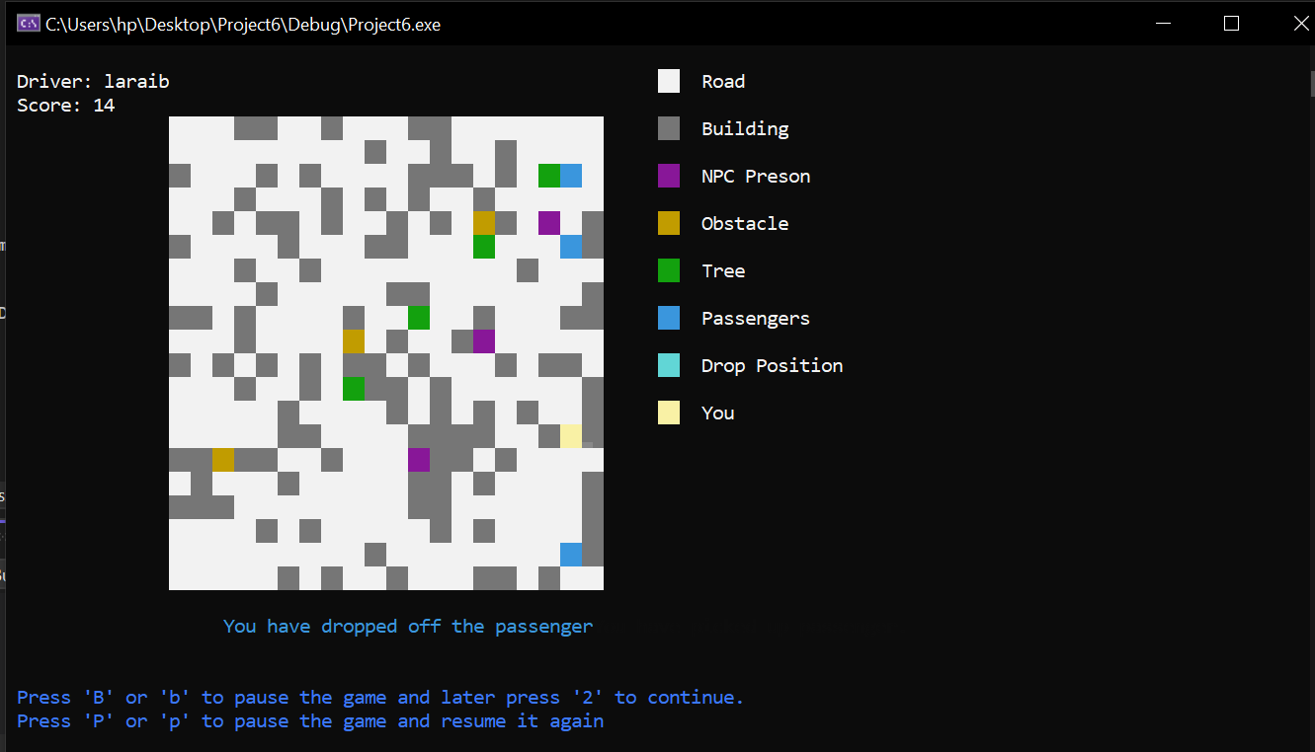
Pause game:
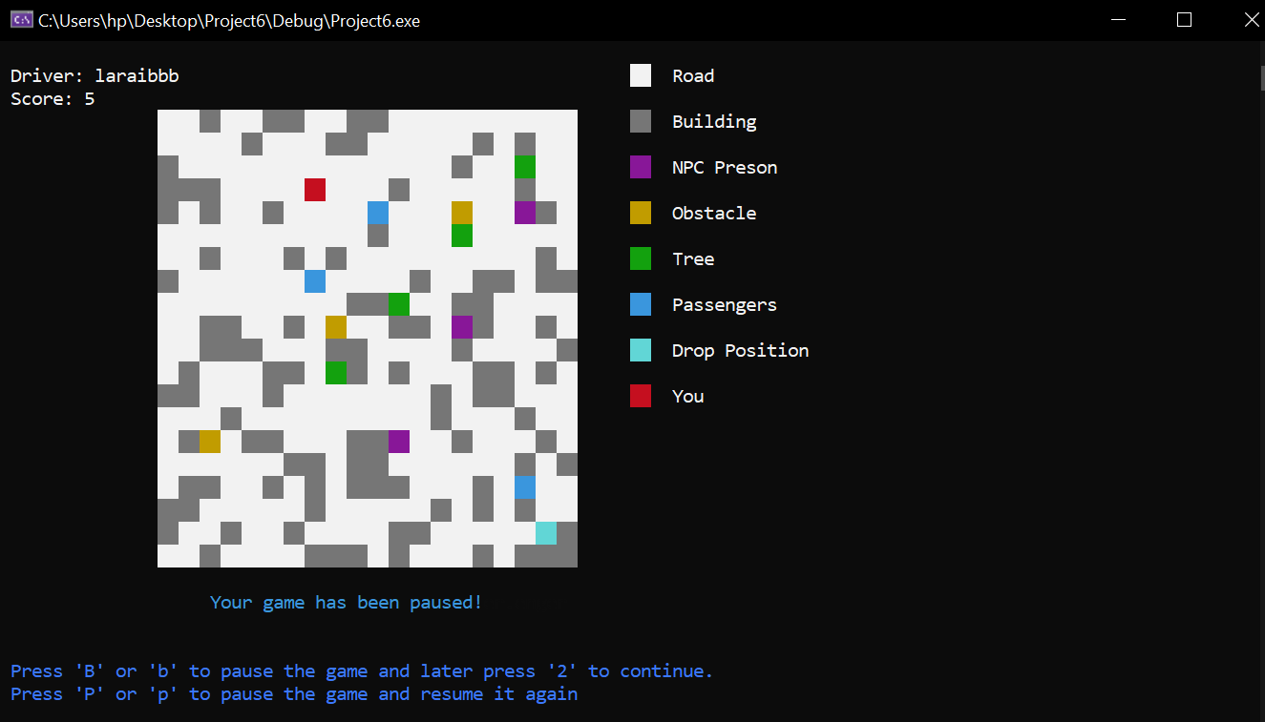
Game over screen:
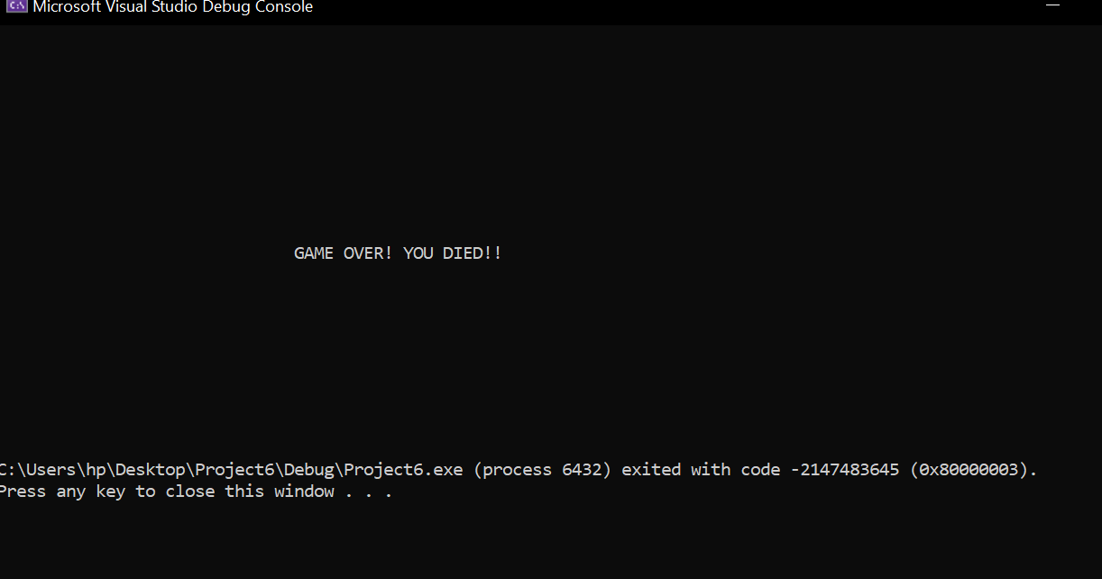

VIDEO LINK
https://drive.google.com/file/d/1_vz_GFnyRTIQjQvEM8PdEij-I7s68N6T/view?usp=sharing

