|  |  |
| --- | --- |
| **MRU** | **Department of Computer Science & Technology, MRU, Faridabad** |
| **LAB-12** |
| **Subject:** Cloud Computing LAB **Subject Code**: **CSH438 Semester: VII** | |
| **Name: Laraib Siddiqui Roll Number:2K17CSUN01130** | |

***Objective: Understanding on* VPC Networks.**

***Course Outcome*: Understanding VPC*.***

***Blooms Taxonomy Level****:* **BT2, BT4**

**Lab XII: VPC NETWORKING FUNDAMENTALS**

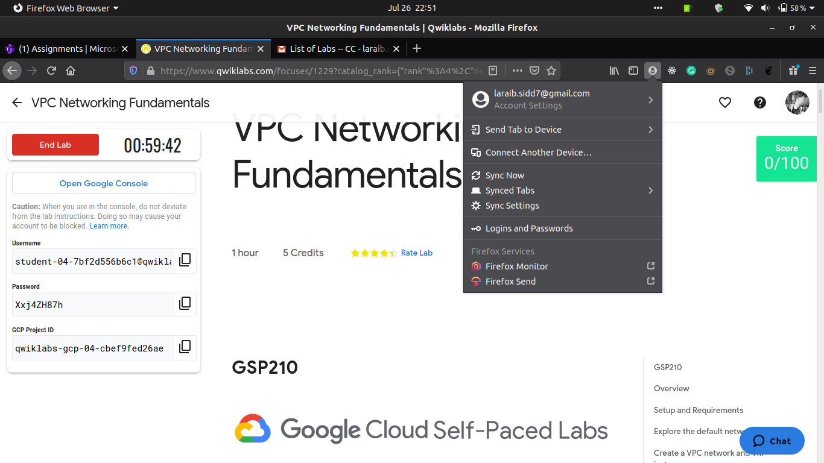

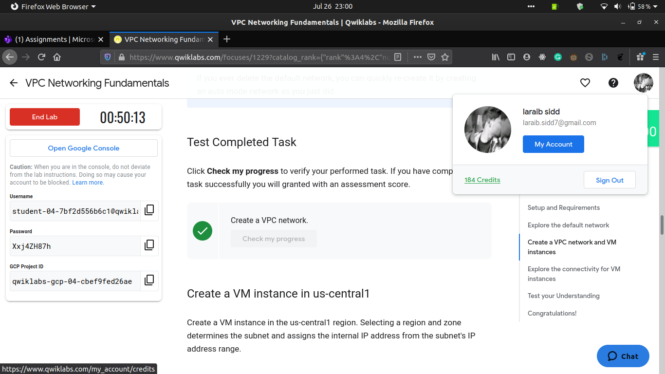

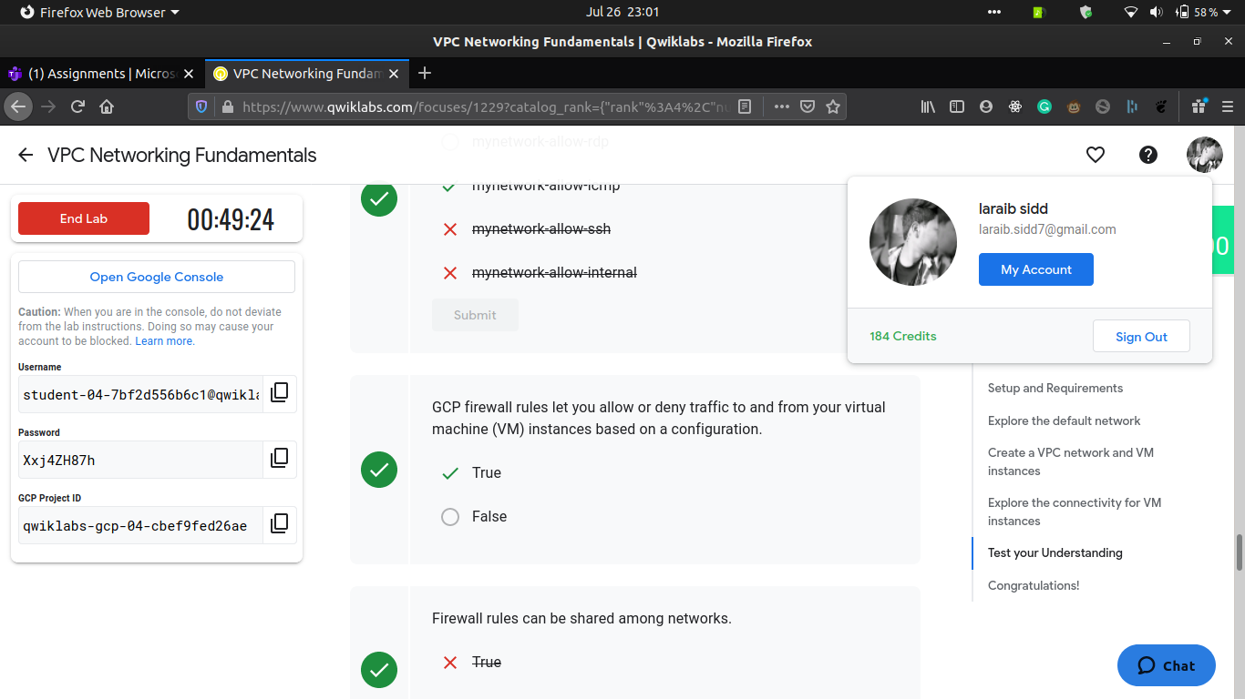

|  |  |
| --- | --- |
| **MRU** | **Department of Computer Science & Technology, MRU, Faridabad** |
| **LAB-13** |
| **Subject:** Cloud Computing LAB **Subject Code**: **CSH438 Semester: VII** | |

***Objective: Understanding on* VPC Networks.**

***Course Outcome*: Understanding VPC*.***

***Blooms Taxonomy Level****:* **BT2, BT4**

**Lab XII: Multiple VPC Networks.**

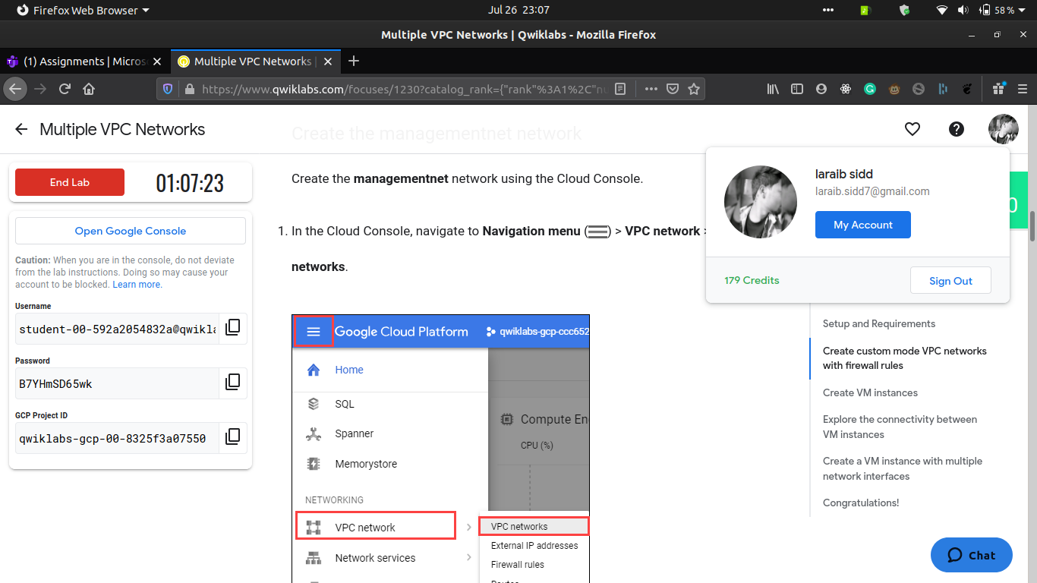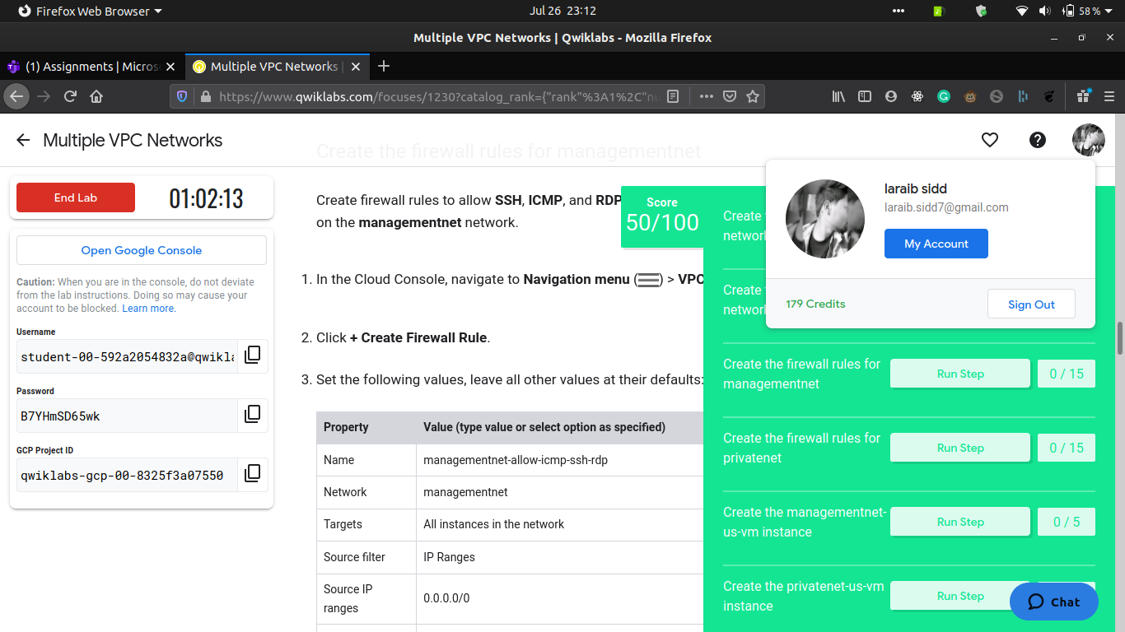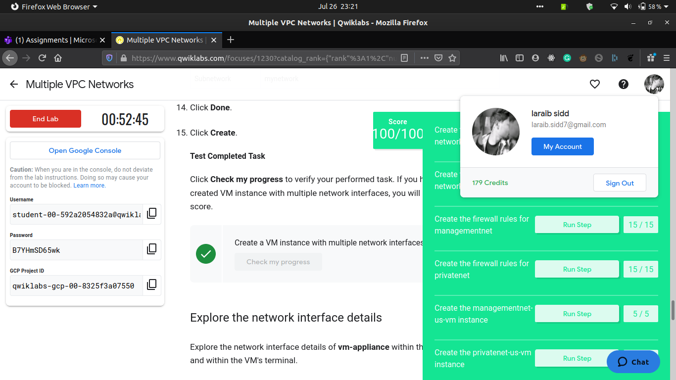

|  |  |
| --- | --- |
| **MRU** | **Department of Computer Science & Technology, MRU, Faridabad** |
| **LAB-13** |
| **Subject:** Cloud Computing LAB **Subject Code**: **CSH438 Semester: VII** | |

***Objective: Understanding on* Controlling Access.**

***Course Outcome*: Understanding VPC.**

***Blooms Taxonomy Level****:* **BT2, BT4**

**Lab XIII: VPC Networks - Controlling Access.**

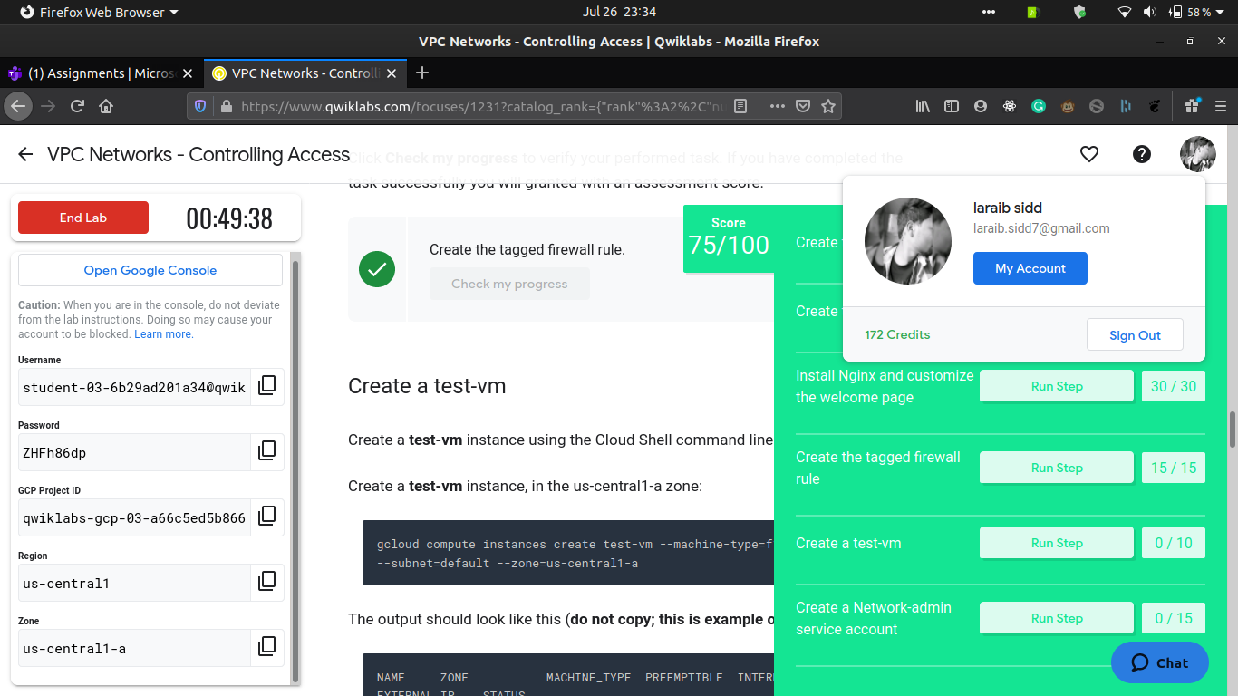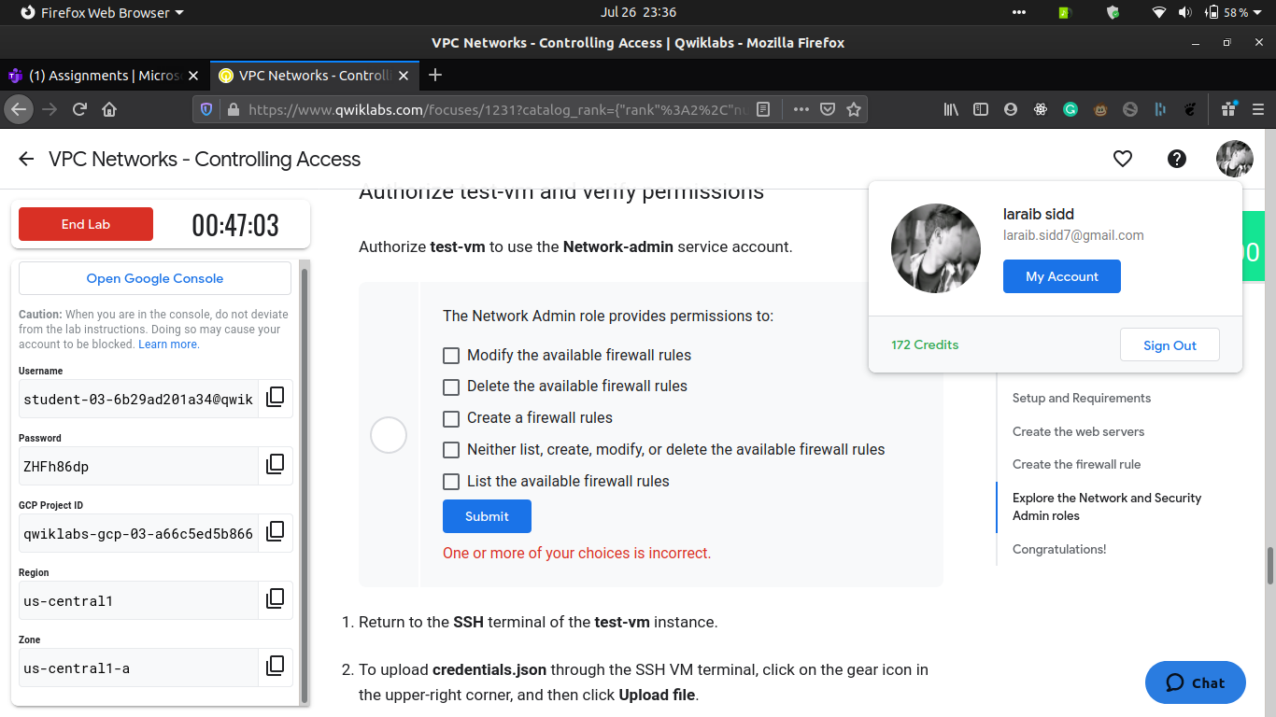

|  |  |
| --- | --- |
| **MRU** | **Department of Computer Science & Technology, MRU, Faridabad** |
| **LAB-15** |
| **Subject:** Cloud Computing LAB **Subject Code**: **CSH438 Semester: VII** | |

***Objective: Understanding Load Balancing*.**

***Course Outcome*: Working on Load Balancer.**

***Blooms Taxonomy Level****:* **BT2, BT4**

**Lab XV: HTTP Load Balancer with Cloud Armor**

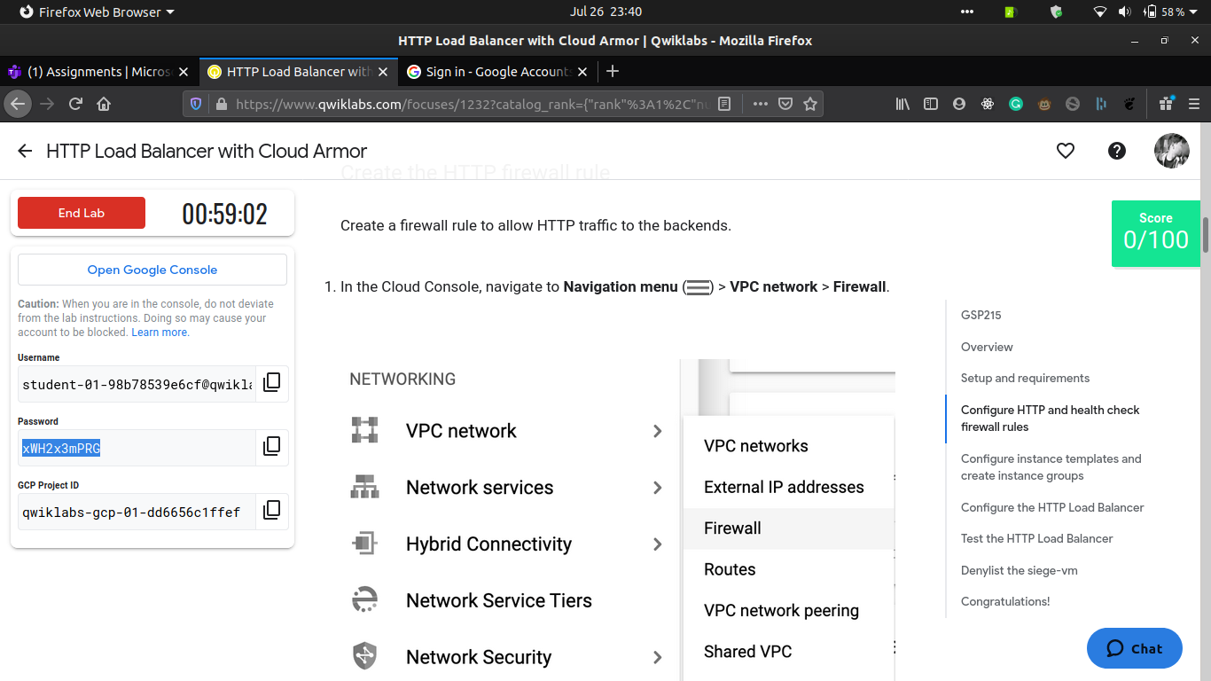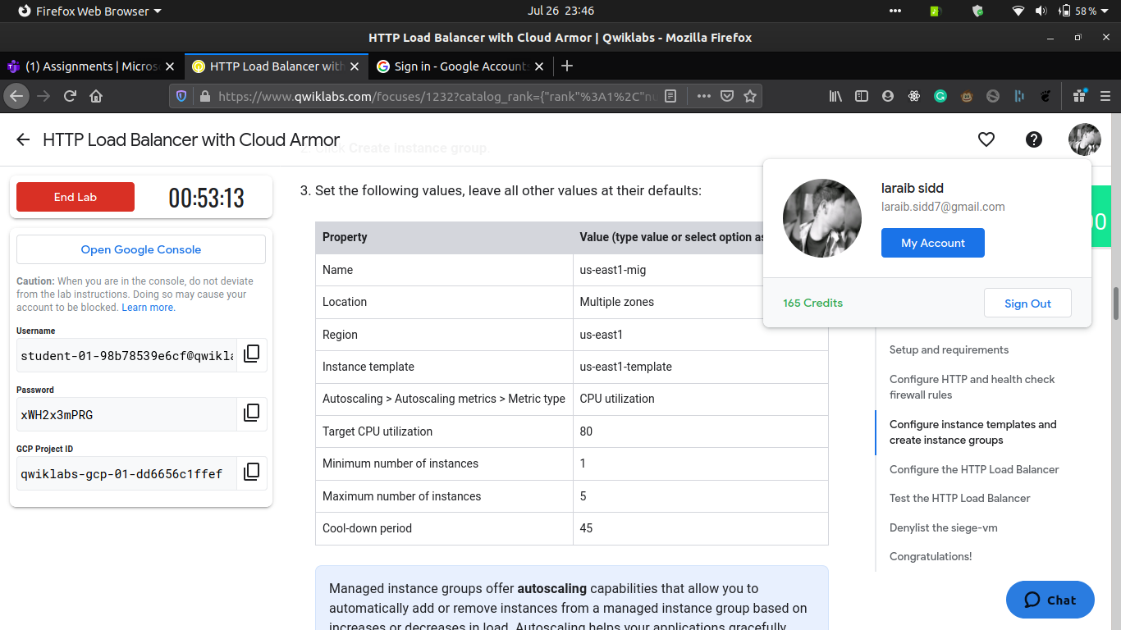

|  |  |
| --- | --- |
| **MRU** | **Department of Computer Science & Technology, MRU, Faridabad** |
| **LAB-16** |
| **Subject:** Cloud Computing LAB **Subject Code**: **CSH438 Semester: VII** | |

***Objective: Understanding Load Balancing*.**

***Course Outcome*: Working on Load Balancer.**

***Blooms Taxonomy Level****:* **BT2, BT4**

**Creating an Internal Load Balancer.**

