**NAMAL UNIVERSITY**

**Department of Computer Science**

**BS Computer Science Program**

**6th Semester, Spring 2025 Assignment 1**

**CS-371 Cloud Computing** Due Date: Mar 05, 2025

**Name: Laraib Sultana Roll Num: NUM-BSCS-2022-06**

**Practical Task: Deploying Web Apps on Azure with Visual Studio Code**

**Web App creation:**

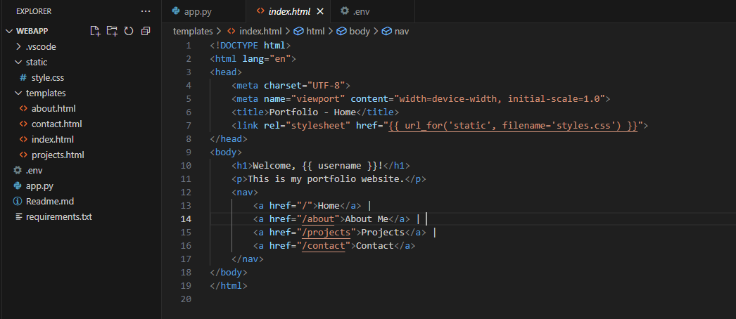

**Azure App service setup:**

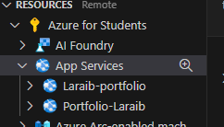

Used Laraib-portfolio for this.

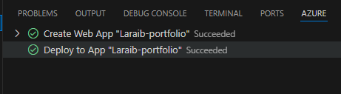

**Deploy to Azure:**

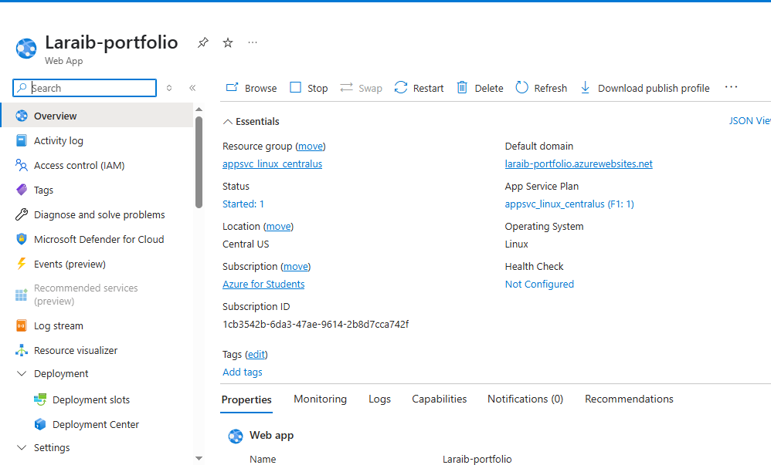

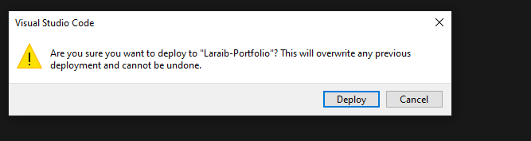

Website Link:

laraib-portfolio.azurewebsites.net

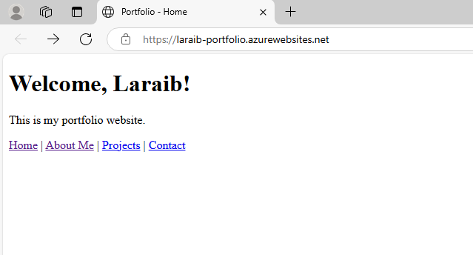

Problems:

At first I could not create web service

Then I created website but could not deploy it completely.

So I cleared all the previous work and all the steps again . this time it was successful

I could not change much in my website beacause of the short time. But of course we can make changes later and make it more functional.