Department of Information Science & Engineering

A Report
On
“Analysis of Human Development Index and Visualization”
Submitted for the partial fulfillment in
Data Visualization Lab (BISL504)
Submitted By
Muhammad Laraib Jamal 4NI24IS109
Nadeem Siddique 4NI24IS113
Manan Maheshwari 4NI24IS099
N Ravi Kiran 4NI24IS112
Under the Guidance of
Dr. K. Raghuveer  Professor  Dept. of ISE  NIE, Mysuru | Ms. Sandhya N  Assistant Professor  Dept. of ISE  NIE, Mysuru

The National Institute of Engineering
(Autonomous Institution under Visvesvaraya Technological University)
MYSURU – 570018
2026-27

The National Institute of Engineering
Department of Information Science and Engineering
MYSURU- 570018

Certificate
Certifies that the project titled “Analysis of Human Development Index and Visualization” submitted in partial fulfillment of Data Visualization Lab (BISL504) is presented by Muhammad Laraib Jamal, Nadeem Siddique, Manan Maheshwari and N Ravi Kiran bearing 4NI24IS109, 4NI24IS113, 4NI24IS099 and 4NI24IS112 respectively, of the Fifth semester BE in Information Science & Engineering prescribed by The National Institute of Engineering, Autonomous Institution under Visvesvaraya Technological University, Belagavi. It is certified that all corrections/suggestions indicated for Internal Assessment have been incorporated.

Signature of Guide | Signature of Guide | Signature/Seal of HOD
Dr. K. Raghuveer  Professor  Dept. of ISE  NIE, Mysuru | Ms. Sandhya N  Assistant Professor  Dept. of ISE  NIE, Mysuru | Dr. Shashank Dhananjaya  Assoc. Prof. and Head  Dept. of ISE  NIE, Mysuru

ACKNOWLEDGEMENTS
The success and the final outcome of the project required a lot of guidance and assistance from many people and we are extremely fortunate to have got this all along with the completion of the project presentation.
We express our profound thanks to Dr. B. S. Nagendra Parashar, Principal, NIE, Mysuru for his much needed moral support and encouragement.
We are grateful to Dr. Shashank Dhananjaya, Assoc. Prof. & Head, Dept. of Information Science & Engineering, NIE, Mysuru for his support and encouragement in facilitating the progress of this work.
We would like to sincerely thank our Guides Dr. K. Raghuveer, Professor and Ms. Sandhya N, Assistant Professor in the Dept. of IS&E for their guidance, technical expertise, encouragement, and timely help in making this work a reality.
Also, we would like to extend our sincere regards to all the non-teaching staff of the IS&E Dept. for their timely support.

Muhammad Laraib Jamal 4NI24IS109
Nadeem Siddique 4NI24IS113
Manan Maheshwari 4NI24IS099
N Ravi Kiran 4NI24IS112
ABSTRACT
The Human Development Index (HDI), published annually by the United Nations Development Programme (UNDP), summarises the achievements of a country in health, education and standard of living as a single number between zero and one. Although the index is widely quoted, the data behind it are distributed as large spreadsheets that are difficult for students, researchers and policy makers to explore. This project, Analysis of Human Development Index and Visualization, addresses this gap by designing and implementing an interactive dashboard in Python using Pandas, Plotly and Dash.
The dataset is the UNDP composite indices time series, covering 193 countries and territories and four component indicators: life expectancy at birth, expected years of schooling, mean years of schooling and gross national income per capita. The data were cleaned, reshaped from wide to long format and enriched with HDI group labels. The dashboard combines filters, key performance indicator cards, a world choropleth map, trend lines, a ranked bar chart, a bubble scatter plot and a regional box plot. A year slider and region, country and HDI group selectors allow users to move from a global overview to a single country within a few clicks.
The dashboard reproduces the published rankings, for example Iceland at the top with an HDI of 0.972 and India at the 130th position with 0.685 in 2023, and it exposes patterns such as the wide gap between high and low human development countries, the spread of values within South Asia and the concave relationship between income and life expectancy. The report documents the objectives, tools, data preparation, methodology, design, results and possible future enhancements of the work.
TABLE OF CONTENTS
Acknowledgement i
Abstract ii
Contents iii
List of Figures iv
CHAPTERS PAGE NO
CHAPTER 1: INTRODUCTION 1
CHAPTER 2: OBJECTIVES 4
CHAPTER 3: TOOLS AND TECHNOLOGY 5
CHAPTER 4: DATA SELECTION AND DATASET UNDERSTANDING 7
CHAPTER 5: PROJECT PROPOSAL AND METHODOLOGY 10
CHAPTER 6: DASHBOARD DEVELOPMENT PROCESS 12
CHAPTER 7: DESIGN AND FEATURES OF THE DASHBOARD 15
CHAPTER 8: RESULTS AND DISCUSSION 17
CONCLUSION WITH FUTURE ENHANCEMENTS 22
REFERENCES 24
LIST OF FIGURES
Figure No. | Description | Page No.
1.1 | Structure of the Human Development Index | 2
5.1 | Methodology followed for the project | 10
6.1 | Architecture of the dashboard | 12
7.1 | Layout of the dashboard with annotated regions | 15
8.1 | Dashboard view: average HDI of all countries, 1990–2023 | 17
8.2 | Dashboard view: top 10 and bottom 10 countries by HDI, 2023 | 18
8.3 | Dashboard view: HDI trend of India compared with Sri Lanka, Bangladesh, Nepal and Pakistan, 1990–2023 | 19
8.4 | Dashboard view: life expectancy and GNI per capita against HDI, 2023 | 19
8.5 | Dashboard view: mean and expected years of schooling against HDI, 2023 | 20
8.6 | Dashboard view: HDI distribution and correlation between indicators, 2023 | 20

Chapter 1
Introduction
1.1 Dashboards in Data Visualization
A dashboard is a single-screen, visually organised collection of the most important information needed to understand a situation and act on it. Instead of reading through rows of a spreadsheet or a long statistical report, a user looks at a small number of carefully chosen charts, maps, tables and key performance indicators that have been arranged so that patterns, outliers and trends are visible at a glance. Modern dashboards are also interactive: filters, sliders, drop-down menus and tooltips allow the viewer to change what is displayed and to move from a high-level summary to the detail behind it without leaving the page.
Data visualization is the discipline that makes this possible. It relies on the ability of the human visual system to compare lengths, positions, colours and shapes much faster than it can compare numbers. A well-designed dashboard therefore combines visual encodings that suit the type of data (geographic, temporal, categorical or relational) with a clear layout, consistent colours and minimal clutter [9].
1.2 Importance of Dashboards in Decision-Making and Business Intelligence
Dashboards are one of the most visible outputs of business intelligence (BI). They shorten the distance between raw data and a decision in several ways:
- Speed: summaries are available immediately and are updated automatically when the underlying data change.
- Clarity: a visual summary exposes trends, comparisons and exceptions that are hidden in tables of numbers.
- Shared understanding: stakeholders from different backgrounds look at the same numbers and charts, which reduces disagreement about what the data say.
- Self-service exploration: non-technical users can answer their own follow-up questions by filtering and drilling down, without requesting a new report from an analyst.
- Monitoring: indicators can be tracked against thresholds, so that deviations are noticed early.
These advantages apply equally to commercial and public-sector settings. Governments, international organisations and researchers use dashboards to monitor social and economic indicators, to compare regions and to evaluate the effect of policies.
1.3 Context and Purpose of the Project
This project applies the dashboard approach to one of the best-known composite indicators in international development, the Human Development Index (HDI). The HDI is published every year by the United Nations Development Programme (UNDP) in its Human Development Report. The data behind it are freely available, but they are released as large wide-format tables with one column for every year and indicator, which makes them hard to explore by hand. A student, a journalist or a policy analyst who wants to know how a country has progressed since 1990, how it compares with its neighbours, or which component of the index is holding it back must first clean and reshape the data.
The purpose of the project, titled Analysis of Human Development Index and Visualization, is to remove this barrier. It prepares the UNDP data for analysis and presents it through an interactive dashboard built with Python, Pandas, Plotly and Dash. The dashboard supports both an overview (a world map and a ranking of countries) and detailed analysis (trends over time and relationships between the underlying indicators).
1.4 About the Human Development Index
The HDI was introduced in the first Human Development Report in 1990, inspired by the work of Mahbub ul Haq and the capability approach of Amartya Sen [7], [8]. Its central idea is that the development of a country should be judged by what its people are able to be and to do, and not by national income alone. The index therefore combines three dimensions, shown in Figure 1.1:
- A long and healthy life, measured by life expectancy at birth.
- Knowledge, measured by mean years of schooling for adults aged 25 and above and expected years of schooling for children of school-entry age.
- A decent standard of living, measured by gross national income (GNI) per capita in purchasing power parity (PPP) dollars.
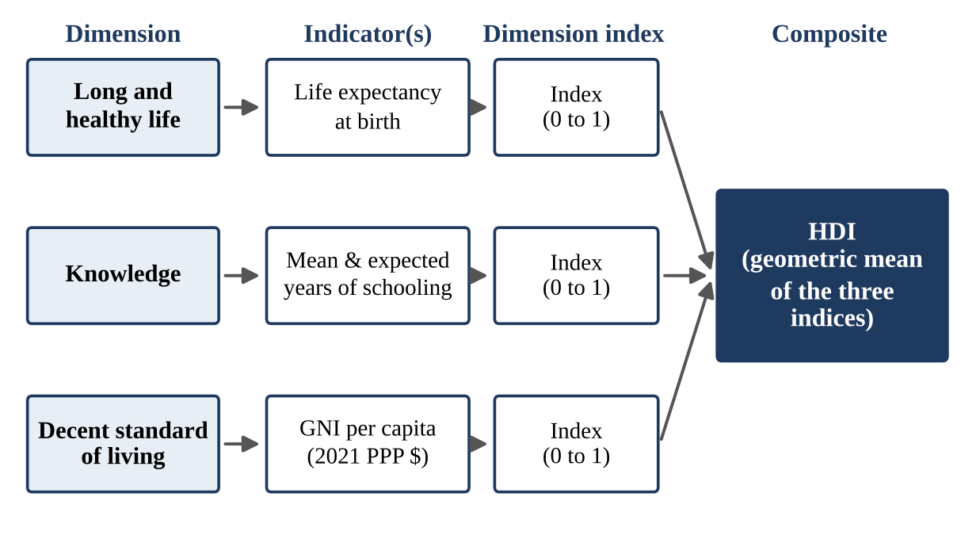
Figure 1.1: Structure of the Human Development Index
Each indicator is converted into an index between 0 and 1 using fixed minimum and maximum values ("goalposts"): life expectancy between 20 and 85 years, expected years of schooling between 0 and 18, mean years of schooling between 0 and 15, and GNI per capita between 100 and 75,000 dollars, the last being transformed with a natural logarithm [3]. The education index is the average of the two schooling indices. The HDI is the geometric mean of the three dimension indices:
HDI = ( I_{health} × I_{education} × I_{income} )^{1/3}
Because a geometric mean is used, a low score in one dimension cannot be fully offset by a high score in another. Countries are then grouped as low (below 0.550), medium (0.550 to 0.699), high (0.700 to 0.799) and very high (0.800 and above) human development.
1.5 Organisation of the Report
Chapter 2 lists the objectives of the project. Chapter 3 describes the tools and technologies. Chapter 4 explains the dataset and the pre-processing steps. Chapter 5 sets out the problem statement and methodology, and Chapter 6 details the dashboard development process. Chapter 7 presents the design and features of the final dashboard. Chapter 8 discusses the results. The report closes with the conclusion and future enhancements and the list of references.
Chapter 2
Objectives
The overall aim of the project is to turn the UNDP Human Development Index data into an interactive, easy-to-use dashboard that supports analysis and decision-making. The specific objectives are:
- To study the structure and calculation of the Human Development Index and its component indicators.
- To select, understand and pre-process the UNDP composite indices time series so that it is suitable for visualization.
- To design and implement an interactive dashboard that presents the HDI of countries from 1990 to the latest available year.
- To explore various data visualization components, namely choropleth maps, line charts, bar charts, scatter (bubble) plots, box plots, tables, key performance indicator cards and filters.
- To enable comparison of countries and regions, and of low, medium, high and very high human development groups.
- To visualize the relationships between the HDI and its components, such as GNI per capita and life expectancy, so that the drivers of human development can be identified.
- To create a user-friendly interface in which stakeholders such as students, researchers and policy makers can make data-driven decisions without technical training.
- To validate the dashboard by cross-checking the displayed values and rankings against the figures published by UNDP.
- To document the work and to identify limitations and possible enhancements for future development.
Chapter 3
Tools and Technologies
3.1 Tools Used
The dashboard is a custom Python solution. Table 3.1 lists the tools and the role each plays in the project.
Table 3.1: Tools and technologies used
Tool | Category | Purpose in the project
Python 3 | Programming language | Main language for data preparation, chart creation and the web application.
Pandas | Data analysis library | Reading the CSV file, cleaning, reshaping from wide to long format, grouping and filtering.
NumPy | Numerical library | Numerical operations, handling of missing values and verification of the geometric mean.
Plotly Express and Graph Objects | Visualization library | Choropleth map, line, bar, scatter and box charts with hover tooltips and zoom.
Dash | Web application framework | Page layout and callbacks that connect user inputs to charts.
Dash Bootstrap Components | UI components | Responsive grid, cards, and consistent styling of controls.
Jupyter Notebook and VS Code | Development environment | Exploratory analysis, prototyping and final coding.
Git | Version control | Tracking changes and sharing code among the four team members.

3.2 Justification of the Tool Choice
Commercial tools such as Tableau and Power BI are strong choices for dashboards, but a Python-based stack was preferred for the following reasons:
- Open source and free: every library used is open source, so the project can be reproduced by anyone without a licence.
- Full control: Dash callbacks allow every interaction to be programmed explicitly, for example synchronising a map selection with a trend chart.
- Integration of preparation and visualization: the same Pandas code that cleans the data also feeds the charts, so the whole pipeline lives in one place and can be version controlled.
- Rich interactivity at no extra effort: Plotly charts provide tooltips, zooming, panning and legend filtering by default.
- Learning value: the project builds practical skills in Python, which is widely used in data science.
3.3 Additional Libraries and Plugins
Apart from the core libraries, the following components were used: dash-bootstrap-components for the layout grid, cards and theme; the ISO 3166 three-letter country codes supplied in the dataset, which Plotly matches to its built-in world map shapes so that no separate map file is required; and Plotly's built-in sequential colour scales so that colour carries a consistent meaning across all charts.
3.4 Development Environment
- Hardware: an ordinary laptop or desktop computer is sufficient, since the dataset has fewer than 200 rows per indicator-year and is held entirely in memory.
- Operating system: Windows, Linux or macOS; all libraries are cross-platform.
- Software: Python 3 with the libraries listed in Table 3.1, installed with pip into a virtual environment.
- Browser: any modern web browser (Chrome, Edge or Firefox) to view the dashboard served locally by Dash.
3.5 How the Tools Work Together
Pandas prepares the data frame, Plotly Express turns filtered slices of that data frame into figures, and Dash places those figures in a web page and re-runs the relevant Python functions whenever the user changes a control. Dash Bootstrap Components supply the responsive grid that arranges the panels. Because all of these libraries are written for Python, data preparation, charting and user interaction can be developed and debugged in a single language.
Chapter 4
Data Selection and Dataset Understanding
4.1 Dataset Chosen
The dataset used is the Composite Indices Complete Time Series published by the Human Development Report Office of UNDP and downloadable from its Human Development Data Center [3]. It contains the Human Development Index and its components for 193 countries and territories, covering the years from 1990 up to 2023 in the edition accompanying the 2025 report, together with related composite indices such as the inequality-adjusted HDI and the Gender Inequality Index. The time series is recalculated by UNDP with a consistent methodology in each edition, which is why values from different editions of the report should not be mixed. All values in the dashboard were taken from a single edition.
4.2 Structure of the Dataset
The file is in wide format: each row represents one country or aggregate, and there is one column for every indicator and year. The main columns are summarised in Table 4.1.
Table 4.1: Main columns of the dataset
Column | Data type | Description
iso3 | Text | Three-letter ISO country code, used to match countries to map shapes.
country | Text | Country or territory name.
hdicode | Text | Human development group assigned by UNDP for the latest year.
region | Text | UNDP regional grouping, for example South Asia or Sub-Saharan Africa.
hdi_rank | Integer | Rank of the country on the HDI in the latest year.
hdi_YYYY | Float | HDI value for each year from 1990 onwards (0 to 1).
le_YYYY | Float | Life expectancy at birth in years.
eys_YYYY | Float | Expected years of schooling.
mys_YYYY | Float | Mean years of schooling.
gnipc_YYYY | Float | GNI per capita in 2021 PPP dollars.

Not every country has a value for every year and every indicator, so a number of cells are empty. The file also contains aggregate rows for regions and development groups, which are not countries and must be excluded from country-level charts.
4.3 Relevance to the Dashboard
The dataset is well suited to a dashboard for four reasons. First, it is the official source of the HDI, so the results can be trusted and verified. Second, it has a geographical dimension (country and region) that suits maps. Third, it has a long time dimension that suits trend analysis. Fourth, it contains the four indicators from which the HDI is built, which allows the drivers of a country's score to be explored.
4.4 Pre-processing Steps
The raw file was prepared as follows before visualization:
- Reading the file with an explicit text encoding, because the country names contain accented characters.
- Removing aggregate rows, identified by ISO codes beginning with ZZ, so that only countries and territories remain.
- Reshaping from wide to long format with the Pandas melt function, producing one row per country, year and indicator. The year was extracted from the column name and converted to an integer.
- Merging indicators back into one table with columns for HDI, life expectancy, expected and mean years of schooling and GNI per capita for each country-year.
- Handling missing values by leaving them empty instead of filling them with estimates, because inventing values for a development index would be misleading. Rows with missing values are simply skipped by the charts, and a note is shown when no data exist for a selection.
- Creating the HDI group column from the thresholds in Table 4.2, so that every country-year is classified consistently.
- Validation by comparing a sample of the cleaned values with the published UNDP tables.
The core of the transformation is shown below.
import pandas as pd

df = pd.read_csv("HDR_composite_indices_timeseries.csv", encoding="latin-1")
df = df[~df["iso3"].str.startswith("ZZ")] # drop aggregate rows

def to_long(df, prefix, name):
cols = [c for c in df.columns
if c.startswith(prefix + "_") and c.split("_")[-1].isdigit()]
out = df.melt(id_vars=["iso3", "country", "region"], value_vars=cols,
var_name="year", value_name=name)
out["year"] = out["year"].str.split("_").str[-1].astype(int)
return out

keys = ["iso3", "country", "region", "year"]
data = to_long(df, "hdi", "hdi")
for pre, name in [("le", "life_exp"), ("eys", "exp_school"),
("mys", "mean_school"), ("gnipc", "gni_pc")]:
data = data.merge(to_long(df, pre, name), on=keys, how="left")
def hdi_group(v):
if pd.isna(v): return "Not classified"
if v >= 0.800: return "Very high"
if v >= 0.700: return "High"
if v >= 0.550: return "Medium"
return "Low"

data["group"] = data["hdi"].apply(hdi_group)
Table 4.2: HDI groups used for classification
Group | HDI range | Interpretation
Very high human development | 0.800 and above | Highest level of achievement
High human development | 0.700 to 0.799 | Above the global middle
Medium human development | 0.550 to 0.699 | Intermediate achievement
Low human development | Below 0.550 | Largest development deficits

Chapter 5
Project Proposal and Methodology
5.1 Problem Statement
The Human Development Index is quoted widely, but the data behind it are hard to explore. A reader who sees that a country is ranked 130th does not learn from the rank alone whether the country is improving, which of the three dimensions is weakest, or how it compares with its neighbours. Answering such questions from the raw spreadsheet requires data-cleaning and charting skills that many stakeholders do not have. The problem addressed by this project is therefore how to present the HDI data so that a non-technical user can explore it interactively and reach reliable conclusions in a short time.
5.2 Proposed Solution
The proposed solution is an interactive web dashboard, developed in Python, that reads the cleaned UNDP data and presents it through coordinated visualizations. The dashboard answers four groups of questions: where countries stand (map and ranking), how they have changed (trend), why they differ (component relationships) and how groups compare (regional distribution).
5.3 Methodology
The project followed an iterative methodology consisting of eight stages, illustrated in Figure 5.1:
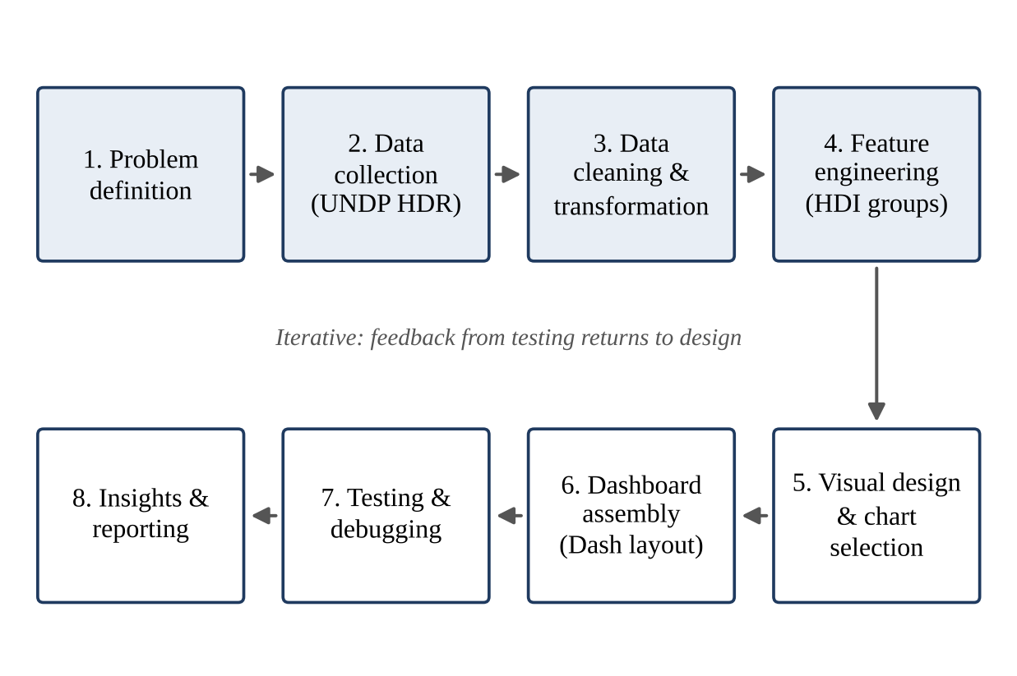
Figure 5.1: Methodology followed for the project
- Problem definition: identifying the users and the questions the dashboard must answer.
- Data collection: downloading the composite indices time series from UNDP.
- Data cleaning and transformation: the steps described in Chapter 4.
- Feature engineering: adding HDI group labels and, where required, derived columns such as the rank within a year.
- Visual design and chart selection: matching each question to the most suitable chart type.
- Dashboard assembly: building the layout and writing the callbacks in Dash.
- Testing and debugging: checking values, interactions and layout.
- Insight generation and reporting: interpreting the results and documenting them.
5.4 Approach to User Interface Design
The interface was designed from the top down. Controls that affect the whole dashboard (year, region, HDI group and country) are placed together at the top, so that the user always knows what is currently selected. Summary indicators follow, then the large visualizations that give the overview, and finally the detailed charts and the table. A single sequential blue colour scale is used for HDI values in every chart, so that a darker colour always means a higher level of human development. Text is kept short, and units are shown on every axis.
5.5 Integration of Data Visualizations
All charts read from the same filtered data frame, so a change in any control updates every chart together. This coordination is implemented with Dash callbacks that take the control values as inputs and return updated figures as outputs. Selecting a country in the multi-select list, for instance, highlights it in the trend chart and in the scatter plot and updates the key performance indicator cards.
Chapter 6
Dashboard Development Process
This chapter describes, step by step, how the dashboard was built. The overall architecture is shown in Figure 6.1: the data layer feeds the processing layer (Pandas), whose output is turned into charts by Plotly and arranged and made interactive by Dash, and is finally shown to the user in a web browser.
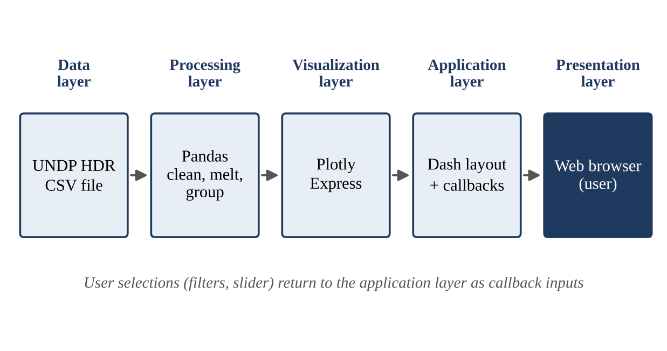
Figure 6.1: Architecture of the dashboard
6.1 Data Ingestion and Cleaning
The CSV file is read once when the application starts, and the cleaned, long-format data frame described in Chapter 4 is kept in memory. Because the dataset is small (about 190 countries and 30-odd years), no database is needed, and every callback can filter the data frame instantly. Cleaning was developed first in a Jupyter notebook, where each step could be inspected, and then moved into a separate module so that the dashboard code remained short.
6.2 Choice of Visualizations
Each chart was selected for the question it answers best:
- Choropleth map shows the HDI of every country for the selected year. Geographical patterns, such as the contrast between regions, are seen immediately.
- Line chart shows the HDI of selected countries from 1990 onwards. A line is the standard choice for change over time.
- Horizontal bar chart ranks the top and bottom countries. Bars aligned on a common baseline allow accurate comparison of lengths.
- Bubble scatter plot relates GNI per capita (log scale) to life expectancy, with bubble size for mean years of schooling and colour for HDI group, so that all three dimensions of the index appear in one chart. It shows the relationship between income and health and highlights outliers.
- Box plot by region shows the median, spread and outliers of HDI within each region.
- KPI cards and data table give exact numbers for the selected country and allow sorting.
6.3 User Interaction Features
Interactivity is provided by a year slider, a region drop-down, a country multi-select, an HDI group checklist and the built-in tooltips of Plotly. A simplified version of the callback that updates the map and the average HDI card is given below.
@app.callback(
Output("map", "figure"),
Output("kpi-avg", "children"),
Input("year", "value"),
Input("region", "value"),
Input("groups", "value"),
)
def update_map(year, region, groups):
d = data[(data["year"] == year) & (data["group"].isin(groups))]
if region != "All":
d = d[d["region"] == region]
if d.empty:
return go.Figure(), "No data"
fig = px.choropleth(d, locations="iso3", color="hdi", hover_name="country",
color_continuous_scale="Blues", range_color=(0.3, 1.0))
return fig, f"{d['hdi'].mean():.3f}"
6.4 Testing and Debugging
Testing was carried out at three levels. First, data validation: the HDI values and ranks of a sample of countries, including the top and bottom of the ranking and the four countries of the South Asian comparison, were checked against the published UNDP tables. Second, functional testing: every control was exercised on its own and in combination, including edge cases such as an HDI group with no countries in the selected region and the first and last years of the slider. Third, usability review: the layout, labels and default selections were reviewed for clarity, using simple tasks such as finding the HDI of a given country and comparing two regions.
The main problems found and fixed during debugging were:
- an encoding error when reading country names, solved by specifying the file encoding;
- blank map regions caused by codes that did not match the map shapes, solved by checking the ISO codes and dropping aggregate rows;
- an error in the bubble chart caused by missing values in the size or axis columns, solved by dropping incomplete rows before plotting;
- charts that failed when a filter combination returned no data, solved by returning an empty figure with an explanatory message;
- an unreadable income axis, because GNI per capita is highly skewed, solved by using a logarithmic scale.
Chapter 7
Design and Features of the Dashboard
7.1 Layout
The dashboard is organised as a grid of panels on a single page, as shown in the layout diagram in Figure 7.1. The numbers in the figure correspond to the annotations in Section 7.5.
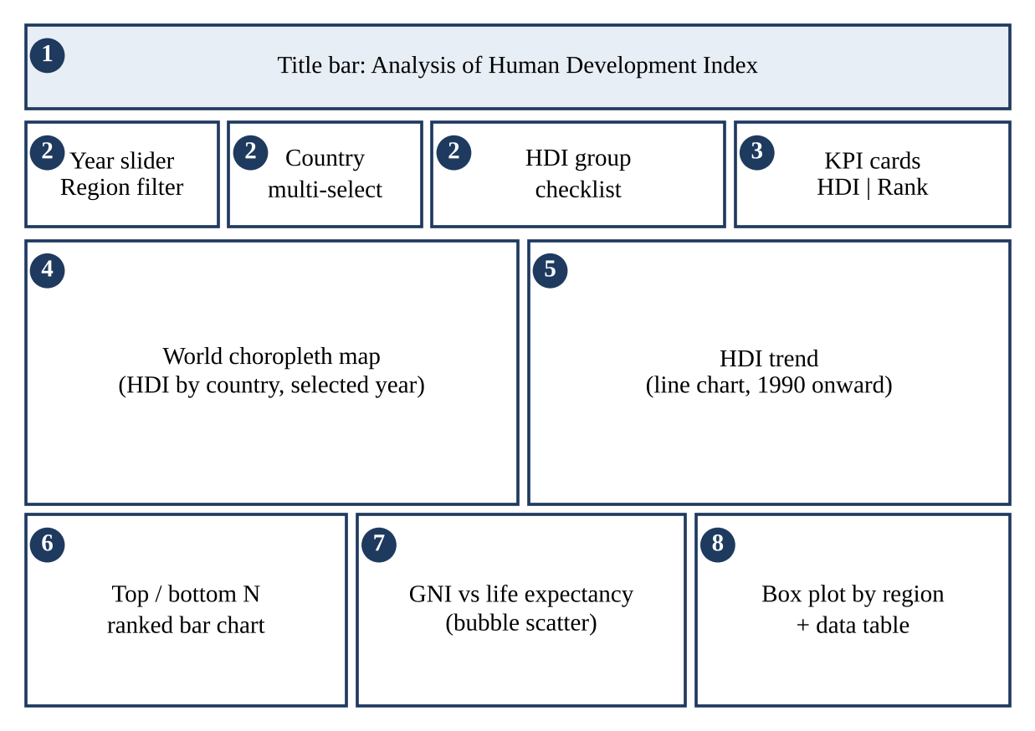
Figure 7.1: Layout of the dashboard with annotated regions
The title bar is followed by a control row and the KPI cards. Below them are the two main visualizations, the world map on the left and the trend chart on the right, because these answer the first questions a user asks. The lower row holds the ranking, the relationship chart and the regional distribution with the data table. The grid collapses to a single column on narrow screens.
7.2 Interactivity
- Year slider: moves through the years and updates every chart.
- Region drop-down: limits the map, ranking and scatter plot to one region.
- Country multi-select: adds countries to the trend chart for comparison and highlights them in other charts.
- HDI group checklist: shows or hides the low, medium, high and very high groups.
- Tooltips: display the country, the HDI and its four components when the pointer is placed on a map region, line, bar or bubble.
- Zoom, pan and legend clicks: provided by Plotly for detailed inspection.
7.3 User Experience
The dashboard is intended to be usable by someone who has never seen it before. All controls are visible at once and carry plain-language labels. Default selections show a meaningful starting view (the latest year, all regions and all HDI groups), so the user sees results immediately instead of an empty page. The same colour scale and the same font are used in all panels, and axis titles state the units. Feedback is immediate because the data are held in memory, and empty selections produce a clear message instead of an error.
7.4 Visualization Choices
The reasons for the choice of each chart were explained in Section 6.2. In summary, the map is used because HDI is a country-level quantity with a geographic pattern; the line chart because the question is about change over time; the bar chart because ranking requires precise comparison; the scatter plot because the relationship between two quantities is the question; and the box plot because the distribution within a region matters as much as its average. Pie charts and three-dimensional effects were deliberately avoided because they make accurate comparison difficult.
7.5 Formatting and Annotations of Key Features
Colours, fonts and spacing follow a single scheme: a dark navy title bar, white panels with thin borders, and a sequential blue colour scale for HDI values. Highlighted values, such as the selected country, use a contrasting red. The key features, numbered as in Figure 7.1, are:
- (1) Title bar: names the dashboard and the data source and edition.
- (2) Control row: year slider, region filter, country selector and HDI group checklist; together they define the current view.
- (3) KPI cards: show the HDI value and rank of the selected country for the selected year.
- (4) World map: colours each country by HDI; hovering shows the country name and exact value.
- (5) Trend chart: one line per selected country from 1990, with the 0.550, 0.700 and 0.800 group thresholds as reference lines.
- (6) Ranking chart: the top or bottom N countries for the selected year and region.
- (7) Bubble scatter plot: GNI per capita on a log scale against life expectancy, with bubble size showing mean years of schooling and colour showing the HDI group.
- (8) Regional box plot and data table: the spread of HDI by region and the exact values behind the charts, sortable by any column.
Chapter 8
Results and Discussion
8.1 Insights Revealed by the Dashboard
The figures quoted in this section are the HDI values for 2023 published in the UNDP Human Development Report 2025 [1], which is the latest edition used in the project.
Global picture
Iceland has the highest HDI at 0.972, followed by Norway and Switzerland, both at 0.970, Denmark at 0.962 and Germany at 0.959. At the other end of the ranking, South Sudan has the lowest value, 0.388, which places it in the low human development group [1]. The difference between the first and last country is therefore close to 0.58 on a scale that runs from 0 to 1. Figure 8.2 shows the ten highest and ten lowest countries in the dashboard, and Figure 8.1 shows the rise of the all-country average HDI since 1990. The Human Development Report 2025 also notes that global progress in human development has slowed to its weakest pace since 1990, excluding the pandemic years, and that the gap between countries with high and low HDI is widening [1].
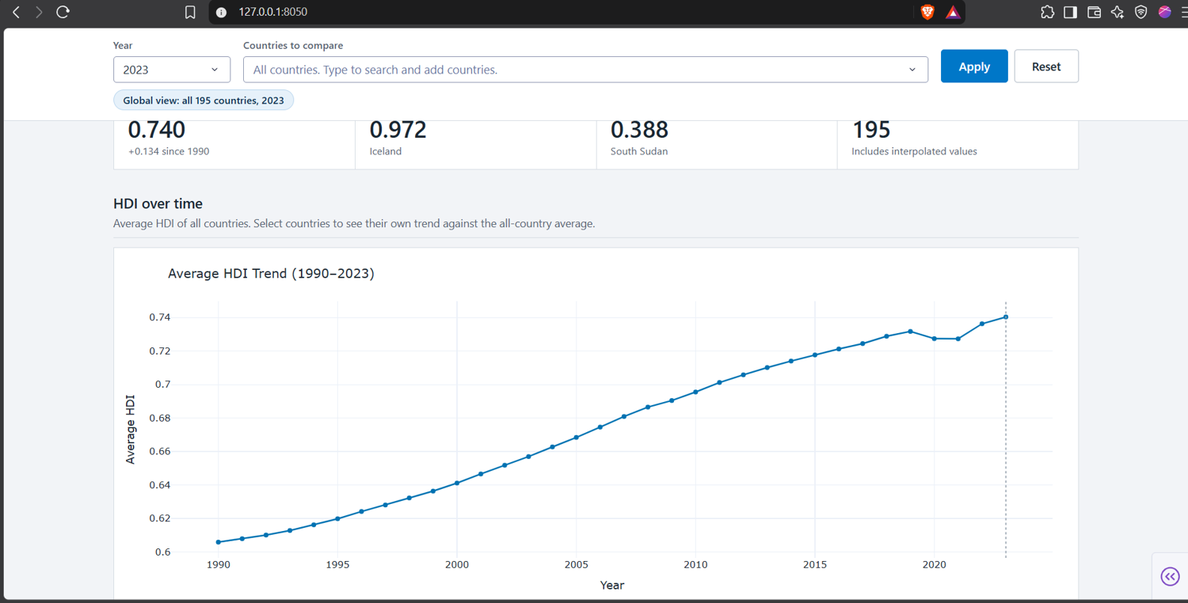
Figure 8.1: Dashboard view: average HDI of all countries, 1990–2023
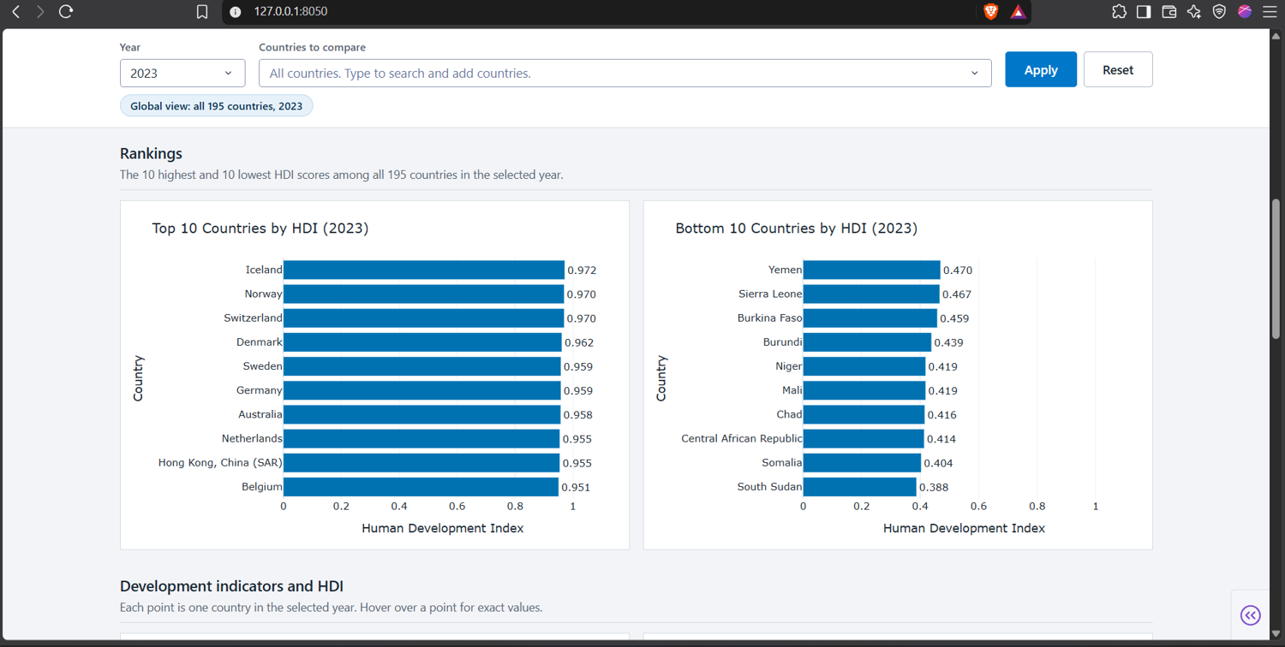
Figure 8.2: Dashboard view: top 10 and bottom 10 countries by HDI, 2023
India
India's HDI rose from 0.676 in 2022 to 0.685 in 2023, and its rank improved from 133rd to 130th among 193 countries and territories [1], [10]. India remains in the medium human development group but is close to the high human development threshold of 0.700. The dashboard's trend line, with the thresholds drawn as reference lines, makes this "almost there" position clear immediately. The report also states that inequality reduces India's HDI by about 30.7 percent when the inequality-adjusted HDI is used, the largest such loss in the region, which shows why the average value alone can hide large differences within a country [1].
South Asia
Comparing neighbouring countries in the dashboard's trend chart (Figure 8.3) shows a wide spread in 2023. Sri Lanka (0.776) is in the high group, Bhutan (0.698) is just below the high threshold, India and Bangladesh share a value of 0.685, Nepal has 0.622, and Pakistan, at 0.544, is the only one of the six in the low group [1]. Such a comparison, which would need several steps in a spreadsheet, takes a few clicks in the dashboard by selecting the region and adding countries to the trend chart.
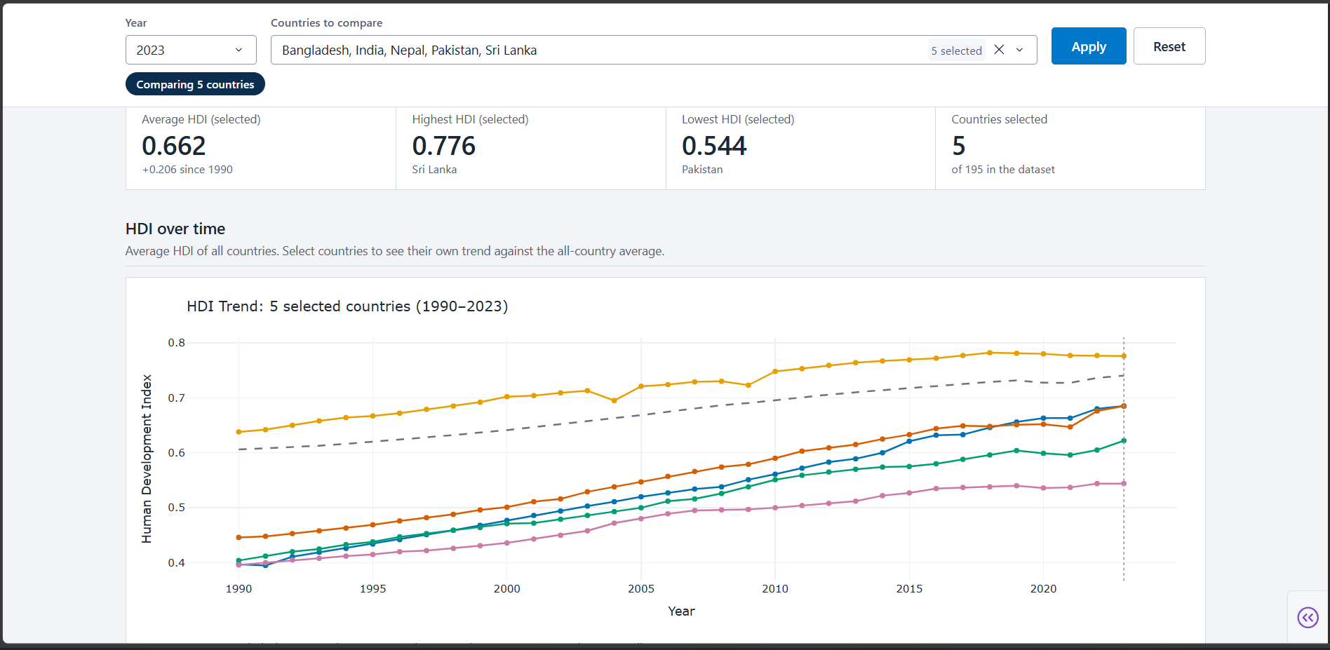
Figure 8.3: Dashboard view: HDI trend of India compared with Sri Lanka, Bangladesh, Nepal and Pakistan, 1990–2023
Relationship between income and health
The scatter plots of HDI against GNI per capita and life expectancy (Figure 8.4) show the well-known concave pattern for income: at low income levels small increases in income are associated with large gains in HDI, while at high income levels the curve flattens. Figures 8.5 and 8.6 show that HDI rises steadily with mean and expected years of schooling, and the correlation matrix links HDI most strongly to mean years of schooling (0.91) and life expectancy (0.89). Countries lying well above or below the general curve stand out immediately and can be examined through their tooltips. This illustrates a key message of the human development approach, that the same income can be converted into very different levels of health and education.
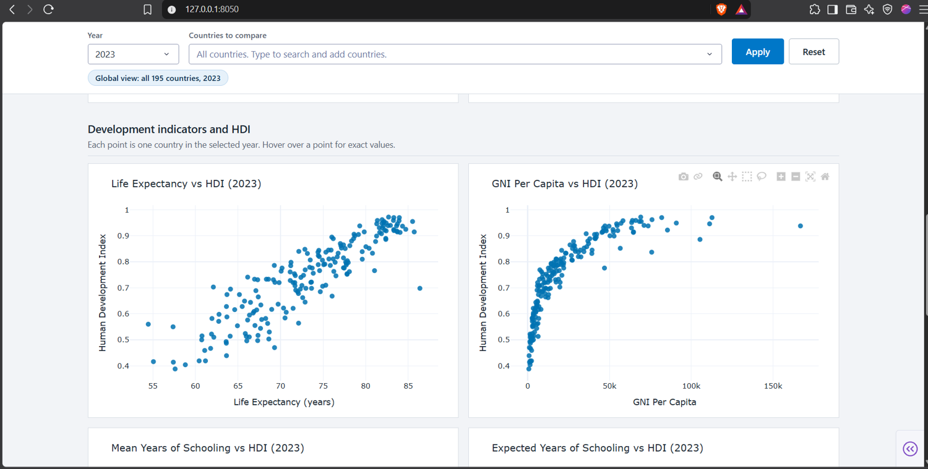
Figure 8.4: Dashboard view: life expectancy and GNI per capita against HDI, 2023
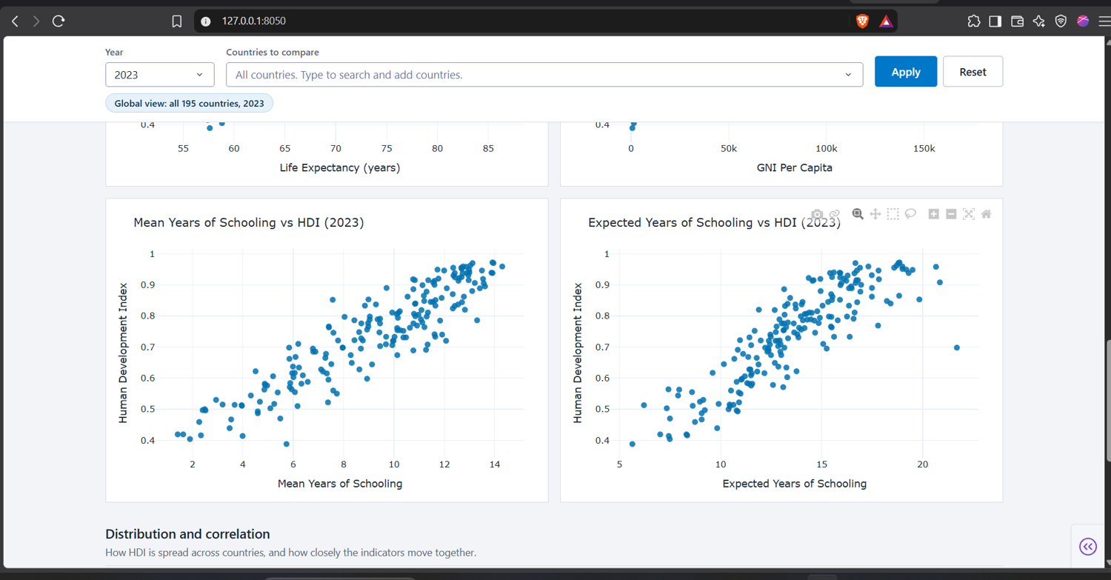
Figure 8.5: Dashboard view: mean and expected years of schooling against HDI, 2023
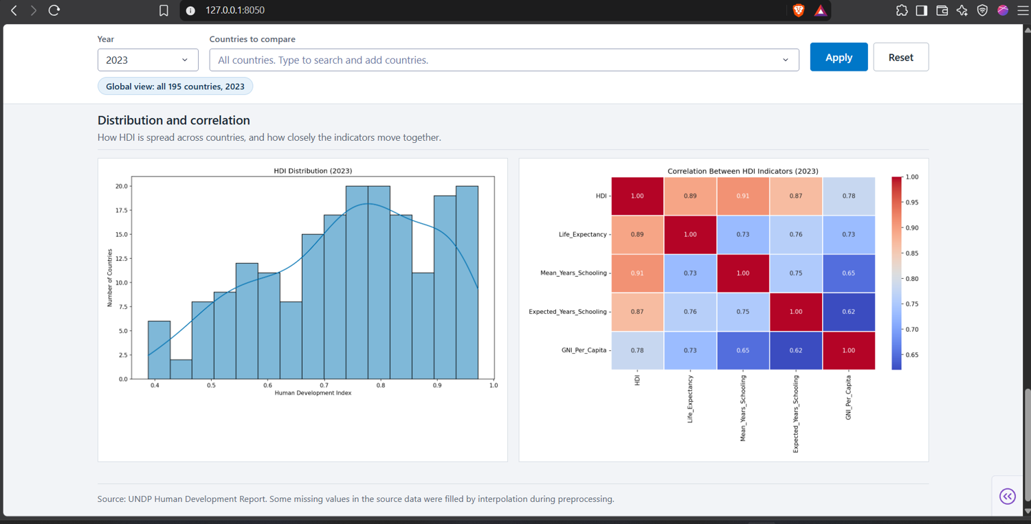
Figure 8.6: Dashboard view: HDI distribution and correlation between indicators, 2023
8.2 Answering the Research Question
The research question of the project was how the HDI data can be presented so that users can understand where countries stand, how they have changed and why they differ. The dashboard answers each part: the map and ranking show where countries stand; the trend chart shows how they have changed; the scatter plot and the component values in the tooltips show why they differ; and the regional box plot shows how groups compare. A user can move from the global view to a single country in two or three interactions.
8.3 Effectiveness of the Dashboard
The dashboard is effective in the following ways: it reproduces the published HDI values and ranks, which was verified for a sample of countries; it allows exploration without any technical knowledge; it presents seven different views on the same data while keeping a consistent look; and it responds instantly because the data are held in memory. The main limitation of the evaluation is that usability was reviewed only informally; a structured study with a larger group of users would be needed for firm conclusions and is listed under future enhancements.
8.4 Challenges Faced
- Design: fitting eight panels on one page without overcrowding required several rounds of rearrangement and the decision to place details in tooltips instead of labels.
- Data: the wide format, aggregate rows, missing values and encoding issues all required cleaning before the charts could be drawn.
- Interactivity: keeping all charts consistent when several filters are combined required careful ordering of the filtering steps in the callbacks.
- Performance: redrawing the map and the scatter plot on each slider movement can be slow on low-end machines, so the data are filtered once per callback and the number of traces is kept small.
- Methodology changes: UNDP revises its methodology and data from time to time, so values from different editions are not strictly comparable. The project therefore uses a single edition.
Conclusion and Future Enhancements
Summary of Key Findings and Achievements
The project achieved its aim of turning the UNDP Human Development Index data into an interactive dashboard. The raw wide-format time series was cleaned and reshaped, classified into HDI groups and presented through a coordinated set of visualizations: a world map, trend lines, a ranking chart, a bubble scatter plot, a regional box plot and a data table, controlled by a year slider and region, country and group filters. The dashboard reproduces the published values, such as Iceland at the top with 0.972 and India at 130th with 0.685 in 2023, and makes patterns visible that are hard to see in a spreadsheet, including the very wide gap between the highest and lowest countries, the spread within South Asia and the concave relationship between income and life expectancy.
Impact on Data Analysis
The dashboard reduces the effort needed to analyse the HDI from many manual steps to a few clicks. It shifts the user's attention from preparing the data to interpreting it, encourages comparison across countries and time, and makes the underlying components of the index visible instead of only the final score.
Limitations and How They Were Addressed
- Missing data: some country-year values do not exist. They were not estimated, and the dashboard clearly shows when data are unavailable.
- Single edition: only one edition of the UNDP data is used, which avoids inconsistencies between methodologies but means the dashboard must be updated when a new report is released.
- Averages hide inequality: the HDI is a national average. This is partly addressed by explaining the inequality-adjusted HDI in the discussion, but sub-national differences are not shown.
- Informal usability review: a structured study with a larger group of users was not carried out.
Future Enhancements
- Add the inequality-adjusted HDI, the Gender Inequality Index and the Multidimensional Poverty Index as additional selectable measures.
- Include state-level and district-level data for India, which would make the analysis more useful for domestic policy.
- Connect the dashboard to the UNDP data service so that new editions are loaded automatically (real-time or scheduled updates).
- Add forecasting of HDI trends and a what-if tool for exploring the effect of changes in income, schooling or life expectancy.
- Conduct a structured usability study and improve usability with a guided tour, downloadable charts and reports, multilingual labels and better accessibility, such as colour-blind-safe palettes and keyboard navigation.
- Deploy the application on a public cloud service so that it is available to all users through a web link.
Potential Applications and Scalability
The same architecture can be applied to other indices and domains, for example the World Bank development indicators, the Sustainable Development Goals indicators, public health statistics, education data or a company's sales and operations data. Because the data layer is separate from the visualization layer, only the data-preparation module has to be changed for a new dataset. The in-memory approach is adequate for datasets of this size; for much larger datasets, a database back end and caching could be added without changing the interface.
References
[1] United Nations Development Programme, Human Development Report 2025: A Matter of Choice: People and Possibilities in the Age of AI. New York, NY, USA: UNDP, 2025.
[2] United Nations Development Programme, Human Development Report 2023/24: Breaking the Gridlock: Reimagining Cooperation in a Polarized World. New York, NY, USA: UNDP, 2024.
[3] UNDP Human Development Report Office, "Human Development Data Center and technical notes: Calculating the human development indices." [Online]. Available: https://hdr.undp.org/data-center. [Accessed: Nov. 2026].
[4] Plotly Technologies Inc., "Plotly Python Graphing Library documentation." [Online]. Available: https://plotly.com/python/. [Accessed: Nov. 2026].
[5] Plotly Technologies Inc., "Dash documentation and user guide." [Online]. Available: https://dash.plotly.com/. [Accessed: Nov. 2026].
[6] W. McKinney, "Data structures for statistical computing in Python," in Proc. 9th Python in Science Conf., Austin, TX, USA, 2010, pp. 56–61.
[7] M. ul Haq, Reflections on Human Development. New York, NY, USA: Oxford University Press, 1995.
[8] A. Sen, Development as Freedom. Oxford, U.K.: Oxford University Press, 1999.
[9] S. Few, Information Dashboard Design: Displaying Data for At-a-Glance Monitoring, 2nd ed. Burlingame, CA, USA: Analytics Press, 2013.
[10] "India ranks 130th on Human Development Index, says UNDP 2025 report," Business Standard, May 2025. [Online]. Available: https://www.business-standard.com. [Accessed: Nov. 2026].
[11] A. Cairo, The Functional Art: An Introduction to Information Graphics and Visualization. Berkeley, CA, USA: New Riders, 2012.
[12] C. R. Harris et al., "Array programming with NumPy," Nature, vol. 585, pp. 357–362, 2020.

