Lab 2: Storm induced beach profile erosion

General Instructions & Background

The goals of this lab are:

* to give you a broad understanding on how to use hydrodynamic & morphodynamic numerical models (here we will use **XBeach**) to perform some 1D simulations.
* to explore the evolution of beach profiles subject to storm conditions.
* to investigate different beach nourishment scenario that can be used to reduce dune and beach erosion during storm event.

Through the notes and the notebooks you will see questions. You will need to provide solution for each of them.

Here we will mostly use the same **IPython notebook** for the entire lab and we will run different models with changing input conditions.

Again if at any point you don’t understand something, don’t be shy and ask for help.

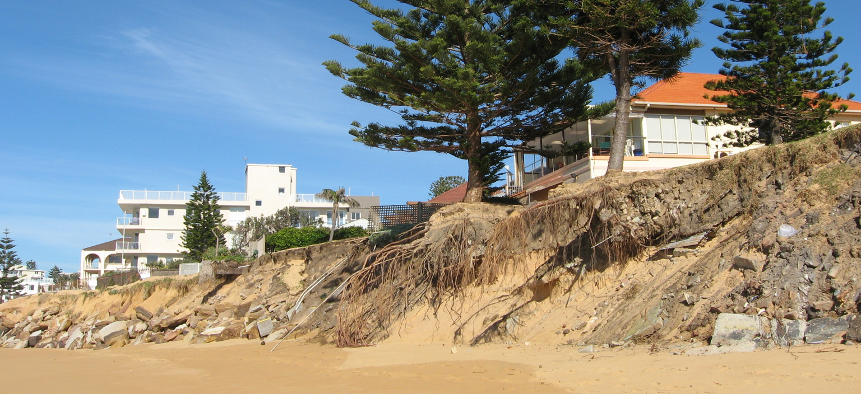

Figure 1 Collaroy-Narrabeen Beach is the most vulnerable beach to erosion from coastal storms in Warringah and is ranked the third most at risk area from coastal processes in Australia.

**XBeach model**

**XBeach** is an open-source numerical model that was originally developed to simulate hydrodynamic and morphodynamic processes and impacts on sandy coasts with a domain size of kilometers and on the time scale of storms.

The model includes the hydrodynamic processes of short wave transformation (refraction, shoaling and breaking), long wave (infragravity wave) transformation (generation, propagation and dissipation), wave-induced setup and unsteady currents, as well as overwash and inundation. The morphodynamic processes include bed load and suspended sediment trans- port, dune face avalanching, bed update and breaching. Effects of vegetation and of hard structures have been included. The model has been validated with a series of analytical, laboratory and field test cases using a standard set of parameter settings.

Beyond sandy coasts, the model has been applied to coral fringing and atoll reefs, in cooperation with and with funding by the University of Western Australia, the USGS and the Asian Development Bank.

It is recommended to look at the XBeach manual for an overview of the code capabilities as well as some understanding of the different parameters required to run the model.

* [User manual link](http://xbeach.readthedocs.io/en/latest/user_manual.html)

Lab 2: Exercises

NAME: _________________________________ SID: ________________________________

In the first part of this lab, you will get familiarized with **XBeach** input/output files to understand the basic commands and parameters that can be set. Like many numerical models there is a steep learning curve before being able to run complex and meaningful simulations. The first step in this process often consists in reproducing some simple examples and modifying them.

**We will first open the DelflandStorm folder and use the** Delfland.ipynb **notebook.**

**1953 storm surge**

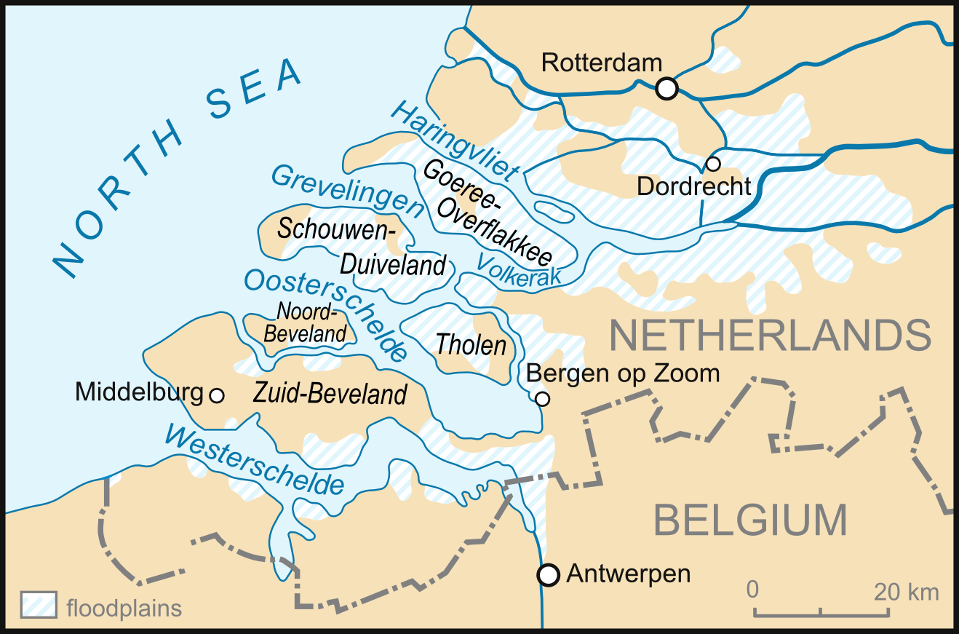

Figure 2 Extent of 1953 flooding in the Netherlands.

The first case we will run is a relative simple 1D case. It concerns a profile along the Dutch coast and the hydraulic boundary conditions are based on the 1953 storm surge that caused substantial flooding in the Netherlands.

All the parameters used in an **XBeach** run are defined in a file called *params.txt*.

The *params.txt* file contains grid and bathymetry info, wave input, flow input, morphological input, etc. in the form of keyword/value pairs. Each keyword/value pair may contain an actual model parameter or refer to another file with additional information on the model setup. If a *params.txt* file cannot be found then **XBeach** will not run.

Go to the folder **DelflandStorm** and have a look in the *params.txt* file. In this file there can be a single keyword/value pair per line. The keywords can be specified in any order. A keyword/value pair is separated by an equal sign (=). Each line containing an equal sign is interpreted as a keyword/value pair. Reversely, any lines without an equal sign are ignored and may be used for comments. Only a few keywords are required for the model to run, others have default values that are used in case the keyword is not mentioned in the params.txt file.

It is strongly recommended to specify as few parameters explicitly as possible and rely on the defaults for the other parameters. When running **XBeach**, a file called *xbeach.log* is created, which lists all the parameters set through the *params.txt* file but also all parameters not set, for which the defaults are used. When the user starts the model, it generates a file named *XBlog.txt*. In this file all the different keyword available are determined. When no keyword is defined the default value will be applied.

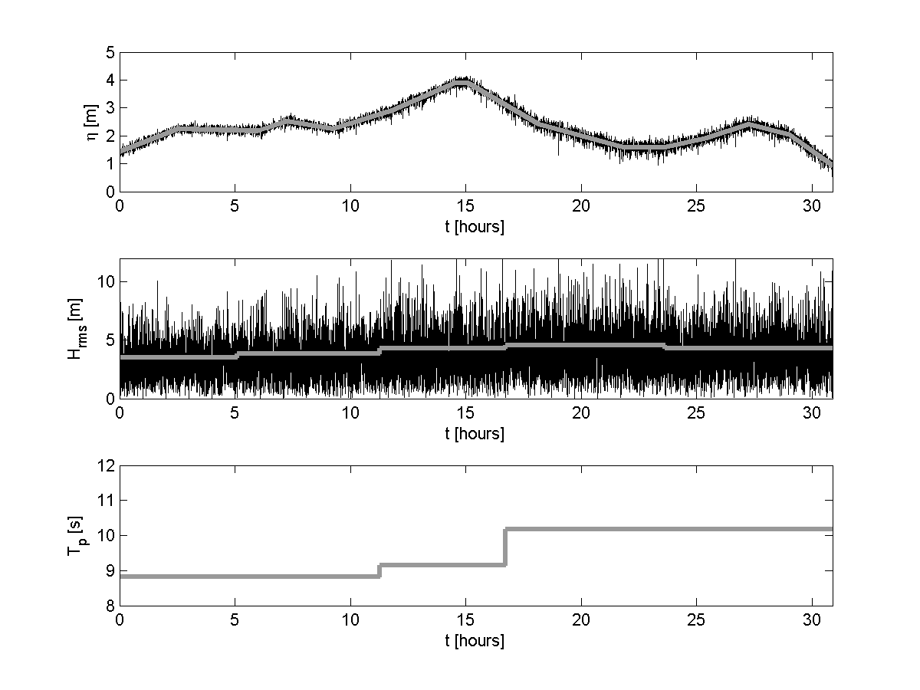

Figure 3 1953 storm surge characteristics.

Go to the folder **DelflandStorm** and open the Delfland.ipynb notebook. Play the first 3 cells to start running the simulation. The model will run for a few minutes, but in the meantime you can already work on the questions below.

To answer the next 3 questions you will need to have a look to the following resources:

* **XBeach JONSWAP parameter description:** [link](http://xbeach.readthedocs.io/en/latest/xbeach_manual.html#id163)
* **XBeach Time-varying tide/surge parameter description:** <link>
* **XBeach sediment transport parameter description:** [link](http://xbeach.readthedocs.io/en/latest/xbeach_manual.html?highlight=morfac#due-to-sediment-fluxes)
* **XBeach output parameter description:** [link](http://xbeach.readthedocs.io/en/latest/xbeach_manual.html#output-types)

Q1. In the params.txt file check the filenames in which you specify the wave conditions (keyword: bcfile) and the storm surge level (SSL) (keyword: zs0file). Do the wave conditions change during the simulation? What is/are the wave height(s) and wave period(s) applied in the simulation? Based on Figure 3, does it make sense?

____________________________________________________________________________________________________________________________________________________________________________________________________________________________________________________________________________________________________________________________________________________________________________________________________________________________________________________________________________________________________________

Q2. Does the storm surge level change during the simulation? What is the maximum surge height in the simulation? Surge height is defined with respect to the mean sea level (MSL)?

__________________________________________________________________________________________________________________________________________________________________________________________________________________________________________________________________________________________________________________________________________________________________________________________________________________________

Q3. What is the simulation time (keyword: tstop)? Do we apply a morphological acceleration factor (keyword: morfac)? What variables are stored as output and with what time interval? How much hydrodynamic time is simulated?

__________________________________________________________________________________________________________________________________________________________________________________________________________________________________________________________________________________________________________________________________________________________________________________________________________________________

Q4. Probably the simulation has finished. When you start the model. It generates a file named XBlog.txt. Open this file and check what is stored in the file. What was the total simulation time? What is the format of the output file?

__________________________________________________________________________________________________________________________________________________________________________________________________________________________________________________________________________________________________________________________________________________________________________________________________________________________

Q5. Using the IPython notebook (Delfland.ipynb) load the output file and explain why the wave_height array as a shape of (1112,259), what are these number referring to?

________________________________________________________________________________________________________________________________________________________________________________________________________________________________________________________________________________________________________________________________________

Q6. Run the IPython notebook (Delfland.ipynb) until the end and comment on the effect of the storm on the Beach profile evolution.

__________________________________________________________________________________________________________________________________________________________________________________________________________________________________________________________________________________________________________________________________________________________________________________________________________________________________________________________________________________________________________________________________________________________________________________________________________________________________________________________________________________________________________________________________________________________________

**Testing beach nourishment scenarios**

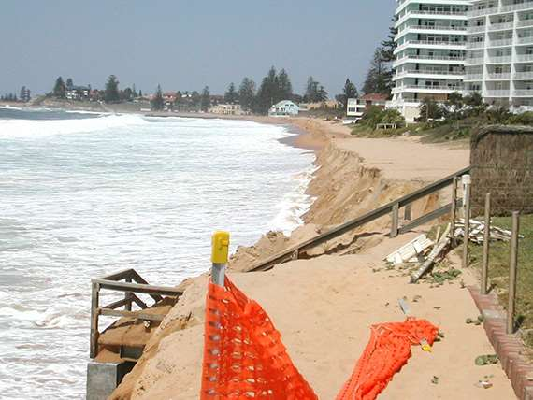

Figure 4 South Narrabeen March 2009: sand nourishment of Ausyrlia Surfing beaches. Coastalwatch article from Andrew Short ([link](http://www.coastalwatch.com/environment/5411/sand-nourishment-of-australia-s-iconic-surfing-beaches)).

This exercise concerns the exploration of a nourishment strategy in exposed beaches such as Collaroy Beach in Sydney North Shore. In June 2016, severe storms that ripped through Sydney beaches left serious damages to this specific beach ([DailyTelegraph article](http://www.dailytelegraph.com.au/newslocal/northern-beaches/two-weeks-on-a-solution-to-collaroys-erosion-problems-remains-unclear/news-story/7cb5aa294985a90b67c8bd5de232b093)). Here, we will explore to what extent nourishments can reduce the (dune and beach) erosion during a storm event.

We will build upon what we have done in the previous exercise and run a series of simulation using **XBeach** model. The required dataset for this exercise are located in the **NourishmentCase** folder and consist in 4 scenarios:

1. Reference Model: undisturbed profile
2. Shoreface Model: shoreface nourishment
3. Beach Model: beach nourishment
4. Banquette Model: special type of beach nourishment where a highly elevated flat area connected to the foot dune on which beach restaurants can be build

Each of these scenarios is run using the associated **IPython Notebook**. (*RefModel.ipynb*, *ShorefaceModel.ipynb*, *BeachModel.ipynb* and *BanquetteModel.ipynb* respectively).

All these models will run for a few minutes so you might want to start by opening the 4 notebooks and by playing the 3 top python cells in each of them to get your models running. Each model will run for a few minutes. While running you can already answer questions 7 to 9 based on the links provided here:

* **XBeach surf beat mode:** [link](http://xbeach.readthedocs.io/en/latest/xbeach_manual.html?highlight=instat#surf-beat-mode-instationary)
* **XBeach temporally varying wave boundary conditions:** [link](http://xbeach.readthedocs.io/en/latest/xbeach_manual.html?highlight=instat#temporally-and-or-spatially-varying-wave-boundary-conditions)

Q7. For the reference case open the params.txt in which you specify model input files and settings, Check the number of grid points in the x-direction (keyword: nx) and y-direction (keyword: ny). How many directional wave bins are defined and what is their width (keywords: thetamin, thetamax, dtheta).

________________________________________________________________________________________________________________________________________________________________________________________________________________________________________________________________________________________________________________________________________

Q8. Do the wave conditions change during the simulation? What is/are the wave height(s) and wave period(s) applied in the simulation? Does the storm surge level change during the simulation? What is the maximum surge height in the simulation?

____________________________________________________________________________________________________________________________________________________________________________________________________________________________________________________________________________________________________________________________________________________________________________________________________________________________________________________________________________________________________________

Q9. What is the simulation time (keyword: tstop)? Do we apply a morphological acceleration factor (keyword: morfac)? What variables are stored as output and with what time interval? How much hydrodynamic time is simulated?

__________________________________________________________________________________________________________________________________________________________________________________________________________________________________________________________________________________________________________________________________________________________________________________________________________________________

Probably all the simulations have finished. Using the respective IPython Notebooks inspect the morphological changes for each scenario by making animation of short wave height (H), water level (including long wave variations, zs) and bed level (zb) as function of time.

To compare the scenarios results we will use the CompModels.ipynb notebook.

**Initial condition comparisons**

Q10. At what cross-shore position where the shoreface nourishment and beach nourishment placed? What is the (average) thickness of the nourishments? Is the volume of the nourishments comparable between the scenarios? (Attached required figures and script to support your explanation in your report).

__________________________________________________________________________________________________________________________________________________________________________________________________________________________________________________________________________________________________________________________________________________________________________________________________________________________________________________________________________________________________________________________________________________________________________________________________________________________________________________________________________________________________________________________________________________________________________________________________________________________________________________________________________________________________________________________________________________________________________________________________________________________________________________________________________________________________________________________________________________________________________________________________________________________________________________________________________________________________________________________________________________________________________________________________________________________________________________

**Final condition comparisons**

Q11. What is the dune face retreat in the 4 simulations you have carried out? Where does the eroded sediment forming the dune is deposited? What nourishment type is most effective in reducing the impact of a storm and do you have an explanation for this? What will be your approach to further reduce beach and dune erosion? (Attached required figures and scripts to support your explanation in your report).

__________________________________________________________________________________________________________________________________________________________________________________________________________________________________________________________________________________________________________________________________________________________________________________________________________________________________________________________________________________________________________________________________________________________________________________________________________________________________________________________________________________________________________________________________________________________________________________________________________________________________________________________________________________________________________________________________________________________________________________________________________________________________________________________________________________________________________________________________________________________________________________________________________________________________________________________________________________________________________________________________________________________________________________________________________________________________________________________________________________________________________________________________________________________________________________________________________________________________________________________________________________________________________________________________________________________________________________________