Week 2 Mandatory Hands-on Exercise Answers

# PL/SQL programming - Exercise 1: Control Structures

Code:

DECLARE

    v_number NUMBER := 15;

    v_result VARCHAR2(50);

BEGIN

    -- IF-THEN-ELSE structure

    IF v_number < 10 THEN

        v_result := 'Less than 10';

    ELSIF v_number = 10 THEN

        v_result := 'Equal to 10';

    ELSE

        v_result := 'Greater than 10';

    END IF;

    DBMS_OUTPUT.PUT_LINE('IF result: ' || v_result);

    -- CASE structure

    CASE

        WHEN v_number BETWEEN 1 AND 10 THEN

            v_result := 'Between 1 and 10';

        WHEN v_number BETWEEN 11 AND 20 THEN

            v_result := 'Between 11 and 20';

        ELSE

            v_result := 'Outside range';

    END CASE;

    DBMS_OUTPUT.PUT_LINE('CASE result: ' || v_result);

    -- FOR LOOP

    FOR i IN 1..5 LOOP

        DBMS_OUTPUT.PUT_LINE('FOR LOOP iteration: ' || i);

    END LOOP;

    -- WHILE LOOP

    DECLARE

        v_counter NUMBER := 1;

    BEGIN

        WHILE v_counter <= 3 LOOP

            DBMS_OUTPUT.PUT_LINE('WHILE LOOP iteration: ' || v_counter);

            v_counter := v_counter + 1;

        END LOOP;

    END;

END;

**OUTPUT:**

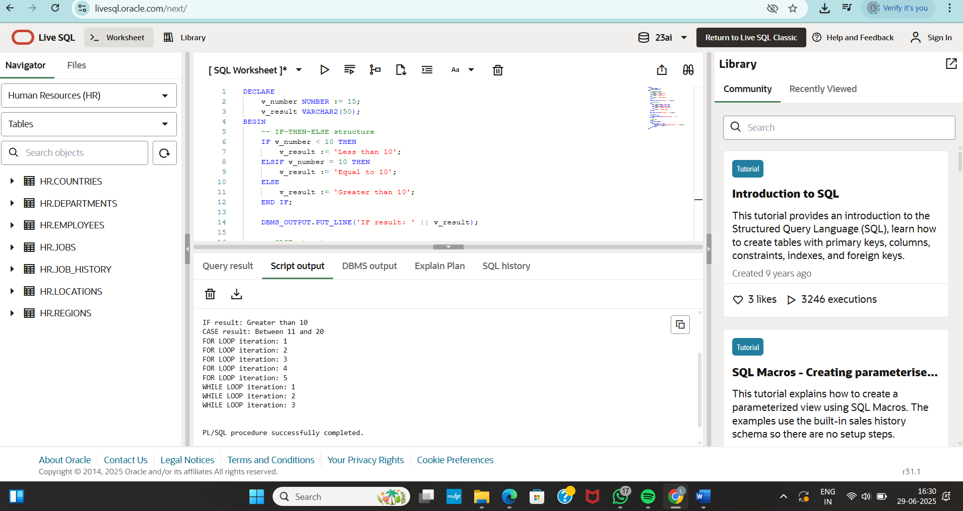

# PL/SQL programming - Exercise 3: Stored Procedures

CODE:

SET SERVEROUTPUT ON;

DECLARE

v_input NUMBER := 6;

v_result NUMBER;

BEGIN

v_result := v_input * v_input;

DBMS_OUTPUT.PUT_LINE('Square of ' || v_input || ' is: ' || v_result);

END;

OUTPUT:

