Nama : Larastika Putri Hendarti

Npm : G1F021030

Mata Kuliah : Algoritma Struktur Data

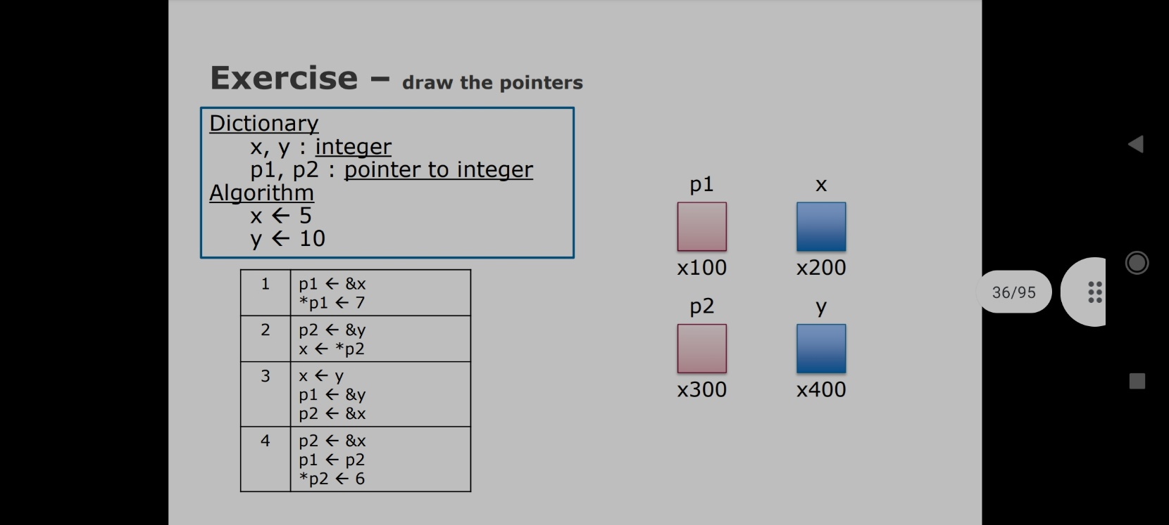

**a.** P1 <- &x P1 x

*P1 <- 7

7

X 200 X200

P2 y

10

X300 X400

P1 x

1. P2 <- &y

10

x <- *P2

X200 x200

P2 y

10

X400 x400

P1 x

1. X <- y

10

P1 <- &y

P2 <- &x

X400 x200

P2 y

10

X200 x400

P1 x

1. P2 <- &x

6

P1 <- P2

*P2 <- 6

X200 x200

P2 y

10

X200 x400

1. 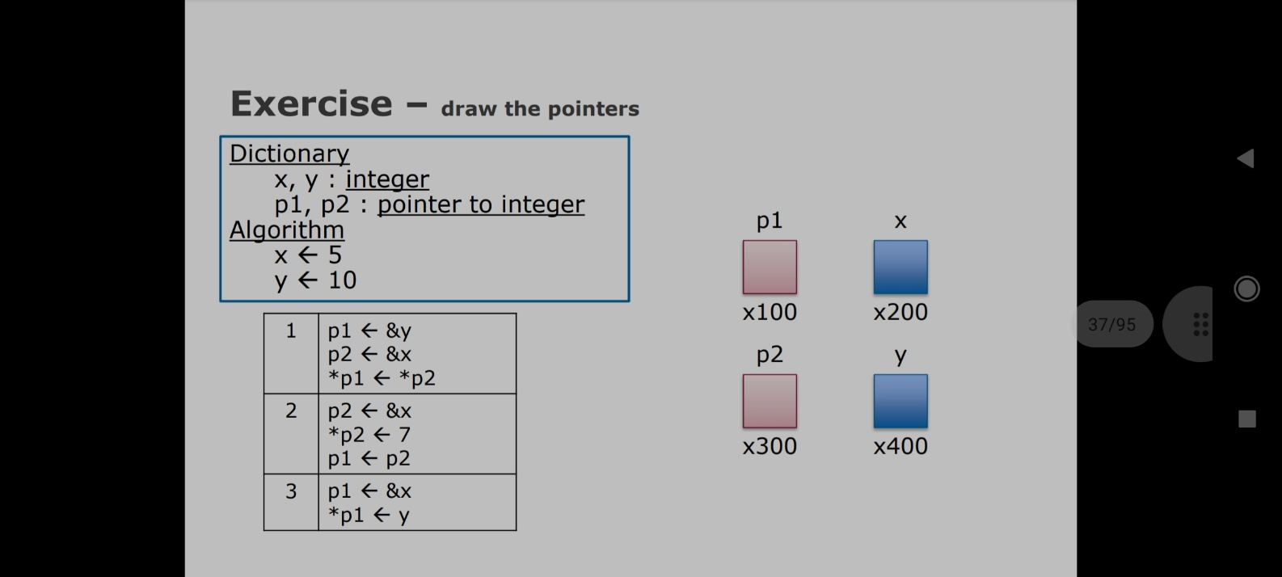

P1 x

**a.** P1 <- &y

5

P2 <- &x

*P1 <- *P2

X400 x200

P2 y

5

X200 x400

P1 x

7

**b.** P2 <- &x

*P2 <- 7

P1 <- P2

X200 x200

P2 y

5

X200 x400

P1 x

5

**c.** P1 <- &x

*P1 <- y

X200 x200

P2 y

5

X200 x400

1. Exercise – write the value inside each variable and pointer

Dictionary

a, b, c : integer

p1,p2,p3 : pointer to integer What Is The Output?

|  |  |  |  |  |  |
| --- | --- | --- | --- | --- | --- |
| A | B | C | P1 | P2 | P3 |
| 10 | 15 | 27 | 0x6ffdec | 0x6ffdec | 0x1 |
| 27 | 8 | 27 | 0x6ffde8 | 0x6ffdec | 0x6ffdec |
|  |  |  |  |  |  |
|  |  |  |  |  |  |
|  |  |  |  |  |  |
|  |  |  |  |  |  |
|  |  |  |  |  |  |
|  |  |  |  |  |  |
|  |  |  |  |  |  |

Algorithm

A <- 10

B <- 15

p1 <- &b

p2 <- p1

c <- 27

p1 <- &c

a <- *p1

p3 <- &b

*p2 <- 8

1. Exercise – write the value inside each variable and pointer

|  |  |  |  |  |  |
| --- | --- | --- | --- | --- | --- |
| A | B | C | P1 | P2 | P3 |
| 10 | 15 | 27 | 0x6ffde4 | 0x6ffde0 | 0x40ea45 |
| 27 | 15 | 27 | 0x6ffde4 | 0x6ffde0 | 0x40ea45 |
| 15 | 6 | 27 | 0x6ffde4 | 0x6ffde0 | 0x6ffde0 |
| 27 | 6 | 27 | 0x6ffde4 | 0x6ffddc | 0x6ffddc |
|  |  |  |  |  |  |
|  |  |  |  |  |  |
|  |  |  |  |  |  |
|  |  |  |  |  |  |
|  |  |  |  |  |  |
|  |  |  |  |  |  |

Dictionary

a, b, c : integer What Is The Output?

p1, p2, p3 : pointer to integer

Algorithm

A <- 10

b <- 15

c <- 27

p1 <- &a

p2 <- &b

*p1 <- c

a <- *p2

b <- 6

p3 <- &b

p3 <- &c

*p1 <- *p