LLM Augmentation Project Documentation

# Introduction

This document provides an overview of the LLM Augmentation project, including the process, model architecture, hyperparameters, evaluation, and results. The project uses the Project Gutenberg catalog to fine-tune language models and enhance them with vector databases like Qdrant.

# Figure 1: Hugging Face Repository

This figure shows the Hugging Face repository where the fine-tuned models are stored. The repository includes three models: flan_t5_small_finetuned_kmfodabooksum_13books, flan_t5_small_finetuned_kmfodabooksum_75books, and flan_t5_small_finetuned_kmfodabooksum_77books.

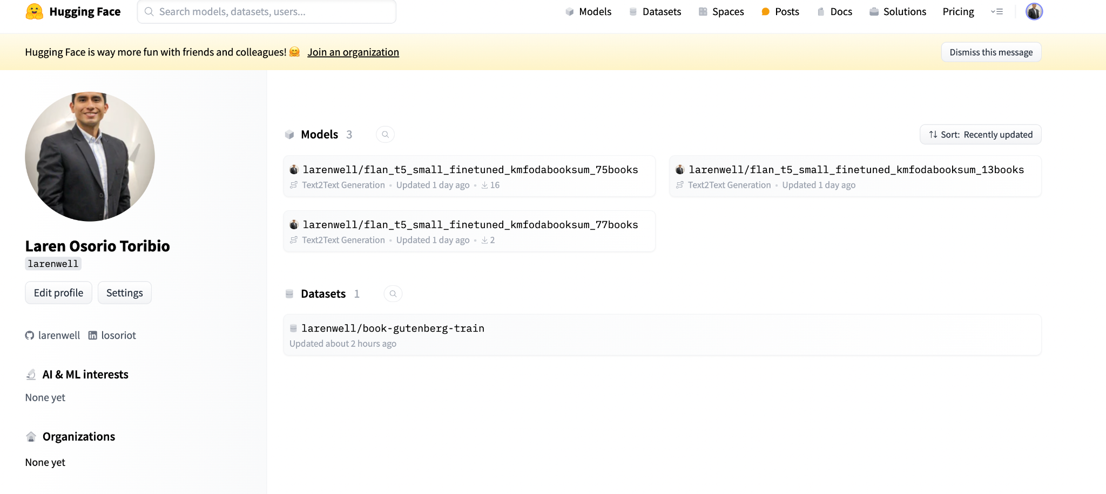

# Figure 2: Qdrant Client

This figure shows the Qdrant client interface where the 'gutenberg_book_embeddings_cleaned' collection is stored. The collection contains metadata and embeddings for the books processed in this project.



# Figure 3: Collection Info

This figure provides detailed information about the 'gutenberg_book_embeddings_cleaned' collection in Qdrant. The collection has 17,296 points distributed across 8 segments.

